Skip to main content

Search Products

More from ColesAccountLists
$0.00
- Shop products
- Specials & catalogues
- Bought before
- Recipes & inspiration
- Ways to shop
- Help
- Free trial
Mount Druitt
When

- Home
- Lists
- Price Compare

Price Compare
Invite others

Estimated total

$315.11
Estimated savings
$9.85
Add list to trolley
63 items
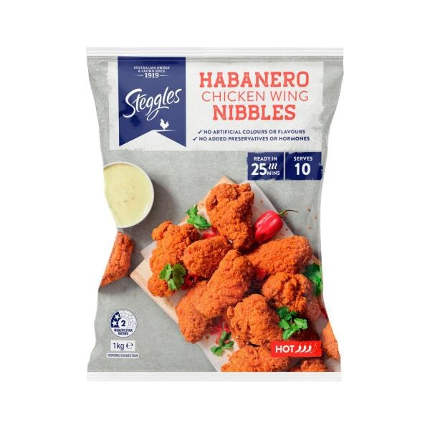

Steggles Habanero Chicken Wings | 1kg
$13.50
$13.50/ 1kg
Currently unavailable
Quantity
1234567891011121314151617181920
Habanero Chicken Wings quantity is 1 item
Remove from list
Shop similar
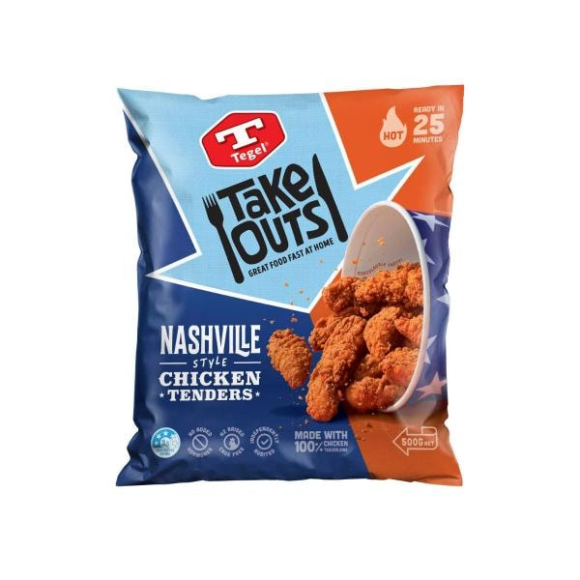

Tegel Take Outs Frozen Chicken Tenderloins Nashville Style | 500GRAM
$14.00
$28.00/ 1kg
Quantity
1234567891011121314151617181920
Take Outs Frozen Chicken Tenderloins Nashville Style quantity is 1 item
Remove from list
Add
Product is not in your trolley
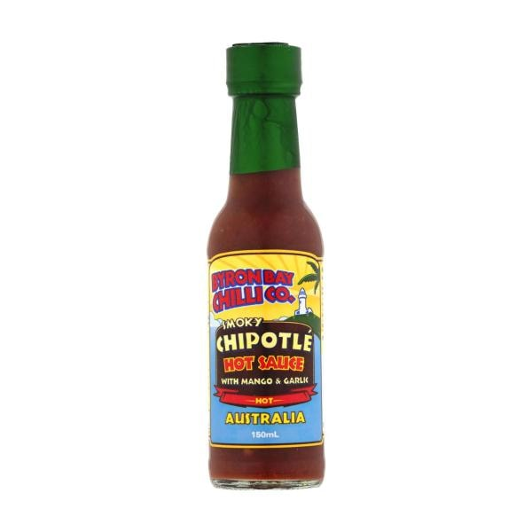

Byron Bay Chilli Co. Smoky Chipotle Hot Sauce | 150mL
$4.50
$3.00/ 100mL
Quantity
1234567891011121314151617181920
Smoky Chipotle Hot Sauce quantity is 1 item
Remove from list
Add
Product is not in your trolley
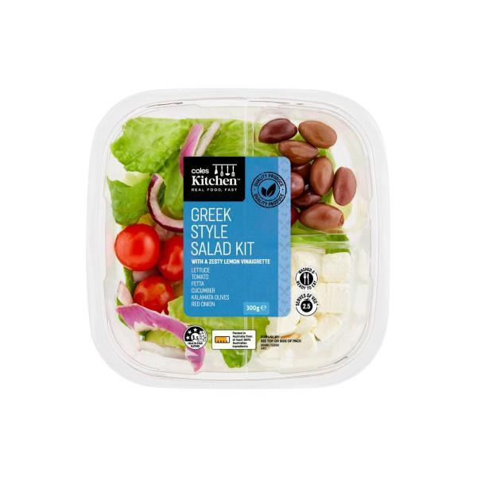

Coles Kitchen Made For Sharing Salad Kit Greek Style | 300g
$8.80
$29.33/ 1kg
Quantity
1234567891011121314151617181920
Made For Sharing Salad Kit Greek Style quantity is 1 item
Remove from list
Add
Product is not in your trolley
Bonus credit^
See footnote
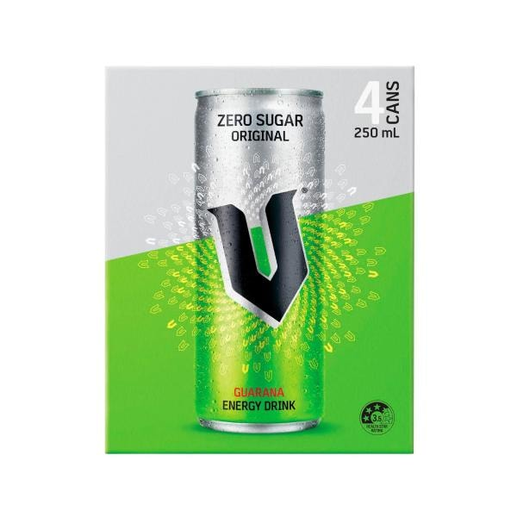

V Energy Drink Sugar Free 4x250ml | 1L
$12.00
$12.00/ 1L
Quantity
1234567891011121314151617181920
Energy Drink Sugar Free 4x250ml quantity is 1 item
Remove from list
Add
Product is not in your trolley
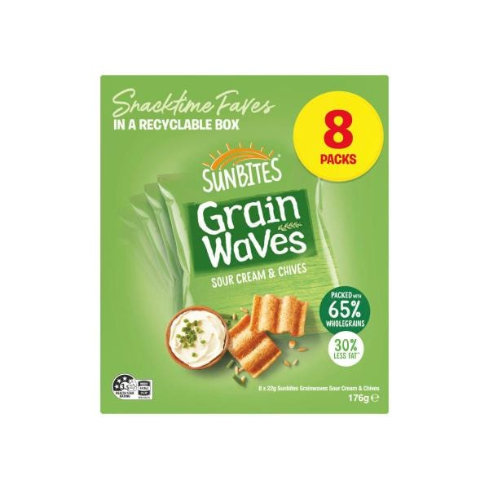
SPECIAL

Sunbites Grain Waves Chips Kids' Lunchbox Multipack 8 Pack | 176g
$4.00
Save $2.00
$2.27/ 100g | Was $6.00
9 more buying options
Quantity
123456789101112
Grain Waves Chips Kids' Lunchbox Multipack 8 Pack quantity is 1 item
Remove from list
Add
Product is not in your trolley
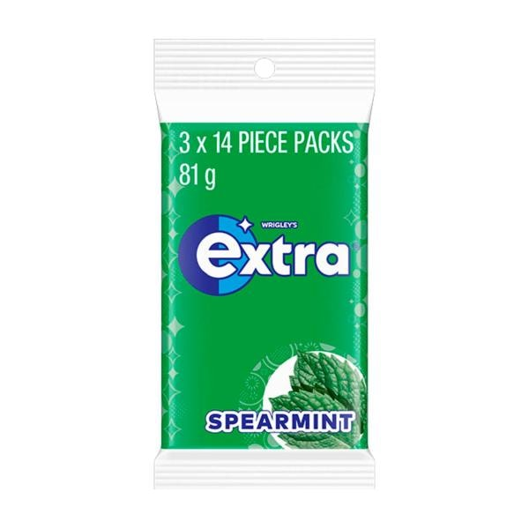
EVERY DAY

Extra Spearmint Sugar Free Chewing Gum 3x27g | 81g
$5.50
$6.79/ 100g
4 more buying options
Quantity
1234567891011121314151617181920
Spearmint Sugar Free Chewing Gum 3x27g quantity is 1 item
Remove from list
Add
Product is not in your trolley
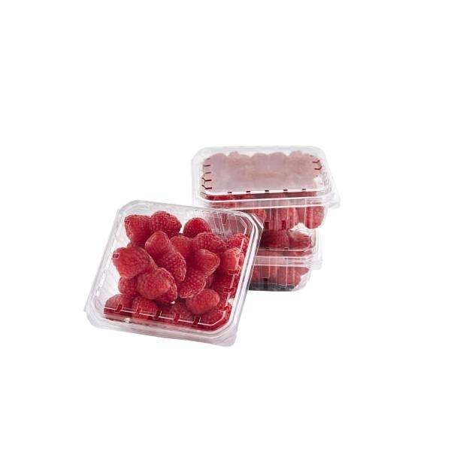
SPECIAL

Coles Raspberries | 125g
$4.00
$32.00/ 1kg
1 more buying option
Quantity
1234567891011121314151617181920212223242526272829303132333435363738394041424344454647484950
Raspberries quantity is 1 item
Remove from list
Add
Product is not in your trolley
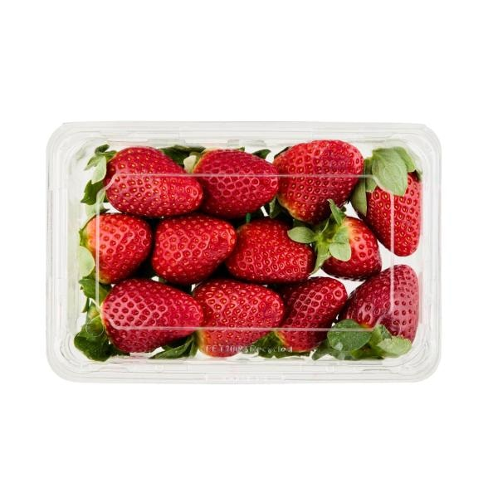

Coles Strawberries | 250g
$6.00
$24.00/ 1kg
1 more buying option
Quantity
1234567891011121314151617181920212223242526272829303132333435363738394041424344454647484950
Strawberries quantity is 1 item
Remove from list
Add
Product is not in your trolley
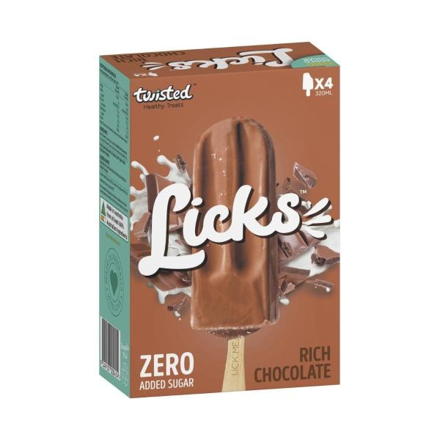

Twisted Healthy Treats Licks Zero Rich Choc 4 Pack | 320mL
$9.50
$2.97/ 100mL
Quantity
1234567891011121314151617181920
Healthy Treats Licks Zero Rich Choc 4 Pack quantity is 1 item
Remove from list
Add
Product is not in your trolley
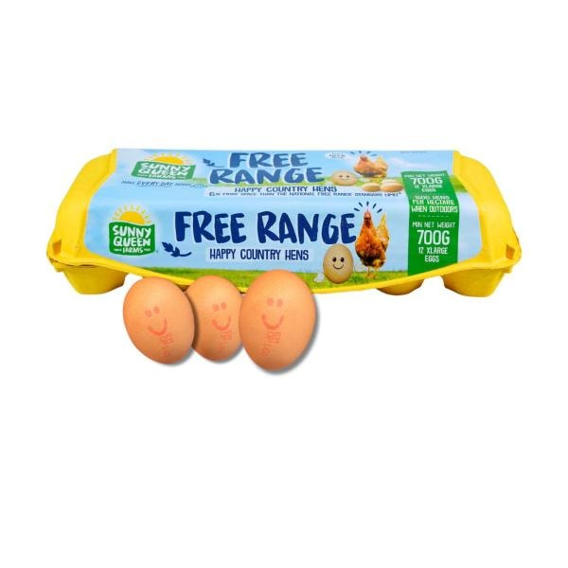

Sunny Queen Free Range Extra Large Eggs 12 Pack | 700g
$8.80
$1.26/ 100g
Quantity
1234567891011121314151617181920
Free Range Extra Large Eggs 12 Pack quantity is 1 item
Remove from list
Add
Product is not in your trolley
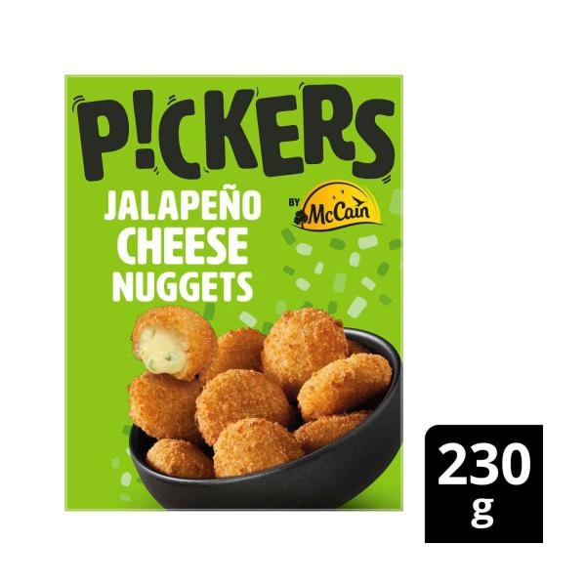

Pickers Jalapeno Cheese Nugget | 230g
$7.50
$3.26/ 100g
5 more buying options
Quantity
1234567891011121314151617181920
Jalapeno Cheese Nugget quantity is 1 item
Remove from list
Add
Product is not in your trolley
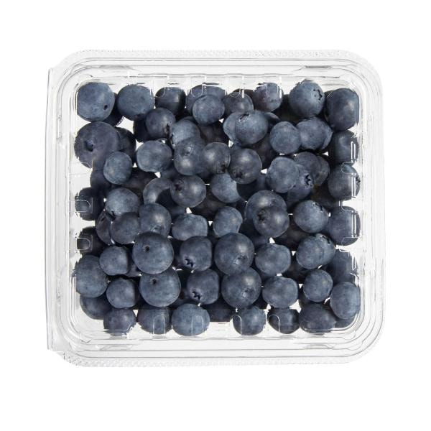
SPECIAL

Coles Blueberries | 125g
$4.50
$36.00/ 1kg
Quantity
1234567891011121314151617181920212223242526272829303132333435363738394041424344454647484950
Blueberries quantity is 1 item
Remove from list
Add
Product is not in your trolley
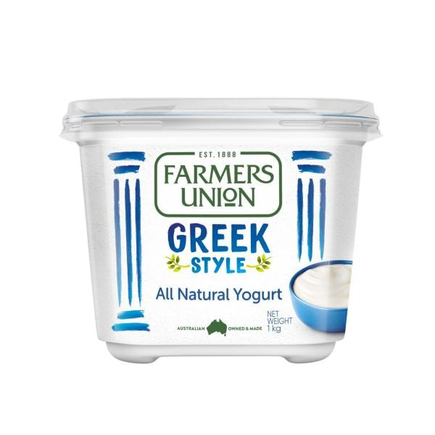

Farmers Union Greek Style Natural Yoghurt | 1kg
$7.50
$0.75/ 100g
6 more buying options
Quantity
1234567891011121314151617181920
Greek Style Natural Yoghurt quantity is 1 item
Remove from list
Add
Product is not in your trolley
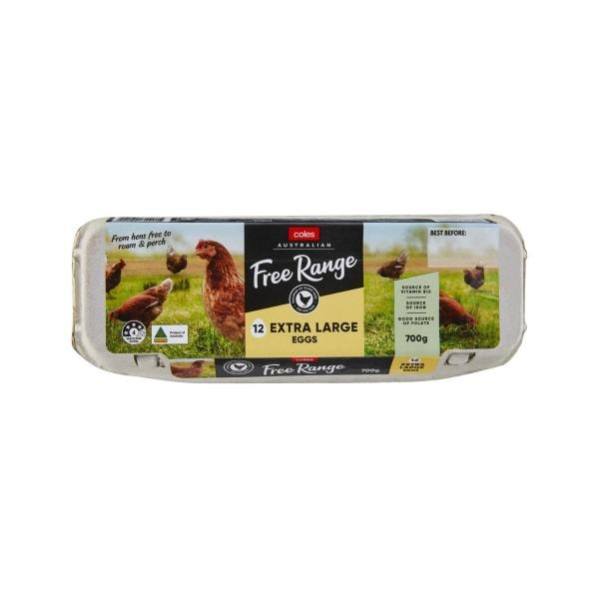
EVERY DAY

Coles Free Range Eggs 12 Pack | 700g
$6.50
$0.93/ 100g
2 more buying options
Quantity
123456789101112
Free Range Eggs 12 Pack quantity is 1 item
Remove from list
Add
Product is not in your trolley
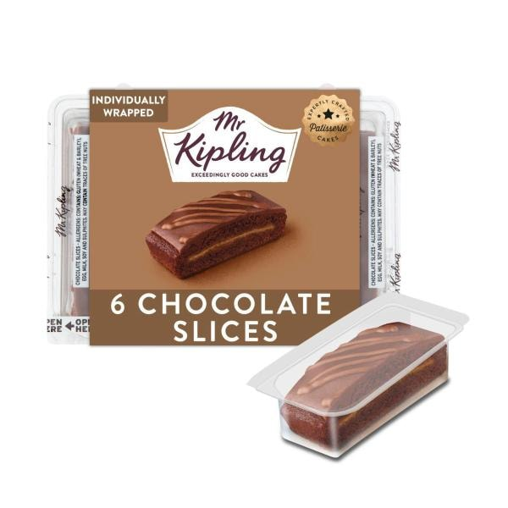

Mr Kipling Chocolate Slices 6 Pack | 155g
$6.20
$4.00/ 100g
Quantity
1234567891011121314151617181920
Chocolate Slices 6 Pack quantity is 1 item
Remove from list
Add
Product is not in your trolley
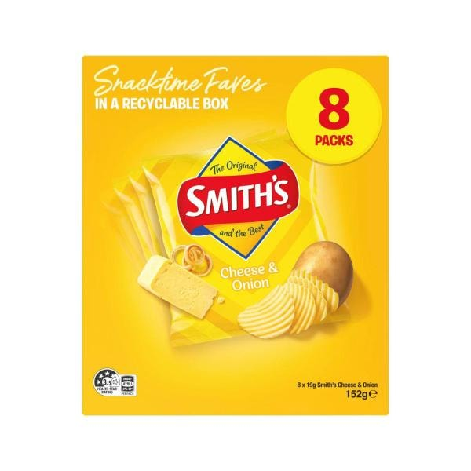
SPECIAL

Smith's Potato Chips Lunchbox Multipack Cheese & Onion 8 Pack | 152g
$4.00
Save $2.00
$2.63/ 100g | Was $6.00
9 more buying options
Quantity
123456789101112
Potato Chips Lunchbox Multipack Cheese & Onion 8 Pack quantity is 1 item
Remove from list
Add
Product is not in your trolley
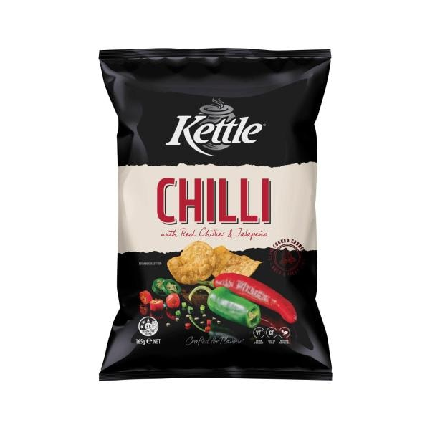
SPECIAL

Kettle Chilli Potato Chips | 165 gram
$6.00
$3.64/ 100g
Any 2 | $9
$2.73/ 100g
7 more buying options
Quantity
123456789101112
Chilli Potato Chips quantity is 1 item
Remove from list
Add
Product is not in your trolley
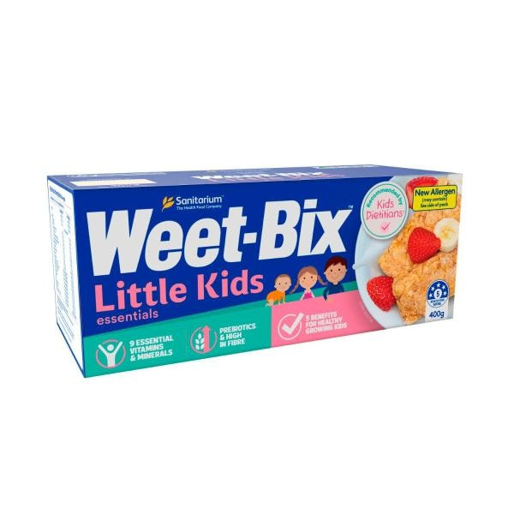

Sanitarium Weet-bix Little Kids Essentials Breakfast Cereal | 400g
$5.00
$1.25/ 100g
Quantity
1234567891011121314151617181920
Weet-bix Little Kids Essentials Breakfast Cereal quantity is 1 item
Remove from list
Add
Product is not in your trolley
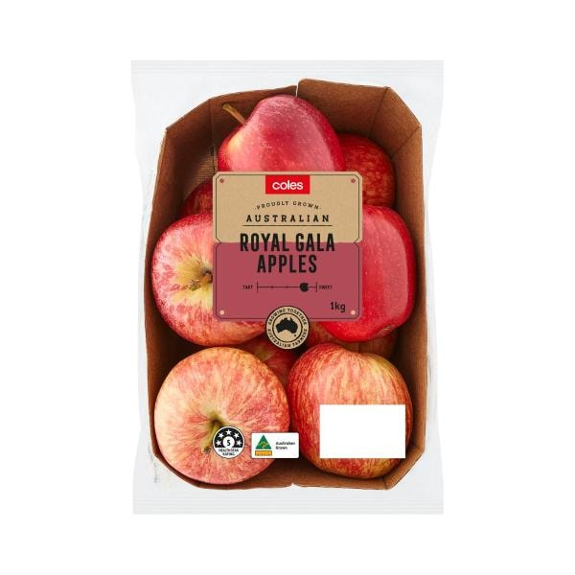

Coles Royal Gala Apples 1kg | 1 each
$7.90
$7.90/ 1kg
Quantity
1234567891011121314151617181920212223242526272829303132333435363738394041424344454647484950
Royal Gala Apples 1kg quantity is 1 item
Remove from list
Add
Product is not in your trolley
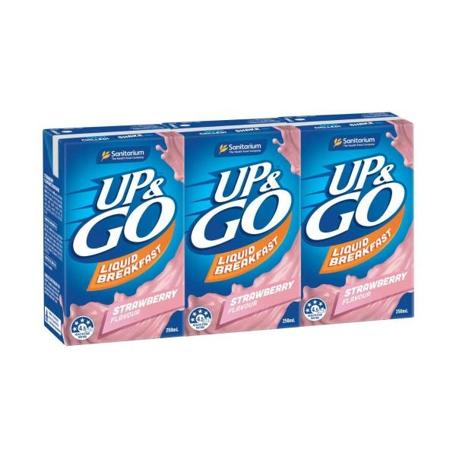

UP&GO Liquid Breakfast Strawberry 3x250ml | 750mL
$7.00
$9.33/ 1L
5 more buying options
Quantity
1234567891011121314151617181920
Liquid Breakfast Strawberry 3x250ml quantity is 1 item
Remove from list
Add
Product is not in your trolley
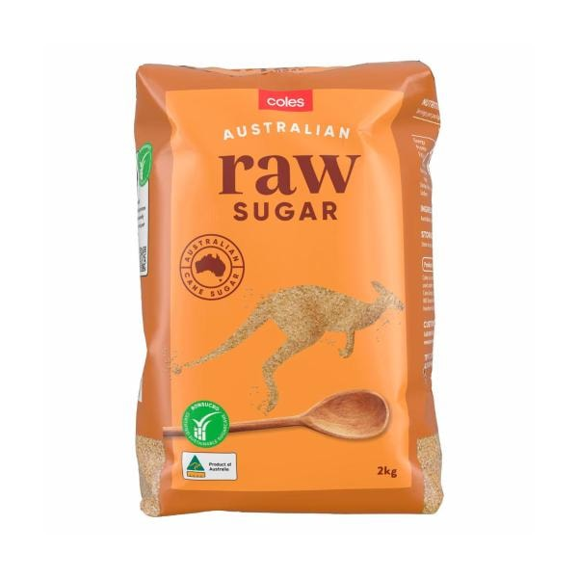
EVERY DAY

Coles Raw Sugar | 2 kg
$3.20
$0.16/ 100g
1 more buying option
Quantity
1234567891011121314151617181920
Raw Sugar quantity is 1 item
Remove from list
Add
Product is not in your trolley
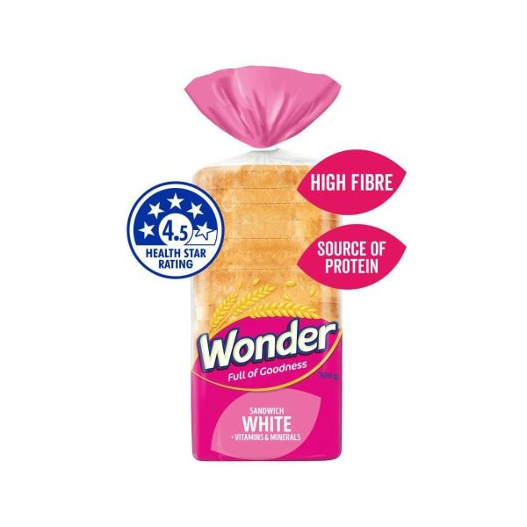

Wonder White Bread + Vitamins & Minerals | 700g
$4.70
$0.67/ 100g
2 more buying options
Quantity
1234567891011121314151617181920
White Bread + Vitamins & Minerals quantity is 1 item
Remove from list
Add
Product is not in your trolley
Bonus credit^
See footnote
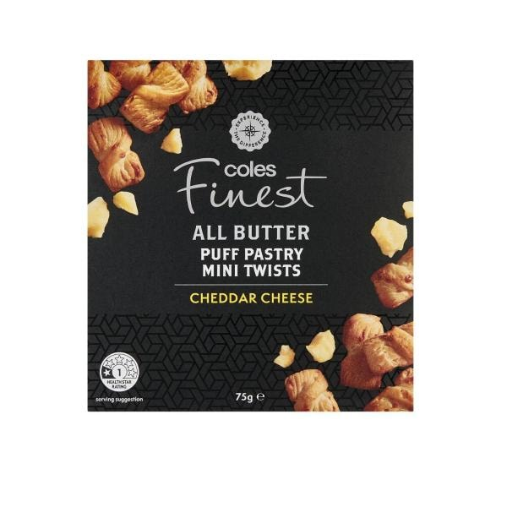

Coles Finest All Butter Puff Pastry Cheese Mini Twists Crackers | 75g
$2.50
$3.33/ 100g
Quantity
1234567891011121314151617181920
All Butter Puff Pastry Cheese Mini Twists Crackers quantity is 1 item
Remove from list
Add
Product is not in your trolley
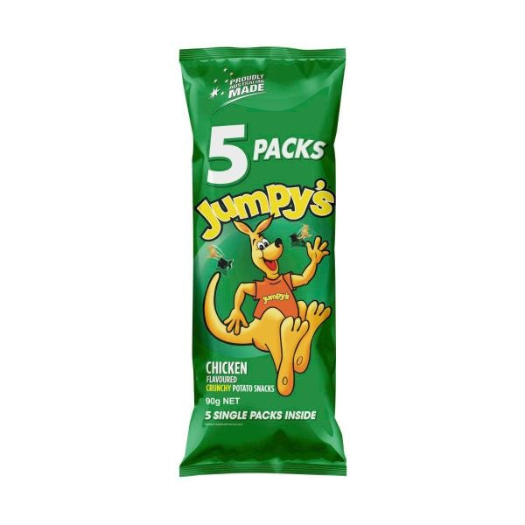
SPECIAL

Jumpy's Chicken Potato Chips Multipack School Snacks 5 Pack | 90g
$4.00
$4.44/ 100g
Any 2 | $7
$3.89/ 100g
7 more buying options
Quantity
123456789101112
Chicken Potato Chips Multipack School Snacks 5 Pack quantity is 1 item
Remove from list
Add
Product is not in your trolley
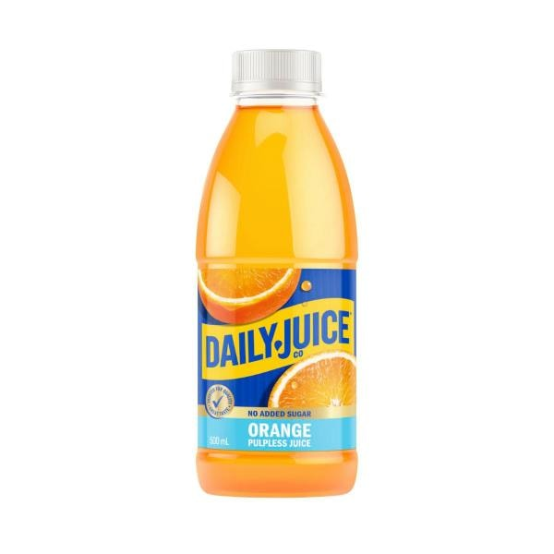

Daily Juice Pulp Free No Added Sugar Orange Juice | 500mL
$3.65
$7.30/ 1L
2 more buying options
Quantity
1234567891011121314151617181920
Pulp Free No Added Sugar Orange Juice quantity is 1 item
Remove from list
Add
Product is not in your trolley
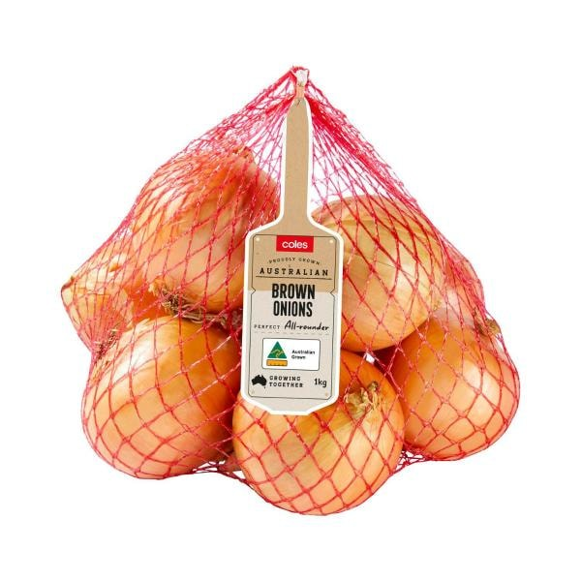

Coles Brown Onions | 1kg
$3.60
$3.60/ 1kg
Currently unavailable
Quantity
1234567891011121314151617181920212223242526272829303132333435363738394041424344454647484950
Brown Onions quantity is 1 item
Remove from list
Shop similar
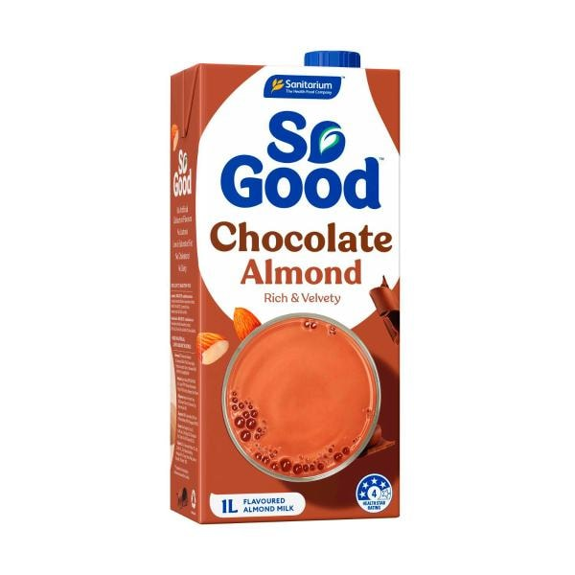

Sanitarium So Good Almond Milk Chocolate Uht | 1L
$3.50
$3.50/ 1L
4 more buying options
Quantity
1234567891011121314151617181920
So Good Almond Milk Chocolate Uht quantity is 1 item
Remove from list
Add
Product is not in your trolley
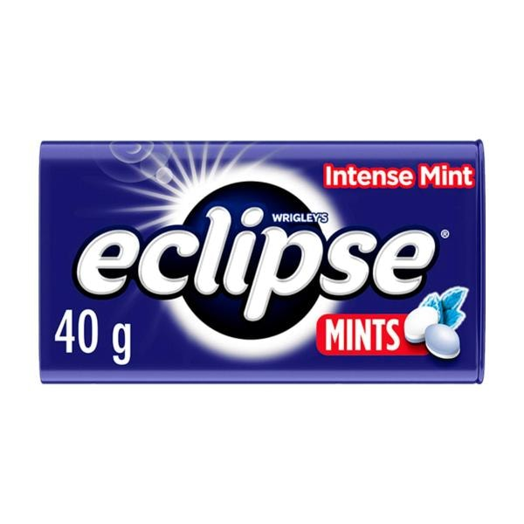
SPECIAL

Eclipse Intense Mint Sugar Free Mints Tin | 40g
$3.50
Save $0.50
$8.75/ 100g | Was $4.00
8 more buying options
Quantity
123456789101112
Intense Mint Sugar Free Mints Tin quantity is 1 item
Remove from list
Add
Product is not in your trolley
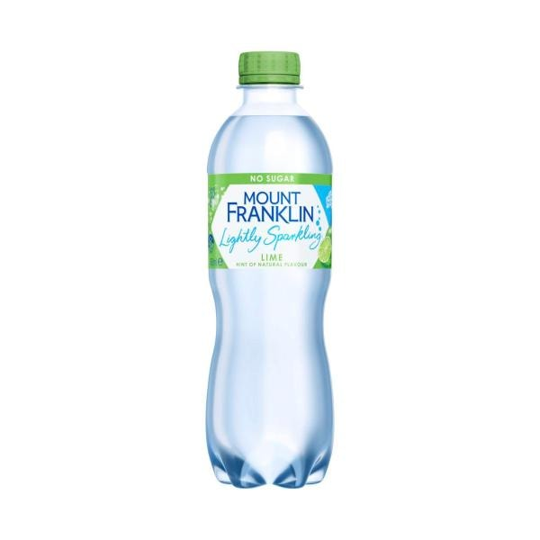

Mount Franklin Lightly Sparkling Water Lime Bottle | 450mL
$3.35
$7.44/ 1L
Quantity
1234567891011121314151617181920
Lightly Sparkling Water Lime Bottle quantity is 1 item
Remove from list
Add
Product is not in your trolley
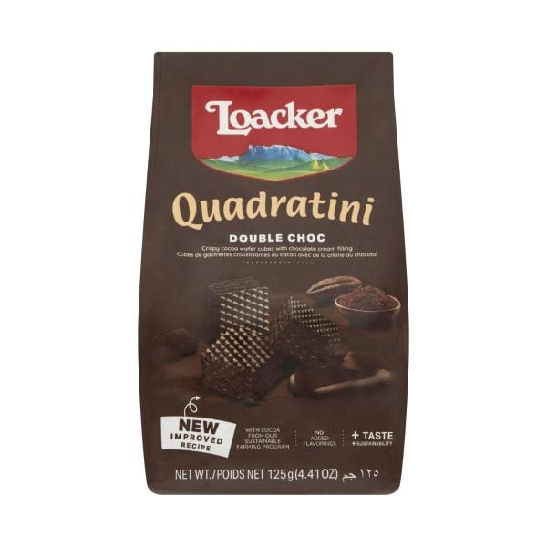

Loacker Quadratini Wafers Biscuits Double Choc | 125g
$3.30
$2.64/ 100g
Quantity
1234567891011121314151617181920
Quadratini Wafers Biscuits Double Choc quantity is 1 item
Remove from list
Add
Product is not in your trolley
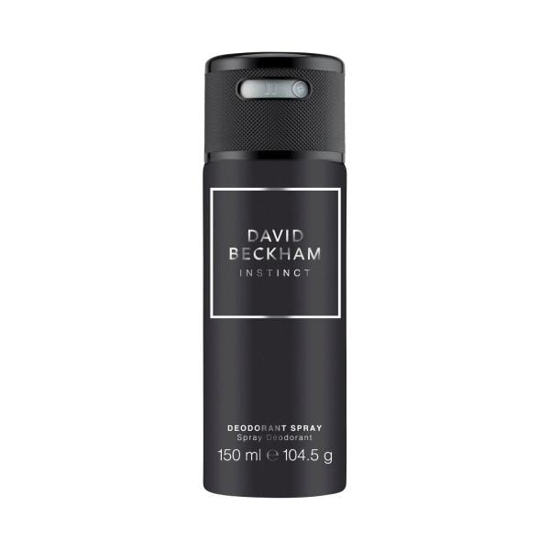

David Beckham Instinct Deodorant Body Spray | 150mL
$9.00
$6.00/ 100mL
Quantity
1234567891011121314151617181920
Instinct Deodorant Body Spray quantity is 1 item
Remove from list
Add
Product is not in your trolley
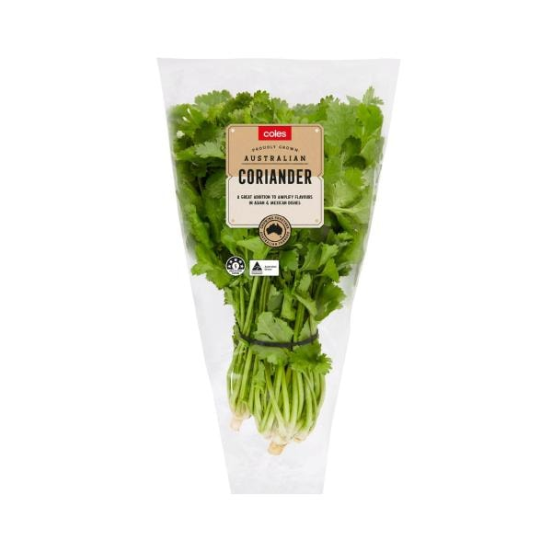
SPECIAL

Coles Sleeved Herbs Coriander | 1 Bunch
$3.30
$3.30/ 1ea
Any 2 | $6
$3.00/ 1ea
6 more buying options
Quantity
1234567891011121314151617181920212223242526272829303132333435363738394041424344454647484950
Sleeved Herbs Coriander quantity is 1 item
Remove from list
Add
Product is not in your trolley
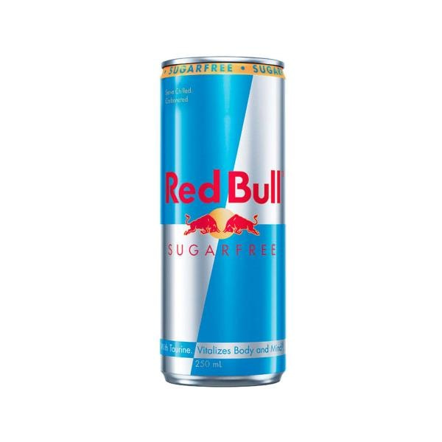
EVERY DAY

Red Bull Sugar Free Energy Drink Single Can | 250mL
$3.20
$12.80/ 1L
Quantity
123456789101112
Sugar Free Energy Drink Single Can quantity is 1 item
Remove from list
Add
Product is not in your trolley
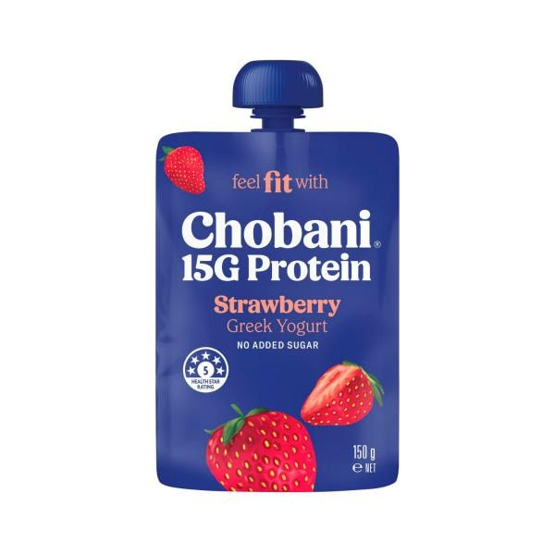

Chobani 15g High Protein Greek Yogurt Strawberry Pouch | 150g
$3.30
$2.20/ 100g
9 more buying options
Quantity
1234567891011121314151617181920
15g High Protein Greek Yogurt Strawberry Pouch quantity is 1 item
Remove from list
Add
Product is not in your trolley
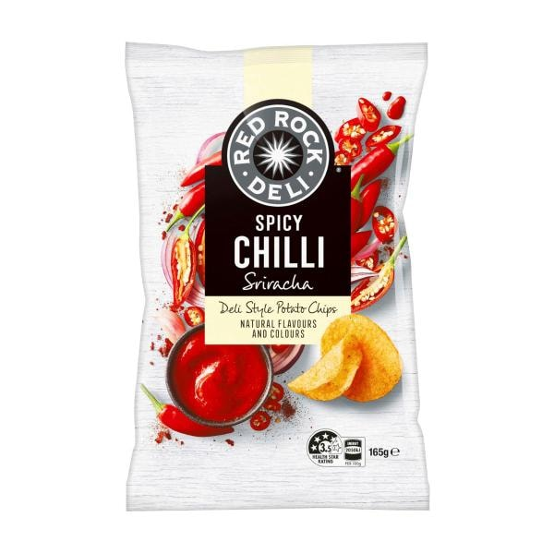
SPECIAL

Red Rock Deli Chips Spicy Chilli Sriracha | 165 GRAM
$3.60
Save $2.40
$2.18/ 100g | Was $6.00
Quantity
123456789101112
Spicy Chilli Sriracha quantity is 1 item
Remove from list
Add
Product is not in your trolley
Bonus credit^
See footnote
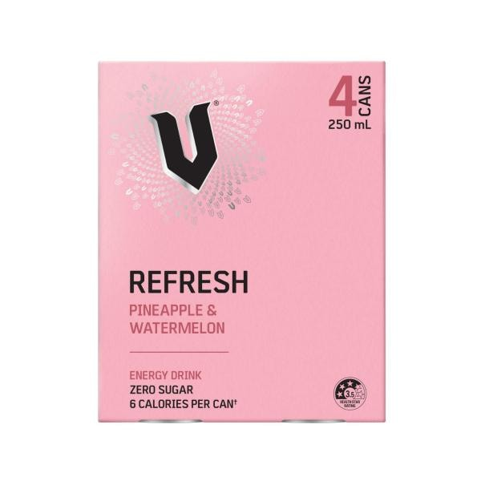

V Energy Drink Pineapple 4x250ml | 1L
$12.00
$12.00/ 1L
Quantity
1234567891011121314151617181920
Energy Drink Pineapple 4x250ml quantity is 1 item
Remove from list
Add
Product is not in your trolley
Bonus credit^
See footnote
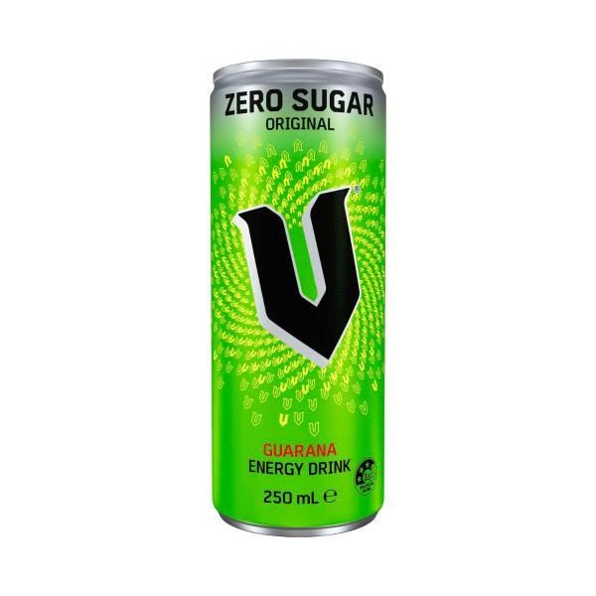
EVERY DAY

V Sugarfree Energy Drink | 250mL
$2.65
$10.60/ 1L
Quantity
1234567891011121314151617181920
Sugarfree Energy Drink quantity is 1 item
Remove from list
Add
Product is not in your trolley
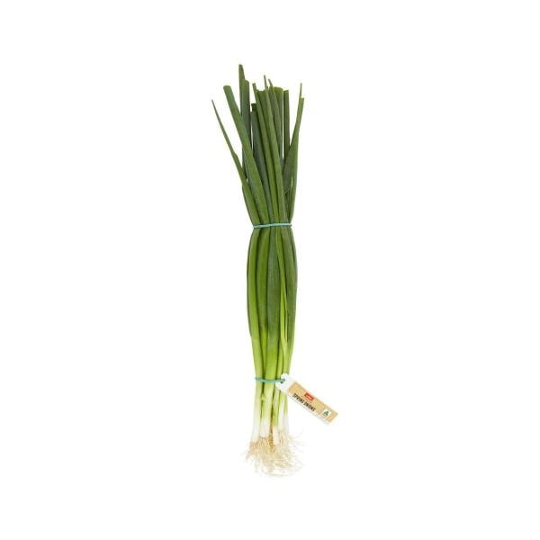

Coles Spring Onions | 1 Bunch
$3.00
$3.00/ 1ea
Quantity
1234567891011121314151617181920212223242526272829303132333435363738394041424344454647484950
Spring Onions quantity is 1 item
Remove from list
Add
Product is not in your trolley
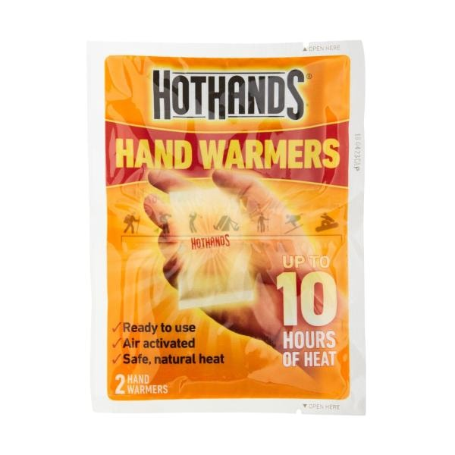
DOWN DOWN

Hot Hands Hand Warmers | 2 Pack
$1.85
$0.93/ 1ea
Was $2.50 on May 2026
Quantity
123456789101112
Hand Warmers quantity is 1 item
Remove from list
Add
Product is not in your trolley
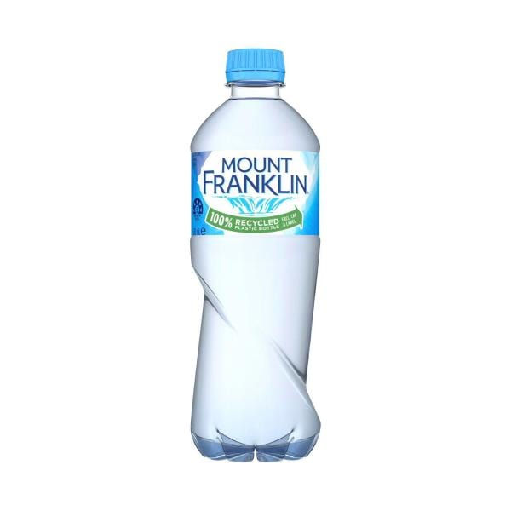
EVERY DAY

Mount Franklin Spring Water Bottle | 600mL
$2.45
$4.08/ 1L
2 more buying options
Quantity
1234567891011121314151617181920
Spring Water Bottle quantity is 1 item
Remove from list
Add
Product is not in your trolley
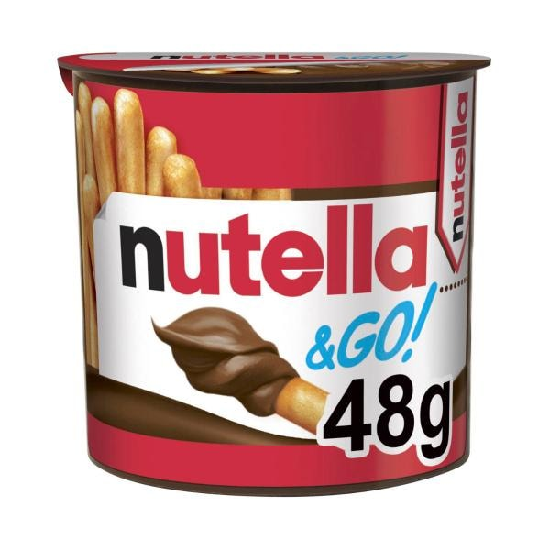
SPECIAL

Nutella & Go With Breadsticks | 48g
$2.00
Save $0.80
$4.17/ 100g | Was $2.80
Quantity
123456789101112
& Go With Breadsticks quantity is 1 item
Remove from list
Add
Product is not in your trolley
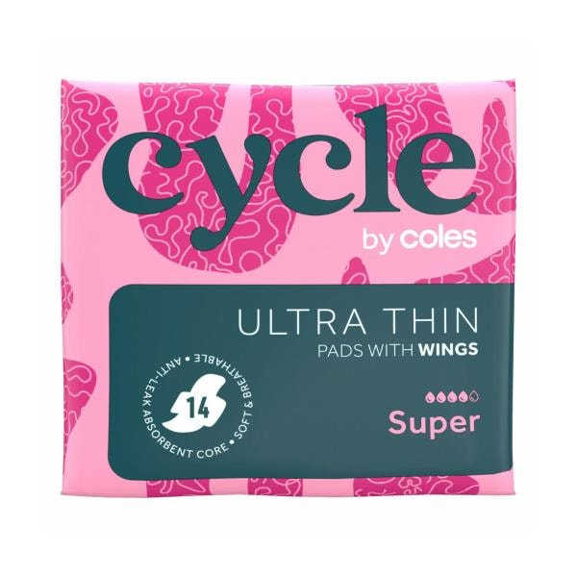
EVERY DAY

Cycle By Coles Pads Ultra Thin Super Wings | 14 pack
$2.20
$0.16/ 1ea
2 more buying options
Quantity
1234567891011121314151617181920
Pads Ultra Thin Super Wings quantity is 1 item
Remove from list
Add
Product is not in your trolley
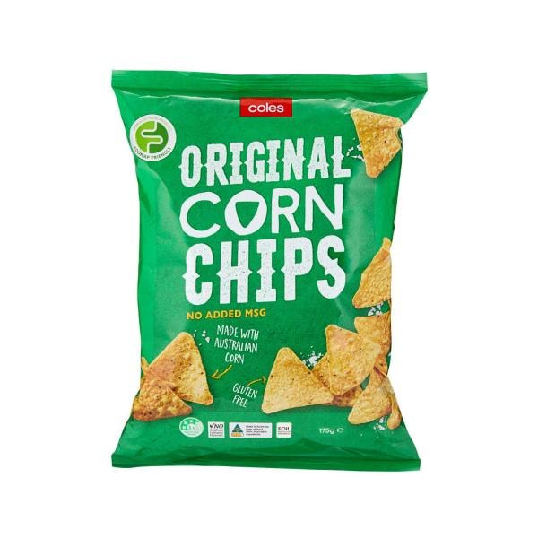
EVERY DAY

Coles Corn Chips Original | 175g
$2.20
$1.26/ 100g
Quantity
1234567891011121314151617181920
Corn Chips Original quantity is 1 item
Remove from list
Add
Product is not in your trolley
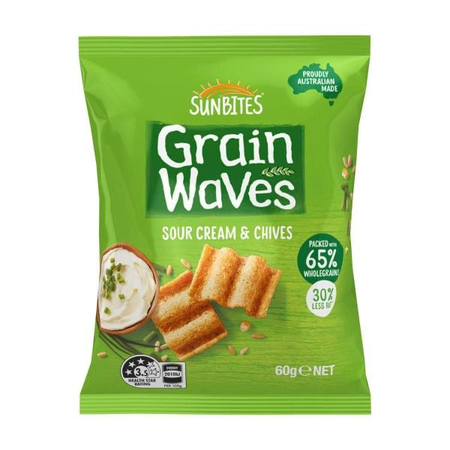

Sunbites Grainwaves Sour Cream & Chive | 60g
$2.70
$4.50/ 100g
Quantity
1234567891011121314151617181920
Grainwaves Sour Cream & Chive quantity is 1 item
Remove from list
Add
Product is not in your trolley
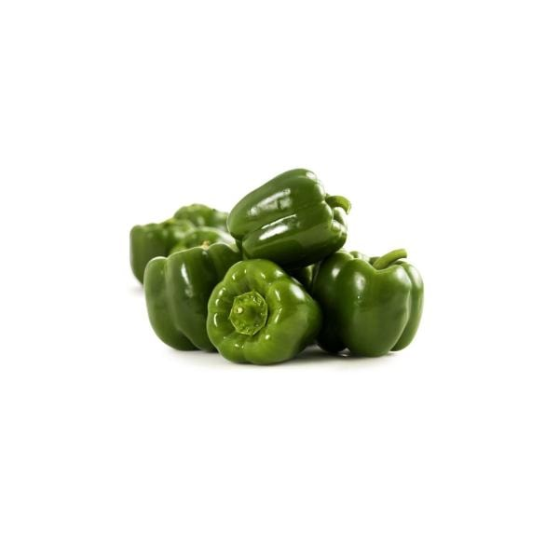
SPECIAL

Coles Capsicum Green Loose | approx. 220g
$1.30
$5.90/ 1kg
Final price is based on weight
Quantity
1234567891011121314151617181920212223242526272829303132333435363738394041424344454647484950
Capsicum Green Loose quantity is 1 item
Remove from list
Add
Product is not in your trolley
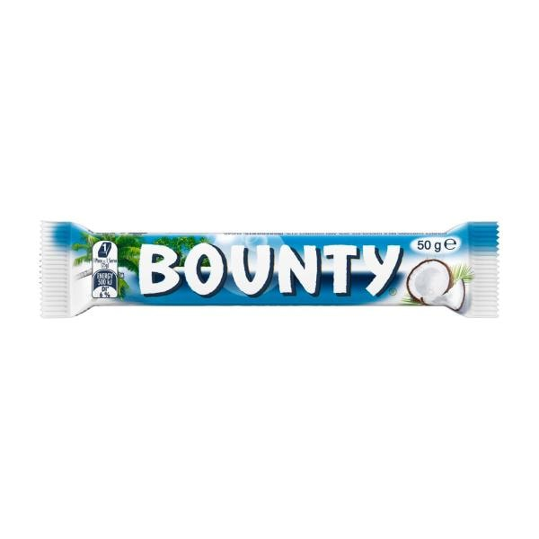
1/2 PRICE

Bounty Coconut Chocolate Bar | 50 GRAM
$1.50
Save $1.50
$3.00/ 100g | Was $3.00
Quantity
123456789101112
Coconut Chocolate Bar quantity is 1 item
Remove from list
Add
Product is not in your trolley
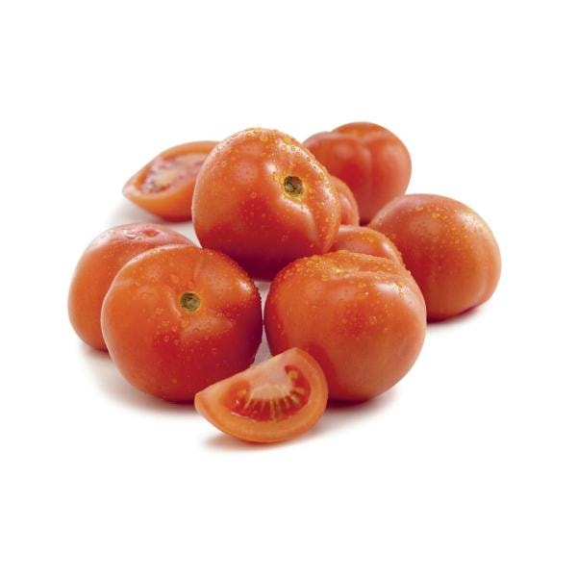
SPECIAL

Coles Tomatoes Gourmet | approx. 130g
$0.51
$3.90/ 1kg
Final price is based on weight
Quantity
1234567891011121314151617181920212223242526272829303132333435363738394041424344454647484950
Tomatoes Gourmet quantity is 1 item
Remove from list
Add
Product is not in your trolley
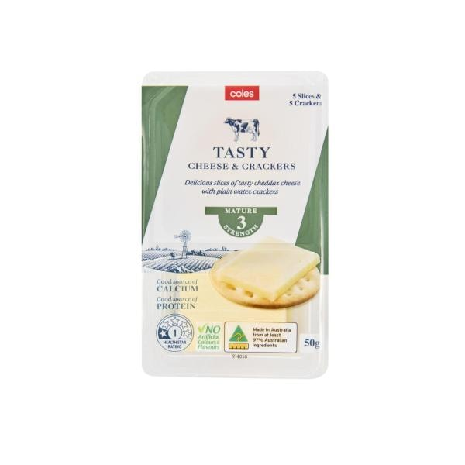
EVERY DAY

Coles Tasty Cheese & Crackers | 50g
$2.00
$4.00/ 100g
Quantity
1234567891011121314151617181920
Tasty Cheese & Crackers quantity is 1 item
Remove from list
Add
Product is not in your trolley
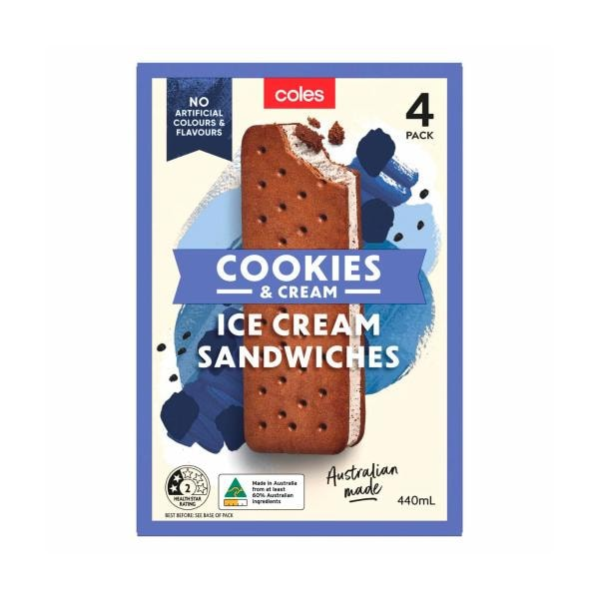
EVERY DAY

Coles Cookies & Cream Ice Cream Sandwich 4 Pack | 440mL
$3.80
$0.86/ 100mL
1 more buying option
Quantity
1234567891011121314151617181920
Cookies & Cream Ice Cream Sandwich 4 Pack quantity is 1 item
Remove from list
Add
Product is not in your trolley
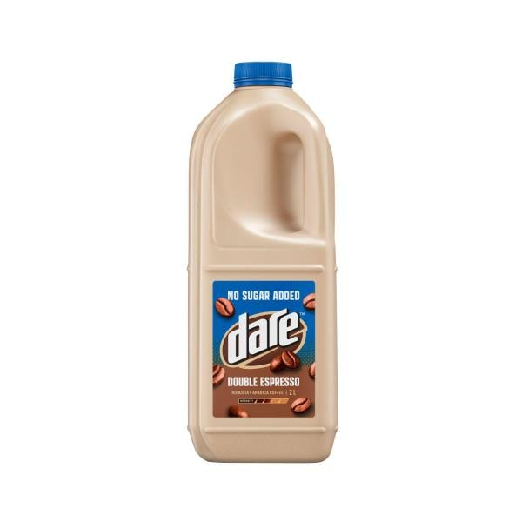

Dare No Sugar Added Iced Coffee Double Espresso | 2L
$8.00
$4.00/ 1L
Currently unavailable
Quantity
1234567891011121314151617181920
No Sugar Added Iced Coffee Double Espresso quantity is 1 item
Remove from list
Shop similar
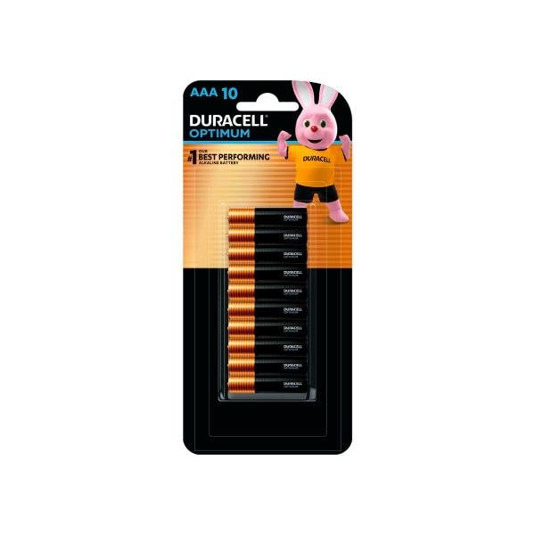

Duracell Optimum AAA Alkaline Batteries | 10 Pack
$23.00
$2.30/ 1ea
2 more buying options
Quantity
1234567891011121314151617181920
Optimum AAA Alkaline Batteries quantity is 1 item
Remove from list
Add
Product is not in your trolley
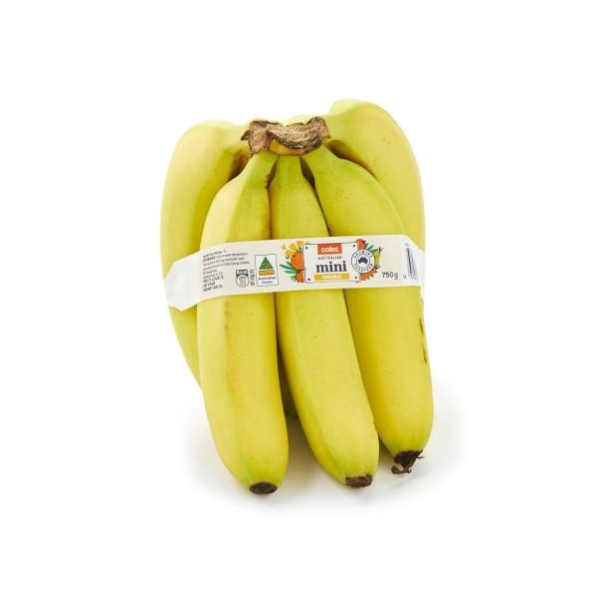

Coles Bananas Mini Pack | 750g
$4.90
$6.53/ 1kg
Quantity
1234567891011121314151617181920212223242526272829303132333435363738394041424344454647484950
Bananas Mini Pack quantity is 1 item
Remove from list
Add
Product is not in your trolley
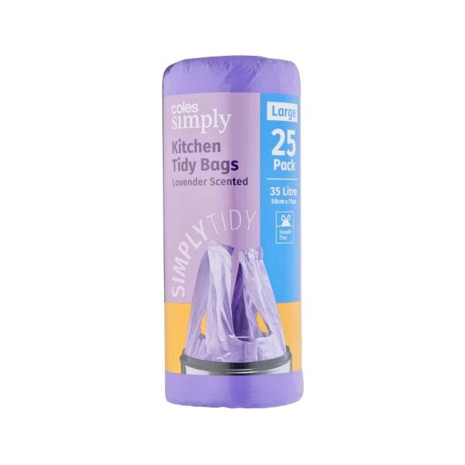

Coles Simply Kitchen Tidy Bags Lavendar Scented Large | 25 Pack
$2.30
$0.09/ 1ea
2 more buying options
Quantity
1234567891011121314151617181920
Kitchen Tidy Bags Lavendar Scented Large quantity is 1 item
Remove from list
Add
Product is not in your trolley
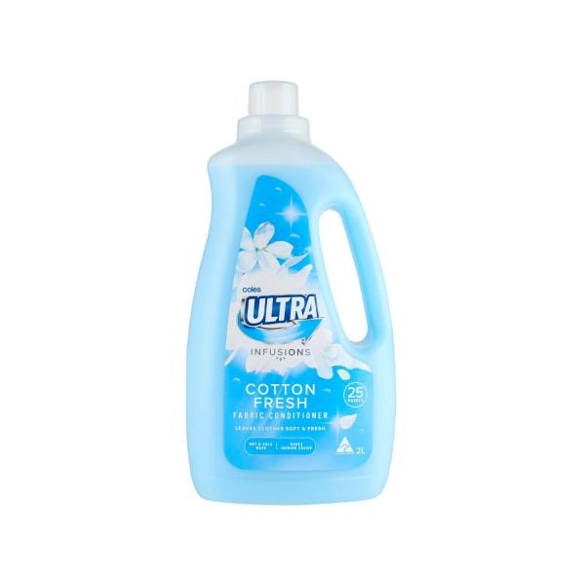
EVERY DAY

Coles Ultra Fabric Conditioner Cotton Fresh | 2L
$3.00
$1.50/ 1L
3 more buying options
Quantity
1234567891011121314151617181920
Fabric Conditioner Cotton Fresh quantity is 1 item
Remove from list
Add
Product is not in your trolley
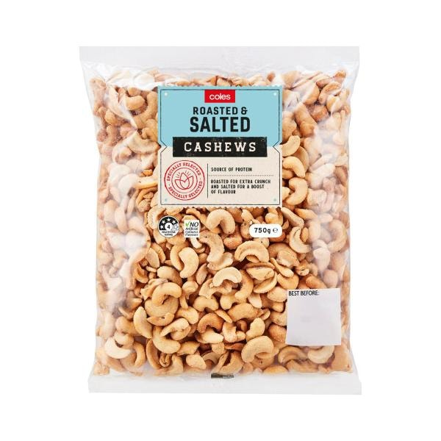

Coles Roasted And Salted Cashews | 750g
$14.00
$18.67/ 1kg
Quantity
1234567891011121314151617181920
Roasted And Salted Cashews quantity is 1 item
Remove from list
Add
Product is not in your trolley
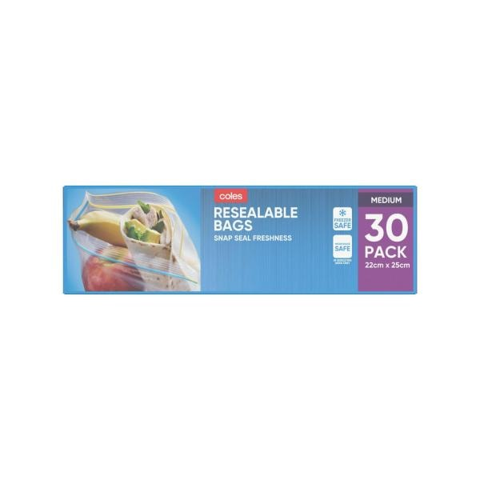
EVERY DAY

Coles Medium Resealable Storage Bags | 30 pack
$2.80
$0.09/ 1ea
3 more buying options
Quantity
1234567891011121314151617181920
Medium Resealable Storage Bags quantity is 1 item
Remove from list
Add
Product is not in your trolley
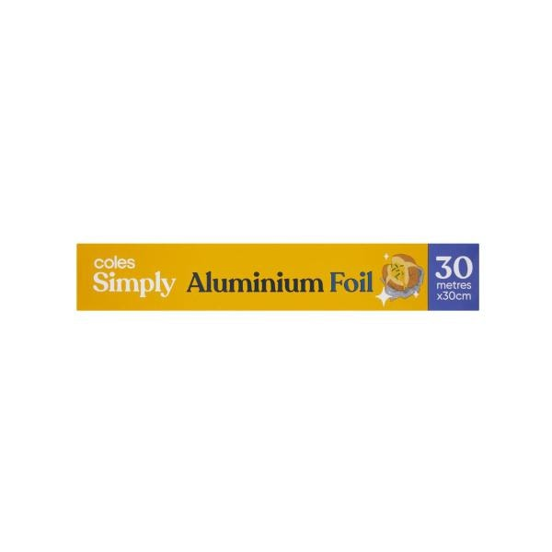

Coles Simply Aluminium Foil | 30 metre
$4.50
$0.15/ 1M
1 more buying option
Quantity
1234567891011121314151617181920
Aluminium Foil quantity is 1 item
Remove from list
Add
Product is not in your trolley
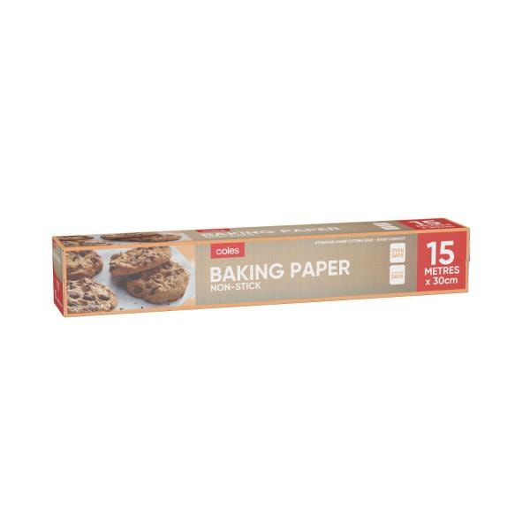
EVERY DAY

Coles Non Stick Baking Paper | 15 metre
$2.70
$0.18/ 1M
1 more buying option
Quantity
1234567891011121314151617181920
Non Stick Baking Paper quantity is 1 item
Remove from list
Add
Product is not in your trolley
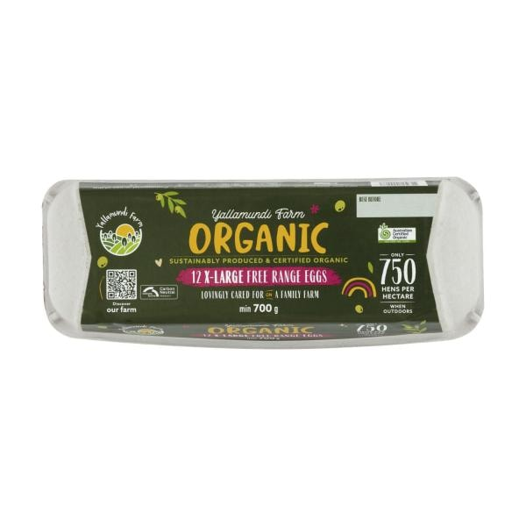

Yallamundi Farm Organic Free Range Eggs 12 Pack | 700g
$14.00
$2.00/ 100g
1 more buying option
Quantity
1234567891011121314151617181920
Organic Free Range Eggs 12 Pack quantity is 1 item
Remove from list
Add
Product is not in your trolley
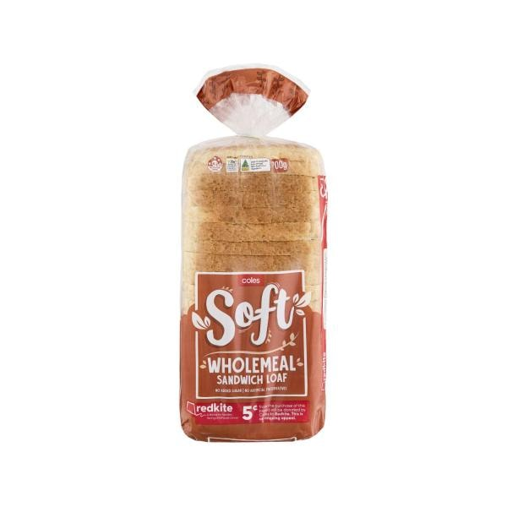

Coles Soft Wholemeal Sandwich Loaf | 700g
$2.80
$0.40/ 100g
4 more buying options
Quantity
1234567891011121314151617181920
Soft Wholemeal Sandwich Loaf quantity is 1 item
Remove from list
Add
Product is not in your trolley
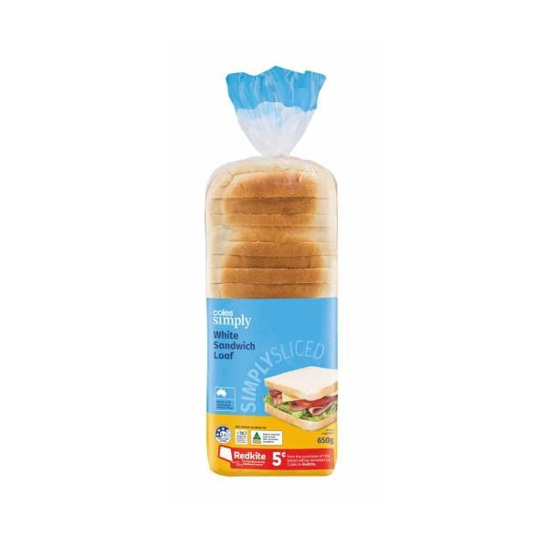
EVERY DAY

Coles Simply White Sandwich Loaf | 650g
$2.50
$0.38/ 100g
Quantity
123456789101112
White Sandwich Loaf quantity is 1 item
Remove from list
Add
Product is not in your trolley
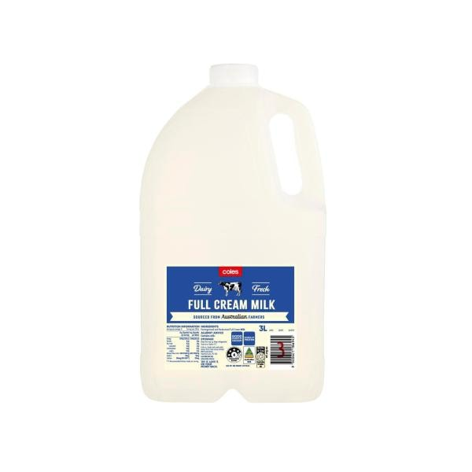

Coles Full Cream Milk | 3L
$5.15
$1.72/ 1L
27 more buying options
Quantity
1234567891011121314151617181920
Full Cream Milk quantity is 1 item
Remove from list
Add
Product is not in your trolley

Customer help
- Contact us
- Help Centre
- Staying safe online
- Returns & refunds
- Product recalls
- Accessibility

Useful links
- Stores near you
- Browse Products
- Coles magazines
- Gift cards
- Coles Radio
- Coles Plus
Free trial
- Competition winners

About Coles
- Introducing us
- Our brands
- Careers
- Our history
- Sustainability at Coles
- Media releases
- Investor information
- How Flybuys works

Follow us

Download the Coles app

Explore our brands

^Spend $20 in one transaction and scan or link your Flybuys to receive one Glass Container credit (after savings and discounts). Receive a bonus Glass Container credit when you also purchase a selected product from a participating brand. Limit of one bonus Glass Container credit applies per brand, per transaction. An additional bonus credit also applies per Deliver More order. Earn credits until 4/8/26 and redeem credits (excludes the Coles app) by 11/8/26 or while stocks last. Excludes Uber Eats, liquor, tobacco, tobacco related product purchases, subscription fees, delivery fees and other purchases. Full T&Cs apply. CURTIS STONE® is a registered trademark in Australia. All rights reserved.
No alcohol can be sold or supplied to anyone under 18. It's against the law. It's an offence to supply liquor to a person under the age of 18 years. All liquor products are sold and supplied by Liquorland (Australia) Pty Ltd. For more specific legislation in your state or territory, and to view our liquor and tobacco licences, visit our help page. To voluntarily exclude yourself from being able to purchase liquor online at Coles, please contact us.
- Privacy policy
- Terms and conditions
- Customer agreement
- Sitemap

Coles Online - Hawthorn East, Victoria Australia 3123 © Copyright Coles 2026

My Shopping Lists | Coles

Need help?

