
Everyday & Other Services

Search products, recipes & ideasSearch Everyday MarketSearch gluten-free breadSearch apples in stockSearch vegan dessertsSearch cereal on specialSearch dairy-free milk

Lists &
Buy again

Hi, Abdul Rakib
My Account

$111.90
Your Cart has 30 items worth $111.90 in total

30

Browse products
View cart button
Specials & catalogueRecipes & ideasGet more valueWays to shopHelpShop for businessStores

Delivery to:U 10 38-40 Methven St, MOUNT DRUITT NSW 2770
Change

Select a time:View available times
Choose Time of Delivery. View available times

Choose

Back to Lists

Edit List

Price Compare (79 Products)
Add all to cart (73)

Sort by:
Aisle
Specials only:
Categorise:

Fruit & Veg
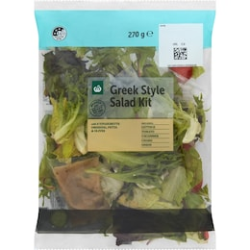
Toggle Fruit & Veg group Dropdown
Woolworths Greek Salad Kit 270g
$6.10
$22.59 / 1KG
1 item(s) left
Add to cart
Decrease quantity. Current quantity 1
Increase quantity. Current quantity 1

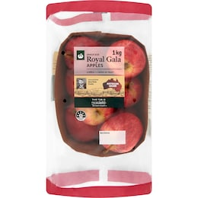
120 PTS
120 Points,
Boosted. Shop & enjoy the points. Ends 7 Jul.
Woolworths Royal Gala Apple Punnet 1kg
Ends 7 Jul.
$4.90
$4.90 / 1KG
Add to cart
Decrease quantity. Current quantity 1
Increase quantity. Current quantity 1

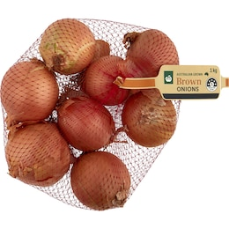
80 PTS
80 Points,
Boosted. Shop & enjoy the points. Ends 7 Jul.
Woolworths Onion Brown Bag 1kg
Ends 7 Jul.
$3.60
$3.60 / 1KG
Add to cart
Decrease quantity. Current quantity 1
Increase quantity. Current quantity 1

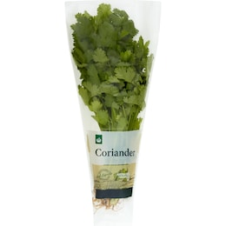
Woolworths Fresh Herb Coriander Bunch each
$3.30
$3.30 / 1EA
Add to cart
Decrease quantity. Current quantity 1
Increase quantity. Current quantity 1

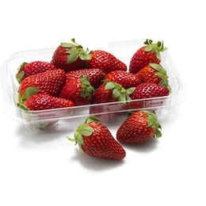
Est. Restock 07/07/26
Strawberries Punnet 250g
View similar
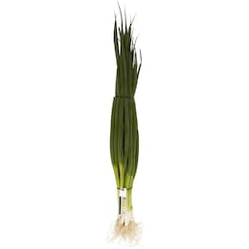
Spring Onion Bunch each
$3.00
$3.00 / 1EA
Add to cart
Decrease quantity. Current quantity 1
Increase quantity. Current quantity 1

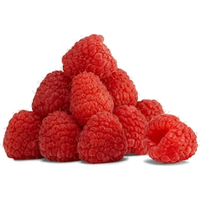
Out of stock
Raspberries Punnet 170g
View similar
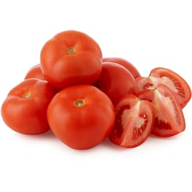
Gourmet Tomato each
$0.43
$0.43 / 1EA
Update cart
Decrease quantity. Current quantity 1
Increase quantity. Current quantity 1

5 item(s) in cart
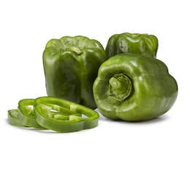
Capsicum Green each
$1.48
$1.48 / 1EA
Add to cart
Decrease quantity. Current quantity 1
Increase quantity. Current quantity 1

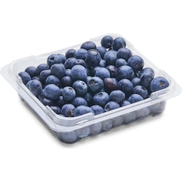
Blueberries Punnet 125g
$4.00
$32.00 / 1KG
Add to cart
Decrease quantity. Current quantity 1
Increase quantity. Current quantity 1

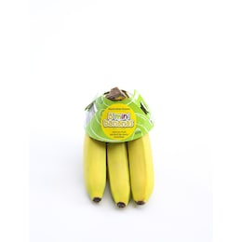
Bananas Kids 5 pack
$3.50
$3.50 / 1EA
Add to cart
Decrease quantity. Current quantity 1
Increase quantity. Current quantity 1

Dairy, Eggs & Fridge
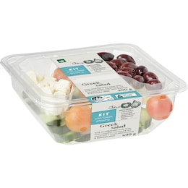
Toggle Dairy, Eggs & Fridge group Dropdown
Woolworths Greek Salad Kit 400g
$9.90
$2.48 / 100G
Add to cart
Decrease quantity. Current quantity 1
Increase quantity. Current quantity 1

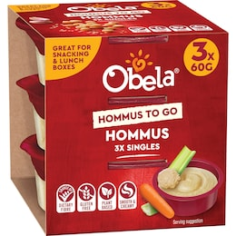
Obela Smooth Classic Hommus To Go Singles 60g x 3 pack
$3.80
$2.11 / 100G
Add to cart
Decrease quantity. Current quantity 1
Increase quantity. Current quantity 1

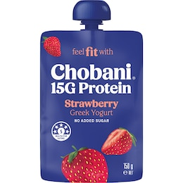
Chobani 15G Protein Greek Yogurt Strawberry Pouch 150g
$3.30
$2.20 / 100G
Add to cart
Decrease quantity. Current quantity 1
Increase quantity. Current quantity 1

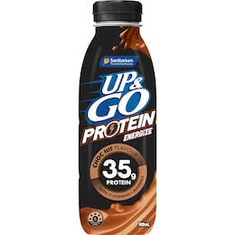
SAVE $0.90
Up&Go Protein Energize Liquid Breakfast Choc 500mL
$3.60
$7.20 / 1L
Add to cart
Decrease quantity. Current quantity 1
Increase quantity. Current quantity 1

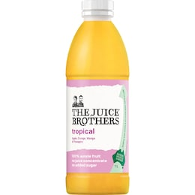
The Juice Brothers Tropical Juice 1L
$5.15
$5.15 / 1L
Add to cart
Decrease quantity. Current quantity 1
Increase quantity. Current quantity 1

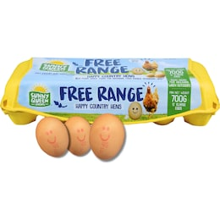
Sunny Queen 12 Extra Large Free Range Eggs 700g
$8.80
$1.26 / 100G
Update cart
Decrease quantity. Current quantity 1
Increase quantity. Current quantity 1

1 item(s) in cart
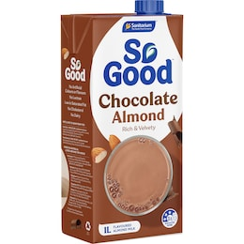
So Good Chocolate Almond Long Life Milk UHT 1L
$3.50
$3.50 / 1L
Update cart
Decrease quantity. Current quantity 1
Increase quantity. Current quantity 1

1 item(s) in cart
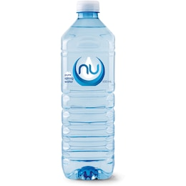
EVERYDAY LOW PRICE
Nu Pure Still Spring Water 600mL
$1.25
$2.08 / 1L
Add to cart
Decrease quantity. Current quantity 1
Increase quantity. Current quantity 1

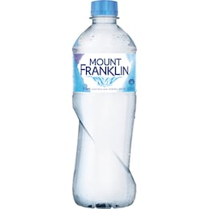
EVERYDAY LOW PRICE
Mount Franklin Spring Water Bottle 600mL
$2.45
$4.08 / 1L
Add to cart
Decrease quantity. Current quantity 1
Increase quantity. Current quantity 1

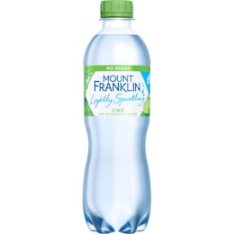
EVERYDAY LOW PRICE
Mount Franklin Mineral Water Lightly Sparkling Lime Bottle 450mL
$3.35
$7.44 / 1L
Add to cart
Decrease quantity. Current quantity 1
Increase quantity. Current quantity 1

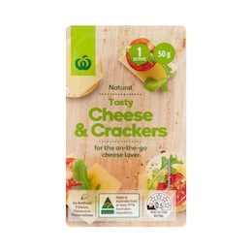
Woolworths Natural Tasty Cheese & Crackers 50g
$2.00
$40.00 / 1KG
Add to cart
Decrease quantity. Current quantity 1
Increase quantity. Current quantity 1

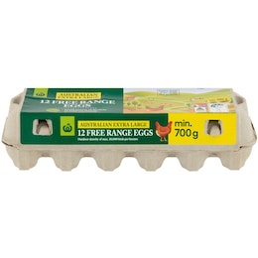
LOWER SHELF PRICE
Woolworths 12 Extra Large Free Range Eggs 700g
$6.50
$0.93 / 100G
Was $6.60 - 22/10/2025
Add to cart
Decrease quantity. Current quantity 1
Increase quantity. Current quantity 1

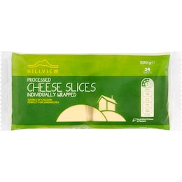
Out of stock
Hillview Cheese Slices Full Fat 500g
View similar
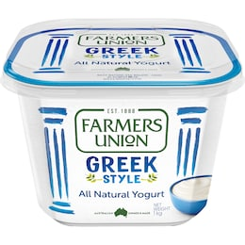
Farmers Union Greek Style Natural Yoghurt 1kg
$7.50
$0.75 / 100G
Add to cart
Decrease quantity. Current quantity 1
Increase quantity. Current quantity 1

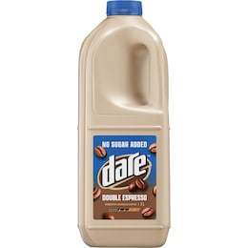
Dare No Added Sugar Double Espresso Iced Coffee 2L
$8.00
$4.00 / 1L
Add to cart
Decrease quantity. Current quantity 1
Increase quantity. Current quantity 1

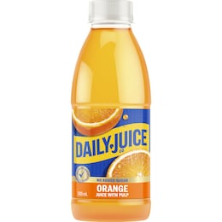
Daily Juice Co Orange Fruit Juice With Pulp 500mL
$3.65
$7.30 / 1L
Add to cart
Decrease quantity. Current quantity 1
Increase quantity. Current quantity 1

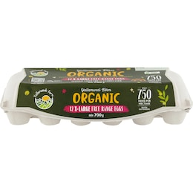
Yallamundi Farm 12 Organic Extra Large Eggs 700g
$14.00
$2.00 / 100G
Add to cart
Decrease quantity. Current quantity 1
Increase quantity. Current quantity 1

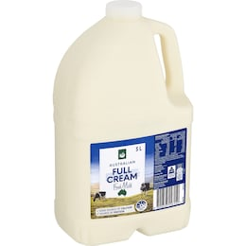
Woolworths Full Cream Milk 3L
$5.15
$1.72 / 1L
Update cart
Decrease quantity. Current quantity 1
Increase quantity. Current quantity 1

1 item(s) in cart

Bakery
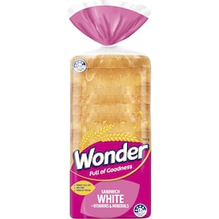
Toggle Bakery group Dropdown
Wonder White Bread Vitamins & Minerals Sandwich 700g
$4.70
$0.67 / 100G
Update cart
Decrease quantity. Current quantity 1
Increase quantity. Current quantity 1

1 item(s) in cart
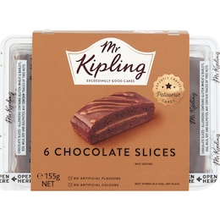
Mr Kipling Choc Slice 6 pack
$6.20
$1.03 / 1EA
Add to cart
Decrease quantity. Current quantity 1
Increase quantity. Current quantity 1

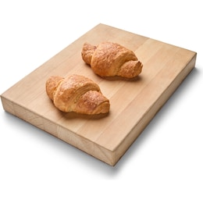
SAVE $0.50
Woolworths Jalapeno & Cheese Croissant 2 pack
$3.25
$1.63 / 1EA
Add to cart
Decrease quantity. Current quantity 1
Increase quantity. Current quantity 1

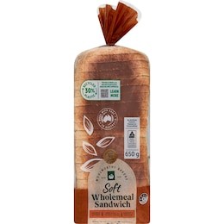
Woolworths Wholemeal Soft Sandwich Bread 650g
$2.80
$0.43 / 100G
Add to cart
Decrease quantity. Current quantity 1
Increase quantity. Current quantity 1

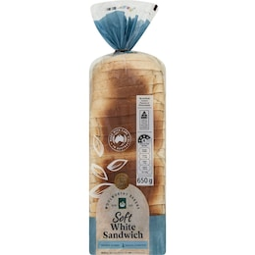
Woolworths White Soft Sandwich Bread 650g
$2.80
$0.43 / 100G
Add to cart
Decrease quantity. Current quantity 1
Increase quantity. Current quantity 1

Freezer
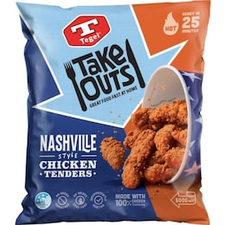
Toggle Freezer group Dropdown
SAVE $2.00
Tegel Take Outs Nashville Style Chicken Tenders 500g
$12.00
$24.00 / 1KG
Add to cart
Decrease quantity. Current quantity 1
Increase quantity. Current quantity 1

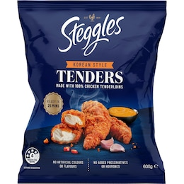
SAVE $2.00
Steggles Chicken Tenders Korean Style 600g
$12.00
$20.00 / 1KG
Add to cart
Decrease quantity. Current quantity 1
Increase quantity. Current quantity 1

Page 1 of 3
123Next
You are on
Page
Page
Page
Go to Next Page

Items available:
73 of 79

You'll collect:
6640 pts

You’ll save up to:
$29.17

Estimated total:
$394.09
Excl. service, bag & delivery fees

Add all to cart (73)

Back to top

Customer Service
Help & Support
Contact Us
Feedback
Product Safety
Product Recalls
Return Policy
Scam Warning

Shop Groceries Online
View My Account
Pick up
Delivery
Delivery Now
New to Online Shopping?
Shop for your Business

Useful Links
Store Locations & Trading Hours
Everyday Rewards
Recipes & Easy Dinner Ideas
Woolworths Catalogue
Our pricing
Meal Planner
Woolworths Fresh Magazine
Woolworths App

About Woolworths
Careers
Our Brands
Woolworths Group Privacy Centre
Community
Suppliers
Become an Affiliate
Corporate Responsibility
About Us

Our Partners
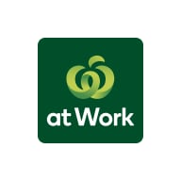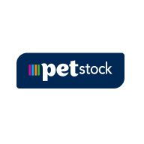
Connect on Social
Follow us on Instagram, Opens in a new window
Follow us on Facebook, Opens in a new window
Follow us on Pinterest, Opens in a new window
Follow us on Youtube, Opens in a new window
Follow us on Twitter, Opens in a new window

We acknowledge the Traditional Owners and Custodians of Country throughout Australia. We pay our respects to all First Nations peoples and acknowledge Elders past and present.
Read more about our commitment to reconciliation

Woolworths Group aims to create more inclusive access for team members and customers with disabilities.
Website accessibility

New South Wales | Liquor Act 2007: No alcohol can be sold or supplied to anyone under 18. It's against the law.
For all Woolworths Online liquor orders, Woolworths Group is acting as an agent on behalf of Endeavour Group Limited (ABN 77 159 767 843). Pricing (including any 'was' or 'strikethrough' price) displayed on the Woolworths website and app for these liquor products are provided by Endeavour Group and reflects pricing on their BWS website which is set by location. They do not, however, include particular specials, clearances and offers which are exclusive to BWS. For Everyday Market from Woolworths orders involving the sale of liquor, Woolworths Marketplace Pty Limited is acting as an agent on behalf of the relevant Everyday Market partner. Woolworths Online supports the Responsible Service of Alcohol. For liquor licence numbers visit the Liquor and Tobacco Licences page.
If you wish to voluntarily exclude yourself from being able to purchase alcohol from our site, you can find out more at our Alcohol Self Exclusion page.
© Woolworths Group Limited 1997-2026 - All Rights Reserved. Woolworths Group Privacy Policy Woolworths Group Cookies Statement Woolworths Collection Notice Terms & Conditions Accessibility


Everyday & Other Services

Search products, recipes & ideasSearch Everyday MarketSearch gluten-free breadSearch apples in stockSearch vegan dessertsSearch cereal on specialSearch dairy-free milk

Lists &
Buy again

Hi, Abdul Rakib
My Account

$111.90
Your Cart has 30 items worth $111.90 in total

30

Browse products
View cart button
Specials & catalogueRecipes & ideasGet more valueWays to shopHelpShop for businessStores

Delivery to:U 10 38-40 Methven St, MOUNT DRUITT NSW 2770
Change

Select a time:View available times
Choose Time of Delivery. View available times

Choose

Back to Lists

Edit List

Price Compare (79 Products)
Add all to cart (73)

Sort by:
Aisle
Specials only:
Categorise:

Freezer
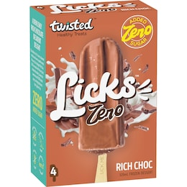
Toggle Freezer group Dropdown
SAVE $1.00
Twisted Healthy Treats Licks Rich Chocolate Frozen Dessert Sticks 80mL x 4 pack
$8.50
$2.66 / 100ML
Add to cart
Decrease quantity. Current quantity 1
Increase quantity. Current quantity 1

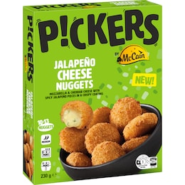
McCain Pickers Jalapeno Cheese Nuggets 230g
$7.50
$3.26 / 100G
Add to cart
Decrease quantity. Current quantity 1
Increase quantity. Current quantity 1

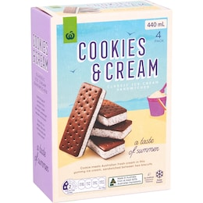
EVERYDAY LOW PRICE
Woolworths Cookies & Cream Ice Cream Sandwich 4 pack
$3.80
$0.86 / 100ML
Add to cart
Decrease quantity. Current quantity 1
Increase quantity. Current quantity 1

Snacks & Confectionery
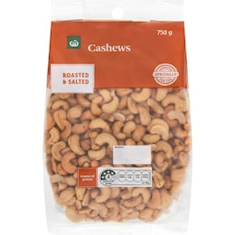
Toggle Snacks & Confectionery group Dropdown
LOWER SHELF PRICE
Woolworths Cashews Roasted & Salted 750g
$14.00
$18.67 / 1KG
Range was $18 - 02/06/2026
Add to cart
Decrease quantity. Current quantity 1
Increase quantity. Current quantity 1

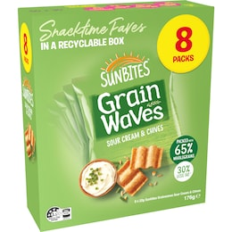
SAVE $2.00
Sunbites Grain Waves Sour Cream & Chives 22g x 8 pack
$4.00
$2.27 / 100G
Add to cart
Decrease quantity. Current quantity 1
Increase quantity. Current quantity 1

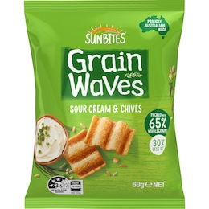
Sunbites Grainwaves Wholegrain Chips Sour Cream & Chives 60g
$2.00
$3.33 / 100G
Add to cart
Decrease quantity. Current quantity 1
Increase quantity. Current quantity 1

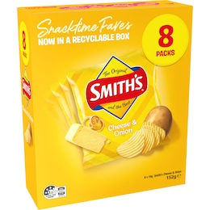
SAVE $2.00
Smith's Cheese & Onion Potato Chips 19g x 8 pack
$4.00
$2.63 / 100G
Update cart
Decrease quantity. Current quantity 1
Increase quantity. Current quantity 1

1 item(s) in cart
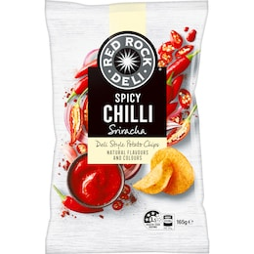
Red Rock Deli Potato Chips Spicy Chilli Sriracha 165g
$6.00
$3.64 / 100G
2 for $9.00 - $2.73/100G
Add to cart
Decrease quantity. Current quantity 1
Increase quantity. Current quantity 1

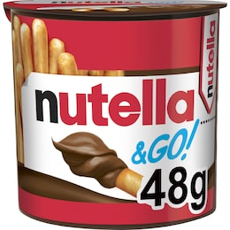
Nutella Hazelnut Chocolate Spread With Breadsticks 48g
$2.80
$5.83 / 100G
Add to cart
Decrease quantity. Current quantity 1
Increase quantity. Current quantity 1

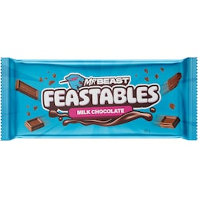
Out of stock
Mr Beast Feastables Milk Chocolate Bar 60g
View similar
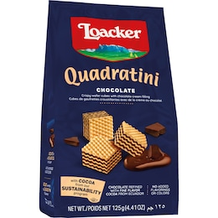
Loacker Quadratini Chocolate 125g
$3.30
$2.64 / 100G
Add to cart
Decrease quantity. Current quantity 1
Increase quantity. Current quantity 1

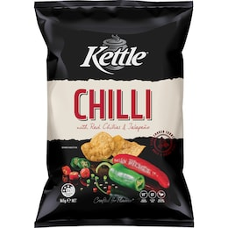
LOWER SHELF PRICE
Kettle Potato Chips Chilli 165g
$3.60
$2.18 / 100G
Range was $6 - 30/06/2026
Add to cart
Decrease quantity. Current quantity 1
Increase quantity. Current quantity 1

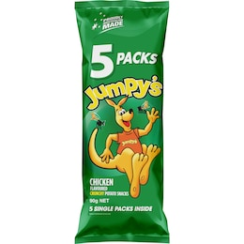
Jumpy's Chicken Potato Chips 5 pack
$4.00
$4.44 / 100G
2 for $7.00 - $3.89/100G
Update cart
Decrease quantity. Current quantity 1
Increase quantity. Current quantity 1

1 item(s) in cart
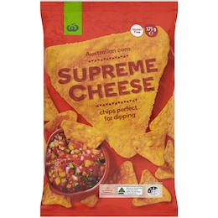
Woolworths Supreme Cheese Corn Chips 175g
$2.20
$1.26 / 100G
Add to cart
Decrease quantity. Current quantity 1
Increase quantity. Current quantity 1

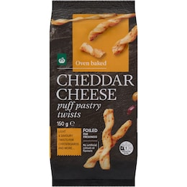
EVERYDAY LOW PRICE
Woolworths Cheddar Cheese Puff Pastry Twist Crackers 150g
$4.00
$2.67 / 100G
Add to cart
Decrease quantity. Current quantity 1
Increase quantity. Current quantity 1

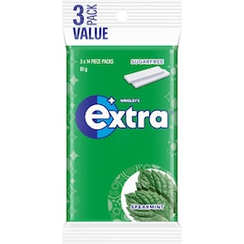
EVERYDAY LOW PRICE
Extra Spearmint Sugar Free Chewing Gum 81g
$5.50
$6.79 / 100G
Add to cart
Decrease quantity. Current quantity 1
Increase quantity. Current quantity 1

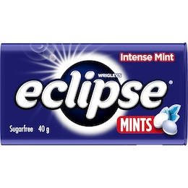
Eclipse Intense Sugar Free Mints Tin 40g
$4.00
$10.00 / 100G
2 for $7.00 - $8.75/100G
Add to cart
Decrease quantity. Current quantity 1
Increase quantity. Current quantity 1

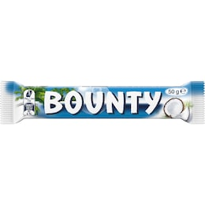
Bounty Chocolate Bar 50g
$3.00
$6.00 / 100G
2 for $4.00 - $4.00/100G
Add to cart
Decrease quantity. Current quantity 1
Increase quantity. Current quantity 1

Pantry
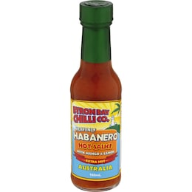
Toggle Pantry group Dropdown
Byron Bay Chilli Co. Heavenly Habanero Hot Sauce 150mL
$4.50
$3.00 / 100ML
Add to cart
Decrease quantity. Current quantity 1
Increase quantity. Current quantity 1

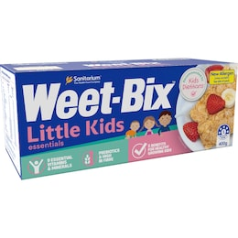
Weet-Bix Little Kids Breakfast Cereal 400g
$5.00
$1.25 / 100G
Update cart
Decrease quantity. Current quantity 1
Increase quantity. Current quantity 1

1 item(s) in cart
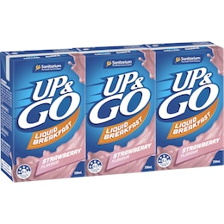
Up&Go Liquid Breakfast Strawberry 250mL x 3 pack
$7.00
$9.33 / 1L
Add to cart
Decrease quantity. Current quantity 1
Increase quantity. Current quantity 1

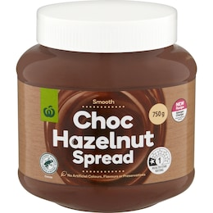
Woolworths Choc Hazelnut Spread 750g
$6.45
$0.86 / 100G
Add to cart
Decrease quantity. Current quantity 1
Increase quantity. Current quantity 1

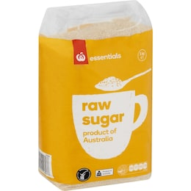
EVERYDAY LOW PRICE
Essentials Raw Sugar 3kg
$4.80
$0.16 / 100G
Add to cart
Decrease quantity. Current quantity 1
Increase quantity. Current quantity 1

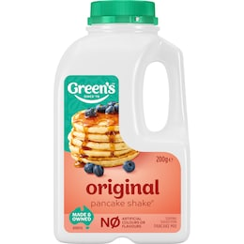
Out of stock
Green's Pancake Mix Original Shake 200g
View similar
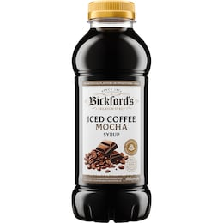
Out of stock
Bickford's Iced Mocha Coffee Syrup 500mL
View similar

Drinks
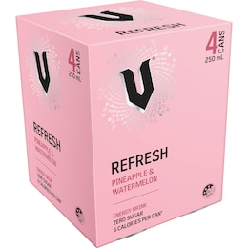
Toggle Drinks group Dropdown
V Energy Refresh Pineapple & Watermelon Zero Sugar Cans 250mL x 4 pack
$12.00
$12.00 / 1L
Add to cart
Decrease quantity. Current quantity 1
Increase quantity. Current quantity 1

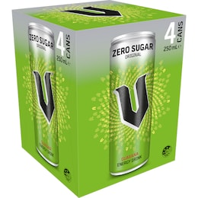
V Energy Sugar Free 250mL x 4 pack
$12.00
$12.00 / 1L
Add to cart
Decrease quantity. Current quantity 1
Increase quantity. Current quantity 1

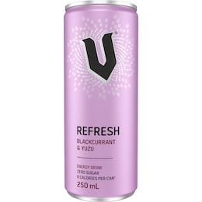
EVERYDAY LOW PRICE
V Refresh Energy Drink Zero Sugar Blackcurrant & Yuzu 250mL
$2.65
$10.60 / 1L
Add to cart
Decrease quantity. Current quantity 1
Increase quantity. Current quantity 1

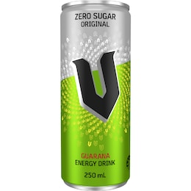
EVERYDAY LOW PRICE
V Energy Zero Sugar Drink 250mL
$2.65
$10.60 / 1L
Add to cart
Decrease quantity. Current quantity 1
Increase quantity. Current quantity 1

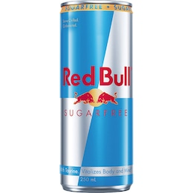
EVERYDAY LOW PRICE
Red Bull Energy Drink Sugar Free 250mL
$3.20
$12.80 / 1L
Add to cart
Decrease quantity. Current quantity 1
Increase quantity. Current quantity 1

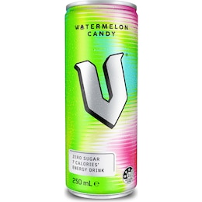
EVERYDAY LOW PRICE
V Energy Drink Watermelon Candy Zero Sugar 250mL
$2.65
$10.60 / 1L
Add to cart
Decrease quantity. Current quantity 1
Increase quantity. Current quantity 1

Personal Care
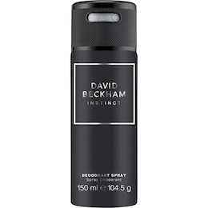
Toggle Personal Care group Dropdown
SAVE $2.70
David Beckham Instinct Deodorant Body Spray 150mL
$6.30
$4.20 / 100ML
Add to cart
Decrease quantity. Current quantity 1
Increase quantity. Current quantity 1

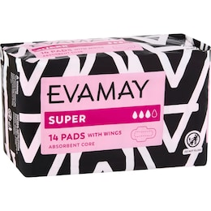
EVERYDAY LOW PRICE
Evamay Pads With Wings Super 14 pack
$2.20
$0.16 / 1EA
Add to cart
Decrease quantity. Current quantity 1
Increase quantity. Current quantity 1

Cleaning & Maintenance
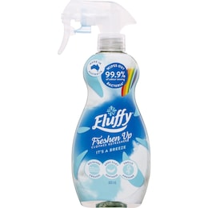
Toggle Cleaning & Maintenance group Dropdown
LOWER SHELF PRICE
Fluffy Fabric Softener Freshen Up Spray Breeze 400mL
$5.50
$13.75 / 1L
Range was $7 - 09/09/2025
Add to cart
Decrease quantity. Current quantity 1
Increase quantity. Current quantity 1

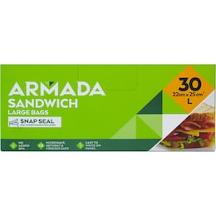
Armada Resealable Sandwich Bag 30 pack
$2.80
$0.09 / 1EA
Add to cart
Decrease quantity. Current quantity 1
Increase quantity. Current quantity 1

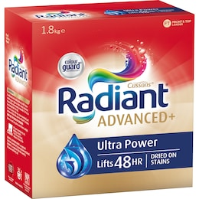
SAVE $11.00
Radiant Advanced+ Ultra Power Laundry Detergent Washing Powder 1.8kg
$11.00
$6.11 / 1KG
Add to cart
Decrease quantity. Current quantity 1
Increase quantity. Current quantity 1

Page 2 of 3
Previous123Next
Return to Previous Page
Page
You are on
Page
Page
Go to Next Page
Items available:
73 of 79
You'll collect:
6640 pts
You’ll save up to:
$29.17
Estimated total:
$394.09
Excl. service, bag & delivery fees
Add all to cart (73)

Back to top

Customer Service
Help & Support
Contact Us
Feedback
Product Safety
Product Recalls
Return Policy
Scam Warning

Shop Groceries Online
View My Account
Pick up
Delivery
Delivery Now
New to Online Shopping?
Shop for your Business

Useful Links
Store Locations & Trading Hours
Everyday Rewards
Recipes & Easy Dinner Ideas
Woolworths Catalogue
Our pricing
Meal Planner
Woolworths Fresh Magazine
Woolworths App

About Woolworths
Careers
Our Brands
Woolworths Group Privacy Centre
Community
Suppliers
Become an Affiliate
Corporate Responsibility
About Us

Our Partners

Connect on Social
Follow us on Instagram, Opens in a new window
Follow us on Facebook, Opens in a new window
Follow us on Pinterest, Opens in a new window
Follow us on Youtube, Opens in a new window
Follow us on Twitter, Opens in a new window

We acknowledge the Traditional Owners and Custodians of Country throughout Australia. We pay our respects to all First Nations peoples and acknowledge Elders past and present.
Read more about our commitment to reconciliation

Woolworths Group aims to create more inclusive access for team members and customers with disabilities.
Website accessibility

New South Wales | Liquor Act 2007: No alcohol can be sold or supplied to anyone under 18. It's against the law.
For all Woolworths Online liquor orders, Woolworths Group is acting as an agent on behalf of Endeavour Group Limited (ABN 77 159 767 843). Pricing (including any 'was' or 'strikethrough' price) displayed on the Woolworths website and app for these liquor products are provided by Endeavour Group and reflects pricing on their BWS website which is set by location. They do not, however, include particular specials, clearances and offers which are exclusive to BWS. For Everyday Market from Woolworths orders involving the sale of liquor, Woolworths Marketplace Pty Limited is acting as an agent on behalf of the relevant Everyday Market partner. Woolworths Online supports the Responsible Service of Alcohol. For liquor licence numbers visit the Liquor and Tobacco Licences page.
If you wish to voluntarily exclude yourself from being able to purchase alcohol from our site, you can find out more at our Alcohol Self Exclusion page.
© Woolworths Group Limited 1997-2026 - All Rights Reserved. Woolworths Group Privacy Policy Woolworths Group Cookies Statement Woolworths Collection Notice Terms & Conditions Accessibility

Feedback


Everyday & Other Services

Search products, recipes & ideasSearch Everyday MarketSearch gluten-free breadSearch apples in stockSearch vegan dessertsSearch cereal on specialSearch dairy-free milk

Lists &
Buy again

Hi, Abdul Rakib
My Account

$111.90
Your Cart has 30 items worth $111.90 in total

30

Browse products
View cart button
Specials & catalogueRecipes & ideasGet more valueWays to shopHelpShop for businessStores

Delivery to:U 10 38-40 Methven St, MOUNT DRUITT NSW 2770
Change

Select a time:View available times
Choose Time of Delivery. View available times

Choose

Back to Lists

Edit List

Price Compare (79 Products)
Add all to cart (73)

Sort by:
Aisle
Specials only:
Categorise:

Cleaning & Maintenance
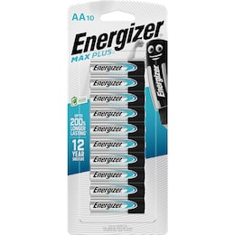
Toggle Cleaning & Maintenance group Dropdown
Energizer Max Plus High Performance AA Alkaline Batteries 10 pack
$23.00
$2.30 / 1EA
Add to cart
Decrease quantity. Current quantity 1
Increase quantity. Current quantity 1

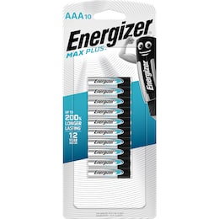
Energizer Max Plus High Performance AAA Alkaline Batteries 10 Pack
$23.00
$2.30 / 1EA
Add to cart
Decrease quantity. Current quantity 1
Increase quantity. Current quantity 1

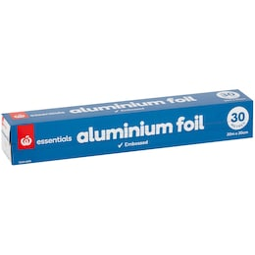
Essentials Aluminium Foil 30m each
$4.50
$0.15 / 1M
Add to cart
Decrease quantity. Current quantity 1
Increase quantity. Current quantity 1

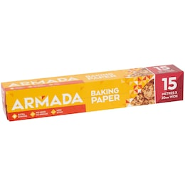
EVERYDAY LOW PRICE
Armada Baking Paper 15m
$2.70
$0.18 / 1M
Add to cart
Decrease quantity. Current quantity 1
Increase quantity. Current quantity 1

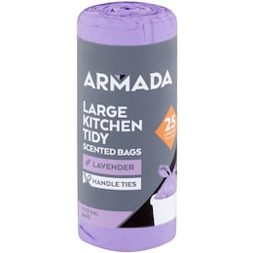
LOWER SHELF PRICE
Armada Large Kitchen Tidy Bag Lavender/Lemon Scented 25 pack
$2.25
$0.09 / 1EA
Was $2.50 - 03/07/2026
Add to cart
Decrease quantity. Current quantity 1
Increase quantity. Current quantity 1

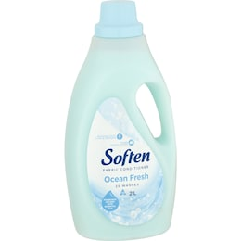
EVERYDAY LOW PRICE
Soften Fabric Conditioner Ocean Fresh 2L
$3.00
$1.50 / 1L
Add to cart
Decrease quantity. Current quantity 1
Increase quantity. Current quantity 1

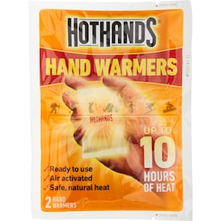
SEASONAL PRICE
Hot Hands Hand Warmers Pair each
$1.85
$1.85 / 1EA
Was $2.50 - 02/06/2026
Add to cart
Decrease quantity. Current quantity 1
Increase quantity. Current quantity 1

Page 3 of 3
Previous123
Return to Previous Page
Page
Page
You are on
Page

Items available:
73 of 79

You'll collect:
6640 pts

You’ll save up to:
$29.17

Estimated total:
$394.09
Excl. service, bag & delivery fees

Add all to cart (73)

Back to top

Customer Service
Help & Support
Contact Us
Feedback
Product Safety
Product Recalls
Return Policy
Scam Warning

Shop Groceries Online
View My Account
Pick up
Delivery
Delivery Now
New to Online Shopping?
Shop for your Business

Useful Links
Store Locations & Trading Hours
Everyday Rewards
Recipes & Easy Dinner Ideas
Woolworths Catalogue
Our pricing
Meal Planner
Woolworths Fresh Magazine
Woolworths App

About Woolworths
Careers
Our Brands
Woolworths Group Privacy Centre
Community
Suppliers
Become an Affiliate
Corporate Responsibility
About Us

Our Partners

Connect on Social
Follow us on Instagram, Opens in a new window
Follow us on Facebook, Opens in a new window
Follow us on Pinterest, Opens in a new window
Follow us on Youtube, Opens in a new window
Follow us on Twitter, Opens in a new window

We acknowledge the Traditional Owners and Custodians of Country throughout Australia. We pay our respects to all First Nations peoples and acknowledge Elders past and present.
Read more about our commitment to reconciliation

Woolworths Group aims to create more inclusive access for team members and customers with disabilities.
Website accessibility

New South Wales | Liquor Act 2007: No alcohol can be sold or supplied to anyone under 18. It's against the law.
For all Woolworths Online liquor orders, Woolworths Group is acting as an agent on behalf of Endeavour Group Limited (ABN 77 159 767 843). Pricing (including any 'was' or 'strikethrough' price) displayed on the Woolworths website and app for these liquor products are provided by Endeavour Group and reflects pricing on their BWS website which is set by location. They do not, however, include particular specials, clearances and offers which are exclusive to BWS. For Everyday Market from Woolworths orders involving the sale of liquor, Woolworths Marketplace Pty Limited is acting as an agent on behalf of the relevant Everyday Market partner. Woolworths Online supports the Responsible Service of Alcohol. For liquor licence numbers visit the Liquor and Tobacco Licences page.
If you wish to voluntarily exclude yourself from being able to purchase alcohol from our site, you can find out more at our Alcohol Self Exclusion page.
© Woolworths Group Limited 1997-2026 - All Rights Reserved. Woolworths Group Privacy Policy Woolworths Group Cookies Statement Woolworths Collection Notice Terms & Conditions Accessibility

Feedback

