**Traffic stop 0202**

**Contents:**

1. **Baseline Logistic Regression (speeding over limit-yearly)**
2. **Logistic Regression with Interaction Terms (speeding over limit-yearly)**

**--- coefficient estimates are in excel files.**

1. **Baseline Logistic Regression (school zone-all year combined)**
2. **Logistic Regression with Interaction Terms (school zone-all year combined)**
3. **Race Distribution for drivers with only speeding violation that are searched**
4. **Race Distribution for drivers with only low-citation-rate speeding violation that are searched**
5. **Race Distribution for ‘speeding over limit’**

From last week’s meeting:

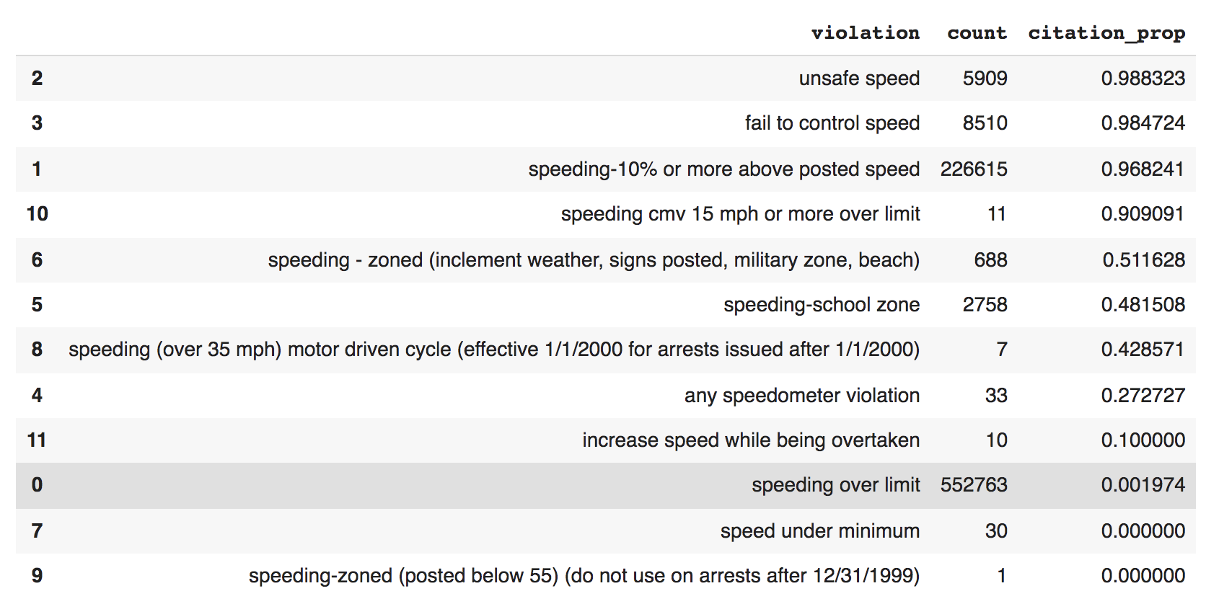

Definition: ‘low-citation-rate speeding violation’ excludes the top 4 categories: ‘unsafe speed’, ‘fail to control speed’, ‘speeding – 10% or more above posted speed’, ‘speeding cmv 15 mph or more over limit’.

From last weekly meeting, we decided to run the following model:

1.**Baseline** Logistic Regression Model - **‘speeding over limit’**:

**Variables:**

1. race variables (baseline: white, subject_race_black, subject_race_hispanic, subject_race_asian/pacific);
2. county type (baseline: noncore, metropolitan, micropolitan)
3. holiday (holidays + weekends)

**Without CI: Race variable odds ratio trend**

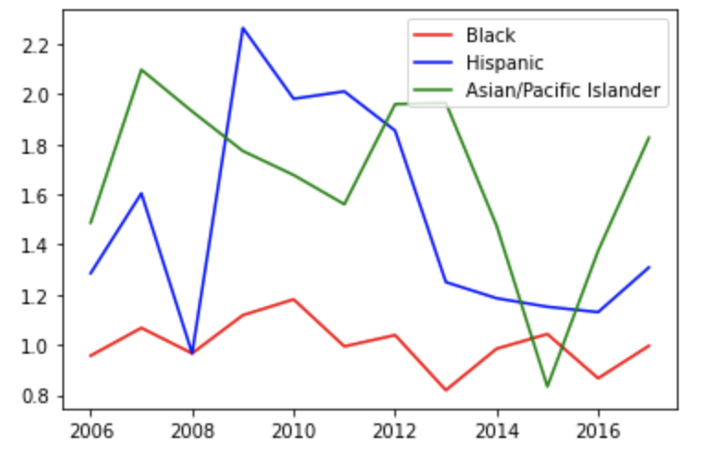

**With CI**

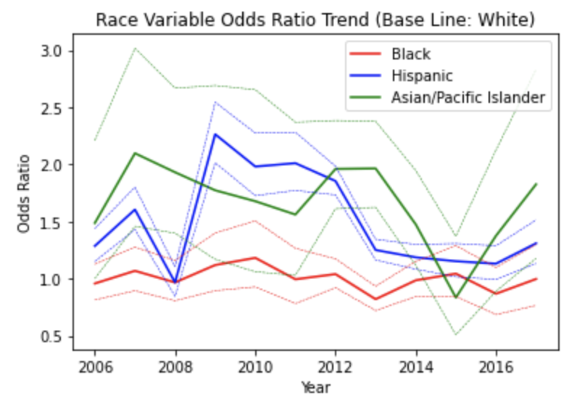

Black – not significant

2.Logistic Regression Model **with Interaction terms** - **‘speeding over limit’:**

**Variables:**

Baseline + interactions of **every race variable** with **metropolitan** (reason: as we discussed in last meeting, logistic regression (low citation rate speeding) show that the coefficient of micropolitan is not significant)

**Main effect**

**Without CI:**

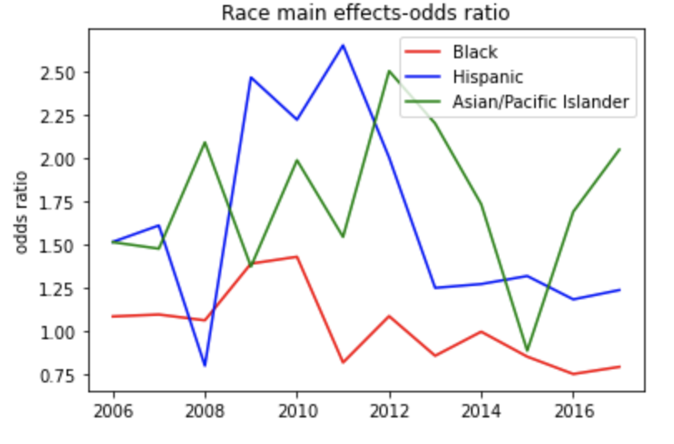

**With CI:**

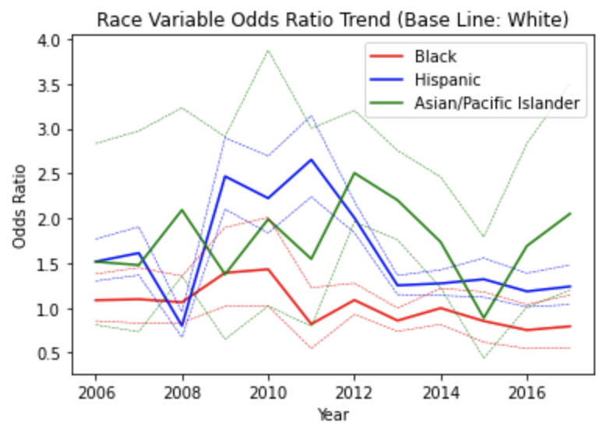

**Race & metropolitan (adding 2 coefficients together)**

**Without CI:**

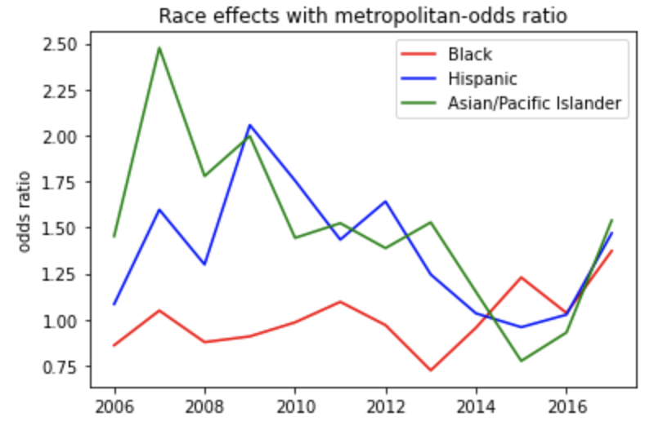

**With CI: -- not finished: I think instead of simply adding, we might need to consider joint CI.**

3.**Baseline** model for **‘speeding-school zone’** – all year combined

# speeding-school zone records: 19476

citation issued: True: 10422; False: 9054

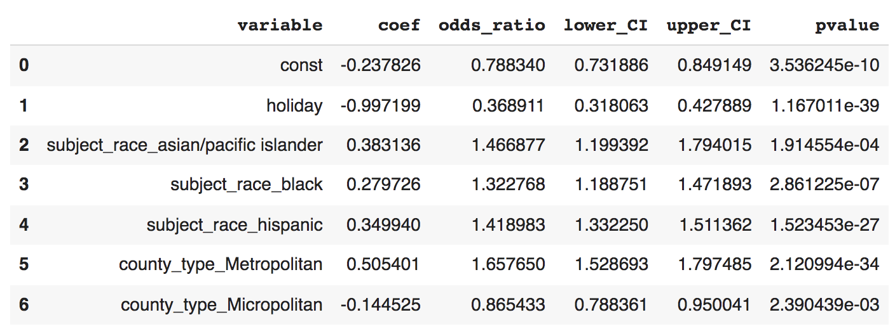

**Notes:** All variables are significant. Race variables coefficients > 0.

4. **Interaction** model for **‘speeding-school zone’** – all year combined

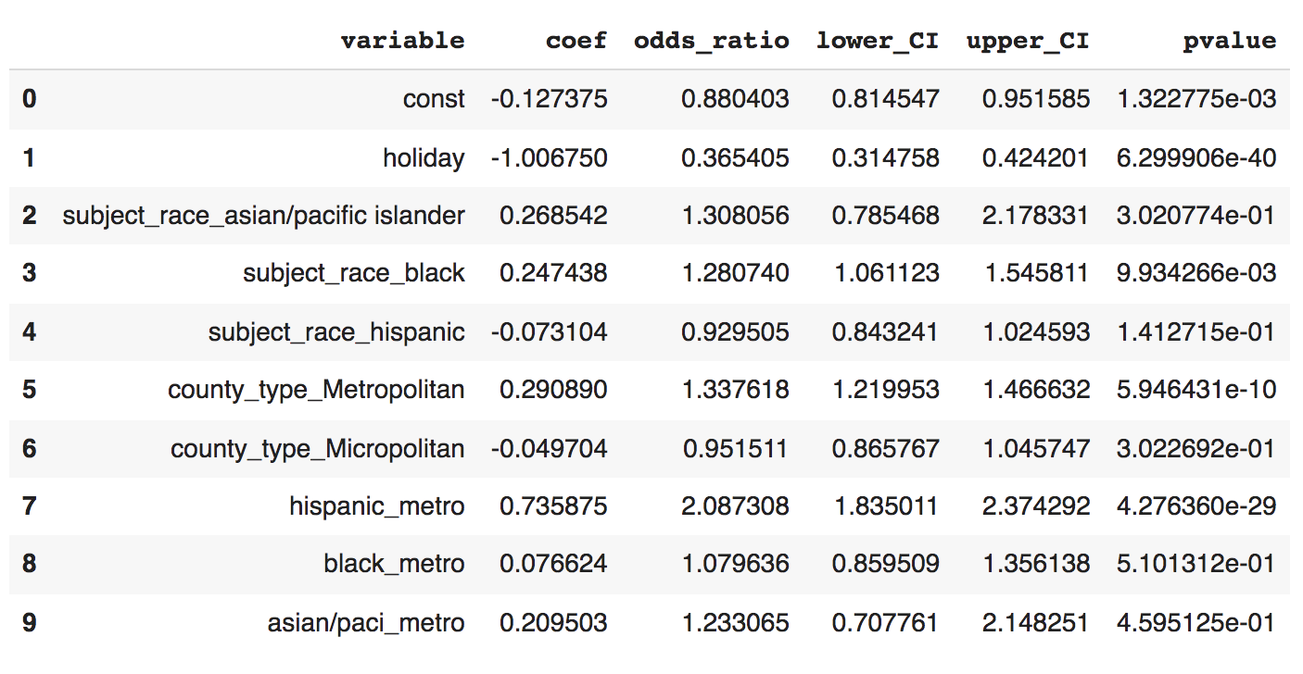

**Notes:** Insignificant coefficients in red. Adding interaction terms makes several race variables and race-related interaction terms insignificant (CI contains 1).

5.Race Distribution for drivers with **only speeding violation (can be one speeding violation, multiple speeding violations)** that are **searched**

**Percentage of searched drivers for each race: Black and Hispanic are most searched.**

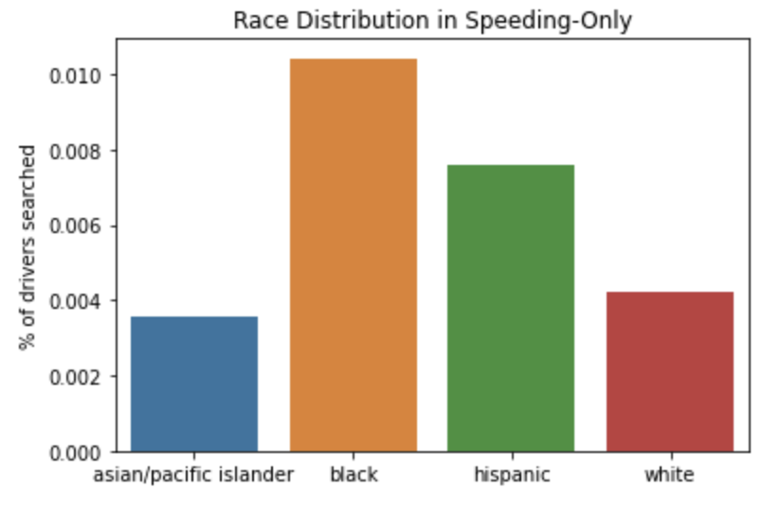

white 0.4210%

hispanic 0.7580%

black 1.0427%

asian/pacific islander 0.3568%

**Notes:**

Total # drivers of different races in ‘speeding only’

white 7670258

hispanic 2900079

black 1057167

asian/pacific islander 215240

The rate of searching for drivers with only speeding violation is low. The sample distribution shows search rate having black > Hispanic> white > Asian/pacific islander.

6.**Race Distribution for drivers with only speeding violation of low citation rate that are searched**

**Speeding violation categories with low citation rate:**

Excluding ['speeding-10% or more above posted speed','unsafe speed','fail to control speed','speeding cmv 15 mph or more over limit']

**Percentage of searched drivers for each race: Black and Hispanic are most searched.**

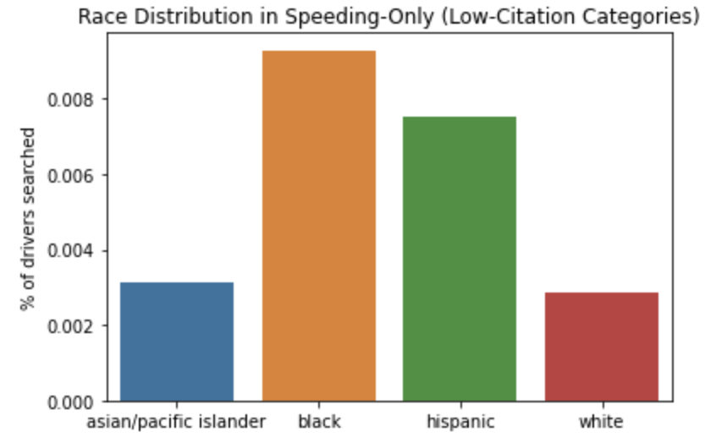

white 0.2858%

hispanic 0.7512%

black 0.9287%

asian/pacific islander 0.3125%

**Notes:**

# drivers of different races in ‘low-cite-rate speeding only’

white 5428440

hispanic 1893840

black 697569

asian/pacific islander 116818

Explore the search result variable: usually no contraband_found.

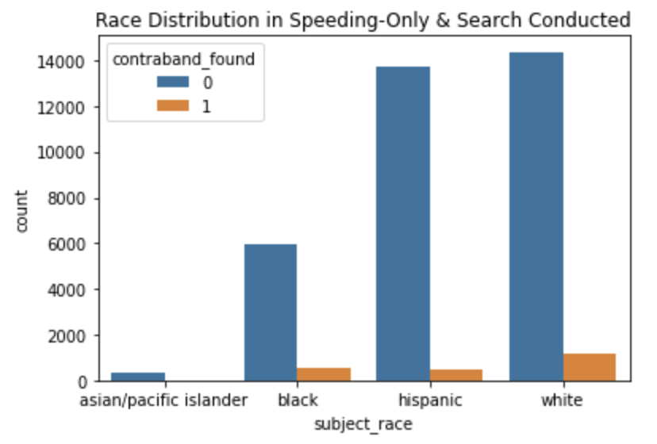

7.**Race Distribution for the only violation is ‘speeding over limit’**

From last meeting: ‘speeding over limit’ is a violation type that has very **low citation rate**. Is it possible that, it is the violation type that officers write down when they do not want to give a ticket?



For each race, the **percentage** of **‘speeding over limit’ violation** out of **all single speeding violation:**

**White slightly higher, but it seems like it is not very large difference. (percentage of speeding over limit/all speeding)**

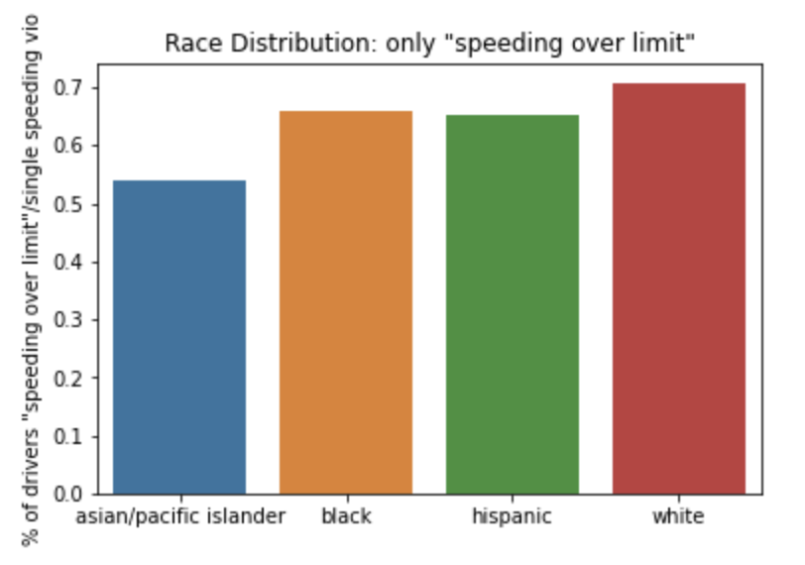

white 70.6546%

hispanic 65.1020%

black 65.7511%

asian/pacific islander 54.0374%