**Contents**

Page 2: Citation Rate for different speeding violation categories (in single-speeding violation records) (Tx Patrol, 2006-2017)

Page 3: Logistic Regression Model – Speeding Only (Tx Patrol, 2006-2017)

Page 4: Only violation is ‘speeding-school zone’- Logistic Regression (TX patrol, 2006-2017 data combined)

Page 5: Race Distribution of citation in ‘speeding over limit’: % of drivers getting citation

**Page 6 - Page 8:**

**Race distribution of not getting citation in high-citation-rate categories (% of drivers not getting citation)**

Page 6: Unsafe Speed

Page 7: Fail to control Speed: % not getting citation

Page 8: Speeding – 10% or more above posted speed: % not getting citation

Page 9: % ‘speeding over limit’ in all single speeding records

Page 10: % search_conducted in speeding only

Page 11: % search_conducted in low-citation rate speeding only

Page 12: % contraband found in search conducted (speeding only)

1. **Citation Rate for different speeding violation categories (in single-speeding violation records) (Tx Patrol, 2006-2017)**

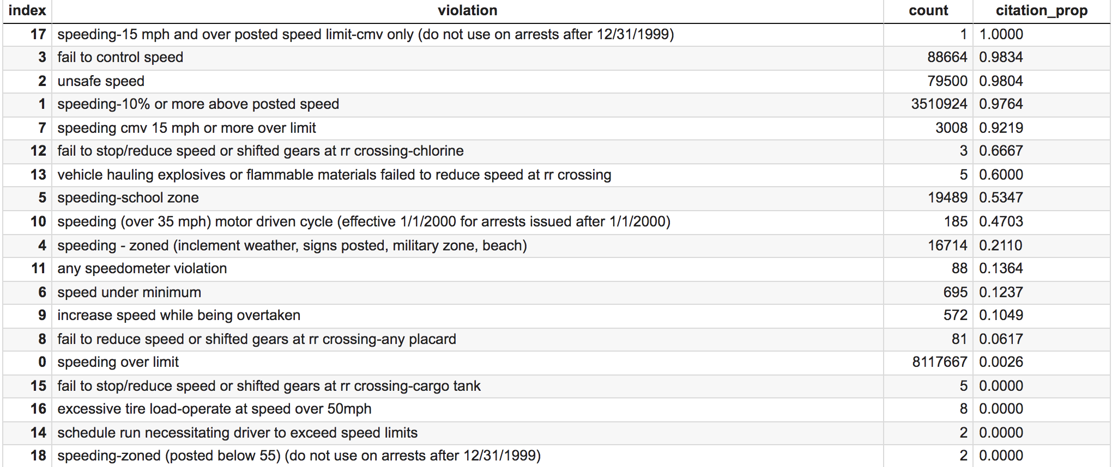

categories with citation rate > 90%:

* fail to control speed
* unsafe speed
* speeding-10% or more above posted speed
* speeding cmv 15 mph or more over limit

‘speeding over limit’ has a low citation rate of 0.26%

Definition: ‘low-citation-rate speeding violation’ excludes the top 4 categories: ‘unsafe speed’, ‘fail to control speed’, ‘speeding – 10% or more above posted speed’, ‘speeding cmv 15 mph or more over limit’.

1. **Logistic Regression Model – Speeding Only (Tx Patrol, 2006-2017)**

Note: This includes records with

* only 1 speeding violation
* repeated entries of 1 speeding violation (e.g., [speeding over limit, speeding over limit])
* multiple different speeding violations

Logistic Regression Base: White, Metropolitan, not holiday.

Holiday Definition:

Holidays + Saturday + Sunday + Friday after dusk + Christmas – New Year

Y variable: citation_issued

Confidence intervals are shown in dashed lines.

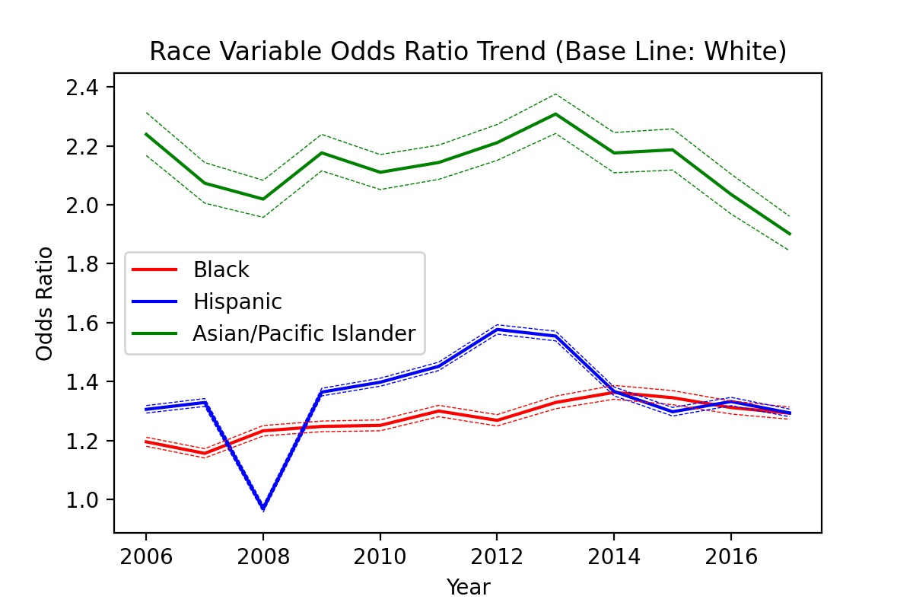

coefficient estimates: details on Github - 'baseline_speedingonly_yearwise.csv'

1. **Only violation is ‘speeding-school zone’- Logistic Regression (TX patrol, 2006-2017 data combined)**

# of school zone speeding: 19489

1 10421

1. 9068

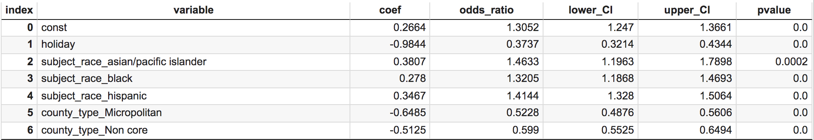

Coefficient estimates can also be found on Github - 'baseline_schoolzone.csv'

1. **Race Distribution of citation in ‘speeding over limit’: % of drivers getting citation**

Formula for each race:

# drivers only having that speeding violation and get a citation

_________________________________________________

# drivers only having that speeding violation

# speeding over limit

white 5418665

hispanic 1887721

black 694991

asian/pacific islander 116290

# cited:

white 13085

hispanic 6279

black 1552

asian/pacific islander 470

# Ratio:

asian/pacific islander 0.4042%

black 0.2233%

hispanic 0.3326%

white 0.2415%

dtype: float64

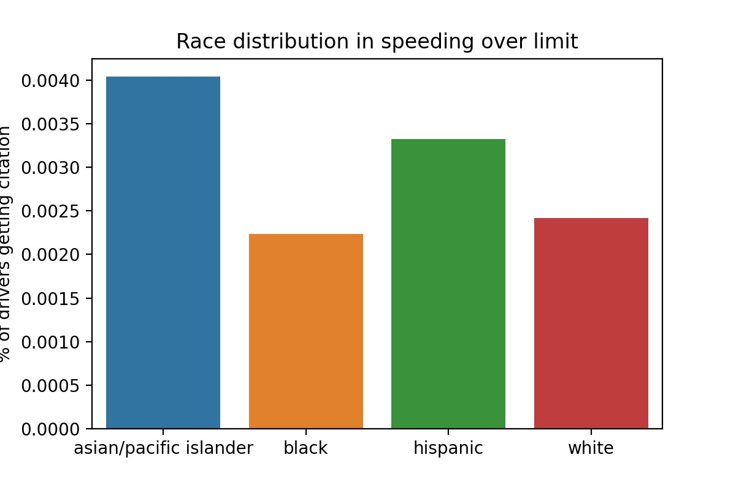

1. **Race distribution of not getting citation in high-citation-rate categories (% of drivers not getting citation)**

Formula for each race:

# drivers only having that speeding violation and not getting a citation

_________________________________________________

# drivers only having that speeding violation

Unsafe Speed

# Unsafe speed:

white 52879

hispanic 17764

black 7346

asian/pacific islander 1511

# not cited:

white 801

hispanic 613

black 120

asian/pacific islander 28

# ratio:

asian/pacific islander 1.8531%

black 1.6335%

hispanic 3.4508%

white 1.5148%

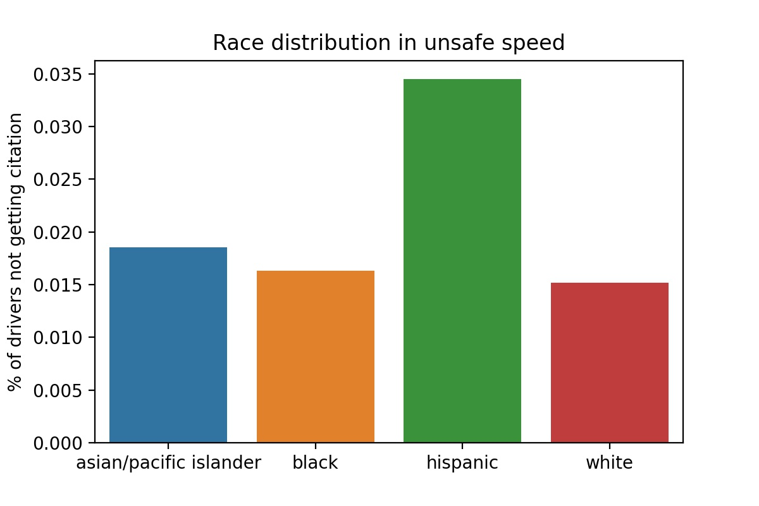

Fail to control Speed

# fail to control speed:

white 61134

hispanic 17953

black 7749

asian/pacific islander 1828

# not cited:

white 842

hispanic 421

black 172

asian/pacific islander 34

# ratio

asian/pacific islander 1.8600%

black 2.2196%

hispanic 2.3450%

white 1.3773%

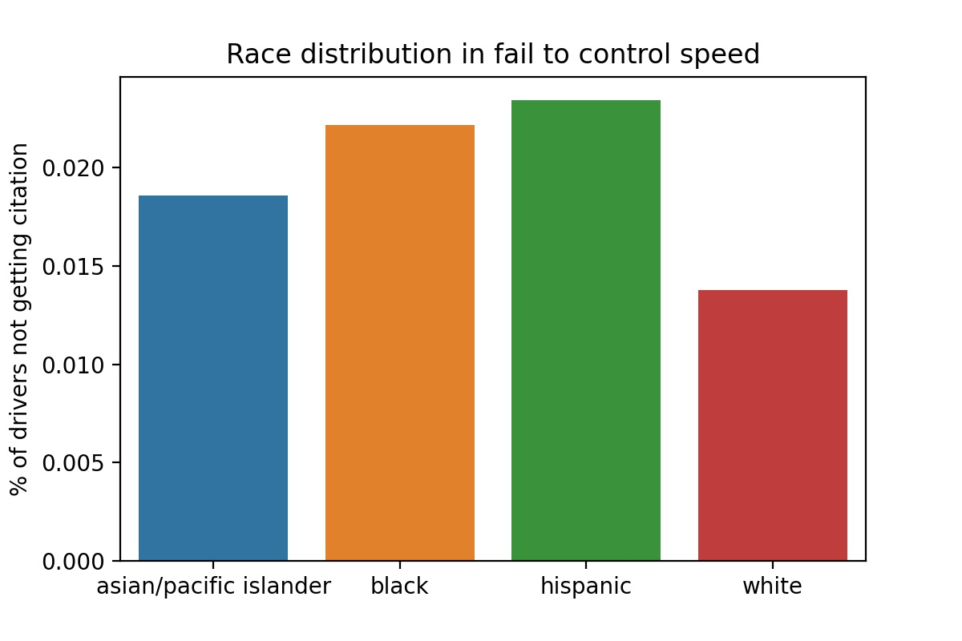

Speeding – 10% or more above posted speed

# speeding-10% or more above posted speed

df_all:

white 2109068

hispanic 964141

black 342859

asian/pacific islander 94856

# not cited

white 48904

hispanic 26216

black 6473

asian/pacific islander 1309

Ratio:

asian/pacific islander 1.3800%

black 1.8879%

hispanic 2.7191%

white 2.3187%

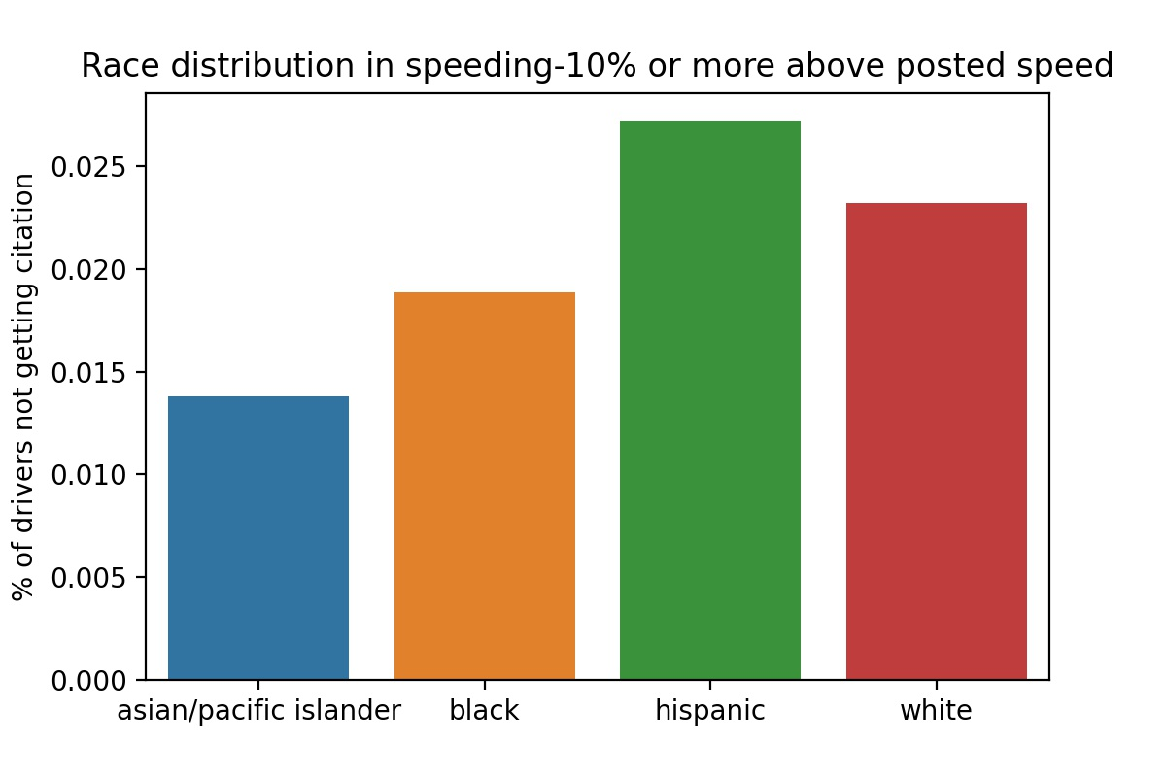

1. **% ‘speeding over limit’ in all single speeding records**

Formula for each race:

# drivers having a single violation and it is ‘speeding over limit’

_________________________________________________

# drivers having a single speeding violation

# single speeding:

white 7667102

hispanic 2898583

black 1056729

asian/pacific islander 215199

# speeding over limit:

white 5418665

hispanic 1887721

black 694991

asian/pacific islander 116290

# % speeding over limit

asian/pacific islander 54.0384%

black 65.7681%

hispanic 65.1256%

white 70.6742%

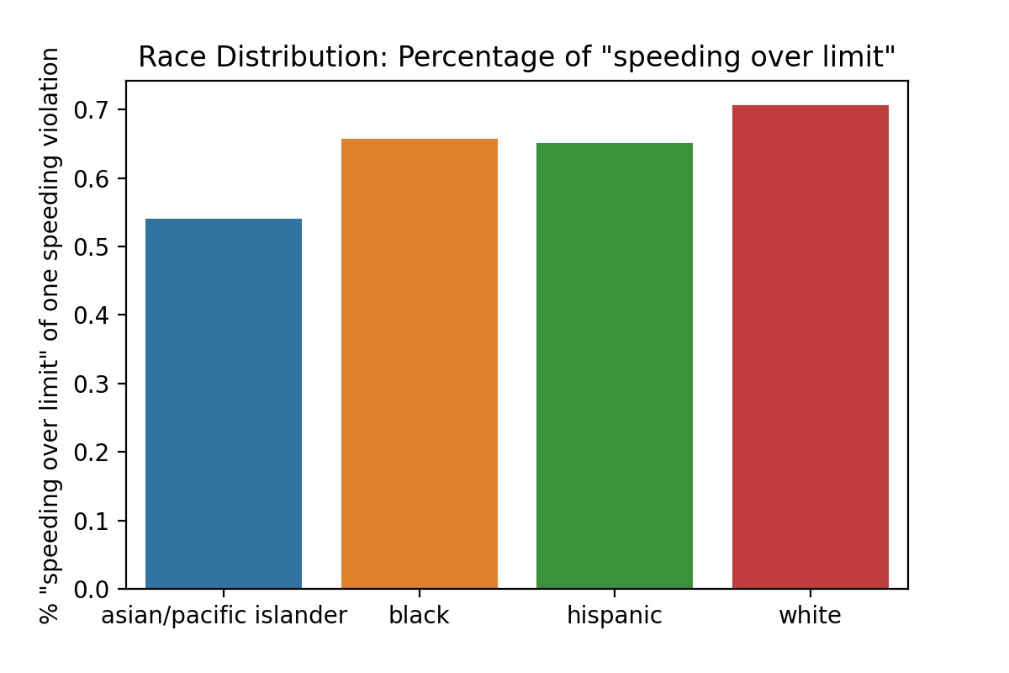

1. **% search_conducted in speeding only**

Note: only-speeding include records with multiple different speeding violations!

Formula for each race:

# drivers having only speeding violations and searched

_________________________________________________

# drivers having only speeding violations

# speeding only:

white 7670255

hispanic 2900073

black 1057167

asian/pacific islander 215239

# searched:

white 32294

hispanic 21982

black 11023

asian/pacific islander 768

# % searched in speeding-only

asian/pacific islander 0.3568%

black 1.0427%

hispanic 0.7580%

white 0.4210%

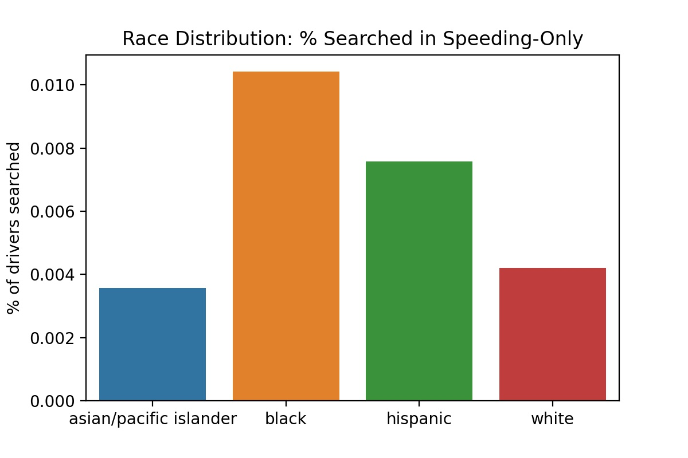

1. **% search_conducted in low-citation rate speeding only**

This focus on single violation of certain speeding categories **(excluding top 4)**

# drivers having only speeding violations in low_citation cats and searched

______________________________________________________________

# drivers having only speeding violations in low_citation cats

# low citation rate speeding

white 5442290

hispanic 1897876

black 698396

asian/pacific islander 116955

# searched:

white 15501

hispanic 14222

black 6473

asian/pacific islander 365

# % searched

asian/pacific islander 0.3121%

black 0.9268%

hispanic 0.7494%

white 0.2848%

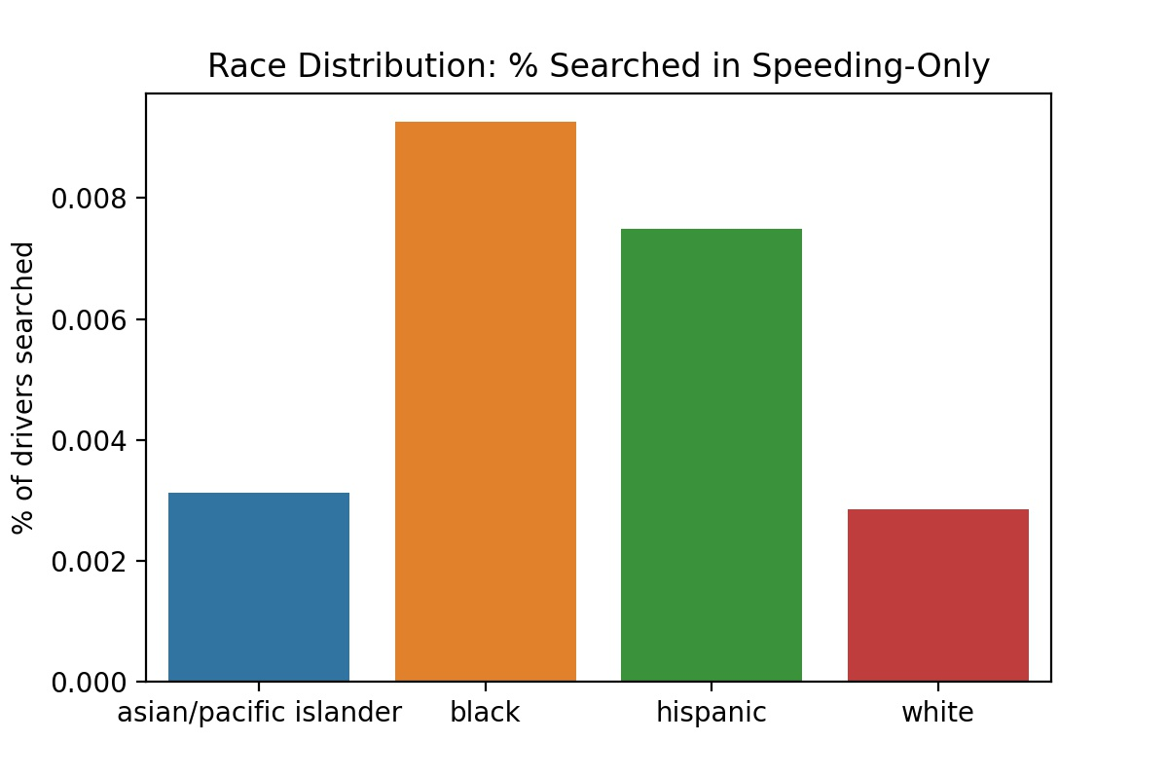

1. **% contraband found in search conducted (speeding only)**

This includes records with multiple speeding violations

Formula for each race:

# drivers having only speeding violations and searched, and contraband found

______________________________________________________________

# drivers having only speeding violations and searched

# searched:

white 32294

hispanic 21982

black 11023

asian/pacific islander 768

# contraband found:

white 2510

hispanic 1010

black 1004

asian/pacific islander 44

% contraband in searched

asian/pacific islander 5.7292%

black 9.1082%

hispanic 4.5947%

white 7.7723%

