Problem 2:

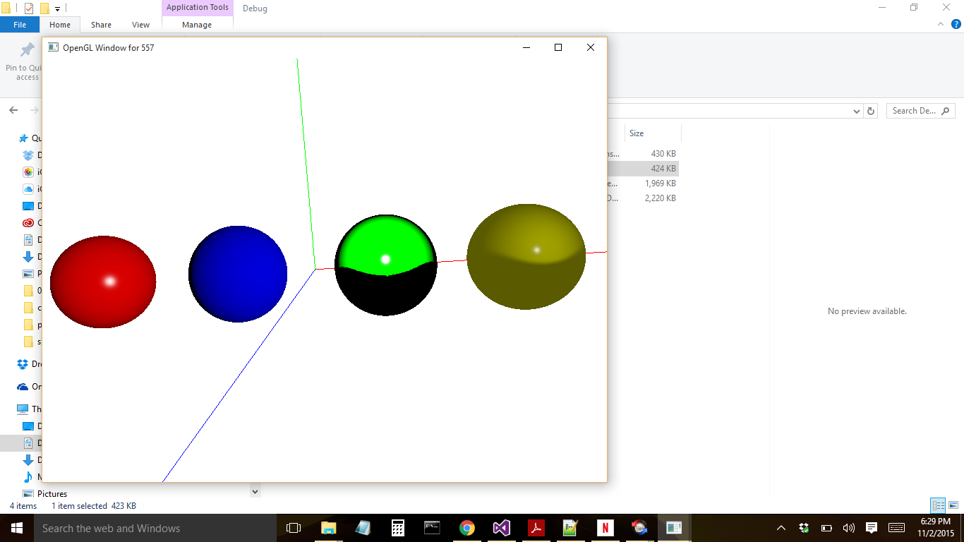

Red Sphere:

Sphere position: (-23, 0, 0)

To achieve this affect a direct light source was used. The position of the light source was at (50, 10, 50), ambient intensity set to 0, specular intensity set to 1, diffuse intensity set to 1. Shininess = 100 for the small highlight focus.

Blue Sphere:

Sphere position: (-8, 0, 0)

To achieve this affect, a direct light was used. Ambient and Specular intensities were set to 0. Diffuse intensity was set to 1. This results in a diffuse light effect on the sphere.

Green Sphere:

Sphere position: (7,0,0)

Light position: (7, 3.5, 10.0)

The ambient intensity was set 0 which results in a black shadow on the bottom half of the sphere. Specular light was set to 20.0, diffuse intensity to 10.0. The cone angle was set to 35* with the cone direction directed towards the –z axis. The shininess was set to 150 to get a small reflection.

Yellow Sphere:

Sphere position: (20,0,0)

Two light sources were used to achieve this affect. The first light source was a spotlight source positioned at (20.0, 3.5, 10.0). The ambient intensity for this light was set to 0.4, specular intensity was set to 0.9 to see the small highlight and the diffuse intensity was set to 0.6. The cone angle was 35* with the cone direction in –z direction.

The direct light source was positioned at (-15, -7, 12) with ambient intensity = 0, specular intensity = 0 and diffuse intensity = 1.

To achieve the smooth cut off angle, used the hermite interpolation = smoothstep function in the shader code = multi_vertex_lights1.vs