Plug-in Documentation: guiManager

1. Overview

guiManager creates a Gtk.Main window with a left pane (Gtk.ScrolledWindow) , center area (Gtk.Stack) and a Gtk.HeaderBar. On request, guiManager places Widgets created by other plug-ins in these areas.

2. Dependencies

guiManager needs settings plug-in.

3. Gui changes

guiManager creates the following gui.

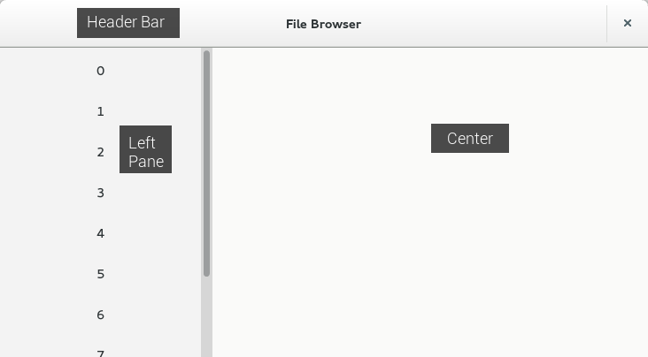

4. Signals

4.1 started

Creates the gui described above.

4.2 request-place-left-pane

onLeftPanePlaceRequest
Places kwargs[“widget”] on kwargs[“side”] of leftPane, kwargs[“side”] being “top” or “bottom” with “top” as default.

4.3 request-place-center

onCenterPlaceRequest
Places kwargs[“widget”] on kwargs[“side”] of center, kwargs[“side”] being “top” or “bottom” with “top” as default.

4.4 request-place-header

onHeaderPlaceRequest
Places kwargs[“widget”] on kwargs[“side”] of headerBar, kwargs[“side”] being “left”, “start”, “right” or “end”.

4.5 request-remove-left-pane

onLeftPaneRemoveRequest (not implemented)
Removes kwargs[“widget”] from leftPane.

4.6 request-remove-center

onCenterRemoveRequest
Removes kwargs[“widget”] from center and sets last visible child visible again.

4.7 request-remove-left-pane

onLeftPaneRemoveRequest (not implemented)
Removes kwargs[“widget”] from headerBar.

