Plug-in Documentation: dirFrame

1. Overview

dirFrame shows the content of a directory in the center area. It is also responsible for creating signals for opening/previewing file.

2. Dependencies

dirFrame needs settings plug-in. and dirTree to select directories.

3. Gui changes

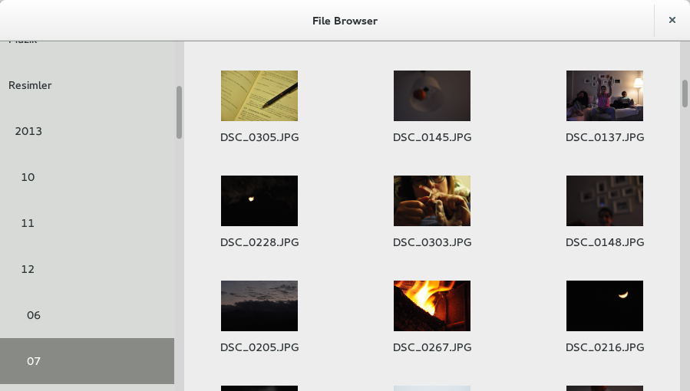

4. Signals

4.1 started
onStart

Answer before: dirTree
Answer after: settings

Create the frame unpopulated.

4.2 change-dir
onChangeDir

Show the content of kwargs[“newPath”].

