Plug-in Documentation: dirTree

1. Overview

dirTree provides a gui in the left pane to browser directories. One can toggle the subdirectories of a directory by space key or a single click. Enter key or double click selects the directory and raises “change-dir” signal.

2. Dependencies

dirTree needs settings. Useful but not mandatory is a plug-in that listens “change-dir” signal and shows directory content.

3. Gui changes

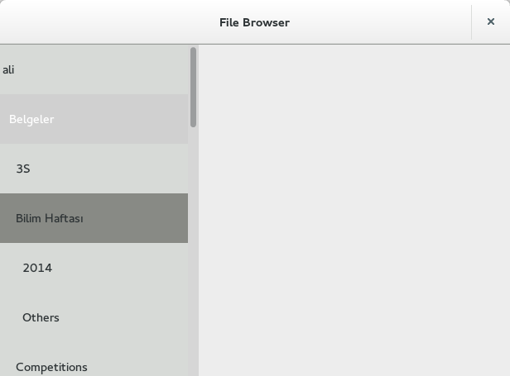
dirTree plug-in using the left pane. Directory “Bilim Haftası” is selected, “Belgeler” is highlighted by keyboard, which means space and return keys would toggle/select “Belgeler”.

4. Signals

4.1 started
onStarted

Answer after: settings

Inits with path in “start-path” setting.

4.2 change-dir
onChangeDir

Selects kwargs[“newPath”] if it is in dirTree. This signal is raised by dirTree when a directory is selected.

