EF:

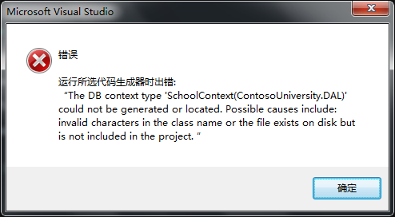

建立controller的时候出错了

挑完了其他model的错之后出现了：

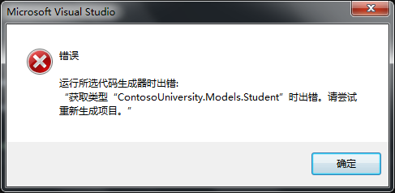

重新生成之后：

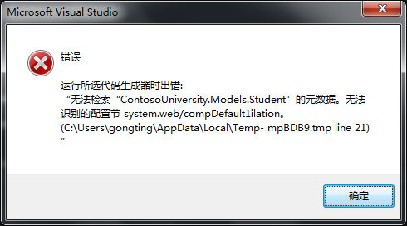

结果就是：connectstring 写错了_(:з)∠)_

# EF第二章：Basic CRUD Functionality

原文tutorial传送门：<http://www.asp.net/mvc/overview/getting-started/getting-started-with-ef-using-mvc/implementing-basic-crud-functionality-with-the-entity-framework-in-asp-net-mvc-application>

译文传送门：http://www.cnblogs.com/Bce-/p/3688423.html

MVCScaffolding：

MVC脚手架，带来类似Ruby On Rails一样创建代码结构的快感。

### Route data

Route data is data that the model binder found in a URL segment specified in the routing table. For example, the default route specifies controller, action, and id segments:

 routes.MapRoute(  
    name: "Default",  
    url: "{controller}/{action}/{id}",  
    defaults: new { controller = "Home", action = "Index", id = UrlParameter.Optional }  
);