Networks in Equity and Sustainability: A Preliminary Tool for Intercultural Analysis and Discussion

Arlene Ducao ^{1, 2}  arlduc@media.mit.edu | Alexander Simoes ¹  simoes@media.mit.edu |  | Ilias Koen ²  ikoen@dukode.com
Henry Holtzman ¹  holtzman@media.mit.edu |  | Cesar Hidalgo ¹  cesar@media.mit.edu

ABSTRACT

Some of the world's most pressing problems can be traced to inequity between people, both in the present and over time. Long periods of inequity can lead to both social and environmental degradation. In its 2011 Human Development Report (HDR), the United Nations incisively examines some of the complex relationships between socioeconomic equity and environmental sustainability. Members of the MIT Media Lab and The DuKode Studio created “Networks in Equity and Sustainability,” a visualization tool that shows, via a network graph, how nations are multi-dimensionally linked. Examining linkages with this tool can illuminate potential partnerships between cultures. As the tool is expanded in the future, it will support intercultural discussions in the global effort for a world that is more equal today and more sustainable over time.

Keywords
United Nations, Human Development Report, network graphs, visualization, DuKode, MIT, Equality, Equity, Sustainability

INTRODUCTION
The United Nations’ annual Human Development Report (HDR) provides a wide array of data that compares nations in several major dimensions. This data includes nation-by-nation information on income, gender, education, poverty, health, birth rates, mortality rates, and environmental sustainability. Each year, HDR also provides a comprehensive series of analytic articles based on a timely theme. The HDR 2011 theme is Sustainability and Equity:
A Better Future for All [1]. The HDR’s articles make the compelling point that sustainability and equity must be addressed together, for sustainability is the same as equity over generations. Unsurprisingly, the world’s most disadvantaged people suffer the most in terms of both environmental sustainability (resource depletion) and economic equity. However, the HDR highlights positive synergies within and between nations working to improve systems that support sustainability and equity.

The handful of example synergies highlighted in the HDR were our starting point as we developed “Networks in Equity and Sustainability” [2] (Figure 1), a tool to visualize important dimensions of the HDR 2011 dataset. Inspired by these synergies, we aim to make a tool that could highlight both actual and potential synergies between nations, via nearest neighbors in a network graph. For each nation, we show the most similarly performing nations in sustainability, economic equity, gender equity, and income. In showing nearest neighbors, we want to suggest both predictable and unexpected intersections for intercultural exchange between nations working to improve and sustain human development. In addition to highlighting potential inter-nation synergies, we also present ways to examine larger regional and continental patterns through a system of data-activation switches.

PRECEDENTS
The UN HDR includes detailed datasets and calculations printed pages of the HDR document. While deeply extensive, these documents do not dynamically show relationships for any given country. As a result, interested parties must spend time sorting through the printed to find specific countries and extrapolate specific relationships. In recent years, the UN HDR has included an interactive online component [3,4]. Most of these components have had limited interactivity, allowing limited access to nation-by-nation and relational data.
The UN HDR 2011 presents a highly extensive, flexible set of data tools and visualizations for analyzing many facets of HDR data [5]. These tools are particularly useful for examining detailed information on individual countries, examining large global patterns, and examining time-based changes in long-lived UN HDR indicators (human development, education, health, and income). While these tools provide much information, they do not provide visually intuitive relational data between countries, especially for newer UN HDR indicators like the Environmental Performance Index.
The web site Visualizing.org [6], a repository of data visualizations sponsored by General Electric and the Seed Media Group [7], recently held a competition for visualizations of UN HDR 2011 data. Our visualization, which was entered in this competition, is unique in presenting relational data for a number of key indices and indicators, including the new Environmental Performance Index.

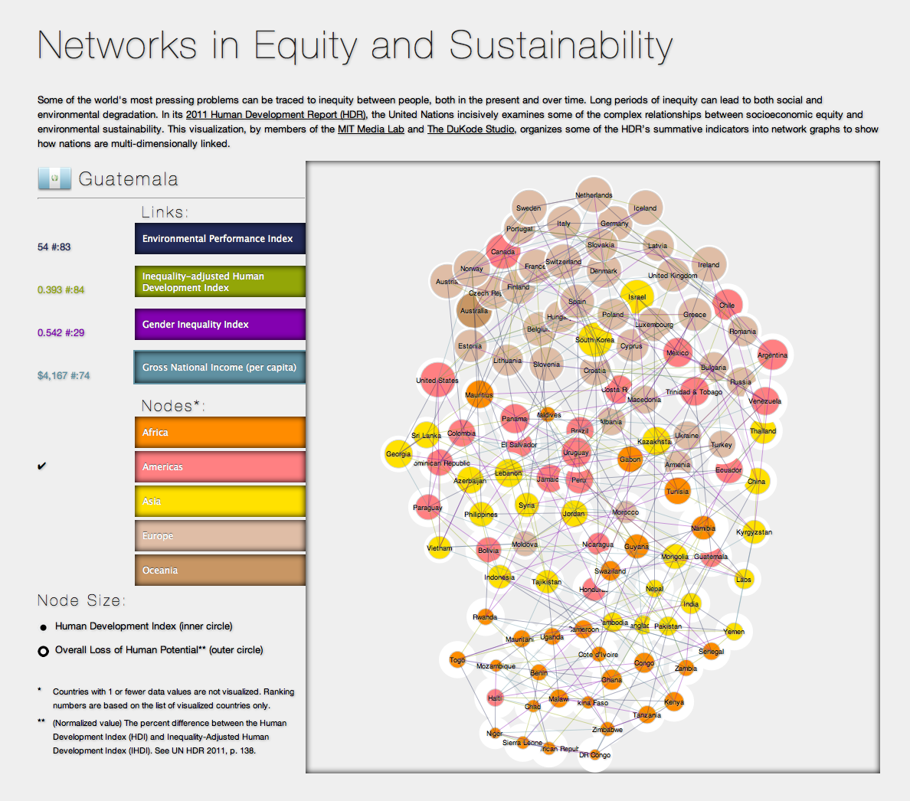Figure 1: visualization screenshot.

CONTRIBUTION: INTERCULTURAL UTILITY
By emphasizing relational data and nations’ nearest neighbors for several indicators, our tool places priority on inter-nation visualization, as opposed to fine-grained intra-nation or large-grained global visualization. Focusing the visualization at this middle scale of granularity allows users to more clearly see unexpected links between nations. These links can then be used as a basis for intercultural synergy in planning and policy. For instance, Namibia’s nearest neighbors in the Gender Inequality Index are Jordan and Ecuador. While these countries are not geographically close to Namibia, models that improve gender equality may be applicable between these three countries. Namibia’s nearest neighbors along several other dimensions (environmental performance, inequality-adjusted human development, and gross national income) include several countries in South or Southeast Asia: Pakistan, Bangladesh, and Laos. This suggests that South and Southeast Asia have the potential for strong synergies with Namibia.
In our visualization tool, nation-nodes are sorted vertically based on which indicator-links are activated. This sorting reveals interesting regional and continental trends for the indicators being visualized (environmental performance, inequality-adjusted human development, gender inequality, and gross national income). For instance, while western European countries and Australia consistently score high across indicators, and while southern African countries consistently score low across indicators, Asian, northern African, eastern European, and American countries are more in flux from indicator to indicator. This suggests synergies across both similar and complementary regions.
These synergies are already playing out, in an often self-selecting matchmaking process. For instance, UN Global Pulse, a new division of the United Nations focused on innovation in technology and entrepreneurship, is opening a series of startup incubators, called ‘Pulse Labs,’ in Uganda and Indonesia. These incubators are sponsored by organizations in the UK and Australia. In another example, there seems to be a weak correlation between countries that are in flux from indicator and countries that are rapidly industrializing. Some of these countries are known as BRIC (“Brazil Russia India China” or “Big Rapidly Industrializing Countries”) and are grouped together in financial and development circles. In both of these examples, our visualization is a potentially useful “matchmaking” device for practitioners contemplating next steps in policy, planning, development, and trade.

CONSTRUCTION AND USER INTERFACE
“Networks in Equity and Sustainability” was constructed using HTML, CSS, SVG, and d3.js [8], a Javascript library that allows for fast-performing, vector-based, data-driven documents. The d3 Force module is primarily used to construct a network graph of colored nodes, colored links, and spatial sorting.
UN HDR Data is visualized as follows: Countries are represented by nodes. Node size is represented by an inner and outer circle: the inner circle maps to the Human Development Index, and the outer circle maps to Overall Loss in Human Potential (the percent difference between the Human Development Index (HDI) and Inequality-Adjusted Human Development Index (IHDI)) [9]. Node color is segmented by continent.
4 link colors are mapped to the Environmental Performance Index (EPI), Inequality-Adjusted Human Development Index (IHDI), Gender Inequality Index (GII), and Gross National Income (GII). The IHDI index is adjusted by the Multidimensional Poverty Index of health, education, and living standards. Users can activate 1 or more link types and can activate 1 or more country colors.
Of the UN HDR datasets, those chosen for this visualization were selected to reflect composite calculations for equity, sustainability, gender, development, and income. Of the chosen metrics, a higher number indicates a comparatively positive status. The only exception is the Gender Inequality Index (GII), in which lower numbers indicate positive status. Some of the metrics are too new to analyze temporally; for instance, the Environmental Performance Index was first calculated in 2010. As a result, this visualization is not time-based. Also, countries with one or fewer data values are not visualized.
In addition to toggling links and continents, users can see a nation’s nearest neighbors for any activated link type by rolling the cursor over that nation’s node (Figure 2). A nation’s next-smaller neighbor is indicated by a thick line, while its next-larger neighbor is indicated by a thin line. Rolling the cursor over a nation’s node also result in a display of specific data values and rankings for every indicator (EPI, IHDI, GII, and GNI) being visualized. Ranking numbers are based on the list of visualized countries only.

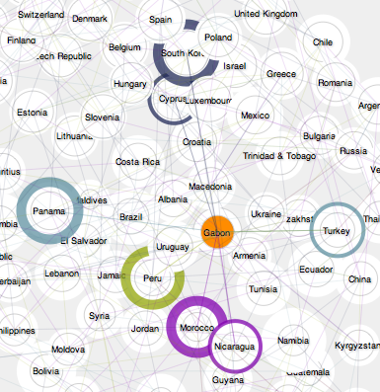
Figure 2: node with nearest-neighbors highlighted.

FUTURE WORK
One apparent feature for increasing collaboration and communication with this tool is to implement mechanisms for user input, comments, and discussion. As new indices mature, a time-based element can be added to the visualization as well. Currently, we are discussing the advantages of adding a gameplay to the visualization system in order to incentivize potential users to participate.
We are also interested in integrating non-UN data that more broadly reflects culture and living situations. This includes language, religion, and climate data.
Next steps for this visualization include user testing with diverse human development professionals to evaluate the use of this tool for intercultural collaboration. The ACM ICIC and the United Nations may be relevant settings for these tests. During the tests, it will be important to examine what kinds of intercultural questions are best explored by this visualization tool.

ACKNOWLEDGMENTS
We thank CHI, ICIC volunteers, all publications support and staff, our colleagues at MIT Media Lab and DuKode, and additional colleagues who provided feedback on the visualization and on this document.

REFERENCES
- UN Human Development Report 2011. Available at http://hdr.undp.org/en/reports/global/hdr2011/
- “Networks in Equity and Sustainability.” Available at http://hdr.media.mit.edu/.
- UN Human Development Report 2009. Available at http://hdr.undp.org/en/reports/global/hdr2009/
- UN Human Development Report 2007-08. Available at http://hdr.undp.org/en/reports/global/hdr2007-8/
- UN HDR Data Tools and Visualizations. Available at http://hdr.undp.org/en/statistics/
- Visualizing.org.
Available at http://www.visualizing.org/
- Seed Media Group. Available at
http://seedmediagroup.com/
- d3.js. Available at
http://mbostock.github.com/d3/
- UN HDR 2011, p. 138. Available at
http://hdr.undp.org/en/media/HDR_2011_EN_Complete.pdf

MIT Media Lab, 77 Massachusetts Ave, E14/E15, Cambridge, MA, USA
The DuKode Studio, 166 7th Street, Brooklyn, NY 11215

