Team Regular
Adam Rodi, Adriean Lemoine, Alameen Adeku, Nicholas Burgo
PA1 Report
Data Mining
October 27, 2025

This report summarizes the dataset, provides a sample of the structured data, showcases initial exploratory plots, and documents team participation.

Dataset Overview
Data Source: The dataset consists of zebrafish brain imaging TIFF stacks organized by treatment condition.
Data structure: Data is located at ~/Condition/S#/ZS-1.tif with Condition $∈$ {Control, Stimulant, Anesthetic} and S# $∈$ {S1, S2, S3, …, S10}.
Features: Each fish sample is converted to a 2D pandas Data Frame which includes sample id, x, y, and z position in the stack, and normalized intensity, texture, and gradient values.
Normalization: Intensity, texture, and gradient was normalized to [0,1] using max scaling. Percentile-based can be used in later project stages if it improves comparability between conditions.

Sample Data Table (Data.xslx)

Visual Exploration
Histograms
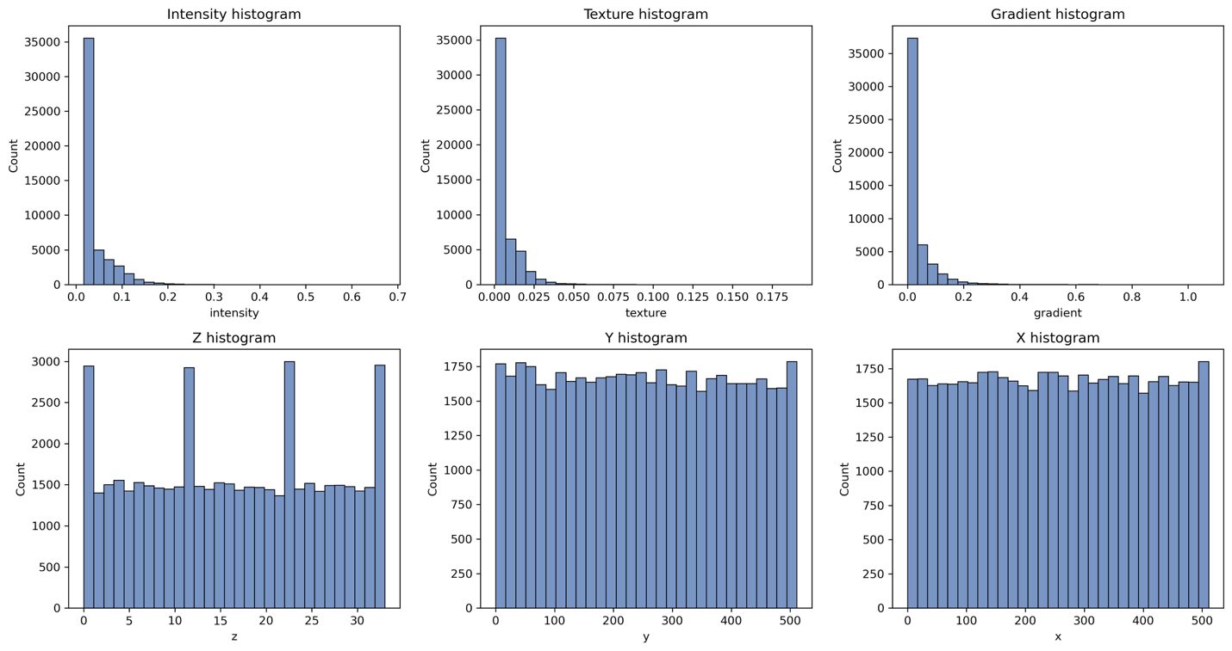
Distributions
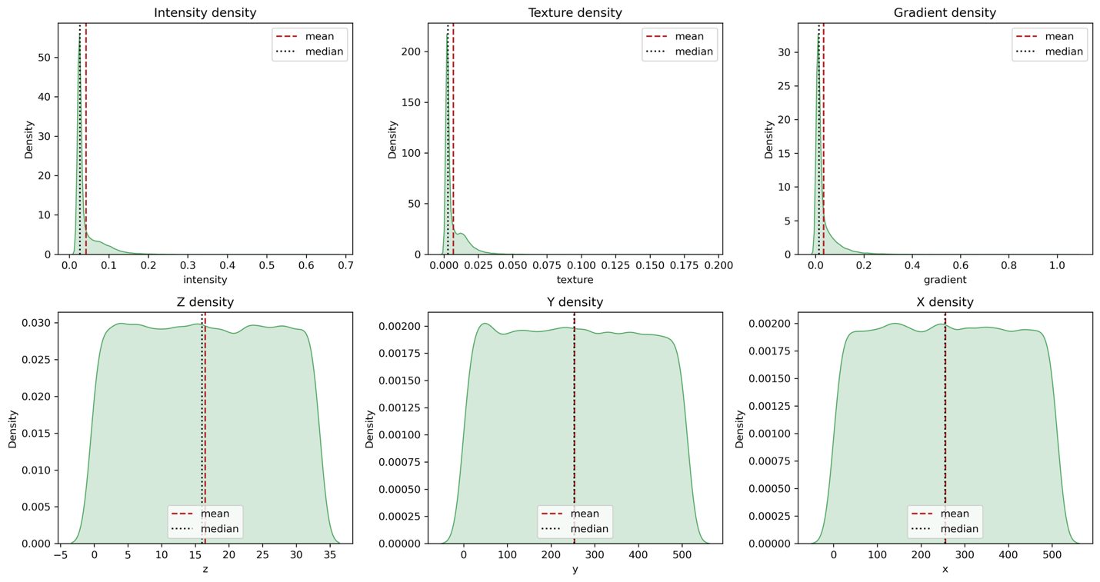
Box-Whisker Plots
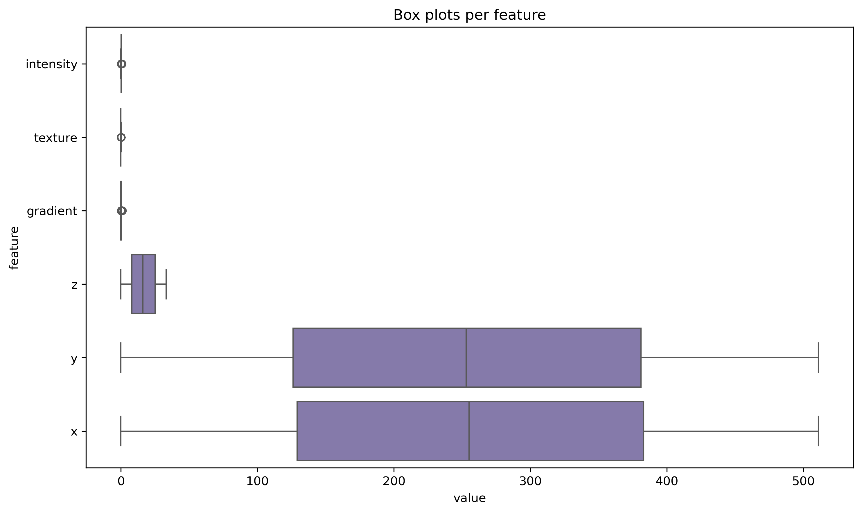
Violin Plots
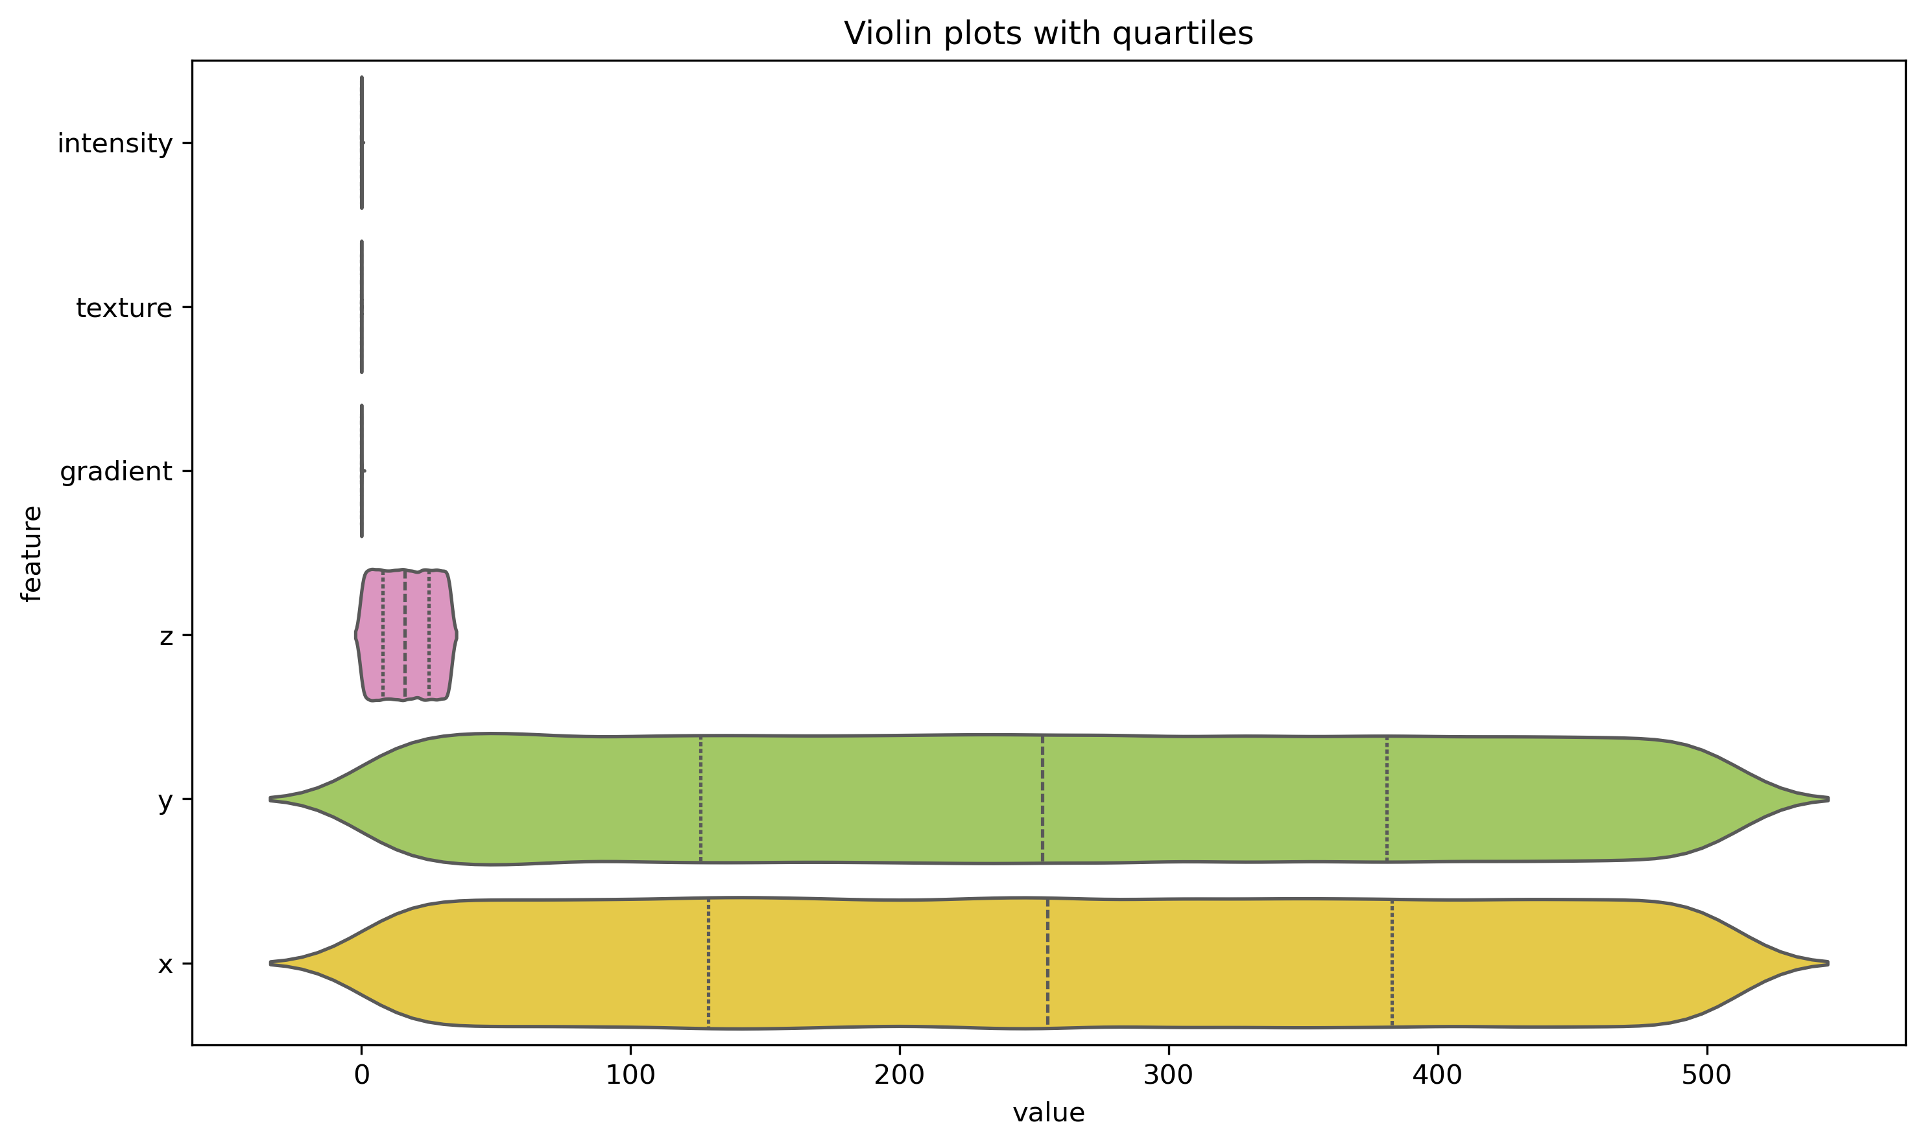
Summary

Team Participation

