PROJECT 9

Keypad Combination Lock

Date October 15, 2026
GitHub: github.com/arlengj995-bit

This project turns a 4x4 keypad, a servo, two LEDs and a buzzer into a combination lock. A correct 4-digit code opens the servo "bolt" for five seconds. Three wrong codes in a row lock the keypad out for 30 seconds.

1. What This Project Does
This project is a keypad combination lock. I type a 4-digit code on the keypad and press # to check it. If the code is right, the servo turns to 90° like a bolt sliding open, the green LED turns on and the buzzer beeps twice. After five seconds it locks itself again.
If the code is wrong, the red LED flashes three times. After three wrong codes in a row, the lock goes into a 30-second lockout. The red LED stays on and every key is ignored until the time is up. Pressing * while typing clears the digits so I can start again.
In Project 5, the traffic light changed state because time passed. Here, the lock changes state mostly because of what someone types. That is the new idea in this project; the system waits for input and reacts to it, while timers still handle the relock and the lockout.
This is one of ten projects building toward an automated aquarium controller. My aquarium in Grades 7–8 failed because I could not control light, CO₂, temperature and water chemistry at the same time. The capstone controller needs a way to change settings like the target temperature or the light schedule without plugging in a laptop, and a keypad is the simplest way to type numbers. A device that switches a heater should also not let anyone who walks past change its settings, so the lock matters too. I built this project before Projects 7 and 8 because it only needs parts from the ELEGOO kit.

2. Four New Concepts in This Project

2.1 Matrix keypad scanning
The keypad has 16 buttons but only 8 wires. Inside, four row wires run across and four column wires run down. Each button sits where one row crosses one column. Pressing a button connects its row wire to its column wire.
 | Col 1 (pin 5) | Col 2 (pin 6) | Col 3 (pin 7) | Col 4 (pin 8)
Row 1 (pin 1) | 1 | 2 | 3 | A
Row 2 (pin 2) | 4 | 5 | 6 | B
Row 3 (pin 3) | 7 | 8 | 9 | C
Row 4 (pin 4) | * | 0 | # | D

The Arduino finds the key by scanning. It sets one row LOW and checks which column also reads LOW, then moves to the next row. The row and column together point to exactly one key. For example, pressing 5 connects Row 2 to Column 2 and nothing else. The Keypad library does this scan for me every time loop() runs, which is so fast that a press feels instant.
Sixteen separate buttons would need 16 pins. The grid needs only 8 (4 rows + 4 columns). This matters for my capstone, where the SD card, relays, sensors and keypad will all be competing for pins.

2.2 Input-driven state machine
Like Project 5, the lock is a finite state machine. It is always in exactly one of three states:
State | Number in code | What it means
LOCKED | 0 | Servo at 0°, waiting for a code
UNLOCKED | 1 | Servo at 90°, green LED on, relocks after 5 s or *
LOCKOUT | 2 | Red LED on, all keys ignored for 30 s

In Project 5, a timer moved the light from one state to the next. Here, key presses move the lock from LOCKED to UNLOCKED or LOCKOUT, and timers bring it back. The aquarium controller will need both kinds: timers for the light schedule and input for the settings menu.
This time I stored the state as a plain int (0, 1, 2) with a comment explaining each number, to keep the sketch simple. In the capstone, where there will be more states, I plan to go back to enum like in Project 5 so the names are clear.

2.3 Storing and checking the code with String
Each digit I press gets added to a String called entered. When I press #, the sketch compares it with the password:
entered += key; // add the digit
if (entered == password) // check the whole code
Two small rules keep it safe. entered.length() < 4 stops the code from getting longer than four digits, and entered = "" after every check means old digits never carry into the next try. The Serial Monitor shows * for each digit instead of the real number, because printing the code would defeat the point of a lock.
String is easy to use, but it can break the memory into small unusable pieces (fragmentation) on a board with only 2 KB of RAM. It is fine for a short four-digit code.

2.4 Attempt limit and lockout
Without a limit, someone could just try every code. A 4-digit code has 10,000 combinations. With three tries allowed per 30-second lockout, trying all of them would take about:
10,000 ÷ 3 × 30 s ≈ 100,000 s ≈ 28 hours
That is not real security, but it shows the idea: slowing down guessing is as important as having a code. A correct code also resets the wrong-try counter, so a person who makes one typo is not punished later.

3. State Diagram
I drew the states and transitions to check the logic. Every box is a state, every arrow is a transition, and the label on the arrow is what causes it.
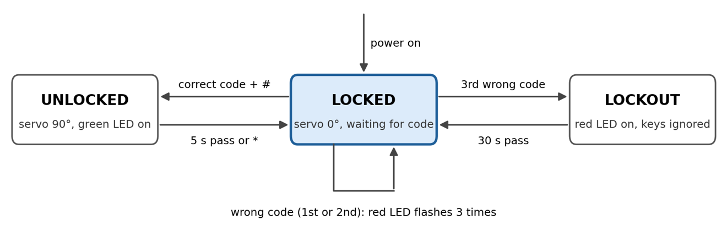
Normal use:
LOCKED + correct code and # → UNLOCKED (5 s or *) → LOCKED
Wrong codes:
LOCKED + 1st or 2nd wrong code → red flashes 3 times → LOCKED
LOCKED + 3rd wrong code → LOCKOUT (30 s) → LOCKED
Every path ends back at LOCKED, and the sketch always starts in LOCKED, even after a power cut.
Outputs for each state
State | Servo | Green LED | Red LED | Buzzer
LOCKED | 0° | - | - | Short beep per digit
UNLOCKED | 90° | ON | - | Two short beeps on entry
LOCKOUT | 0° | - | ON | One 1-second beep on entry

On a 1st or 2nd wrong code, the red LED flashes three times with three beeps, then the lock stays in LOCKED. I did not add this to the table because it is not a separate state.

4. Components
Components: ELEGOO UNO R3 board; one 4x4 membrane keypad; one SG90 micro servo; one green and one red LED; two 220 Ω resistors; one active buzzer; one breadboard; jumper wires; and a USB cable. Everything came from the ELEGOO starter kit.
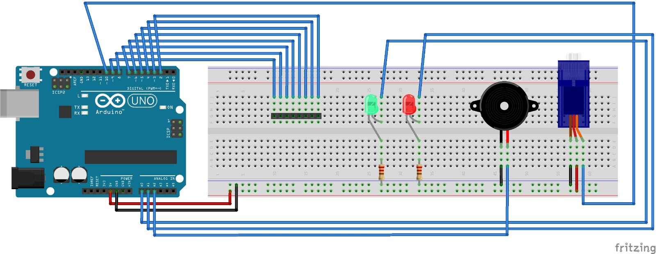

5. Circuit Design
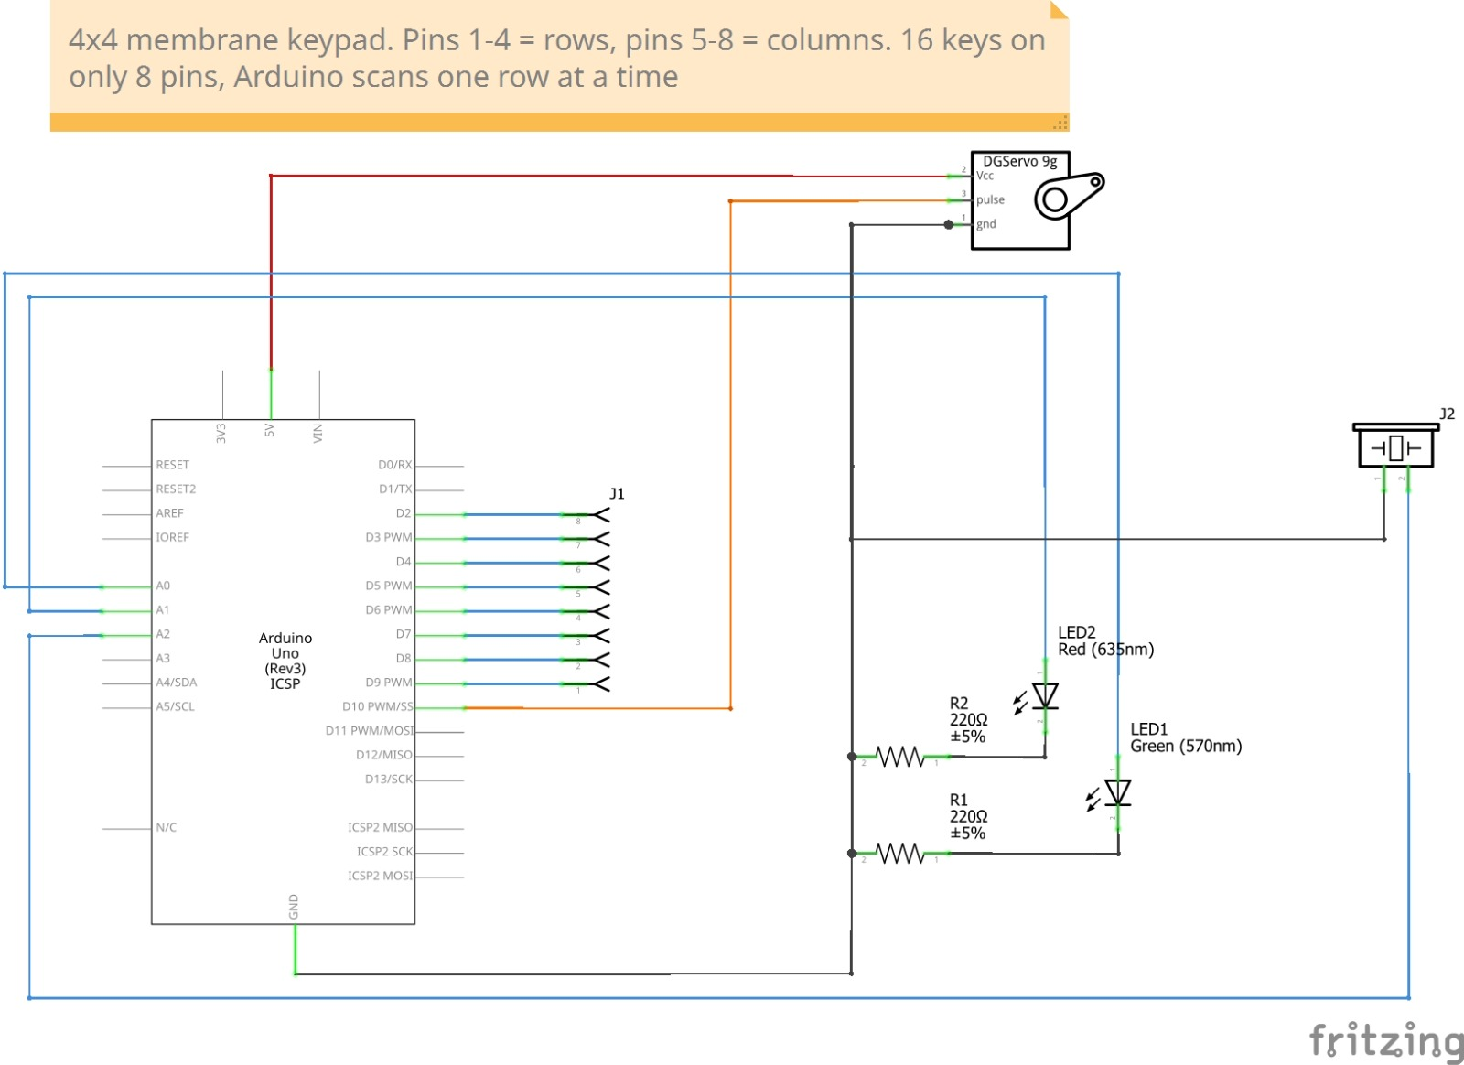

Component | Arduino pin | Notes
Keypad rows (pins 1–4) | D9, D8, D7, D6 | Pin 1 is the left end of the ribbon
Keypad columns (pins 5–8) | D5, D4, D3, D2 | Pin 1 is the left end of the ribbon
Servo signal (orange) | D10 | Red to 5V, brown to GND
Green LED | A0 | Through 220 Ω to GND
Red LED | A1 | Through 220 Ω to GND
Active buzzer + | A2 | − to GND

The keypad uses D2–D9, so I moved the LEDs and buzzer to A0–A2. The analog pins work as normal digital outputs with pinMode() and digitalWrite(). The keypad needs no resistors because the library turns on the Arduino's internal pull-ups.
Each LED has a 220 Ω series resistor. Assuming about 2 V across the LED, the current is about (5 V − 2 V) ÷ 220 Ω ≈ 13.6 mA, which is under the 20 mA per pin that Arduino recommends. The real value depends on each LED's forward voltage.
The servo is powered from the Arduino's 5V pin through USB. This works when the servo moves freely, but not when it is stalled. I found that out the hard way (see Section 7).

6. How the Code Works
The sketch has one loop() with a switch on the state. In LOCKED it reads keys and builds the code. In UNLOCKED and LOCKOUT it only checks timers with millis(), the same non-blocking pattern from Project 5, so the keypad is still read while it waits.
The short beeps and the wrong-code flashes use delay(). That is fine here because nothing else needs to run during those few hundred milliseconds, but it would not be acceptable in the aquarium controller, which has to keep watching the temperature.
Stage 1 used a short test sketch based on the Keypad library example. The complete final sketch is included below.
#include <Keypad.h>
#include <Servo.h>

const byte ROWS = 4;
const byte COLS = 4;
char keys[ROWS][COLS] = { // same layout as the labels printed on the keypad
{'1','2','3','A'},
{'4','5','6','B'},
{'7','8','9','C'},
{'*','0','#','D'}
};
byte rowPins[ROWS] = {9, 8, 7, 6}; // ribbon pins 1-4 are the rows
byte colPins[COLS] = {5, 4, 3, 2}; // ribbon pins 5-8 are the columns, all 16 keys checked in Stage 1
Keypad keypad = Keypad(makeKeymap(keys), rowPins, colPins, ROWS, COLS);

Servo lockServo; // same SG90 from the radar project, now it's the "bolt"

int greenLed = A0; // D2-D9 are taken by the keypad so the LEDs moved to analog pins
int redLed = A1;
int buzzer = A2; // active buzzer, the passive one only clicks with digitalWrite

String password = "1234"; // hardcoded for now, changing it from the keypad is a future upgrade
String entered = "";
int wrongTries = 0;

// 0 = locked, 1 = unlocked, 2 = lockout
int state = 0; // same state machine idea as the traffic light, but keys change it not a timer
unsigned long stateStart = 0; // millis instead of delay so the keypad still works while waiting

void beep(int ms) { // made this a function because I beep in like 5 places
digitalWrite(buzzer, HIGH);
delay(ms);
digitalWrite(buzzer, LOW);
}

void setup() {
Serial.begin(9600);
pinMode(greenLed, OUTPUT);
pinMode(redLed, OUTPUT);
pinMode(buzzer, OUTPUT);
lockServo.attach(10);
lockServo.write(0); // always start locked, even after a power cut
Serial.println("Locked. Enter code and press #");
}

void loop() {
char key = keypad.getKey(); // returns nothing if no key is pressed, so loop keeps running

switch (state) {

case 0: // locked
if (key) {
if (key >= '0' && key <= '9' && entered.length() < 4) { // only digits, and never more than 4
entered += key;
Serial.print("*"); // showing the real digits would defeat the point
beep(30); // so you know the press actually counted
}
else if (key == '*') { // * is the "oops" button
entered = "";
Serial.println(" cleared");
}
else if (key == '#') { // # means "check my code"
Serial.println();
if (entered == password) {
state = 1;
stateStart = millis(); // start the 5 second unlock timer
wrongTries = 0; // correct code wipes out earlier mistakes
lockServo.write(90);
digitalWrite(greenLed, HIGH);
beep(100);
delay(50);
beep(100); // two short beeps = good, easy to tell apart from the error sound
Serial.println("Unlocked");
}
else {
wrongTries++;
Serial.print("Wrong code ");
Serial.print(wrongTries);
Serial.println("/3");

if (wrongTries >= 3) { // otherwise someone could just try all 10,000 codes
state = 2;
stateStart = millis();
digitalWrite(redLed, HIGH); // red stays on the whole lockout so you know why nothing works
beep(1000);
Serial.println("Too many tries. Locked out for 30 seconds");
}
else {
for (int i = 0; i < 3; i++) { // delay is fine here, nothing else has to run
digitalWrite(redLed, HIGH);
beep(150);
digitalWrite(redLed, LOW);
delay(150);
}
}
}
entered = ""; // never let old digits carry into the next try
}
// A, B, C, D do nothing yet, saving them for the capstone menu
}
break;

case 1: // unlocked
if (key == '*' || millis() - stateStart >= 5000) { // auto relock, nobody remembers to do it
state = 0;
lockServo.write(0);
digitalWrite(greenLed, LOW);
Serial.println("Locked");
}
break;

case 2: // lockout, keys ignored on purpose
if (millis() - stateStart >= 30000) { // 30 s makes guessing all codes take over a day
state = 0;
wrongTries = 0;
digitalWrite(redLed, LOW);
Serial.println("Lockout over. Locked");
}
break;
}
}

7. Build Process and Testing
I built and tested the lock in two stages, like Project 6, so I only had one new thing to debug at a time.
Stage 1: Keypad only (D2–D9)
I wired only the keypad and uploaded a test sketch that prints each key to the Serial Monitor.
My first run printed 14 keys and missed 4 and 6. Both keys are in Row 2, and 5 from Row 2 had printed, and their columns had also printed other keys. So it was not wiring. I had just skipped them. I pressed them again and all 16 keys printed correctly.
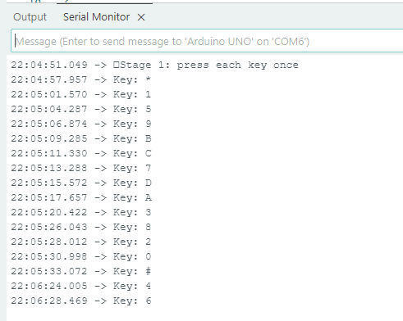
Stage 2: Full lock
I added the servo, both LEDs and the buzzer, then uploaded the full sketch. This is where things went wrong.
Problem 1: Upload stuck and board going dark
The upload stayed on "Uploading..." and never finished. When I connected the servo, the board's LEDs went off. I removed the servo and uploaded again, and it worked. That told me the rest of the circuit was fine and the servo was the problem.
Then I found the cause. In Project 4, I had mounted the HC-SR04 on the servo arm with a rubber band, and the band was still on. It jammed the arm. A stuck (stalled) SG90 can draw around 650–800 mA, but a computer USB port usually supplies about 500 mA, so the voltage dropped and the Arduino lost power. I removed the band, checked that the arm turned freely by hand, and reconnected the servo. It worked.
Problem 2: Wrong COM port
The IDE was set to COM4, but the Port menu listed my board as "COM6 (Arduino UNO)". COM4 was another device on my computer. Now I check the port before uploading.
Problem 3: Serial Monitor not connected
Selecting the right port did not reconnect the Serial Monitor. Closing and reopening the Arduino IDE fixed it, because that fully let go of the port.

8. Results
All four tests passed. I checked the timing using the Serial Monitor timestamps:
Test | What I did | Expected | Serial Monitor evidence | Result
1. Correct code | 1234 then # | Unlock, relock after 5 s | Unlocked 21:41:12.855, Locked 21:41:17.608 | Pass
2. Wrong code | 1111 then # | Red LED flashes 3 times | Wrong code 1/3 | Pass
3. Lockout | 3 wrong codes in a row | Keys ignored for 30 s | Wrong code 3/3 21:40:35.089, Lockout over 21:41:05.199 (30.1 s) | Pass
4. Clear | 12, *, then 1234 # | * wipes old digits | ** cleared, then ****, then Unlocked | Pass

At first the relock looked short: 4.75 s instead of 5 s. Then I realized the timer starts before the two unlock beeps (100 + 50 + 100 = 250 ms), but "Unlocked" prints after them. So 4.75 + 0.25 ≈ 5.0 s, as designed. The 1-second gap between "Wrong code 3/3" and "Too many tries" is the same kind of thing: the long beep runs before the message prints.
My first try at Test 4 did not prove anything. The log showed "cleared" with no ** before it, so there were no digits to clear. I redid it and got "** cleared" followed by an unlock.
These are approximate values from Serial Monitor timestamps, which are added by the computer, not the Arduino.

9. Conclusion
The code part of this project worked almost the first time. The hard part was hardware. A leftover rubber band from Project 4 stalled the servo, the board lost power, and uploads failed. Finding it by removing one part at a time taught me more than the lock itself.
The biggest lesson is about power. A motor under load cannot share USB power with the controller. My aquarium pumps, heater and lights will need their own supply switched through relays.

