PROJECT 3

PWM Motor Controller

Date August 16, 2026

GitHub: github.com/arlengj995-bit

A potentiometer controls how fast a DC motor spins. Turning the rotary dial from one end to the other smoothly changes the motor from completely stopped to full speed. A fan blade on the motor shaft makes the speed easy to see, at low speed I could count the individual blades, at full speed it looks like a solid disc. The most interesting part was discovering that the motor would not start below a certain speed setting. It just hummed. Figuring out why and fixing it was the most useful thing I learned.

1. What This Project Does
This project controls the speed of a DC motor using a potentiometer. The potentiometer is a rotary dial, turning it changes a voltage from 0V to 5V. The Arduino reads that voltage, converts it to a PWM signal, and sends it to the L293D motor driver chip, which then controls how much power reaches the motor.
The key thing I learned is that an Arduino output pin must not power a motor directly. Arduino specifies 20 mA per UNO I/O pin. Motor current varies with the motor and its load and can rise substantially during startup or stall. The L293D handles the motor current from the separate supply while the Arduino provides control signals.
Before this project I had only controlled LEDs and read sensors. This was the first time I made something physical move and controlled how fast it moved. Watching the fan speed change smoothly as I turned the dial made the PWM concept feel real in a way that reading about it did not.
This is the third of ten projects building toward an automated aquarium controller. The aquarium needs to control physical devices, a water pump, an air pump, grow lights, and a CO₂ solenoid valve.

2. How PWM Works
PWM controls power by switching a digital output rapidly between HIGH and LOW. The duty cycle is the fraction of each cycle spent HIGH. In this project the PWM signal controls the L293D Enable input, which switches the motor drive on and off.
On UNO pin 9, the default PWM frequency is approximately 490 Hz. The motor winding inductance and mechanical inertia smooth the response to these pulses. Motor speed depends on duty cycle, supply voltage, driver losses, and load; it is not a direct measurement of voltage or speed.
Idealized PWM voltage estimate = duty-cycle fraction × nominal 5 V supply
Idealized PWM voltage estimate = (duty cycle / 100) × 5 V

3. The L293D H-Bridge Why I Cannot Connect the Motor Directly
Arduino specifies 20 mA per UNO I/O pin. A motor requires a driver and a suitable power supply; its running, startup, and stall currents must be checked against the driver and supply ratings. I did not measure motor current in this project.
The L293D contains four half-bridge drivers, which can be paired into two H-bridges. An H-bridge can reverse the voltage applied across a motor. The Arduino supplies control signals; the driver switches motor current supplied by the separate power source.
How the four switches work:
SW1 + SW4 closed → current flows left to right → motor spins forward
SW2 + SW3 closed → current flows right to left → motor spins backward
All open → no current → motor coasts to stop
SW1+SW2 or SW3+SW4 → short circuit → never do this
In the saved working sketch, IN1 (D8) is LOW and IN2 (D7) is HIGH, fixing one rotation direction. The observed direction depends on which way the motor leads are connected. PWM on the Enable input controls the drive duty cycle.
The L293D includes output clamp diodes for inductive loads. When motor current is interrupted, winding inductance produces a voltage transient; the clamp diodes provide paths for that current. This switching transient is distinct from the back-EMF generated by a rotating motor. Common grounding and suitable supply decoupling remain important.

4. Converting the Potentiometer Reading to Motor Speed
The potentiometer produces a voltage between 0V and 5V. The Arduino ADC (Analog to Digital Converter) converts this to a number between 0 and 1023. But analogWrite() needs a number between 0 and 255. The map() function handles this conversion: The displayed voltage estimate is calculated from the PWM command, not measured across the motor; the L293D introduces voltage drops.
// map() rescales one range to another
// Formula: pwmValue = potValue x 255 / 1023
int pwmValue = map(potValue, 0, 1023, 0, 255);
This is a linear rescaling. Every value in the 0–1023 range maps to exactly one value in the 0–255 range. At the midpoint:
potValue = 511 → pwmValue = 511 × 255 / 1023 = 127
Idealized PWM voltage estimate = (duty cycle / 100) × 5 V
This is the same linear scaling idea as the ADC-to-voltage conversion in Project 2. There I converted a raw ADC reading to volts. Here I convert a raw ADC reading to a PWM value. The maths is identical, just different ranges.

5. Something I Discovered, The Dead Zone
When I first ran the code and turned the potentiometer to a low position, I heard the motor making a humming sound but the shaft was not spinning. I turned the potentiometer higher and at some point the motor suddenly started rotating.
I had not read about this anywhere. I had to figure out what was happening.
The problem is static friction. A motor at rest has friction in its bearings and brushes, the small carbon contacts that conduct electricity to the rotating coils. Below a certain voltage, the motor generates some force but not enough to overcome that initial friction. Current flows through the coils, which is why it hums, but the shaft does not move.
I tested different PWM values one at a time to find the threshold:
Below pwmValue 40: motor hums but shaft does not rotate
At pwmValue 40: motor starts rotating reliably
Duty cycle at threshold: (40/255) × 100 = 15.7%
Idealized PWM voltage estimate at threshold: (40/255) × 5.0 = 0.78 V. The L293D output voltage drops and motor current recirculation are not included in this estimate.
The fix was a guard in the code:
if (pwmValue < 40) {
pwmValue = 0; // Stop completely instead of stalling
}
// This means the motor either stops cleanly or runs.
// No in-between where it hums and draws current without doing anything.
Commands below 40 are set to zero so that the driver is disabled instead of applying a low duty cycle that produced humming in my tests. A motor can still stall above this threshold if its load increases. Stall current can heat the motor and driver.
The threshold of 40 was observed with this particular motor, supply, and load. Startup and running thresholds can differ and change with operating conditions. The guard reduces low-duty humming in the tested setup; it cannot guarantee that the motor will never stall.

6. Why the Motor Slows Down When I Push Against It
I ran a simple test. While the motor was spinning at a fixed potentiometer position, I pressed my finger lightly against the fan blade. The motor slowed down noticeably. When I lifted my finger, it sped back up. I did not change the potentiometer at all.
This happens because of something called back-EMF (back Electromotive Force).
When a motor spins, the coils inside rotate through a magnetic field. A conductor moving through a magnetic field generates its own voltage, this is how generators work. In a motor, this generated voltage pushes back against the supply voltage and reduces the current flowing in.
What happens when I push the blade:
- Motor slows down, back-EMF drops because the coils are spinning slower
- Less back-EMF means less opposition to current, more current flows in
- More current creates more force, motor tries to speed back up
- But the PWM average voltage is fixed, it cannot fully compensate and hence the motor runs slower under load
Closed-loop speed control would measure motor speed, compare it with a target, and adjust PWM to compensate for changes in load. A PI or PID controller is one possible approach. This project is open-loop: it reads the potentiometer but does not measure or regulate actual motor speed.

7. Components
Components: one UNO R3-compatible board, one L293D motor driver, one small DC motor with fan blade, one 10 kΩ potentiometer, one MB-V2 breadboard power supply with both rails set to 5 V, one breadboard, jumper wires, a USB cable, and an external supply suitable for the module. Motor current and voltage ratings must be matched to the driver and power supply.
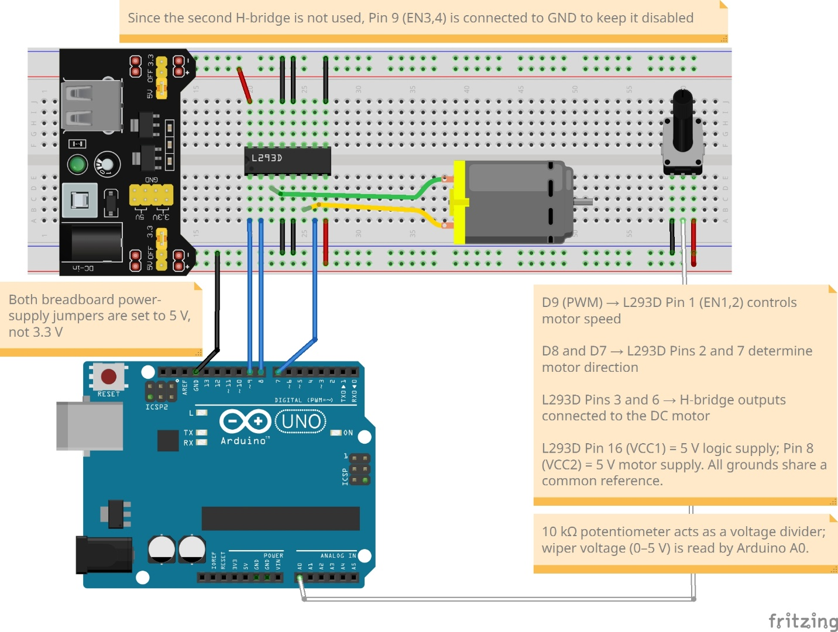

8. Circuit Design
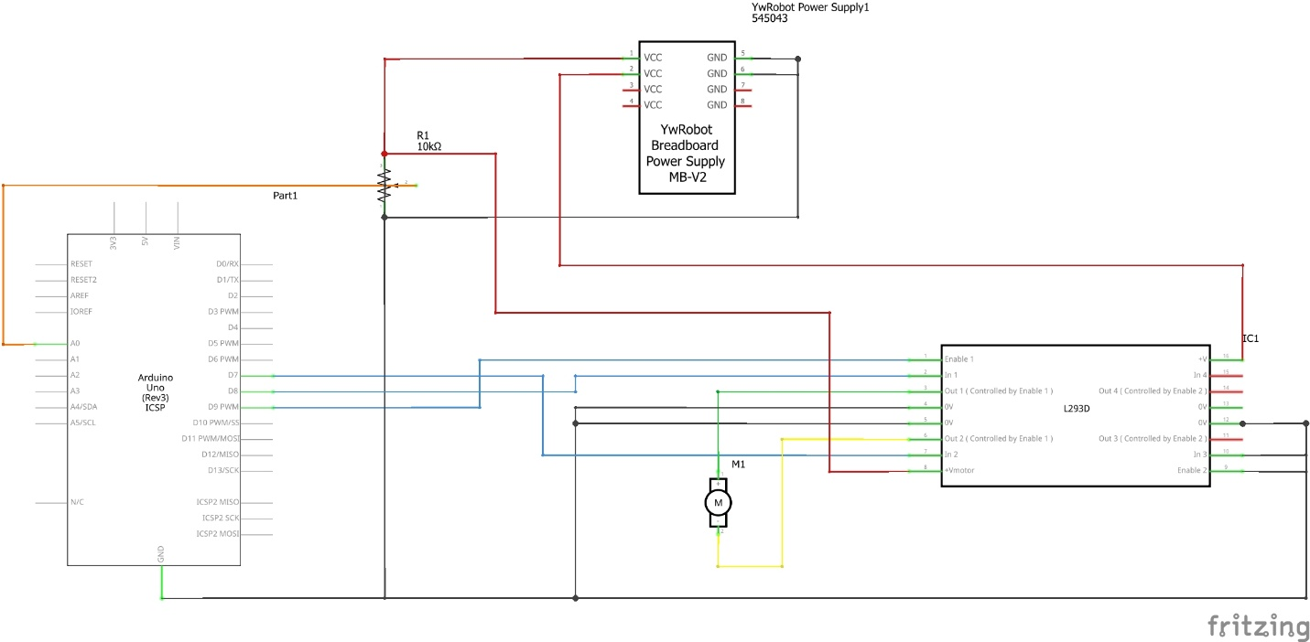

9. The Code
This listing follows the saved working sketch direction and two-second update delay. Serial output has been consolidated and the calculated voltage relabeled as an idealized estimate. During delay(2000), the potentiometer is not read, so changes can take about two seconds to affect the PWM output.
const int potPin = A0;
const int enablePin = 9; // L293D pin 1
const int input1Pin = 8; // L293D pin 2
const int input2Pin = 7; // L293D pin 7

void setup() {
pinMode(enablePin, OUTPUT);
pinMode(input1Pin, OUTPUT);
pinMode(input2Pin, OUTPUT);
digitalWrite(input1Pin, LOW);
digitalWrite(input2Pin, HIGH);
Serial.begin(9600);
}

void loop() {
int potValue = analogRead(potPin);
int pwmValue = map(potValue, 0, 1023, 0, 255);
// Observed low-duty threshold for this setup.
if (pwmValue < 40) pwmValue = 0;
float dutyCycle = (pwmValue / 255.0) * 100.0;
// Calculated reference only; excludes driver losses.
float idealVoltage = (pwmValue / 255.0) * 5.0;
analogWrite(enablePin, pwmValue);
Serial.print("ADC: "); Serial.print(potValue);
Serial.print(" PWM: "); Serial.print(pwmValue);
Serial.print(" Duty: "); Serial.print(dutyCycle, 1);
Serial.print("% Ideal PWM estimate: ");
Serial.print(idealVoltage, 2); Serial.println(" V");
// Blocks potentiometer updates for about two seconds.
delay(2000);
}

10. Problems I Ran Into
Problem 1: Power supply jumper at 3.3V
What happened: motor did not run at any potentiometer position.
Cause: both supply jumpers were set to 3.3 V. The L293D logic supply requires at least 4.5 V, so 3.3 V is outside its specified operating range. Driver voltage drops also reduce the voltage available to the motor.
Fix: moved jumper to the 5V position. Motor started immediately.
Lesson: always check the power supply voltage before assuming the circuit or code is wrong. This was the simplest possible fault, a single jumper in the wrong position.

Problem 2: Motor humming but not spinning
What happened: at low potentiometer positions the motor made a humming sound but the shaft did not rotate.
Cause: the average voltage was below the minimum needed to overcome the motor's static friction. Current was flowing through the coils (hence the hum) but not enough force was generated to start the shaft moving.
Fix: added a dead zone guard that sets PWM commands below 40 to zero. This removed low-duty humming in the tested setup; it does not provide stall detection or protection.
Lesson: the observed threshold depends on the motor, supply, and load. I tried PWM values from 20 upward until startup was reliable under the conditions tested.

11. Results
After fixing both problems I tested the full potentiometer range. The fan blade confirmed the speed range visually:
- PWM 0: blade completely still
- PWM 84: individual blades clearly visible, rotating slowly
- PWM 155: blades starting to blur at the edges
- PWM 255: blade looks like a solid disc, individual blades impossible to see

12. Conclusion
This was the first project where I controlled something physical. Every project before this either lit LEDs or read sensor values. Watching the fan speed change as I turned the potentiometer, and then slow back down when I pushed against the blade, made the electronics feel connected to the physical world in a new way.
The dead zone was the most useful discovery. I had not read about it in any tutorial. I noticed the motor humming without spinning and had to figure out why from scratch. Understanding static friction, then testing to find the minimum threshold, then writing the guard in code, that process taught me more than any section I could have read.
The back-EMF observation was also something I found by accident. Pressing my finger against the fan blade was not part of any planned test. I was just curious what would happen. Seeing the motor slow down at a fixed potentiometer position made me ask why, and the answer connected to how generators work. That kind of sideways connection, from a motor slowing down to how a generator produces electricity, is the type of thing that makes the subject interesting to me.
The aquarium I lost in Grade 8 had equipment running at fixed power levels without any feedback. The filter ran at one speed. The light was either on or off. There was no way to adjust based on what the sensors measured. This project is the first time I built something where one measurement (the potentiometer position) directly controlled one output (the motor speed).

