PROJECT 6

Water Temperature Logger

Date October 12, 2026
GitHub: github.com/arlengj995-bit

This is the first project in my portfolio that runs completely on its own. There is no computer and no Python script. Every 10 seconds the Arduino reads the water temperature, gets the date and time from a real-time clock, and saves both to a file called log.csv on an SD card. After a session I take the card out, open the file in Excel, and graph it.

1. What This Project Does
A waterproof DS18B20 probe measures temperature. A DS3231 real-time clock (RTC) gives the exact date and time. An SD card module saves every reading as one line in log.csv. Once the Arduino has power, it keeps logging by itself.
I built it in three stages. Stage 1 tested the temperature probe alone. Stage 2 added the clock and printed time and temperature together on Serial Monitor. Stage 3 added the SD card. Because I added one part at a time, I always knew which part caused a problem.
This is the sixth of ten projects building toward an automated aquarium controller capstone project. When my planted aquarium failed, I had no record of what the water was doing. I only noticed when the plants were already dying. This project is the first piece of the fix: a sensor that reads the water, a clock that stamps the time, and a log I can look back at. The same probe, the same clock, and the same SD logging will go into the capstone.

2. Three New Concepts in This Project
This project uses three different ways for chips to talk to the Arduino. Each part uses a different one, so I had to learn all three.

2.1 OneWire, why the probe needs only one data wire
The DS18B20 sends and receives on the same single wire. The Arduino and the sensor take turns, so they never talk at the same time.
When nobody is talking, the wire has to sit at HIGH (5V). The 4.7 kΩ pull-up resistor between pin 7 and 5V does this. To send data, the sensor or the Arduino pulls the wire LOW for a short or a long time, and the length of each LOW pulse means a 1 or a 0. Without the pull-up resistor, the data line can float, making communication with the sensor unreliable.
I found this out the hard way. In Stage 1 the sensor count showed 0, and the cause was the pull-up resistor sitting in the wrong breadboard row (see Section 7).

2.2 I²C, two wires that many devices can share
The DS3231 clock uses I²C (Inter-Integrated Circuit), a simple wiring and communication method that lets different integrated circuits talk to each other on the same circuit board using only two wires. It has two wires: SDA (data) and SCL (clock). Many devices can share these same two wires, because each device has its own address. The Arduino calls an address, and only that device answers. The DS3231 address is 0x68. The Wire.h library handles the timing for me.
This will be useful in my capstone. The clock and an LCD screen can share pins A4 and A5 without any extra wiring. The DS3231 board already has pull-up resistors for SDA and SCL. I did not have to add them, but after learning OneWire I understand why they are there.

2.3 SPI, four wires for fast data
The SD card module uses SPI, Serial Peripheral Interface. It is a communication method that allows Arduino to exchange data with electronic components such as SD card modules, sensors, and displays. It has four wires: MOSI (data out), MISO (data in), SCK (clock), and CS (chip select). Several SPI devices can share MOSI, MISO and SCK. Each device gets its own CS pin, and that is how the Arduino picks which one to talk to. My SD card uses CS on D10.
The SD card runs at 3.3V and the Arduino runs at 5V. My SD module has level shifting built in, so I could connect it directly. Level shifting means changing a signal from one voltage to another, so two chips that run at different voltages can safely talk to each other. Arduino UNO runs at 5V. When it sends a 1 (HIGH) on D11, D13 or D10, that pin goes to 5V. An SD card runs at 3.3V. Its pins are only rated to about 3.6V. Sending 5V straight into it can damage the card over time, or right away.

3. How the Three Parts Connect
Before wiring, I made this table so I could see which protocol each part uses and which Arduino pins it needs. None of the pins overlap, so all three parts can run at the same time.

Part | Protocol | Wires | Arduino pins | Job
DS18B20 probe | OneWire | 1 data | D7 (+4.7 kΩ to 5V) | Reads temperature
DS3231 clock | I²C | 2 (SDA, SCL) | A4, A5 | Gives date and time
SD card module | SPI | 4 (CS, MOSI, MISO, SCK) | D10, D11, D12, D13 | Saves log.csv

Data flow every 10 seconds:
DS3231 time + DS18B20 temperature → Arduino builds one line of text → line saved to log.csv on the SD card

4. Components
Components: one Arduino UNO R3; one DS18B20 waterproof temperature probe; one 4.7 kΩ resistor; one DS3231 RTC module with a CR2032 battery; one SD card module; one 8 GB micro SD card formatted as FAT32; one breadboard; jumper wires; and a USB cable.
The CR2032 battery keeps the clock running when the Arduino is unplugged. Without it, the time would reset every time I unplugged the board.
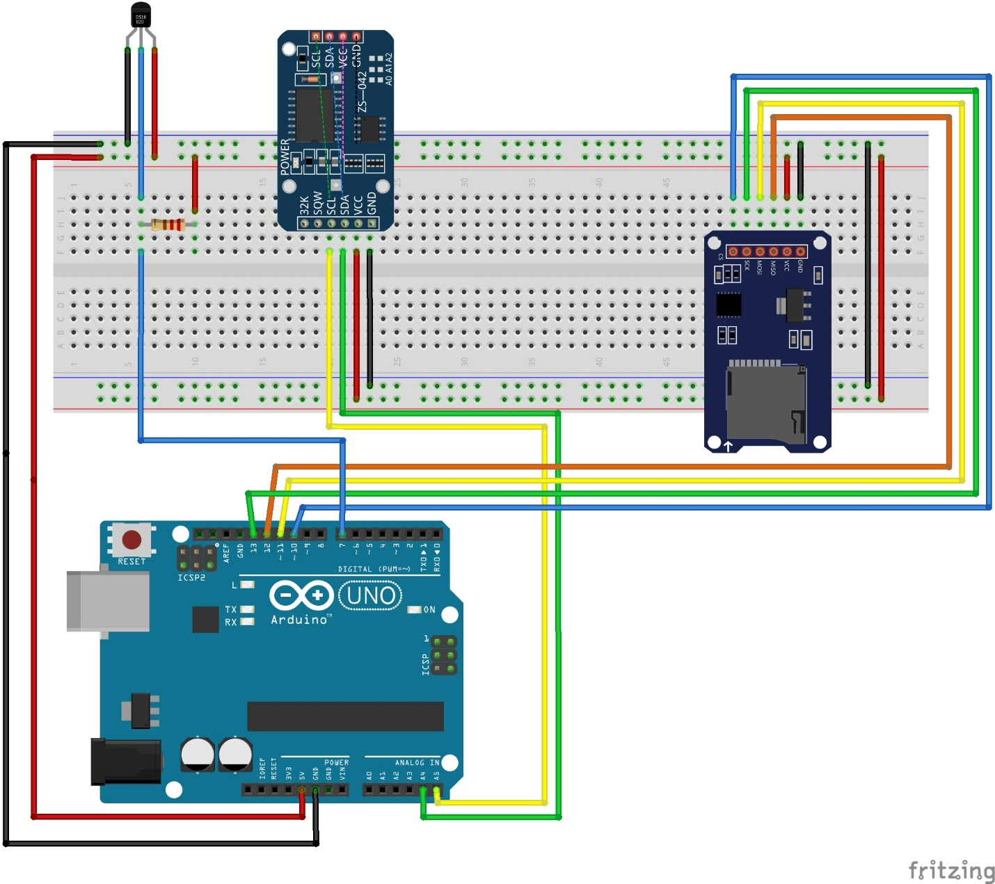
Fritzing shows the small TO-92 version of the DS18B20. My waterproof probe has the same three wires: red to 5V, black to GND and yellow (data) to D7.

5. Circuit Design
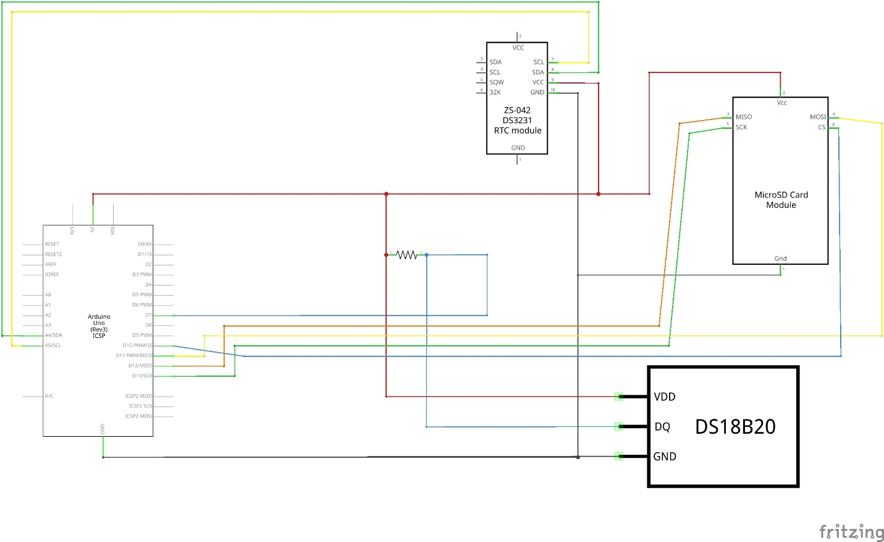

DS18B20 probe (Stage 1)
Wire | Connected to | Notes
Red | 5V | Power
Black | GND | Ground
Yellow | Pin D7 | OneWire data line
4.7 kΩ resistor | Between D7 and 5V | Pull-up, sensor count shows 0 without it

DS3231 RTC module (Stage 2)
Pin | Connected to | Notes
VCC | 5V | Power
GND | GND | Ground
SDA | A4 | I²C data
SCL | A5 | I²C clock

SD card module (Stage 3)
Pin | Connected to | Notes
CS | D10 | Chip select, picks this SPI device
MOSI | D11 | Data from Arduino to SD card
MISO | D12 | Data from SD card to Arduino
SCK | D13 | SPI clock
VCC | 5V | Module steps down to 3.3V for the card
GND | GND | Ground
MOSI and MISO sit right next to each other on D11 and D12. They are easy to swap, and I did swap them once (Problem 2 in Section 7).

6. How the Code Works
I kept a separate sketch for each stage so I could test one part at a time. Stage 1 checks that the probe is found and reads a sensible temperature. Stage 3 is the final version. In setup() it checks each part and stops with a clear message if one is missing. In loop() it reads the clock and the probe, builds one line of text, opens log.csv, adds the line, and closes the file.
Stage 1, DS18B20 alone:
#include <OneWire.h>
#include <DallasTemperature.h>
#define SENSOR_PIN 7
OneWire oneWire(SENSOR_PIN);
DallasTemperature sensors(&oneWire);
void setup() {
Serial.begin(9600);
sensors.begin();
// 0 here means pull-up resistor is in wrong row
Serial.print("Sensors found: ");
Serial.println(sensors.getDeviceCount());
}
void loop() {
sensors.requestTemperatures();
float tempC = sensors.getTempCByIndex(0);
// -127 means sensor disconnected
if (tempC == DEVICE_DISCONNECTED_C) {
Serial.println("Error: check wiring");
delay(2000);
return;
}
Serial.print("Temperature: ");
Serial.print(tempC, 2);
Serial.println(" C");
delay(2000);
}

Stage 3, full logging code (final, same as Water_Temperature_Logger.ino on GitHub)
// Testing the DS18B20 sensor alone before I add the RTC and SD card in later stages
//OneWire is a communication protocol invented by Dallas Semiconductor in the 1990s. The name tells what it does; it lets a sensor communicate with the Arduino using only one wire for data.
//Arduino pulls the line LOW for a specific time → sensor reads this as a command
//Sensor pulls the line LOW for a specific time → Arduino reads this as a bit
//Short LOW = bit 1
//Long LOW = bit 0
//Very long LOW = reset signal (start of conversation)
//The pull-up resistor is what makes this possible. Between turns, the line must return to HIGH on its own. The 4.7kΩ resistor does that.

//Dallas Semiconductor made the DS18B20 sensor. They also designed a specific way to ask it for a temperature reading using the OneWire protocol.
//Sending the "start measuring" command
//Waiting up to 750ms for the sensor to finish
//Reading the raw 12-bit number back
//Converting that number to degrees Celsius

// Wire is a communication protocol. It lets multiple devices share just two wires and still talk to the Arduino independently.
//SDA → Serial Data (the actual data)
//SCL → Serial Clock (keeps both sides in sync)
//Every device on those two wires has a unique address, like a house number. The Arduino calls out an address and only that device responds. Everything else ignores it.

#include <OneWire.h>
#include <DallasTemperature.h>
#include <Wire.h>
#include <RTClib.h>
#include <SPI.h> // required for SD card
#include <SD.h>

#define SENSOR_PIN 7
#define CS_PIN 10 // chip select for SD card

OneWire oneWire(SENSOR_PIN);
DallasTemperature sensors(&oneWire);
RTC_DS3231 rtc;

void setup() {
Serial.begin(9600);

// test DS18B20
sensors.begin();
// 0 here means pull-up resistor is in wrong row
Serial.print("Sensors found: ");
Serial.println(sensors.getDeviceCount());

// test DS3231
if (!rtc.begin()) {
Serial.println("RTC not found. Check SDA=A4, SCL=A5");
while (1); // stop here if RTC missing
}
Serial.println("RTC ready");

rtc.adjust(DateTime(F(__DATE__), F(__TIME__)));

if (!SD.begin(CS_PIN)) {
Serial.println("SD card not found - check wiring");
while (1);
}
Serial.println("SD card ready");

// FILE_WRITE appends to existing file, creates it if not there yet
File dataFile = SD.open("log.csv", FILE_WRITE);
if (dataFile) {
dataFile.println("date,time,temperature_C");
dataFile.close(); // learned this the hard way. Data does not save until closed
}
}

void loop() {
DateTime now = rtc.now();

// get temperature from DS18B20
sensors.requestTemperatures();
float tempC = sensors.getTempCByIndex(0);

// -127 means sensor disconnected
if (tempC == DEVICE_DISCONNECTED_C) {
Serial.println("Error: check DS18B20 wiring");
delay(10000);
return;
}

// format: 2026/10/12,21:05:10,26.87
String line = "";
line += now.year(); line += "/";
line += now.month(); line += "/";
line += now.day(); line += ",";
line += now.hour(); line += ":";
line += now.minute(); line += ":";
line += now.second(); line += ",";
line += tempC;

File dataFile = SD.open("log.csv", FILE_WRITE);
if (dataFile) {
dataFile.println(line);
dataFile.close(); // if power cuts here before close, this line is lost
Serial.println("Saved: " + line);
} else {
Serial.println("Error: could not open log.csv");
}

delay(10000); // one reading every 10 seconds
}
I open and close the file for every reading on purpose. It is slower, but if the power cuts out, I lose at most one line instead of the whole session.

7. Build Process and Testing
I built and tested the circuit in three stages. Each stage had to work before I added the next part.
Stage 1: DS18B20 probe only (pin D7)
Uploaded the Stage 1 sketch. At first Serial Monitor said "Sensors found: 0". After I fixed the pull-up resistor (Problem 1), it said 1 and printed about 26.12 °C every 2 seconds.
Stage 2: DS3231 clock added (A4, A5)
Printed the time and temperature together. The first date I saw was 2000/1/1, because the clock had never been set (Problem 3). After setting it once, the battery kept the correct time even when the Arduino was unplugged.
Stage 3: SD card added (D10 to D13)
The first upload said "SD not found" (Problem 2). After rewiring, the card was found and lines started saving to log.csv. I let it run, then opened the file in Excel.
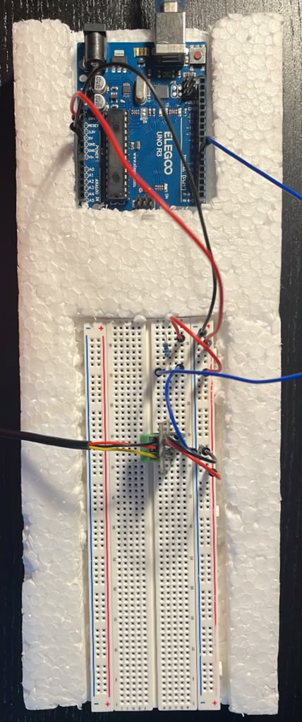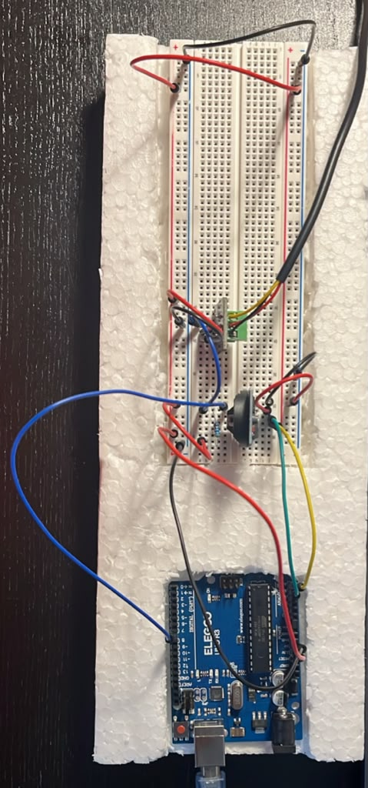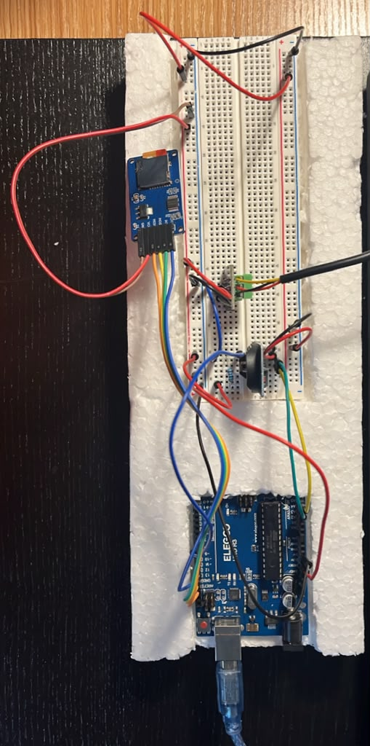

Problems I ran into
Problem 1, sensor count showed 0. The bottom leg of the 4.7 kΩ resistor was not in the same breadboard row as the yellow data wire, so the data line was floating. I moved the leg into the right row and the count changed to 1 right away. Now, if the count is 0, the pull-up is the first thing I check.
Problem 2, SD card not found. One of the six SD wires was on the wrong pin. MOSI and MISO are next to each other and easy to swap. I pulled every SD wire out and put them back one at a time, checking each pin label. The next upload printed "SD card ready".
Problem 3, date showed 2000/1/1. I had removed the rtc.adjust() line before the clock was ever set, so it started from its default date. I put rtc.adjust(DateTime(F(__DATE__), F(__TIME__))) back and uploaded to set the clock. Then I forgot to take it out again, which caused a second problem that I only found in the data (see Section 8). I left the line in the sketch on GitHub, because that is the exact code I logged this data with.
Problem 4, many header rows in the CSV. FILE_WRITE adds to the end of the file. Every time the Arduino reset during testing, it wrote another "date,time,temperature_C" header. I deleted the extra headers and the 2000/1/1 rows in Excel before graphing.

8. Results
Stage 1 Serial Monitor output:
20:58:21.173 -> Sensors found: 1
20:58:21.204 -> Temperature: 26.12 C
20:58:23.269 -> Temperature: 26.12 C
20:58:25.281 -> Temperature: 26.12 C

Stage 3 Serial Monitor output (final):
21:38:21.811 -> Sensors found: 1
21:38:23.515 -> RTC ready
21:38:23.515 -> SD card ready
21:38:23.548 -> Saved: 2026/10/12,21:37:57,25.25
21:38:33.638 -> Saved: 2026/10/12,21:38:7,25.19
21:38:43.710 -> Saved: 2026/10/12,21:38:17,25.19

Sample rows from log.csv (opened in Excel):
Date | Time | Temperature (°C)
10/12/2026 | 21:35:08 | 25.69
10/12/2026 | 21:35:18 | 25.69
10/12/2026 | 21:36:08 | 25.50
10/12/2026 | 21:37:09 | 25.25
10/12/2026 | 21:37:19 | 25.19
10/12/2026 | 21:38:27 | 25.25
10/12/2026 | 21:39:37 | 25.44
10/12/2026 | 21:40:38 | 25.63
10/12/2026 | 21:41:08 | 25.69

After cleaning, log.csv had 38 good rows. Here is what I noticed:
Temperature changed. It dropped from 25.69 °C to 25.19 °C in the first few minutes, then rose back to 25.69 °C. The drop makes sense, because I had been holding the probe while wiring and it was cooling down to room temperature. I do not know for sure why it rose again. It could be my room heating up, but I did not measure that.
The clock was 26 seconds behind my laptop. Serial Monitor (laptop time) said 21:38:23 when the RTC said 21:37:57. I think this is because rtc.adjust() uses the time the code was compiled, not the time the upload finished.
Each reading took a little more than 10 seconds. On Serial Monitor the gap between saves was about 10.1 seconds, because reading the probe and writing the card take time on top of delay(10000). Over a full day that adds up.
Times are not zero-padded. The Arduino writes 21:38:7 instead of 21:38:07 (see the Serial Monitor output). The LOG.csv file on GitHub shows 21:38:07 and 10/12/2026 only because I opened and re-saved it in Excel, which changed the format. I will zero-pad the time in the next version.
The clock jumped backward three times. In the middle of the log the time stamp goes back to 21:37:57 three times. Because rtc.adjust() was still in the sketch, every time the board reset, the clock was set back to the time the code was compiled. I did not see this while testing. I only found it when I looked closely at the CSV. That showed me why it is worth checking the data, not just whether the program runs.

9. Conclusion
This was the most satisfying project so far. Every earlier project showed numbers on a screen. This one saved data to a real file on a card that I could pull out, plug into my laptop, and open in Excel. That felt different.
Building in three stages worked better than I expected. When the SD card failed in Stage 3, I already knew the probe and the clock worked, because I had tested them first. I only had to check six SD wires instead of debugging everything at once.
Learning why each protocol exists was more useful than just copying the wiring. OneWire uses one wire because it was made for simple sensors in tight spaces. I²C uses two shared wires so many chips on one board can talk. SPI uses four wires because it is faster, which suits things like memory cards. Now I can choose the right one for a new sensor instead of just copying a diagram.
Temperature was one of the things that went wrong with my aquarium, and I never saw it happen. I am planning to connect this with my automated aquarium controller capstone project. The DS18B20 in this project is the same probe that I am planning to use in the tank. The DS3231 will turn the grow light and CO₂ on and off at set times. However, the DS3231 does not change for daylight saving time by itself, so I will need to handle that in code. The SD card will keep a record of temperature, pH, and every relay switch, so I can look back after a week and see exactly when something started to drift, not just when it was already too late.

