PROJECT 4

Ultrasonic Radar Sweep

Date August 27, 2026

GitHub: github.com/arlengj995-bit

A servo motor sweeps from 15° to 165° and back. At each angle, an ultrasonic sensor measures how far away the nearest object is. A Python script on my computer plots all the readings as a radar chart that updates in real time. The most interesting part was not the sensor or the servo, it was discovering where the distance formula comes from.

1. What This Project Does
This project builds an ultrasonic scanner with a radar-style display. It uses sound rather than radio waves. A servo sweeps an HC-SR04 sensor from 15° to 165° and back in 2° steps. The Arduino sends commanded angle and distance readings to a Python script, which plots them on a polar chart. The commanded angle is not independently measured.
The chart updates as readings arrive. Radial position represents distance in centimeters, up to the 200 cm display limit. Sudden changes may indicate an object boundary, a different reflector, or an unreliable echo. They do not identify an exact edge without further checks.
Before this project I had separately learned how servos and the HC-SR04 worked. Here I combined an actuator that changes the sensor direction with a sensor that measures distance. This produces a simple spatial scan rather than combining two distance sensors.
This is the fourth of ten projects building toward an automated aquarium controller. It combines movement, distance sensing, serial communication, and plotting. A future improvement is to compensate ultrasonic measurements using air temperature along the sound path. Aquarium water temperature should not be assumed to equal the air temperature above it.

2. How the HC-SR04 Works
The HC-SR04 is the sensor with two silver cylinders on the front that look like robot eyes. One cylinder sends a sound pulse. The other listens for the echo. The pulse is at 40kHz, too high-pitched for humans to hear, which is why it is called ultrasonic.
Here is what happens step by step when I call measureDistance():
- Pull the TRIG pin LOW for 2 microseconds. This clears any leftover signal so the sensor starts clean.
- Pull TRIG HIGH for 10 microseconds. This tells the sensor to fire.
- The sensor sends eight pulses at 40kHz and pulls the ECHO pin HIGH at the same time.
- When the echo returns, the sensor pulls ECHO LOW.
- pulseIn() measures how long ECHO was HIGH, in microseconds. That is the round-trip travel time.
I set the pulseIn() timeout to 30,000 microseconds to limit waiting when no valid echo arrives. This corresponds to approximately 515 cm at the assumed sound speed, beyond the nominal 400 cm sensor range. Without an explicit timeout, pulseIn() defaults to one second rather than waiting indefinitely.
The HC-SR04 nominal range is approximately 2 to 400 cm. Close targets are affected by the transmitted burst, transducer ringing, and receiver limitations. The saved sketch encodes timeouts and calculated readings outside this range as 400 cm. This is a sentinel for an invalid or out-of-range reading, not proof of a target at 400 cm.

3. Where the Distance Formula Comes From
Almost every HC-SR04 tutorial says: distance = echoDuration / 58.31. Almost none of them explain where 58.31 comes from. I worked it out before writing any code.
Step 1: Speed of sound at 20°C
The approximate relationship v = 331.3 + 0.606T, with T in °C, gives 343.42 m/s at 20°C. Converting m/s to cm/µs gives 0.034342 cm/µs, the constant used in the sketch. This is an approximation, not a calibrated value for the room.
Step 2: The pulse travels twice the distance
The echo duration is the time for the sound to go OUT to the object and come BACK. The actual distance is only half of that round trip:
distance = (echoDuration × speedOfSound) / 2
distance = (echoDuration × 0.034342) / 2
Step 3: Where does 58.31 come from?
If you flip the formula: 1 / (0.034342 / 2) = 2 / 0.034342 = 58.27. That is all it is. The 58.31 constant in tutorials is just the speed of sound divided into the round-trip factor. I chose to write the formula in full in my code so anyone reading it can see the physics rather than a mystery number:
float speedOfSound = 0.034342; // cm/microsecond at 20 degrees C
float distance = (echoDuration * speedOfSound) / 2.0;
For an object at 18 cm, the fixed-constant formula predicts an echo duration of approximately 1048.28 µs. The reported measurement of 1053 µs calculates to 18.081 cm, an error of +0.081 cm. This small difference alone does not identify a cause.

4. Why Temperature Affects the Reading
Sound travels faster in warmer air because warmer air has faster-moving molecules. The relationship is:
Speed of sound in m/s, v = 20.05 × √T_Kelvin.
At 0°C → T_Kelvin = 273.15
v = 20.05 × √273.15 = 20.05 × 16.528 = 331.4 m/s
At 0°C (freezing point), the speed of sound in dry air is 331.3 m/s.
v = 331.3 + (0.606 × T) {T = air temperature in °C; 0.606 = how many m/s faster sound travels for each 1°C increase}
The physics behind this connects to things I had seen in school: molecules in warmer gas move faster, which passes sound vibrations along more quickly.
Temperature compensation is a proposed extension, not implemented in the current sketch. With an air-temperature reading from a suitable sensor, the fixed constant could be replaced by the following approximate expression:
Proposed air-temperature compensation:
float speedOfSound = 0.03313 + (0.0000606 * temperature);
This would replace the fixed 0.034342 cm/µs constant after adding an air-temperature sensor and reading its value.
At 24°C: 0.03313 + (0.0000606 × 24) = 0.0345844 cm/µs.

5. Components
Components: one UNO R3-compatible board, one HC-SR04 ultrasonic sensor, one SG90 servo, one breadboard, jumper wires including flexible female-to-male leads for the sensor, a USB cable, and mounting tape or a suitable bracket.
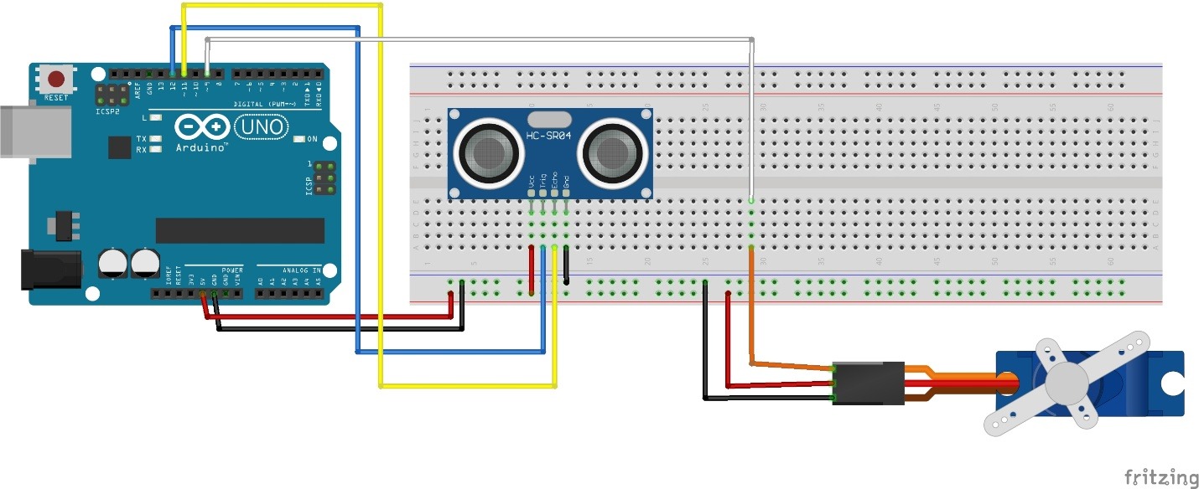

6. Circuit and Wiring
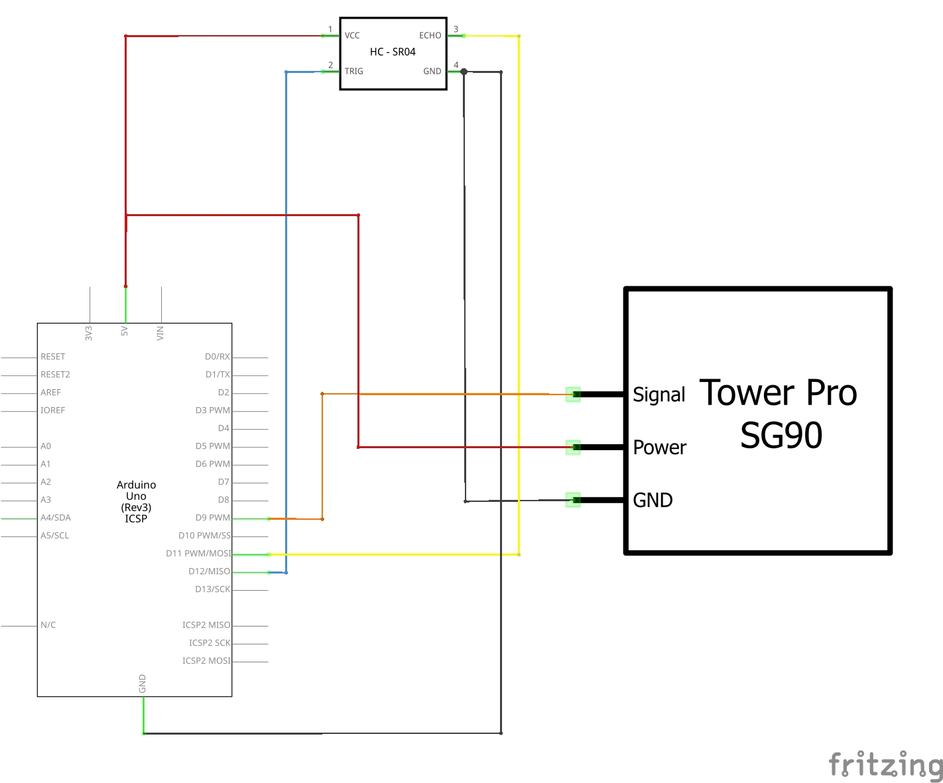

6.1 Mounting the sensor on the servo horn
This was the trickiest part of the build. The sensor starts by sitting in the breadboard. For the radar to work, it needs to physically rotate with the servo, otherwise the servo sweeps but the sensor always points the same direction and every reading is the same.
To fix this, I removed the HC-SR04 from the breadboard and plugged female-to-male Dupont wires onto its four pins. This gave me long flexible wires so the sensor could sit on the servo horn while still connecting to the breadboard. I taped it flat on the horn with the two cylinders pointing forward.
Most important detail:
Leave a small loop of wire near the servo body. Without that loop, the wires go tight as the servo rotates and either pull the sensor off the horn or stop the servo from turning. With the loop, the servo sweeps the full 150° freely.
Before I added the loop: the servo stalled at about 90° and the wires started pulling loose. After I added the loop: full sweep with no problems.

7. How the Code Works
These are excerpts from Radar1.ino, not a complete standalone sketch. That sketch defines trigPin = 12, echoPin = 11, servoPin = 9, minAngle = 15, maxAngle = 165, and angleStep = 2; it attaches radarServo in setup(), starts Serial at 9600 baud, and waits 500 ms at the initial angle.
I kept the sweep loop and the measurement function separate so the sweep logic and the distance calculation are not tangled together. This made it easier to test each part independently.

7.1 Sweep settings
I used 15° and 165° instead of 0° and 180° because servos at their mechanical limits sometimes jitter or draw too much current. Staying 15° inside each limit keeps the servo comfortable.

7.2 The distance function
void measureDistance(int angle) {
digitalWrite(trigPin, LOW);
delayMicroseconds(2);
digitalWrite(trigPin, HIGH);
delayMicroseconds(10);
digitalWrite(trigPin, LOW);
unsigned long echoDuration = pulseIn(echoPin, HIGH, 30000);
if (echoDuration == 0) {
Serial.print(angle);
Serial.println(",400"); // Invalid-reading sentinel
return;
}
float speedOfSound = 0.034342; // Fixed approximation at 20 C
float distance = (echoDuration * speedOfSound) / 2.0;
if (distance < 2.0 || distance > 400.0) distance = 400.0;
Serial.print(angle);
Serial.print(',');
Serial.println(distance, 1);
}

7.3 The main sweep loop
// Forward sweep: 15 to 165 degrees
for (int angle = minAngle; angle <= maxAngle; angle += angleStep) {
radarServo.write(angle);
delay(30); // Existing sketch delay; see timing limitation below
measureDistance(angle);
}
// Reverse sweep: 165 to 15 degrees
for (int angle = maxAngle; angle >= minAngle; angle -= angleStep) {
radarServo.write(angle);
delay(30);
measureDistance(angle);
}
The saved sketch waits 30 ms after each servo command before measuring. This is a chosen delay, not confirmation that the servo has reached the commanded angle. Actual settling depends on load, movement, supply, and the servo. The HC-SR04 datasheet recommends measurement cycles longer than 60 ms; future timing should enforce that interval between triggers independently of servo settling.

7.4 The Python polar chart
Plot interpretation: the current Python script uses min(distance, 200), so valid readings beyond 200 cm and the 400 cm invalid-reading sentinel all appear at the 200 cm boundary. These boundary points are not confirmed objects. It joins sequential readings across forward and reverse sweeps and fills the resulting shape; the zigzags and filled regions are plotting artifacts as well as possible changes in returns, not a measured continuous object outline. Chart 1 is an empty plotting grid; Chart 2 shows the current display behavior. Future plotting should filter invalid readings, label distance in cm, and distinguish sweep directions.
Python is still new to me. The script opens COM6 at 9600 baud with a one-second read timeout, parses angle,distance lines, converts degrees to radians, and plots the latest 150 points. The port must be changed to match the connected Arduino. The current script places 0° at the top and increases angles counterclockwise, so the 15°–165° sweep appears on the left of the full-circle chart. A full-circle plotting grid does not mean the hardware scans 360°.
Why radians? Matplotlib’s polar chart uses radians, not degrees.

8. Problems I Ran Into
Problem 1: Two setup() functions in one file
What happened: sketch would not compile.
Cause: I had pasted test code below my working code without realizing both contained setup() functions. Arduino sketches can only have one setup() and one loop().
Fix: deleted the duplicate functions. Compiled immediately.
Lesson: when I get a duplicate function error, I check the entire file from top to bottom, not just the line the error points to.

Problem 2: Sensor not rotating with the servo
What happened: servo swept but all distance readings were the same number.
Cause: the HC-SR04 was still sitting in the breadboard. The servo was rotating but the sensor was not moving with it, so it measured the same fixed object from the same fixed angle every time.
Fix: plugged female-to-male Dupont wires onto the HC-SR04 pins and taped the sensor flat on the servo horn. Added a wire loop near the servo body to stop the wires going tight during rotation.

Problem 3: Python polar chart was empty
What happened: Python ran without errors but the polar chart showed nothing.
Cause: the serial stream could include empty reads or incomplete/unparseable lines. With a one-second timeout, readline() may return empty data if no line arrives. Validating input prevents these reads from being treated as measurements.
Fix: added a check before parsing, if the line was empty or did not contain a comma, skip it. Chart started filling in immediately.

9. Results
Distance formula check
Actual distance | Expected duration | Measured duration | Error
18cm | 18 × (2/0.034342) = 1048μs | 1053μs | +0.08cm
26cm | 26 × (2/0.034342) = 1514μs | 1516μs | +0.03cm

Using the fixed sound-speed constant, the calculated errors are +0.081 cm at 18 cm and +0.030 cm at 26 cm. These two readings do not establish temperature as the cause. Warmer air shortens travel time for a fixed distance; using a 20°C constant at 24°C would underestimate distance by approximately 0.70%, rather than produce the positive errors shown here. Alignment, target geometry, timing, and measurement uncertainty may also contribute.
Object edge detection
Angle | Distance | Change | What it means
64° | 22.3cm | - | Sensor facing object
66° | 126.7cm | +104.4cm | Beam crossed edge of object
68° | 128.1cm | +1.4cm | Sensor now facing open space

The reported 104.4 cm jump over a 2° command step is consistent with a change in the reflecting surface or a target boundary. Beam width, angled surfaces, missed echoes, and other reflections can also produce abrupt changes.

10. Connection to the Aquarium Capstone
- The HC-SR04 could be used to measure water level in the aquarium tank, the distance from the sensor to the water surface tells me how full the tank is. Temperature compensation using the DS18B20 would be needed because warm aquarium water heats the air above it and changes the speed of sound. I now know how to do that.
- The servo sweep taught me how to schedule a physical movement in code. The aquarium grow light will be controlled by a DS3231 real-time clock. That is time-based scheduling rather than angle-based, but the pattern of checking a value and triggering an action is the same.

11. Conclusion
This turned out to be more interesting than I expected. The hardware part, getting the sensor to rotate with the servo without the wires pulling tight, was the most mechanical problem I had encountered in the portfolio. Solving it with a wire loop and some tape felt satisfying in a different way from fixing code.
The formula derivation was the part I was most proud of. Deriving distance from echo travel time and sound speed helped me understand the round-trip factor. Reviewing the results also taught me to check arithmetic and the expected direction of a temperature effect before attributing a small error to it.
When I first saw the small errors, I assumed temperature caused them. Then I checked the direction, warmer air makes sound faster, which would make my readings too short, but mine were slightly too long. That surprised me, and it taught me to check whether an explanation actually fits the evidence before I accept it.
Every measurement in every sensor project comes down to the same idea: measure something you can measure, and calculate the thing you actually want.

