PROJECT 1

8-Bit LED Binary Counter

with Pause and Reset Control

Date: August 9, 2026

GitHub: github.com/arlengj995-bit

Eight LEDs count from 0 to 255 in binary. Each LED is one bit, lit means 1, dark means 0. One button pauses and resumes the count. Another button resets it to zero. The counting part was easy. The hard part was making the buttons behave, physical buttons bounce when pressed, which caused one press to register as several. Figuring out why and fixing it was the most useful thing I learned.

1. What This Project Does
Eight LEDs are connected to the Arduino in a row. They count from 0 to 255 in binary. Each LED represents one bit of the number. When an LED is ON, it means 1. When it is OFF, it means 0.
At 0, all eight LEDs are off. At 255, all eight are on. After 255 the counter wraps back to 0 and starts again.
Two buttons control the counting:
- Releasing the first button pauses the count. Releasing it again resumes counting from the displayed value.
- Releasing the second button resets the display to zero and resumes counting, even if the counter was paused.
The counting itself was not the hard part. The challenge was getting the buttons to respond to one press exactly once. Physical buttons do not make clean contact, they bounce. Without fixing this, one press could pause, resume, and pause again all in one go. Solving this was the most useful part of the whole project.
This is the first of ten projects building toward an automated aquarium controller. The button control and debounce logic practiced here will be needed when the capstone requires physical input for setting target temperature and pH values. Before starting this project I completed a series of hands-on exercises to learn the basics of Arduino. These covered how to control a single LED, how to read a button press, how to use the Serial Monitor to check what the program was doing, and how digital pins work as inputs and outputs. Each exercise was one thing at a time. Project 1 was the first time I combined several of these together, eight LEDs, two buttons, and timing logic, into a circuit. It was also the first time I ran into a problem I had not seen in any tutorial: button bounce. That forced me to actually understand how physical buttons work rather than just accepting that pressing a button sends a signal. Releasing the reset button returns the display to zero and resumes counting, even if paused.

2. Binary Numbers
Binary is how computers store and process everything. When I use analogRead() in Project 2 to measure a sensor, the Arduino returns a number from 0 to 1023. That range exists because the ADC is 10-bit (2¹° = 1024 values). When Project 3 uses PWM for motor speed, values go from 0 to 255 because that is 8-bit. Understanding binary before getting to those projects made them much easier to understand
The number system we use every day is called decimal. It has ten digits: 0 through 9. Each position in a number is worth ten times the one to its right. So 345 means 3 hundreds, 4 tens, and 5 ones.
Binary works the same way but with only two digits: 0 and 1. Each position is worth two times the one to its right. The eight positions from left to right are worth:
128 · 64 · 32 · 16 · 8 · 4 · 2 · 1
Example: the decimal number 13 written in 8-bit binary is 00001101.
Check: 0×128 + 0×64 + 0×32 + 0×16 + 1×8 + 1×4 + 0×2 + 1×1 = 8 + 4 + 1 = 13
With 8 bits, the largest number is 11111111 = 128+64+32+16+8+4+2+1 = 255. That gives 256 possible values (0 through 255). This is exactly one byte of computer memory. That is why the counter goes from 0 to 255, it covers the complete range of one byte.
Bit 7 Bit 6 Bit 5 Bit 4 Bit 3 Bit 2 Bit 1 Bit 0 Decimal
0 0 0 0 0 0 0 0 0
0 0 0 0 1 1 0 1 13
1 1 1 1 1 1 1 1 255

3. LEDs and Resistors
An LED needs a series resistor to limit current. Connecting an LED directly to an Arduino output without a resistor can cause excessive current and damage the LED or the output pin.
A resistor in series with each LED fixes this. It takes leftover voltage and limits how much current flows.
Current = (Supply voltage − LED voltage) ÷ Resistance

4. How the Code Lights the Right LEDs
The counter stores one number (0 to 255). To light the correct LEDs, the code needs to check each individual bit of that number and turn the matching LED on or off. This is done with two operations.
Right shift >>
This moves all the bits in a number one position to the right. Any bit that falls off the right end disappears.
13 in binary = 00001101
13 >> 0 = 00001101 = 13 (no shift)
13 >> 1 = 00000110 = 6 (shift right 1)
13 >> 2 = 00000011 = 3 (shift right 2)
13 >> 3 = 00000001 = 1 (shift right 3)
13 >> 4 = 00000000 = 0 (shift right 4)

AND with 1 ( &1 )
This keeps only the lowest bit of a number and sets everything else to 0. The result is always 0 or 1.
00001101 & 00000001 = 1 (bit 0 of 13 is 1)
00000110 & 00000001 = 0 (bit 1 of 13 is 0)
00000011 & 00000001 = 1 (bit 2 of 13 is 1)
Combining both
(val >> i) & 1 extracts bit number i from val. The code loops through all 8 bits and sends each one to the correct LED pin:
void displayBinary(int val) {
for (int i = 0; i < 8; i++) {
// Shift right by i positions, then keep only the lowest bit
// This gives us bit i of val: either 0 or 1
digitalWrite(ledPins[i], (val >> i) & 1);
}
}
At count 13 (binary 00001101) this lights the LEDs on pins 2, 4, and 5 and leaves the others dark. I verified this in the Serial Monitor by printing both the decimal and binary version of each count.

5. The Button Problem, Debouncing
This was the part that surprised me most. I expected the buttons to be the simple part. They were not.
What is button bounce?
When I press a physical button, the metal contacts inside do not make clean contact straight away. They touch, separate, touch, separate, bouncing back and forth for about 10 to 50 milliseconds before settling. During this time the Arduino reads a rapid series of HIGH and LOW signals instead of one clean change.
For the pause button this meant one physical press could toggle the pause state several times almost simultaneously, pause, resume, pause again, all from one finger press. The visible effect was nothing happening, or completely unpredictable behaviour.
How I fixed it
Each button has an independent 200 ms lockout after an accepted release event. When a button event is detected, record the time. If another event arrives within 200 milliseconds, ignore it. This gives the contacts time to settle completely before the next press is accepted.
unsigned long lastPauseTime = 0;
const int debounceThreshold = 200; // milliseconds

// In loop():
if (pauseState == HIGH && prevPauseState == LOW) {
// Button was just released (rising edge)
if (millis() - lastPauseTime > debounceThreshold) {
// Enough time has passed -- this is a real press
isPaused = !isPaused;
lastPauseTime = millis();
}
}
I started with 50ms because that is what tutorials recommend. It was not enough, I still got occasional double-toggles on long presses. I increased it to 200ms and the problem disappeared completely.
Why I detect release instead of press
With INPUT_PULLUP, each button reads HIGH at rest and LOW when pressed. The code responds to a LOW-to-HIGH transition, normally on release. Both pressing and releasing can produce contact bounce; release detection alone does not eliminate bounce.

6. Components
Build quantities: one UNO R3-compatible board, eight LEDs (two each of red, yellow, green, and blue), eight 220 ohm resistors, two push buttons, one breadboard, jumper wires, and one USB cable.
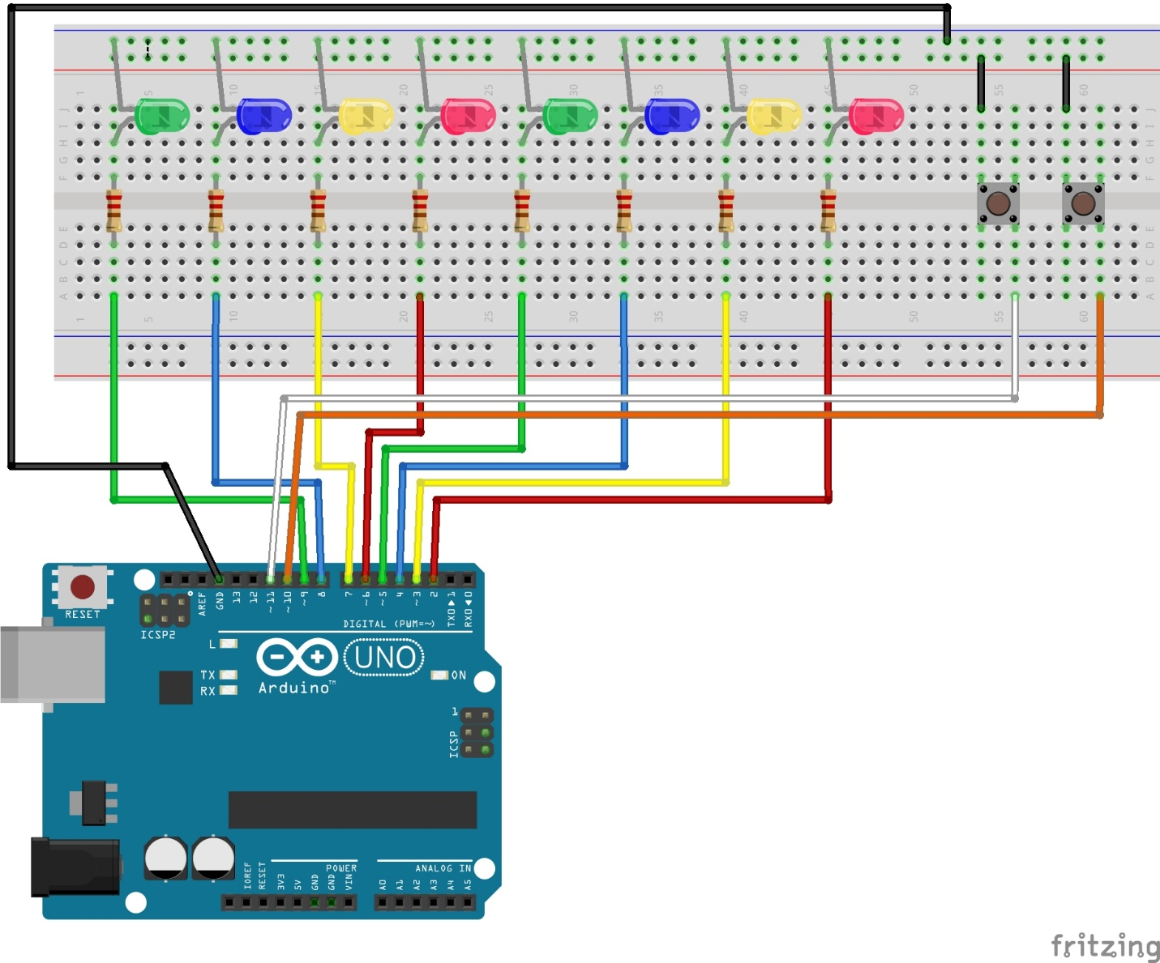

7. Circuit Design
Wiring reference: D2 to D9 drive bits 0 to 7 respectively. Viewed from the front, the LEDs are arranged MSB on the left and LSB on the right. D10 is pause/resume and D11 is reset; both buttons connect their input pin to GND when pressed. Note: the schematic swaps the drawn S1/S2 connections relative to its annotations. The intended mapping is S1 to D10 and S2 to D11.
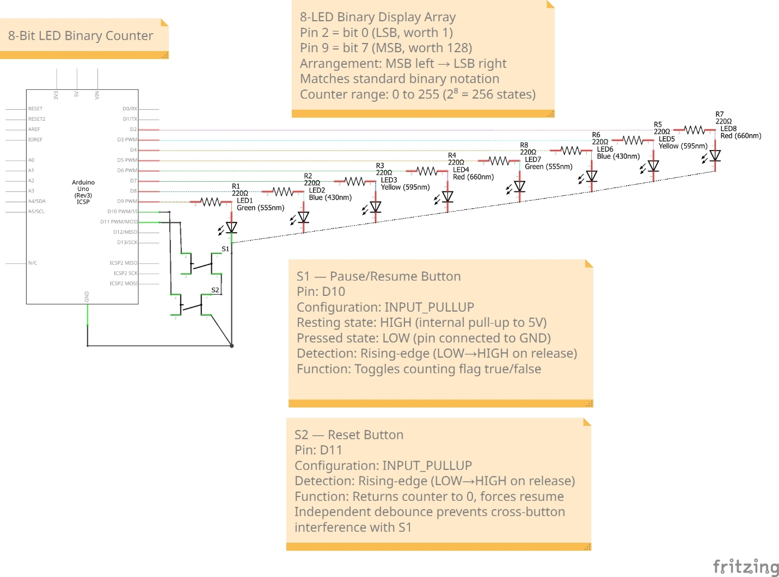

8. The Code
I organised loop() into three jobs: check the pause button, check the reset button, and update the counter. The counter updates every 500 ms. Because delay(500) blocks button checks while counting, a quick press and release can be missed. Reset clears the display to zero and resumes counting, including when paused.
const int ledPins[] = {2,3,4,5,6,7,8,9};
const int pausePin = 10;
const int resetPin = 11;

int counter = 0;
bool counting = true;
unsigned long lastPauseDebounce = 0;
unsigned long lastResetDebounce = 0;
bool lastPauseState = HIGH;
bool lastResetState = HIGH;

void setup() {
for(int i=0; i<8; i++) pinMode(ledPins[i], OUTPUT);
pinMode(pausePin, INPUT_PULLUP);
pinMode(resetPin, INPUT_PULLUP);
Serial.begin(9600);
}

void displayBinary(int val) {
for(int i=0; i<8; i++) {
digitalWrite(ledPins[i], (val >> i) & 1);
}
}

void loop() {
// Pause button: rising edge (release)
bool currentPauseState = digitalRead(pausePin);
if(lastPauseState==LOW && currentPauseState==HIGH
&& millis()-lastPauseDebounce>200) {
counting = !counting;
lastPauseDebounce = millis();
}
lastPauseState = currentPauseState;

// Reset button: rising edge (release)
bool currentResetState = digitalRead(resetPin);
if(lastResetState==LOW && currentResetState==HIGH
&& millis()-lastResetDebounce>200) {
counter = 0;
counting = true;
displayBinary(0);
lastResetDebounce = millis();
Serial.println("--- RESET ---");
}
lastResetState = currentResetState;

// Counter
if(counting) {
displayBinary(counter);
Serial.print("Decimal: "); Serial.print(counter);
Serial.print(" Binary: ");
for(int i=7; i>=0; i--) Serial.print((counter>>i)&1);
Serial.println();
counter = (counter+1) % 256;
delay(500);
}
}

9. Problems I Ran Into
Problem 1: one LED never lit up
What happened: the bit 7 LED (leftmost) never turned on even at count 255.
Cause: the short leg (cathode) of the LED was not fully pushed into the breadboard. It looked fine from above but was not making contact.
Fix: pressed the leg firmly into the hole. LED worked immediately.
Lesson: before loading the main code, run a quick test that lights each LED individually. This finds loose connections immediately.

Problem 2: button always read LOW
What happened: Serial Monitor showed the pause pin always reading LOW even when the button was not pressed.
Cause: a 4-leg tactile button has two pairs of legs that are internally connected. Both wires were in the same pair, so the circuit was always closed without pressing.
Fix: moved one wire to the leg on the opposite side of the button. The pin reads HIGH at rest and LOW when pressed.

Problem 3: pause only worked while holding the button
What happened: the counter paused only while the button was held down. When released, counting resumed immediately.
Cause: the code was checking the live button state every loop. While held LOW, isPaused was forced true. When released, it went back to false.
Fix: added a boolean flag, counting, that toggles on an accepted release event. The counter checks that flag rather than the live pin state.

Problem 4: double-toggle on long press
What happened: holding the pause button for more than 2 seconds sometimes caused two toggles on release.
Cause: release bounce. The contacts briefly re-closed during release, registering a second event. My initial 50ms debounce threshold was not long enough.
Fix: increased debounce threshold from 50ms to 200ms. No further double-toggles in all subsequent testing.
Lesson: debounce values depend on the specific button. The commonly recommended 50ms is a starting point, not a guarantee.

10. Results
After fixing all four problems I tested every function:
Test Expected Result
Counter goes from 0 to 255 and wraps LED pattern cycles Pass ✓
Count 13 (00001101) Pins 2, 4, 5 lit only Pass ✓
Single press on pause button Toggle state once Pass ✓
Long press then release Toggle state once only Pass ✓
Reset during pause Display goes to 0 and counting resumes Pass ✓
All 8 LEDs at count 255 All on simultaneously Pass ✓
Releasing the reset button returns the display to zero and resumes counting, even if paused.

11. Conclusion
The aquarium controller capstone I am building toward needs buttons and physical controls for setting target temperature and pH limits. Working through real button faults taught me how to make physical inputs more reliable. This project also introduced binary representation, bitwise operations, and cyclic counting, which are useful foundations for later work with digital systems and timing.
The binary counter itself was not difficult. What taught me the most was the button debugging, four separate problems, each with its own specific cause and fix.
The habit of running a quick component test before loading the main code (lighting each LED individually, printing each button state to Serial Monitor) found problems in 5 minutes that would have taken much longer to find inside a full circuit. I used this same approach in every project after this.
The debounce problem also changed how I think about hardware. A button looks like a simple on/off switch. Physically it is not. Understanding that the mechanical contacts bounce, and that the solution is timing not more code, was a useful way to learn that hardware and software problems look different even when the symptom is the same.

