First Request: http://pokeapi.co/api/v2/pokemon/1

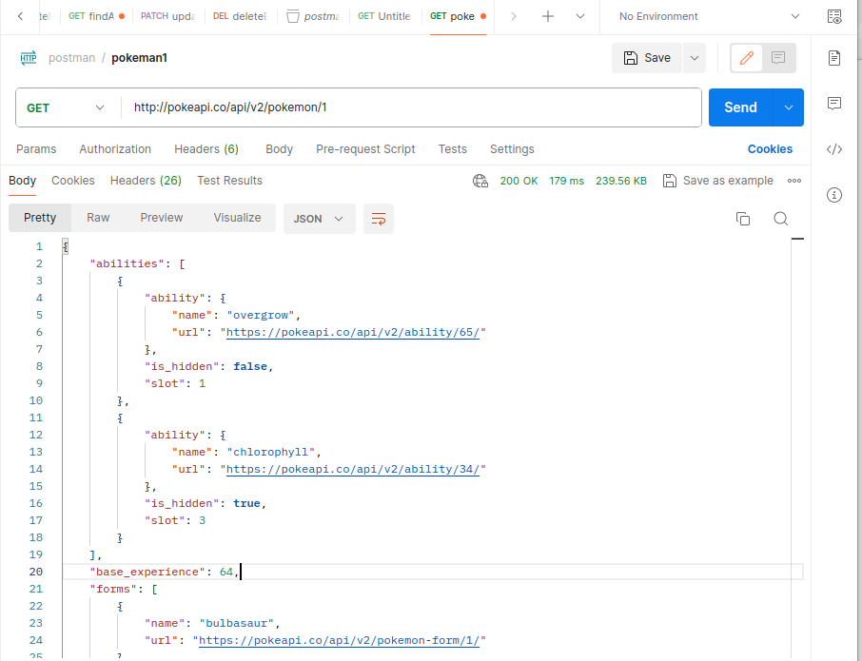

Second Request: http://pokeapi.co/api/v2/evolution-chain/2

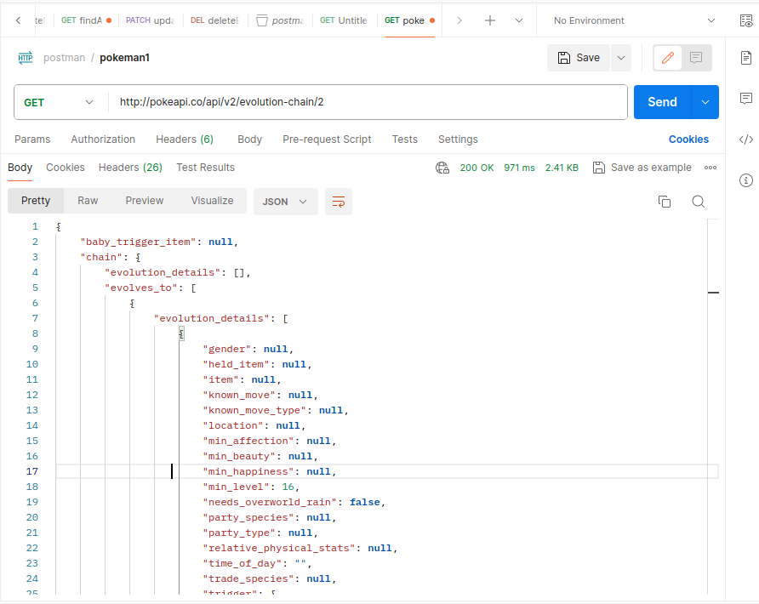
Third Request: http://pokeapi.co/api/v2/encounter-condition-value/2

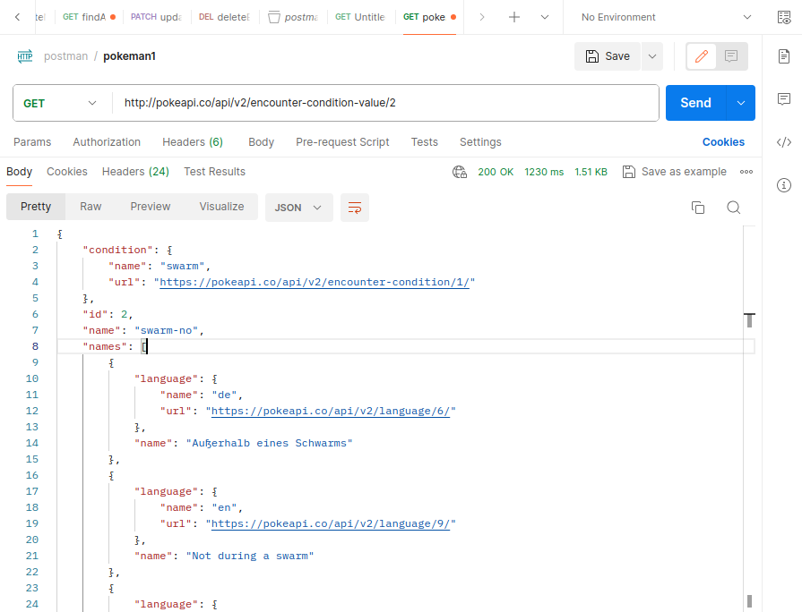
Fourth Request: http://pokeapi.co/api/v2/encounter-condition/2

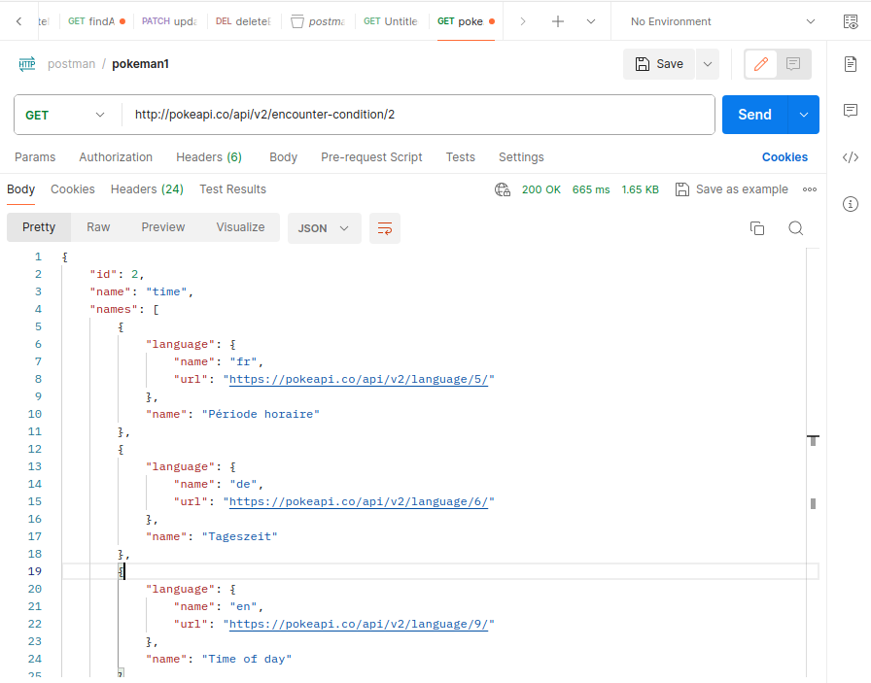
Firth Request: http://pokeapi.co/api/v2/generation/2
