**The University of Prishtina "Hasan Prishtina"**

**The Faculty of Electrical and Computer Engineering**



**Technical documentation**

**Course: Operating Systems**

**Project Title: Communication between two processes**

**Name of Professor / Assistant Name & Surname of students / email address**

|  |  |  |
| --- | --- | --- |
| Prof. Dr. Artan MAZREKAJ  Msc. Dalinë VRANOVCI | 1. Arlinda Kastrati | arlinda.kastrati4@student.uni-pr.edu |
| 2. Alberiana Tofaj | alberiana.tofaj@student.uni-pr.edu |
| 3. Fortesa Mujaj | fortesa.mujaj@student.uni-pr.edu |
| 4. Veranda Blakaj | veranda.blakaj@student.uni-pr.edu |

Prishtinë, 2022

**Table of Contents**

**Abstract** 3

**Introduction** 4

**1.** **The purpose of the project** 5

**2.** **The main part** 6

**2.1** **The Code** 6

**2.2** **Results from testing the code** 11

**3.** **Conclusion** 13

**References** 14

# **Abstract**

This report reports a detailed summary regarding the description of the design, implementation and enforcement of a communication program between two parent / child processes. This project was implemented using Ubuntu operating methods and the C programming language.

The main objective of the report is to present the principles behind the programming of operating systems or processes and the synchronization of the operating system that belongs to the Linux family.

# **Introduction**

Operating systems are software programs that are used to manage computer devices such as: smartphones, tablets, computers, supercomputers, Internet servers, machines, smartwatches, etc. Operating systems are those that eliminate the need to know the coding language to interact with computer devices. Operating systems are a layer of graphical user interface (GUI), which acts as a platform between the user and the computer hardware. Furthermore, the operating system manages the software side of a computer and controls the execution of programs.

Without an operating system, each application will need to include its own UI, as well as the comprehensive code needed to handle all the basic low-level functions of the underlying computer, such as disk storage, network interfaces, and so on. Given the large range of basic hardware available, this would greatly increase the size of any application and make software development impractical.

The operating system today offers a comprehensive platform that identifies, configures and manages a range of hardware, including processors, memory devices and their management, chipsets, storage, networking, communication between ports such as Video Graphics Array (VGA), High-Definition Multimedia Interface (HDMI), Universal Serial Bus (USB) and subsystem interfaces such as Peripheral Component Interconnect Express (PCIe).

The five most common operating systems are: Microsoft Windows, Apple macOS, Linux, Android and Apple iOS.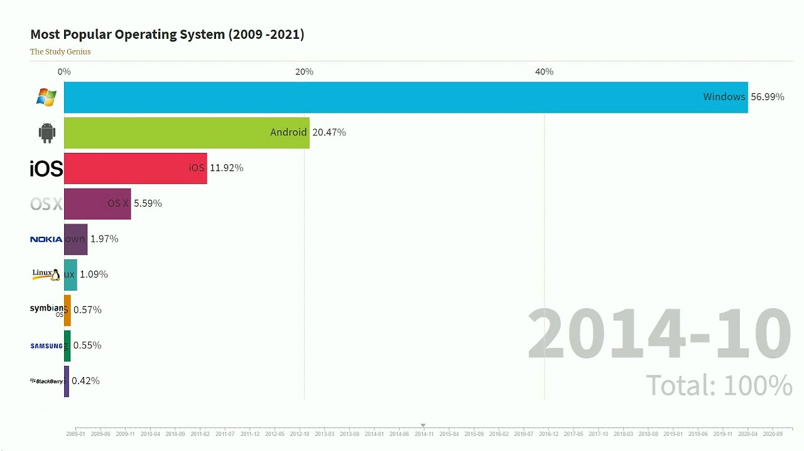

Figure 1: The most used operating systems (2009-2021)

# **The purpose of the project**

Interprocess communication (IPC) is a mechanism that allows processes to communicate with each other and synchronize their actions. It also enables the exchange of resources and data between processes without interference.

Processes that are running simultaneously on the operating system can be:

* independent process
* cooperating process

A process is independent and may or may not be affected by other processes running on the system. Any process that does not share data with any other process is independent.

Suppose if a process is cooperating then, it may be affected by other processes running on the system. Any process that shares data with another process is called a collaborative process.

To realize the communication between the two processes (parent / child) in such a way that the parent process writes in a file and the child process reads the contents of the file we can use pipes.

Pipe is a technique used for inter-processor communication. A pipe is a mechanism by which the output of one process is directed to the inlet of another process. Thus it provides a one-way flow of data between two related processes. Pipes communicate with the FIFO method. If the pipe is full, the process is blocked until the pipe condition changes. Similarly, a read process is blocked if it tries to read more bytes that are currently in the pipe, otherwise the read process is executed. Only one process can enter a pipe at a time.

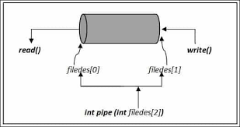

Figure 2: Pipe()

# **The main part**

Since the **Ubuntu** operating system is already installed in the **Virtual** **Machine**, through the terminal we create a new file in the directory where the file we accessed with the **cd** command will be saved.

Figure 3: The file creation process

## **The Code**

Below we have presented the code in the C programming language.

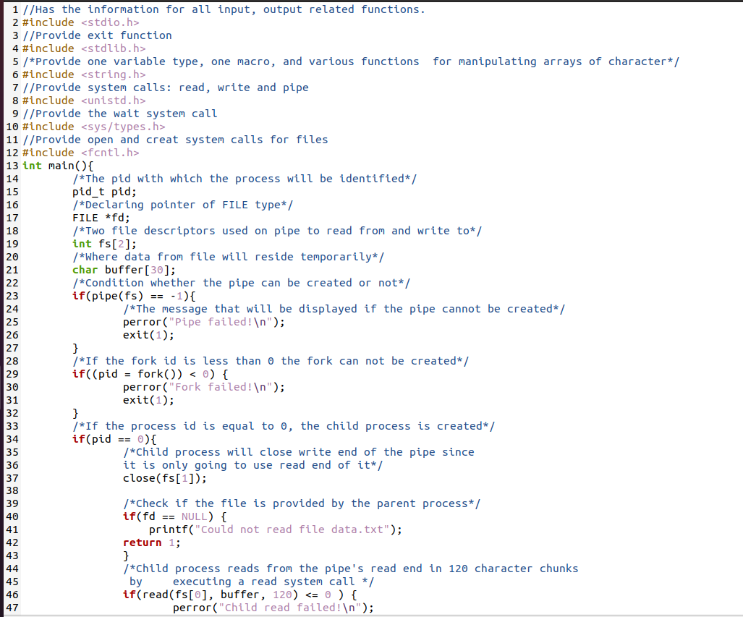

Figure 4: The first part of the code

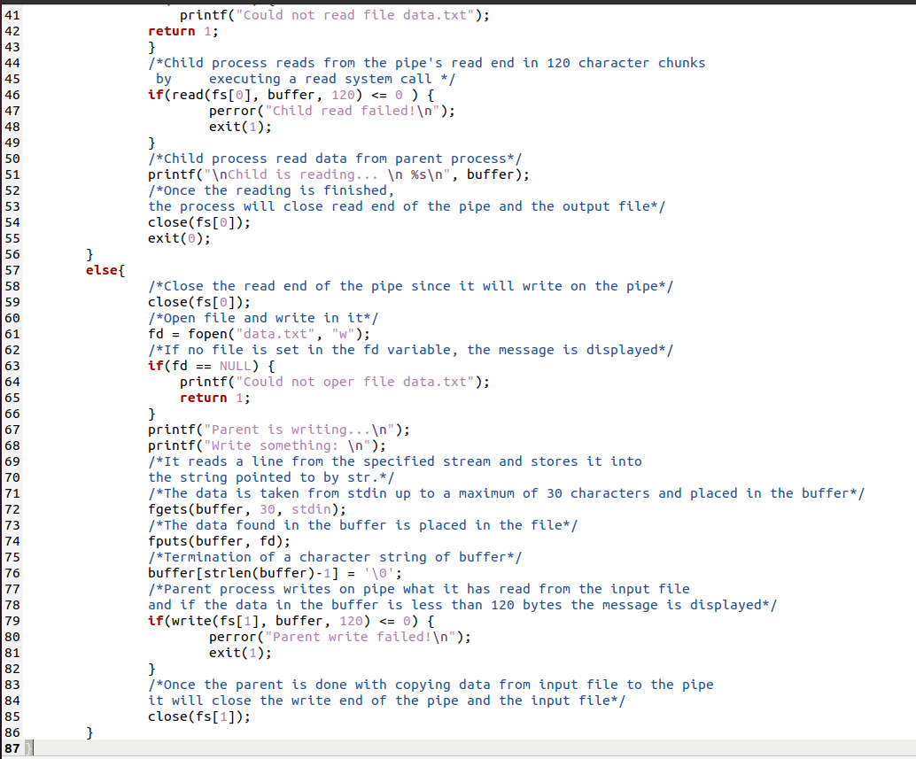

Figure 5: The second part of the code

Below are the libraries that will be used to enable parent-child communication.

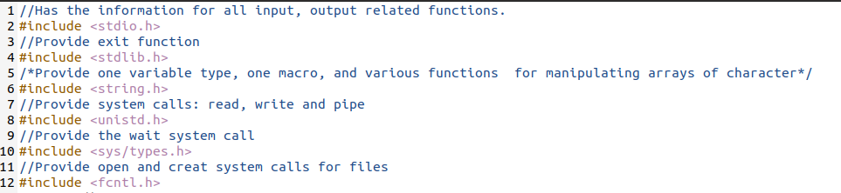

Figure 6: Libraries

Declaration of variables that will be used later in the program.

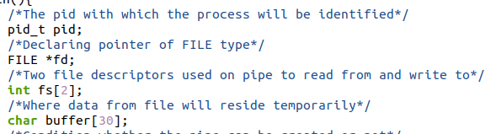

Figure 7: Declared variables

Creating conditions that if the pipe and process can not be created the message will be displayed as a notification.

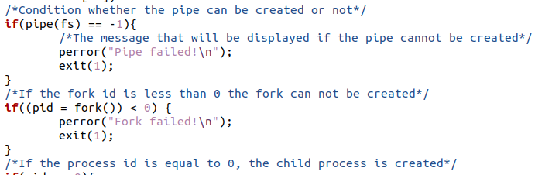

Figure 8: Pipe() and fork()

In this part of the code is presented the child process means that if the condition for **pid == 0** is met then the program continues with the execution of the code for the child process. First the pipe closes because the child process will only read the file sent by the parent process then the condition that if the parent process has not placed the file in the declared variable the corresponding message is displayed.

In the other condition **if**, we look at whether the child process can read or not in the declared file, if it can display the message it has read if not then the corresponding message is displayed. Finally the reading pipe is closed.

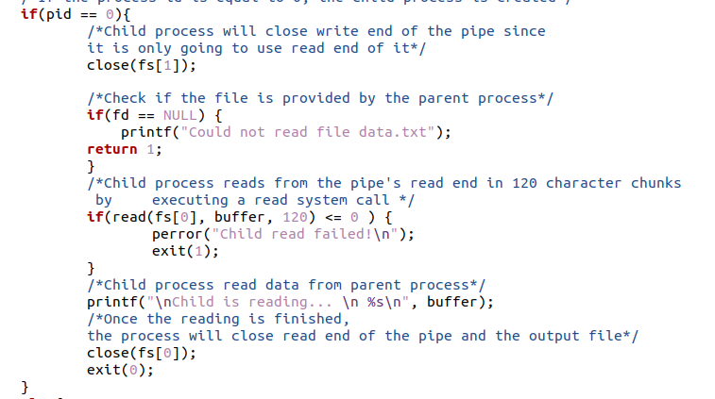

Figure 9: The child process

The following is the part of the code for the parent process. First the pipe for reading gets closed then the pipe for writing gets open.

The condition if the file can not be opened presents the corresponding message while if the file can be opened the process starts reading the data written by the parent process in the file.

If no data is written to the file the message is displayed. And finally closes the pipe for writing on it.

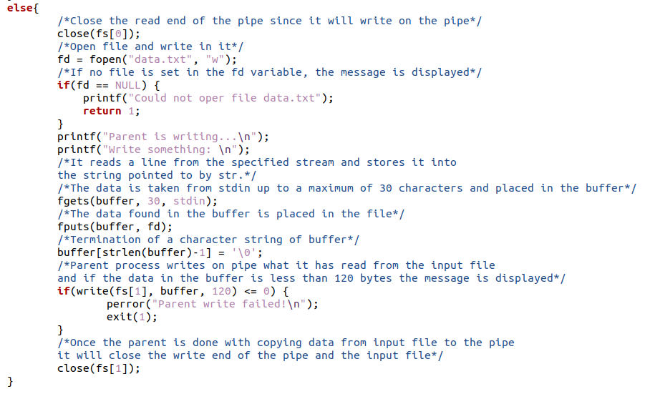

Figure 10: The parent process

## **Results from testing the code**

In the following we have presented the whole process of testing parent-child communication through **pipes ().**

The following figure shows the commands for creating the file in the programming language and the text file in which we will enter the data.

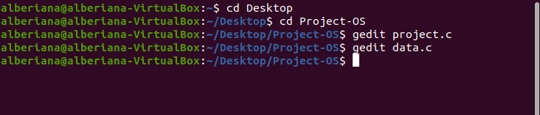

Figure 11: Creating files

The data in the file is written by the parent process. The process expects the data to be recorded in the corresponding declared file.

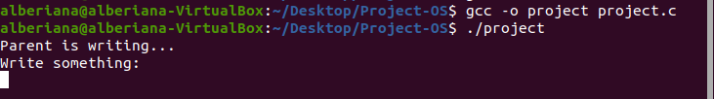

Figure 12: The process waits for the input data

The data are written by the parent process through the terminal in the declared file and also the data is read by the child process appearing in the terminal.

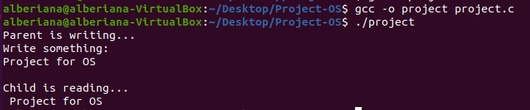

Figure 13: The data written in the file and getting read from the child process

The data details in the data.txt file are as follows:

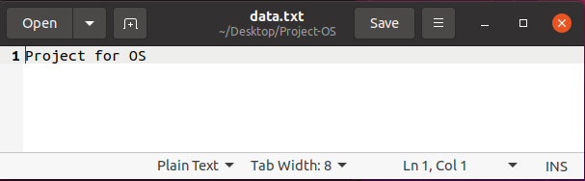

Figure 14: File data.txt

# **Conclusion**

The realization of the whole project was quite challenging but at the same time it was fun. This project is the first project we have worked on of this nature that belongs to the operating systems, especially about processes and their communication. As a beginner student in this field we have encountered some obstacles during the implementation of the project. But, with the help of literature from foreign books, basic concepts taken from lectures and exercises from the course of Operating Systems, cooperation, common ideas and numerous researches we believe that we have successfully achieved the realization of communication between the two processes. All of this has also resulted into greater reinforcement of concepts that include architecture and process communication of the operating systems.

The program implemented above realizes the communication between two processes (parent / child) in that way:

• The parent process writes to a file

• The child process reads the contents of the file

and works properly.

# **References**

|  |  |
| --- | --- |
| [1] | "Stack Exchange," 26 May 2021. [Online]. Available: https://unix.stackexchange.com/questions/446131/the-file-used-by-parent-and-child-process.. |
| [2] | "Geeksforgeeks," 14 May 2020. [Online]. Available: https://www.geeksforgeeks.org/ipc-technique-pipes/#:~:text=A%20Pipe%20is%20a%20technique,data%20between%20two%20related%20processes... |
| [3] | "Tutorialspoint," [Online]. Available: https://www.tutorialspoint.com/inter_process_communication/inter_process_communication_pipes.htm.. |
| [4] | H. Darvis, "Quick Adviser," 4 November 2021. [Online]. Available: https://quick-adviser.com/how-parent-processes-communicate-with-child-process/.. |