* Create New Project

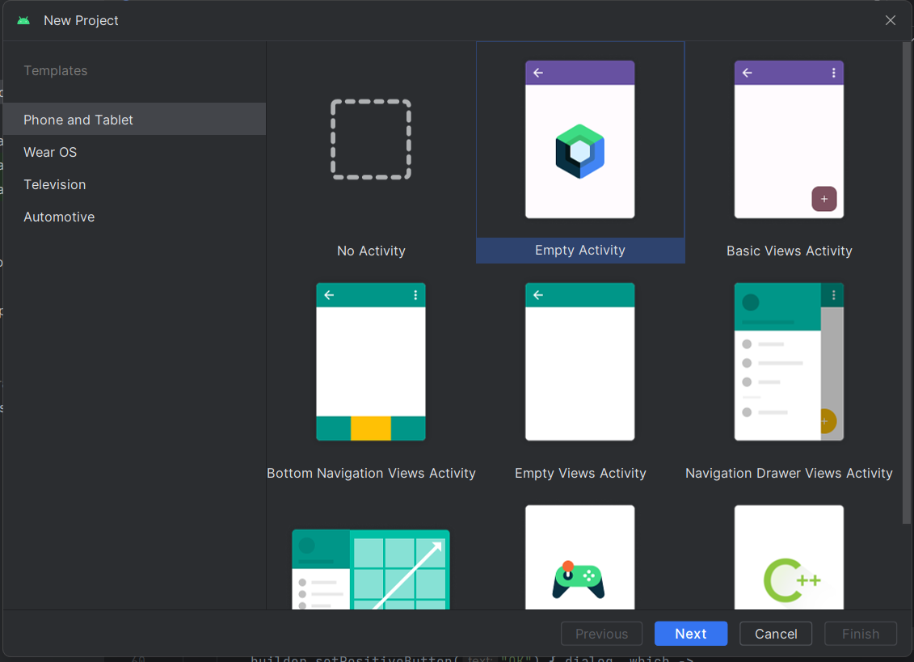

Next

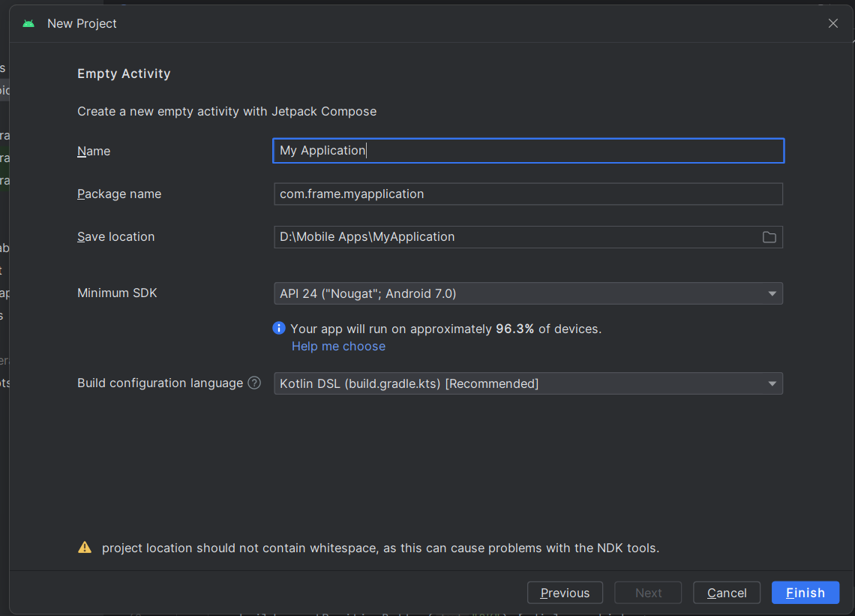

Name – **your application name**

Package anem = **com.exmple.exp**

**( com = domain extension, example = domain name, exp = app signature )**

**But you can random all of these**

Save Location = **file Location**

After finish

* Copy the **MainActivity.kt** File from app_frame_folder
* And then paste in your project the **MainActivity.kt** file
* And Copy the **assets** folder to your project

**Next Step**

* **You need to test it because right or wrong that program**

**Next Step**

* **Change Application Icon**

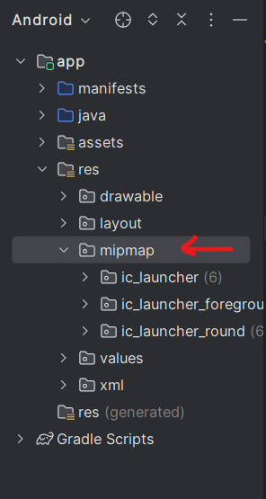

* Right Click on **mipmap**
* Go to the **new > image asset** and then click that

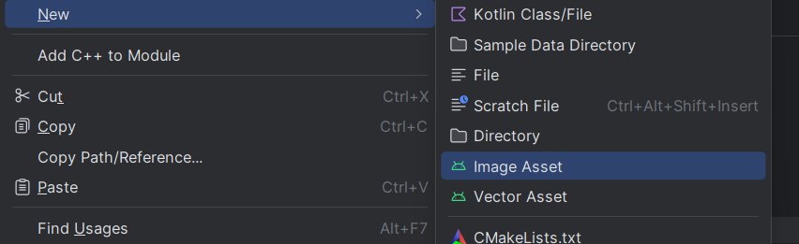

**Next Step**

* You will got like this

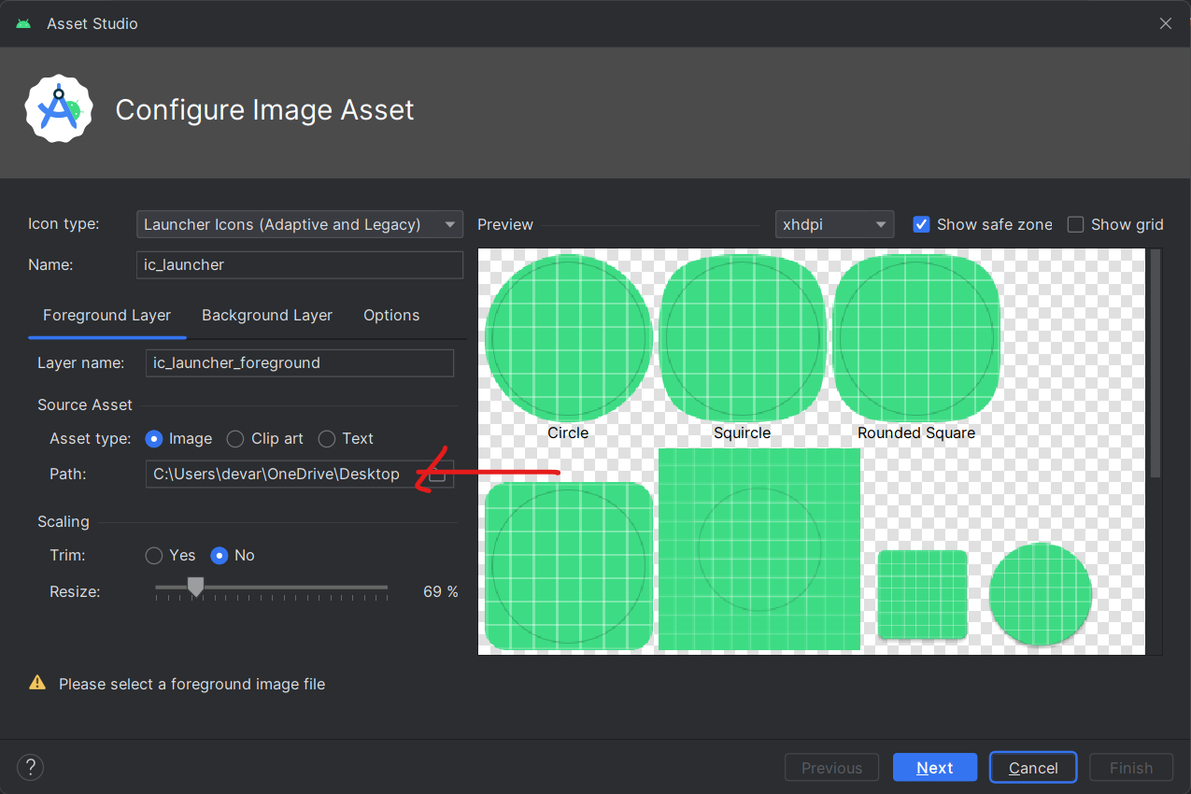

* **Put your icon image**

***Note: If you change the name you need to do another setting***

* **If you change Icon name need to do step**
  + Go to – **manifests > AndroidManifest.xml**
  + Change > **android:icon=”your icon name”**

> **android:roundIcon=”your round icon name”**

**Next Step : Change Application Name**

* Go to the **res > values > strings.xml**

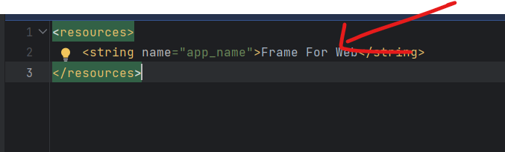

**Change Your Application Name**

**Next Step: Version Change**

* **If you want change version**

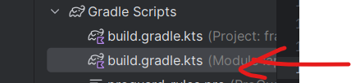

* Go to that **build.gradle.kts ( Module:app)**
* Change the
  + versionCode
  + versionName

**Next Step**

**- Application Export**

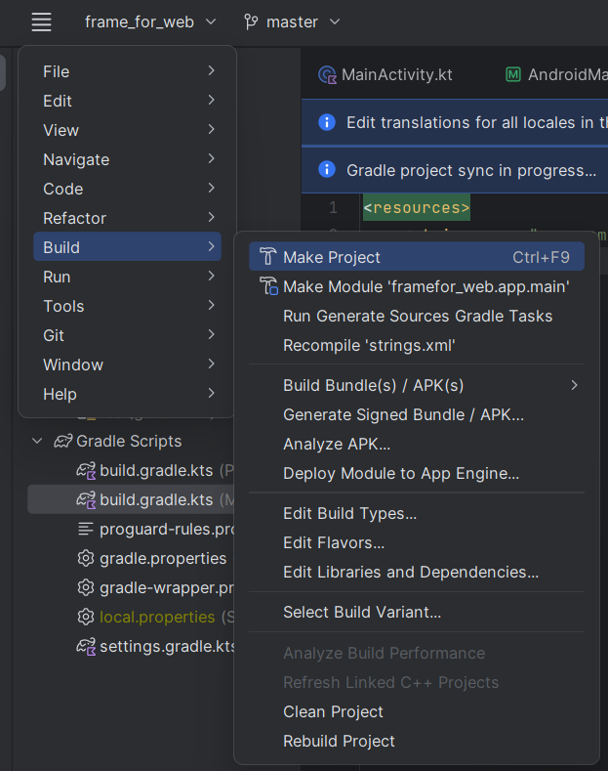

**- There is two way for Application Generate**

**Note: if you want to generate with key**

**Note: No key way**

* Go to the **Menu > Build > Build Bundle > APK**

**Application Output**

Got to the **your** **project > app > build > outputs > apk/aab**

* Go to the **Menu > Build > Generate Signed Bundle /APK**

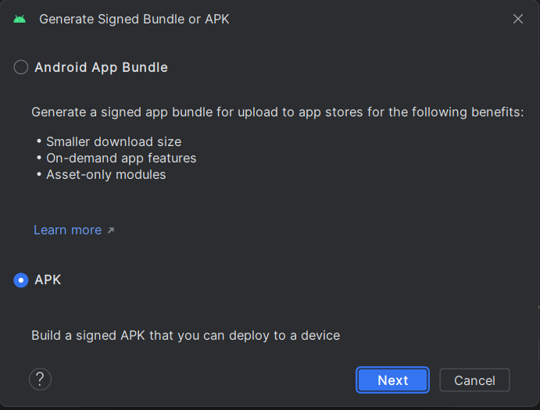

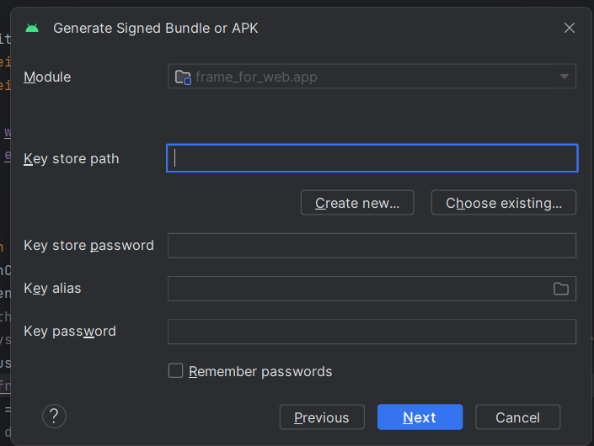

**: You can create new key**

* **Finish**

Got to the **your** **project > app > build > outputs > apk/aab**

**Thank you**