Hotel模块的度量

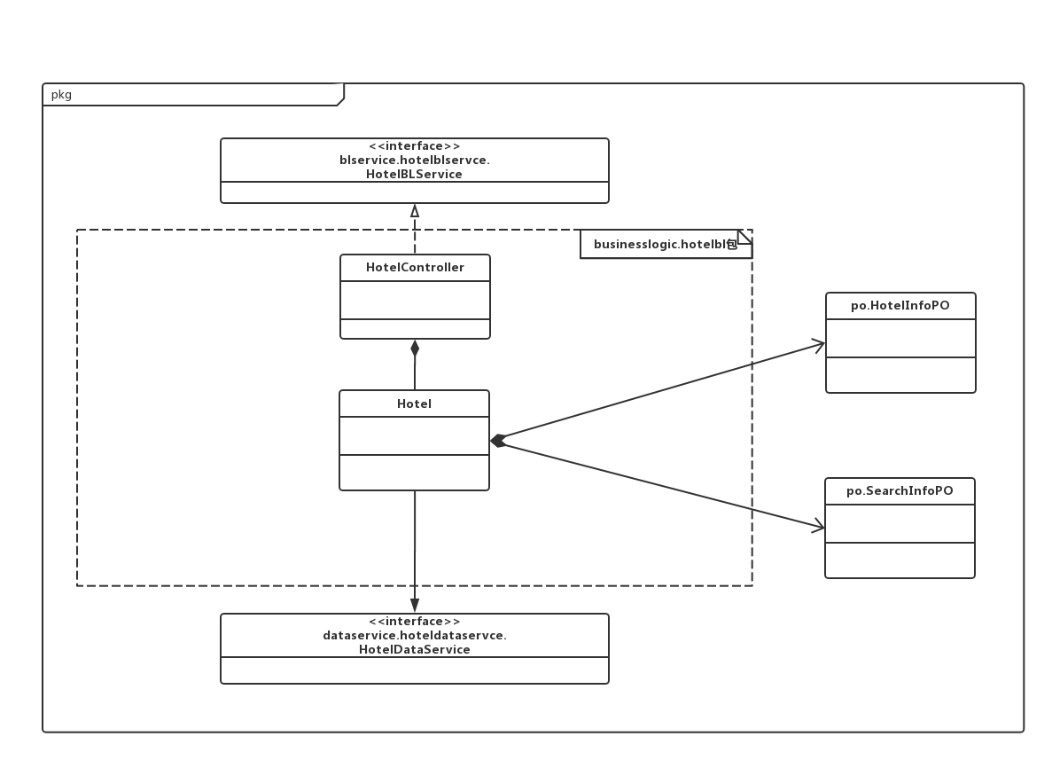

|  |  |  |
| --- | --- | --- |
| 类名 | CBO | DAC |
| Hotel | 2 | 3 |
| 调用其他类2 | HotelInfoPO  SearchInfoPO  Order |

|  |  |  |
| --- | --- | --- |
| 类名 | NOC | DIT |
| Hotel | 0 | 0 |
| HotelController | 0 | 1 |

Room模块的度量

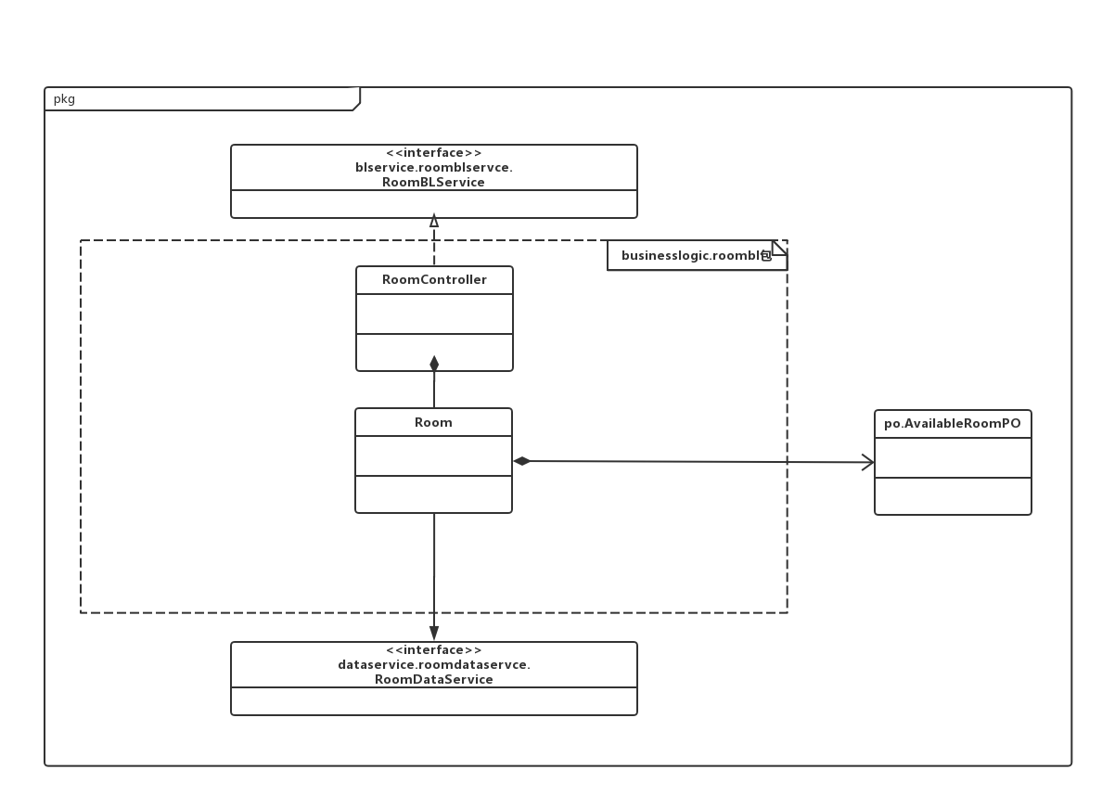

|  |  |  |
| --- | --- | --- |
| 类名 | CBO | DAC |
| Room | 3 | 1 |
| 调用其他类1  被其他类调2 | AvailableRoomPO |

|  |  |  |
| --- | --- | --- |
| 类名 | NOC | DIT |
| Room | 0 | 0 |
| RoomController | 0 | 1 |

Manager模块的度量

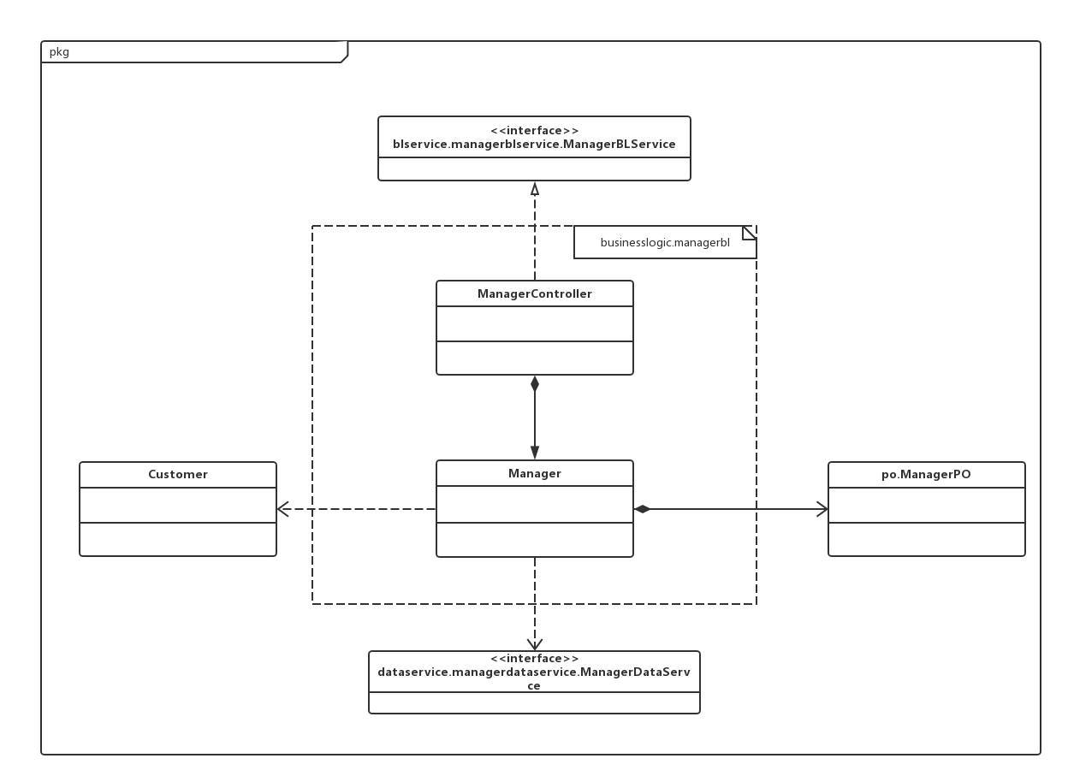

|  |  |  |
| --- | --- | --- |
| 类名 | CBO | DAC |
| Manager | 3 | 2 |
| 调用其他类2  被其他类调用1 | ManagerPO  Customer |

|  |  |  |
| --- | --- | --- |
| 类名 | NOC | DIT |
| Manager | 0 | 0 |
| ManagerController | 0 | 1 |

SalePromotion模块的度量

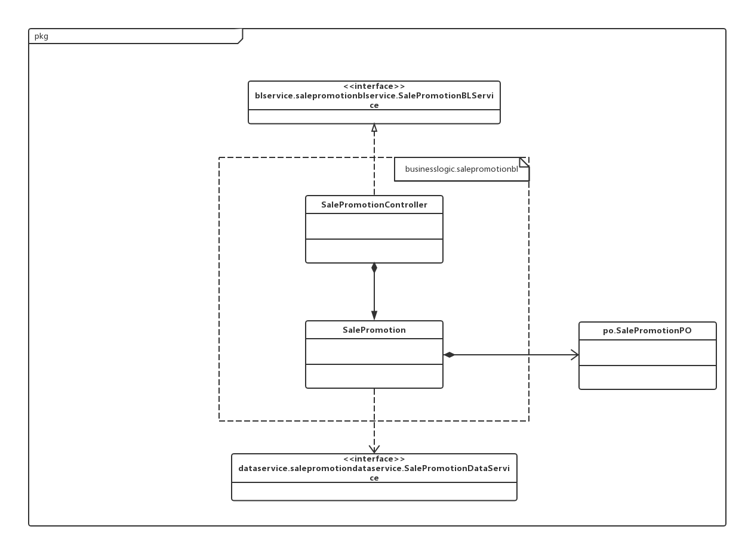

|  |  |  |
| --- | --- | --- |
| 类名 | CBO | DAC |
| SalePromotion | 2 | 1 |
| 调用其他类1  被其他类调用1 | SalePromotionPO |

|  |  |  |
| --- | --- | --- |
| 类名 | NOC | DIT |
| SalePromotion | 0 | 0 |
| SalePromotionController | 0 | 1 |

Customer模块的度量

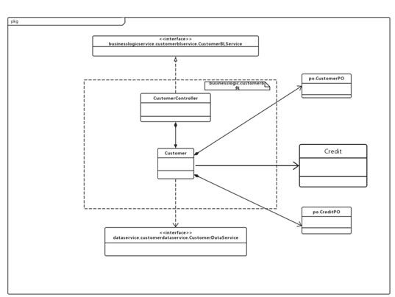

|  |  |  |
| --- | --- | --- |
| 类名 | CBO | DAC |
| Customer | 3 | 2 |
| 调用其他类2  被其他类调用1 | CustomerPO  Credit |

|  |  |  |
| --- | --- | --- |
| 类名 | NOC | DIT |
| Customer | 0 | 0 |
| CustomerController | 0 | 1 |

Credit模块的度量

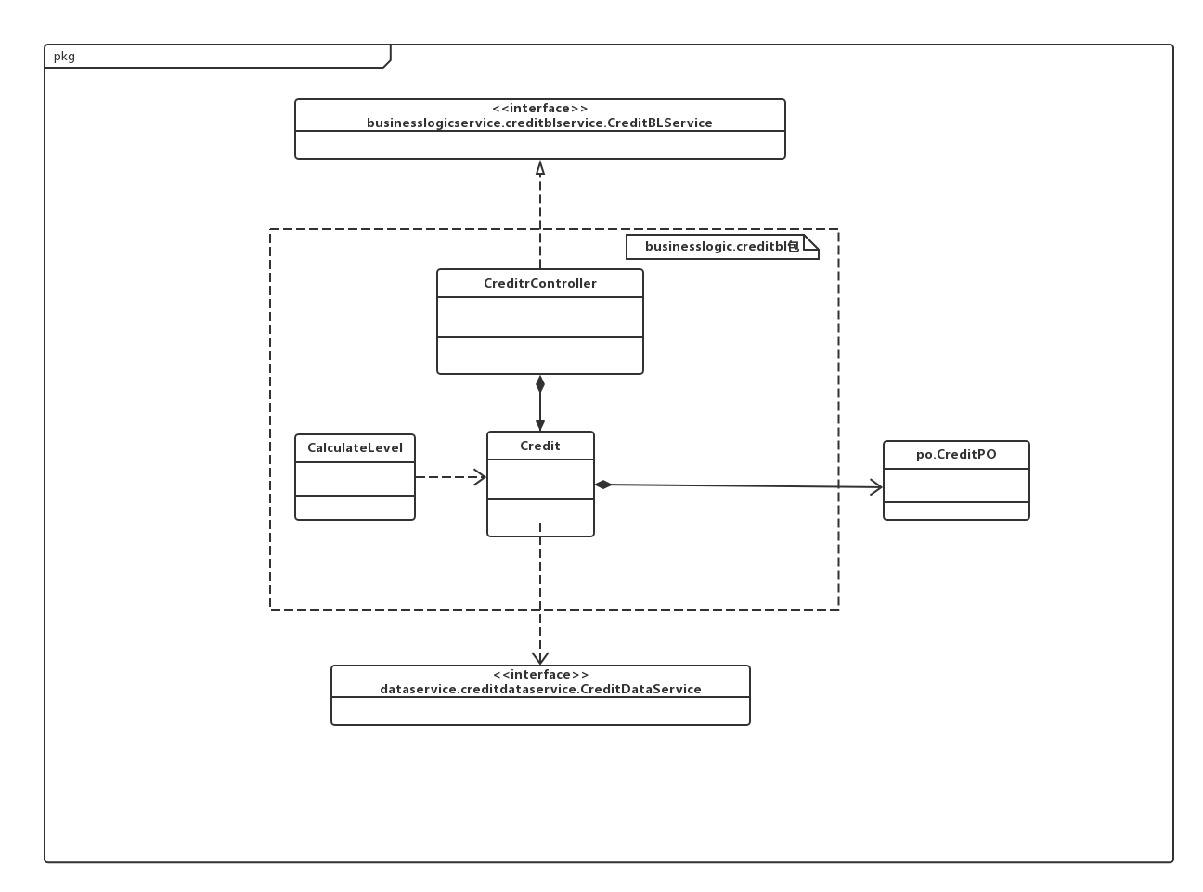

|  |  |  |
| --- | --- | --- |
| 类名 | CBO | DAC |
| Credit | 4 | 1 |
| 调用其他类1  被其他类调用3 | CreditPO |

|  |  |  |
| --- | --- | --- |
| 类名 | NOC | DIT |
| Credit | 0 | 0 |
| CreditController | 0 | 1 |

Order类

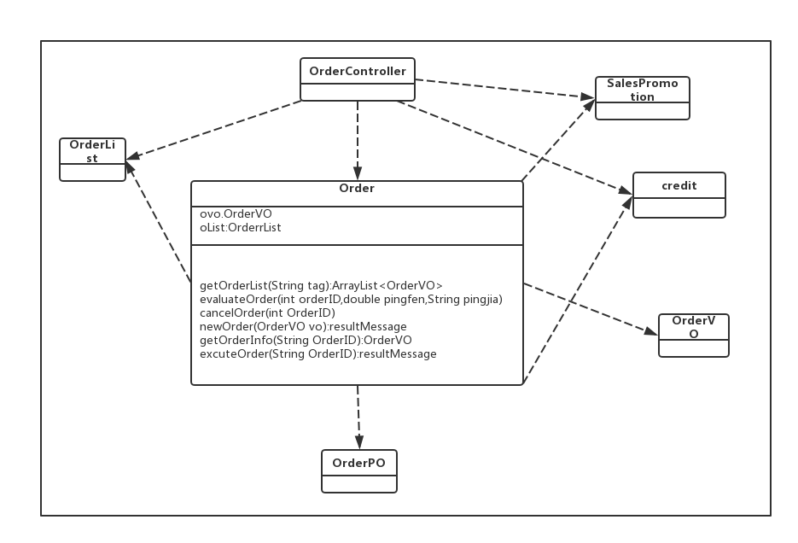

Order类的CBO和DAC

|  |  |  |
| --- | --- | --- |
| 类名 | CBO | DAC |
| Order | 6 | 2 |
| 调用其他类：5  被其他类调用：1 | OrderVO  OrderList |

Order类相关的NOC和DIT

|  |  |  |
| --- | --- | --- |
| 类名 | NOC | DIT |
| Order | 0 | 0 |
| OrderList | 2 | 1 |
| Credit | 0 | 0 |
| SalesPromotion | 0 | 0 |