**Name:** Maureen Beau M. Pera **Student registration number:** E20-00412

1. The image below is the screenshot of the content of the user table.

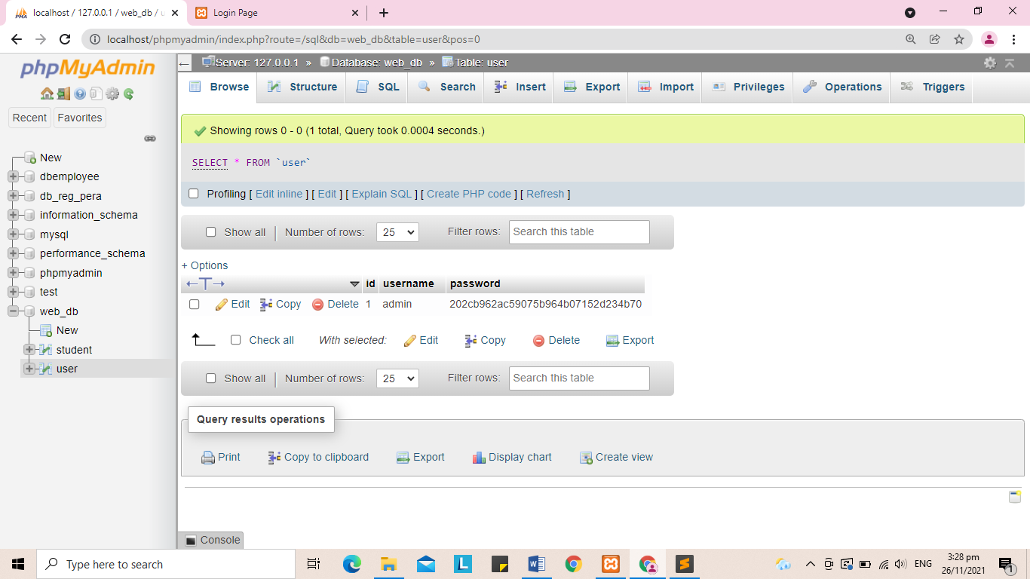

2. <?php

$hostname = "localhost";

$username = "root";

$password = "";

$database = "web_db";

$connect = mysqli_connect($hostname, $username, $password, $database);

if ($connect) {

echo "Connection to MySQL successful<br>";

}

else{

echo "Connection to MySQL failed". mysqli_connect_error();

}

$query = "CREATE TABLE user(

id INT PRIMARY KEY AUTO_INCREMENT,

username VARCHAR(20) NOT NULL,

password VARCHAR(50))";

if(mysqli_query($connect, $query)){

echo "user table created successfully";

}

else{

echo "user table failed to create <br>". mysqli_error($connect);

}

mysqli_close($connect);

?>

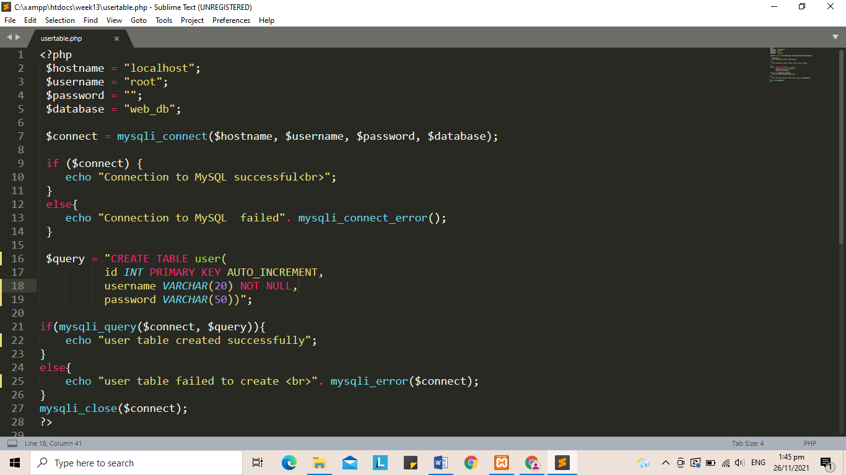

3. <?php

$hostname = "localhost";

$username = "root";

$password = "";

$database = "web_db";

$connect = mysqli_connect($hostname, $username, $password, $database);

if ($connect) {

echo "Connection to MySQL successful<br>";

}

else{

echo "Connection to MySQL failed". mysqli_connect_error();

}

$query = "INSERT into user(username,password)

VALUES('admin', '123')";

if (mysqli_query($connect, $query)) {

echo "New data added succesfully";

}

else{

echo"New data failed to add <br>". mysqli_error($conect);

}

mysqli_close($connect);

?>

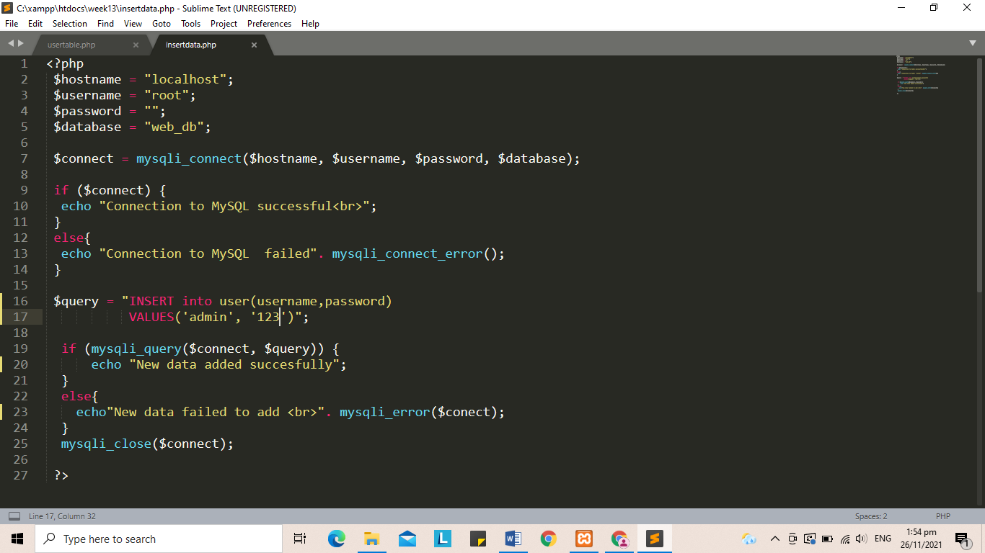

4. After saving the file and run the program code by typing localhost/week13/loginForm.php I saw that there is a log in form asking me to input the username and password. I have observed that there is message error displayed saying “Failed to log in, please login again” after trying to enter “admin” in the username and “234” in the password and click the “Login” button. There is an error message displayed in my browser because the password that I have enter didn’t match to the password that we inserted a while ago and there is no “234” password in our user table that’s why there is an error message.

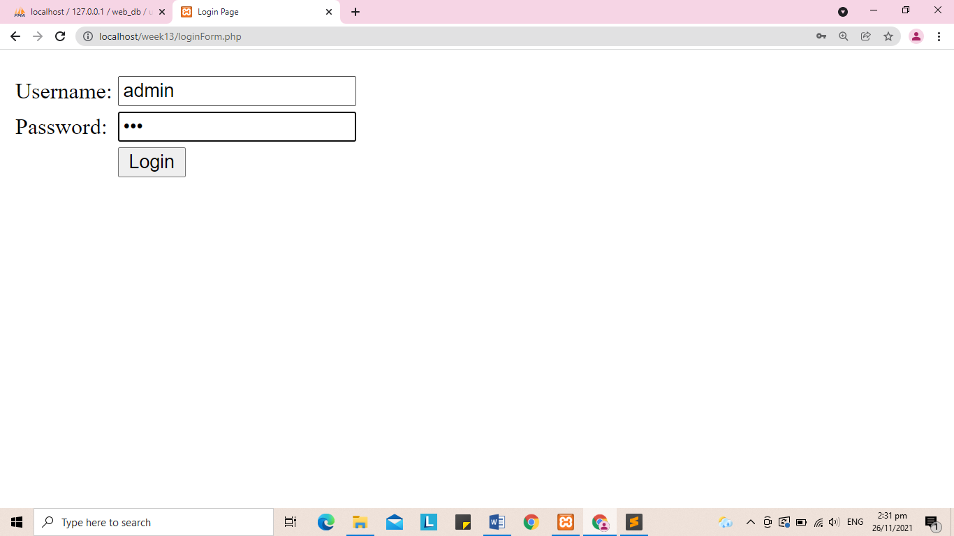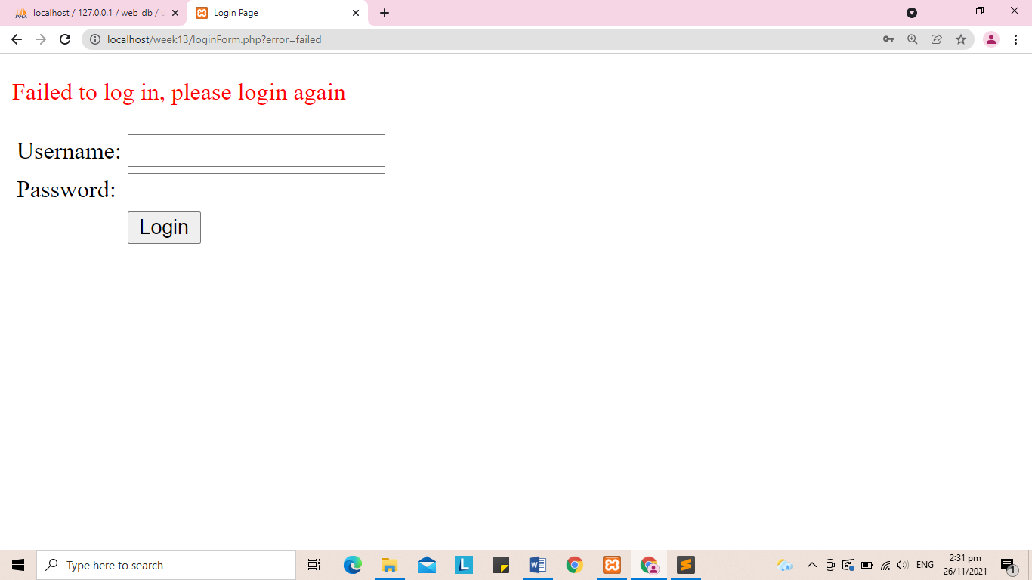

5. In my second try, I entered again the “admin” for username and this time I entered “123” for the password. I have observed that when I click the login button it was process and it redirects me to another page. I have learned that the md5() function calculates the MD5 hash of a string input and returns the hash hexadecimal number. It is use to verify the integrity of any message or file that is hashed.

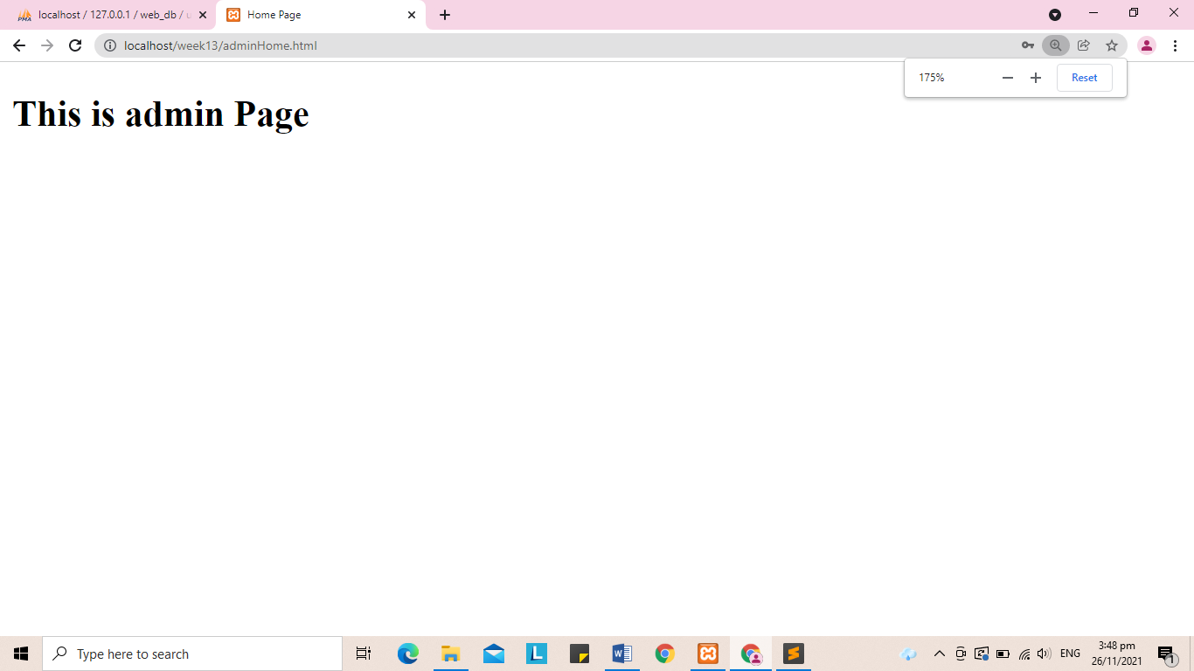

6. I have observed that performing the SQL command and click the “go” button and go the browse area, I saw that it was successfully create the column for the level and after editing the record I saw that it has now finally a level 1 in the first record. And base from the result and my observations I have learned that we use in our SQL command the “ALTER” we want to modify the columns in our table we can add or remove by using this “ALTER” statement. Just like what we did we use alter to add columns in our user table that’s why we have successfully modify and add another column for the “level”. We can also use alter if we want to change the name of our table.

7. The image below shows the contents of the user table.

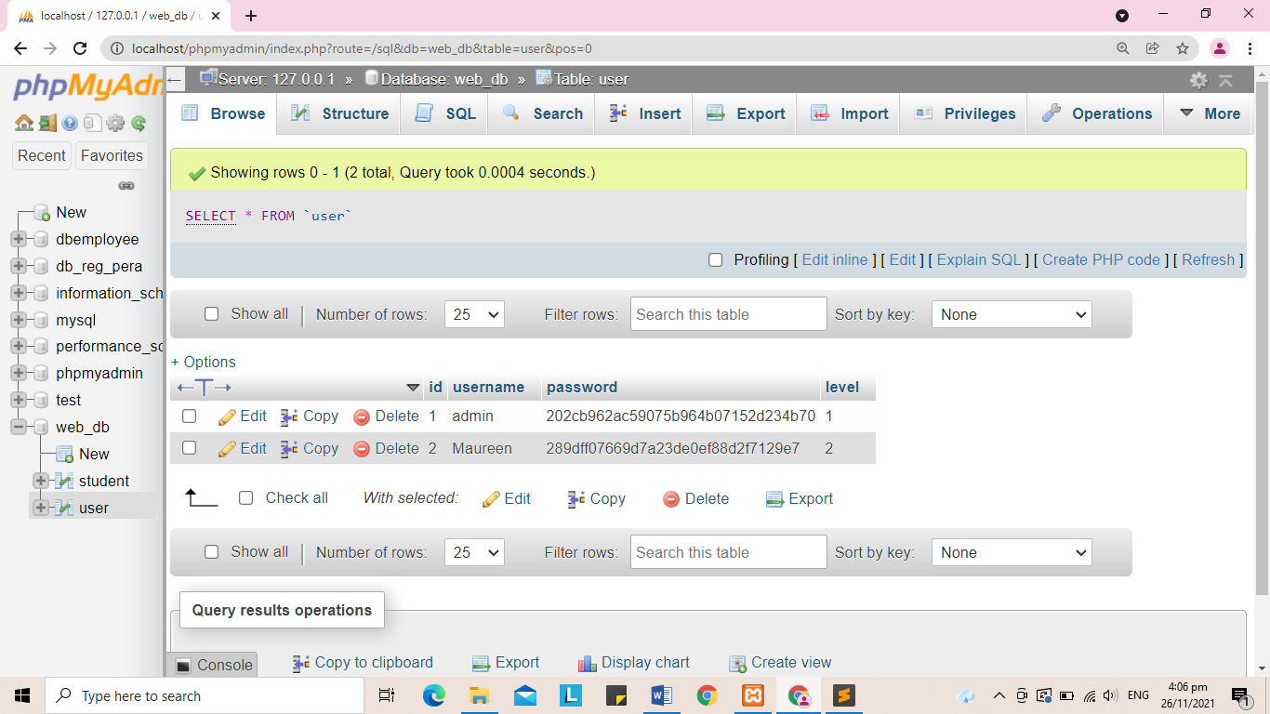

8. When I entered admin for the username and 123 for the password and click the login button it will redirect me to the admin page and there is a message displayed saying “This is admin page”. Also, I have observed from the codes that we use again the query to get the username and password, the only difference is that we use the level to check if it is match in the records that we entered earlier in the database. The username and password that I entered was matched to the level 1 that’s why it redirects me to the admin page.

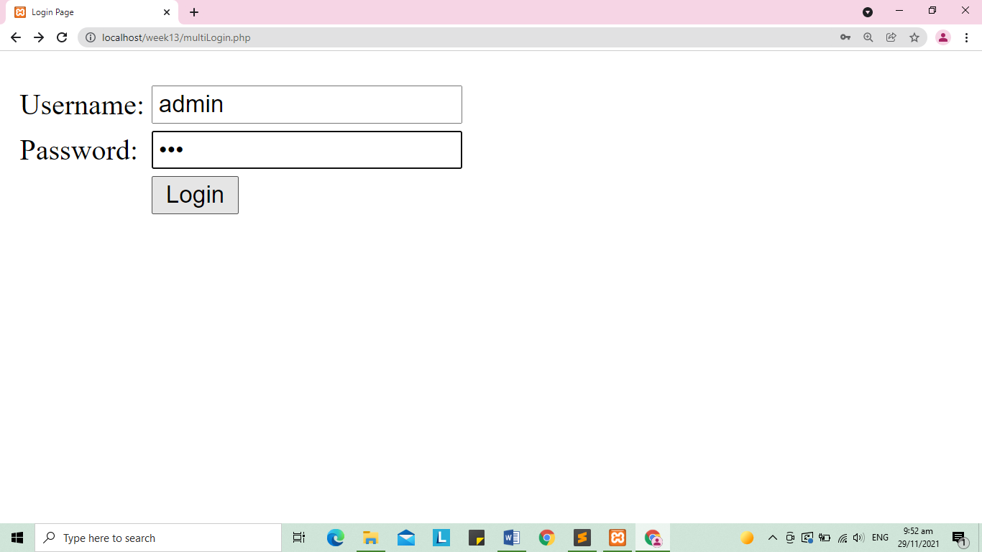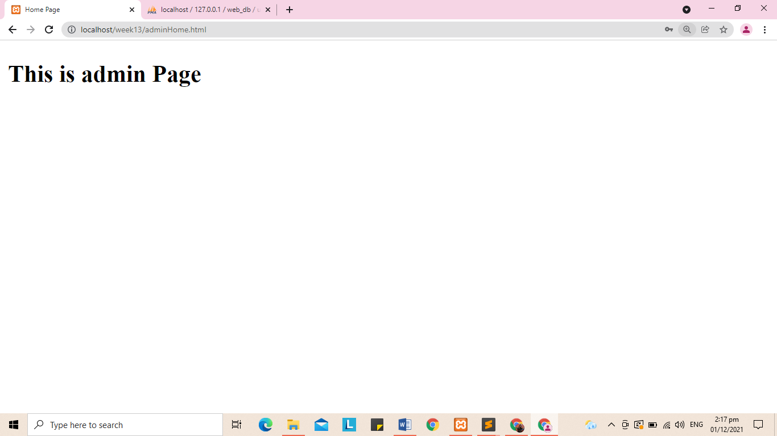

9. It will redirect me to the guest page when I entered my username “Maureen” and 234 for the password. I have understood that it will redirect me to the guest page since we make a condition in our codes to check that if the username and password will match into the level 2 in the records the header location will redirect to the guesHome.html.

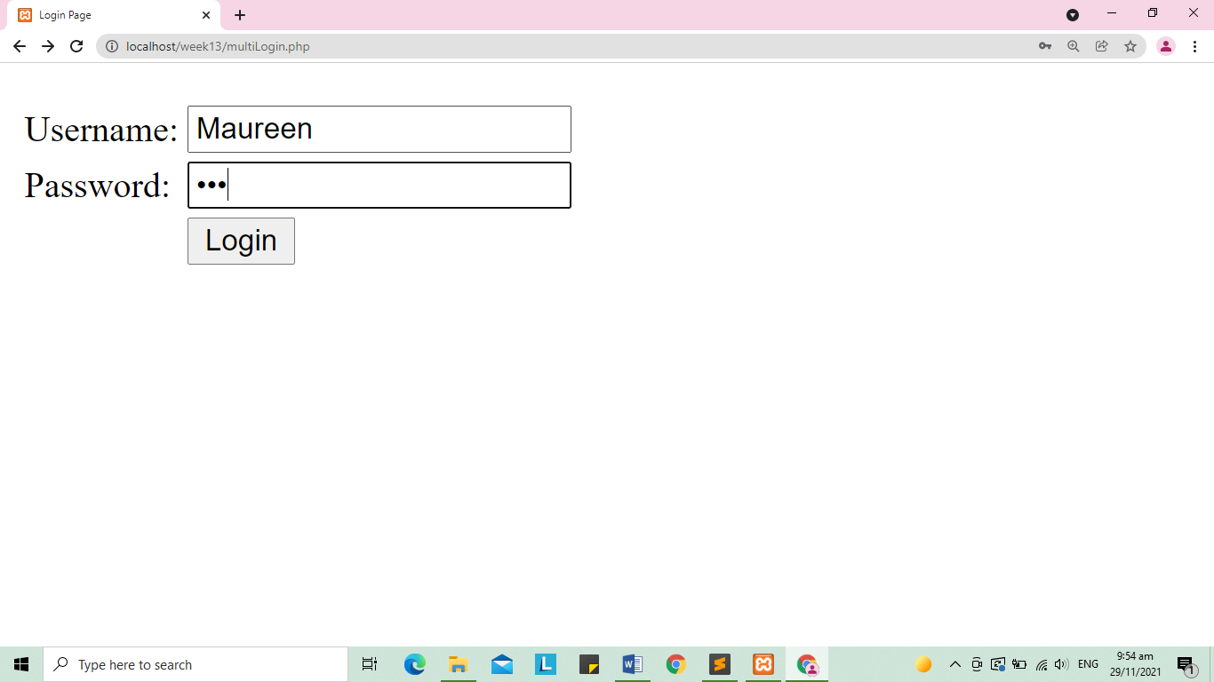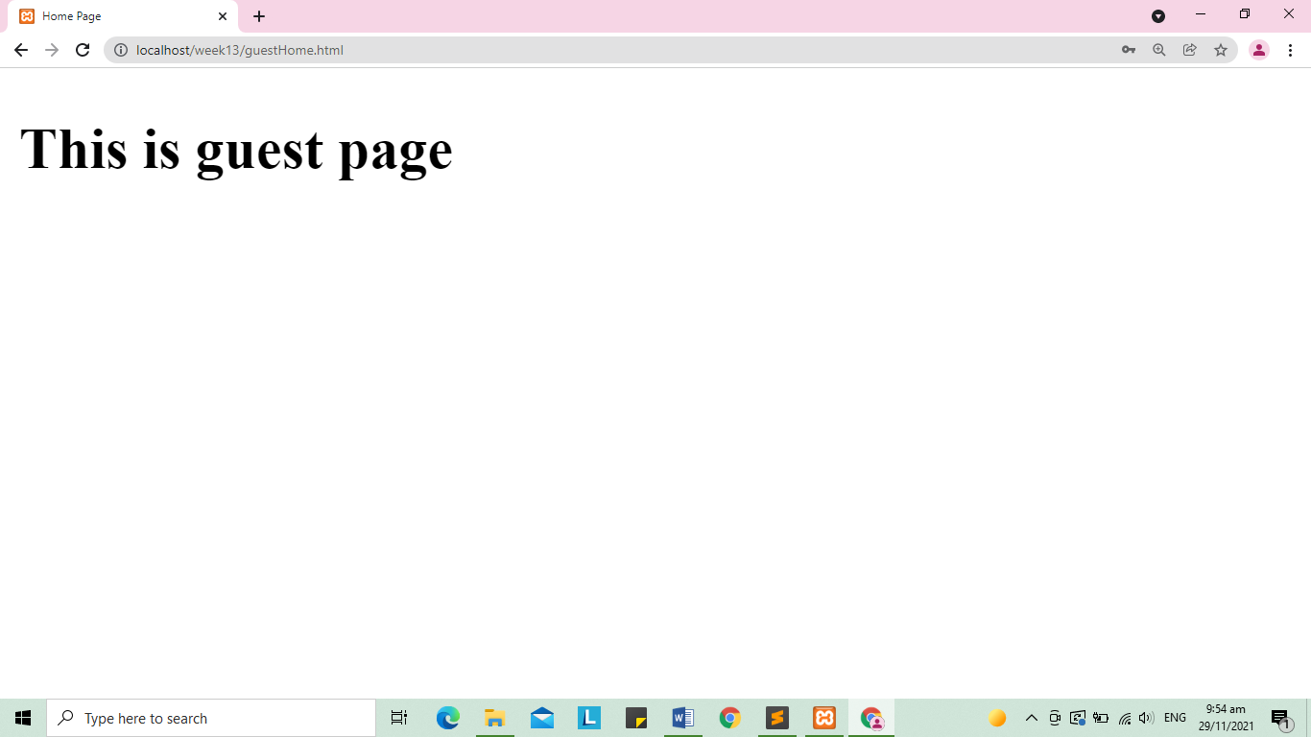

10. I have observed that there is a warning message saying “Failed to login, please to login again” after entering the “guest” in the username and “123” in the password.

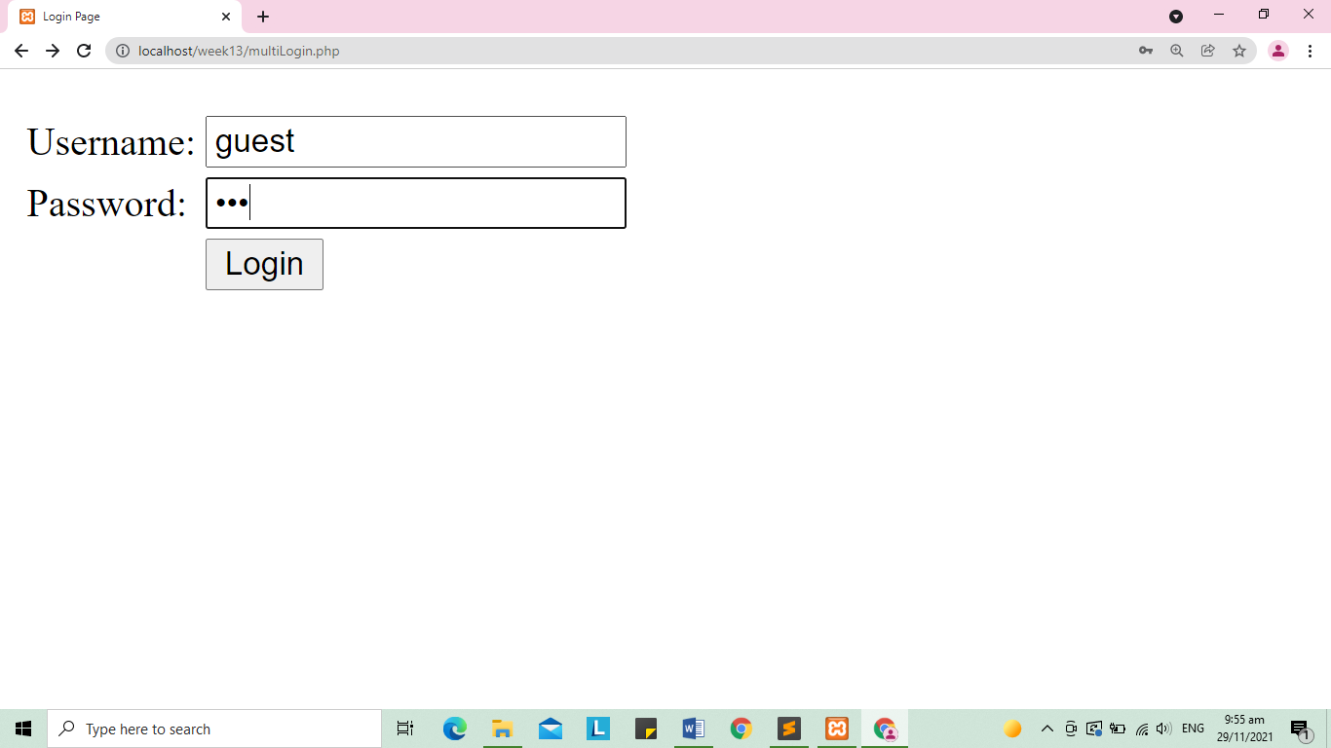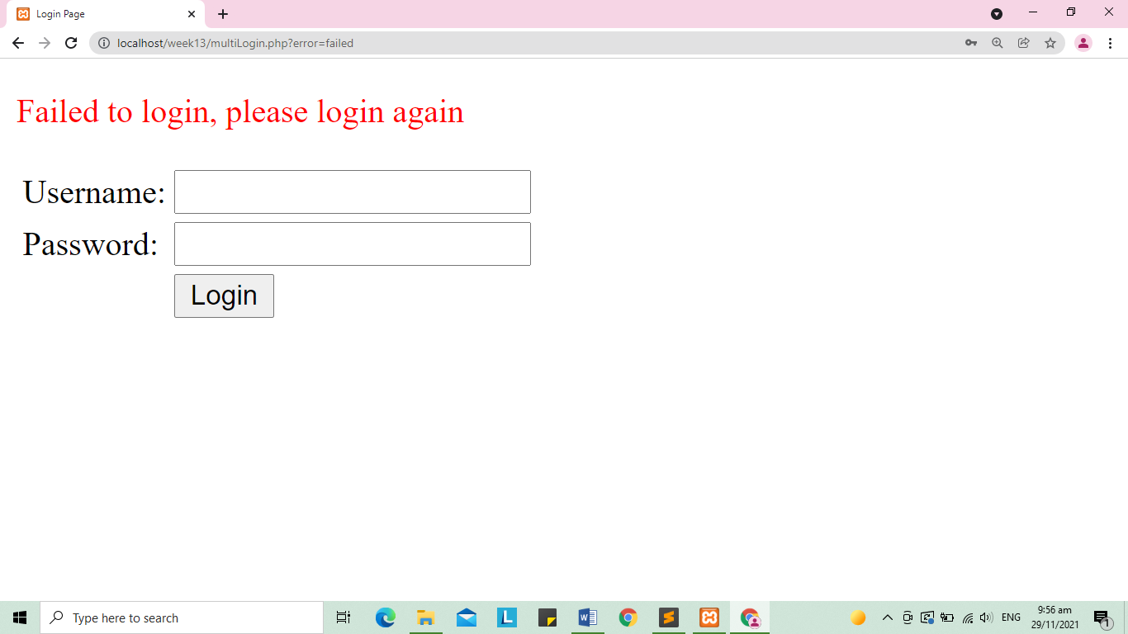

11. After opening the browser and run the program code in step 2 by typing localhost/week13/cookiesCall.php I have observed in my browser that there is something wrong because of there is a warning message displayed in my browser it said that there is an undefined array key “user”.

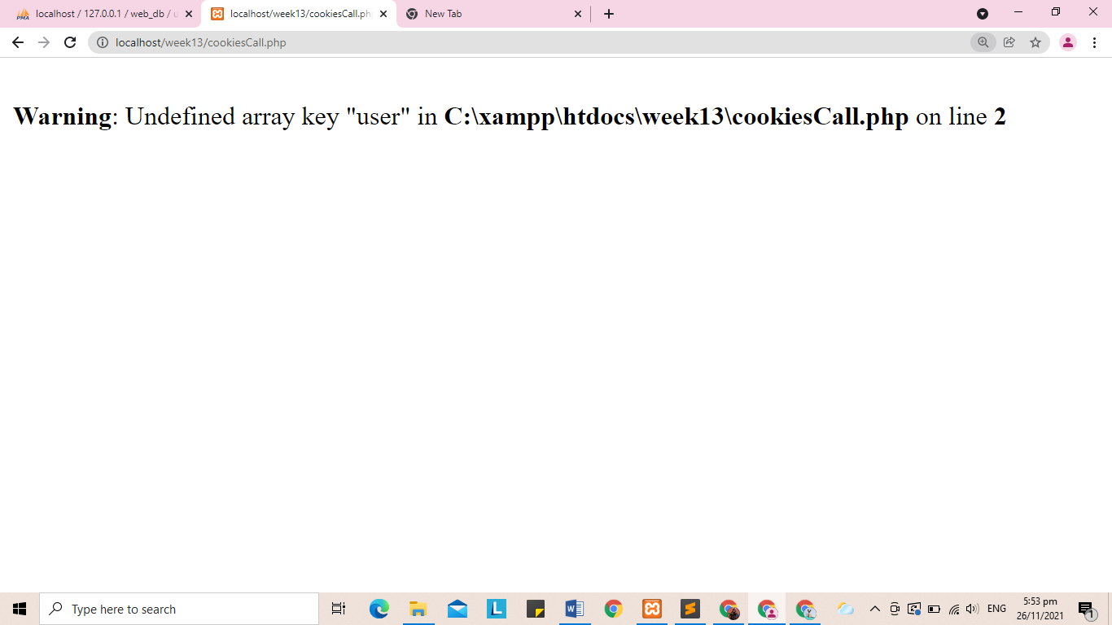

12. I followed the steps in number 3, first I open the browser and run the program code step 1 by typing localhost/week13/cookiesCreate.php I have observed that there is no any message displayed in my browser it just a plain white background but when I repeat to perform the step 3 and access the program code by localhost/week13/cookiesCall.php I have observe that there is message displayed already in my browser unlike the result in number 11, now the word “Polinema” was displayed in my browser. I understand that we need to run first the createCokies.php for us to call the word user and display the value which is the word Polinema. Also, I have learned in this part that we used and set cookies to save information like as a username that the site may access to customize the page the next time the visitor visits the website. Like other headers, cookies must be sent before any output from our script.

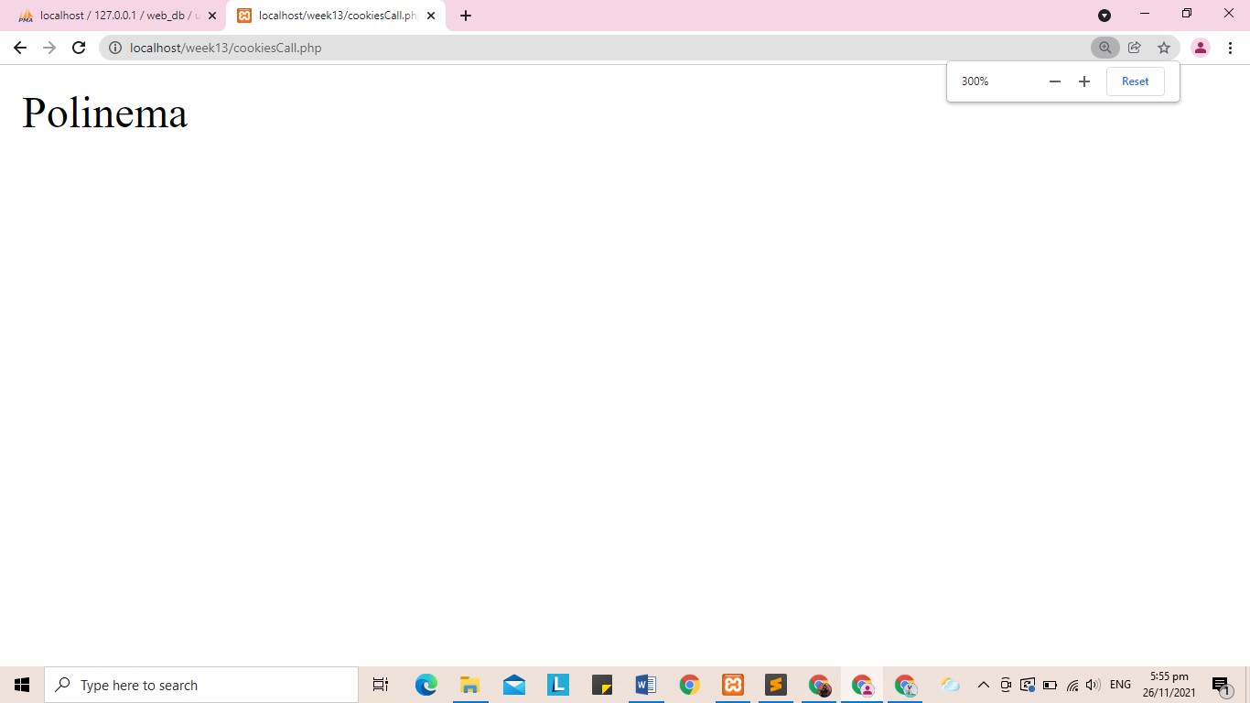

13. The result is the same in number 11 , there is a warning message because there is an undefined array key, this is because we run the cookiesDel.php , it deleted the cookies that we set.

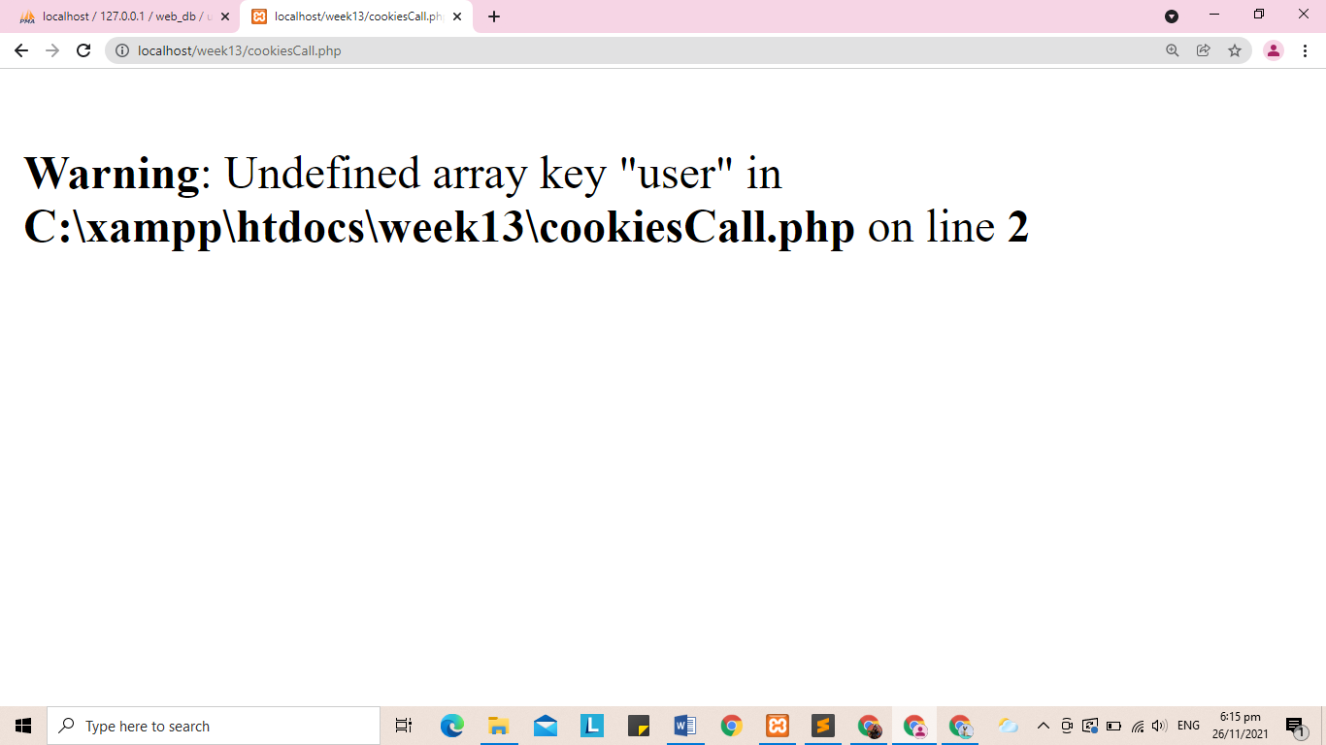

14. There is a warning message saying that there are two undefine array because we didn’t set first the ammount of comic and books and the transactionForm, I understand that we must acces it first and set the number of books and comics for us to acces the cart.php without any error or warning message

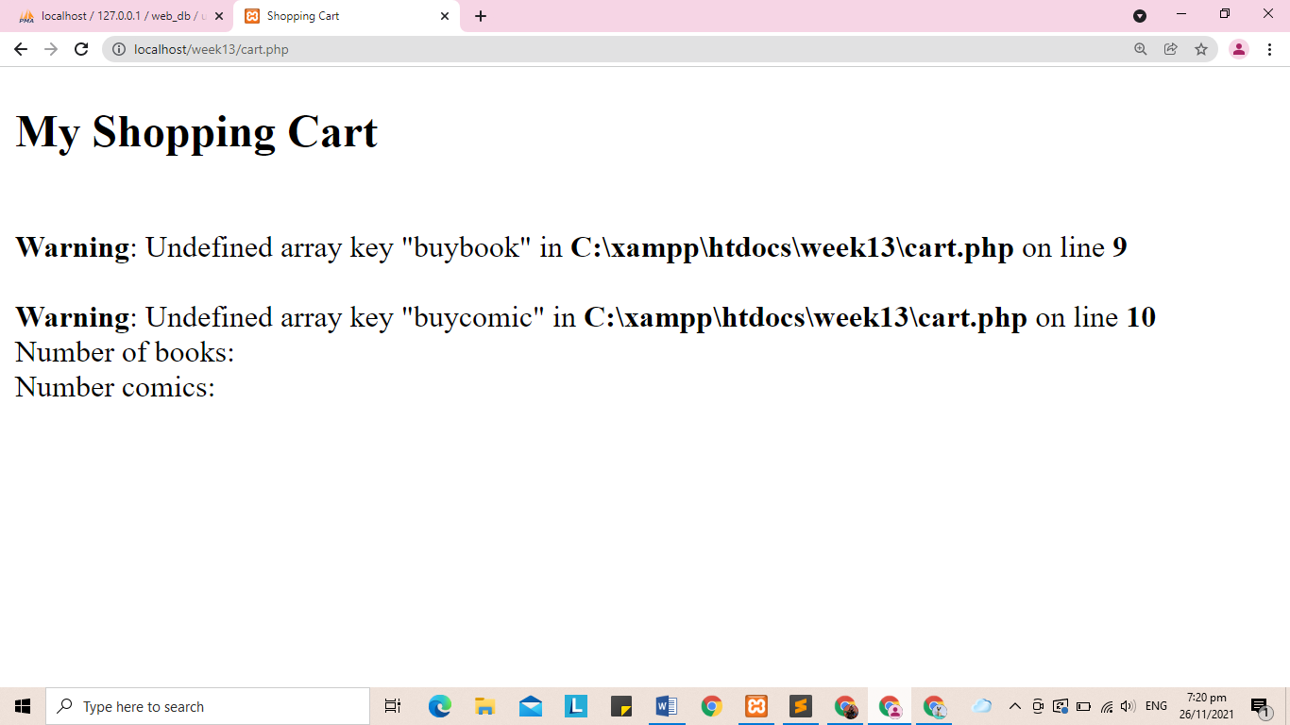

15. After accessing the transanctionform.html it shows the input asking me to set the number or amount of the books and comics, so I entered 4 for the books and 5 for the comics after that I click the submit button and I have observed that it will redirect me in the cart page and it displays/shows the number/amount of books and comics that I have entered in the transactionForm.html page.

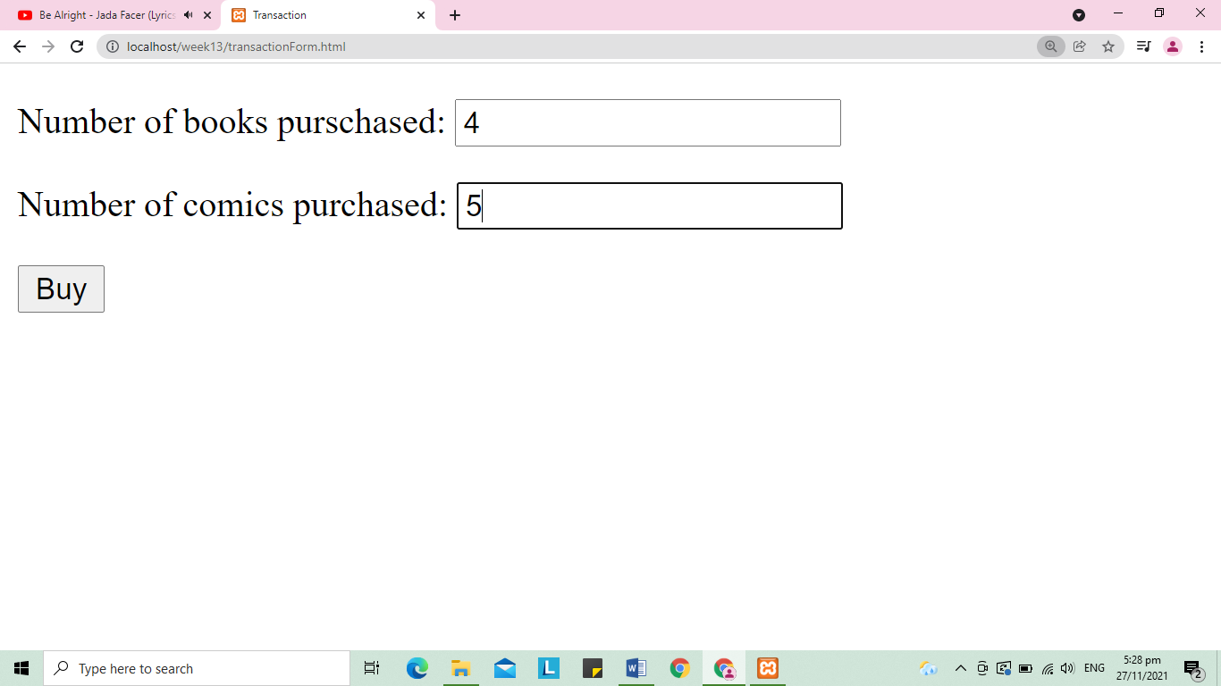

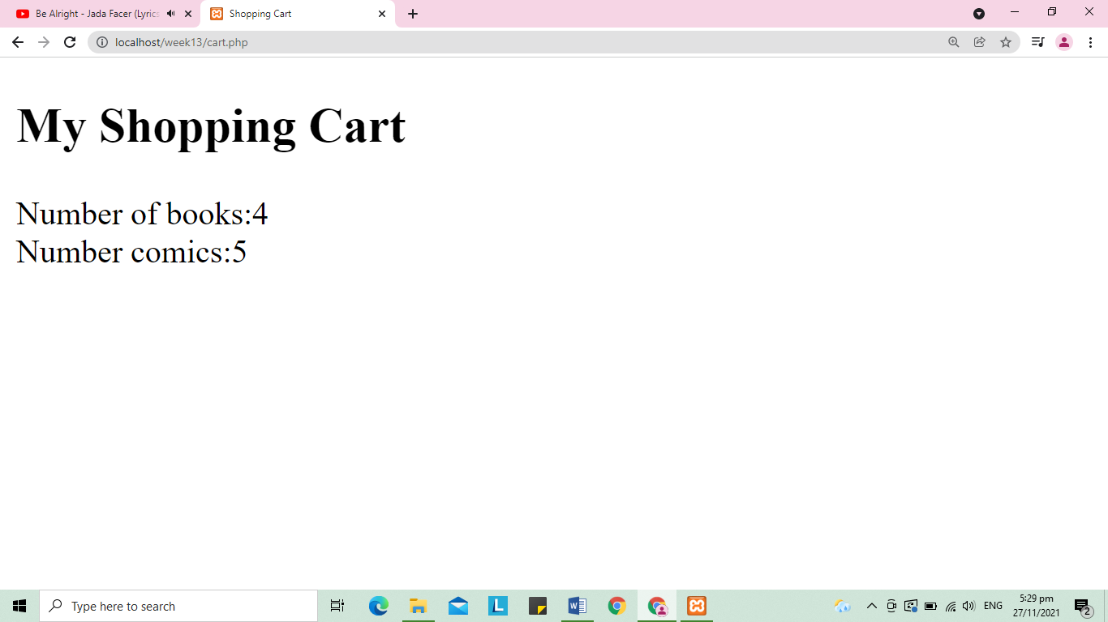

16. I have observed that it displays the same value/number of the books and comics, because it was saved in my browser.

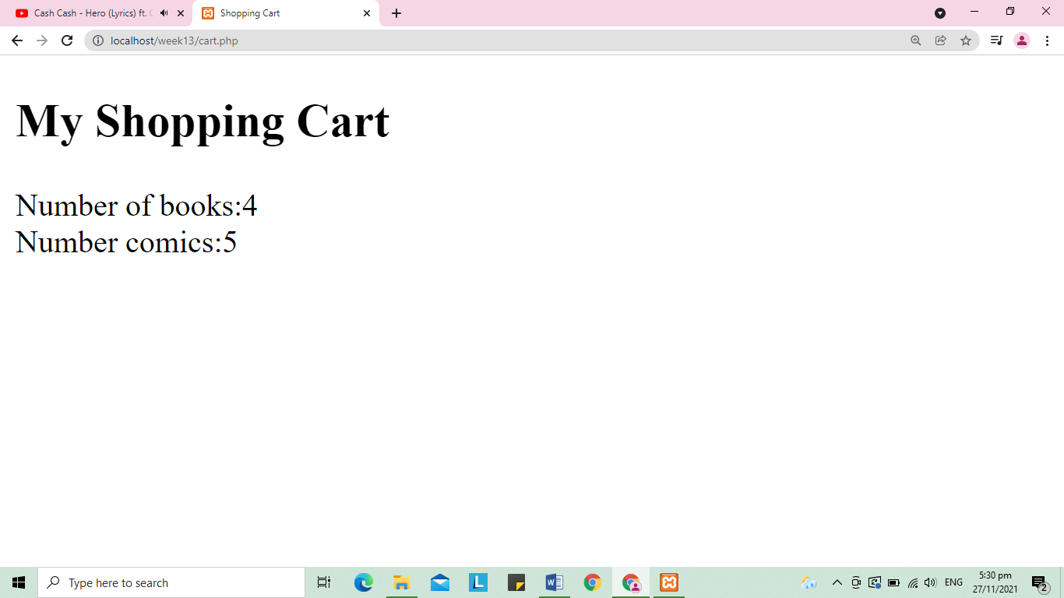

17. The image below is the result after opening the browser and run the program code in step 2 by typing localhost/week13/sessionCall.php. I saw that there is a warning message displayed in my browser saying there is an undefined array key, I understand and observed that there is a warning message because we need to run first the sessionCreate.php for us to call the session that we made.

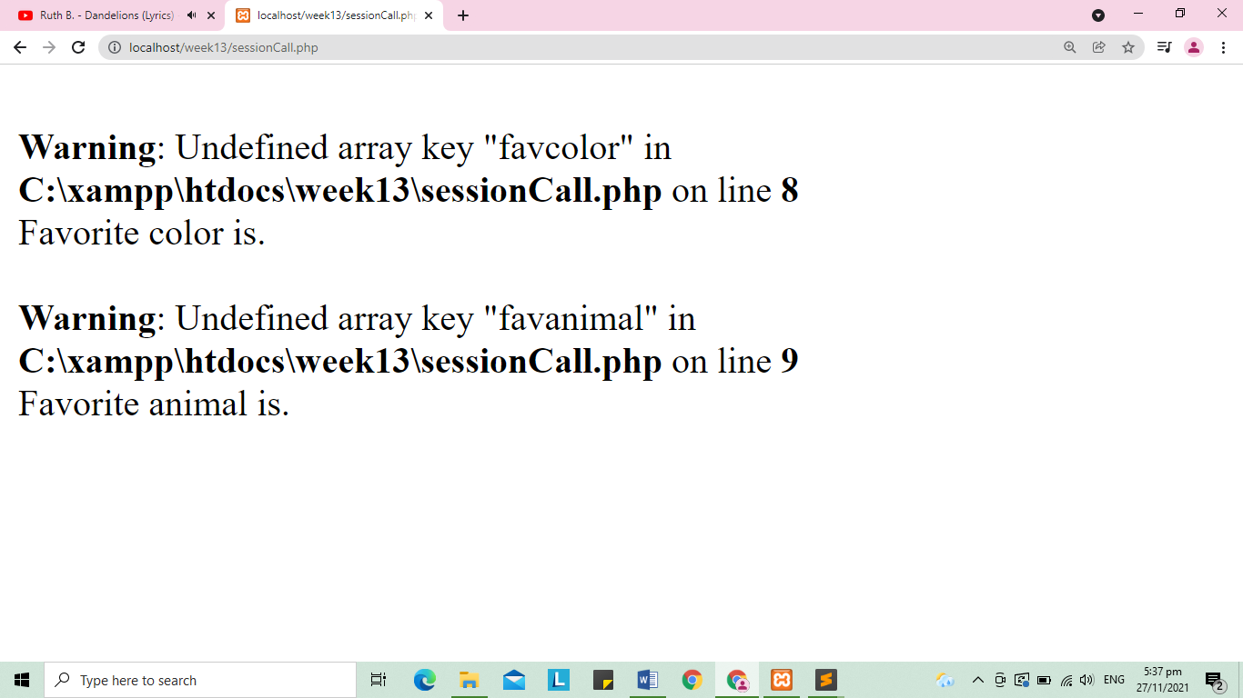

There is a message displayed when I run the sessionCreate.php it says that the session variable is set. So, I try to access again the program code in step 2 by typing the localhost/week13/sessionCall.php this time there is no warning message and it was displayed the two sentences “Favorite color is green.” and “Favorite color is cat.”. In this part I learned and understand that session_start() function must be sent to the browser as the first thing, else it will not operate properly. It must come before any HTML tags. It must come before attempting to access the $_SESSION data. Also, I understand the we to used $_SESSION to set and get session variable values. In other words, it is used to save data that you want to save between page loads as well as variables from the current session. This is the reason why does the word green and cat was displayed together with the connected message because we use $_SESSION to set these variables values and get or call these variable values.

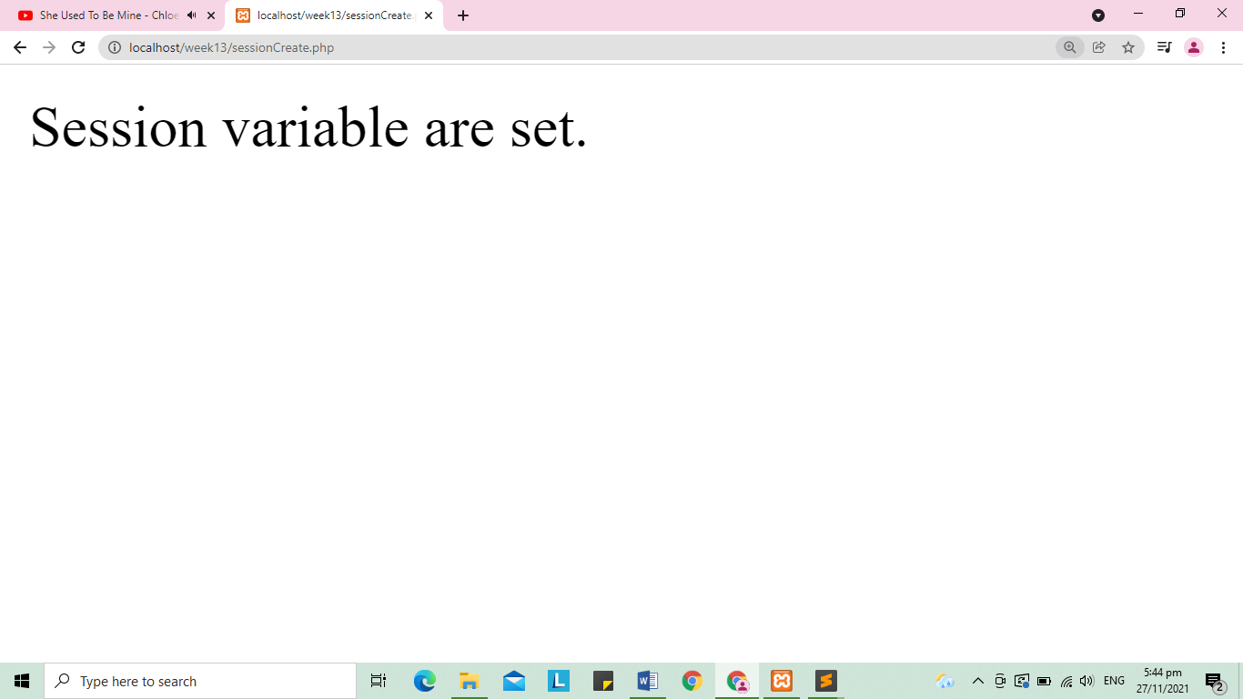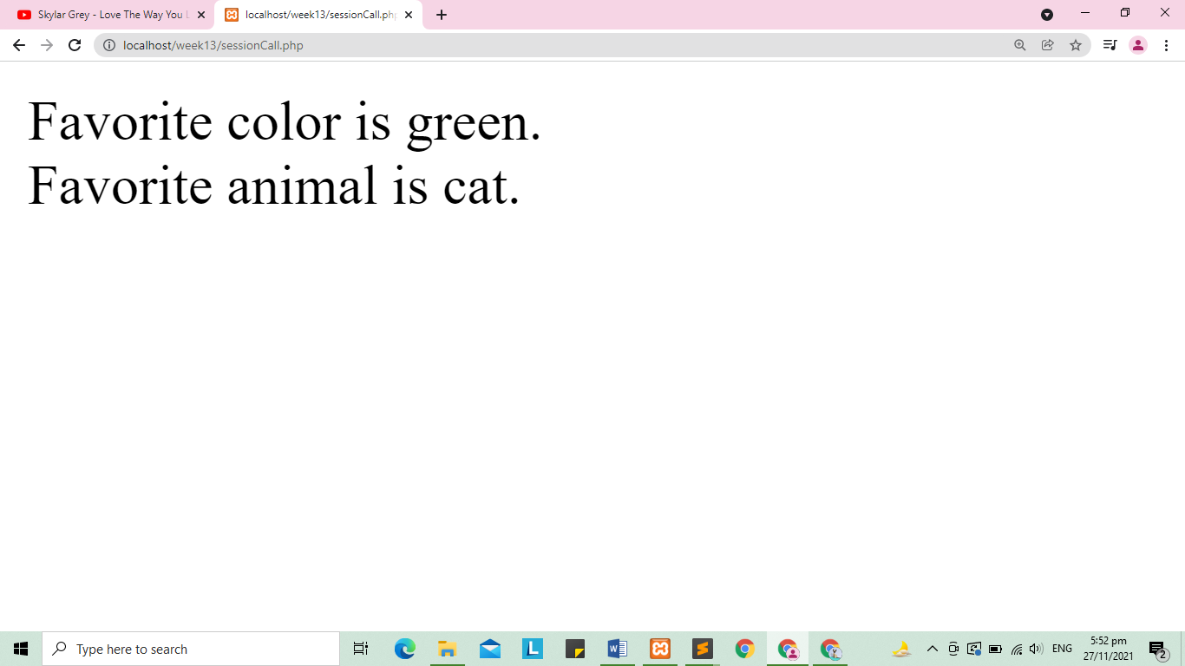

18. There is message displayed saying that “all session variables removed, and the session is destroyed” after accessing sessionDel.php. After that I access again the sessionCall.php and just like the result in number 17 there is a warning messaged displayed saying that there is an unidentified key, this means that the variables was deleted since we used session_unset() function. I have learned in this part that we used session_destroy() if we want to delete or destroy the whole session or data.

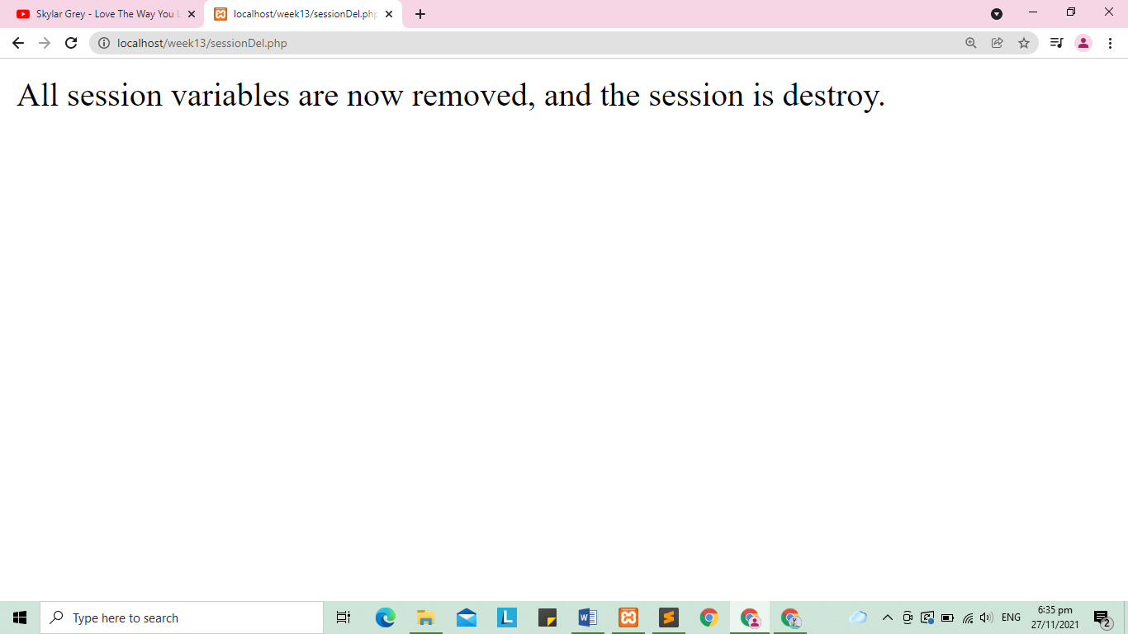

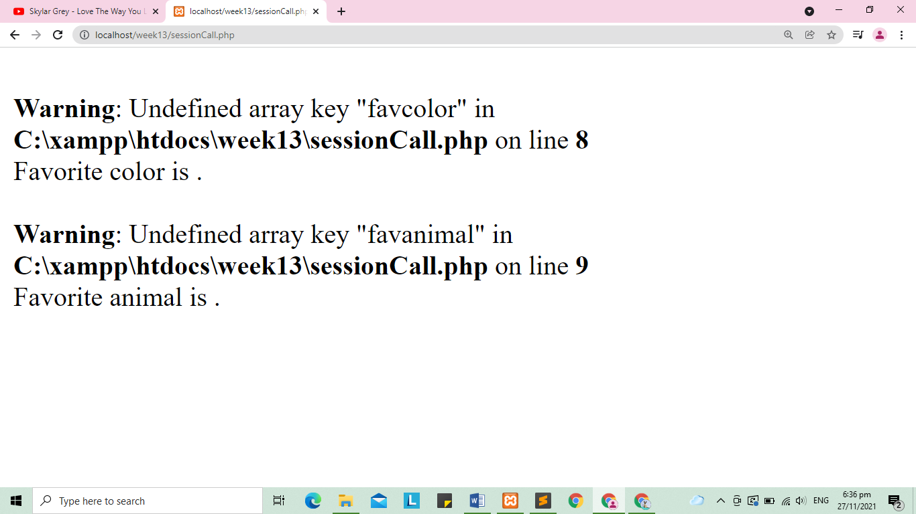

19. After accessing the sessionLoginForm.php I saw in my browser a login form, I entered the admin for the username and the password and when I click the submit button I redirects me to the to the home page, after that I click the logout and it was process the sessionLogout.php file and there is message saying I have successfully logged out.

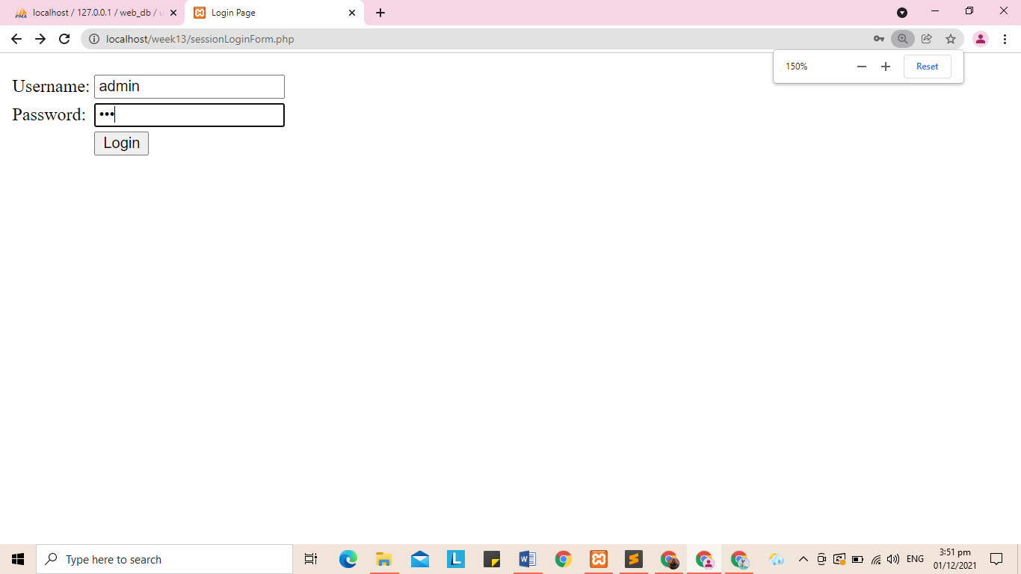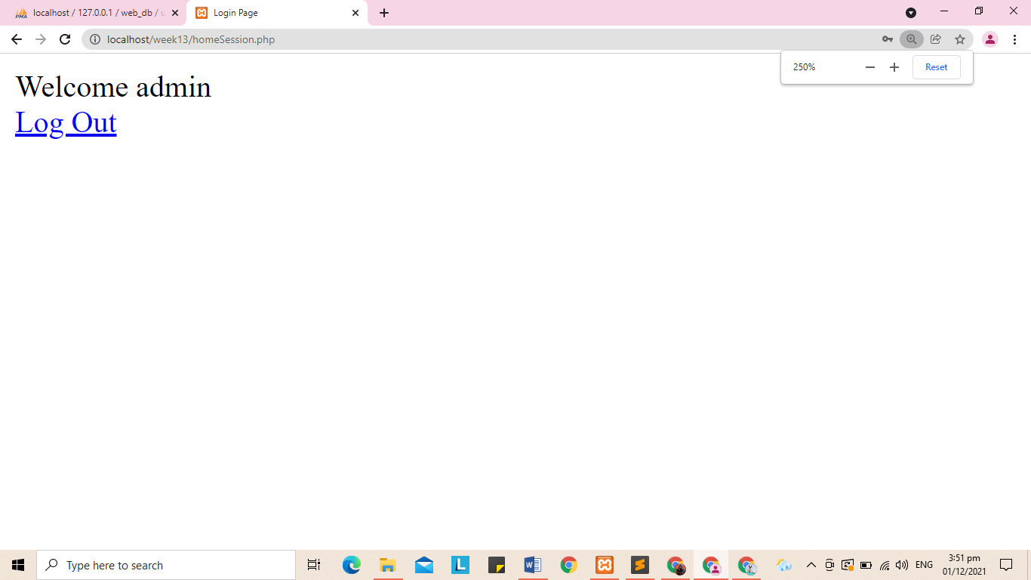

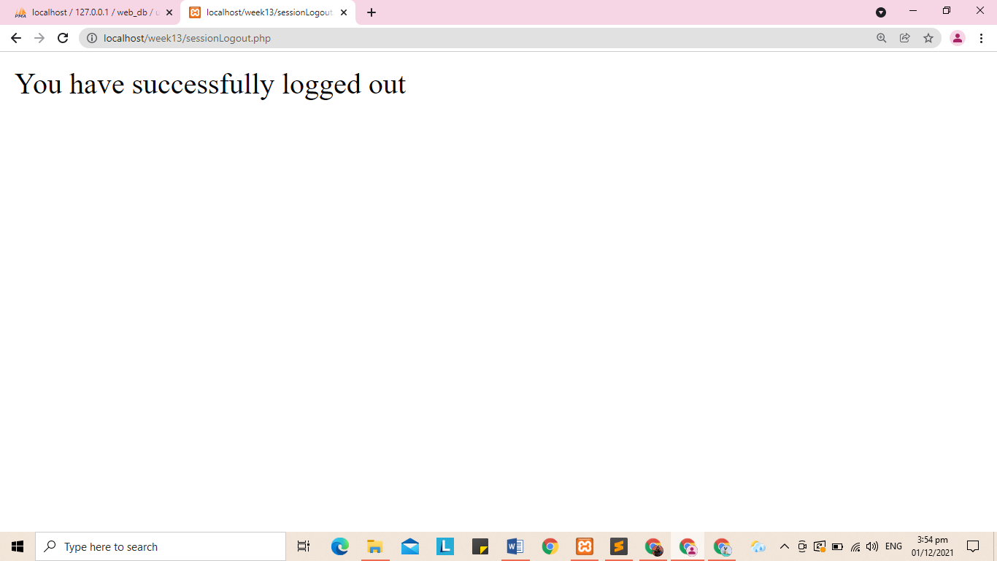

20. It shows that there is a warming message aftring directly accessing the home page and it has a message on it saying “ You are note logged in.Please Login” in when I click the link/word “Login” it ridirects me to the Login page.

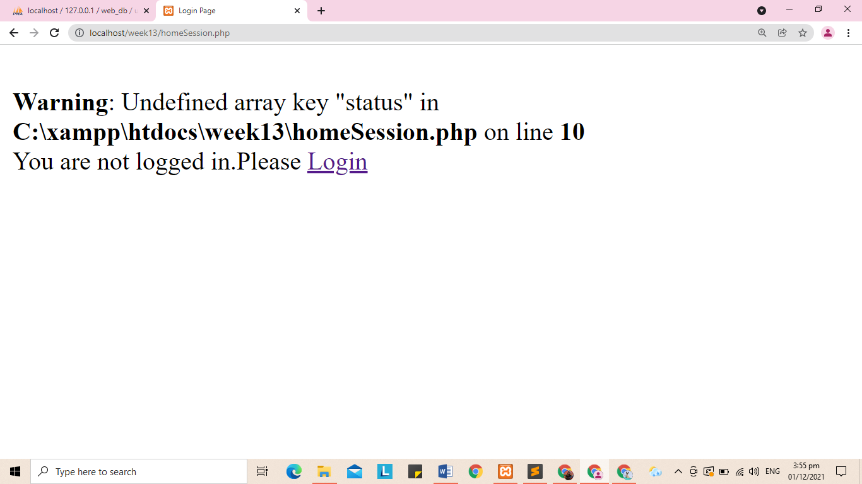

21. First the user must access the sessionLoginForm.php to access the form.Then the user will enter his/her username and password, that input from username and password will be processed by the sessionLoginProcess.php file. In the sessionLoginProcess file we used query and used the “SELECT” to select the username and password. When the username and password entered by the user was found in the database, it will start the session and save the session username and status(login), then with the help of header it will redirect the user in the homeSession.php file. In the home page it displays the welcome message and the logout link. If the user wants to logout he/she can click the logout link, in this part the sessionLogout.php file will be run and process.

So the first one to run is the sessionLoginForm.php, second to be process is the sessionLoginProcess.php file , the third one is the homeSession.php file, and last to process is the the sessionLogout.php file.