DSP Education Kit
LAB 03
Finite Impulse Response (FIR) Filters
Issue 1.0

Contents
1 Introduction 1
1.1 Lab overview 1
2 Requirements 1
3 The Moving Average Filter 1
4 Frequency Response of the Moving Average Filter 2
5 Observation of Frequency Response Using a Sinusoidal Input Signal 2
5.1 Exercise 4
6 Observation of Frequency Response Using a Pseudorandom Input Signal 5
6.1 Exercise 5
7 Higher-Order Moving Average Filters 6
7.1 Exercise 6
8 Finite Impulse Response (FIR) Filters 7
8.1 Exercise 7
9 FIR Filter Programs with Coefficients Specified in Separate Header File 9
10 Generating FIR Filter Coefficient Header Files Using MATLAB 9
11 Frequency Responses of Simple FIR Filters 11
11.1 Exercise 11
12 Designing a High Pass Filter Using the Window Method 13
12.1 Exercise 13
14 Conclusions 13
15 Additional References 13

Introduction

Lab overview
The examples in this exercise introduce some of the concepts of Finite Impulse Response (FIR) filtering. Also explored are various methods of estimating the magnitude frequency response of a filter implemented in real-time and the relative computational efficiency of different implementation options.

Requirements
To carry out this lab, you will need:
- An STM32F746G Discovery board
- A PC running Keil MDK-Arm
- MATLAB
- GoldWave
- An oscilloscope
- 3.5 mm audio jack
- An audio frequency signal generator
- Optional: External microphone, although you can also use the microphones on the board
- Optional: additional STM Discovery board and audio jack

The Moving Average Filter
The Moving Average filter is widely used in DSP and is arguably one of the easiest of all digital filters to understand. It is particularly effective at removing high-frequency random noise from a signal.
The moving average filter operates by taking the arithmetic mean, or average value of a number of past input samples, in order to form each output sample. This may be represented by the following equation:
$$y\left(n\right)=\frac{1}{N}\sum_{i=0}^{N-1}{x\left(n-i\right),}$$
where x(n) represents the nth sample of an input signal and y(n) is the nth sample of the filter output, which is equal to the average value of the previous N input samples. A ten-point moving average filter is implemented by the example program stm32f7_average.c.

Frequency Response of the Moving Average Filter
A simple experiment, using the test signal contained in file mefsin.wav, demonstrates that the moving average filter attenuates some frequency components of a signal more than others.
Listen to the test signal using GoldWave, Windows Media Player, or similar. It contains a recording of some speech corrupted by the addition of a sinusoidal tone. Then, connect the PC sound output to the LINE IN socket on the Discovery board. Alternatively, you could play the test signal using a smartphone. Run program stm32f7_average_intr.c on the Discovery board and use headphones connected to HEADPHONE OUT to listen to the filtered version of the test signal. You should find that the sinusoidal tone has been attenuated very significantly and that the speech sounds less bright than in the original signal. Both observations are consistent with the moving average filter having a low pass frequency response.
The subsequent exercises in this lab manual introduce a number of different, and more quantitative, methods of assessing the frequency response of the filter.
Note: The BSP has been modified to support simultaneous audio line-in and line-out.

Observation of Frequency Response Using a Sinusoidal Input Signal
The frequency response of a filter tells us its gain at different frequencies, and hence one way of assessing the frequency response of the filter is simply to measure its gain using a sinusoidal input signal at a number of different frequencies. As shown in Figure 1, connect the output of a sinusoidal signal generator to the LINE IN socket on the Discovery board and connect the HEADPHONE OUT socket either to an oscilloscope or to the input of the soundcard on a PC running GoldWave.

Figure 1: Connection diagram for measuring the magnitude frequency response of the five-point moving average filter implemented by program stm32_average.c using a signal generator and an oscilloscope
Figures 2 and 3 show the output from program stm32f7_average.c displayed using the Fast Fourier Transform (FFT) function of an oscilloscope and using the spectrum display in GoldWave. The input signals were sinusoids at frequencies of 2.0 kHz and 1.3 kHz, respectively. The trace shown in Figure 2 might be plotted as a single point on the sketch axes at 2.0 kHz and −20 dB, and Figure 3 might be plotted as a single point at 1.3 kHz and −30 dB. However, the calibration of the oscilloscope and of the PC soundcard will not be the same, and measurements from the two cannot be combined. The absolute level, in dBs, read from either is not important (and depends, in any case, on the amplitude of the input signal). What is important is its relative level across the range of frequencies measured using one or other method.
As the frequency of the inputs signal is varied, the amplitude of the output signal should change. The gain of the filter is higher at low frequencies than at high frequencies, and there are some frequencies at which the gain is almost zero. Overall, the moving average filter has a low pass characteristic.
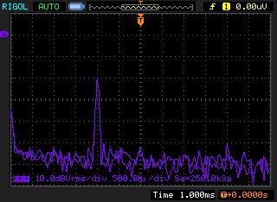
Figure 2: Output signal from program stm32f7_average.c viewed using FFT function of Rigol DS1052 oscilloscope. It’s difficult to read, but the text at the bottom of the screen indicates 500 Hz/div and 10 dBVrms/div. The marker on the left-hand side of the display indicates a level of 0 dBVrms
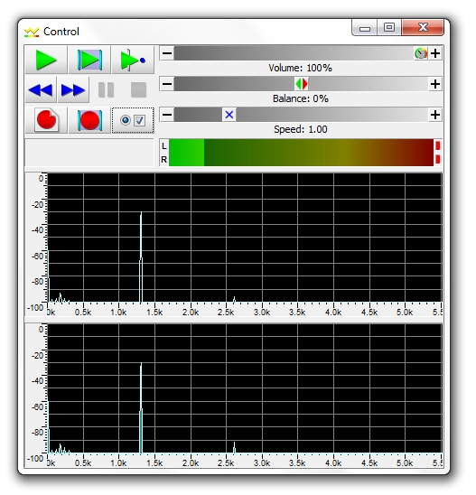
Figure 3: Output signal from program stm32f7_average.c viewed using spectrum display in GoldWave

Exercise
Run program stm32f7_average.c and vary the frequency of the applied sinusoid between 100 Hz and 5000 Hz. Keep the amplitude of the sinusoidal input signal constant at approximately 2 volts peak to peak. Record the amplitude of the output signal, at different frequencies, on the axes below.
Sketch of the magnitude frequency response of five point moving average filter implemented by program stm32f7_average.c and measured using sinusoidal input signals:

Observation of Frequency Response Using a Pseudorandom Input Signal
Alternatively, an indication of the magnitude frequency response of the filter may be obtained by applying a pseudorandom input signal, containing equally weighted components at all frequencies, to the filter and observing the spectral content of the filter output. Program stm32f7_average_prbs.c combines the moving average filter of program stm32f7_average.c with a pseudorandom noise generator (implemented within the program using function prbs()).

Exercise
Use either the FFT function of an oscilloscope or GoldWave to view the spectral content of the filtered noise output by the program. Sketch what you see on the axes below and verify that the results indicate a similar magnitude frequency response to that measured using a signal generator and plotted in the previous task.
Note: Using pseudorandom noise as a test signal is a quick and easy method of obtaining an indication of the magnitude frequency response of a filter.
Sketch of magnitude frequency response of ten point moving average filter measured using program stm32f7_average_prbs.c:

Higher-Order Moving Average Filters
What would happen if the moving average were calculated over a different number of previous samples?
Modify either program stm32f7_average_prbs_intr.c or program stm32f7_sysid_average_CMSIS_intr.c so that N = 20 and observe the frequency response of the twenty-point moving average filter using:
- either the FFT function of an oscilloscope or using GoldWave in the case of program stm32f7_average_prbs.c or
Record your observations in the exercise below.

Exercise
- Sketch of magnitude frequency response of twenty-point moving average filter:

Finite Impulse Response (FIR) Filters
What would happen if the values of the filter coefficients h(n) were changed? To answer this question, modify either program stm32f7_average_prbs.c again so that N = 10 and h[N] = {0.001953125, 0.017578125, 0.070312500, 0.164062500, 0.246093750, 0.246093750, 0.164062500, 0.070312500, 0.017578125, 0.001953125}.

Exercise
- Observe the frequency response of the filter and record your observations on the axes below.
You should find that higher frequencies are attenuated more than they were by the ten-point moving average filter and that the “notches” in the frequency response of the ten-point moving average filter at 1600 Hz and 3200 Hz have disappeared. You have effectively applied a Hann window to the coefficients of the ten-point moving average filter.

Magnitude frequency response of ten-point moving average filter with Hann window:

- Changing the values of the filter coefficients has (not unexpectedly) changed the magnitude frequency of the filter.
Use the Discrete Time Fourier transform (DTFT) to derive an algebraic expression for the frequency response of the filter having coefficients h[N] = {0.001953125, 0.017578125, 0.070312500, 0.164062500, 0.246093750, 0.246093750, 0.164062500, 0.070312500, 0.017578125, 0.001953125}. Write down each step of the derivation in the space provided below and sketch the magnitude of that theoretical frequency response on the axes.
Derivation of theoretical frequency response of five-point moving average filter with Hann window using DTFT:

Theoretical magnitude frequency response of five-point moving average filter with Hann window:

FIR Filter Programs with Coefficients Specified in Separate Header File
Programs stm32f7_fir.c and stm32f7_fir_prbs.c implement FIR filters for which the filter coefficients h(n) are not specified within these source files but are read from a separate header file. To change the characteristics of the FIR filters implemented by these programs, simply add the preprocessor command
for example,
#include “lp33.h”
and Rebuild the project.

Note: Additional header and source files are provided in the lab-specific folder provided.
The file maf5.h listed in the following code snippet contains filter coefficient values that will result in implementation of a five-point moving average filter.
// maf5.h
// this file was generated using function stm32f7_fir_coeffs.m

#define N 5

float h[N]={0.2, 0.2, 0.2, 0.2, 0.2};

Several different example coefficient files have been provided. Investigate the characteristics of one or two of these using the program stm32f7_fir_prbs.c and observe the filtered noise signal output at HEADPHONE OUT using an oscilloscope or GoldWave the graphs on the LCD.

Generating FIR Filter Coefficient Header Files Using MATLAB
If the number of filter coefficients is small, a coefficient header file may be edited by hand. To be compatible with program stm32f7_fir.c and others, a coefficient header file must define a constant N and declare and initialize the contents of an array h[], which contains N floating point values.
For larger numbers of coefficients, the MATLAB function stm32f7_fir_coeffs(), defined in file stm32f7_fir_coeffs.m, can be used. This function should be passed a MATLAB array of real-valued coefficient values and will prompt the user for an output filename.
For example, the coefficient file maf5.h was created by typing the following at the MATLAB command prompt.
>> x = [0.2, 0.2, 0.2, 0.2, 0.2]
>> stm32f7_fir_coeffs(x)
enter filename for coefficients maf5.h

The coefficient filename must be entered in full, including the suffix .h.
Alternatively, the MATLAB filter design and analysis tool filterDesigner can be used to calculate FIR filter coefficients and to export them to the MATLAB workspace (File – Export… – Export To Workspace / Export As Coefficients). Then, function stm32f7_fir_coeffs() can be used to create a coefficient file compatible with programs including stm32f7_fir.c. It is recommended that the filter coefficients values passed to function stm32f7_fir_coeffs() are normalized such that their gain is unity. filterDesigner does it automatically, but if you are designing filter coefficients without the aid of filterDesigner, you should aim for a passband gain of 1.
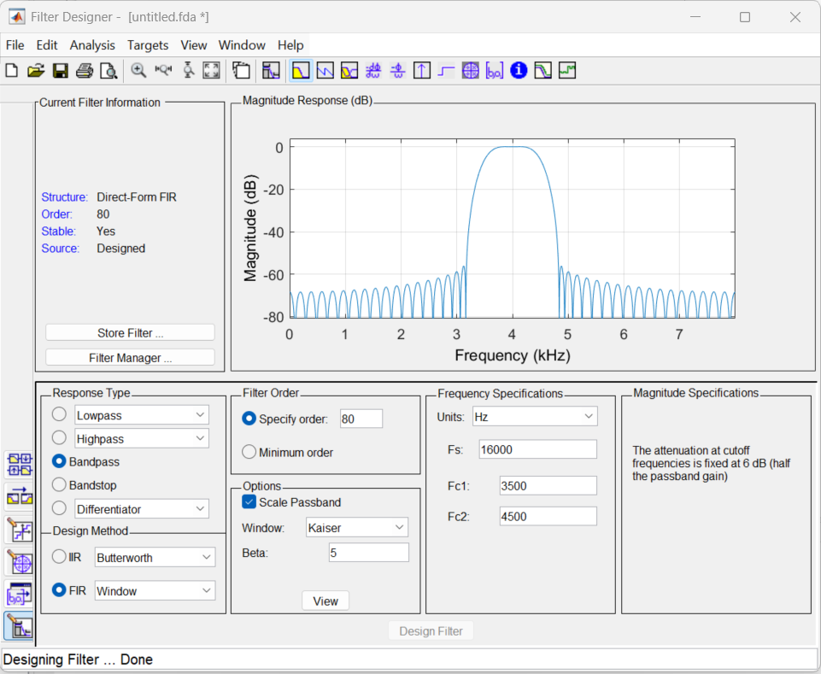

Figure 7: Design of a bandpass FIR filter using MATLAB filterDesigner
Coefficient header file bp1750.h was generated using MATLAB function stm32f7_fir_coeffs()after designing the filter using filterDesigner (as shown in Figure 7).

Frequency Responses of Simple FIR Filters

Exercise
Using the techniques introduced in this lab, for the following three sets of coefficients
Filter X: h(n) = {0.2, 0.4, -0.4, -0.2}
Filter Y: h(n) = {0.5, -0.5}
Filter Z: h(n) = {0.5, 1.0, 0.5}
- Derive the theoretical frequency response, showing your working, and sketching the magnitude and phase frequency responses on the axes below.

Filter X:

Filter Y:
Filter Z:

Designing a High Pass Filter Using the Window Method

Exercise
Create a coefficient file myhpf.h for use with programs stm32f7_fir.c and stm32f7_fir_prbs.c that will implement a high pass filter at sample frequency 8000 Hz, with a cutoff frequency of 2 kHz and which uses N = 31 coefficients.
If you use MATLAB to create a vector of coefficient values, you can generate a header file using the function stm32f7_fir_coeffs().
Compare the theoretical magnitude frequency response of your design with its magnitude frequency response measured using the program stm32f7_fir_prbs.c.

Conclusions
This laboratory exercise has introduced the FIR filter and explored several different methods of measuring its characteristics in the time and frequency domains.

Additional References
Moving average filters:
https://www.analog.com/media/en/technical-documentation/dsp-book/dsp_book_Ch15.pdf

