introduction to linux kernel and application profiling

goal
The goal of this lab is to enable you to use the Arm Development Studio Streamline tool to profile the execution of code running on the Raspberry Pi 5.

prerequisites
To follow this Lab, you need:
- Raspberry Pi 5 board full;
- USB-C power supply for Raspberry Pi 5 (official 27W Raspberry Pi 5 power supply recommended);
- 8 GB Micro SD card (32 GB card recommended);
- USB-to-Serial debug module for Raspberry Pi 5 or USB-to-TTL adapter;
- A host PC installed with Ubuntu Desktop 22.04 LTS or 24.04 LTS, or a virtual machine hosting Ubuntu Desktop with at least 100 GB of free space (recommend Ubuntu 24.04 LTS natively, but it’s possible to run via Windows WSL 2);
- A Micro SD card reader attached to the host PC/virtual machine;
- An Ethernet cable connecting the host PC/virtual machine with the Raspberry Pi 5;
- The Arm Development Studio tool installed on your development host (this will be covered in the lab);
- (Optional) Micro HDMI cable.

workplace setup
Assuming you have completed all the previous labs, move to the raspberrypi5 directory and prepare the build environment:
cd ~/raspberrypi5
source sources/poky/oe-init-build-env rpi-build
You now have the system ready to build the embedded Linux distribution for the Raspberry Pi 5. We now need to:
- Customize the configuration of the Linux kernel to activate the functionalities required for code profiling, which involves measuring the execution time of code on the Raspberry Pi 5 target.
- Prepare the Yocto recipe to deploy Streamline-specific kernel modules and middleware to the Raspberry Pi 5.

Configuring the kernel
To configure the Linux kernel, you need to modify the Linux configuration file (.config) using the kernel configuration utility. To do this, proceed as follows:
Run the following command:
bitbake linux-raspberrypi -c devshell
This command instructs the Yocto build system to prepare the Linux kernel for compilation (bitbake linux-raspberrypi) and to open a development shell (option -c devshell) with the build system configured for the selected recipe (linux-raspberrypi). From this development shell, you can run the Linux kernel configuration utility as follows:
make menuconfig
Customize the Linux kernel configuration as follows (in the list below, an asterisk indicates that the option should be selected. Press the spacebar to select a highlighted option:
General setup --->
[*] Embedded system
Kernel Performance Events and Counter --->
[*] Kernel Performance Events and Counter
[*] Profiling support
Kernel features --->
[*] Enable hardware performance counter support for perf events
Kernel hacking --->
-*- Kernel debugging
[*] Tracers --->
[*] Kernel Function Tracer
[*] Kernel Function Tracer Graph
[*] Interrupts-off Latency Tracer
[*] Preemption-off Latency Tracer
[*] Scheduling Latency Tracer
[*] Trace syscalls
-*- Create a snapshot trace buffer
-*- Allow snapshot to swap per CPU
[*] enable/disable function tracing dynamically
[*] Kernel function profiler
When you finish this configuration, exit the Linux configuration utility, which saves the configuration to the .config file. The current configuration is valid only for the current instance of the bitbake command. If you close the development shell, thereby terminating the current instance of the bitbake command, the next instance will revert to the default configuration. Therefore, you need to make the current configuration the new default. To do this, copy the newly generated .config file to the default configuration file in the linux-raspberrypi recipe as follows:
cd /home/user/raspberrypi5/rpi-build/tmp-glibc/work/raspberrypi5-oe-linux/linux-raspberrypi/6.1.77+git/linux-raspberrypi5-standard-build
Your exact directory name will have a similar form to the following. You can find it using a command such as:
find . -name ".config"
in a parent directory.
Next, copy this file as follows:
# first create directory if it’s missing
mkdir ~/raspberrypi5/sources/meta-raspberrypi/recipes-kernel/linux/linux-raspberrypi

# then copy the config file
cp .config ~/raspberrypi5/sources/meta-raspberrypi/recipes-kernel/linux/linux-raspberrypi/defconfig
This command makes the customizations to the Linux kernel configuration permanent.

Preparing the recipes
To profile the execution of code on the Raspberry Pi 5, we will use the Streamline tool, which is part of the Arm Development Studio suite.
To install the Arm Development Studio trial version, visit https://developer.arm.com/tools-and-software/embedded/arm-development-studio.
Select "Evaluate for free" and follow the on-page instructions to download and install it. Note that university educators can request free licenses for Arm Development Studio by completing a software request form at https://www.arm.com/resources/education/education-kits/software-form
A Unix shell script file will be downloaded, which can be executed to install Arm Development Studio. Note that this requires sudo/root privileges. It is also possible to install Arm Development Studio on Windows.
On my Ubuntu PC, streamline is installed by default at:
/opt/arm/developmentstudio-2024.1-1/bin/streamline
Streamline uses three cooperating elements to perform profiling:
- gator.ko - a kernel module built for the target Linux kernel running on the Raspberry Pi 5, providing controlled user-level access to Arm performance counters.
- gatord – a service that can be installed on the Raspberry Pi 5 to interact with gator.ko to collect the performance counter values and deliver them through the Ethernet network to the development host.
- streamline - an application running on the development host PC that configures the operations of gator.ko and gatord, and displays the gathered execution traces.
These components can be built from source . However, it is also possible to use the pre-built gatord binary that is included with Arm Development Studio. This binary can be found at /opt/arm/developmentstudio-2024.1-1/sw/streamline/bin/linux/arm64/gatord and it can be copied directly onto the Micro SD card and executed on the Raspberry Pi 5.

Building and deploying the new system
You are now ready to build the new system as follows:
cd ~/raspberrypi5/rpi-build
bitbake -c clean rpi-test-image
bitbake rpi-test-image
After a while, a new Micro SD card image should be available, which you can deploy to the Micro SD card as follows (assuming the card is available to the PC as /dev/sdN). Alternatively, you can use a program of your choice to flash the image.
First, run the:
sudo fdisk -l
command to determine which device to flash (plug in and unplug the SD card to identify it). In this example, the SD card is named “sdc” (this may differ in your environment). Next, ensure that the device is unmounted. This can be done using the following command:
sudo umount /dev/sdc*
Once this is done, use the following command to copy the image to the SD card (substitute any folder names and device names to match your specific environment).
sudo dd bs=1M if=/home/user/raspberrypi5/rpi-build/tmp/deploy/images/raspberrypi5/rpi-basic-image-raspberrypi5.rpi-sdimg of=/dev/sdc
Note that if this is not done correctly, the image flashed to the SD card may cause problems when attempting to power on the board. If this happens, retry the process and ensure that it is completed properly, or use a flashing program to automate the process.
Also note that this time, the most recently built image should be in the “tmp” folder, not “tmp-glibc”.

Running the module
After booting the new Linux system, and logging into the Raspberry Pi 5, you can enter the following commands:
root@raspberrypi5:/# chmod +x /usr/bin/gatord
root@raspberrypi5:/# /usr/bin/gatord &
These commands prepare and launch the gatord daemon, enabling the Raspberry Pi 5 to communicate with Arm Streamline on the host system for performance data capture.

Finally, you need to set up the IP address of the target by editing the /etc/network/interfaces file and modifying the configuration of the network device eth0 as follows:
# Wired or wireless interfaces
auto eth0
iface eth0 inet static
address 192.168.1.2
netmask 255.255.255.0
gateway 192.168.1.255
Make sure that the Raspberry Pi 5 is connected to the development host PC via an Ethernet cable and that the IP address of the Ethernet connection on the development host is 192.168.1.1.

Profiling the target
To profile code execution on the Raspberry Pi 5 device, you need to start Streamline on the development host PC, but first, you must add it to the PATH:
export PATH=/opt/arm/developmentstudio-2024.1-1/bin:$PATH
Reload the shell configuration:
source ~/.bashrc

You should now be able to call Streamline directly:

Development-host@ubuntu:~/$ streamline &
If you are using a Windows machine, find and run the Streamline application.
Then, click the Capture & Analysis button, followed by the Configure button:
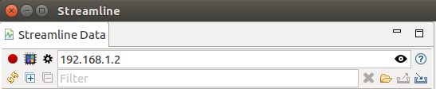
In the dialog window, configure the connection address by setting it to 192.168.1.2, as shown below. Then, click the Add ELF image button on the Program Images section (the first icon on the left), and add the ELF binary image of the Linux kernel located at:
/home/user/raspberrypi5/rpi-build/tmp/work/raspberrypi5-poky-linux-gnu/linux-raspberrypi/1_6.1.xx/linux-raspberrypi5-standard-build/vmlinux

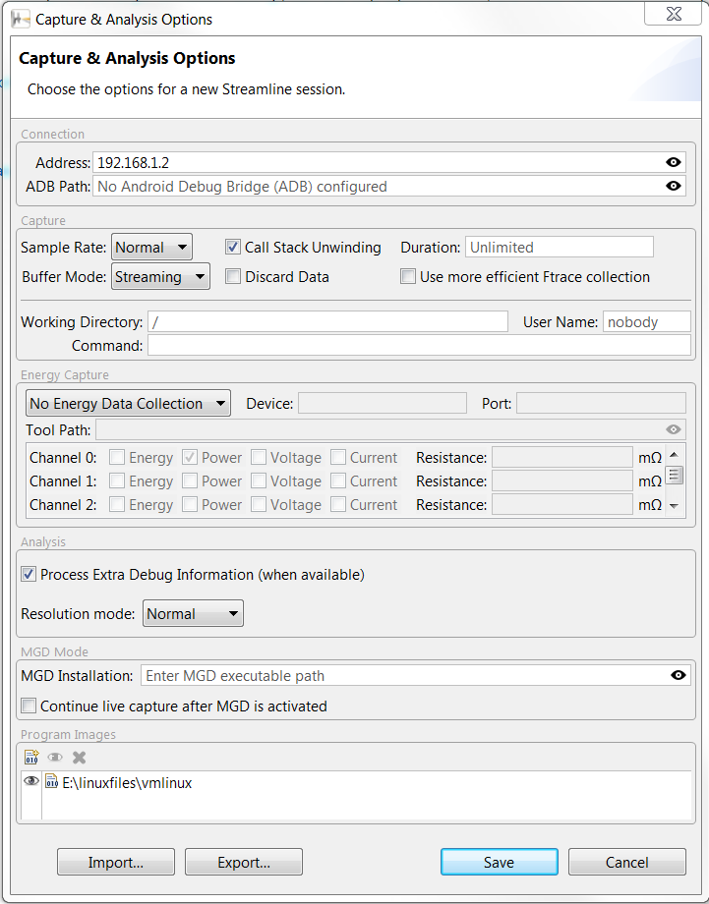
Streamline uses the symbols in the ELF files to decode the profiling timeline collected on the target and display the collected data in a useful format.
When finished, click on Save.
You can then click Start capture, and after specifying where to save the collected timeline, the main window of Streamline will begin displaying Raspberry Pi 5 activity.
While Streamline is running, execute the top command on the target console to obtain the following output:
top - 14:04:35 up 2 min, 1 user, load average: 0.11, 0.05, 0.02
Tasks: 82 total, 1 running, 81 sleeping, 0 stopped, 0 zombie
%Cpu(s): 1.3 us, 5.1 sy, 0.0 ni, 91.4 id, 2.0 wa, 0.0 hi, 0.3 si, 0.0 st
KiB Mem : 1016600 total, 815980 free, 161220 used, 39400 buff/cache
KiB Swap: 0 total, 0 free, 0 used. 833040 avail Mem

PID USER PR NI VIRT RES SHR S %CPU %MEM TIME+ COMMAND
455 root 20 0 3012 1096 832 R 17.6 0.1 0:00.08 top
1 root 20 0 1712 580 516 S 0.0 0.1 0:01.52 init
2 root 20 0 0 0 0 S 0.0 0.0 0:00.00 kthreadd
3 root 20 0 0 0 0 S 0.0 0.0 0:00.03 ksoftirqd/0
4 root 20 0 0 0 0 S 0.0 0.0 0:00.00 kworker/0:0
5 root 0 -20 0 0 0 S 0.0 0.0 0:00.00 kworker/0:0H
6 root 20 0 0 0 0 S 0.0 0.0 0:00.00 kworker/u2:0
7 root 20 0 0 0 0 S 0.0 0.0 0:00.04 rcu_preempt
8 root 20 0 0 0 0 S 0.0 0.0 0:00.00 rcu_sched
9 root 20 0 0 0 0 S 0.0 0.0 0:00.00 rcu_bh
10 root rt 0 0 0 0 S 0.0 0.0 0:00.00 migration/0
11 root 0 -20 0 0 0 S 0.0 0.0 0:00.00 khelper
12 root 20 0 0 0 0 S 0.0 0.0 0:00.00 kdevtmpfs
13 root 0 -20 0 0 0 S 0.0 0.0 0:00.00 writeback
14 root 0 -20 0 0 0 S 0.0 0.0 0:00.00 bioset
15 root 0 -20 0 0 0 S 0.0 0.0 0:00.00 crypto
16 root 0 -20 0 0 0 S 0.0 0.0 0:00.00 kblockd

root@raspberrypi3:~#
While top is running on the Raspberry Pi 5, you can observe increased CPU activity associated with the top process on the Streamline timeline
(in the example below, top was executed from second 4 to about second 5).
After collecting few seconds of data, click Stop. The resulting timeline should appear as shown below (refer to the Streamline manual for details on interpreting the output):
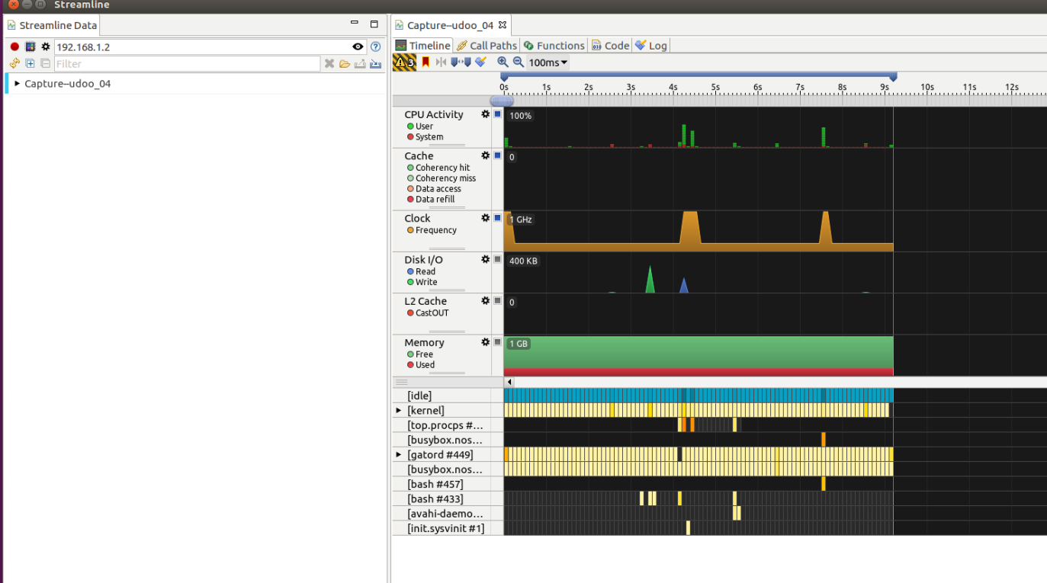

Post-lab practice
In the previous lab, you successfully enabled and used the debugger for a given program. The GNU debugger provides a wide range of functionalities, and we will be using them extensively in this session. In addition to the GNU debugger, you have also used Streamline for resource monitoring in the current lab. This is particularly useful when examining execution time, memory usage, and the clock frequency of a running program.
Now run the executable hello (or helloChallenge) file that is provided with this challenge. This program is compiled with debugging features enabled. Note that the program is completely different from the one used in the lab. Try to answer the questions with the help of GNU debugger and Streamline.

1. Use an appropriate tool to identify the program, explain its functionality and operation.
A: The program is provided as an executable. However, you can always view the source code using the list command in the GNU debugger. Assuming your image is from the previous lab with debugging features enabled, simply run it on your Raspberry Pi 5:
root@raspberrypi5:~# gdbserver localhost:2000 hello
Then, set up your host by typing the following in the terminal:
. /opt/poky/5.0.11/environment-setup-cortexa76-poky-linux
And start the remote debugger:
~/hello-dbg$ aarch64-poky-linux-gdb hello

GNU gdb (GDB) 14.2
Copyright (C) 2023 Free Software Foundation, Inc.
License GPLv3+: GNU GPL version 3 or later <http://gnu.org/licenses/gpl.html>
This is free software: you are free to change and redistribute it.
There is NO WARRANTY, to the extent permitted by law. Type "show copying"
and "show warranty" for details.
This GDB was configured as "--host=x86_64-pokysdk-linux --target=arm-poky-linux-gnueabi".
Type "show configuration" for configuration details.
For bug reporting instructions, please see:
<http://www.gnu.org/software/gdb/bugs/>.
Find the GDB manual and other documentation resources online at:
<http://www.gnu.org/software/gdb/documentation/>.
For help, type "help".
Type "apropos word" to search for commands related to "word"...
Reading symbols from hello...done.

(gdb) target remote 192.168.1.2:2000

Remote debugging using 192.168.1.2:2000
warning: Unable to find dynamic linker breakpoint function.
GDB will be unable to debug shared library initializers
and track explicitly loaded dynamic code.
0x76fcfac0 in ?? ()
(gdb)

Now you can view the source code by typing:
(gdb) list
2
3 unsigned long long operation(unsigned int x)
4 {
5 if(x == 0)
6 return 0;
7 else if (x == 1)
8 return 1;
9 else
10 return (operation(x-1)+operation(x-2));
11 }
12
13 int main()
14 {
15 unsigned long long num;
16 printf("Enter the input number: ");
17 scanf("%llu", &num);
18 printf("%llu\n", operation(num));
19 return 0;
20 }
Upon viewing the code, the main function only asks for input and passes it to the operation function. The operation function is non-tail-recursive, with two base cases when x=0 and x=1. According to the mathematical definition, the program calculates the Fibonacci series for the given input number.
2. Try the program with input values of 30, 35, 40, and 45, respectively. Record the execution time for each run. What findings or observations can you make from the results?
To conveniently record and monitor the execution time of a program, you can use Arm Streamline as described in the main lab. Streamline requires a small user-space daemon, gatord, running on the Raspberry Pi 5. Since this platform does not use the historical gator.ko kernel module, no kernel instrumentation step is needed. However, gatord is still required as the target-side capture agent: it communicates with the Streamline host and collects profiling data using standard Linux kernel interfaces (such as perf_event) that are already available in the running kerne
root@raspberrypi5:/# chmod +x /usr/bin/gatord
root@raspberrypi5:/# /usr/bin/gatord &
These commands prepare and launch the gatord daemon, enabling the Raspberry Pi 5 to communicate with Arm Streamline on the host system for performance data capture.
You are now ready to start Streamline and begin monitoring the operation. Open Streamline and follow the same steps as in the main lab to start a new capture session. Then, execute the hello program with the required input numbers. You can measure the execution time by monitoring CPU activity and clock frequency.
Here are example measurements and a corresponding plot (note that your results may vary slightly):

Upon inspecting the plot above, it is clear that the execution time increases exponentially with the input value. The curve becomes significantly steeper as the input value increases, and this trend becomes noticeable starting from around 35.

3. You should have observed increase in execution time as the input number increases. Why does this happen? How many factors contribute to the increase in execution time?
There are two main factors that cause the exponential growth: the input number and function call overhead. Since the program is implemented using non-tail-recursion, the operation function is called each time an element in the Fibonacci sequence is calculated. Each function call requires additional stack space and time to store the previous function call and its variables. This becomes more significant as the recursion depth increases, eventually becoming unmanageable. Under extreme circumstances, a stack overflow may occur.

4. Justify your answer to the previous question using GNU debugger.
To justify the previous answer, we will visualize the function calls. First, run the program with remote debugging:
~/hello-dbg$ aarch64-poky-linux-gdb hello

GNU gdb (GDB) 14.2
Copyright (C) 2023 Free Software Foundation, Inc.
License GPLv3+: GNU GPL version 3 or later <http://gnu.org/licenses/gpl.html>
This is free software: you are free to change and redistribute it.
There is NO WARRANTY, to the extent permitted by law. Type "show copying"
and "show warranty" for details.
This GDB was configured as "--host=x86_64-pokysdk-linux --target=arm-poky-linux-gnueabi".
Type "show configuration" for configuration details.
For bug reporting instructions, please see:
<http://www.gnu.org/software/gdb/bugs/>.
Find the GDB manual and other documentation resources online at:
<http://www.gnu.org/software/gdb/documentation/>.
For help, type "help".
Type "apropos word" to search for commands related to "word"...
Reading symbols from hello...done.

(gdb) target remote 192.168.1.2:2000

Remote debugging using 192.168.1.2:2000
warning: Unable to find dynamic linker breakpoint function.
GDB will be unable to debug shared library initializers
and track explicitly loaded dynamic code.
0x76fcfac0 in ?? ()
(gdb)
You can view the source code by typing:
(gdb) list
2
3 unsigned long long operation(unsigned int x)
4 {
5 if(x == 0)
6 return 0;
7 else if (x == 1)
8 return 1;
9 else
10 return (operation(x-1)+operation(x-2));
11 }
12
13 int main(void)
14 {
15 unsigned long long num;
16 printf("Enter the input number: ");
17 scanf("%llu", &num);
18 printf("%llu\n", operation(num));
19 return 0;
20 }
Now you can insert a break point at line 10, at which the program will stop temporarily:
(gdb) break 10
Breakpoint 1 at 0x104f4: file hello.c, line 10.
With the help of the break point, you can continue the program by typing continue or c. Meanwhile, you can also use backtrace or bt to display the function calls. Repeatedly using these two commands allows you to observe how the number of function calls changes with different input values. For example, you can try input values of 3, 5, and 7. The number of functions calls will not increase linearly but exponentially.
Evidently, when the input value equals 3, operation(3) is called once, operation(2) is called once, operation(1) is called twice. When the input number equals 4, operation(4) is called once, operation(3) is called once, operation(2) is called twice, and operation(1) is called 4 times.
On the other hand, if you are familiar with big O notation, by inspecting the last line of code, it will become clear that:
O(2^{n-1}) + O(2^{n-2}) + O(1) = O(2^{n})

5. How much memory does one function call occupy? Use your GNU debugger to find a specific value.
Building upon the previous question, a very useful command from GNU debugger is info frame:
(gdb) info frame 1
Stack frame at 0x7efffca8:
pc = 0x10508 in operation (hello.c:10); saved pc = 0x10508
called by frame at 0x7efffcc0, caller of frame at 0x7efffc90
source language c.
Arglist at 0x7efffc90, args: x=<optimized out>
Locals at 0x7efffc90, Previous frame's sp is 0x7efffca8
Saved registers:
r4 at 0x7efffc90, r5 at 0x7efffc94, r6 at 0x7efffc98, r7 at 0x7efffc9c, r8 at 0x7efffca0, lr at 0x7efffca4
(gdb) info frame 2
Stack frame at 0x7efffcc0:
pc = 0x10508 in operation (hello.c:10); saved pc = 0x10374
called by frame at 0x7efffcd0, caller of frame at 0x7efffca8
source language c.
Arglist at 0x7efffca8, args: x=<optimized out>
Locals at 0x7efffca8, Previous frame's sp is 0x7efffcc0
Saved registers:
r4 at 0x7efffca8, r5 at 0x7efffcac, r6 at 0x7efffcb0, r7 at 0x7efffcb4, r8 at 0x7efffcb8, lr at 0x7efffcbc
By subtracting the addresses of two adjacent stack frames, you can determine that one stack frame occupies 24 addresses, and therefore 24 bytes. For reference, see “info stack” at: https://stackoverflow.com/questions/37321252/check-used-stack-size-using-core-file
6. Suggest and implement a new approach to solving the timing issue (Hint: consider recursion and iteration. You can reuse the Makefile from the lab session).
Since most of the increase in execution time is due to function call overhead, you can eliminate it by replacing the recursion method with an iteration method. Here is an example solution:
#include <stdio.h>
unsigned long long operation(unsigned int n)
{
unsigned long long a = 0;
unsigned long long b = 1;
unsigned long long temp;

while (n != 0)
{
temp = a;
a = b;
b = b + temp;
n--;
}

return a;
}
int main(void)
{
unsigned int num;
printf("Enter the input number: ");
scanf("%llu", &num);
printf("%llu\n", operation(num));
return 0;
}

7. Repeat step 2 and comment on the improvement of your new program.
Now build your program as you did in the previous lab with debugging features enabled. Run it with or without remote debugging and use Streamline to record the execution time.
The iteration method has the time complexity O(n) and memory complexity O(1). In addition, because only one function is called during the computation process, the program does not suffer from significant function call overhead. Therefore, the program responds quickly for the given inputs.

.

