Handling general purpose i/o using linux kernel modules

goal
The goal of this lab is to build a loadable kernel module using the Yocto build environment. The module will provide access to one general-purpose input/output pin (GPIO) as an output and one GPIO pin as input, handled in interrupt mode.

prerequisites
To follow this lab, you need:
- Raspberry Pi 5 board full;
- USB-C power supply for Raspberry Pi 5 (official 27W Raspberry Pi 5 power supply recommended);
- 8 GB Micro SD card (32 GB card recommended);
- USB-to-Serial debug module for Raspberry Pi 5 or USB-to-TTL adapter;
- A host PC installed with Ubuntu Desktop 22.04 LTS or 24.04 LTS, or a virtual machine hosting Ubuntu Desktop with at least 100 GB of free space (recommend Ubuntu 24.04 LTS natively, but it’s possible to run via Windows WSL 2) ;
- A Micro SD card reader attached to the host PC/virtual machine;
- An Ethernet cable connecting the host PC/virtual machine with the Raspberry Pi 5;
- (Optional) Micro HDMI cable.

Introduction
The Raspberry Pi 5 offers several I/O pins accessible through the 40-pin header labeled J8 on the board. The pin details are shown in the schematic diagram below, which is oriented like the photo, with the pins along the right-hand edge of the board. An interactive pinout map is available online at https://pinout.xyz/
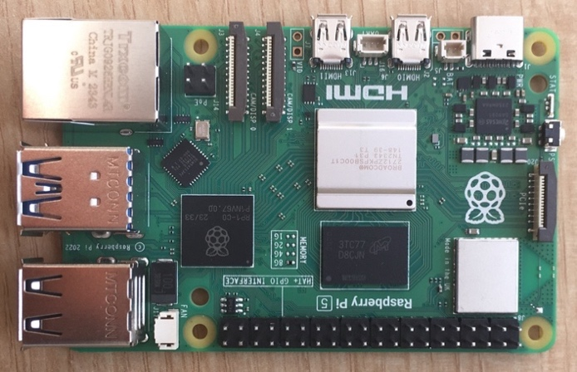
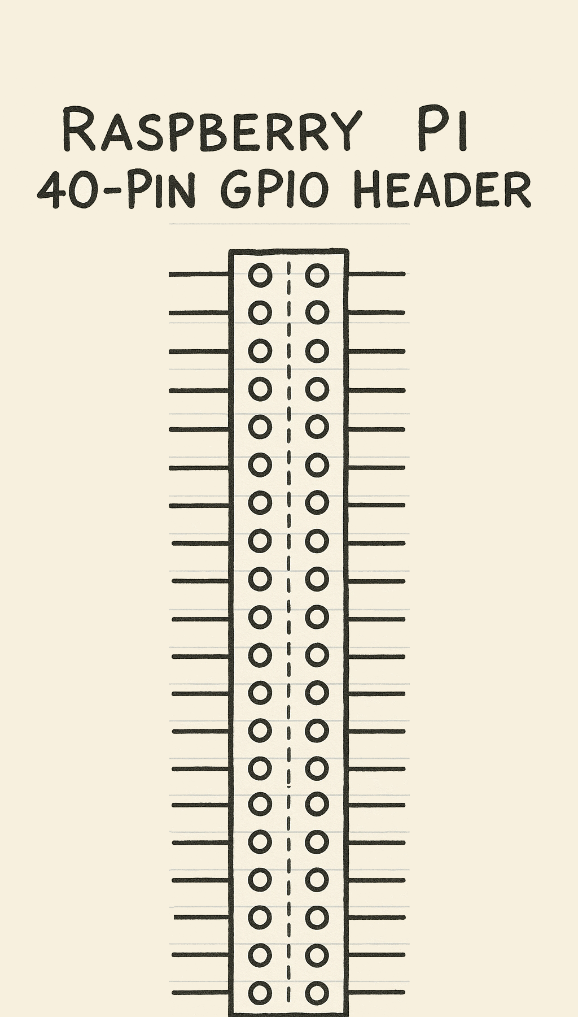

2: 5V power
4: 5V power
6: Ground
8: GPIO 14 (UART TX)
10: GPIO 15 (UART RX)
12: GPIO 18
14: Ground
16: GPIO 23
18: GPIO 24
20: Ground
22: GPIO 25
24: GPIO 8 (SPI0 CE0)
26: GPIO 7 (SPI0 CE1)
28: GPIO 1
30: Ground
32: GPIO 12
34: Ground
36: GPIO 16
38: GPIO 20
40: GPIO 21

3.3V power :1
GPIO 2 (I2C1 SDA) :3
GPIO 3 (I2C1 SCL) :5
GPIO 4 :7
Ground :9
GPIO 17 :11
GPIO 27 :13
GPIO 22 :15
3.3V power :17
GPIO 10 (SPI0 MOSI) :19
GPIO 9 (SPI0 MISO) :21
GPIO 11 (SPI0 SCLK) :23
Ground :25
GPIO 0 :27
GPIO 5 :29
GPIO 6 :31
GPIO 13 :33
GPIO 19 :35
GPIO 26 :37
Ground :39

In this lab, a loadable kernel module is implemented that configures GPIO21 as output and GPIO20 as an input. Moreover, each time the value on the GPIO20 input changes, an interrupt is generated and handled to read the updated value.
The GPIO-based I/O is used as described in the lecture slides in Module 6. In particular, GPIO21 and GPIO20 will be used. These two integer values correspond within Linux to two specific hardware resources of the BCM2712 processor that powers the Raspberry Pi 5 board. The correspondence between a hardware resource and Linux identifier is obtained using the following approach:
At a shell prompt on your running Raspberry Pi board, execute the following command:
cat /sys/kernel/debug/gpio
to see the GPIO pin ids. For older Linux kernels and Raspberry Pi boards, pin GPIO20 should have the integer identifier 20. For newer kernels and Raspberry Pi boards, GPIO20 will be a larger integer identifier, such as 591. Generally, GPIO21 will be the next integer identifier after GPIO20.

To test the correct operation of the module, GPIO21 should be hard-wired to GPIO20.

workplace setup
Assuming you have completed the previous lab, move to the raspberrypi5 directory and prepare the build environment:
cd ~/raspberrypi5
source sources/poky/oe-init-build-env rpi-build
Download the following package and its dependencies so that you can cross-compile user code for the Raspberry Pi:
sudo apt install gcc-aarch64-linux-gnu
The workspace is now set up for the rest of the lab.

Preparing the recipes
Similar to the kernel module files created during the previous lab, create and move to the directory raspberrypi5/sources/meta-raspberrypi/recipes-kernel/gpio-mod/files, and create a file named gpio.c with the following content:
0:  1:  2:  3:  4:  5:  6:  7:  8:  9:  10:  11:  12:  13:  14:  15:  16:  17:  18:  19:  20:  21:  22:  23:  24:  25:  26:  27:  28:  29:  30:  31:  32:  33:  34:  35:  36:  37:  38:  39:  40:  41:  42:  43:  44:  45:  46:  47:  48:  49:  50:  51:  52:  53:  54:  55:  56:  57:  58:  59:  60:  61:  62:  63:  64:  65:  66:  67:  68:  69:  70:  71:  72:  73:  74:  75:  76:  77:  78:  79:  80:  81:  82:  83:  84:  85:  86:  87:  88:  89:  90:  91:  92:  93:  94:  95:  96:  97:  98:  99:  100:  101:  102:  103:  104:  105:  106:  107:  108:  109:  110:  111:  112:  113:  114:  115:  116:  117:  118:  119:  120:  121:  122:  123:  124:  125:  126:  127:  128:  129:  130:  131:  132:  133:  134:  135:  136:  137:  138:  139:  140:  141:  142:  143:  144:  145:  146:  147:  148:  149:  150:  151:  152:  153:  154:  155:  156:  157:  158:  159:  160:  161:  162:  163:  164:  165:  166:  167:  168:  169:  170:  171:  172:  173:  174:  175:  176: | #include <linux/module.h>  #include <linux/init.h>  #include <linux/kernel.h>  #include <linux/types.h>  #include <linux/kdev_t.h>  #include <linux/fs.h>  #include <linux/cdev.h>  #include <asm/uaccess.h>  #include <linux/gpio.h>  #include <linux/interrupt.h>  #define GPIO_OUT 591 // GPIO 20  #define GPIO_IN 592 // GPIO 21  static dev_t gpio_dev;  struct cdev gpio_cdev;  static int gpio_lock = 0;  volatile char gpio_in_value = 0;  static irq_handler_t InterruptHandler( unsigned int irq, struct pt_regs *regs )  {  gpio_in_value = gpio_get_value( GPIO_IN );  printk( KERN_INFO "gpio_dev: %s got GPIO_IN with value %c\n",  __func__, gpio_in_value+'0' );  return (irq_handler_t) IRQ_HANDLED;  }  int gpio_open(struct inode *inode, struct file *file)  {  int ret = 0;  printk( KERN_INFO "gpio_dev: %s\n", __func__ );  if( gpio_lock > 0 )  {  ret = -EBUSY;  }  else  gpio_lock++;  return( ret );  }  int gpio_close(struct inode *inode, struct file *file)  {  printk( KERN_INFO "gpio_dev: %s\n", __func__ );  gpio_lock = 0;  return( 0 );  }  ssize_t gpio_read(struct file *filp, char __user *buf, size_t count, loff_t *f_pos)  {  char buffer[2];  printk(KERN_INFO "gpio read (count=%d, offset=%d)\n", (int)count, (int)*f_pos );  buffer[0] = gpio_in_value;  buffer[1] = 0;  copy_to_user( buf, buffer, 1 );  return 1;  }  ssize_t gpio_write(struct file *filp, const char __user *buffer, size_t length, loff_t *offset)  {  char kbuf[16]; // small kernel buffer  size_t to_copy;  int i;  // Limit how much we read  to_copy = (length < sizeof(kbuf)) ? length : sizeof(kbuf);  if (copy_from_user(kbuf, buffer, to_copy))  return -EFAULT;  for (i = 0; i < to_copy; i++) {  if (kbuf[i] == '0') {  gpio_set_value(GPIO_OUT, 0);  printk(KERN_INFO "gpio_dev: %s wrote %c to GPIO_OUT\n", __func__, kbuf[i]);  } else if (kbuf[i] == '1') {  gpio_set_value(GPIO_OUT, 1);  printk(KERN_INFO "gpio_dev: %s wrote %c to GPIO_OUT\n", __func__, kbuf[i]);  }  }  return to_copy;  }  struct file_operations gpio_fops = {  .owner = THIS_MODULE,  .read = gpio_read,  .write = gpio_write,  .open = gpio_open,  .release = gpio_close,  };  static int __init gpio_module_init(void)  {  char buffer[64];  int ret = 0;  printk(KERN_INFO "Loading gpio_module\n");  alloc_chrdev_region(&gpio_dev, 0, 1, "gpio_dev");  printk(KERN_INFO "%s\n", format_dev_t(buffer, gpio_dev));  cdev_init(&gpio_cdev, &gpio_fops);  gpio_cdev.owner = THIS_MODULE;  cdev_add(&gpio_cdev, gpio_dev, 1);  if( gpio_request( GPIO_OUT, "gpio_dev" ) )  {  printk( KERN_INFO "gpio_dev: %s unable to get GPIO_OUT\n", __func__ );  ret = -EBUSY;  goto Done;  }  if( gpio_request( GPIO_IN, "gpio_dev" ) )  {  printk( KERN_INFO "gpio_dev: %s unable to get GPIO_IN\n", __func__ );  ret = -EBUSY;  goto Done;  }  if( gpio_direction_output( GPIO_OUT, 0 ) < 0 )  {  printk( KERN_INFO "gpio_dev: %s unable to set GPIO_OUT as output\n", __func__ );  ret = -EBUSY;  goto Done;  }  if( gpio_direction_input( GPIO_IN ) < 0 )  {  printk( KERN_INFO "gpio_dev: %s unable to set GPIO_IN as input\n", __func__ );  ret = -EBUSY;  goto Done;  }  if( request_irq( gpio_to_irq( GPIO_IN ), (irq_handler_t) InterruptHandler,  IRQF_TRIGGER_RISING | IRQF_TRIGGER_FALLING, "gpio_dev", NULL ) < 0 )  {  printk( KERN_INFO "gpio_dev: %s unable to register gpio irq for GPIO_IN\n",  __func__ );  ret = -EBUSY;  goto Done;  }  Done:  return ret;  }  static void __exit gpio_module_cleanup(void)  {  printk(KERN_INFO "Cleaning-up gpio_dev.\n");  gpio_free( GPIO_OUT );  gpio_free( GPIO_IN );  free_irq( gpio_to_irq( GPIO_IN ), NULL );  gpio_lock = 0;  cdev_del(&gpio_cdev);  unregister_chrdev_region(gpio_dev, 1);  }  module_init(gpio_module_init);  module_exit(gpio_module_cleanup);  MODULE_AUTHOR("Your name");  MODULE_LICENSE("GPL");
The file contains the source code of the kernel module;
- Lines 0-12 include the needed header files containing the function prototypes and the data structure needed to write a kernel module;
- Lines 17-19 define the data structures to register the module as a character device;
- Line 21 defines a flag used to manage access to the device driver for mutual exclusion: only one user application is allowed to open the device file at a time;
- Line 23 defines the data structure that contains the value read from the GPIO configured as an input. As this data structure is written by an interrupt service routine, it shall be defined as volatile;
- Lines 25-33 implement the interrupt service routine to read the value from the GPIO configured as an input;
- Lines 36-177 implement the virtual file system interface for accessing the two GPIOs used for input and output.
There is a commented version of the kernel module source code, which may merit further careful inspection.

Also in the files directory, create a file called "Makefile". Enter the following code. As with the previous labs, ensure that the indented lines are indented using a single tab and not spaces, otherwise it will not work.
0: obj-m := gpio.o
1:
2: SRC := $(shell pwd)
3:
4: all:
5: $(MAKE) -C $(KERNEL_SRC) M=$(SRC)
6:
7: modules_install:
8: $(MAKE) INSTALL_MOD_DIR=kernel/drivers/my_mod -C $(KERNEL_SRC) M=$(SRC) modules_install
9:
10: clean:
11: rm -f *.o *~core.depend .*.cmd *.ko *.mod.c
12: rm -f Module.markers Module.symvers modules.order
13: rm -rf .tmp_versions Modules.symvers
In the parent directory gpio-mod, create a file called gpio_1.0.bb and add the following code:
0: DESCRIPTION = "gpio driver"
1:
2: LICENSE = "GPLv2+"
3:
4: LIC_FILES_CHKSUM = "file://${BPN}.c;endline=19;md5=02d0f4fb7e7b7125483125efd96a39dc"
5:
6: inherit module
7:
8: PR = "r0"
9:
10: SRC_URI = "file://Makefile file://${BPN}.c"
11:
12: S = "${WORKDIR}"
Once these operations are completed, you must inform the machine layer configuration that the new driver is needed. For this purpose, edit the file:
cd ~/raspberrypi5/rpi-build/conf/local.conf
Add the following statement as the last line of the file (note the space at the start of the string literal):
IMAGE_INSTALL:append = " gpio"
This line tells Yocto that, when building Linux, the newly created device driver should be built and included in the root file system.

Building and deploying the new system
You are now ready to build the new system as follows:
# The one-line workaround below is required on Ubuntu 24.04 to prevent perms errors
sudo apparmor_parser -R /etc/apparmor.d/unprivileged_userns

cd ~/raspberrypi5/rpi-build
bitbake -c clean rpi-test-image
bitbake rpi-test-image

During the build, the compiler will recognize a discrepancy in the license reference. Copy and paste the suggested reference (“the new md5 checksum is..”) into your gpio_1.0.bb file and start the build again.
Once complete, a new Micro SD card image will be available, which you can deploy to the Micro SD as follows (assuming the Micro SD is available to the PC as /dev/sdb). Alternatively, use a program of your preference to flash the image.
First, run the:
sudo fdisk -l
command to determine which device to flash to (plug in and unplug the SD card to identify the correct device). In this example, the SD card is named “sdb” (this may be different in your environment). Next, ensure that the device is unmounted. This can be done using the command:
sudo umount /dev/sdb*
Once this is done, use the following command to copy the image to the SD card (substitute any folder names and device names to ensure they are relevant to your specific environment).
sudo dd bs=1M if=/home/user/raspberrypi5/rpi-build/tmp-glibc/deploy/images/raspberrypi5/rpi-test-image-raspberrypi5.rootfs.rpi-sdimg of=/dev/sdb
Note that if not done properly, the image flashed to the SD card may cause problems when attempting to power on the board. If this occurs, it may be worth retrying the process and ensuring that it is done correctly, or using a flash program to automate the process.
While the SD card is still connected to the development host, use the following commands to navigate to the etc folder on the SD card (assuming the device has been mounted).
cd media/user/SD_name/etc # Use the ls command to find the name of the SD card in the user folder.
Then, use a terminal text editor to open the shadow file.

sudo vim shadow

or

sudo gedit shadow

Check that there are no characters between the first two colons in the first line. If there are, remove them so that the first line looks like this:

root::17728:0:99999:7:::

Exit the text editor (quit vim by entering Esc :wq! ) or simply close the application.

Running the module
After installing the SD card in your Raspberry Pi board and booting the new Linux system, you can check whether the build process was completed successfully. After logging into the Raspberry Pi 5, type the following commands (note that the kernel version number might be different):
root@raspberrypi5:/# ls -la /lib/modules/$(uname -r)/kernel/drivers/my_mod
drwxr-xr-x 2 root root 1024 May 15 08:47 .
drwxr-xr-x 43 root root 1024 May 10 12:09 ..
-rw-r--r-- 1 root root 9080 May 12 03:02 gpio.ko.xz
-rw-r--r-- 1 root root 5384 May 11 08:05 hello.ko.xz
root@raspberrypi5:/#
The directory in the root file system contains gpio.ko.xz, which is the compressed kernel object containing the binary code for the loadable kernel module.
You can now insert the module into the kernel as follows:
root@raspberrypi5:/# insmod /lib/modules/$(uname -r)/kernel/drivers/my_mod/gpio.ko.xz
[ 1981.635413] Loading gpio_module
[ 1981.638775] 510:0
The output messages indicate that the module has been loaded correctly, with major number 510 (this number may vary on your system, so take it into account in the following steps) and minor number 0. You may need to run the dmesg command to see the kernel log output.
To test the module, you must first create the associated device file with the correct device number (in this example, it is 510):
root@raspberrypi5:/# mknod /dev/gpio c 510 0
You can now communicate with the module through the Linux command line.
As an example, you can issue the following command and observe the corresponding output (most likely via dmesg):
root@raspberrypi5:/# echo 1 > /dev/gpio
[ 2150.247267] gpio_dev: gpio_open
[ 2150.250630] gpio_dev: InterruptHandler got GPIO_IN with value 1
[ 2150.256641] gpio_dev: gpio_write wrote 1 to GPIO_OUT
[ 2150.261938] gpio_dev: gpio_close
The messages displayed by the module indicate that the echo user application opens the connection with the module through the device file, sends the data by invoking the write function of the virtual file system, and then closes the connection. If you wired output GPIO21 to input GPIO20, you will see that the interrupt is triggered and the InterruptHandler function is executed, reading the written value.
To test the read operation, you can write a simple test application called test_gpio.c with the following code:
#include <stdio.h>
#include <string.h>
#include <errno.h>
#include <unistd.h>
#include <sys/types.h>
#include <sys/stat.h>
#include <fcntl.h>

int main(int argc, char **argv)
{
char *app_name = argv[0];
char *dev_name = "/dev/gpio";
int fd = -1;
char c;

if ((fd = open(dev_name, O_RDWR)) < 0)
{
fprintf(stderr, "%s: unable to open %s: %s\n", app_name, dev_name, strerror(errno));
return( 1 );
}

read( fd, &c, 1 );

printf( "read: %d\n", c );

close( fd );

return 0;
}

The code can be built (cross-compiled) on the host machine by issuing the following command:
aarch64-linux-gnu-gcc -o test_gpio test_gpio.c
The obtained program, test_gpio, can be executed on the Raspberry Pi 5 target. For example, you can copy it from the development host to a USB stick and then plug the stick into one of the Raspberry Pi 5’s USB ports. Alternatively, you can mount the SD card again and copy the file directly across.
When connecting the USB to the Raspberry Pi, mount it to the /media folder with the mount command:
mount /dev/sda1 media
If your USB is not called sda1, use the following command to find its name:
fdisk -l
The test program can be executed as follows (ensure /dev/gpio exists, as done earlier):
root@raspberrypi5:~# ./media/test_gpio > tmp
[ 947.552708] gpio_dev: gpio_open
[ 947.556149] gpio read (count=1, offset=0)
[ 947.562213] gpio_dev: gpio_close
The test application interacts with the driver through the virtual file system by invoking the open, read, and release functions.

The contents of the tmp file contain the read value from the module. For example:
root@raspberrypi5:~# echo 1 > /dev/gpio
[ 1068.239500] gpio_dev: gpio_open
[ 1068.243109] gpio_dev: InterruptHandler got GPIO_IN with value 1
[ 1068.250988] gpio_dev: gpio_write wrote 1 to GPIO_OUT
[ 1068.256276] gpio_dev: gpio_close

root@raspberrypi5:~# ./media/test_gpio > tmp
[ 1071.322513] gpio_dev: gpio_open
[ 1071.325956] gpio read (count=1, offset=0)
[ 1071.332148] gpio_dev: gpio_close
root@raspberrypi5:~# cat tmp
read: 1
We can see that the contents of tmp corresponds to the value 1 sent to the module.
To remove the module, proceed as follows:
root@raspberrypi5:/# rmmod gpio
[ 240.457807] Cleaning-up gpio_dev.
The message indicates that the module cleanup function executed correctly.

SUMMARY
In this lab, you explored how to interact programmatically with GPIO pins through kernel modules. A simple example involving basic interrupt handling and character devices was presented.

