IoT Education Kit
Lab 5 - Heart Rate Monitor App
Overview
In this lab, we will learn how to connect to the Heart Rate Monitor developed in the previous lab (or, in fact, any compatible heart monitor), over BLE in an Android application and display the information on screen.
Requirements
In this lab, we will be using the following hardware:
- An Android device for testing and debugging
  - It should be possible to complete this lab with any Android smartphone, as long as it supports Bluetooth Low Energy and Android 4.3 (API Level 18) or above. It is strongly recommended that you update to the most recent version of Android to ensure compatibility.
- Appropriate USB cable (usually USB-C) for connecting the mobile device to the computer running Android Studio.
- BLE Heart Rate Monitor
  - Any real heart rate monitor device can be used for this, or you can use the one we developed in the previous lab.
We will also be using the following software:
- Android Studio - for app development. This is the Android development environment, which includes the Android Software Development Kit (SDK), the toolchain, and an emulator.
  - This can be downloaded for free from the Android Developer Tools page:
https://developer.android.com/studio
Creating a new project
Follow the instructions from Lab 3 to start a new project in Android studio, but this time call it Arm-IoT-Lab5.
Preparing the User Interface
Start by deleting unnecessary boilerplate introduced by the project template. Remove the fragments, menus, and the views in the main activity so that you’re starting from a clean slate. You’ll need to delete the layout files and the corresponding source code files.
Then, to the main activity, remove all components, add a LinearLayout, put a “Connect” button at the bottom, and a TextView in the middle.
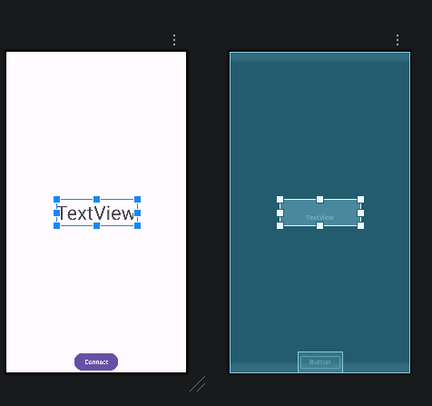
Modify your manifest to include the permissions necessary for accessing Bluetooth:
<uses-permission android:name="android.permission.BLUETOOTH" />
<uses-permission android:name="android.permission.BLUETOOTH_ADMIN" />
<uses-permission android:name="android.permission.ACCESS_FINE_LOCATION" />
<uses-permission android:name="android.permission.ACCESS_COARSE_LOCATION" />
<uses-permission android:name="android.permission.BLUETOOTH_CONNECT" />
<uses-permission android:name="android.permission.BLUETOOTH_SCAN" />
Add code to onCreate() in MainActivity.java to request Bluetooth permissions:
ActivityCompat.requestPermissions(this, new String[] {
Manifest.permission.BLUETOOTH,
Manifest.permission.BLUETOOTH_ADMIN,
Manifest.permission.BLUETOOTH_SCAN,
Manifest.permission.BLUETOOTH_CONNECT,
Manifest.permission.ACCESS_COARSE_LOCATION,
Manifest.permission.ACCESS_FINE_LOCATION
}, 2);
Create a BluetoothManager object, get hold of the Bluetooth adapter, and prepare a reference to the main activity:
BluetoothManager bluetoothManager= (BluetoothManager)getSystemService(Context.BLUETOOTH_SERVICE);
bluetoothAdapter = bluetoothManager.getAdapter();

MainActivity mainActivity = this;
Now, attach an OnClickListener to the Connect button. In this code, you need to scan for Bluetooth devices and display a list for the user to select from. When the user selects a target device, you’ll need to connect to it, resolve the Heart Rate Monitor service, resolve the Measurement characteristic, and enable notifications. Whenever the incoming value changes, you need to update the TextView in the main activity.
Hints:
- Use a BluetoothLeScanner to scan for devices. You can get an instance of this from the Bluetooth adapter object.
  - BluetoothLeScanner scanner = bluetoothAdapter.getBluetoothLeScanner();
- Use an ArrayAdapter to maintain a list of discovered devices, then pass this ArrayAdapter to an AlertDialog. You’ll need to create a resource layout that comprises a single “TextView”, so that Android knows how to display the list item in the dialog.
  - ArrayAdapter<String> devices = new ArrayAdapter<String>(mainActivity, R.layout.list_item);
- Use the Alert Dialog Builder to display a selectable list to the user:
  - AlertDialog.Builder alertDialogBuilder = new AlertDialog.Builder(mainActivity);
  - b.setTitle("Select device");
  - b.setSingleChoiceItems(devices, 0, new DialogInterface.OnClickListener() …
- When the user selects the device that they want to connect to, call connectGatt on the selected device object and override the onCharacteristicChanged and onServicesDiscovered callbacks.
- When services have been discovered, look for the specific service and characteristic UUIDs:
  - BluetoothGattService heartRateService = gatt.getService(UUID.fromString("0000180d-0000-1000-8000-00805f9b34fb"));
  - BluetoothGattCharacteristic heartRateChar = heartRateService.getCharacteristic(UUID.fromString("00002a37-0000-1000-8000-00805f9b34fb"));
  - BluetoothGattDescriptor descr = heartRateChar.getDescriptor(UUID.fromString("00002902-0000-1000-8000-00805f9b34fb"));
- To enable characteristic notifications, you need to attach a callback with setCharacteristicNotification, and also instruct the Bluetooth peer to enable notifications:
  - descr.setValue(BluetoothGattDescriptor.ENABLE_NOTIFICATION_VALUE);
  - gatt.writeDescriptor(descr);
Once you have connected everything and written your application logic, you should be able to connect to your device from the previous lab and display the simulated heart rate in real time.
