IoT Education Kit
Lab 3 - Basic Mobile App
Overview
In this lab, we will learn how to create and build a simple “Hello World” application for your Android device, using the Android SDK. We will walk through the process of configuring the environment, and installing drivers for debugging an Android phone.
Requirements
In this lab, we will be using the following hardware:
- An Android device for testing and debugging
  - It should be possible to complete this lab with any Android smartphone, as long as it supports Bluetooth Low Energy, and Android 4.3 (API Level 18) or above. It is strongly recommended that you update to the most recent version of Android, to ensure compatibility.
- Appropriate USB cable (usually USB-C) for connecting the mobile device to the computer running Android Studio.
We will also be using the following software:
- Android Studio - for app development. This is the Android development environment, which includes the Android Software Development Kit (SDK), the toolchain, and an emulator.
  - This can be downloaded for free from the Android Developer Tools page:
https://developer.android.com/studio
Creating a new project
Once you have installed Android Studio, the first time you start the environment, it may ask you to perform some setup. Follow the wizard, and accept the default settings, unless you wish to customise your settings. When the setup wizard has finished, you’ll be presented with the welcome page:
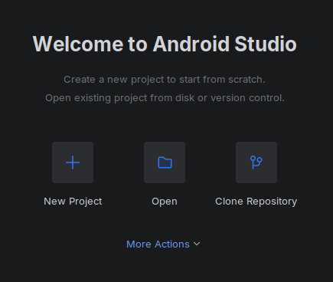
From here, choose “New Project”, then select the “Basic Views Activity” template:
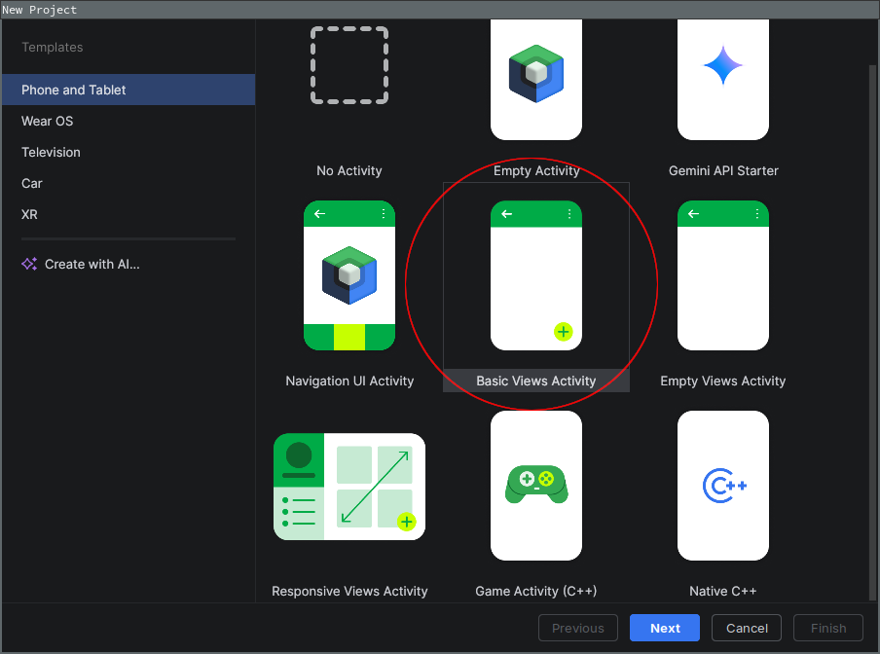
Click “Next”, and give your project a name, e.g. “Arm IoT Lab3”. The package name will auto update – you can leave this as is. Choose a place to save your project, and make sure you select “Java” as the “Language”. These labs will use the Java programming language for Android development, as opposed to Kotlin.
Click “Finish” and the project will be created. It will take a couple of minutes to install and configure dependencies, but once it’s done, the IDE will settle down.
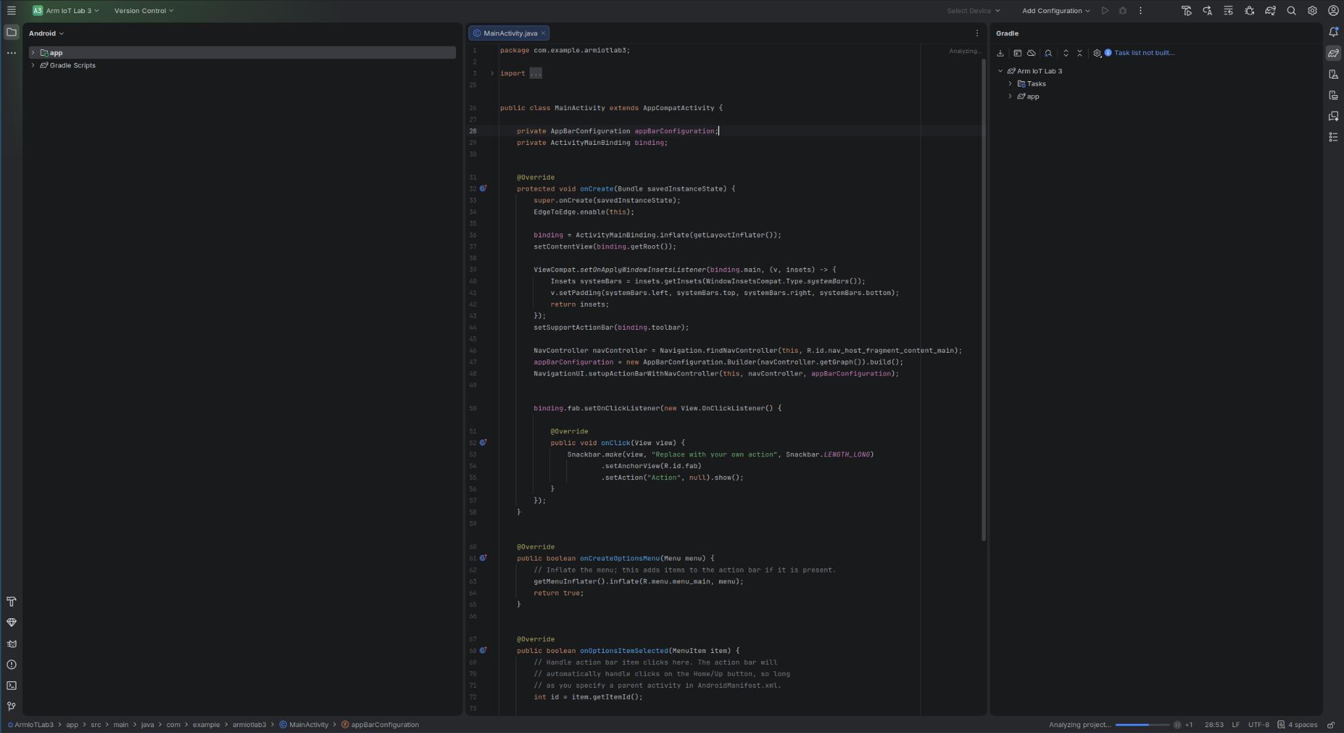
USB Debugging
In order to enable USB debugging on your device, we must first enable the “Developer Options” section of the settings app.
Normally, this is done by opening the “Settings” app, navigating to the “About phone” section, and pressing the “Build number” entry seven times:
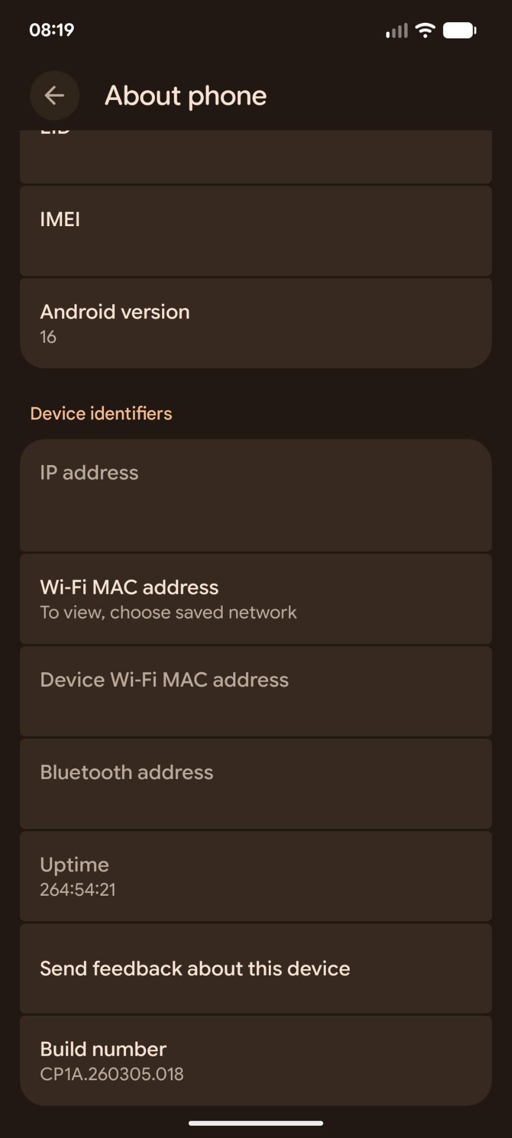
This should popup a notification indicating you have successfully enabled “Developer Mode”. Now, you should be able to access “Developer Options” from the main settings screen.
Turn on “Developer Options”, scroll down to the “Debugging” section, and enable “USB Debugging”.
USB Drivers
Back on your development machine, you may need to install USB drivers, so that Android Debug Bridge (ADB) can detect and communicate with your device. If you are using Linux or Mac, then it’s likely you already have the appropriate drivers installed. If you are using Windows, then you will need to install the Google USB drivers.
Open the “SDK Manager”, by clicking the cog wheel in the top-right of the IDE:
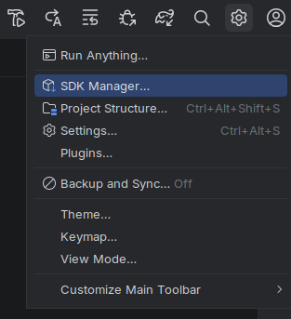
Then, Expand “Language & Frameworks”, select “Android SDK”, and click the “SDK Tools” tab. Find “Google USB Driver” in the list, and tick it.
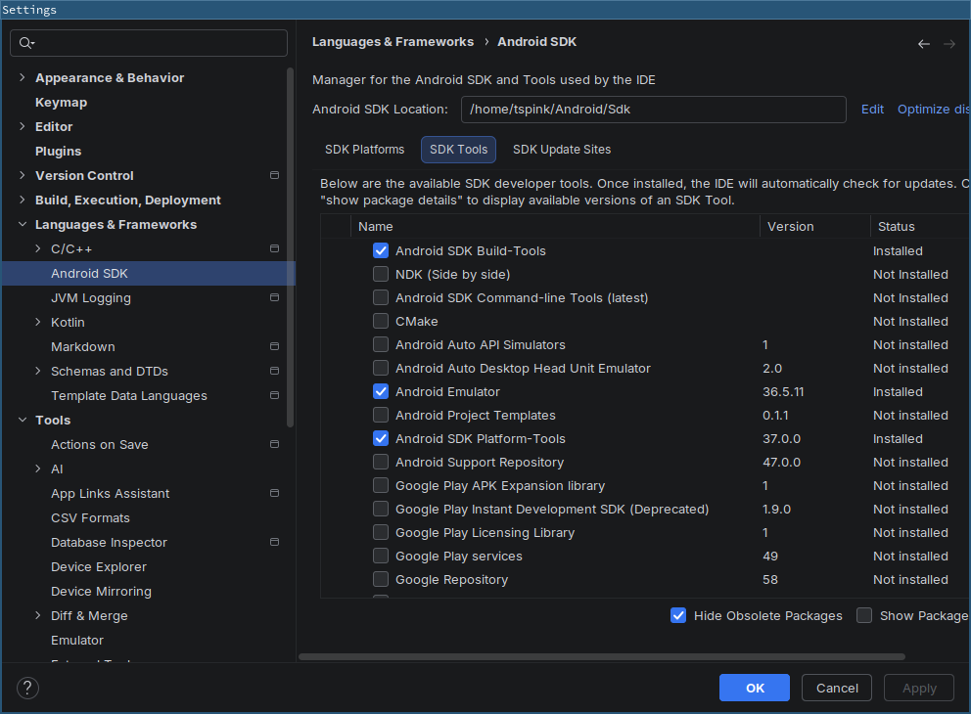
Further information and troubleshooting can be found here:
https://developer.android.com/studio/run/win-usb
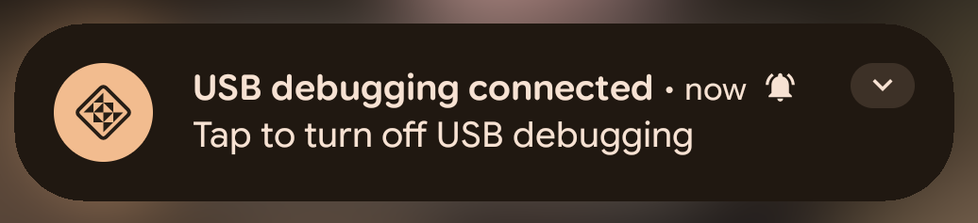
Now, plug your device in. You will get a notification that USB Debugging has activated, but you will need to unlock your phone, and confirm you wish to allow your development machine to connect.
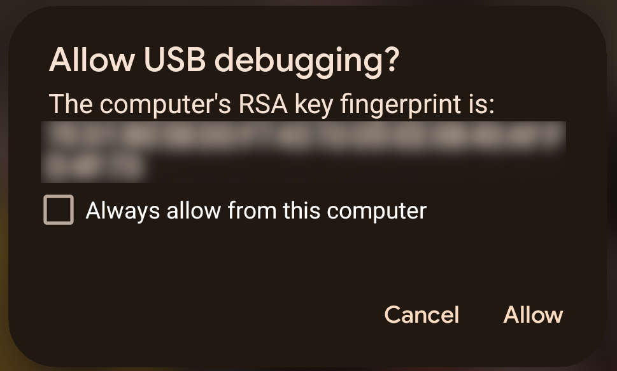
Debugging
Note that your device should now appear at the top of the IDE, in the device list. Click the “Debug” button, and the app will be built, and will start running on your phone!
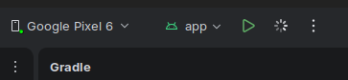

If the app crashes before starting, then you may be experiencing an incompatibility with the navigation component. This is resolved by opening “MainActivity.java”, and replacing this line of code:
NavController navController = Navigation.findNavController(this, R.id.nav_host_fragment_content_main);
With these two lines:
NavHostFragment navHostFragment = (NavHostFragment)getSupportFragmentManager().findFragmentById(R.id.nav_host_fragment_content_main);
NavController navController = navHostFragment.getNavController();
You may also find it convenient to mirror your device screen in the IDE. To do this, click the “Running Devices” tab button on the right of the IDE, then click the “Plus” button and add your device. Your device’s screen will then appear in the IDE, and you can interact with it both physically and virtually.
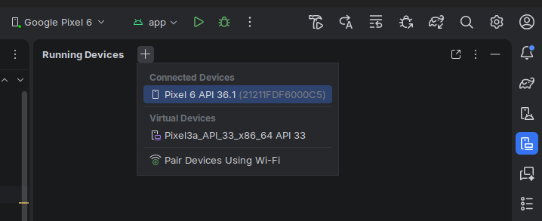
Logcat
Logcat is the logging system that provides detailed information about events occurring on your device. It’s a crucial tool that helps with debugging during the development process. To access it, click the “logcat” icon at the bottom left of the IDE.
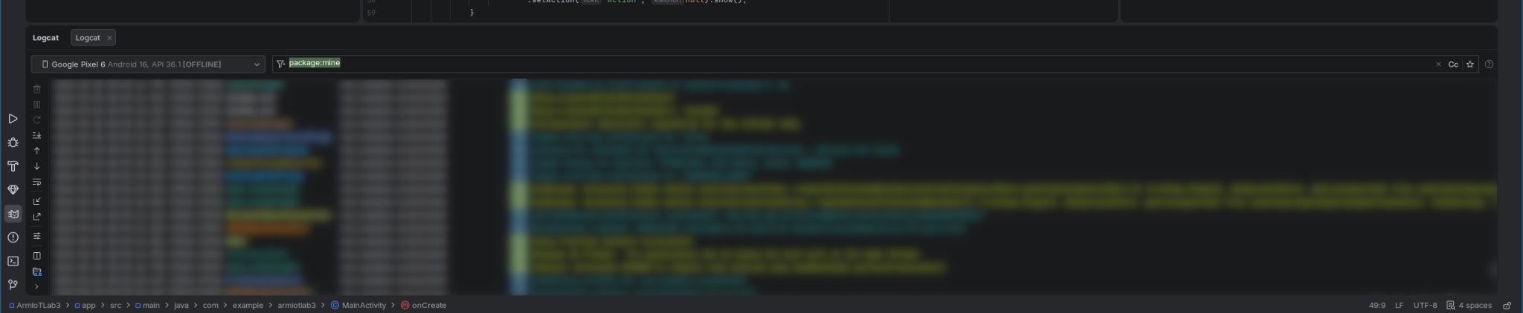
Here, you will see all events logged by the system, but you can also log your own messages.
Add import android.util.Log; to the top of MainActivity.java, and then somewhere near the top of the onCreate function, add Log.d("MainActivity", "Hello from onCreate!");
When you run your application, you should see the message appear in the logcat output.
Breakpoints
Currently, the template application contains some basic interactivity, with some different views and a button. A breakpoint is a way to cause the IDE to stop when the executing code reaches a certain line or condition. This is a very useful way to inspect the state of your application, if things aren’t working as you expect.
Set a breakpoint on the code inside the onClick handler of the email button. To do this, click on the line number in the margin of the line you want to set the breakpoint on, for this example, click on the line that has Snackbar.make(... on it.
Then, make sure your application is running in debug mode. To do this, click the “bug” button in the toolbar, to start debug mode.
Now, on your device, tap the email icon in the bottom right - you should see that the IDE jumps into action, and pauses on the breakpoint line. You can even inspect values in variables, by hovering your mouse over them.
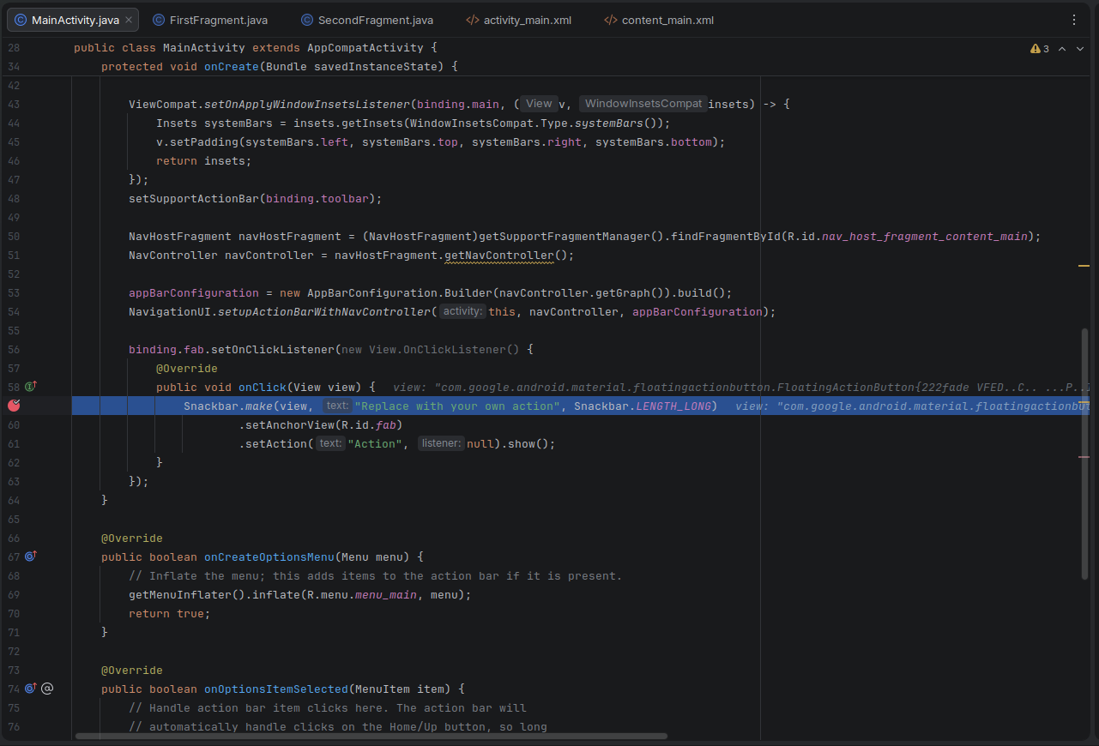
You now have the basic skeleton of a mobile application, working from the Android Studio development environment.
Try playing around with the code, to get a feel for how things fit together – modify some of the user interface, by opening some of the layout files, e.g. layout/fragment_first.xml, and adding/removing components.
Explore how interaction works in the user interface, by looking at the “on click” listeners for the buttons.
Add a new button, and make it change the contents of a text view when it is clicked - this will be a useful technique for future labs!

