IoT Education Kit
Lab 4 - A BLE Program
Overview
In this lab, we will learn how to program the BLE capabilities of a development board, and subsequently use a mobile device to connect to it, and read data.
We will program the device to simulate a heart rate sensor, and will design and build an Android app in the following lab.
Requirements
In this lab, we will be using the following hardware:
- DISCO-L475VG-IOT01A embedded board
You will also need a mobile device, with an app that can discover and inspect nearby Bluetooth devices, such as nRF Connect – available in all popular app stores:
- https://play.google.com/store/apps/details?id=no.nordicsemi.android.mcp
- https://apps.apple.com/gb/app/nrf-connect-for-mobile/id1054362403
Finally, to configure the development board, you’ll need the STM32 CubeMX generator application, which you can download for free from here:
https://www.st.com/en/development-tools/stm32cubemx.html
Creating the solution, and configuring the device
As in previous labs, create a new CMSIS solution in VS Code. This time, call it something like Arm-IoT-Lab4. However, base it on the “CubeMX Basic solution” template.
Once the project has been created, expand the “Components” group in the solution explorer, navigate to the CubeMX device component, and launch the CubeMX configuration generator by clicking the lightning cog that appears when you hover over “Device:CubeMX”.
You should be presented with the CubeMX code generator, and a graphical representation of the processor.
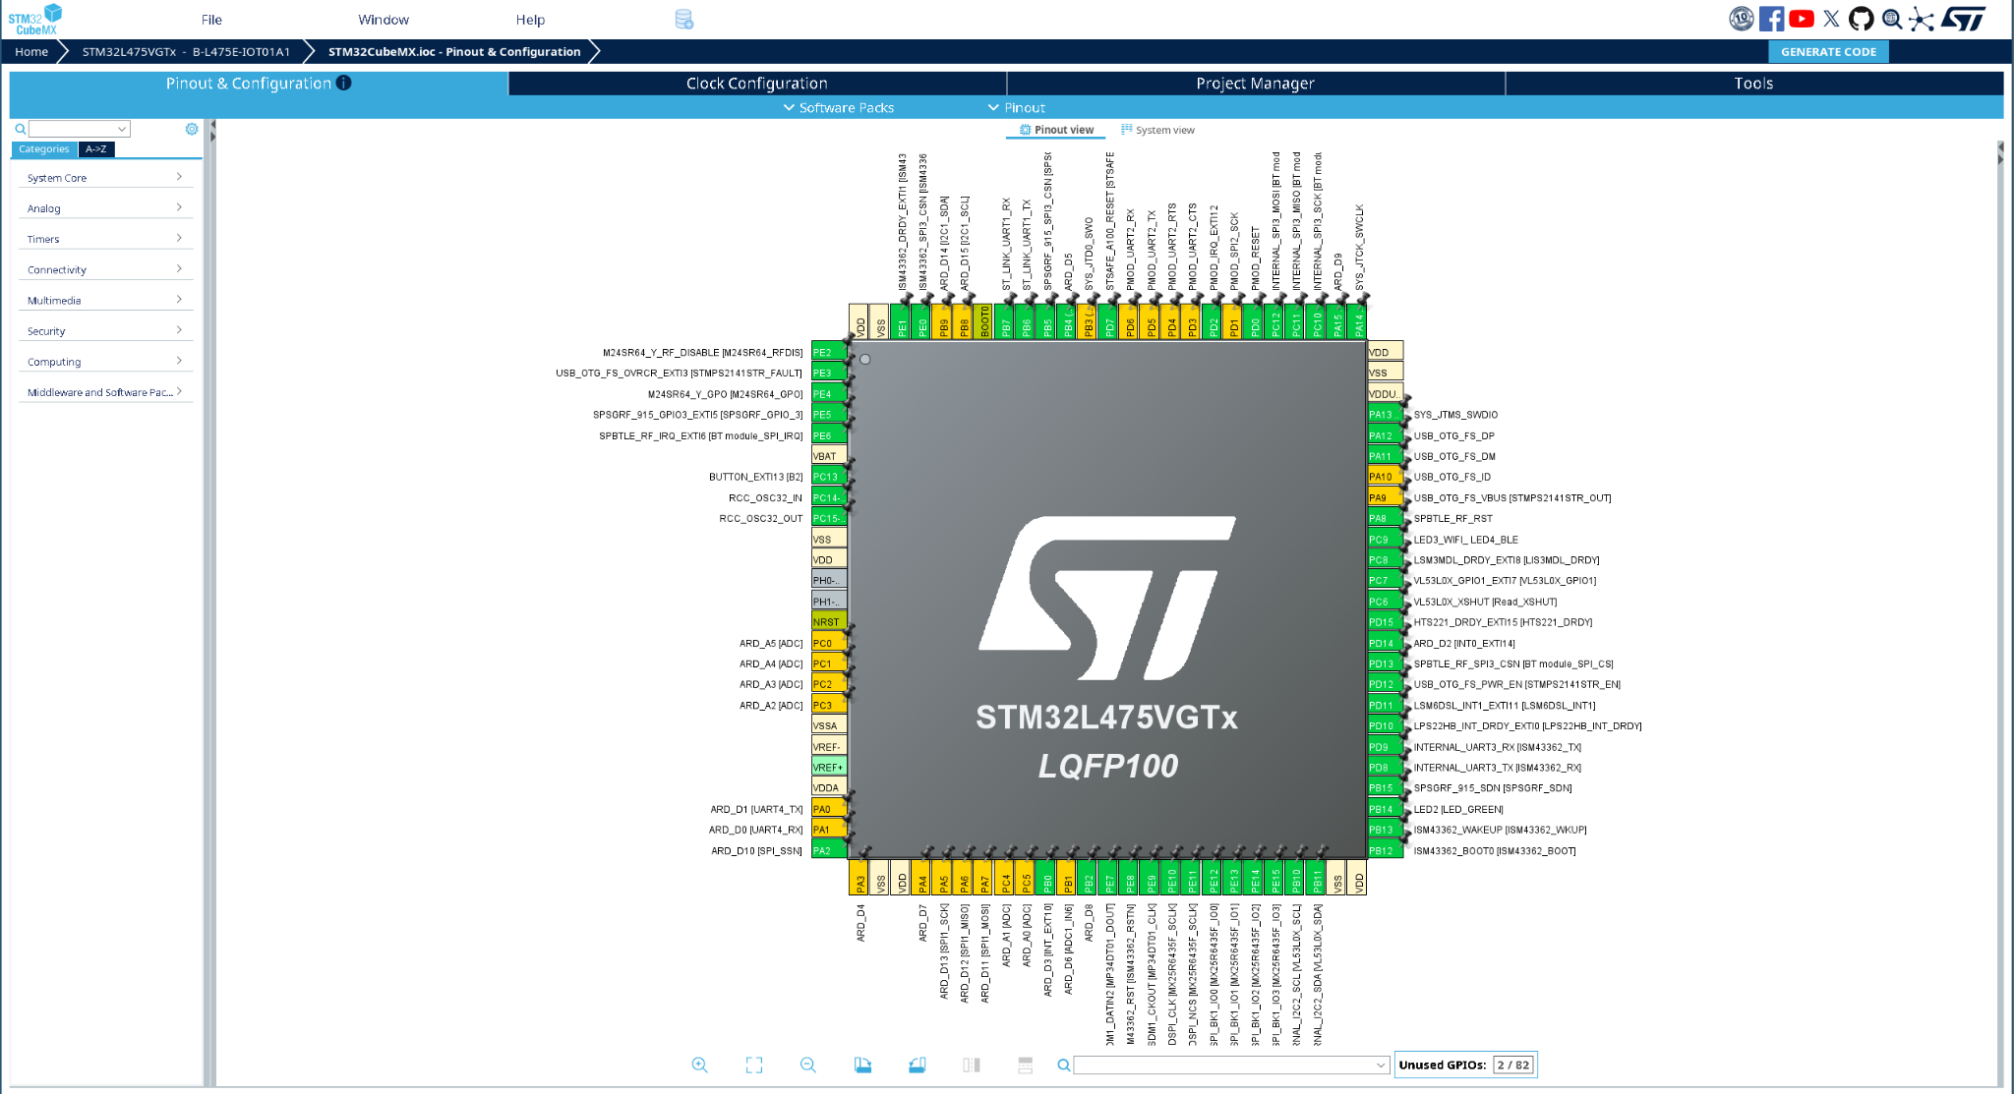
Change the PA5 pin to be a GPIO output, by locating the pin (at the bottom of the diagram), and selecting GPIO_Output from the list. Then, in the tabs on the left, navigate to “Connectivity”, select “SPI3”, and update the Parameter Settings to increase the data size to 8 bits, and the prescaler to 16.
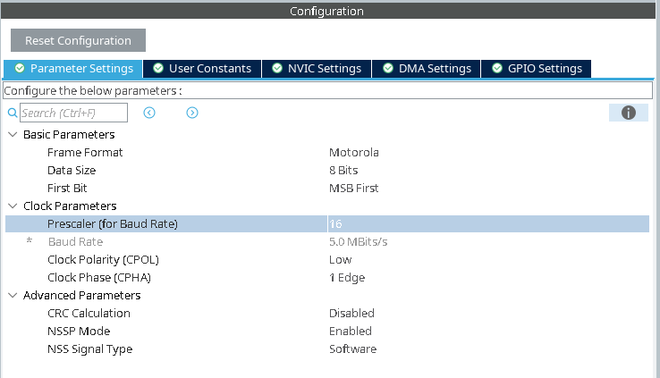
Next, we need to add the Bluetooth software pack; so click “Software Packs”, then “Select Components”, and scroll down to ST Microelectronics.X-CUBE-BLE1, and click “Install”. Once the pack has been installed, expand the pack, then expand “Wireless BlueNRG-MS”, and then “BlueNRG-MS”.
Enable the “Controller” and “Utils” option, and select “Basic” for HCI_TL, then “UserBoard” for HCI_TL_INTERFACE.
Double check that everything in the ST Microelectronics X-CUBE-BLE1 section has a green tick, then click “OK”.
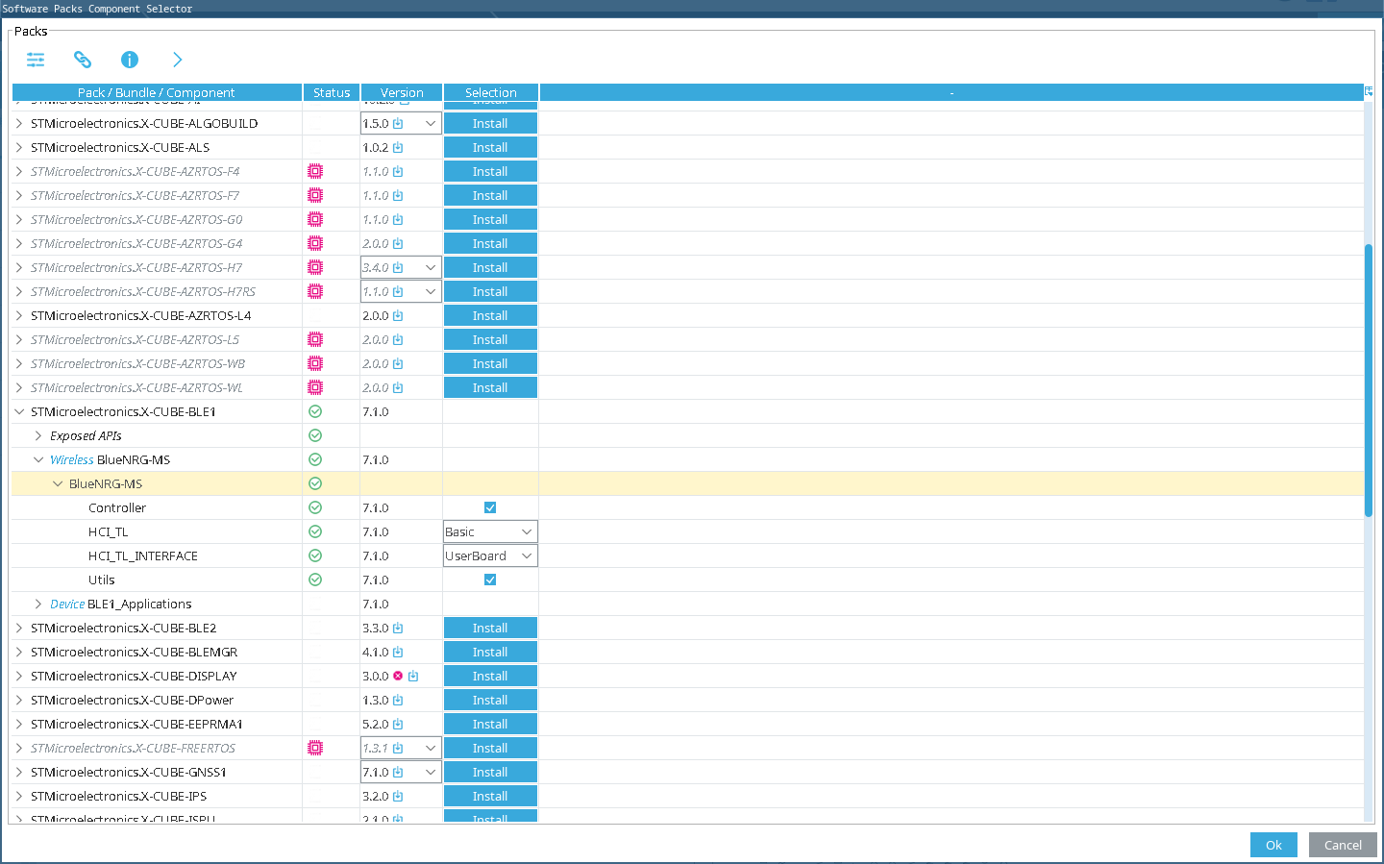
The remaining GPIO pins should already be configured correctly, but we will need to connect the Bluetooth middleware to the various physical pins.
In the tabs on the left, select “Middleware and Software Packs”, then scroll down and select “X-CUBE-BLE1”. Enable the “Wireless BlueNRG MS” checkbox.
In the “Platform Settings” tab, we need to connect the Host Controller Interface, or HCI to the appropriate physical pins. Choose PE6 for the external interrupt line, SPI3 for the BUS IO Driver, PD13 for the CS (or Chip Select) line, and PA8 for the reset line. You should see that those pins also carry the relevant description, for example, PE6 says that it is indeed physically attached to the BT module IRQ.
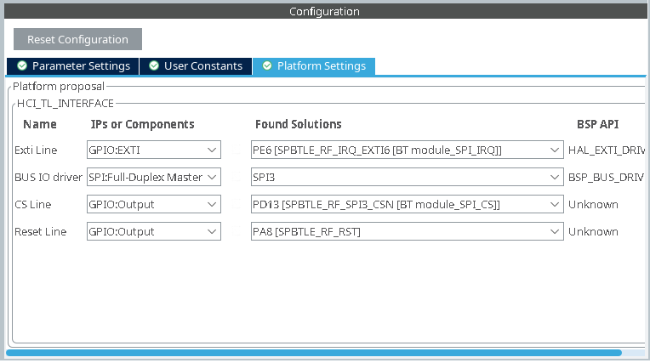
Everything should now be connected, so click “Generate Code”.
Once generation is complete, return to VS Code. Check that everything has been generated correctly, then click “Refresh” from the solution dropdown menu to make sure the CMSIS solution is up-to-date.
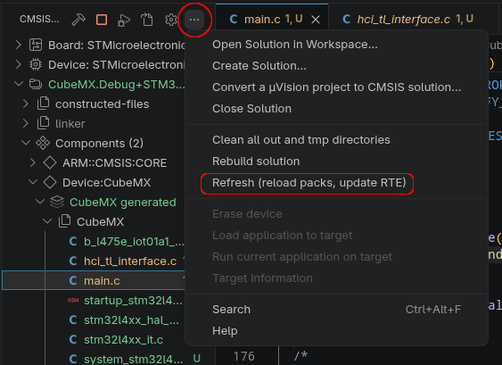
Press the “Build” button to check that everything compiles. You should see “Build Complete” at the bottom, along with a success message.
Profiles and Broadcasting
GATT profiles
GATT profiles define how devices share information. We will set up a GATT “profile” – a chosen set of services, which the BLE device will broadcast. Each of the services is a predefined collection of values called characteristics. For instance, a profile for receiving temperature from a digital thermometer could have services “temperature” and “device information,” the former having a single numerical characteristic and the latter having a couple of string characteristics. Services and characteristics are both identified by a 16 or 128 bit UUID.
To emulate what you might retrieve from a real heart rate monitor, we will have our device advertise the heart rate service.
Heart rate updates
To be able to see the heart rate service working properly, we will need to set up the value for periodic updates. This is fairly easy to do, by updating the value of the measurement characteristic every second, in a loop.
Transmitting Sensor Data over BLE
Now, we’ll write the code to advertise a Heart Rate monitor sensor, and send random data out every second.
Open the main.c source code file – you’ll find this by going to the solution explorer, then expanding Device:CubeMX -> CubeMX generated -> CubeMX
We’ll first add some definitions at the top of the file. Locate the USER CODE BEGIN 0 section, and insert the following after the comment:
/* USER CODE BEGIN 0 */

static uint16_t gap_service_handle;
static uint16_t dev_name_char_handle;
static uint16_t appearance_char_handle;

static uint16_t hr_service_handle;
static uint16_t hr_char_handle;

#define HEART_RATE_SERVICE_UUID 0x180d
#define HEART_RATE_MEASUREMENT_CHAR_UUID 0x2a37
These definitions are variables to contain the handles to the various BLE services, including the Generic Access Profile (GAP) service, which is responsible for discovery, and the heart rate service that will be publishing data.
There are two definitions that hold the well-known 16-bit UUIDs of the Heart Rate service, and the measurement characteristic.

Next, we’ll build the initialisation function. After these definitions, insert the following function:
static void BLE_Init() {
const char deviceName[] = "ArmIotLab4";

const char localName[] = {AD_TYPE_COMPLETE_LOCAL_NAME,
'A', r', 'm', 'I', 'o', 't', 'L', 'a', 'b', '4'};

hci_init(NULL, NULL);
hci_reset();

HAL_Delay(100);
aci_gatt_init();

aci_gap_init_IDB05A1(GAP_PERIPHERAL_ROLE_IDB05A1, 0, 9, &gap_service_handle,
&dev_name_char_handle, &appearance_char_handle);

aci_gatt_update_char_value(gap_service_handle, dev_name_char_handle, 0,
sizeof(deviceName) - 1, deviceName);

aci_gap_set_discoverable(ADV_IND, 0x20, 0x40, PUBLIC_ADDR, NO_WHITE_LIST_USE,
sizeof(localName), localName, 0, NULL, 0, 0);

aci_hal_set_tx_power_level(1, 4);
}
There’s quite a bit going on here, but it’s relatively straightforward.
Any device wishing to advertise BLE services needs to present the Generic Access Profile service - which facilitates device discovery. So, this code firstly initialises and resets the HCI layer, then initialises the GAP service, sets the device name characteristic, and then activates discoverability. Finally, the transmit power level is established.
After this initialise code, insert the following function:
static void BLE_Sensor_Init() {
uint16_t service_uuid = HEART_RATE_SERVICE_UUID;
uint16_t char_uuid = HEART_RATE_MEASUREMENT_CHAR_UUID;

aci_gatt_add_serv(UUID_TYPE_16, (const uint8_t *)&service_uuid,
PRIMARY_SERVICE, 6, &hr_service_handle);

aci_gatt_add_char(hr_service_handle, UUID_TYPE_16,
(const uint8_t *)&char_uuid, 2,
CHAR_PROP_NOTIFY | CHAR_PROP_READ, ATTR_PERMISSION_NONE,
GATT_NOTIFY_ATTRIBUTE_WRITE, 16, 0, &hr_char_handle);
}
Similarly to the BLE_Init() function, this function creates a new service, and adds a characteristic. In particular, it creates a Heart Rate Monitor service, and adds a Heart Rate Measurement characteristic to the service. It makes the characteristic a 2-byte value, and indicates it can be NOTIFY and READ (which means the value will be transmitted every time it changes).
The last function to insert, before we add our main loop, is a function to actually update the value. Add the following function after BLE_Sensor_Init():
static void BLE_Sensor_Update() {
uint16_t measurement_value = (60 + (rand() % 60)) << 8;

aci_gatt_update_char_value(hr_service_handle, hr_char_handle, 0,
sizeof(measurement_value),
(uint8_t *)&measurement_value);
}
Here, we generate a random value between 60 and 119, shift it into the correct byte position in the output packet, and then update the measurement characteristic value.
Finally, we can create our main processing loop, and test the program. Locate main() function, and find the while loop towards the end. Replace it with the following code:
while (1) {
hci_user_evt_proc();
BLE_Sensor_Update();
HAL_Delay(1000);
}
This infinite loop processes any pending HCI events, runs the sensor update function, and waits 1 second – effectively transmitting a new value for the heart rate measurement every second.
Compile and run your program on the device, then open nRF Connect to locate your service:
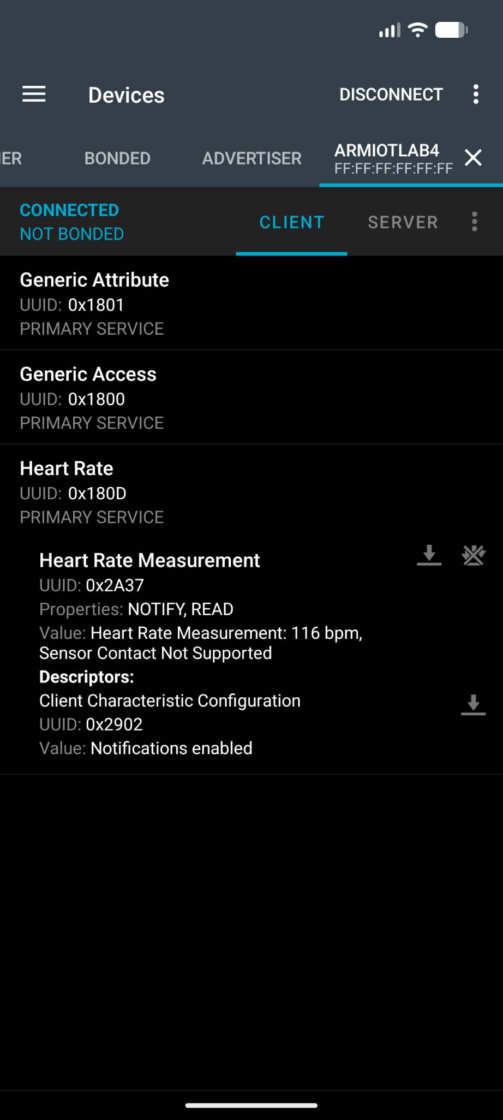
Exercise
Add a new service and characteristic for reporting the device’s battery status (you can simulate this value, since the development board doesn’t have a battery)

