IoT Education Kit
Lab 6 - IoT Sensors
Overview
In this lab, we will learn how to interface with environmental sensors, using a development board and the CMSIS API.
The DISCO-L475VG-IOT01A comes with on-board sensors, including:
- A pressure sensor (LPS22HB)
- A temperature and humidity sensor (HTS221)
- A 3-axis accelerometer and gyroscope (LSM6DSL)
- A 3-axis magnetometer (LIS3MDL)
We will program the device to read these sensors, and send them to the PC via UART. We will be able to monitor the readings in a terminal emulator.
Requirements
In this lab, we will be using the following hardware:
- DISCO-L475VG-IOT01A embedded board
To configure the development board, you’ll need the STM32 CubeMX generator application, which you can download for free from here:
https://www.st.com/en/development-tools/stm32cubemx.html
Creating the solution, and configuring the device
As in previous labs, create a new CMSIS solution in VS Code. This time, call it something like Arm-IoT-Lab6. Base it on the “CubeMX Basic solution” template.
Once the project has been created, expand the “Components” group in the solution explorer, navigate to the CubeMX device component, and launch the CubeMX configuration generator by clicking the lightning cog that appears when you hover over “Device:CubeMX”.
You should be presented with the CubeMX code generator, and a graphical representation of the processor.
Add in the X-CUBE-MEMS1 software pack, and configure the appropriate sensors. They should all be connected to the I2C bus.
- Board Part: AccGyr
  - LSM6DSL: I2C
- Board Part: HumTemp
  - HTS221: I2C
- Board Part: PressTemp
  - LPS22HB: I2C
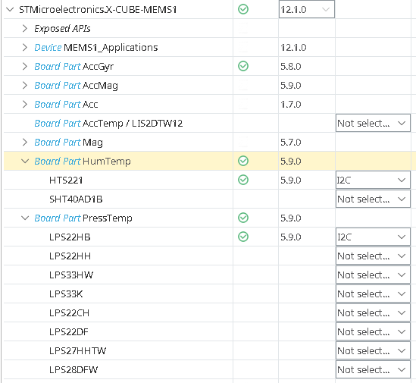
No further configuration is necessary, so click “OK”, and then click “Generate Code”. Return to the IDE, and refresh the solution.
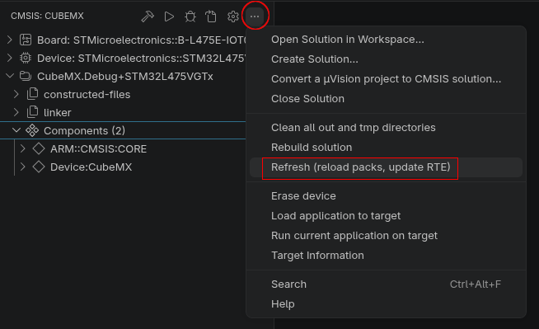

In the main() routine, add in some code to check that the UART is working (add this after the USER CODE BEGIN 2 block):
char buffer[128] = {0};
sprintf(buffer, "--- Sensors ---\n");
HAL_UART_Transmit(&huart1, (const uint8_t *)buffer, strlen(buffer), 10);
At this point, it’s a good idea to check that your solution compiles, and you are seeing output on the UART. Click the “Build” button, then click “Run”, and then open the Serial Monitor. Remember to click “Start Monitoring”, and if your device started before you did this, then press the black RESET button.
Once you have the UART working, you’ll need to add code to initialize the sensors. Here is an example for the HTS221 sensor:
HTS221_Object_t hts221_obj;
HTS221_IO_t hts221_io;

hts221_io.BusType = HTS221_I2C_BUS;
hts221_io.Init = BSP_I2C2_Init;
hts221_io.DeInit = BSP_I2C2_DeInit;
hts221_io.WriteReg = BSP_I2C2_WriteReg;
hts221_io.ReadReg = BSP_I2C2_ReadReg;
hts221_io.GetTick = BSP_GetTick;
hts221_io.Address = HTS221_I2C_ADDRESS;

HTS221_RegisterBusIO(&hts221_obj, &hts221_io);
HTS221_Init(&hts221_obj);
HTS221_TEMP_SetOutputDataRate(&hts221_obj, HTS221_ODR_1Hz);
HTS221_HUM_SetOutputDataRate(&hts221_obj, HTS221_ODR_1Hz);
HTS221_TEMP_Enable(&hts221_obj);
HTS221_HUM_Enable(&hts221_obj);
You’ll need to do the same for the LPS22HB and the LSM6DSL.
Once the sensors are initialized, inside the main while loop you can read the values, and write them to the UART – put a 1 second delay in the loop, so the readings are transmitted every second:
while (1) {
float temperature = 0;
HTS221_TEMP_GetTemperature(&hts221_obj, &temperature);

float humidity = 0;
HTS221_HUM_GetHumidity(&hts221_obj, &humidity);

sprintf(buffer, "Temperature: %f, Humidity: %f\n", temperature, humidity);
HAL_UART_Transmit(&huart1, (const uint8_t *)buffer, strlen(buffer), 10);

… insert code for other sensors here …

HAL_Delay(1000);
}
Build and run your application, then look at the serial port output! If some of your readings are coming back as zero, check to make sure you’re using the correct I2C addresses in your initialization code.
Exercises
- Make the LED flash whilst a reading is being transmitted (sending the readings may be a bit quick, so add a little bit of a delay before you turn it off again).
- Display the temperature in Celsius, Fahrenheit, and Kelvin.
- Modify your code so that the USER button toggles the transmission of values. When it is pressed once, values are sent every second, when it is pressed again, values stop being transmitted.

