IoT Education Kit
Lab 7 - Weather Station
Overview
In this lab, we will use the environmental sensors on a development board, and the CMSIS API, to develop a prototype “weather station”, which transmits sensor information over BLE, to a mobile app.
We will effectively combine Lab 4 (BLE), Lab 5 (the Heart Rate App) and Lab 6 (the IoT Sensors) to achieve this.
Requirements
In this lab, we will be using the following hardware:
- DISCO-L475VG-IOT01A embedded board
- An Android device for testing and debugging
  - It should be possible to complete this lab with any Android smartphone, as long as it supports Bluetooth Low Energy, and Android 4.3 (API Level 18) or above. It is strongly recommended that you update to the most recent version of Android, to ensure compatibility.
- Appropriate USB cable (usually USB-C) for connecting the mobile device to the computer running Android Studio.
We will also be using the following software:
- Android Studio - for app development. This is the Android development environment, which includes the Android Software Development Kit (SDK), the toolchain, and an emulator.
  - This can be downloaded for free from the Android Developer Tools page:
https://developer.android.com/studio
- To configure the development board, you’ll need the STM32 CubeMX generator application, which you can download for free from here:
https://www.st.com/en/development-tools/stm32cubemx.html
The Embedded System
As in previous labs, create a new CMSIS solution in VS Code. This time, call it something like Arm-IoT-Lab7. Base it on the “CubeMX Basic solution” template.
Once the project has been created, expand the “Components” group in the solution explorer, navigate to the CubeMX device component, and launch the CubeMX configuration generator by clicking the lightning cog that appears when you hover over “Device:CubeMX”.
You should be presented with the CubeMX code generator, and a graphical representation of the processor.
Add in the X-CUBE-MEMS1 software pack, and configure the appropriate sensors. They should all be connected to the I2C bus. We are only interested in Temperature, Humidity, and Pressure for this lab.
- Board Part: HumTemp
  - HTS221: I2C
- Board Part: PressTemp
  - LPS22HB: I2C
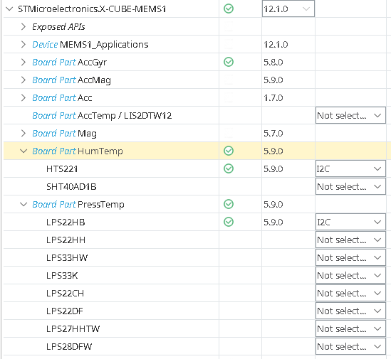
Additionally, add and configure the X-CUBE-BLE1 software package:
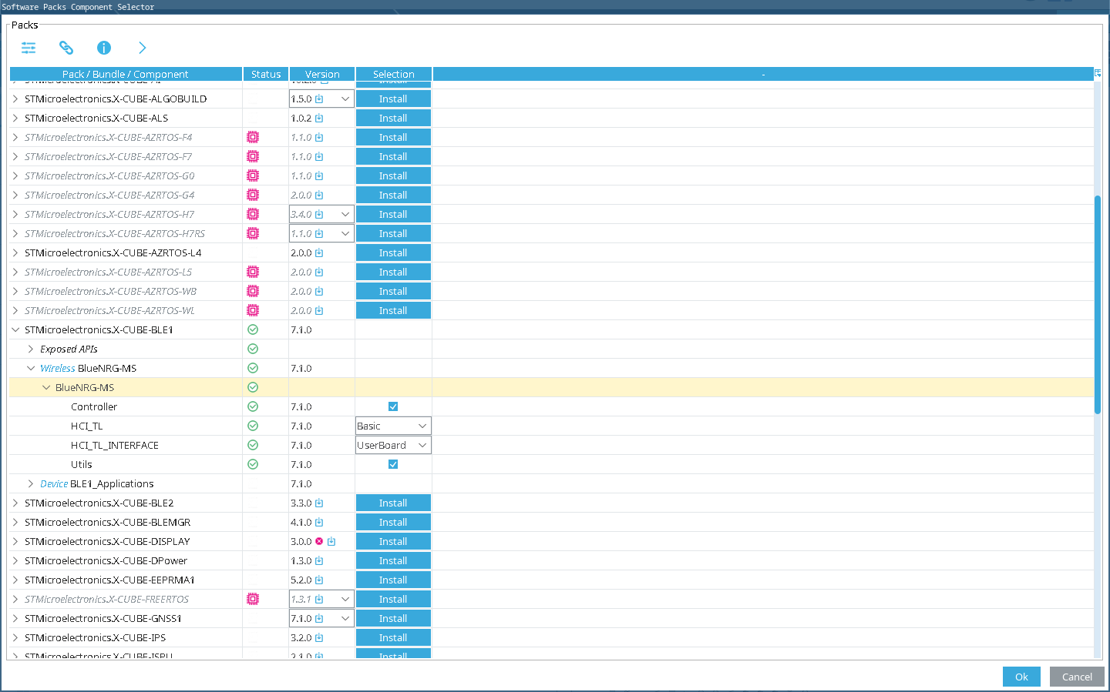
As in Lab 4, the Bluetooth middleware will need to be told what physical pins the Bluetooth module is connected to.
In the tabs on the left, select “Middleware and Software Packs”, then scroll down and select “X-CUBE-BLE1”. Enable the “Wireless BlueNRG MS” checkbox.
In the “Platform Settings” tab, we need to connect the Host Controller Interface, or HCI to the appropriate physical pins. Choose PE6 for the external interrupt line, SPI3 for the BUS IO Driver, PD13 for the CS (or Chip Select) line, and PA8 for the reset line.
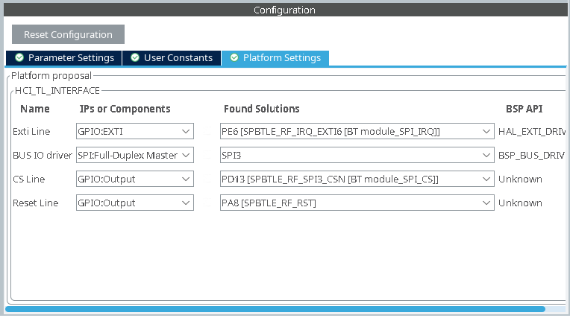
Now go to the X-CUBE-MEMS1 settings, and connect the sensors to the I2C2 bus.
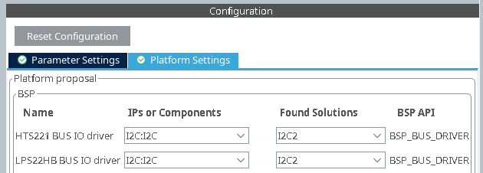
Next, navigate to “Connectivity”, select “SPI3”, and update the Parameter Settings to increase the data size to 8 bits, and the prescaler to 16.
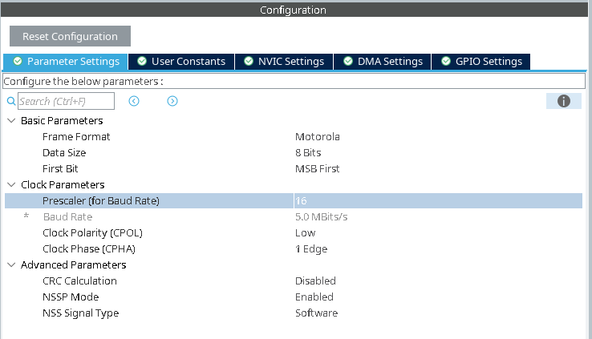
Everything should now be connected, so click “Generate Code”, then back in the IDE, click “Refresh”.
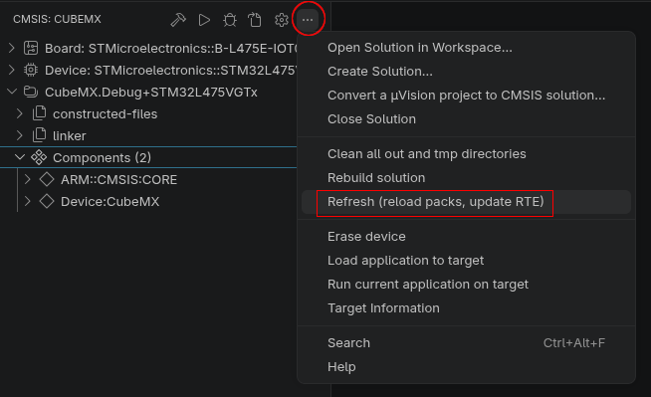
Now that the embedded system is configured, you’ll need to:
- Write code to initialise the Bluetooth interface (take inspiration from Lab 4)
  - Use the Environmental Sensing Service, instead of Heart Rate Monitor (UUID: 0x181a)
  - Use the following characteristics:
    - Temperature: UUID 0x2a6e
    - Pressure: UUID 0x2a6d
    - Humidity: UUID 0x2a6f
- Write code to initialise the on-board sensors (take inspiration from Lab 6)
- In your sensor update function, read from the sensors, and update the three BLE characteristics – once every second.
Once you have completed these tasks, try it out using the nRF Connect app before moving on to the Android App.
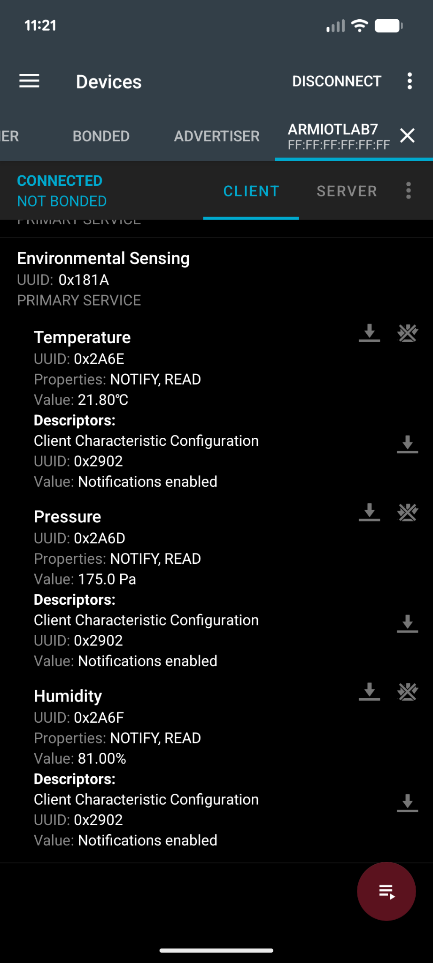
The Android App
In this step, you’ll take inspiration from Lab 5, and build an Android App to display the sensor readings. The structure is very similar to Lab 5, so start with that as your base, but modify your user interface to include values from all three sensors – be creative, and try to make it look good!
Some things to note:
- Be careful when subscribing to multiple characteristics – you can only initiate another subscription once the previous subscription has completed.
- Try to separate your logic out from your MainActivity. Create some new classes to help you, and decompose your methods so they don’t become overly complex.
- You’ll need to convert the raw values coming in over Bluetooth, into the actual values, using the translation formula as given in the specification.
- Use layout containers to position your UI elements, such as TableLayout and LinearLayout.
Here is an example of what you should be able to achieve (numbers are random for testing):
