IoT Education Kit
Lab 8 - Final Project: Activity Recognition
Overview
In this lab, we will build a full-stack Internet-of-Things system for real-time classification of user activities.
We will use the accelerometer and gyroscope sensors onboard the embedded platform, to send data to a cloud service, which will collect the data, classify it using machine learning, and allow a mobile app to read and display it.
This project involves a range of independent tasks across multiple platforms, including:
- Developing firmware for an embedded system
- Collecting readings for different activities
- Training and deploying appropriate machine learning algorithms for motion detection
- Developing a back-end web interface and associated database
- Mobile app development.
If you have followed the previous labs, you should have most of these skills in place, in particular:
- Reading sensors
- Writing a mobile app
The new key elements that you’ll need to investigate are:
- Wi-Fi communication - from the development board
  - Although you could also choose BLE again, and use your smartphone app as a gateway
- Cloud service management - to run virtual machines
- Machine learning - to classify sensor data
- Web framework development - to provide an API for the app
Requirements
In this lab, we will be using the following resources:
- DISCO-L475VG-IOT01A embedded board
- An Android device for testing and debugging
- Appropriate USB cable (usually USB-C) for connecting the mobile device to the computer running Android Studio.
- Access to a cloud platform, such as Google, Microsoft or Amazon. Any of these providers will work, as you’ll be using Infrastructure-as-a-service to start a virtual machine.
We will also be using the following software:
- Android Studio - for app development. This is the Android development environment, which includes the Android Software Development Kit (SDK), the toolchain, and an emulator.
  - This can be downloaded for free from the Android Developer Tools page:
https://developer.android.com/studio
- To configure the development board, you’ll need the STM32 CubeMX generator application, which you can download for free from here:
https://www.st.com/en/development-tools/stm32cubemx.html
- Web server technology: Django, Flask, NodeJS, PHP
- Database technology: MariaDB, PostgreSQL, SQLite
- Machine learning framework: TensorFlow, PyTorch
Tasks
The project involves three key tasks:
- Development of the cloud service and machine learning model
- Development of the device firmware
- Development of the mobile app
These tasks should be tackled in this order, so that when it comes to developing the device firmware, you can connect it to your cloud service immediately.
High Level Overview
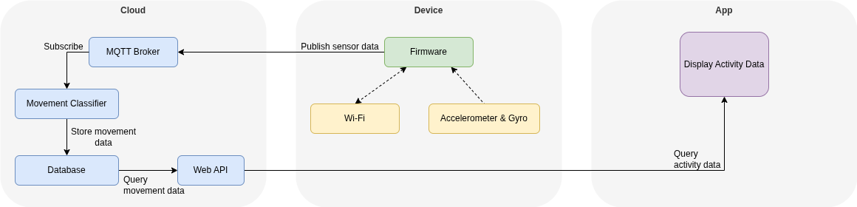
This figure gives a high-level overview of how your system should fit together. Your embedded device should periodically send sensor data to the cloud, over an MQTT connection. In the cloud, a movement classifier should read the sensor data, classify it, and store it in a database. A Web API should allow access to the data. Your mobile app should query the data, via the Web API, and display it on screen.
Cloud Service
Your cloud service will comprise:
- An MQTT broker, for receiving messages from the IoT device
- A machine-learning based classifier, to classify sensor data into movement activity.
- A database, for storing processed activity data
- A Web API server, for accessing the stored data
To do this, you should set-up and prepare a virtual machine on a Cloud Service Provider, such as Amazon, Google, or Microsoft. You can then configure your virtual machine with all the software you need. Often, Cloud Service Providers have a free tier, which lets you experiment. The process for creating a VM is different for each provider, however, once you have the VM, the operating system is the same.
If you are familiar with Docker containers, you could also develop this service locally. For example, you could run a container for the MQTT broker, one for the classifier, one for the database, and one for the Web API. You could use Docker Compose to build a service deployment.
The MQTT broker is what your embedded device connects to, and transmits sensor data. The classic MQTT broker is Mosquitto – which is available as a Linux package in all popular Linux distributions.
You could use an SQL database such as MariaDB or PostgreSQL for your data storage, or you could use a NoSQL database like MongoDB.
You can write your Web API in a range of different technologies:
- Python
- PHP
- Java
- Rust
- NodeJS
Ideally, you’d expose API endpoints to allow classified movement data to be returned, and displayed on a web page, or ultimately, in your mobile app.
Machine Learning Models
To achieve activity recognition, you will leverage the power of machine learning. You may use the following dataset on Kaggle: https://www.kaggle.com/vmalyi/run-or-walk, which contains previously collected sensor data from accelerometers and gyroscopes. The documentation therein explains how the data was collected and what model was used for training.
You are strongly encouraged to read through the posts, in case you might hope to collect additional data later, but also if you wish to enhance the robustness of your model or diversify the detection scenarios. Even if you do not want to do so, the original posts contain a key hint about the measurement unit used in representing sensor data, which is not recorded explicitly in the dataset.
However, you are not advised to use the same model as proposed by the respective author. You may find that their method did/could not make use of readings from all axes. Here comes one important point: you should do your best to make sure that your model can generalize well in multiple rigorous testing scenarios. To achieve this, you need to make your model learn as much useful information as possible.
In terms of model design, you may consider the following aspect, to ensure your model achieves good performance:
- Make use of temporal information.
Clearly, motion detection is a pattern recognition task on time-series multi-dimensional data. In other words, the task is time-sensitive, so you need to ensure that the model can learn temporal correlations from the dataset. For some time-sensitive tasks (even for this one), it might be possible that a time-insensitive model can exhibit reasonable performance. However, be aware that if your model does not extract/learn temporal correlations from the dataset, you may only gain limited insights.
- Keep things lightweight.
Activity tracking is not a difficult learning task that would require thousands of parameters and days of training. When designing a model, you should start from the simplest solution and gradually add blocks to it, rather than going directly for a sophisticated deep learning model. Even though all the computation can be achieved in the cloud, you should not use more than you need. Different models by default would use different resources. You can think of the following questions before you start: Is it better to choose a sophisticated model that should achieve excellent performance, but has many parameters and requires a lot of data for training, or choose a model with fewer parameters that can be trained in one batch? Do you value computation resources or memory resources more? Do you want your model to give probabilistic interpretations or not?
Device Firmware
Once you’re happy that your Cloud service is working, you can develop your device firmware, and start to send real data. Much of the firmware will be based on what you’ve learned previously, but with the addition of using the on-board Wi-Fi interface, and sending data using the MQTT protocol. You’ll be using the on-board Accelerometer and Gyroscope (the LSM6DSL), so make sure this software pack has been added in the CubeMX generator.
To get Wi-Fi working on the development board, you’ll also need to activate the SPI3 global interrupt. Go to the “Connectivity” section, click SPI3, navigate to “NVIC Settings”, and tick the global interrupt box.
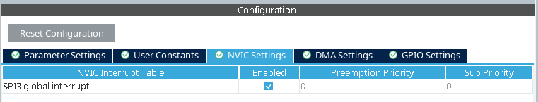
Once you have generated the code, there are a few bits of configuration to take care of. Firstly, you’ll need to install the appropriate Wi-Fi driver pack, along with the MQTT implementation. In the terminal, run the following commands:
cpackget add ARM::CMSIS-Driver
cpackget add AWS::coreMQTT
This will download the CMSIS Driver and MQTT packs, but you also need to include them in your solution. Open the component configuration window for the solution, then enable the following:
- CMSIS Driver
  - SPI (API) -> SPI
  - WiFi (API) -> ISM43362
- FreeRTOS
  - coreMQTT
- Network
  - Core
  - Interface -> Wi-Fi
  - Socket -> UDP
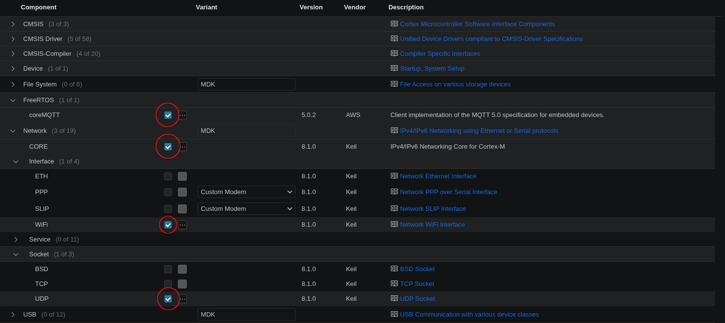
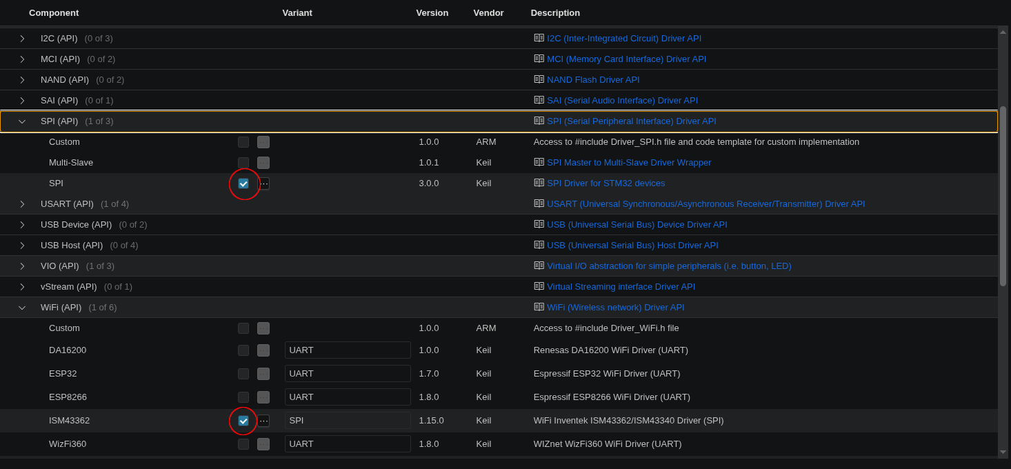
This will enable the MQTT component, and the Wi-Fi driver. There are some additional manual configuration steps that you need to make to complete the board setup.
First, edit your solution.yml file, and add the following to the end:
define:
- MQTT_DO_NOT_USE_CUSTOM_CONFIG
It should come after “compiler: AC6”, and be indented at the same level. This is to tell the MQTT component to use its default configuration. Next, you need to modify the WiFi_ISM43362_HW.c file, to connect the Wi-Fi driver to the appropriate GPIO pins. You’ll find this file under RTE/CMSIS_Driver. Use the provided reference file to populate this. If you’re using a different embedded device, you’ll need to modify the GPIO pin lines accordingly.
Once this is done, you’re ready to connect your board to Wi-Fi. Take inspiration from the IoT sensors lab to build your firmware. You’ll want your firmware to roughly follow this sequence:
- Initialise sensors
- Initialise Wi-Fi
- Connect to the MQTT broker
- Take a sensor reading every second, and send an MQTT message
Here is some sample code for connecting to Wi-Fi. This code is missing error checking, so make sure you adapt as necessary – but it should be good enough to get you started:
Driver_WiFi0.Initialize(NULL);
Driver_WiFi0.PowerControl(ARM_POWER_FULL);

ARM_WIFI_CONFIG_t wifiConfig = {0};
wifiConfig.ssid = "SSID"; // Your network SSID.
wifiConfig.pass = "PASSWORD"; // Your network password.
wifiConfig.security = ARM_WIFI_SECURITY_WPA2; // Your network security mode.
wifiConfig.ch = 0;
wifiConfig.wps_method = ARM_WIFI_WPS_METHOD_NONE;

Driver_WiFi0.Activate(0, &wifiConfig);
You’ll find the documentation for using the coreMQTT library here: https://docs.aws.amazon.com/freertos/latest/userguide/coremqtt.html
Remember, you’ll have to publish your MQTT message in the format expected by your cloud service.
Mobile App
As in previous labs, you should use an Android smartphone on which you should develop a mobile app to display relevant information retrieved from the cloud.
Again, Android Studio is the most accessible tool for developing an app and this lab is deliberately open-ended to let you explore. Indeed, feel free to choose Java or Kotlin as the programming language, depending on what you’d like to learn. Alternatively, if you are more familiar with JavaScript, there are a number of JS mobile frameworks that you can also opt for, such as Cordova and NativeScript.
If you are using Android Studio, the new part to this will be HTTP communications. The recommendation is to use Volley, an HTTP library developed by Google, in order to communicate with the cloud service. More information about Volley can be found at https://developer.android.com/training/volley.
Android strictly discourages I/O-intensive operations, such as networking, from running in the UI thread (that is the main thread). Normally, HTTP requests are wrapped in an Asynctask class and a callback function needs to be defined, which hugely affects productivity. Volley provides convenient APIs for various HTTP requests that can substantially reduce the amount of code.
There are no specific requirements in terms of the design of the mobile app, but in general it should have the following functionalities:
- Display the real-time predictions retrieved from the cloud;
- Display a history of activity records stored in the database in the cloud;
- Ensure the user can interact with the app smoothly and the code is bug-free.
Attractive UIs and animations are also highly encouraged, and remember to pay attention to the software engineering too – decompose functionality into additional classes and methods.

