***DSP Education Kit***

**Getting Started Guide**

**Setting up STM32F7 Discovery Kit with Arm-MDK**

**Issue 1.0**

Contents

1 Introduction 1

1.1 Lab overview 1

2 Requirements 1

2.1 Software requirements 1

2.2 Hardware requirements 2

2.2.1 Overview of STM32F746G Discovery board 2

3 Setting Up Keil MDK-Arm Project 3

3.1 Download and install Keil MDK-Arm 3

3.4 Install the STLink USB driver 4

3.5 Running the project 4

# Introduction

## Lab overview

In the labs for this course, we will use the STM32F7 Discovery Kit to practice digital signal processing concepts and explore some of their applications using advanced hardware.

Some tasks in the labs for this course require you to run example programs on the STM32F7 Discovery Kit. Therefore, you will need to install a suitable development environment on a host PC. This document describes the steps necessary in order to install and configure the Keil MDK-Arm IDE for use with the STM32F7 hardware platform and to start running the example programs.

The instructions in this guide assume that all software is installed in default locations or at the locations specified explicitly in this document. It is beyond the scope of these instructions to anticipate other possible working configurations. Also, it is quite possible that a working configuration may be achieved by different means than described here, but the procedures described in this document have been tested successfully on Windows 11.

# Requirements

## Software requirements

The following table is a list of required software tools that you need for the labs.

|  |  |  |
| --- | --- | --- |
| **Software** | **Website** | **Version**1 |
| Keil MDK-Arm | <https://www.keil.com/update/rvmdk.asp> | **v5.41** or the latest version  **Note**: The licensed version of Keil-MDK is needed due to the code size in the programs for this lab. For more information, see <https://www2.keil.com/mdk5/selector>. |
| MATLAB | <https://mathworks.com/downloads/> | **R2019a** or the latest version |
| GoldWave | <https://www.goldwave.com/release.php> | **v6.41** or the latest version |
| Example programs and ancillary files | Provided with labs | **Note:** The example programs used in this lab were tested using the STM32Cube MCU Package for STM32F7 Series (v1.17.0). |

Table 1: Software tools and versions

**1** The software versions listed here are versions that we have verified to be working with our labs. You can use the latest available (and most stable) versions of the software if backward and forward compatibility is supported.

## Hardware requirements

You will need the STM32F746G Discovery board for these labs.

|  |  |
| --- | --- |
| **Hardware** | **Additional Information** |
| STM32F746G Discovery board | This is the board that will be used to run the programs in the lab exercises.  In some optional exercises, you will need 2 Discovery boards.  The board can be found at: <https://www.st.com/en/evaluation-tools/32f746gdiscovery.html> |
| Oscilloscope | This will be necessary for numerous exercises for various uses such as time measurements of output signals. |
| Signal Generator | Needed for some exercises that require a generated input signal. |
| BNC T-Piece | Used to split the signal generator output that will be necessary in some exercises. |
| Earphones/Headphones with a microphone | This will be used in some exercises to listen to signals/input sound signals. |
| 3.5 mm Audio Jack(s) | Used to connect various peripherals to the Discovery board. |

Table 2: Hardware requirements

### Overview of STM32F746G Discovery board

The STM32F746G Discovery board features a Cirrus Logic WM8994 stereo audio codec, which is accessed via I2C for control and I2S, using the STM32F746G microcontroller’s serial audio interface (SAI) peripheral, for data. Analogue input and output signals are accessible via two three-pole (TRS) 3.5 mm jack sockets (LINE IN (CN11) and HEADPHONE OUT(CN10)).

As configured for these exercises, the WM8994 converts an analogue input signal into 16-bit signed integer sample values and the DAC converts 16-bit signed integer sample values into an analogue output signal.

Additionally, the WM8994 has a digital microphone interface, and the STM32F746G Discovery board provides two MEMS microphones as input devices.

Some of the hardware features of the STM32F746G Discovery board are highlighted in Figure 1.

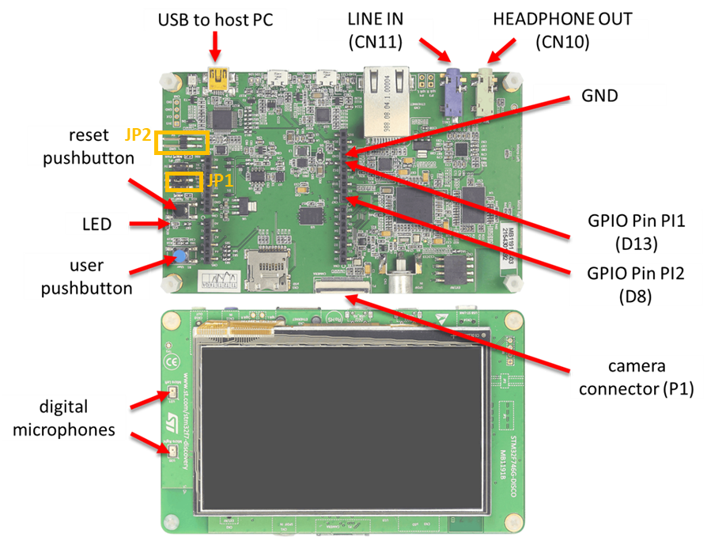

Figure 1: STM32F746G Discovery board

**Note: For this course lab exercises, JP1 should be set to “5V link USB + 5V.” JP2 should be left open.**

# Setting Up Keil MDK-Arm Project

## Download and install Keil MDK-Arm

Keil MDK-Arm is the development environment from which executable code will be built and downloaded to the Arm Cortex-M4 processor on the Pioneer Kit.

Due to the size of the example programs in the labs, **you will need a license for Keil MDK-Arm**. You cannot run the example programs using the code size-limited free version.

To set up Keil MDK-Arm, follow these instructions:

1. Download MDK-Arm from the URL link shown in Software requirements.
2. Install Keil MDK-Arm by running the downloaded executable file (e.g., MDK523.exe) and following the instructions. The files downloaded will, by default, be installed at C:\Keil_v5.
3. Download the released zip file from the [DSP-Edkits-Labs](https://github.com/arm-university/DSP-Edkits-Labs) repository and unzip it.
4. Open the Project.uvprojx file in the Projects/STM32746G-Discovery/<Project-Directory>/MDK-ARM directory.
5. Copy Project_Template(STM32G746G) directory and use it as your project template.

## Install the STLink USB driver

The STLink USB driver enables communication using USB between Keil MDK-Arm and the STM32F407 Discovery.

The STLink USB driver can be found at **C:\Users\<username>\AppData\Local\Keil_v5\ARM\STLink\USBDriver\**. Execute either **dpinst_amd64** (64-bit version) or **dpinst_x86** (32-bit version).

## Running the project

To ensure successful installation and setup of the Arm Keil MDK for the DSP lab, we shall run the project file that is provided with the DSP Education Kit by following these steps:

1. Ensure you are using a licensed version of Arm Keil MDK. Due to the code size, compiling the code will not work on the Arm Keil MDK Lite version.
2. Navigate to the **DSP-Edkits-Labs\Getting_Started\Projects\STM32746G-Discovery\Getting_Started\MDK-ARM** folder and double-click on the **Project.uvprojx** file. You should see a project structure similar to that shown in Figure4. The project should contain the example file **stm32f7_sine_lut.c**, which contains the main() function.

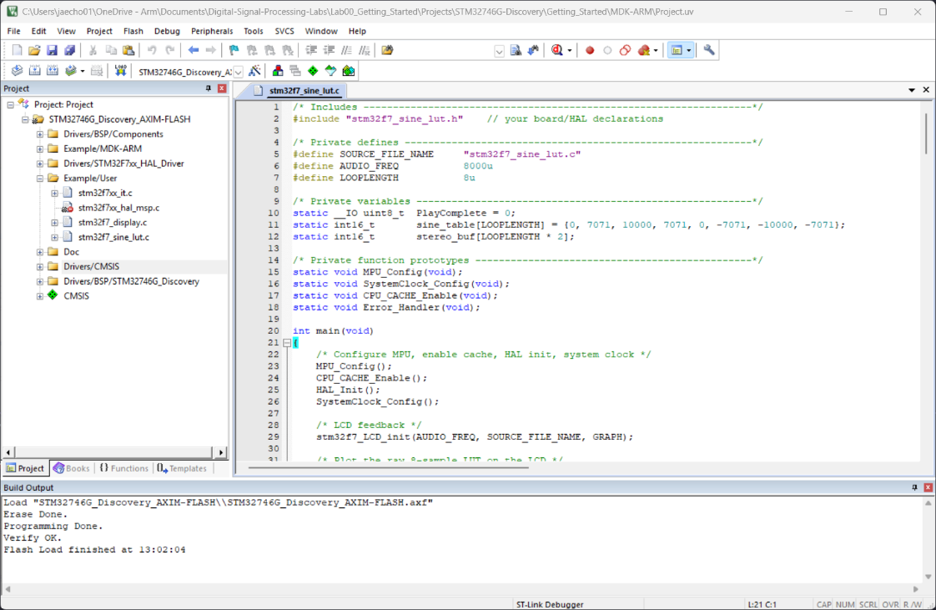

Figure 4: Screenshot of MDK-Arm showing the project

1. Connect the STM32F746 Discovery board to the host PC using a USB A to mini-b cable.
2. Plug the headphones into the output audio jack socket (CN10) on the board.
3. Build the project by selecting the **Project > Build target** or by clicking on the *Build* toolbar button .
4. Ensure that the correct debugger is selected in Keil MDK by following these steps:
   1. Select **Project > Options for Target.**
   2. Open the **Debug** tab in the **Options for Target** window.
   3. On the right side of the **Debug** tab, select the driver for the debugger on the **Use** dropdown menu.
   4. Select **ST-Link Debugger**.
5. After successfully building the project with no errors, switch to the debugger mode (and download the executable code into flash memory) by clicking on the ***Start/Stop Debug Session*** toolbar button .
6. Once the ***Debugger View*** has appeared, click on the ***Run*** toolbar button as shown in the following figure:

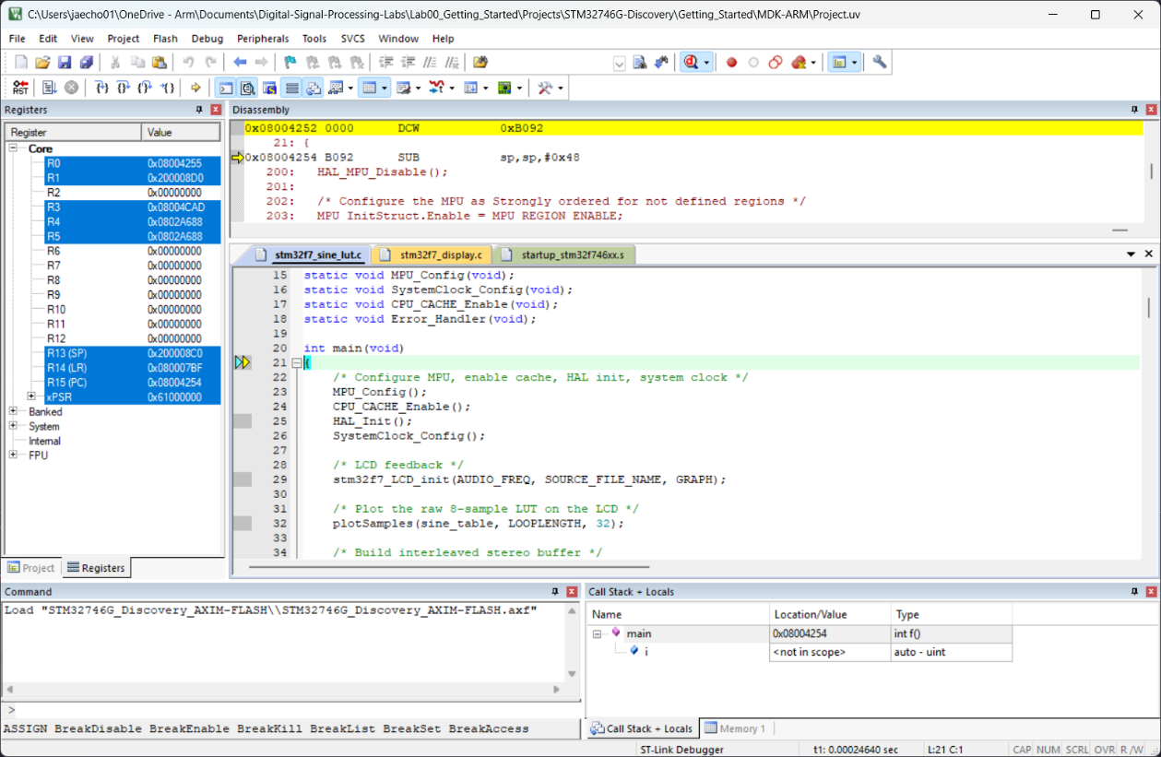



Figure 5: Snapshot of debugger view

**Expected results**

Once the program is running, you should see a start screen on the LCD on the board showing the program name as shown in the following figure.

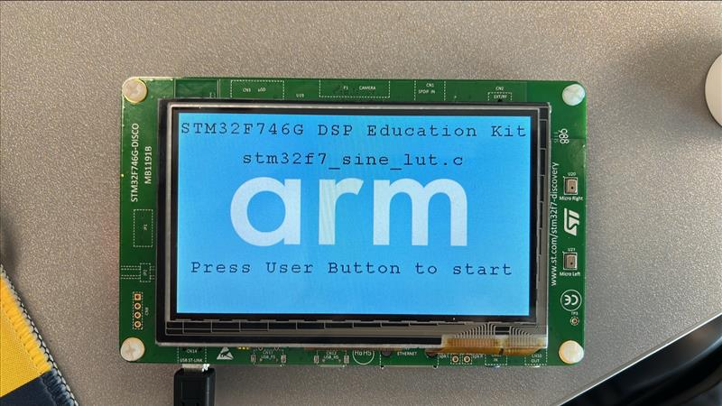

Figure 6: Start screen on LCD

Press the User Button shown in Figure 1. You should get a 1 kHz tone output on the HEADPHONE OUT socket on the Discovery board and the following display.

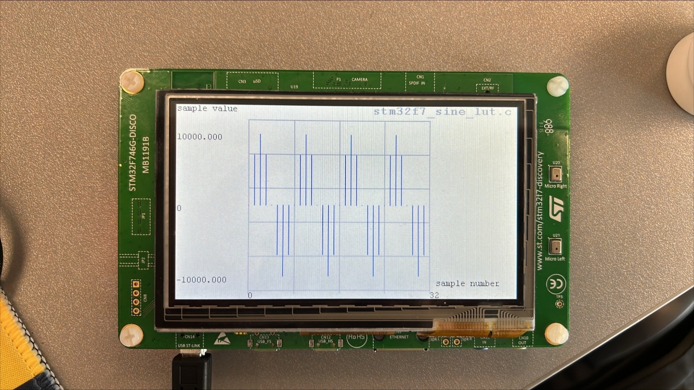

Figure 7: 1 kHz tone display on LCD