***Efficient Embedded Course***

**DAC LAB EXERCISE:**

**SIGNAL GENERATOR**

**Issue 1.0**

Contents

1 Overview 1

2 Details 1

2.1 Hardware 1

2.1.1 Connections 1

3 Procedure 2

3.1 Square Wave 2

3.2 Ramp Wave 2

3.3 SINe Wave 3

# Overview

In this project you will use the DAC to generate various signals which can be viewed on an oscilloscope or heard through a speaker.

# Details

## Hardware

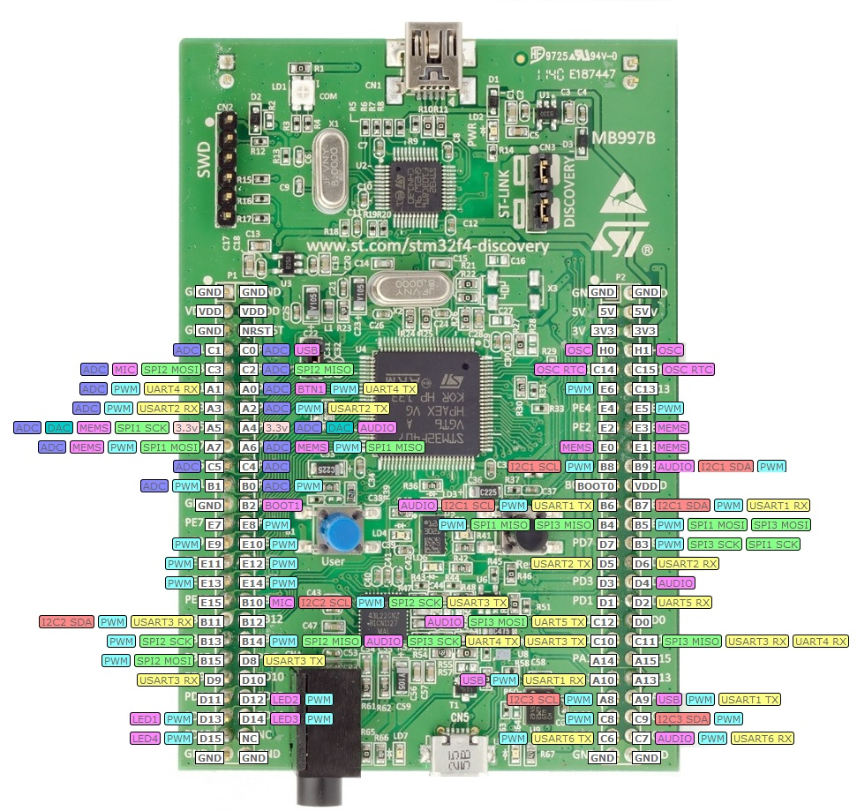

Figure 1. DiscoveryF4 pinout.

### Connections

Connect the oscilloscope probe to the DAC output signal on MCU board as shown in table below. This matches the pin used in the furnished code. Connect the oscilloscope ground to ground on the MCU board.

Table 1. Switch signals and connections

|  |  |  |  |
| --- | --- | --- | --- |
| Signal Name | Description | Direction | MCU |
| DAC_OUT | DAC output | Output from MCU | PA5 |
| GND | Ground | Power |  |

# Procedure

For these experiments you will configure the lab code by changing the last parameter passed to the function tone_play when it is called by main. Valid options are SQUARE, RAMP and SINE.

## Square Wave

Configure the code to generate a square wave. Compile and download the software. Use the oscilloscope to observe the output.

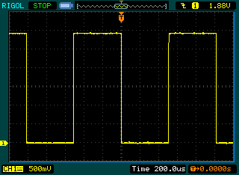

1. What is the minimum output voltage? ______________V
2. What is the maximum output voltage? ______________V
3. What is the rise time of the output signal? _________ ns
4. What is the fall time of the output signal? _________ns
5. What is the period of the output signal? ___________ ms

## Ramp Wave

Configure the code to generate a ramp wave. Compile and download the software. Use the oscilloscope to observe the output.

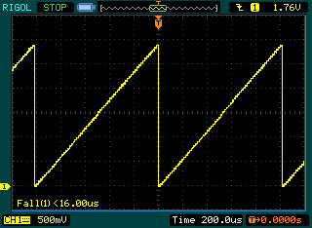

1. Why is the rising edge of the ramp wave not smooth? The DAC has 8 bits of resolution, but the resulting waveform is jagged.

The sampling frequency (set in part by the number of steps) is so low that the signal changes by a large amount between each sample.

1. How can you smooth the rising edge in hardware?

Add a low-pass RC filter.

1. How can you smooth the rising edge in software?

Increase the number of steps in the ramp generation code.

## SINe Wave

Configure the code to generate a sine wave. Compile and download the software. Use the oscilloscope to observe the output.

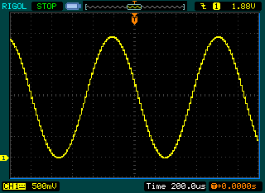

1. Experiment with the code to determine the maximum frequency sine wave which can be generated.

Reducing the delay parameter to 0 raises the frequency.

Raising the frequency of the sine wave in the table raises the output frequency accordingly.

for (n = 0; n < NUM_STEPS; n++) {

sine_table[n] = (int)((MAX_DAC_CODE) * (1 + sin(n * 2 * PI / NUM_STEPS)) / 2);

}

Another way to do this is to reduce the size of the sine table (determined by NUM_STEPS).