**KEIL µVision5 MDK IDE**

**Getting Started Guide**

**Issue 1.0**

Contents

1 Introduction 1

1.1 Course lab overview 1

1.2 Scope of this guide 1

2 Requirements 2

2.1 Software requirements 2

3 Keil setup 3

3.1 Download and Installation of Keil 3

3.2 Creating a new KEIL µVision5 Project 4

3.3 Configuring the Project Options 6

3.4 Simulating/Debugging your program 10

4 Troubleshooting 11

4.1 Issues when using the Keil MDK 11

4.1.1 Cannot download code to the board 11

# Introduction

## Course lab overview

In this guide, you will learn about getting started with the KEIL µVision5 Microcontroller Development Kit Integrated Development Environment.

## Scope of this guide

This Getting Started Guide is intended to give you the necessary information to install and configure the tools for the labs of this course.

**NOTE:** This guide assumes that:

* You are working with a Windows OS, because to-date, the Keil MDK only supports the Windows OS.

# Requirements

## Software requirements

The following table is a list of recommended software tools that are used in this guide.

|  |  |  |  |
| --- | --- | --- | --- |
| **Software** | **Website** | **Version**1 | **OS** |
| Keil MDK | <http://www.keil.com/> | V5.25.2.0 | Windows OS (to-date) |
| Arduino IDE | <https://www.arduino.cc/> | 1.8.7 | Windows, Mac OS X, Linux, Linux ARM |

**1** The software versions listed here are versions that we have verified to be working with our labs. You can use the latest available (and most stable) versions of the software, if backward and forward compatibility is supported.

# Keil setup

## Download and Installation of Keil

The Arm Keil MDK-Lite Edition is a free limited version that provides enough functionality for this course.

Ensure that you have installed the Arm Keil MDK-Lite Edition. For more information, see <http://www2.keil.com/mdk5/editions/lite>.

To download the free version of KEIL µVision 5, follow these instructions:

1. Go to [Keil Product Downloads](https://www.keil.com/download/product/) page.
2. Click on the MDK-Arm download option.
   1. Graphical user interface, text, application, email, website

      Description automatically generated
3. Download the installer by clicking on ‘MDK535.EXE’ and wait for the download to finish.
   1. Graphical user interface, text, website

      Description automatically generated
4. Navigate to your “Downloads” folder and click on the installer.
   1. Graphical user interface, text, application

      Description automatically generated
5. Run the installer using all the default settings and wait for the installation to finish.
6. Click ‘Finish’. This should prompt up the KEIL pack installer. Install the relevant packs related to your board and/or project.
   1. Graphical user interface, text, application, email

      Description automatically generated
7. You are done! You can now install KEIL µVision 5 and start your project.

## Creating a new KEIL µVision5 Project

This section explains the process of creating a new KEIL µVision 5 project.

1. Open KEIL µVision 5 on your computer.
2. Click on Project 🡪 Create new µVision project. It should prompt you to this new window.
   1. Graphical user interface, application

      Description automatically generated
3. Select the target device related to your project
   1. In this example, we will be using the STM32 NUCLEO-F401RE board by STMicroelectronics
4. Manage Run-Time environment as specified in the image below. Do add any extra peripherals to the setup if your project requires.
   1. Graphical user interface, application, table

      Description automatically generated
5. Click ‘OK’ and your project should be setup.
6. Expand ‘Target 1’ on the project file explorer on the left of the screen.
7. Right Click on the ‘Source Group 1’ and ‘Add new item to group ‘Source Group 1’.
8. Select ‘C file’ and name the file ‘main.c’ as such.
   1. Graphical user interface, text, application

      Description automatically generated
   2. This file should contain the main function that the microcontroller executes.
9. Your project is all set!

## Configuring the Project Options

This section concerns on configuring the project to the sui table settings.

1. Click on the ‘Options for Target’ option on the tool bar.
   1. Graphical user interface, application, Word

      Description automatically generated

Each tab in this window relates to different project settings. Here is a brief explanation for each.

* Device: Select the device from the µVision Device Database
  + Graphical user interface, text, application

    Description automatically generated
* Target: Specify the hardware of your application
  + Graphical user interface, table

    Description automatically generated
  + NOTE: The settings for Read/Only Memory Areas and Read/Write Memory Areas are used to create a linker scatter file. This requires that the setting Use Memory Layout from the Target Dialog is enabled in the Linker dialog.
* Output: Define the output files of the tool chain and allows you to start user programs after the build process.
  + Graphical user interface, text, application, email

    Description automatically generated
* Listing: Specify all listing files generated by the tool chain.
  + Graphical user interface, text, application, email

    Description automatically generated
* User: Specify user programs executed before compilation/build or after build.
  + Graphical user interface, text, application, email

    Description automatically generated
* C/C++: Set C/C++ compiler-specific tool options like optimization or variable allocation.
  + Graphical user interface, text, application, email

    Description automatically generated
* Asm: Set assembler-specific tool options like macro processing.
  + Graphical user interface, text, application, email

    Description automatically generated
* Linker: Set linker-related options. Typically, linker settings are required to configure the physical memory layout of the target system. Define the location of memory classes and sections in here.
  + Graphical user interface, text, application

    Description automatically generated
* Debug: Settings for the µVision Debugger. (Leave as default)
* Utilities: Configure utilities for Flash programming. (Leave as default)

## Simulating/Debugging your program

This section concerns using the built-in debugger in the KEIL µVision IDE.

1. Make you that you have built your program as specified in the Building and Flashing program to microcontroller section.
2. Click on the ‘Start/Stop Debug Session’ icon on the tool bar.
   1. Graphical user interface, text, application, Word

      Description automatically generated
3. Ignore the warning message.
4. Use the ‘Run’, ‘Step’, ‘Step over’, ‘Step out’, and ‘Run to Cursor Line’ icons/functionality to run/debug your code.
   1. NOTE: You can observe the values inside each of the registers and variables in the stack through the ‘Registers’ and ‘Call Stack + Locals’ windows respectively.
   2. You can also observe UART and Debug (printf) viewer windows by clicking on the ‘Serial Windows’ icon and selecting the appropriate Serial connection. This will prompt a new window where you can see the characters being printed through these connections.
      1. Graphical user interface, application, Word

         Description automatically generated

# Troubleshooting

This sections concerns troubleshooting the KEIL MDK.

## Issues when using the Keil MDK

### Cannot download code to the board

If you are facing problems with downloading the code on to the board, follow these steps:

1. Ensure that the board is connected to the computer through the debugger.
2. Ensure that the correct driver for the debugger is selected. To do this, in the Keil MDK:
   1. Select **Projects -> Options for Target**.
   2. Open the **Debug** tab in the **Options for Target** window.
   3. On the right side of the **Debug** tab, select the driver for the debugger on the **Use** dropdown menu. For ULINK-ME debugger, select the ULINK2/ME Cortex Debugger option.
3. Next click the **Settings** button next to the dropdown menu, as shown in the following figure.

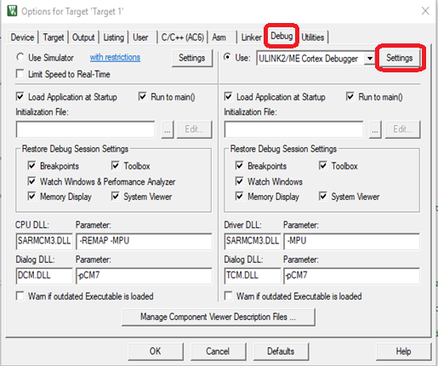

Figure1: Debugger options in Keil MDK.

1. Ensure that the IDCODE and Device Name appear under the **SW Device**, as shown in the following figure. Note, it may not be the same as what is shown here.

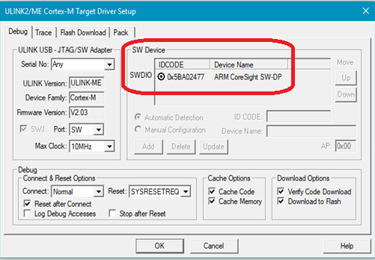

Figure 2: SW Device IDCODE and Device Name in Keil MDK.