Introduction to Graphics and Mobile Gaming
LAB 4: Part 1
Moving objects
Issue 2.0

Contents
1 Introduction 1
2 Moving the chess piece 1
2.1 Collision box 1
2.2 The game script 2
3 Room navigation 2
3.1 Controls 2
3.2 Camera 4
4 Collision 5
4.1 Physics of the room 5
4.2 Physics on the chess pieces 6
4.2.1 Movement direction 8

Introduction
In this lab, we will look at designing a UI and implementing physics and other visual elements in the game.

The aim is to transform the chess room into a short gameplay demonstration to show you how physics, particles, and game programming work in Unity. We will do this by creating a scoring system with a timer to allow gameplay elements to be used.

Before you start, be sure to add the assets for each lab to your project.

Moving the chess pieces
To enable the user to move the chess pieces, we will need to add a collision box around every chess piece and add the script to provide movement instructions.

Collision box
Click once on any chess piece and then, in the Inspector panel, click Add component. Add “Rigidbody” and “Box Collider”. The Rigidbody parameters are as follows:
- Mass = 1
- Drag = 0.5
- Angular drag = 0.05
- Use Gravity ticked
- Use Kinematic ticked

Leave everything else unchanged. The Box Collider element does not need any changes, though the size can be changed to adapt better to the chess piece.

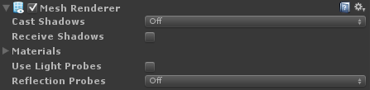
To increase the level of optimization we have, change the Mesh Renderer of each chess piece to the following options:

The game script
First, add a new empty object and rename it “moveChessPiece”. Select it and drag the moveChessPiece script into the Inspector panel.
Now press Play and ensure that none of the chess pieces are falling. If this happens, select them, press Ctrl + Shift, and drag them to ensure they are on the same y-coordinate as the chessboard.
You can build and install the APK now. The screen is divided into three parts, so you’ll notice areas of the screen that cannot be interacted with, such as the sides. This is because the sides handle the joysticks and shadows sliders. The center handles the movement of dynamic objects.

Room navigation
Now let’s enable the user to navigate the room. The first thing to do is create all the missing GUI elements and link them to the corresponding code.

Controls
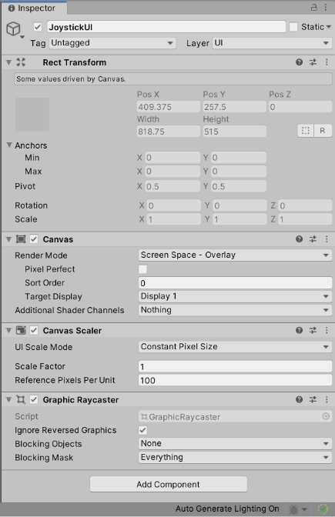
Go to GameObject > Select UI > Canvas. Select this object, rename it JoystickUI, and check its Render Mode is Screen Space - Overlay.
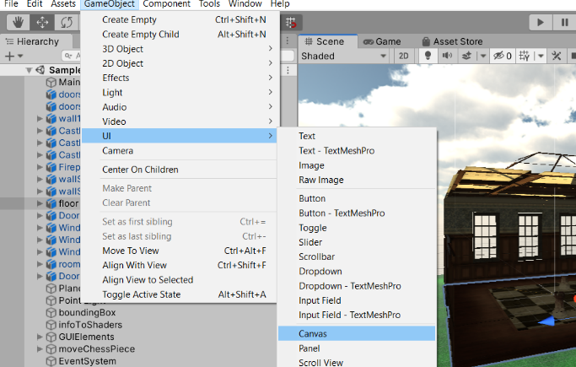

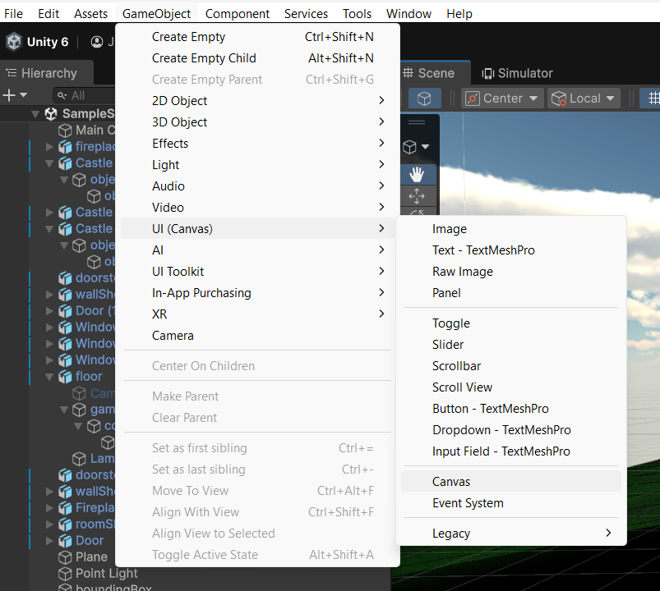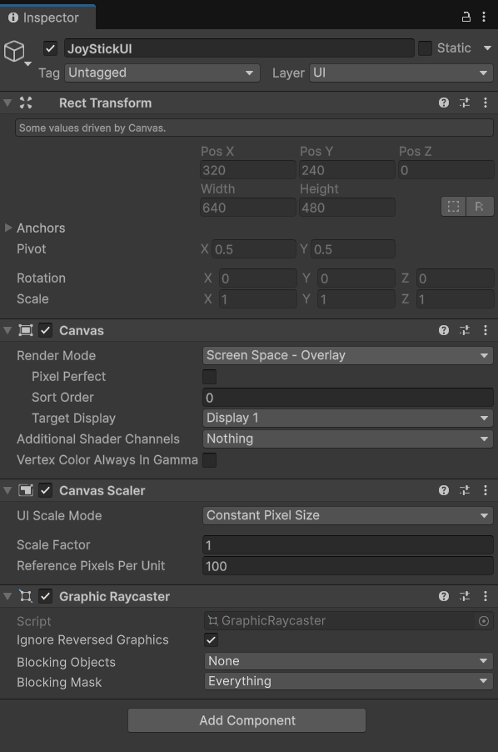

Add four Image objects as children of JoystickUI and rename them as follows: LeftJoystick, LeftJoystickFixed, RightJoystick, and RightJoystickFixed.
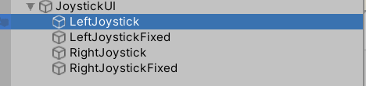
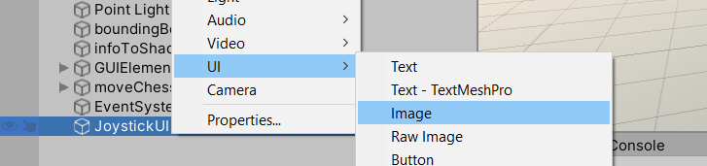

Copy the joystickUI folder into your project. Select Joystick Image in Unity and go to the Inspector. Change the Texture Type from Default to Sprite (2D and UI), then click Apply. Do the same for joystick_fixed img.
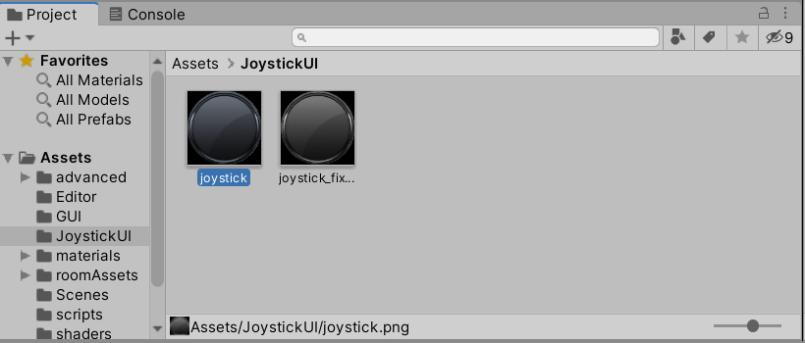
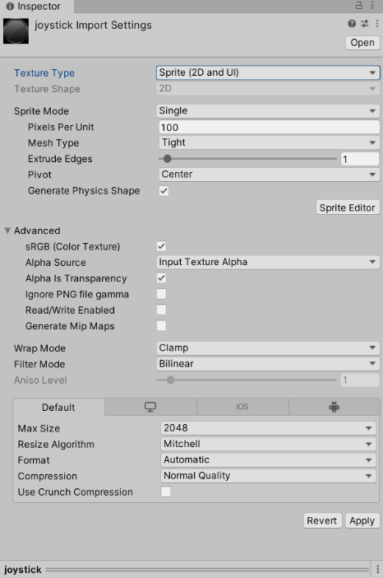

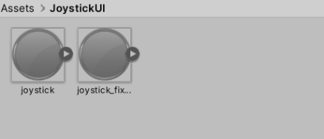

Click on leftJoystick. In the Inspector, click Tag >Add Tag. Click on the + button, enter joystick, and save it. Then assign this tag to both LeftJoystick and RightJoystick.
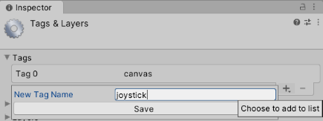
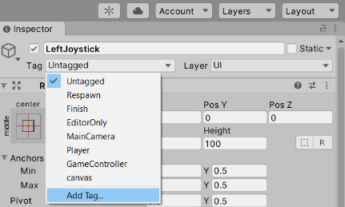
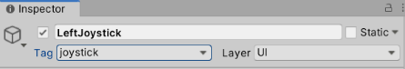

Let’s start assigning properties to these new objects, beginning with LeftJoystickFixed:
- Drag the joystick_fixed sprite into the Source Image field. Set the color to RGBA = 128, 128, 128, 190. Set the Width = 128 and Height = 128, untick Raycast Target and check that Pos X, Y, Z = (0, 0, 0).
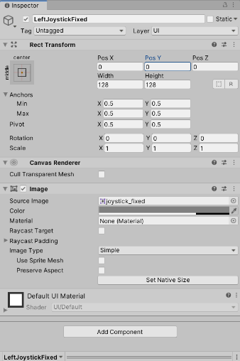

Next, let’s work on the LeftJoystick element:
- Drag the joystick sprite into the Image field. Set the color RGB value to 128, 128, 128, 190. Set the Width = 64 and Height = 64, check that Pos X, Y, Z = (0, 0, 0), tick Raycast Target and add a Graphic Raycaster.
- Drag and drop the NewJoystick script from the Scripts folder in the Project panel to the Inspector of LeftJoystick.
- Specify the Joystick Type to be Left
- J Trans Clamp Value =100, Fade Out = 0.1, Fade in = 0, and Hold threshold = 0
- Link the LeftJoystickFixed image to the Fixed Joystick image field by dragging the LeftJoystickFixed element from the Hierarchy panel
- Finally, set the UI scale factor to 0.001 and the J Trans values to X = 0 and Y = 0.

We need to repeat the same two operations for the right joystick, remembering to apply the correct Joystick Type and the correct Fixed Joystick image.

Camera
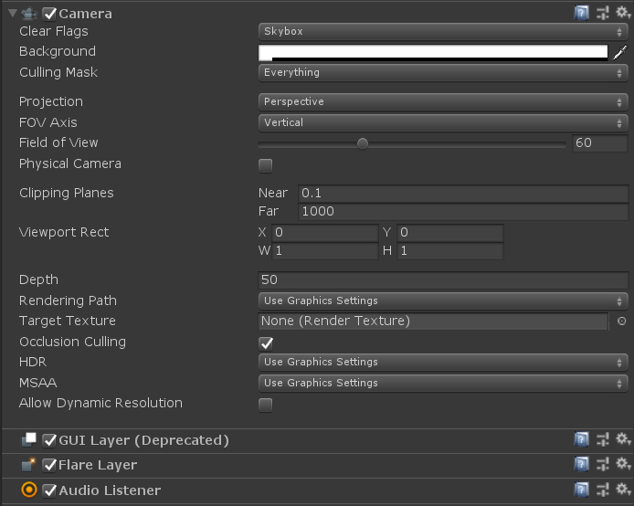
To enable the player to move around, we need to allow the camera to move around the room.
Click on the Main Camera from the Hierarchy panel and make sure the parameters are as shown in the screenshot.

Then, drag and drop the GameCamera script and from the Scripts folder into the Main Camera Inspector tab.
Set the parameters as shown in the screenshot below:
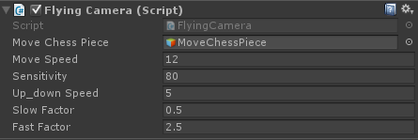
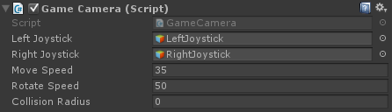
We are now ready to test our application. Build and run the apk on your device. Look at our new elements on screen and think whether they will need adjusting to improve the user experience.

Collision
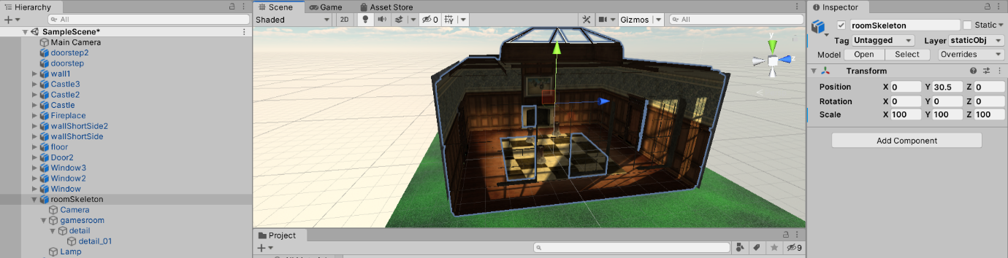
Before implementing physics in the room, check that the roomSkeleton and detail_01 positions are equal to zero on the X and Z axes.

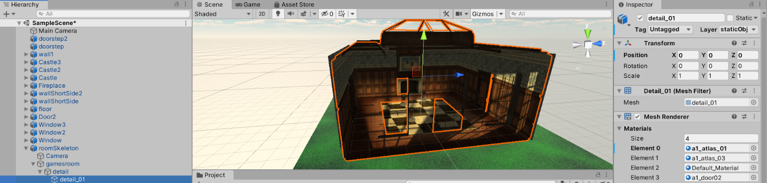

Physics of the room
Currently, we can exit the room. There is the possibility of the pieces moving outside of the room when they collide. We want to avoid this, as the gameplay space will exclusively be within the walls of our room.

We will need some extra 2D planes around the walls, floor, and ceiling to stop the chess pieces from exiting the room. These planes will have physics attached to them.

Create a new game object called a Quad. We use quads instead of planes, as they contain fewer vertices. Scale the quad to match the size of the walls, floor, and ceiling, with one quad for each surface. Place the quads with their faces pointing toward the room, otherwise quads will be ignored by chess pieces.

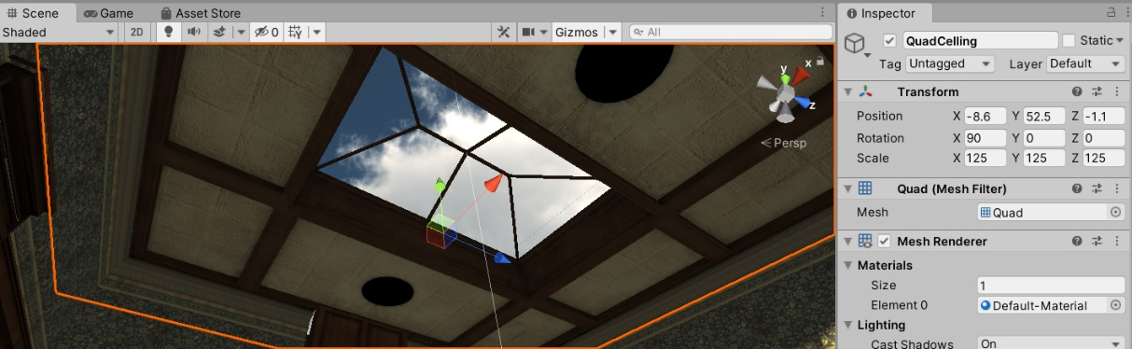

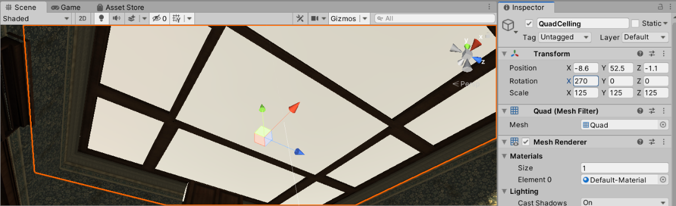

From the Inspector, untick Mesh Renderer to make it invisible and make sure collision is active.
Rebuild the project and install the APK onto our device, now none of the chess pieces should be able to exit the room because of collisions.

Physics on the chess pieces
We would like to create a force in the opposite direction of a screen press when the press is on a chess piece. Open your project and then go to the Scripts folder and double-click on the MoveChessPiece script to open it in the default editor.
Define a public float at the beginning of this class and rename it projectileForce. Initialize it to 500, though note that we will be able to change this later from the Inspector panel of the moveChessPiece element. All public declared variables can be changed from the Unity editor.

To move a chess piece, we will use the following function, which we will call ApplyForceAtChessPiece:
public void ApplyForceAtChessPiece()
{
//Find vector from camera to object
Vector3 camToObjVec = hitGO.transform.position - Camera.main.transform.position;
//Normalize this vector
camToObjVec.Normalize();
//create a random vector and multiply it with the projectileForce
Vector3 force = new Vector3(Random.Range(-1.0f, 1.0f), Random.Range(-1.0f, 1.0f),
Random.Range(-1.0f, 1.0f)) * projectileForce;

//add this vector to the rigid box as something was pushing/colliding with it
hitGO.GetComponent<Rigidbody>().AddForce(force);
}

Now, look at the rest of the code and try to understand how this works.
Inside of the OnGUI() function, there is the following if statement. Note the comments that will explain each portion of the code.
if (Application.platform == RuntimePlatform.WindowsEditor) <- detects if scene is playing on windows
{
// The mouse event
Event e = Event.current; <- creates an event and then will check if it’s of type mouse

if (e.isMouse)
{
//The following line gets the position of the touch on the screen (click on Windows)
Vector2 touchPos = new Vector2(e.mousePosition.x, Screen.height - e.mousePosition.y);

if (e.type == EventType.MouseDown ) <- this corresponds to a click
{
RaycastHit hit; <- this is a ray that detects collision on dynObj
Vector3 touchPos3D = new Vector3(touchPos.x, touchPos.y, 0.0f);
Ray ray = Camera.main.ScreenPointToRay(touchPos3D); <- ray starts from camera

if (Physics.Raycast(ray.origin, ray.direction, out hit, Mathf.Infinity, layerMask))
{
// A Game Object in the layerMask has been hit
hitGO = hit.collider.gameObject;

screenPoint3D = Camera.main.WorldToScreenPoint(hitGO.transform.position);
offset3D = hitGO.transform.position - Camera.main.ScreenToWorldPoint(new
Vector3(touchPos.x, touchPos.y, screenPoint3D.z));

// Store GO Y axis coordinate
goPosY = hitGO.transform.position.y; <- game obj coordinates
}
}

if (e.type == EventType.mouseUp ) <- if is just a click
{
TODO:
If an obj has been hit and user is not dragging
Call the apply force function to move obj

// Reset hit GO
hitGO = null;
}

if (e.type == EventType.MouseDrag && hitGO != null) <- if we are dragging
{
To DO:
Set dragging variable

Vector3 curScreenPoint3D = new Vector3(touchPos.x, touchPos.y, screenPoint3D.z);
Vector3 curPosition = Camera.main.ScreenToWorldPoint(curScreenPoint3D) + offset3D;
// We don't want the object moving along Y axis
curPosition.y = goPosY;

KeepObjectInsideTheRoom(ref curPosition);

// Update hit GO 3D position
hitGO.transform.position = curPosition; <- set new position
}

To DO:
Restore dragging variable when obj hasn’t been hit or user is not dragging
}

}

You now have to complete the TODOs in the code. A few hints:
- hitGO is null at the beginning, meaning no GameObject was hit.
- ApplyForceAtChessPiece applies the force to the object detected as ‘hit’.
- You might find it useful to keep track of whether the user is dragging the mouse on the screen. Usually, the game doesn’t start up with the user dragging the mouse on the screen.

If you get stuck, navigate to the Solutions folder and copy the code if necessary.

We now look at the Update() function. Here, after the if (Input.touchCount > 0) statement, you will find a piece of code similar to the one above, but dedicated to mobile devices.
if ((fingerId == touch.fingerId) && (touch.phase == TouchPhase.Ended || touch.phase == TouchPhase.Canceled))

corresponds to the following line for Windows:

if (e.type == EventType.mouseUp )

while this line:

if (hitGO != null && (touch.phase == TouchPhase.Stationary || touch.phase == TouchPhase.Moved))

corresponds to this one for Windows:

if (e.type == EventType.MouseDrag && hitGO != null)

You will need to fill in the code for applying the force on the chess piece on a mobile device too.

Movement direction
You can build and run the APK now. If you click on a chess piece, you will notice that objects are shot in random directions, with no effect indicating that they have been hit apart from the movement.

The first thing to do is fix the direction in which the chess pieces travel. Navigate through the code until you reach the ApplyForceAtChessPiece() function.
Previously, we defined the force and its direction for moving a chess piece as follows:
//create a random vector and multiply it with the projectileForce
Vector3 force = new Vector3(Random.Range(-1.0f, 1.0f), Random.Range(-1.0f, 1.0f), Random.Range(-1.0f, 1.0f)) *
projectileForce;
As the comment says, this generates a random vector with a random direction for the force. We don’t want that. So, what direction do we actually want?
You can observe from the previous section that we have computed the vector from the camera position to the object position. This would be a sensible vector to use, as it allows us to see the object being pushed in the opposite direction of the camera. Therefore, we simply replace our random vector with the camToObjVec:
Vector3 force = camToObjVec * projectileForce;
You might discover an issue with the sensitivity of the touch function. If the user accidentally drags a chess piece by 1 millimeter, it will not be considered a tap. To fix this, scroll down in the function until you find the if statement that handles dragging on mobile, and modify the code as follows:
//Add variable to keep track of lastTouchPosition
Vector2 lastTouchPos;
…
// If the user drags the finger or keep it touching in the same place
else if (hitGO != null && (touch.phase == TouchPhase.Stationary || touch.phase == TouchPhase.Moved))
{
//TODO: Keep track of dragging on the screen
//LAB4**************************************************

dragging =true;
//LAB4**************************************************

Vector3 curScreenPoint3D = new Vector3(touchPos.x, touchPos.y, screenPoint3D.z);
Vector3 curPosition = Camera.main.ScreenToWorldPoint(curScreenPoint3D) + offset3D;
// We don't want the object moving along Y axis.
curPosition.y = goPosY;
// Additionally to collision detection avoid object passing through walls as we are not using physics to move the obejct

//LAB4**************************************************

Vector3 hitV = hitGO.transform.position;
float dist = Vector3.Distance (hitV, curPosition);
if (dist <= 0.1) {
ApplyForceAtChessPiece ();
}
else {
KeepObjectInsideTheRoom(ref curPosition);
// Update hit GO 3D position.
hitGO.transform.position = curPosition;
}

}

else
{
dragging = false;
}
lastTouchPos.x = touchPos.x;
lastTouchPos.y = touchPos.y;

This should improve the shooting of the chess pieces. You can now build and install the APK again to see the changes.

