Introduction to Graphics and Mobile Gaming
LAB 5
Augmented Reality (AR) App
Issue 2.0

Contents
1 Introduction 1
2 Set Up 1
3 Creating AR Session 4
4 Detecting Point Cloud 11
5 Detecting Plane Surfaces 13
6 Preparing a Model 16
7 Placing an Object on a Surface Plane 21
8 Controlling the Object with a Joystick 28
9 Polishing the Control of the Joystick 39

Introduction
In this lab, we will look at how to develop an augmented reality (AR) application using Unity and the frameworks shown in the lecture. By the end of this lab, you will be able to place and control digital components in the real world using a mobile application.

Set Up
Please check that your mobile device is supported by the AR CORE KIT before starting this lab.

The first thing we will do is create a new project for our AR app. Open Unity Hub > New > Create.
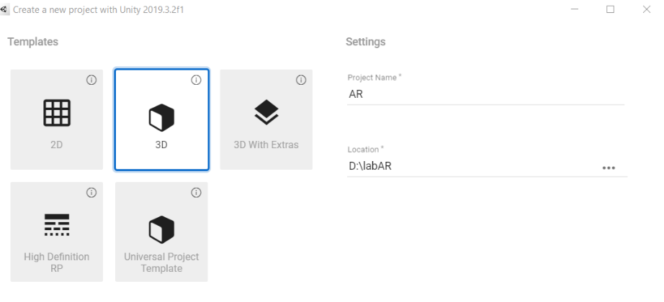

In the Unity Editor, go to Window > Package Manager. Click the drop-down menu, choose All packages, locate AR Foundation, and install it.
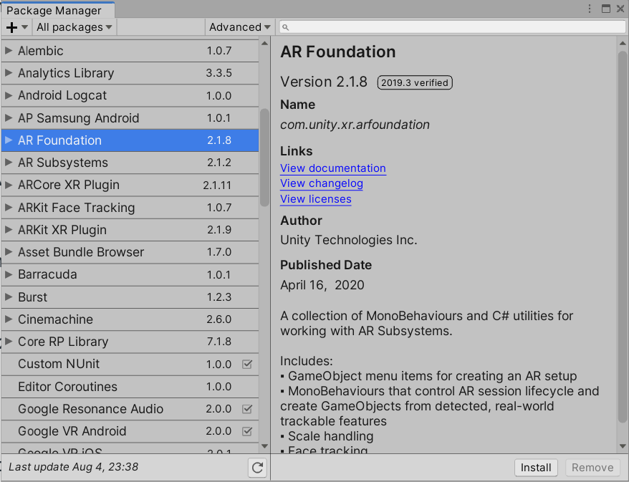

For the AR Foundation framework to work correctly, you will need to install the ARCORE XR Plugin and update the XR Legacy Input Helpers.
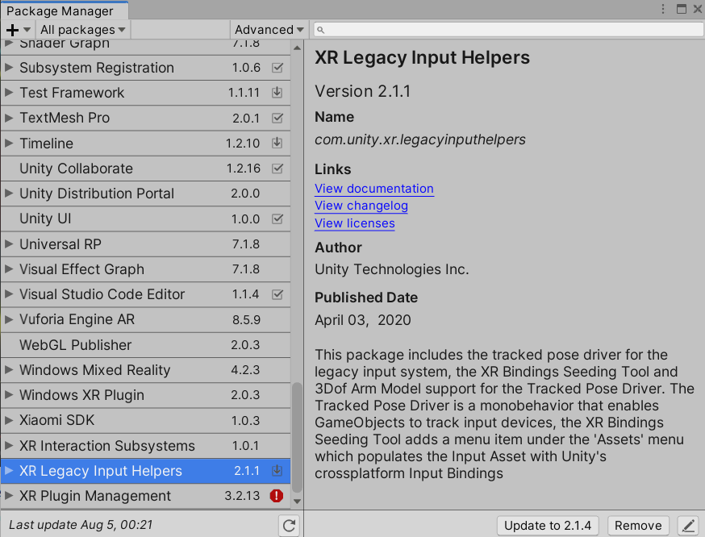
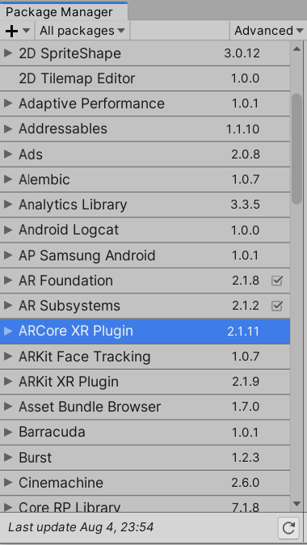

XR Plugin Management should be installed. Otherwise, install it manually.
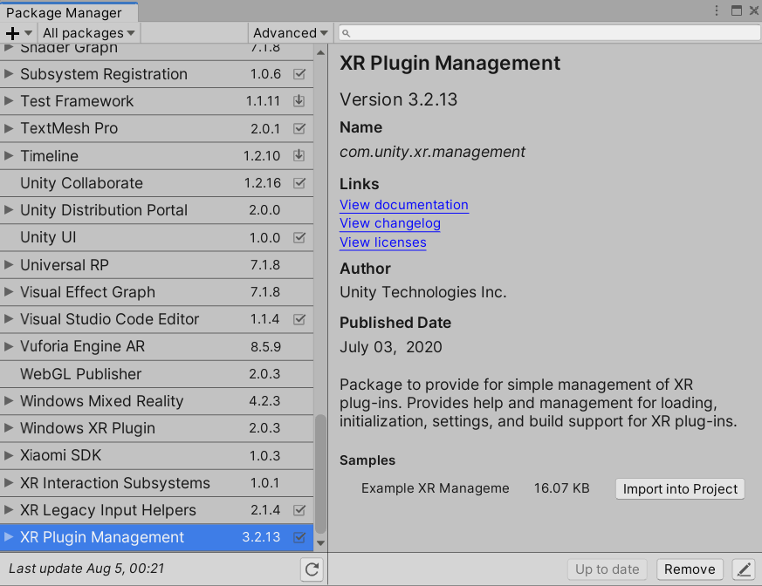

Go to File > Build Settings and switch the platform to Android.
Then, go to Player Settings > Player > Other Settings, tick Auto Graphics API, and select API level 24 as the minimum API version.
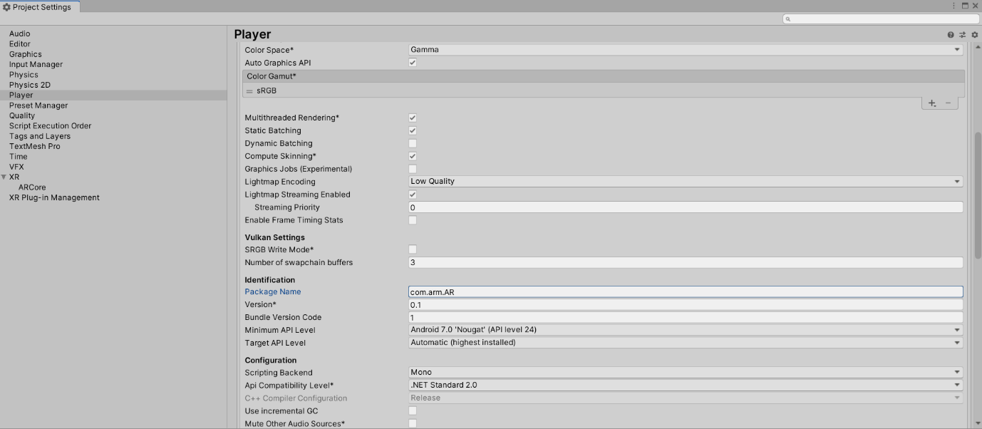

Next, go to XR Plug-in Management and tick ARCORE under Plug-in providers.
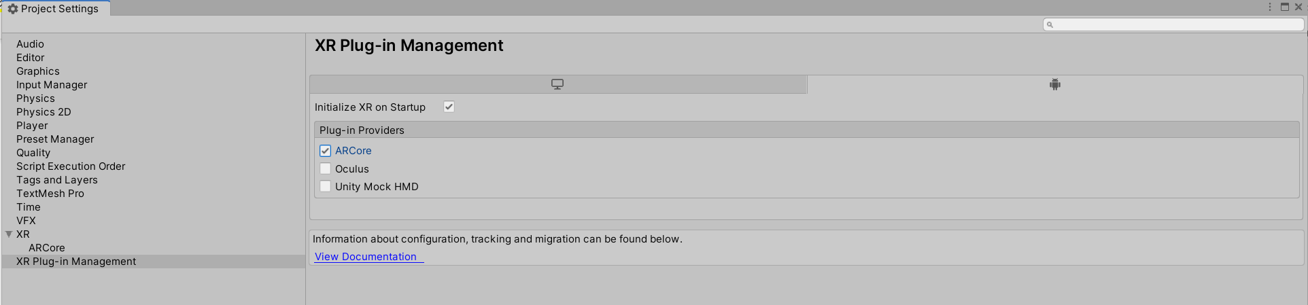

Close Project Settings and Build Settings, return to main scene, and delete the Main Camera.
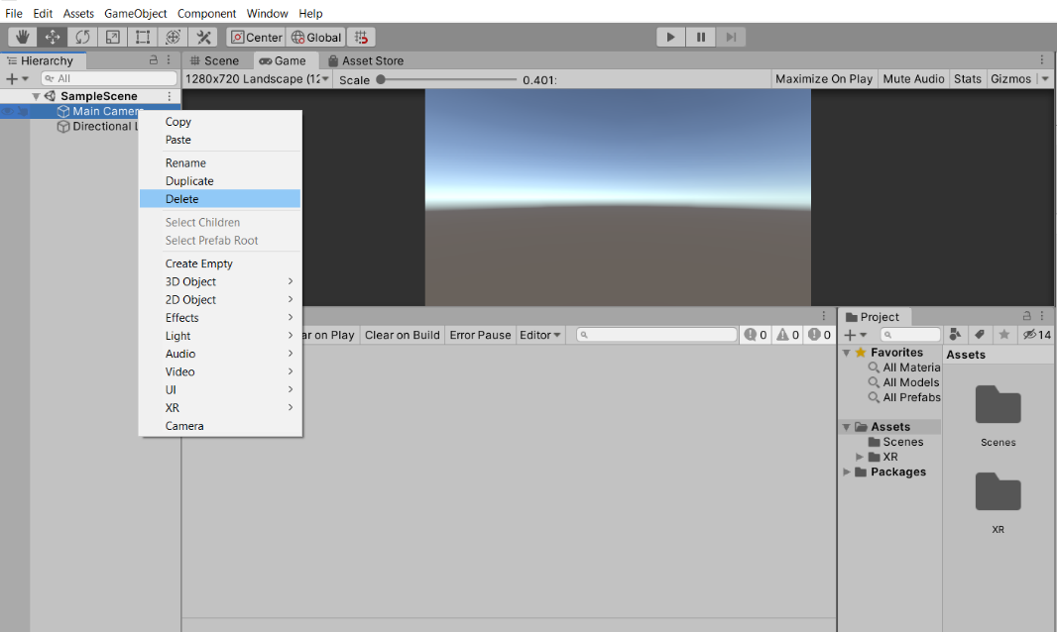

Creating AR Session
A basic AR application requires an AR session and an AR Session Origin in the main scene. To add them, right-click in the Hierarchy and select XR > AR Session. Then do the same for the XR > AR Session Origin.
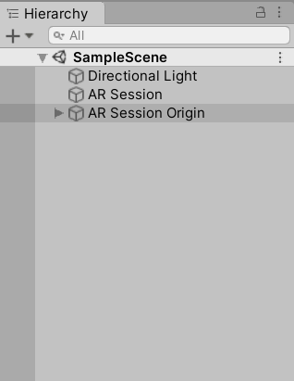
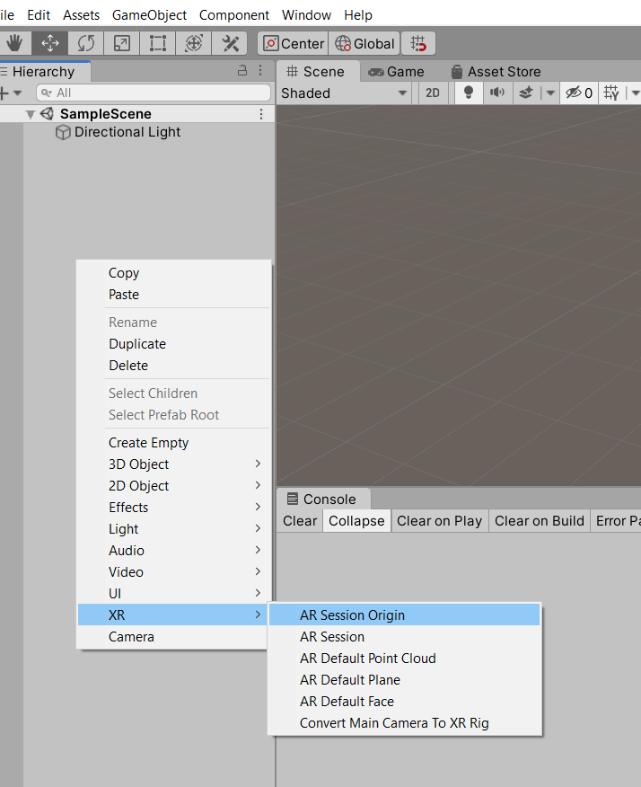
Create two folders in the Assets folder and name them Textures and Prefabs.
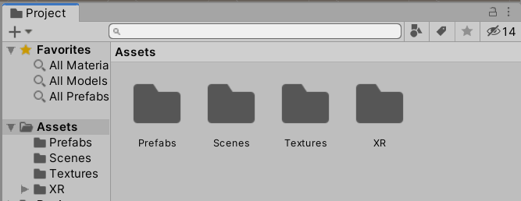

Copy 8k_earth_daymap.jpg and Earth.fbx from the lab resources into Textures and Prefabs folders, respectively.
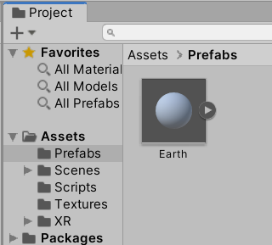
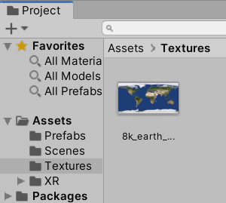

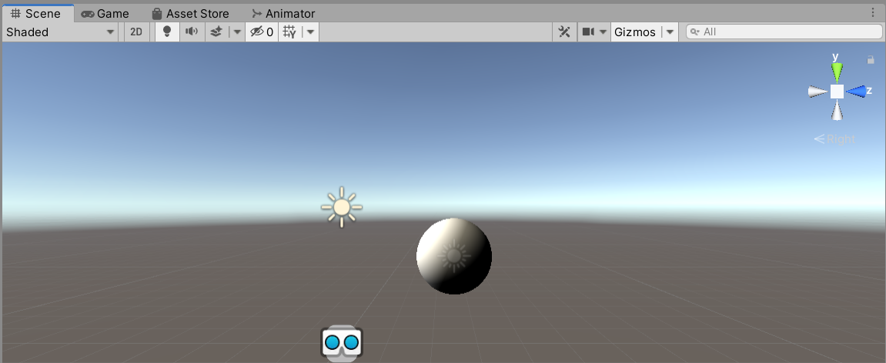
Place the earth prefab in the scene.

As you can see, there is a problem with the lighting. To fix this, go to Window > Rendering > Lighting Settings > Debug Settings and tick Auto Generate General Lighting.
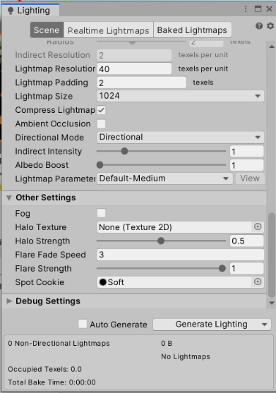
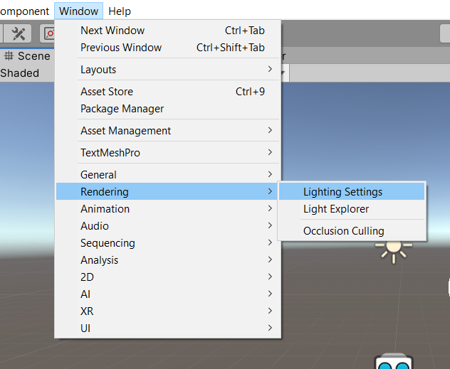

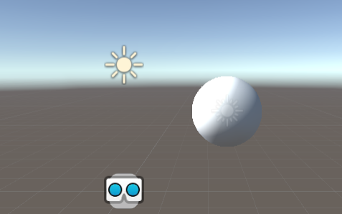

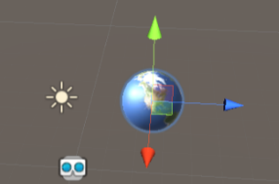
Now, apply the imported texture to Earth.fbx by selecting the prefab and dragging the texture onto it.

Now, expand AR Session Origin, click on the AR Camera object, and in the Inspector, tag it as Main Camera.
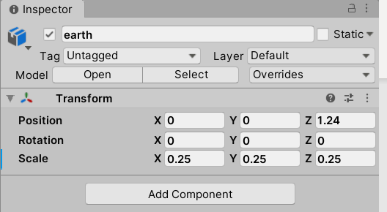
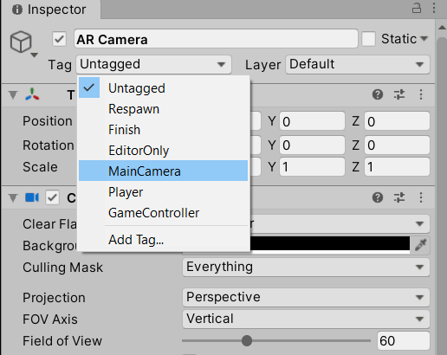
Double-click the AR Camera object and you should be able to locate it in the Scene view.
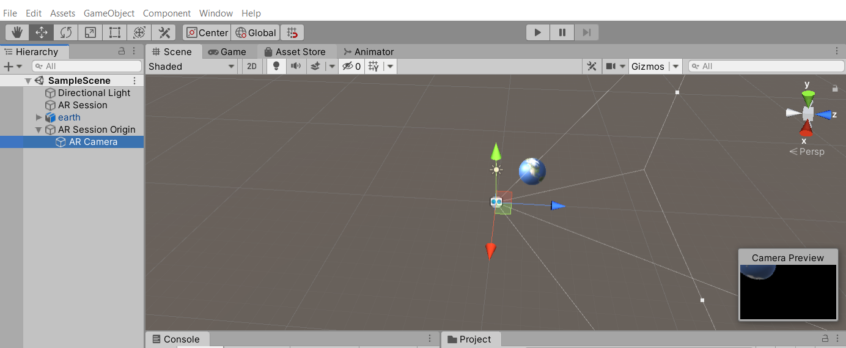
The AR Camera will match the rear camera of your mobile phone when you launch the application. Now, what we would like to do is to place the prefab approximately 1 meter away from the smartphone at a suitable scale. To do this, go to the Earth prefab in the Inspector, position the prefab at (0, 0, 1.25), and scale the asset to (0.25, 0.25, 0.25).
Be careful not to confuse the children of Earth (Earth and Sun); otherwise, you might need to use a different scale.

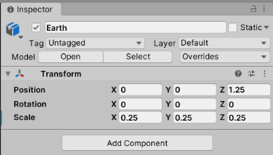

In Unity, one meter in the real worldcorresponds to one Unity unit, or the length of one face of a cube. Since the AR camera should be at the origin (0, 0, 0) by default, we only need to move 1.25 units along the Z-axis, taking into consideration the radius of the Earth prefab.
If you want to verify this yourself, change the Scene view perspective to Y by clicking the view tool and placing a Cube GameObject as a reference. To do this, go to GameObject > 3D Object > Cube. Don’t forget to delete the cube once you have checked this.
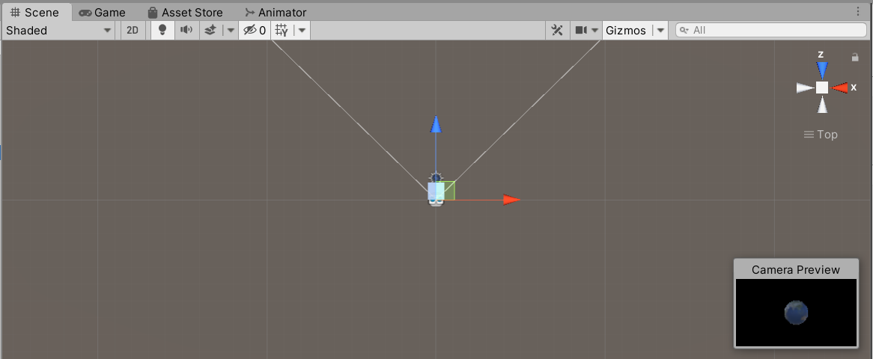
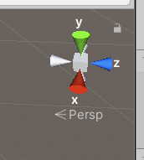

The Earth prefab already contains a source of light, so we can disable the Directional Light for now.
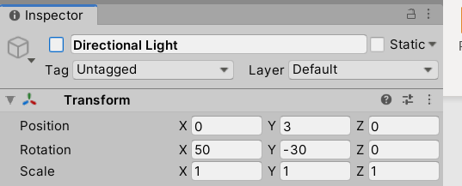

Now let’s add a rotation animation contained in the Earth assets. Go to the Prefabs folder, expand the Earth asset, select Scene, and press Ctrl + D to duplicate this animation.
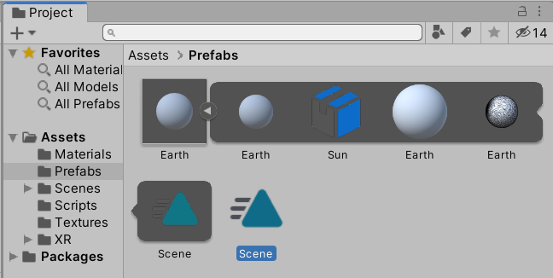
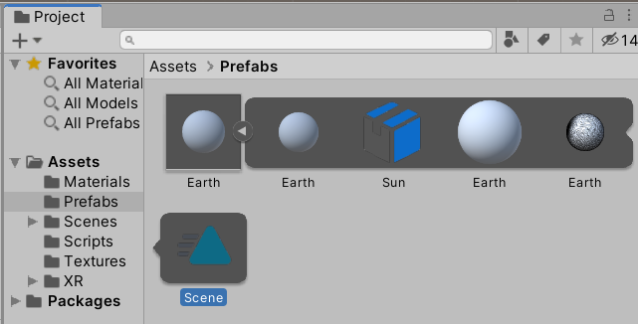

Select the newly created Scene animation, go to the Inspector, and tick Loop Time.
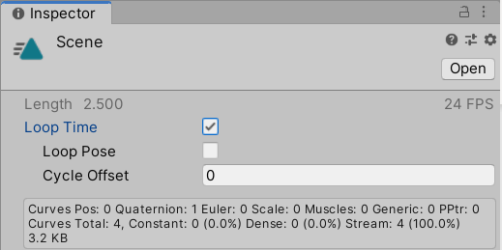

Select Earth prefab, go to the Inspector, and drag the Scene animation onto it. This should generate an Animator component, along with a controller in the Prefabs folder.
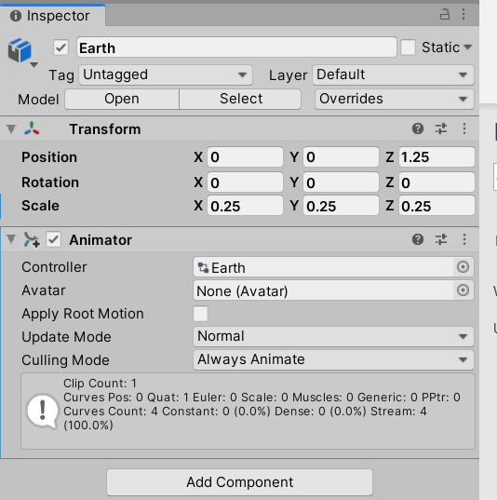

Double-click the Earth controller to open the Animator view and check that there is a transition from the Entry state to the Scene animation, as shown in the following picture.
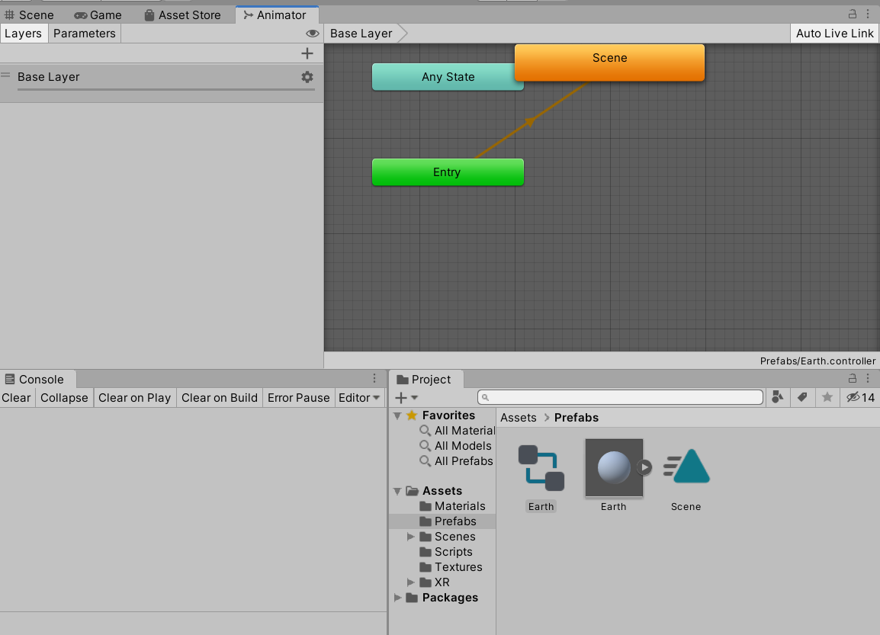
At this point, you can run the Unity editor to check whether the animation is playing.
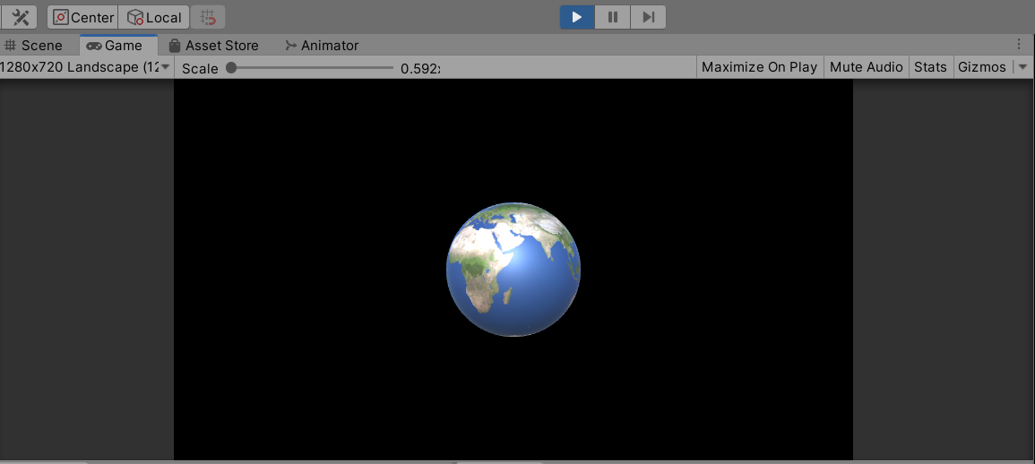

Save your scene (Ctrl + S) and connect your phone to your computer. In Unity, go to File > Build and Run, enter a name for the APK, and save it.
Once the application has been built, it should start automatically in your smartphone. You might need to enable USB debugging when the device is connected via USB in the phone settings, in case you have not already done so during the previous labs.
Since it’s the first time launching this application, it will ask for permissions to take pictures and record videos. Allow these permissions, and you should be able to see the Earth approximately one meter away from you. Notice that the Earth should maintain its position as you move around the environment.
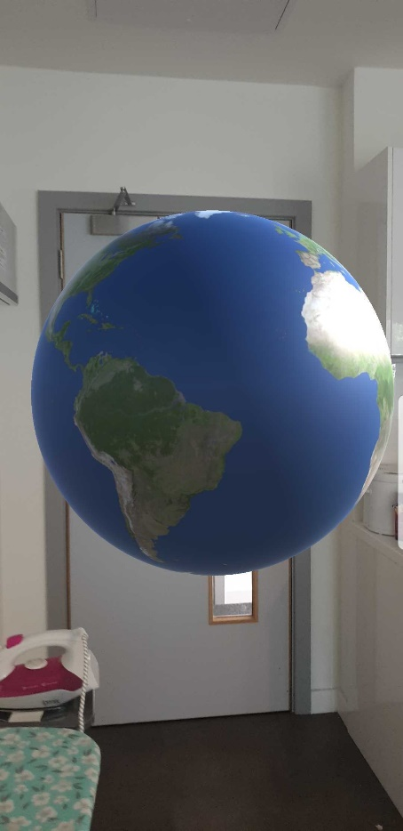
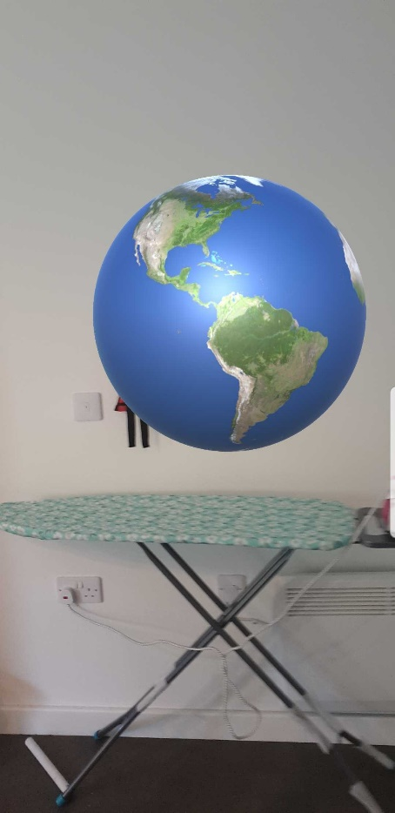
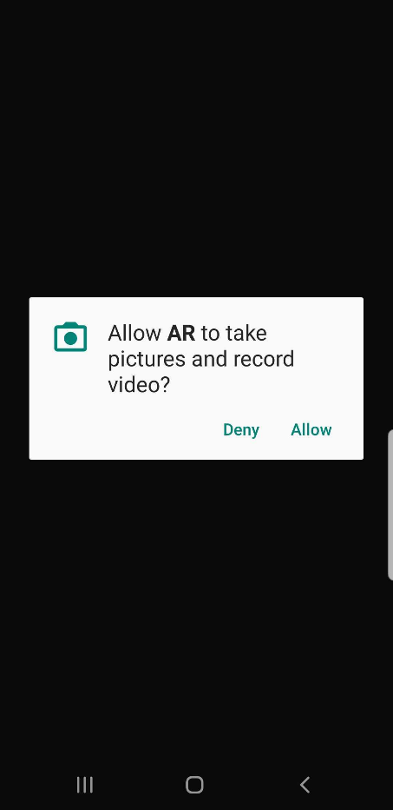

Detecting Point Cloud
AR foundation allows you to detect a point cloud. A point cloud is a set of data points in a space resulting from the reconstruction of an environment, which helps us render objects correctly in the real world. To do this, select AR Session Origin, click Add Component in the Inspector, search for AR Point Cloud Manager, and click on it.
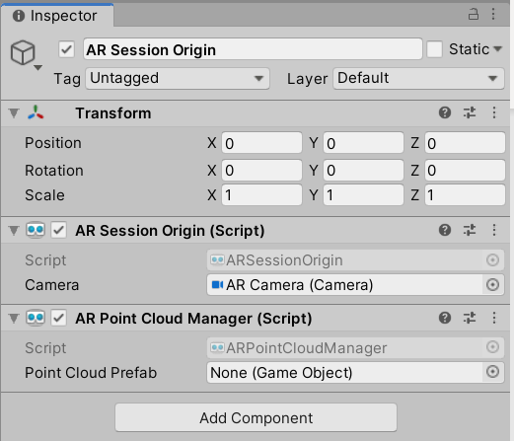

To visualize this, we will need to add a prefab. Right-click in the Hierarchy window and select XR > AR Default Point Cloud.
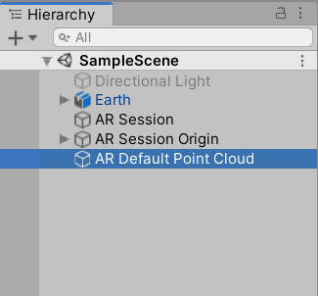
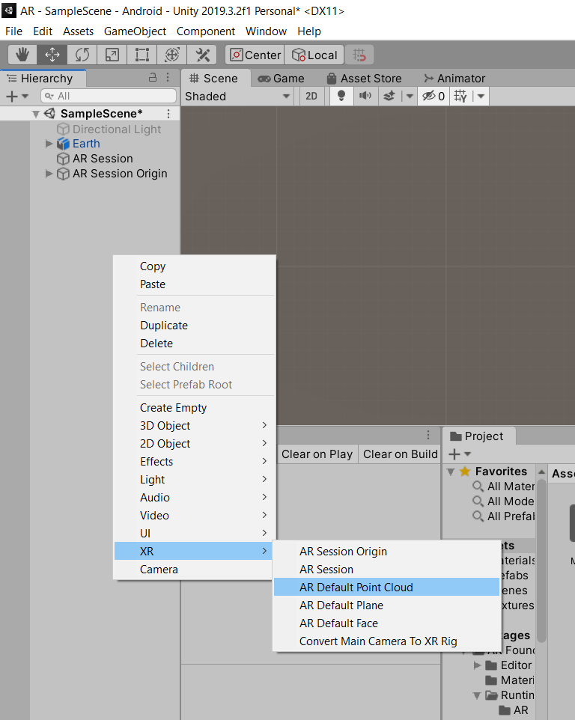

Open the Prefabs folder and drag the AR Default Point Cloud GameObject from the Hierarchy window into the Prefabs folder to create a prefab.
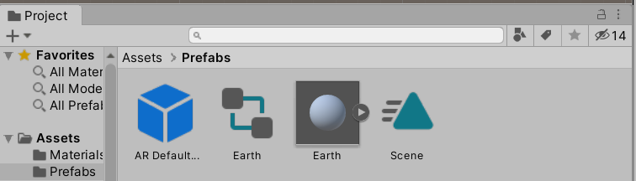

Delete the AR Default Point Cloud object from the Hierarchy window and add the generated prefab to the AR Point Cloud Manager component. You could do this either by dragging the prefab into the field or by clicking on the drop-down menu for the Point Cloud Prefab option, selecting Assets, and then selecting AR Default Point Cloud.
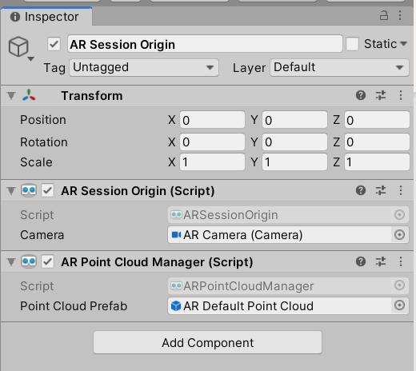
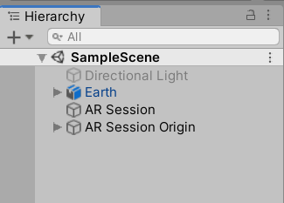

Save your scene (Ctrl + S). Connect your phone to your computer, and in Unity, go to File > Build and Run. When running the application, you will be able to observe point clouds around your environment.
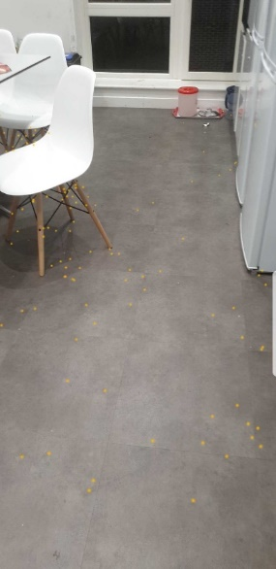
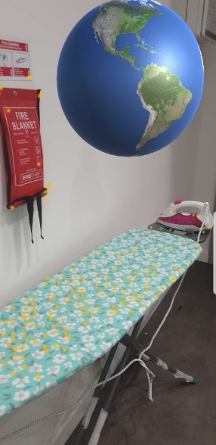
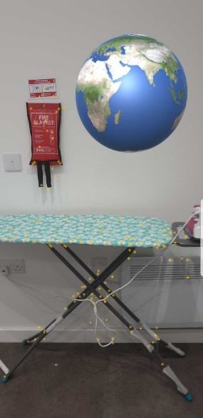

Detecting Plane Surfaces
To implement plane surface detection, we will need to follow the same process that we used for the Point Cloud. Select AR Session Origin, click Add component, in the Inspectorsearch for AR Plane Manager and click on it.
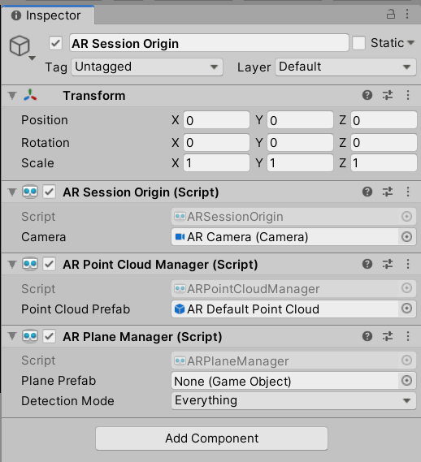

Right-click in the Hierarchy window > XR > AR Default Plane.
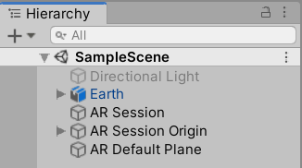
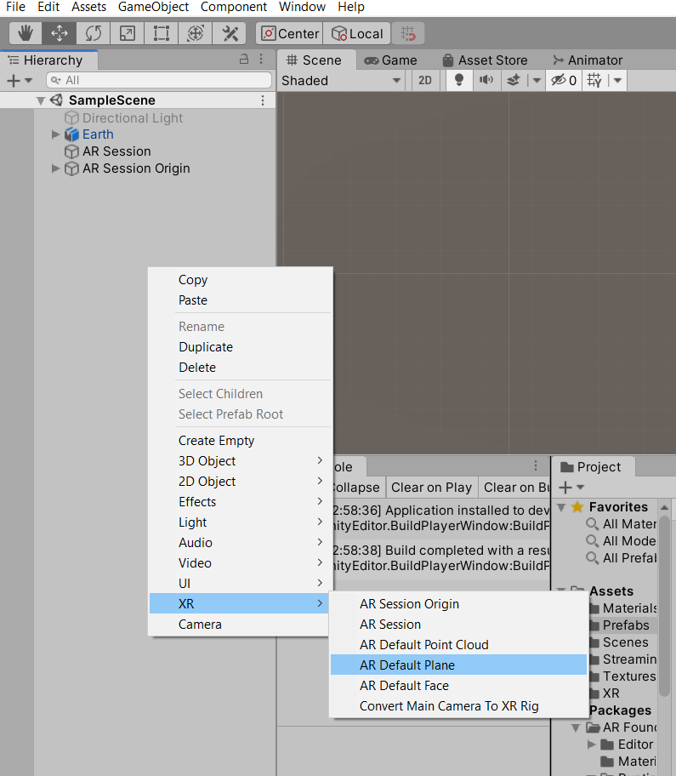
Let’s change the default material of the AR Default Plane to something else. Go to the “Materials” folder (it should have been generated automatically when applying the texture to the Earth prefab), right-click, and select Create > Material. Right-click the new material and rename it ar_plane.
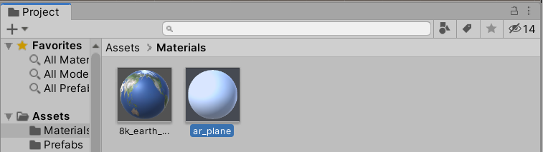

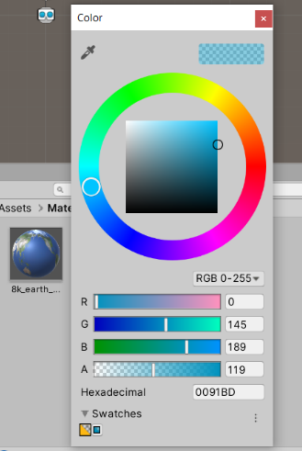
Select the material, and in the Inspector, change the Rendering Mode to Transparent. Click the Albedo color and set the RGB value to (0, 145, 189), or use the hexadecimal value 0091BD.
Then change the alpha value to 119.
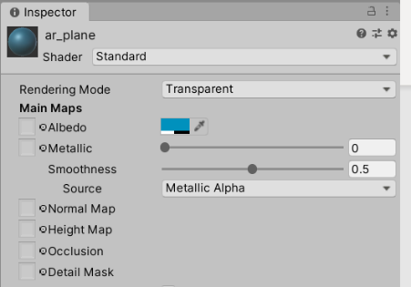
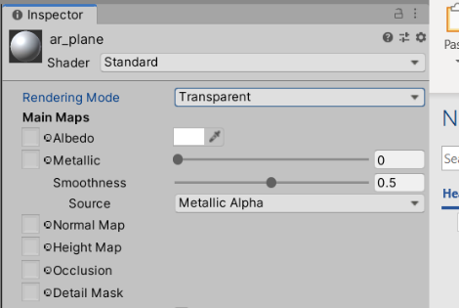

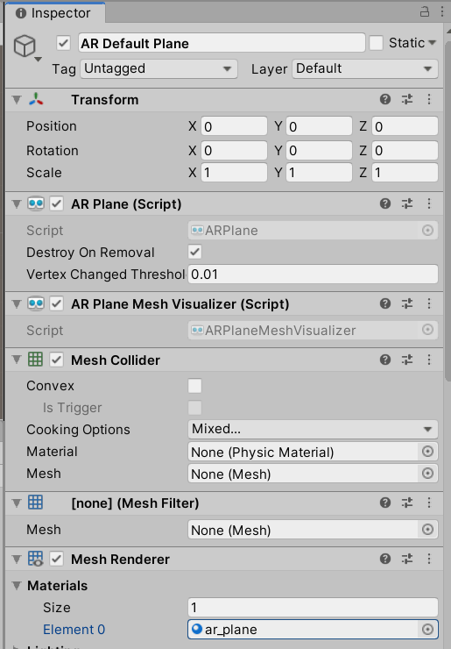
Select the AR Default Plane GameObject in the Hierarchy window and change the material for the one that we have modified.

Open the Prefabs folder and drag the AR Default Plane GameObject from the Hierarchy window into the Prefabs folder to create a prefab.
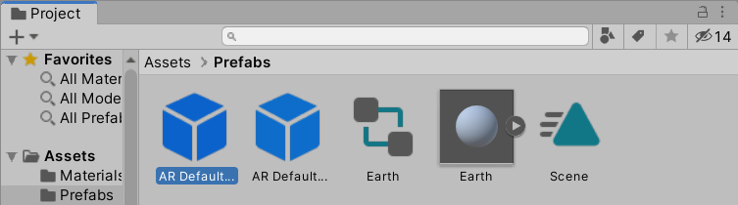

Delete the AR Default Plane prefab from the Hierarchy window and add the generated prefab to the AR Plane Manager component. You can also untick the AR Point Cloud Manager component if you wish.
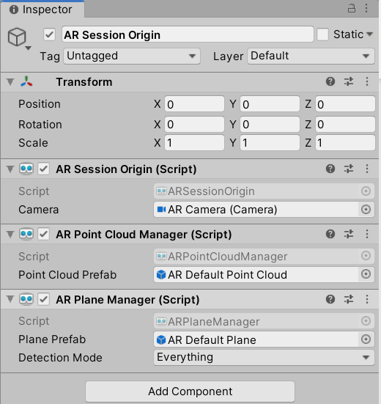

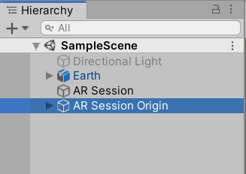

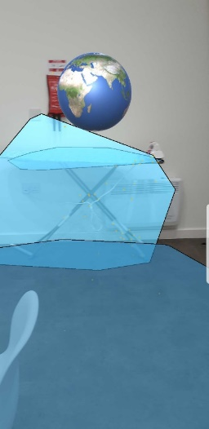
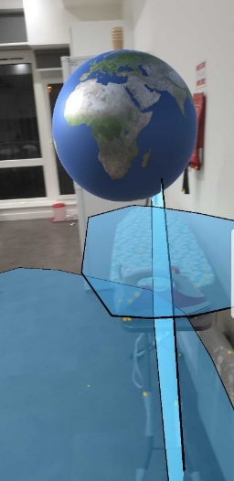
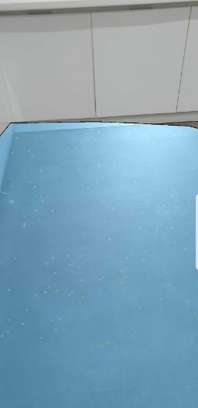
Save your scene (Ctrl + S). Connect your phone to your computer, and in Unity, go to File > Build and Run. When running the application, you will be able to observe planes in your environment.

Preparing a Model
Copy the Model.fbx from the Lab Resources folder and place it in the Prefab folder.
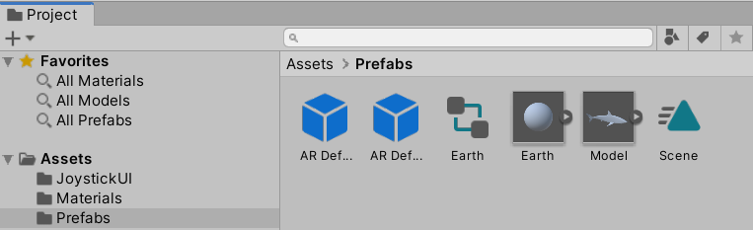

Copy the rest of the textures from Lab Sources in the Texture folder.

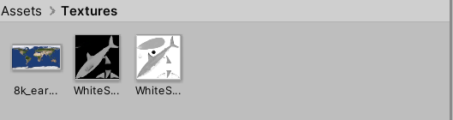

Create a new prefab. To do this, right-click in the Materials window and select Create > Material.
Select the new material and, in the Inspector, click the circle to the left of Albedo. Then, select the WhiteSharkTextBW.png texture.
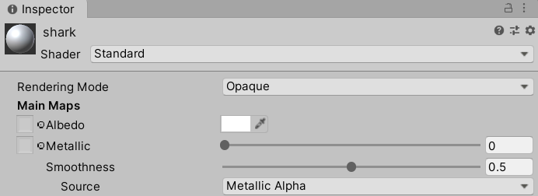

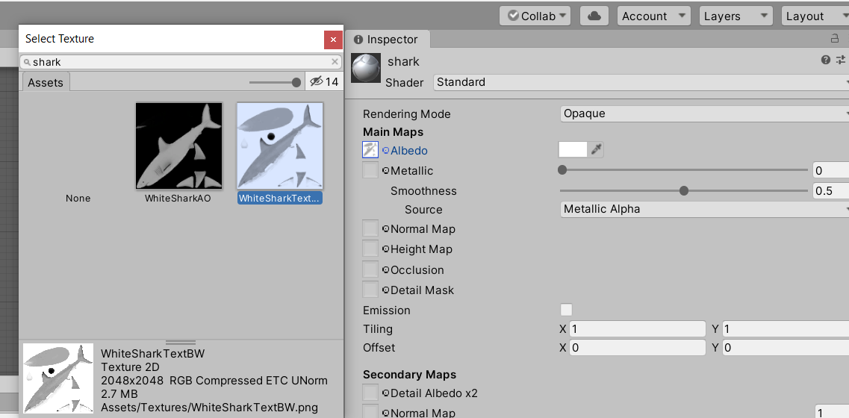

In the same Inspector tab, select Occlusion. Click the circle to the left of Occlusion and select WhiteSharkAO.png.
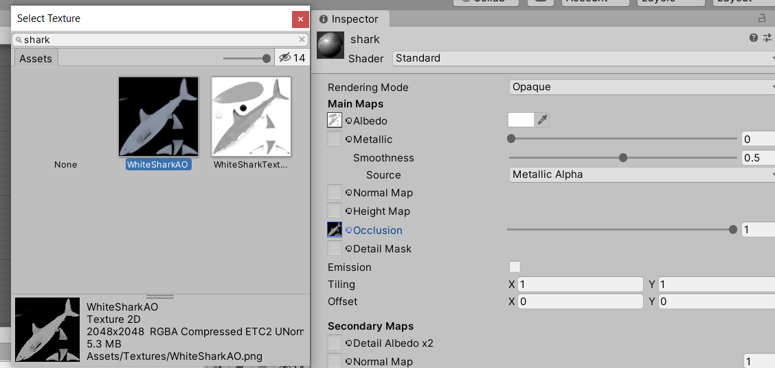
Ctrl + S to save.
Go to the Prefabs folder, select the Model, and open the Inspector. Under Materials, add the material and apply it to the model.
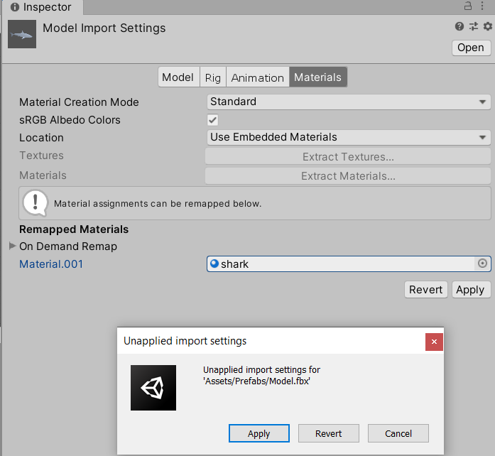

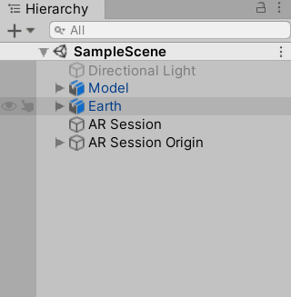
Once this is done, drag the model from the Prefabs folder into the hierarchy window; go to Inspector and change its position to (0, 0, 1) and a scale of (0.08, 0.08, 0.08).

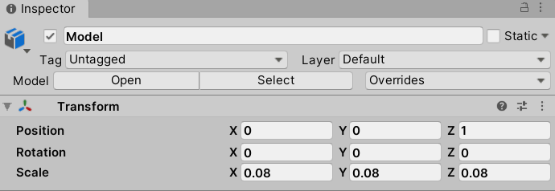

Expand Model.fbx in the Prefab folder, select the Scene animation, and duplicate it with Ctrl + D. Notice that we still have the Scene animation from the Earth asset, so the duplicated animation should be called Armature_ArmatureAction.
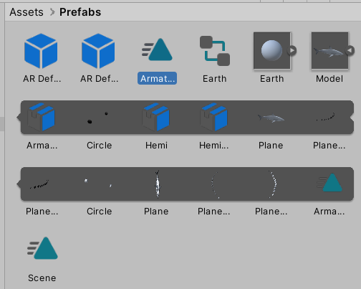

Select > Armature_ArmatureAction > Inspector tab > Tick Loop Time.
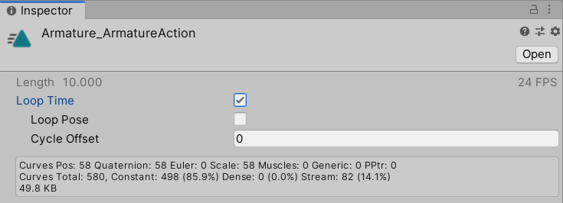

Drag Armature_ArmatureAction onto the Model in the Hierarchy window. As with the Earth asset, an Animator component should be generated automatically.
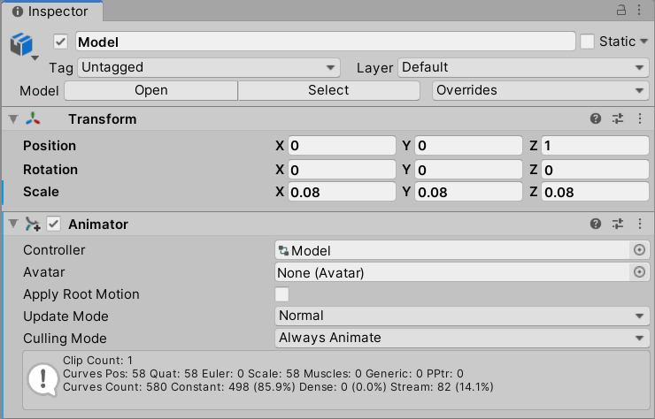

At this point, you can test the animation by pressing play in the Unity Editor.
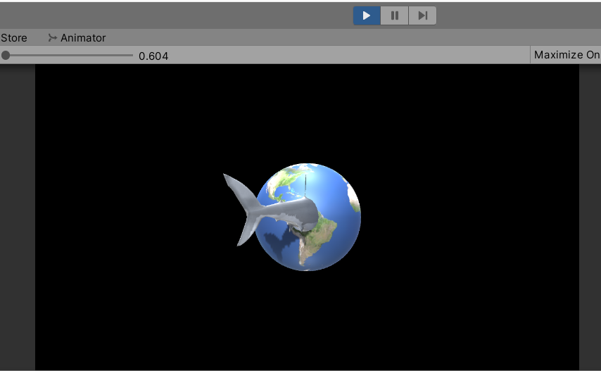

Rename the model from Hierarchy view to animModel and drag into the Prefab folder to create an original prefab.
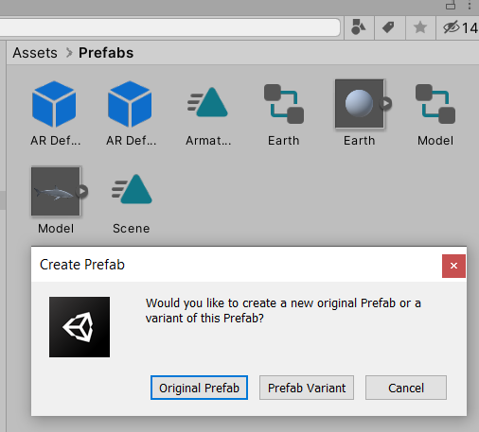

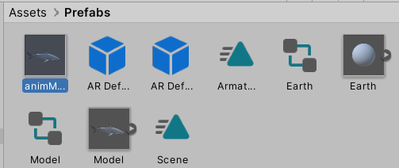

Placing an Object on a Surface Plane
To place an object on a plane, we will need two extra components. Select AR Session Origin > Inspector tab > Add Component > AR Raycast Manager.
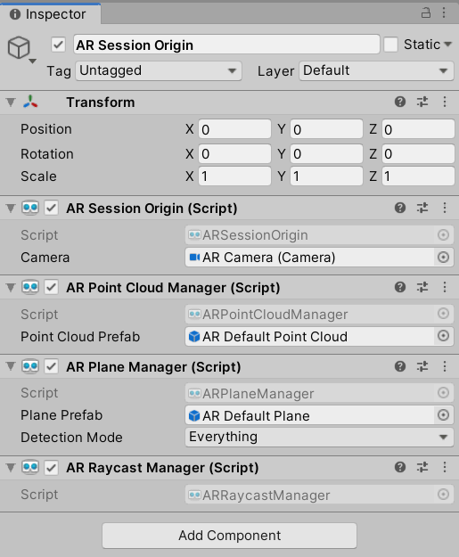

Create a new folder in the Assets folder and call it Scripts. Inside it, create a New C# Script and name it ObjectPlacement.
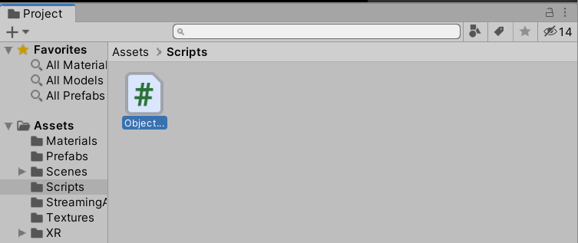

Copy and paste the following code in the ObjectPlacement script:
using System.Collections.Generic;
using UnityEngine;
using UnityEngine.XR.ARFoundation;
using UnityEngine.XR.ARSubsystems;

public class ObjectPlacement : MonoBehaviour
{
//a serialized
[SerializeField]
private GameObject prefabToPlace;
public GameObject prefabPlaced
{
get { return prefabToPlace; }
set { prefabToPlace = value; }
}
public GameObject spawnedObject { get; private set; }

private Animator animator;

static List<ARRaycastHit> s_Hits = new List<ARRaycastHit>();

private ARRaycastManager m_RaycastManager;

void Awake()
{
m_RaycastManager = GetComponent<ARRaycastManager>();
}
bool TryGetTouchPosition(out Vector2 touchPosition)
{
if (Input.touchCount > 0)
{
touchPosition = Input.GetTouch(0).position;
return true;
}

touchPosition = default;
return false;
}

// Update is called once per frame
void Update()
{
if (!TryGetTouchPosition(out Vector2 touchPosition))
return;
if(m_RaycastManager.Raycast(touchPosition, s_Hits, TrackableType.PlaneWithinPolygon))
{
// Raycast hits are sorted by distance, so the first one
// will be the closest hit.
var hitPose = s_Hits[0].pose;
if (spawnedObject == null)
{
spawnedObject = Instantiate(prefabToPlace, hitPose.position, Quaternion.identity);
animator = spawnedObject.GetComponent<Animator>();
//let's disable the animator when the object is instantiated
animator.enabled = false;
}
else
{
spawnedObject.transform.position = hitPose.position;
}
}
}

}
Drag this script onto AR Session Origin in the Inspector. As a result, an Object placement option should appear in the Inspector tab. Then, drag animModel from the Prefabs folder into the “Prefab To Place” field, untick the AR Point Cloud Manager component, and delete or disable any existing models (Earth and animModel) in the Hierarchy window.
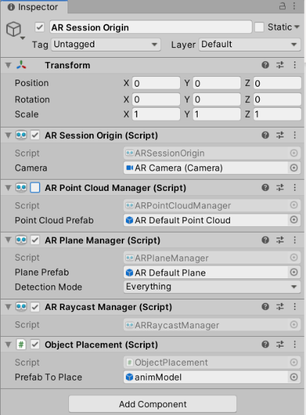

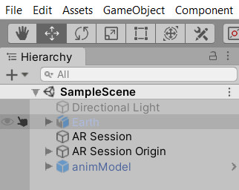

Before downloading this example to your phone, let’s analyze the code.

public class ObjectPlacement : MonoBehaviour
{
[SerializeField]
private GameObject prefabToPlace;
public GameObject prefabPlaced
{
get { return prefabToPlace; }
set { prefabToPlace = value; }
}

public GameObject spawnedObject { get; private set; }

private Animator animator;

We define a GameObject variable called prefabToPlace to take advantage of the Unity Inspector, allowing us to create a field into which we can drag and drop a prefab object. It’s good practice to use private variables in our code to avoid introducing bugs when scaling the project. However, if we do this, the variables won’t appear in the Unity Inspector.
The SerializedField attribute above the private GameObject prefabToPlace forces private variables to appear in the Unity Inspector. As a result, you will use a second variable called GameObject prefabPlaced to correctly get and set the value of prefabToPlace.
Next, we will define a GameObject variable called spawnedObject to reference the instantiated prefab when tapping on a plane.
We then proceed to add an Animator variable that will help us to play and stop the animation of the object.
static List<ARRaycastHit> s_Hits = new List<ARRaycastHit>();

private ARRaycastManager m_RaycastManager;

void Awake()
{
m_RaycastManager = GetComponent<ARRaycastManager>();
}
bool TryGetTouchPosition(out Vector2 touchPosition)
{
if (Input.touchCount > 0)
{
touchPosition = Input.GetTouch(0).position;
return true;
}

touchPosition = default;
return false;
}

We will use a list of ARRaycastHit objects called s_Hits to contain the raycast results generated by casting a ray from a point in screen space (the mobile screen) against trackables (the detected surface plane).
Then, we will create a private ARRaycastManager variable called m_RaycastManager that references the ARRaycastManager component found in AR Session Origin.
After that, we will create a method to test whether the user is pressing the display screen, and if so, return a Vector2(x,y) representing the touch position.
void Update()
{
if (!TryGetTouchPosition(out Vector2 touchPosition))
return;

In the void Update method, we will check if we are touching the display screen of the mobile phone. If not, the function will return. Notice that using return in a void method exits the method without quitting the program.

if(m_RaycastManager.Raycast(touchPosition, s_Hits, TrackableType.PlaneWithinPolygon))
{
// Raycast hits are sorted by distance, so the first one
// will be the closest hit.
var hitPose = s_Hits[0].pose;
if (spawnedObject == null)
{
spawnedObject = Instantiate(prefabToPlace, hitPose.position, Quaternion.identity);
animator = spawnedObject.GetComponent<Animator>();
//let's disable the animator when the object is instantiated
animator.enabled = false;
}
else
{
spawnedObject.transform.position = hitPose.position;
}
}
}

}

If the user is touching the display screen of the mobile phone, then we need to check whether they are tapping on a surface plane. You can do by calling a raycast from the RaycastManager and passing the touchPosition as an argument, along with a list to store the results of the raycast if successful, and specifying the type of trackable that you are casting against to.
If(m_RaycastManager.Raycast(touchPosition, s_Hits, TrackableType.PlaneWithinPolygon))
If that is the case, then we can take the first element in the s_Hits list and extract its Unity world space coordinates, which should be the nearest pose (position and orientation) to where the user was tapping in the plane.
var hitPose = s_Hits[0].pose;

Then, check whether the object has been instantiated. If not, instantiate the object with Instantiate(prefab, hitposition, rotation). Note that Quaternion.identity means that there will be no rotation. In addition, we will store the reference of this instantiation in the GameObject spawendObject, which will help us to get the reference to the Animator controller to stop or play the animation.
if (spawnedObject == null)
{
spawnedObject = Instantiate(prefabToPlace, hitPose.position, Quaternion.identity);
animator = spawnedObject.GetComponent<Animator>();
animator.enabled = false;
}

If there is an instance of the prefab already, then we can use GameObject SpawnedObject.transform.position to assign the new hit position extracted before.
else
spawnedObject.transform.position = hitPose.position;
Save your scene (Ctrl + S). Connect your phone to your computer and, in Unity, go to File > Build and Run.
On your phone, detect a plane in your environment and tap on it to instantiate an object. When you tap on the plane, a static (non-swimming) shark will appear.
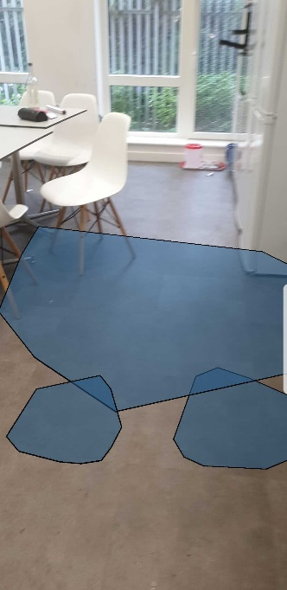
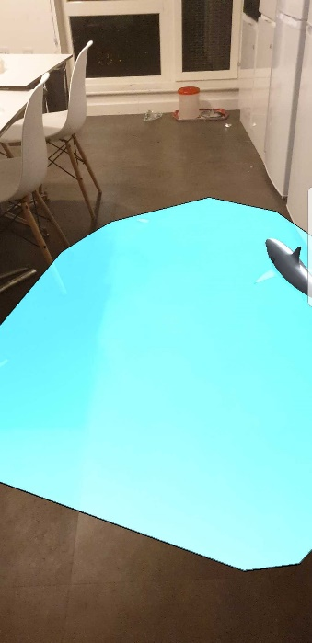
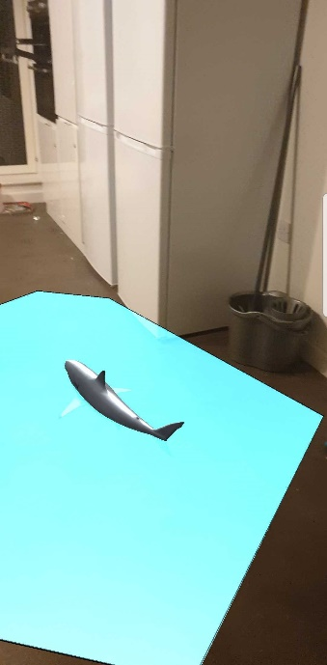

If the model is too large for your environment, you can scale it down further. To do this, select the animModel prefab found in Assets > Prefabs (not the Hierarchy window), go to the Inspector, and adjust theTransform > Scale values as needed.
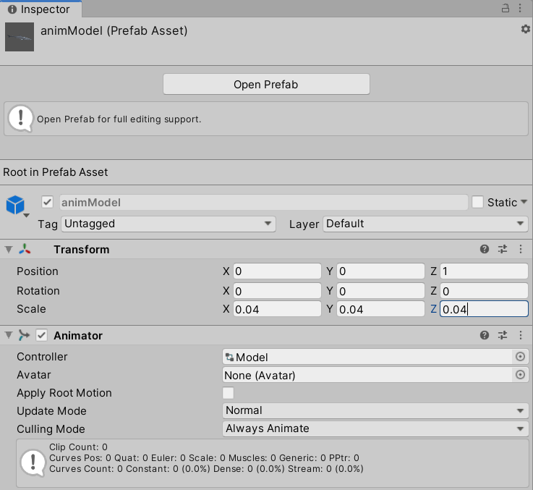

Controlling the Object with a Joystick
The next thing we will do is control the movement of the object with a joystick that you have seen before in the chess example from the previous lab.

Go to GameObject > UI > Canvas
Note: If the Earth and animModel GameObjects still exist in the Hierarchy window, then you might still see a “floating Earth” and a “floating shark” when running the application on your phone. You can choose to delete these from the Hierarchy window.
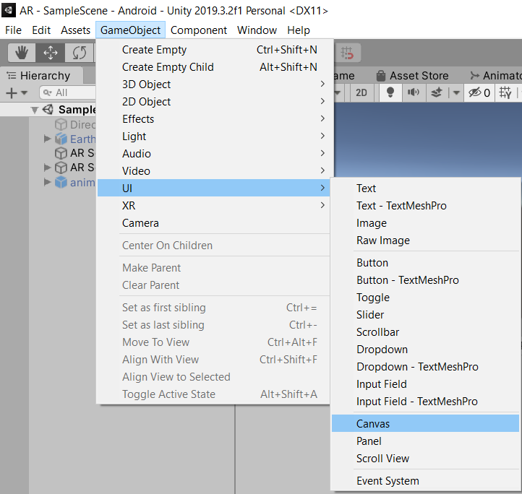

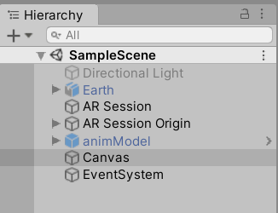

In Canvas, add two Image objects and rename them as follows: LeftJoystick, LeftJoystickFixed
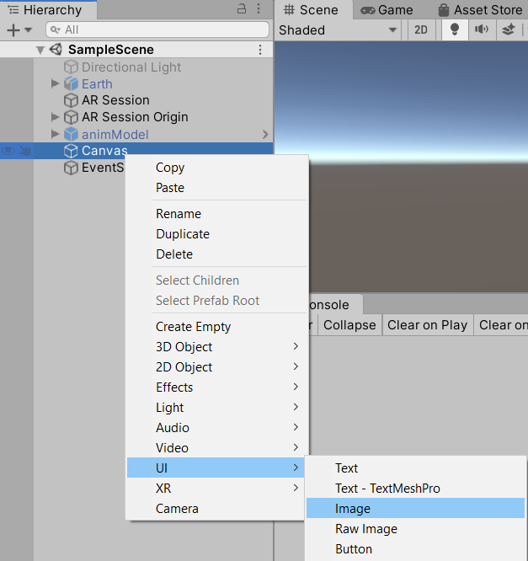

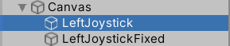

Copy the JoystickUI folder from the lab resources into your Assets folder and NewJoystick.cs from lab resources into the Scripts folder.
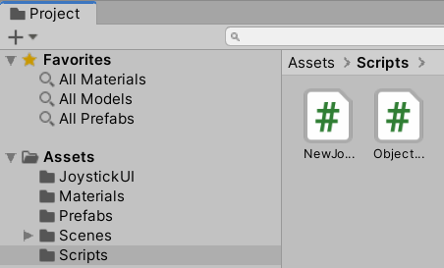
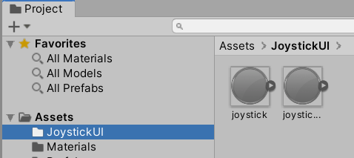

Select LeftJoystickFixed in the Hierarchy window, Open the JoystickUI folder, drag the joystick_fixed sprite, and fill the Source Image field of the LeftJoystickFixed Inspector tab with it. Set the color to RGBA = 128, 128, 128, 255. Set the Width = 128 and Height = 128, untick Raycast Target, and check its Pos X, Y, Z = (0, 0, 0).
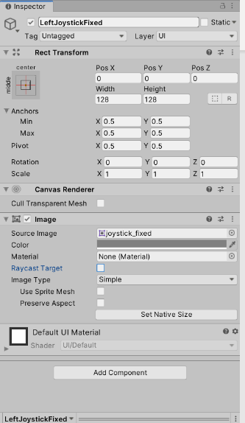

Next, let’s work on the LeftJoystick element:
- Drag the joystick sprite into the image field. Set the RGB color value to 128, 128, 128, 255W. Set the Width = 64 and Height = 64, check its Pos X, Y, Z = (0, 0, 0), tick Raycast Target, and add Graphic Raycaster by selecting Add Component.
- Drag and drop the NewJoystick script from the scripts folder in the project panel to the Inspector of LeftJoystick.
- Specify the joystick type to be Left.
- J Trans Clamp Value =100; Fade Out = 0.1; Fade in = 0; and Hold threshold = 0.
- Link the LeftJoystickFixed image to the ‘Fixed Joystick img’ field by dragging the LeftJoystickFixed element from the Hierarchy panel.
- Finally, set the UI scale factor to 0.001 and the J Trans values to X = 0 and Y = 0.
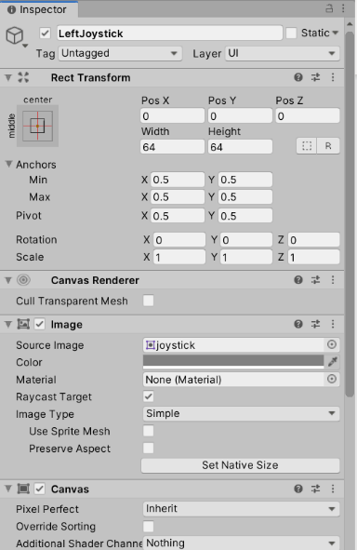
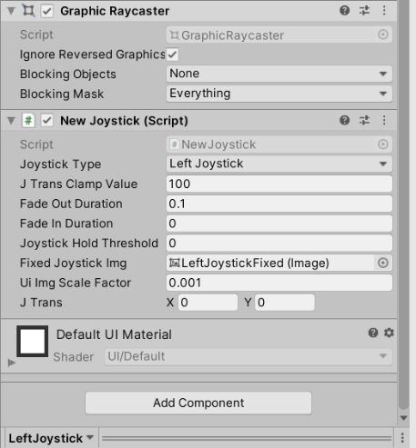

We will add a button to the canvas for two reasons:
- To disable the continuous detection of planes in the app when we think it is no longer necessary.
- To avoid any interference caused from touching the display between the trackable plane and the joystick.

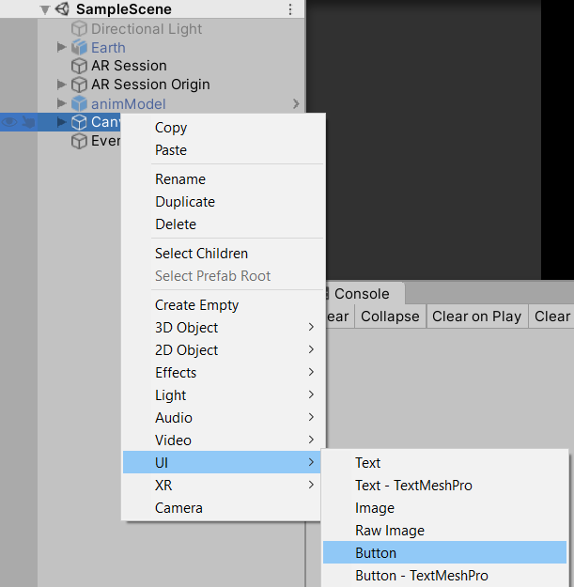

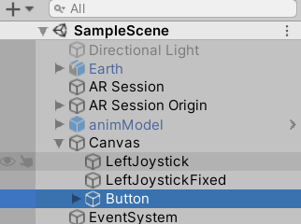

Select Button element > Inspector tab > Rect Transform. Click in the square to bring Anchors selection. Press and hold the Alt key and select center top.
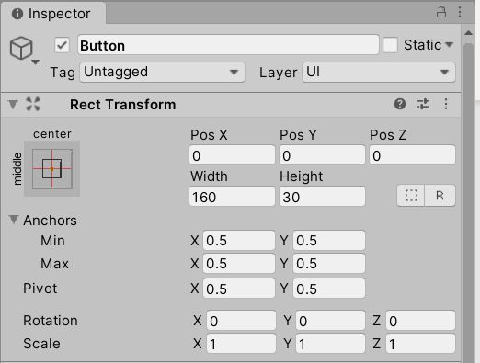
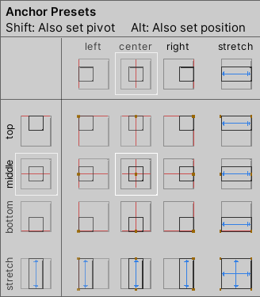

In the same Inspector tab, change Pos Y to −72 and Height to 42.
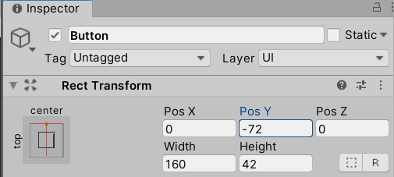

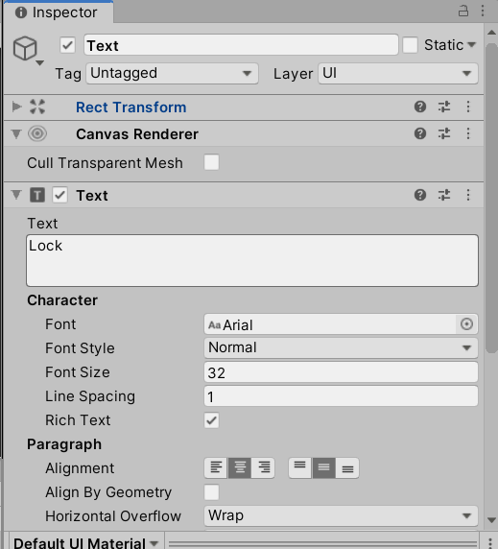
Expand the Button element > Select Text > Inspector tab > Change Text to “Lock” and its font size to 32.

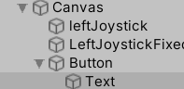

After that, we will do the following modifications to our ObjectPlacement.cs script:
- Add a public GameObject variable to reference the joystick.
- Add a private Vector2 variable to store the x and y coordinates of the Joystick.
- Add a private Vector3 variable to store the new direction of the object according to the joystick coordinates.
- Add a public float variable that will reference the speed of the object.
- Add a public UnityEngine.UI.Button to reference the button in the canvas.
- Add a private ARPlaneManager variable to reference the ARPlaneManager component from the AR Session Origin Game Object.
- Set up the reference of the ARPlaneManager variable in the Awake function as we have done for the RaycastManager.
- Add a private Boolean variable to keep track of two states: Lock and Unlock.
- Set up the Boolean mentioned in the last point to false in the Awake function.
- Add a method to switch between states that will be linked with the button in the canvas.
- Change the text component of the button when switching between states.
- Fix the coordinates of the joystick by multiplying them by −1 in the update function.
- Calculate the direction of the new object in the update function.
- Set up the new movement of the object with the joystick when not in Unlock state and when the spawnedObject does not equal null in the update function.
- Notice that in the Lock state, the detection plane will be turned off. Placing an object on a plane will not be possible, and the Joystick should be able to modify the position of an existent object in the environment. Otherwise, the detection will be turned on when in the Unlock state. Placing an object on the plane should be possible, and the Joystick should not have any effect on an object in the environment.

Before looking at the solution, try to implement the modifications yourself.
Hints
To disable plane detection, you can simply use the reference to the ARPlaneManager variable and set is enabled property to false
<ARPlaneManager private variable>.enabled = false

To extract the correct coordinates of the joystick, you can call the joystick, get its component NewJoystick, get its JTrans property, and multiply by −1
<coordinate variable> = <joy>.GetComponent<NewJoystick>().jTrans * -1

To calculate the direction of joystick, you can take the x and y coordinates, multiply them by a Vector3.right and Vector3.forward, respectively, and add them together.
<direction private variable> = Vector3.right * <joy coordinate variable>.x + Vector3.forward* <joy coordinate variable>.y

The new position of the object can be calculated by adding the spawned object and adding the direction times the speed of the object defined times Time.deltaTime
spawnedObject.transform.position += <direction>*<speed>*Time.deltaTime;

Solution
using System.Collections.Generic;
using UnityEngine;
using UnityEngine.XR.ARFoundation;
using UnityEngine.XR.ARSubsystems;

public class ObjectPlacement : MonoBehaviour
{
//a serialized
[SerializeField]
private GameObject prefabToPlace;
public GameObject prefabPlaced
{
get { return prefabToPlace; }
set { prefabToPlace = value; }
}
public GameObject spawnedObject { get; private set; }

private Animator animator;

static List<ARRaycastHit> s_Hits = new List<ARRaycastHit>();

private ARRaycastManager m_RaycastManager;

public GameObject leftjoy;

private Vector2 coordinatesOfJoy;

private Vector3 directionOfObject;

public float speedOfObject;

public UnityEngine.UI.Button lockButton;

private ARPlaneManager m_ARPlaneManager;

private bool isInLockingState;

public void switchState()
{
if (isInLockingState == false)
{
lockButton.GetComponentInChildren<UnityEngine.UI.Text>().text = "Unlock";
}
else
{
lockButton.GetComponentInChildren<UnityEngine.UI.Text>().text = "Lock";
}
isInLockingState = !isInLockingState;
m_ARPlaneManager.enabled = !m_ARPlaneManager.enabled;
}
void Awake()
{
isInLockingState = false;
m_ARPlaneManager = GetComponent<ARPlaneManager>();
m_RaycastManager = GetComponent<ARRaycastManager>();
}
bool TryGetTouchPosition(out Vector2 touchPosition)
{
if (Input.touchCount > 0)
{
touchPosition = Input.GetTouch(0).position;
return true;
}

touchPosition = default;
return false;
}

// Update is called once per frame
void Update()
{
if (!TryGetTouchPosition(out Vector2 touchPosition))
return;
if (isInLockingState == false)
{
if (m_RaycastManager.Raycast(touchPosition, s_Hits, TrackableType.PlaneWithinPolygon))
{
// Raycast hits are sorted by distance, so the first one
// will be the closest hit.
var hitPose = s_Hits[0].pose;
if (spawnedObject == null)
{
spawnedObject = Instantiate(prefabToPlace, hitPose.position, Quaternion.identity);
animator = spawnedObject.GetComponent<Animator>();
//let's disable the animator when the object is instantiated
animator.enabled = false;
}
else
{
spawnedObject.transform.position = hitPose.position;
}
}
}
else
{
if(spawnedObject != null)
{
coordinatesOfJoy = leftjoy.GetComponent<NewJoystick>().jTrans * -1;
directionOfObject = Vector3.right * coordinatesOfJoy.x + Vector3.forward * coordinatesOfJoy.y;
spawnedObject.transform.position = spawnedObject.transform.position + (directionOfObject*speedOfObject * Time.deltaTime);
}
}
}
}

Once that you have compared your outcome with the solution, return to Unity Editor > AR Session Origin Inspector tab > Object Placement. Fill the new fields that have appeared.
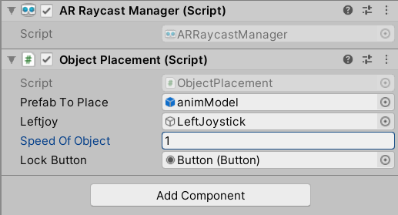

Link the button from Canvas to the method that switches between states. To do this, select Button element > Inspector tab > On click. Click the plus sign, anddrag the AR Session origin into the None Object. Then, select function > ObjectPlacement, and select the switchState() method for switching between states.
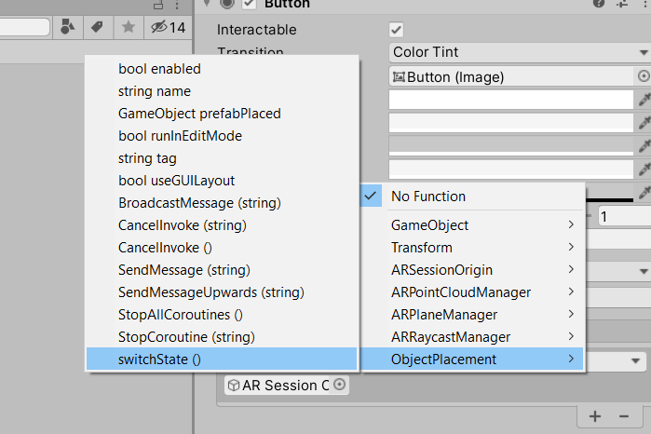
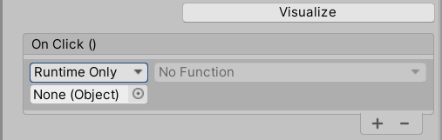

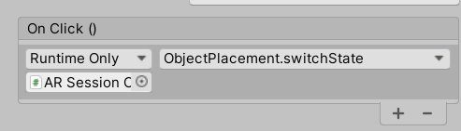

Save your scene (Ctrl + S), connect your phone to your computer, and in Unity, go to File > Build and Run.
Rotate your phone horizontally, detect a plane in your environment, tap on the plane to instantiate an object (the shark), and then press the Lock button to lock the shark state.
The joystick should appear on the bottom-left corner. Check that you can move the object using the joystick. Press, hold, and move the joystick in the bottom left corner of the phone. You will notice that the static (non-swimming) shark moves, and you will also notice that the shark can leave the plane on which it was instantiated. We will refine this in the next section.
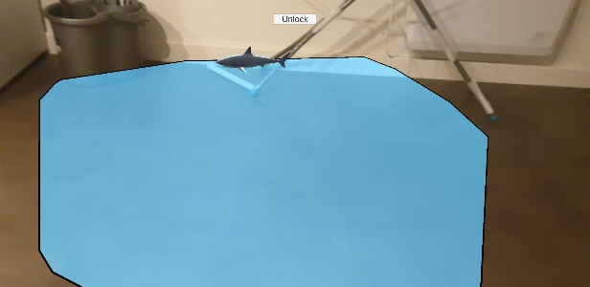
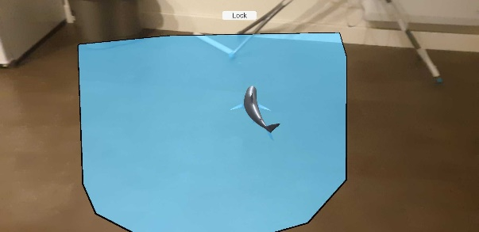

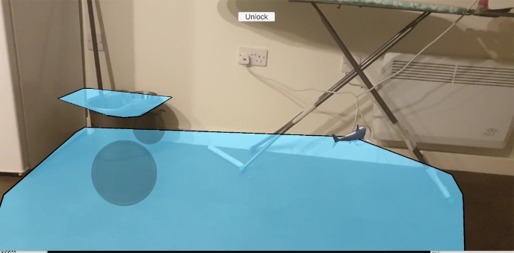

Polishing the Control of the Joystick
To end this lab, we will refine the joystick control over the object. So far, the object moves according to the joystick direction, but we will change this so that the movement is relative to the Main Camera.
Direction depends only on the joystick.
Let’s assume you instantiate an object on a plane. If you press the joystick up, the object will move forward according to the direction in which it was instantiated. This means that, if the camera perspective changes, the object will still move according to the initial direction that was set at the start, without taking the camera perspective into consideration. This is bothersome in situations where the camera perspective changes constantly.
Camera
Camera

Direction depends on the joystick and camera
In this case, we take the perspective of the camera into consideration to calculate the direction, and thus, movement of the object.
Camera
Camera

To implement this, in the ObjectPlacement.cs script, go to the code line before the new position of spawnedObject is set up, calculate the new direction according to the main camera, set its y position to zero, and replace the joystick direction as shown in the following code:
if(spawnedObject != null)
{
coordinatesOfJoy = leftjoy.GetComponent<NewJoystick>().jTrans * -1;
directionOfObject = Vector3.right * coordinatesOfJoy.x + Vector3.forward * coordinatesOfJoy.y;
var newdir = Camera.main.transform.TransformDirection(directionOfObject);
newdir.y = 0.0f;
spawnedObject.transform.position = spawnedObject.transform.position + (newdir * speedOfObject * Time.deltaTime);
}

Next, make the object rotate according to the direction in which you are moving.
if(spawnedObject != null)
{
coordinatesOfJoy = leftjoy.GetComponent<NewJoystick>().jTrans * -1;
directionOfObject = Vector3.right * coordinatesOfJoy.x + Vector3.forward * coordinatesOfJoy.y;
var newdir = Camera.main.transform.TransformDirection(directionOfObject);
newdir.y = 0.0f;
Quaternion rotation = Quaternion.LookRotation(newdir, Vector3.up);
spawnedObject.transform.rotation = rotation;
spawnedObject.transform.position = spawnedObject.transform.position + (newdir * speedOfObject * Time.deltaTime);
}

Then, we will restrict the movement of the object to the plane, which was instantiated.
if(spawnedObject != null)
{
coordinatesOfJoy = leftjoy.GetComponent<NewJoystick>().jTrans * -1;
directionOfObject = Vector3.right * coordinatesOfJoy.x + Vector3.forward * coordinatesOfJoy.y;
var newdir = Camera.main.transform.TransformDirection(directionOfObject);
newdir.y = 0.0f;
Quaternion rotation = Quaternion.LookRotation(newdir, Vector3.up);
spawnedObject.transform.rotation = rotation;
var newPos = spawnedObject.transform.position + newdir;
var ray = new Ray(newPos, Vector3.down);
var insidePlane = m_RaycastManager.Raycast(ray, s_Hits, TrackableType.PlaneWithinPolygon);
if (insidePlane)
spawnedObject.transform.position = newPos;
}
Finally, try to figure how to play or stop the animation of the object when moving.
Look at the full solution in case you get stuck.

Solution
using System.Collections.Generic;
using UnityEngine;
using UnityEngine.XR.ARFoundation;
using UnityEngine.XR.ARSubsystems;

public class ObjectPlacement : MonoBehaviour
{
//a serialized
[SerializeField]
private GameObject prefabToPlace;
public GameObject prefabPlaced
{
get { return prefabToPlace; }
set { prefabToPlace = value; }
}
public GameObject spawnedObject { get; private set; }

private Animator animator;

static List<ARRaycastHit> s_Hits = new List<ARRaycastHit>();

private ARRaycastManager m_RaycastManager;

public GameObject leftjoy;

private Vector2 coordinatesOfJoy;

private Vector3 directionOfObject;

public float speedOfObject;

public UnityEngine.UI.Button lockButton;

private ARPlaneManager m_ARPlaneManager;

private bool isInLockingState;

public void switchState()
{
if (isInLockingState == false)
{
lockButton.GetComponentInChildren<UnityEngine.UI.Text>().text = "Unlock";
}
else
{
lockButton.GetComponentInChildren<UnityEngine.UI.Text>().text = "Lock";
}
isInLockingState = !isInLockingState;
m_ARPlaneManager.enabled = !m_ARPlaneManager.enabled;
}
void Awake()
{
isInLockingState = false;
m_ARPlaneManager = GetComponent<ARPlaneManager>();
m_RaycastManager = GetComponent<ARRaycastManager>();
}
bool TryGetTouchPosition(out Vector2 touchPosition)
{
if (Input.touchCount > 0)
{
touchPosition = Input.GetTouch(0).position;
return true;
}

touchPosition = default;
return false;
}

// Update is called once per frame
void Update()
{
if (!TryGetTouchPosition(out Vector2 touchPosition))
return;
if (isInLockingState == false)
{
if (m_RaycastManager.Raycast(touchPosition, s_Hits, TrackableType.PlaneWithinPolygon))
{
// Raycast hits are sorted by distance, so the first one
// will be the closest hit.
var hitPose = s_Hits[0].pose;
if (spawnedObject == null)
{
spawnedObject = Instantiate(prefabToPlace, hitPose.position, Quaternion.identity);
animator = spawnedObject.GetComponent<Animator>();
//let's disable the animator when the object is instantiated
animator.enabled = false;
}
else
{
spawnedObject.transform.position = hitPose.position;
animator.enabled = false;
}
}
}
else
{
if(spawnedObject != null)
{
coordinatesOfJoy = leftjoy.GetComponent<NewJoystick>().jTrans * -1;
if (coordinatesOfJoy.x != 0 || coordinatesOfJoy.y != 0)
{

directionOfObject = Vector3.right * coordinatesOfJoy.x + Vector3.forward * coordinatesOfJoy.y;
var newdir = Camera.main.transform.TransformDirection(directionOfObject);
newdir.y = 0.0f;
Quaternion rotation = Quaternion.LookRotation(newdir, Vector3.up);
spawnedObject.transform.rotation = rotation;
var newPos = spawnedObject.transform.position + newdir * speedOfObject * Time.deltaTime;
var ray = new Ray(newPos, Vector3.down);
var insidePlane = m_RaycastManager.Raycast(ray, s_Hits, TrackableType.PlaneWithinPolygon);
if (insidePlane)
{
spawnedObject.transform.position = newPos;
animator.enabled = true;
}
else
animator.enabled = false;
}
else
animator.enabled = false;
}
}
}
}
To end this lab, let’s recognize only the horizontal planes. To do this select AR Session Origin > Inspector tab > AR Plane Manager. Change Detection Mode to Nothing and then to Horizontal.
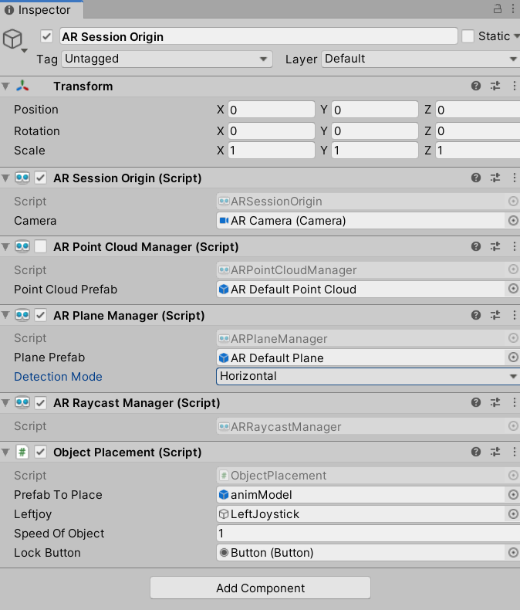

Save your scene (Ctrl + S), connect your phone to your computer, and in Unity, go to File > Build and Run.
Rotate your phone horizontally, detect a plane in your environment, tap on the plane to instantiate an object (the shark), and then press the Lock button to lock the shark state.
The joystick should appear in the bottom-left corner. Check that you can move the object using your joystick. Press, hold, and move the joystick in the bottom-left corner of the phone. You will notice that the shark can swim and move according to the joystick within the plane.
