Introduction to Graphics and Mobile Gaming
Unity LAB 2
Chess Room Project
Issue 2.0

Contents
1 Introduction 1
2 Create the new project 1
3 Navigating the scene view 1
4 Basic tools 2
5 Creating the scene 2
5.1 Creating a plane 2
5.2 Creating the skybox 3
5.3 The room 4
5.3.1 Imports 4
5.3.2 Building the room 6
6 Installing on device 8
7 Appendix 8

Introduction
In this lab, we will begin working on our chess environment, with a view to setting up our scene so that we can start creating our play area. This is the plan we will follow for the coming labs:
- Gaming – Lab 2: The creation of the basic environment in which we will be working. We will create a plane in the foreground and a skybox in the background. We will then create the chess room where the gameplay will take place.
- Gaming – Lab 3: We will look at the use of custom shaders in C#. We will learn how to place lights and create shadows, as well as how to add dynamic elements to the shadows so that the user can change them during gameplay. We will also create a GUI that will allow you to interact with the environment and the camera.
- Gaming – Lab 4: We will look at cameras, and specifically how to set up a movable first-person camera. We will enable the user to move the chess pieces placed around the room. Then, we will add a points counter, a target, and a timer to add a win/loss condition. We will also finish off our scene by creating menu features, particle effects, and visual flare.

Create the new project
Open Unity, then click New in the first window that opens. Give the lab a recognizable name, such as “Lab2”, and then choose where you want to save this project. Select the 3D option and click Create.
We are greeted by the main Unity Editor. We will go through a few of the components we can see. At the center of the screen is the scene, where you will place and be able to view all of the required assets. On the left side, you will see the Hierarchy panel. Here, you will find a list of all assets present in the scene and their relative hierarchy. At the bottom are the Console and Project panels. The Project panel allows you to navigate through your folders and access assets. Finally, on the right, you can find the Inspector panel. Every time something is selected, the Inspector will give you information about the object, as well as its properties.

Navigating the scene view
There are a few basic commands to maneuver around the Scene view.

- To move the view up and down: Ctrl + Alt + left-click or click the scroll wheel and then move your mouse.
- To zoom in and out: Ctrl + Alt + right-click and move the mouse, or use the scroll wheel or the up and down keys. To move the view around a fixed point: right-click and move the mouse left, right, up, or down.

Basic tools
When working in Unity, you will have to move, scale, and rotate assets often. In the top left-hand corner, there are a few buttons that allow you to select what actions you can carry out when moving the mouse.
The first option allows you to grab the view and move it by left-clicking. Main tools
The second option is the standard mode, which allows you to move using the commands noted earlier. If you select an object when using this mode, you will be able to move the object along the X, Y, and Z axes by clicking and dragging the corresponding arrows.
The third and fourth options allow you to rotate and scale selected objects, respectively.

Creating the scene

Creating a plane
Our first task is to create a plane. This is where we will place our assets later to build our chess room. To do this, click on the GameObject option at the top of the screen, then select 3D object and then Plane. Select the plane and make sure its position is 0, 0, 0 in the Inspector window.
This should, by default, appear as a white plane. To change its color, click on Assets in the Project tab and then right-click on Create -> Folder. Name the new folder “materials”, open the folder, and, using the same instructions, create a new material and name it “plane color”.
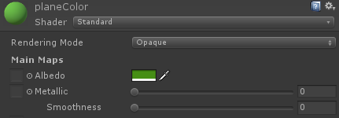
With the new material selected, we can now access all of its settings from the Inspector panel. Since we only need a new color, select the color you prefer from the Albedo option and set Metallic and Smoothness to zero.
Drag the new material from the Project panel to the plane in the Scene window to apply it.
Alternatively, from inside the materials folder, right-click -> Import new asset and look for the ‘Assets’ folder. Navigate to Assets -> Materials and select “grass.tga”. Drag the new texture onto the plane. This will automatically create a new folder with the grass material inside.

Select your plane and then scale it on X and Y axes to make it large enough to host the room you will create. Scale it up 20 times its original size, using the scale values in the Inspector panel. If you want a reference to see how big the plane is, add a cube from GameObject -> 3D Object -> Cube.

Creating the Skybox
Next, we should look at how to create and implement our own custom skybox into Unity. This will allow us to tailor the background of a scene to suit the environment we are trying to create.
- First, create a new folder in the Assets folder called “skyBox”
- Right-click on a blank space in our new folder and create a new material called “MT_skyBox”.
- In the Inspector tab, change “Shader” from Standard to 6 sided. Unity will then ask us to provide six textures for the skybox.
- To add the six textures, open the ‘Assets’ folder provided, open the skybox folder, and then select and copy all six images.
- In Unity, from the Project tab, navigate to the skybox folder and create a new folder called “skyImages”
- Right-click on the new folder, select show in explorer, and then open the folder and paste the six images. Unity will automatically import them for you.
- Now, select MT_skyBox again, go to the Inspector tab, add the textures by clicking Select next to ”Front [+Z]” and then select “sunny1_front”.
- Do the same for the other sides of the skybox, making sure to match each side with the correct texture.
- To apply the new skybox to your scene, drag it on to the screen (but not onto the plane).
You should now have a visible skybox in your scene.
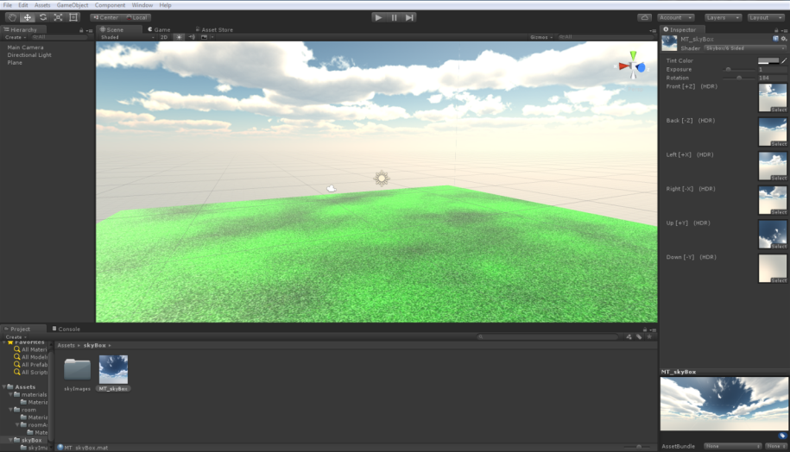

The room

Imports
Now that we have created the basic environment, let’s start creating the room. When creating a new in-game object in Unity, you will generally use an asset or a series of assets to do so. These will be 2D or 3D meshes, with textures or materials applied to them. In this part of the lab, we will look at how to set up our own meshes and materials and then import them to start building the room.
The first thing we do is create a new folder in the Assets folder and name it “Room”. Create a subfolder and name it “roomAssets”.
- Right-click on the folder, click Show in Explorer, and open the folder.
- Copy all of the assets from the Assets folder in the lab materials and paste them here (do not copy the Materials folder or the Materials.meta file into roomAssets, Unity will create the Materials folder by itself).
- Close the folder. Unity should now have imported all of the new assets.
Now, try to place a door in your scene. It will be extremely small, so let’s scale it up by 100.
As you can see, the door is white. This is because we still need to apply a texture to it.

To fix this, we need to import the required textures, following the same process we used to import the room assets. Add another folder to the “room” folder and name it “roomTextures”, then import the textures. Do not copy the skybox textures as we’ve already covered this. You can find them inside the Assets -> Room -> Textures folder.

- Double-click on the door in the Scene window, or open the hierarchy of the new object and click on detail_01.004.
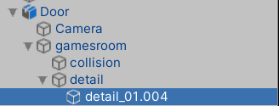

  - In the Inspector tab, next to “a1_door01”, click on “Standard” and change the shader to “Bumped Diffuse(Mobile/Bumped Diffuse)”
  - Click on the small arrow and expand the “a1_door01” section. You will see Unity asks you to select two textures for “Base (RGB)” and “Normalmap”.
- Click on Select for the texture related to “Base (RGB)” and select the “a1_door01” texture.
- Repeat the same process for “a1_atlas_01” using the texture named: “a1_atlas_01”.
If you delete the door and place it again, the texture will be updated correctly.

If you encounter any problem trying to change the shader from a1_door01 from Standard to Bumped Diffused:
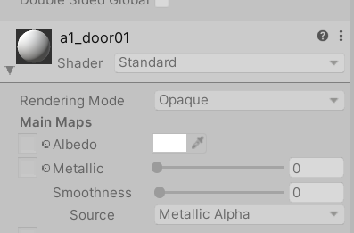

Click on the asset that you want to use and go to Inspector > Materials > Extract Materials. Choose the same folder, and now you should be able to modify the shader.
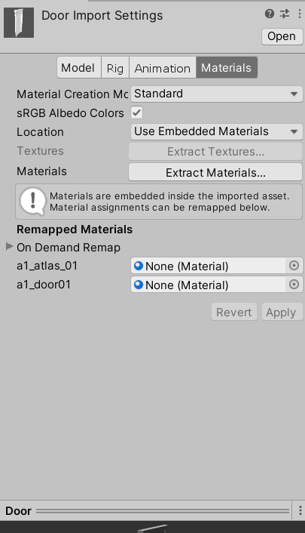
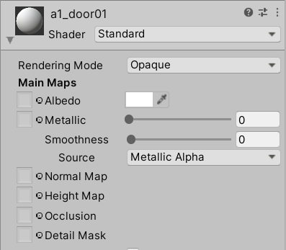
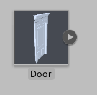

Building the room
Now that we’ve looked at how to apply textures to the meshes needed to create the room, we can start creating it. If you encounter any problems, please refer to the appendix at the end of this lab.

Our first step is to place the skeleton of the room.
- Drag the “roomSkeleton” into the scene.
- Rescale it from the Inspector window to scale x = 100, y = 100, z = 100. This will allow us to have a wider view of the room when the player steps inside, and provide smoother movement.
- Once the skeleton has been placed, the room should appear large from the player’s perspective.
You may have already noticed when setting up the door that one side of the asset can be either partially or completely invisible. This is due to culling some of the vertices that will not be visible when the game is running. Rotate the door until only the visible part is inside the room.

Currently, our room is empty. We will populate it with our 3D assets and textures. Select the “window” mesh and place it in the scene. Scale it to the same scale as the room (approximately 100x in all coordinates, adjusting where needed).
- Double-click on the new window mesh and, as we did for the door, apply the texture “a1_atlas_01”. Then, place it correctly inside the wall.

Continue to place the required elements for the room. The process of applying the correct textures and moving meshes is always the same. Be sure to consult the appendix for details on positioning and other parameters.
If you need to import any new or custom meshes or textures, right-click in the Project panel and select “Import new Asset”.

Here is how the room should look when completed:
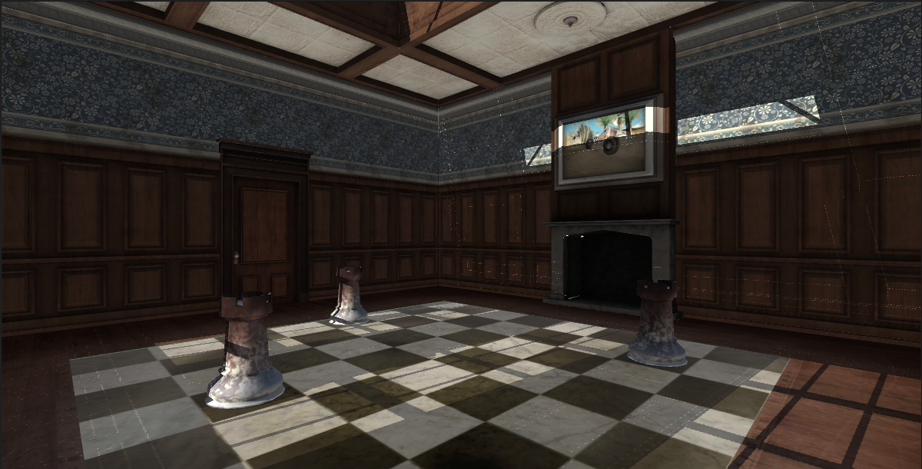
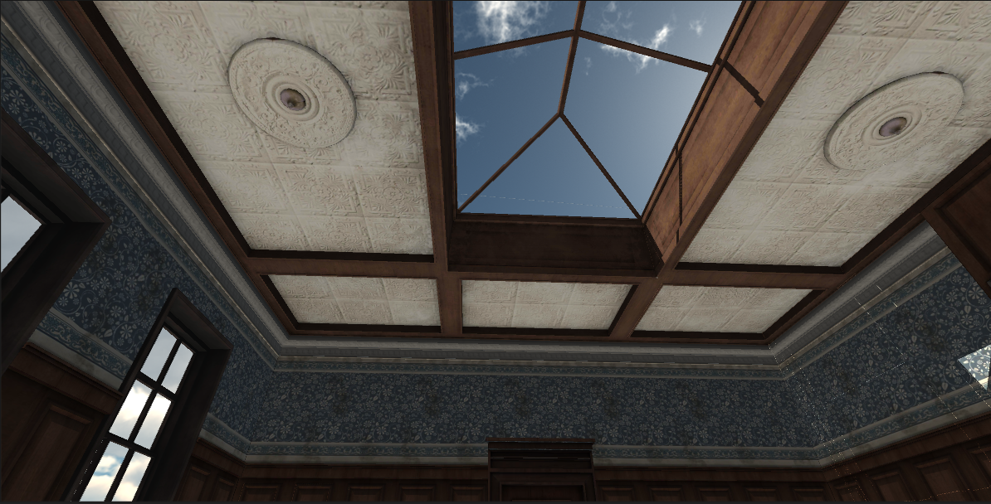
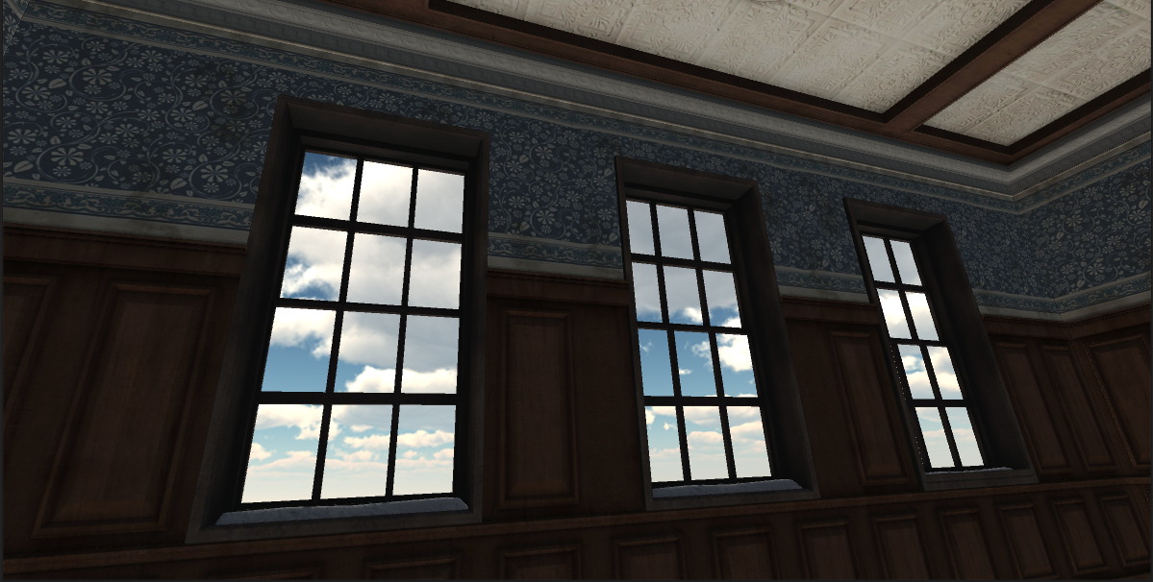

Installing on device
- Let’s now install the chess room on your Android device. First, let’s place the camera in a good position for the user to view the scene from. Bear in mind that we are not yet able to move around the room during gameplay.
- From the Hierarchy panel, select the camera and place it in a suitable position.
- Make sure you connect your device to your PC.
- Navigate to File > Build Setting. Select Android under Platforms. You will notice that the Build and Run button is greyed out and cannot be clicked. This is because we need to rebuild the project for Android devices. Please Select ‘Switch Platform’ and wait for it to complete.
- Click Build and Run. If everything goes smoothly, the app should appear on your device.
Open the application on your device and see how the room looks. You should not be able to see any noticeable gaps or spaces in the environment. If you do, be sure to move the assets around the room to create a seamless view.

Appendix
When placing the doors, you will be able to see empty spaces around the door frame. This is because you need to place the two side walls named “wallShortSide” behind each door.
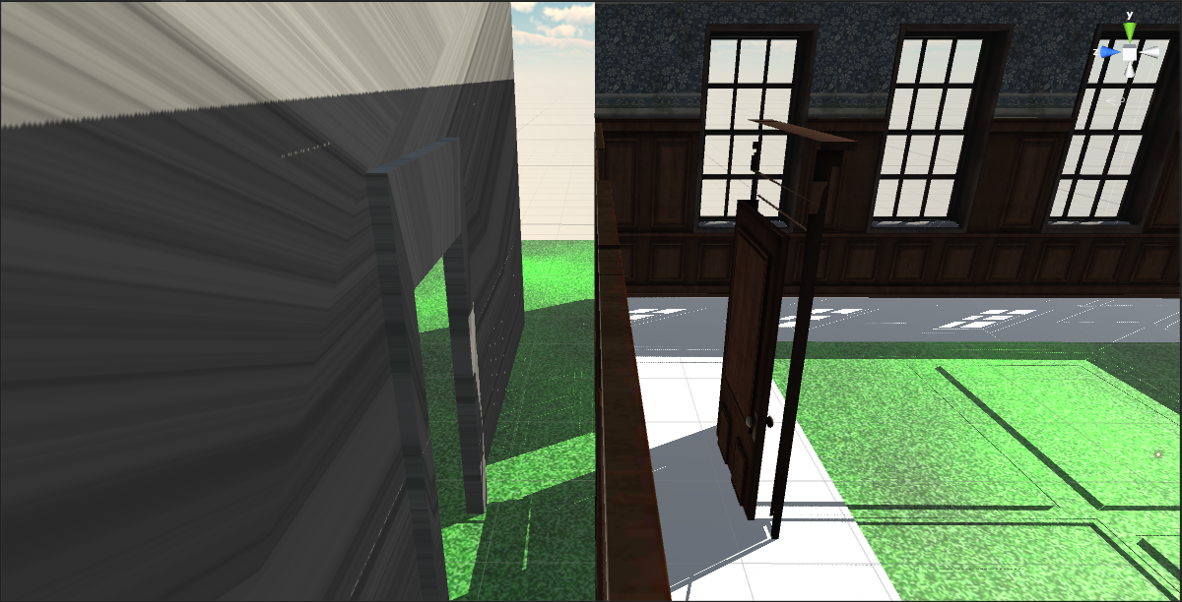
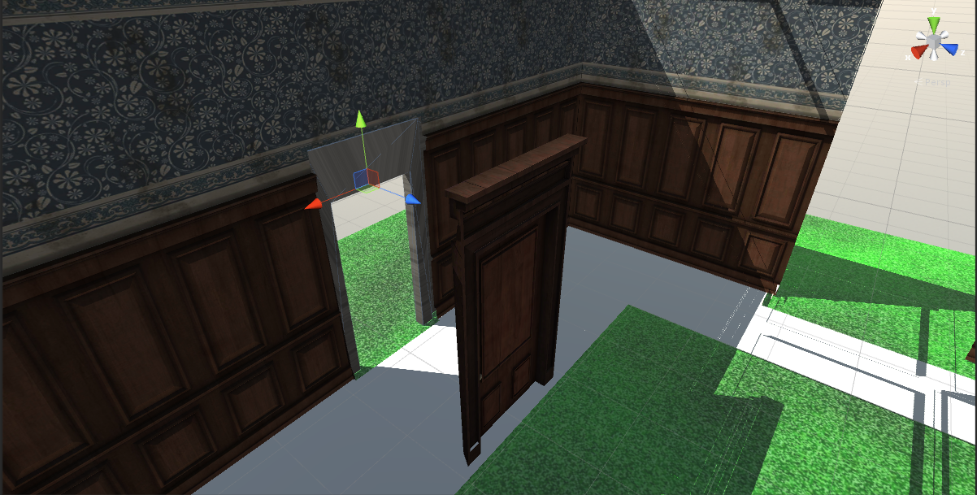
You may have already noticed that when we placed the skeleton for the room, the ceiling and the floor were both white/gray. To apply the correct texture, do as you did previously for the door and select the “a1_atlas_03” texture.
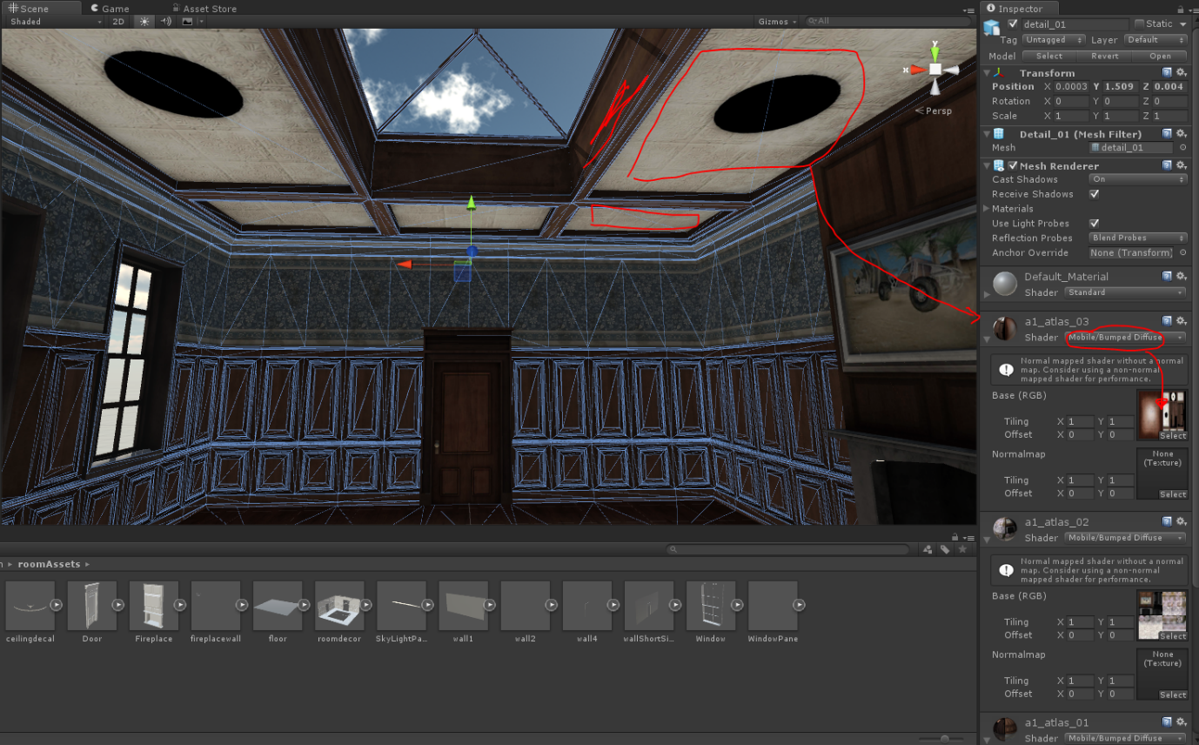
When creating the chessboard, the texture used is located in the room textures folder. The best way to do this is to create another plane, as we did for the grass, and apply the chessboard texture to it.
The correct texture to apply to the “tower” mesh is the “a1_chessPiece”.
As we did for the chessboard, add the provided mesh, scale it appropriately, and then drag and drop the marble texture onto the mesh.

