**Appendix A: Data Science Pipeline: Tools used**

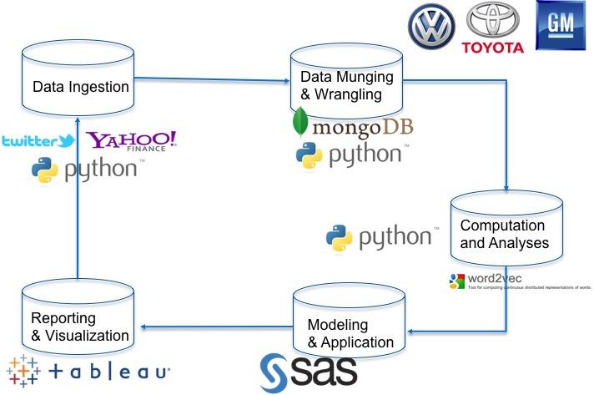

**Appendix B: Architecture: Data Science Pipeline: Facing View**

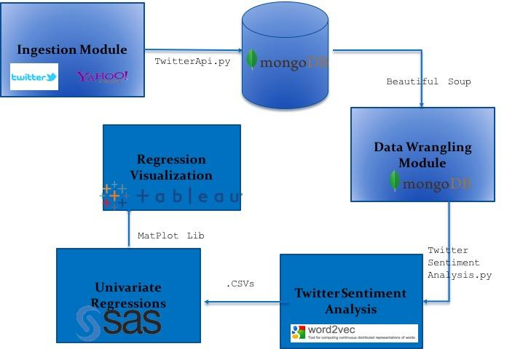

**Appendix C: Architecture Outline**

