## MODULE: 2 (HTML)

# Define the terms: Website, Webpage, Web browser, Web server, HTML, CSS:

## web page

A document which can be displayed in a web browser such as Firefox, Google Chrome, Opera, Microsoft Edge, or Apple Safari. These are also often called just "pages."

## website

A collection of web pages which are grouped together and usually connected together in various ways. Often called a "website" or a "site."

## web server

A computer that hosts a website on the Internet.

The web browser is an application software to explore www (World Wide Web). It provides an interface between the server and the client and requests to the server for web documents and services.

## HTML

HTML stands for Hyper Text Markup Language and it is the language that is used to define the structure of a web page. HTML is used along with CSS and Javascript to design web pages.

## CSS

CSS stands for Cascading Style Sheets and it is used to style web documents. It is used to provide the background color and is also used for styling. It can also be used to style the font and change its size.

# Create a webpage to show “This is my first HTML page.

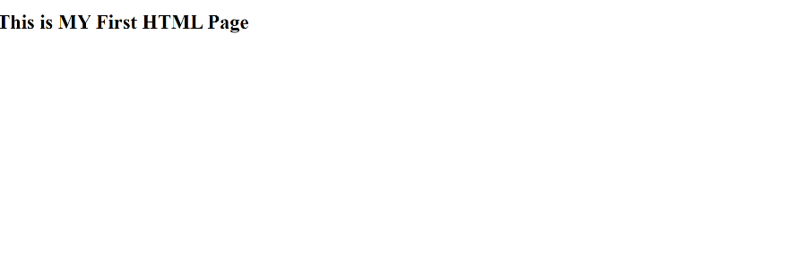

# Display top 10 IT companies list in html webpage.

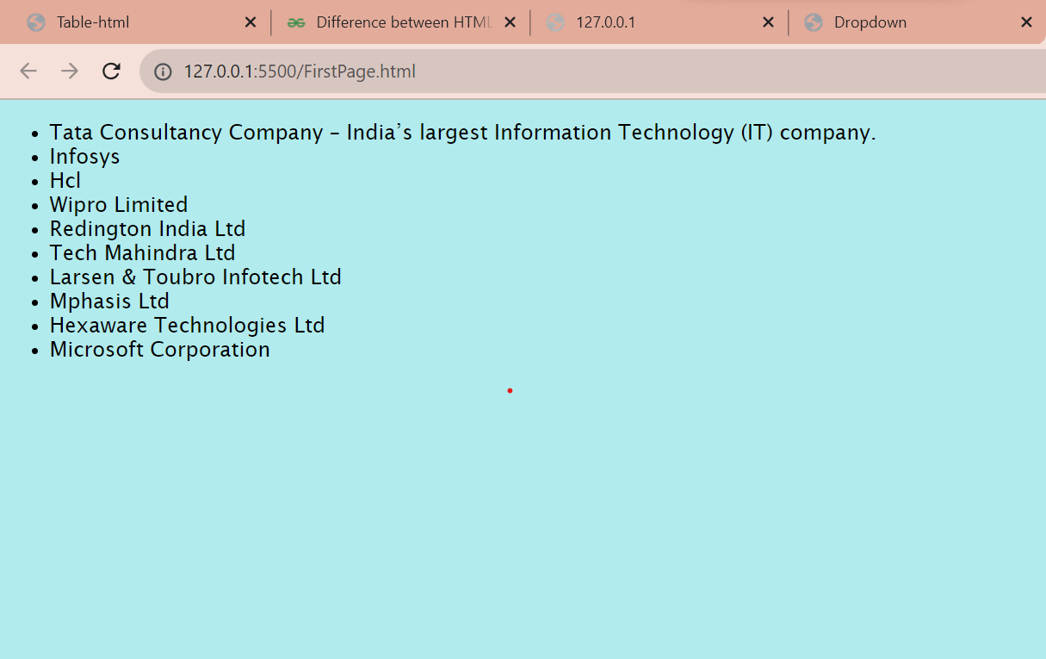

# Create a dropdown list

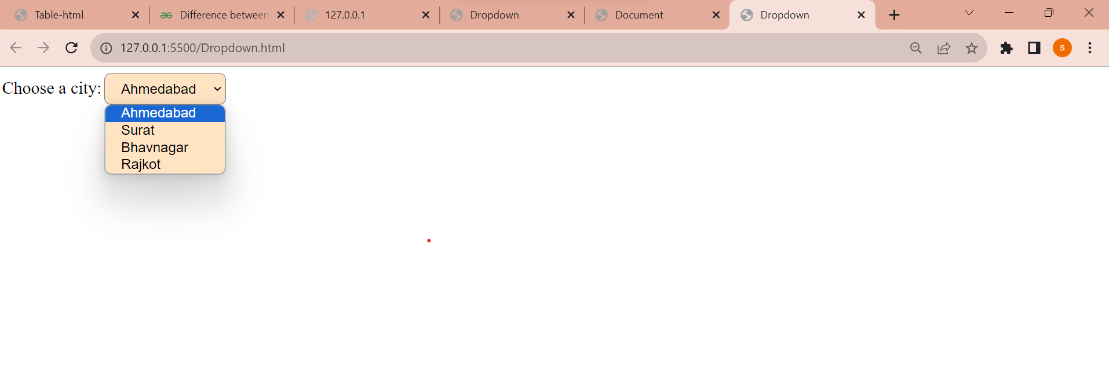

# Create a Table Of college Management system using row span & col span.

# Create below table using HTML table tags

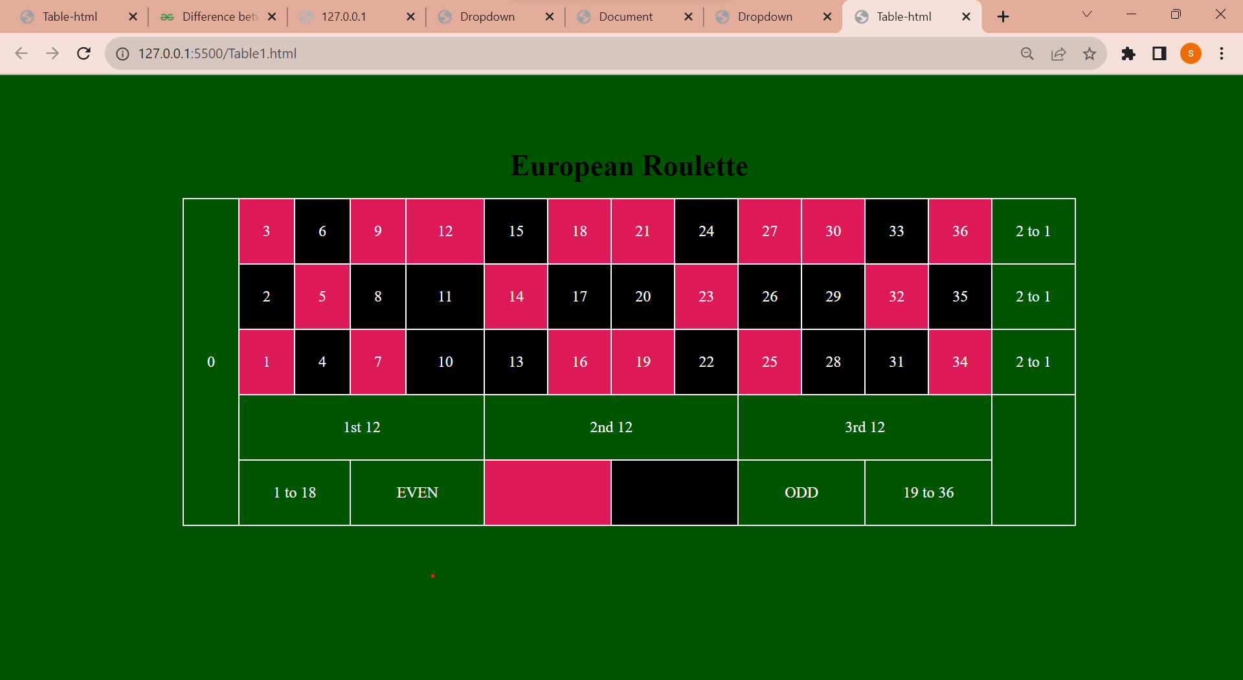

# Create Registration form using HTML, CSS

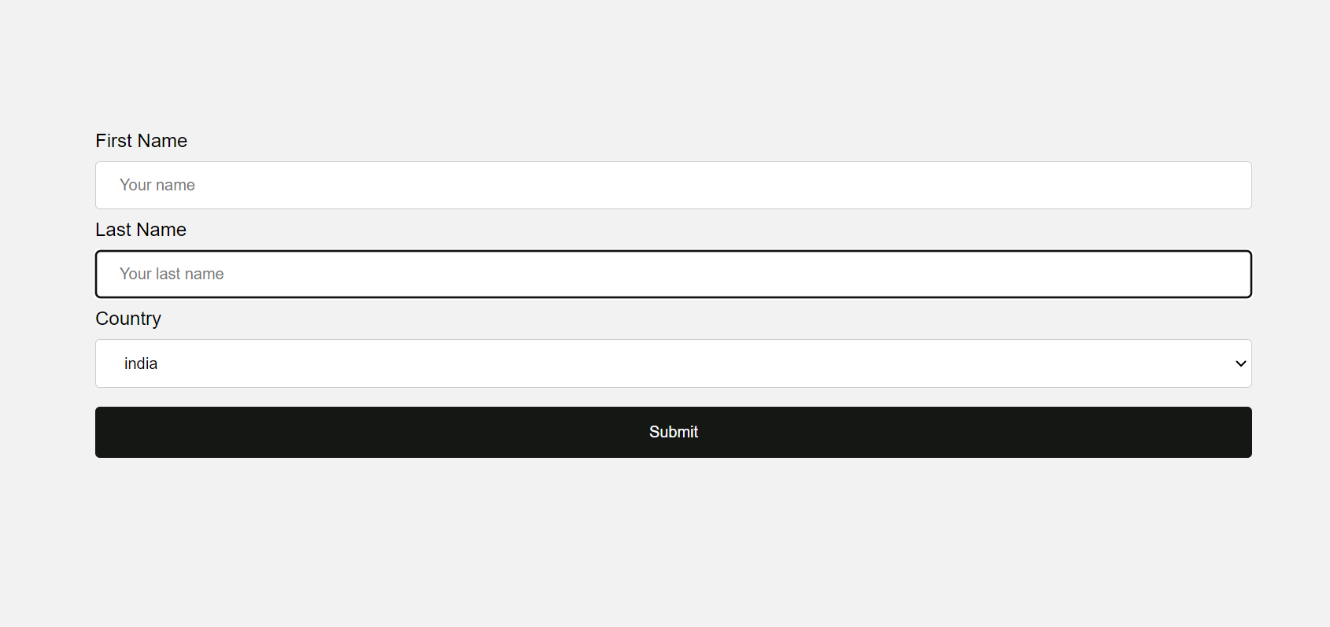

# In how many ways can a CSS be integrated as a web page?

## The CSS code can be implemented in three ways -

Inline - Inline is the term used when you write your CSS code within the style attribute of any HTML element.

e.g. - <p style="color:skyblue;"> Hello world!</p>

2. Internal - internal CSS is implemented within the head element of your web page.

e.g. -

<head>

<style>

p{

color:lime;

background-color: black;

}

</style>

</head>

3. External - external CSS implementation is done by creating a separate CSS file in your workspace and then linking them in every web page you create.

e.g. -

<head>

<link rel="text/css" href="your_CSS_file_location"/>

</head>

# Create below page using HTML CSS.

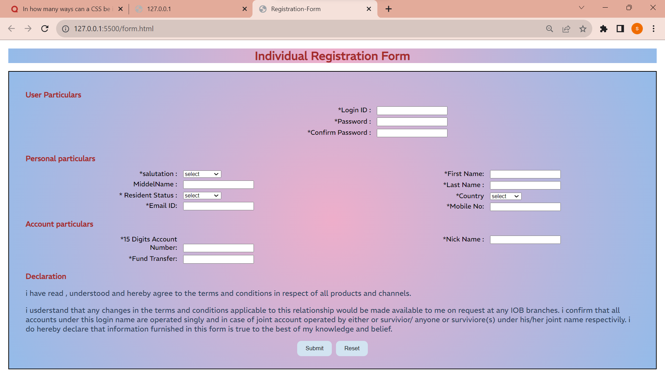

# Create link-pseudo classes using external css, to format links on the pages.

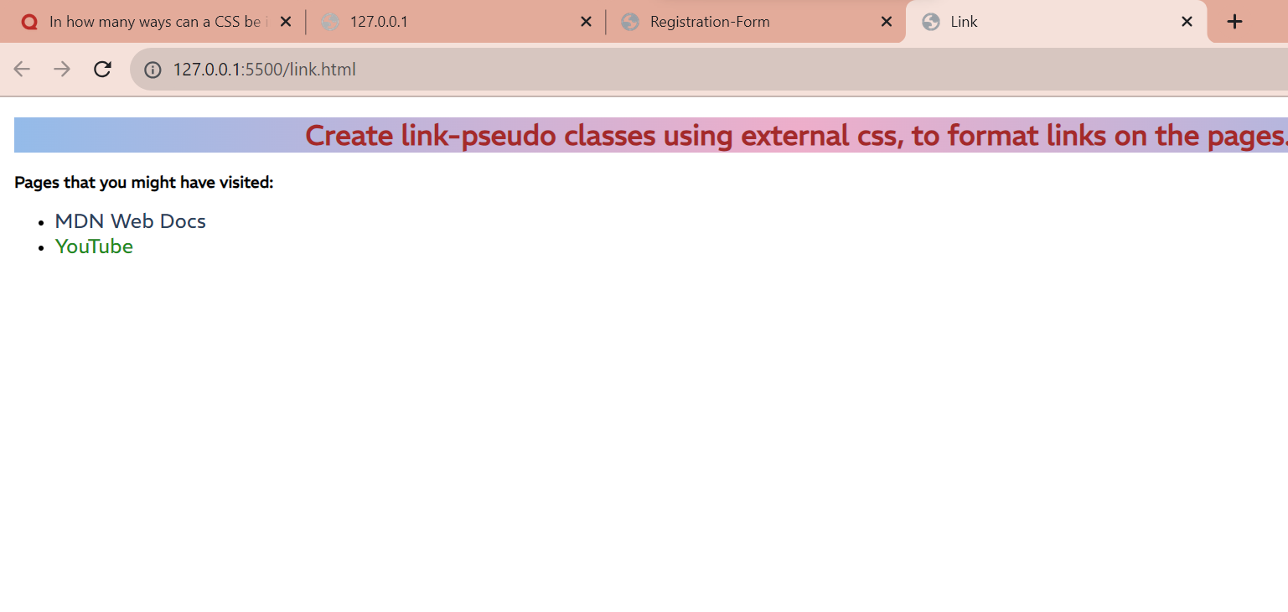

# Create a dynamic pseudo class using HTML, CSS

