Final Project Output Summary
This document presents the complete output of the ML-assisted intraday trading project. It consolidates strategy performance, regime analysis, and risk behavior using visualizations and concise interpretations.

Baseline Strategy Performance
The baseline EMA strategy captures trending movements but exhibits sensitivity to market noise. Performance deteriorates during sideways regimes, making it a suitable benchmark rather than a final system.
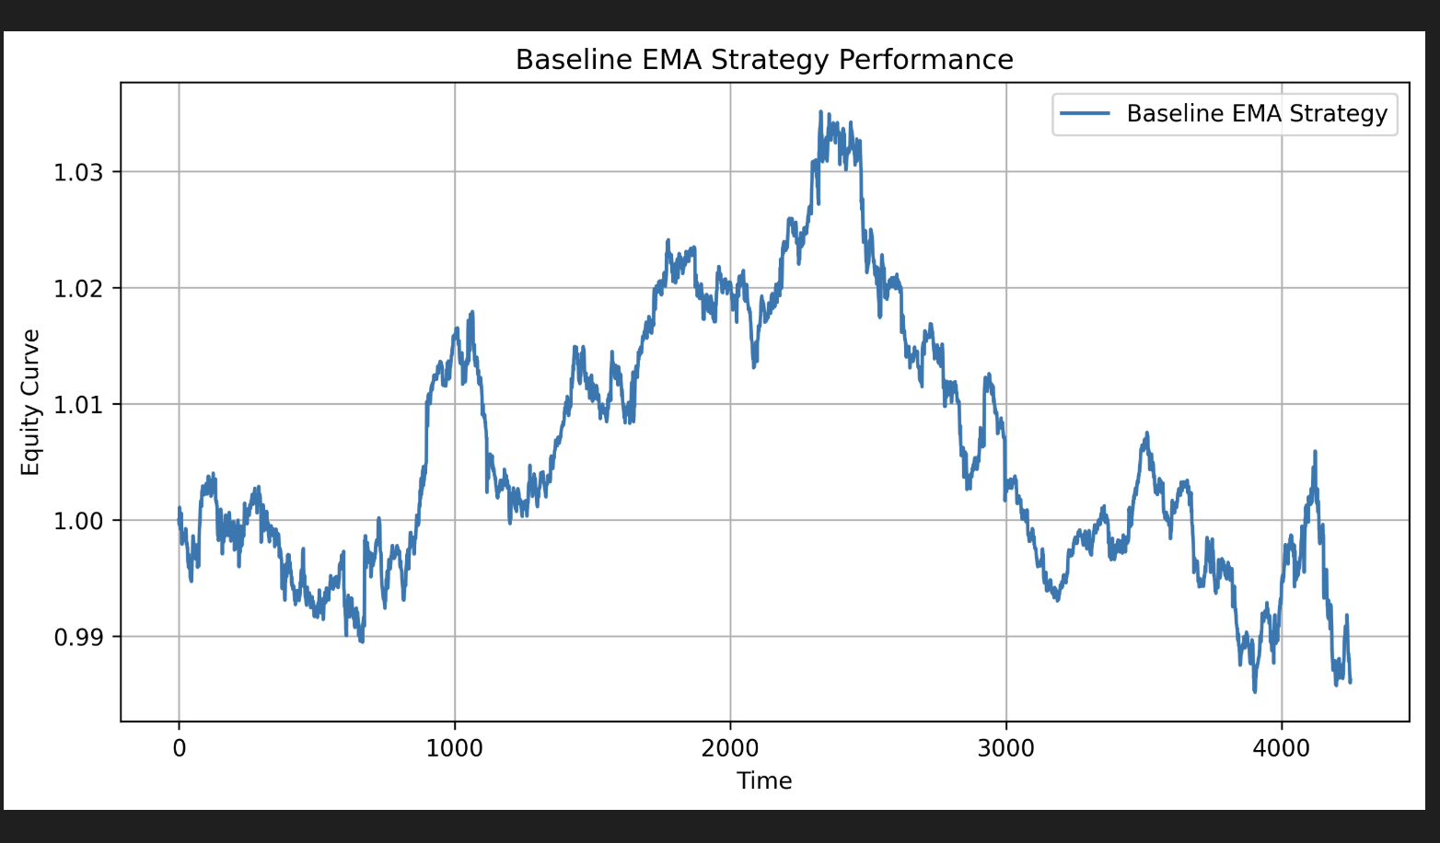

Baseline vs ML-Filtered Strategy
Machine learning is applied as a trade filtering layer. The filtered strategy shows smoother equity behavior by avoiding low-quality trades during unstable conditions.
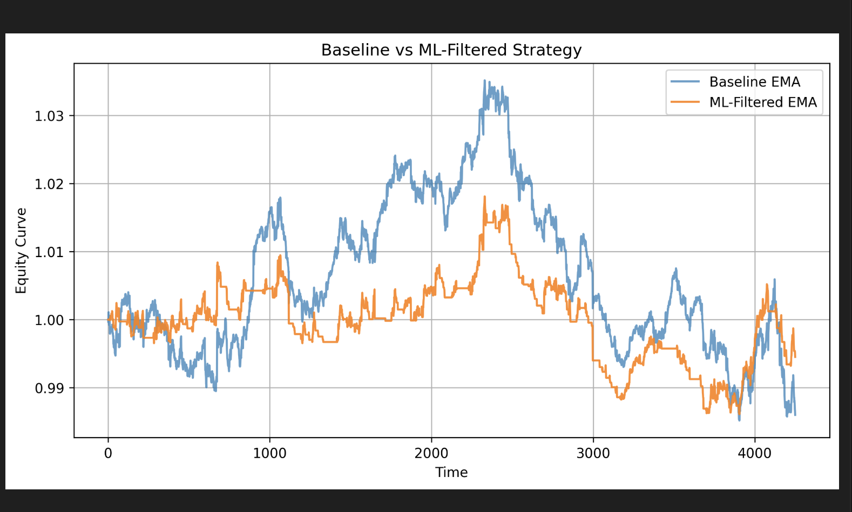

Baseline vs ML vs HMM Strategies
Introducing regime awareness further stabilizes performance. The regime-filtered strategy demonstrates reduced drawdowns and more consistent equity progression.
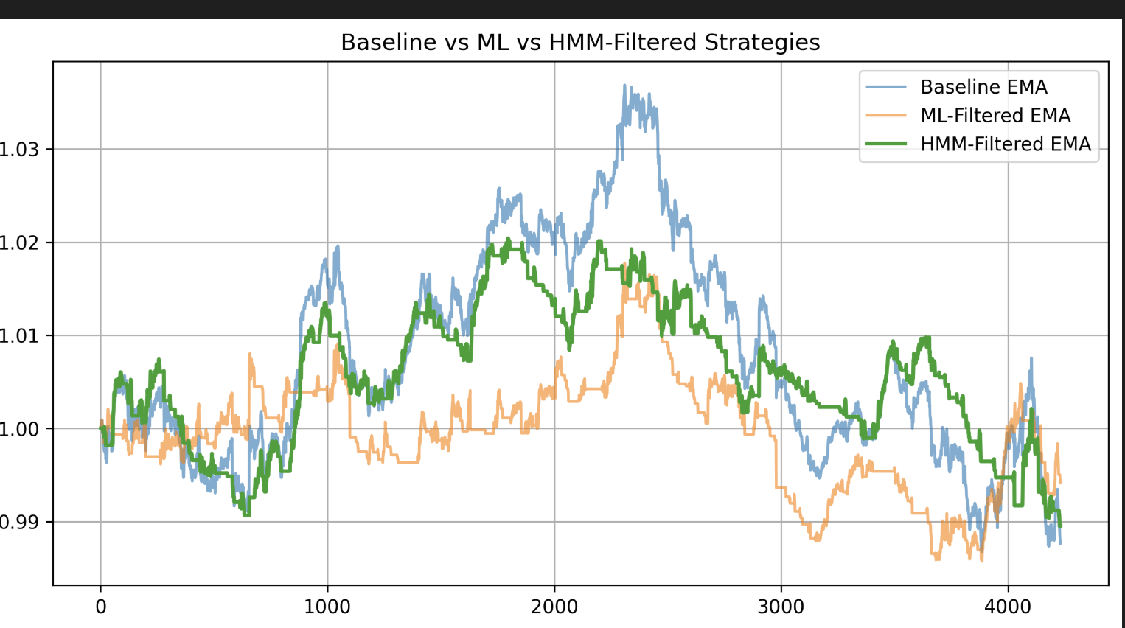

Regime-Filtered Strategy Performance
Trading conditioned on market regimes improves robustness by aligning strategy behavior with prevailing market structure.
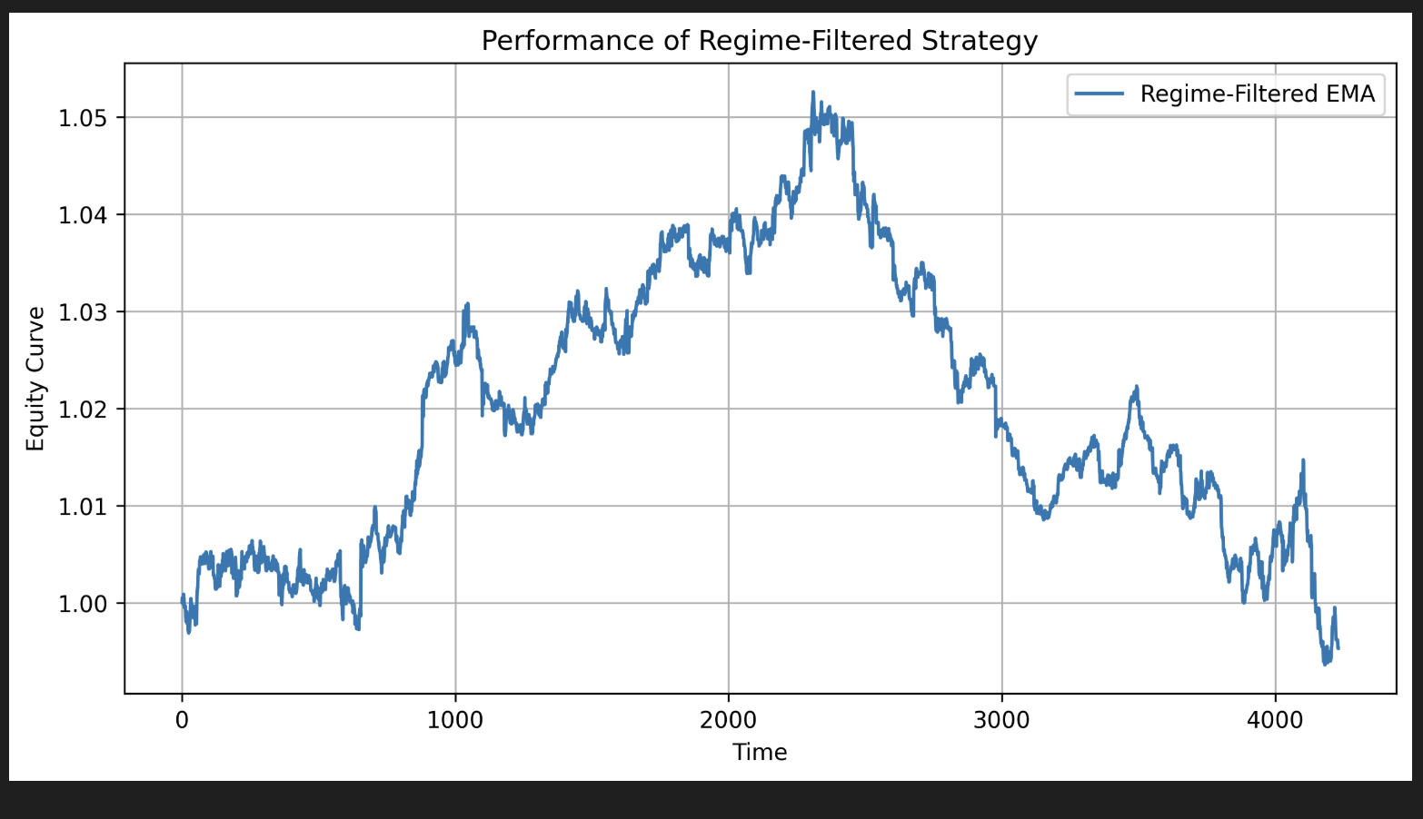

Market Regime Classification
Market states are classified into uptrend, downtrend, and sideways regimes. These classifications align closely with observed price action.
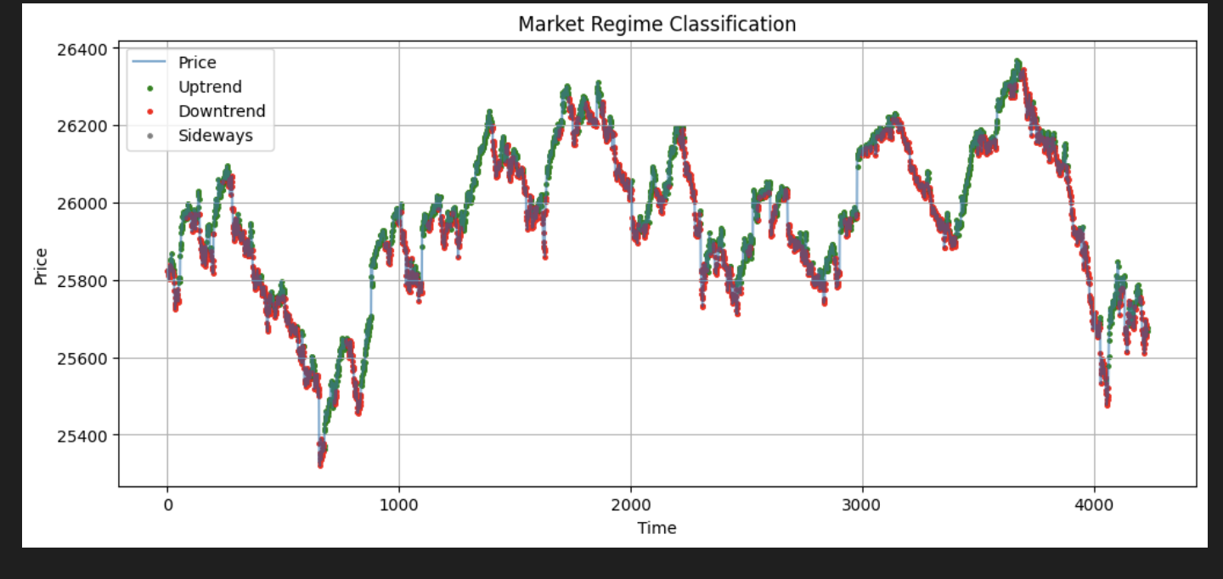

Regime Transition Analysis
The transition matrix shows strong regime persistence, indicating that market states tend to continue over short horizons.
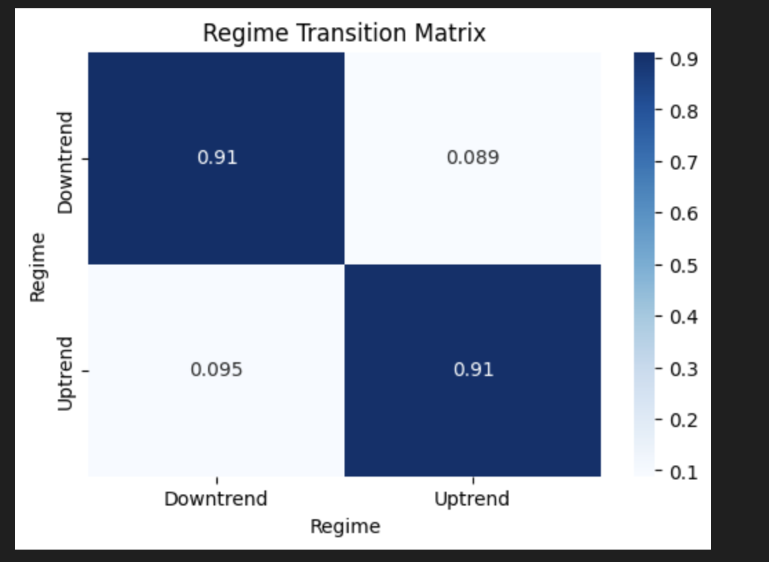

Outlier Trade Analysis
A small number of extreme trades contribute disproportionately to gains and losses. Identifying these outliers helps explain overall risk behavior.
