C:\Users\1992744\Desktop\resize.jpg

**Cégep de la Gaspésie et des Îles, Montreal**

A Project Report

On

**Remind Me At** 

Academic year

2020

Contents

1. Introduction 3

1.1 Purpose 3

1.2 Scope 4

2. General Description 5

2.1 Product Functions 5

2.2 User Characteristics 5

2.3 Admin Characteristics 5

3. Specific Requirements 6

3.1 Functional Requirements 6

3.2 Non-functional Requirements 8

4. Analysis Models 9

4.1 Use Case 9

4.2 Sequence Diagrams 10

4.3 Class Diagram 15

4.4 Screen flows diagram and Screen design 16

5. Database 19

5.1 Conceptual E-R Diagram 19

5.2 Logical E-R Diagram 19

5.3 Database Queries 20

6. Use Case Scenarios 21

6.1 User Story 21

6.2 Use Case Scenario 23

7. Test Cases 30

8. References 40

Figure 1.Use case diagram 9

Figure 2.Registration Sequence Diagram 10

Figure 3.Set Reminder Sequence Diagram 11

Figure 4.Login Sequence Diagram 12

Figure 5.Delete Account Sequence Diagram 13

Figure 6.Delete User (Admin) Sequence Diagram 14

Figure 7.Class diagram 15

Figure 8.Screen flows diagram-1 16

Figure 9.Screen flow diagram-2 17

Figure 10.Screen flow diagram-Admin 18

Figure 11.Screen design 18

Figure 12.Conceptual E-R Diagram 19

Figure 13.Logical E-R Diagram 19

1. Introduction

The “Remind Me At” application is a new and amazing application to help people remember important tasks by setting up reminders based on location. This app is free to download. The user can register, set up their reminders, by adding a title, description and a location for it. Need to remember important things? Just add a reminder and let the app do the rest of the work for you. One can easily change the reminder title, description and location and also set it to active/inactive accordingly. This app makes the lives of people easy and sorted as they can focus on other things rather than just thinking about small day to day things like groceries or meeting someone at some specific place, etc. It’s a very user-friendly app.

It is built by using the following technologies:

Front End - XML

Backend - JAVA and Firebase Database

Development Tool – Android Studio

* 1. Purpose

In today’s busy life, where people have so many different tasks to perform, whether it’s related to office or house work, remembering each and every single task can sometimes get to the nerves. Earlier, people used to make hand written notes to remind themselves of important tasks. But now as there is more and more advancement in the technology and mobile application market, getting a notification of an important task is just a click away. One way to categorize these tasks can be a Location Based. It means a task to be performed at a specific location like going for groceries after leaving office, or getting petrol filled in the car after leaving home, etc. The purpose of the android application project “Remind Me At” is to let people remind themselves of important tasks or reminders through push notifications. Through this application users will be able to set different reminders by searching a location on the map and giving it a title and description. This application will be using Google Maps and Google Places API to track user’s current location with the target location and then send them a push notification if the location matches.

* 1. Scope

The main function of this application is to help users to set reminders on the basis of their location. The application provides the function to the user, where he can set a reminder based on location rather than time. It has solved many problems faced by people nowadays like if a user has defined a desired location, the user will notify automatically when he will enter that location. The user can set a reminder by adding location and he can add a description, title of the reminder or the task he wants to do when he will be at that location. Whenever the user will reach that location, the app is going to match his current location with the target location and will send him a push notification for the same.

1. General Description
   1. Product Functions

* Add reminder
* Search location
* Update profile
* View reminder list
* Delete reminder
* Set reminder as active or inactive
* Search Reminder
* Set reminder range
* View reminder history
* User Feedback
* Login
* Log Out
* Reset user’s password
* Push notification
  1. User Characteristics
* A use of the application can be possible by the registered user only.
* Registered user can use all the functionalities of the app.
* User can login or signup.
* User can send feedback.
* User can manage their profile
* User can view reminders and reminder history.
* Easy to use interface.
* Registered user can set reminders
* User can add title, description to the reminder
* User can set a location range around the target location
* User can search desired locations by searching the map
* User can set reminders to active/inactive.
* Registered user can receive push notifications from the system
* Android native standards across the application.
  1. Admin Characteristics
* Admin can disable/enable user from the application.
* Admin can completely delete a user from the application.
* Admin can send password reset link to user on their registered email.

1. Specific Requirements
   1. Functional Requirements

|  |  |  |  |
| --- | --- | --- | --- |
| Requirement Id | Requirement Statement | Priority | Comments |
| FR001 | Login Page | HIGH | The system must have login screen as a home to login using email and password for registered users. |
| FR002 | Sign Up | HIGH | The application must have a sign up page where the new user can register using email and password. |
| FR003 | User feedback | HIGH | The registered user shall have an option where they can give feedback for application. |
| FR004 | Password Recovery | HIGH | Follow the secure procedure to recover the password in case if registered user forgets. |
| FR005 | Add Reminder | HIGH | Registered user can add reminders with title, description and location. |
| FR006 | Search Location | HIGH | The registered user can search for location using Google Maps API while adding reminder. |
| FR007 | View Reminder | HIGH | The registered user can see all added reminders in list view and map. |
| FR008 | Update Reminder | HIGH | The registered user can update an already existing reminder. (Like Title, Description and Location). |
| FR009 | Delete Reminder | HIGH | The registered user can delete reminder. |
| FR010 | Push Notification | HIGH | System must always send a push notification when registered user enters the target location. |
| FR011 | Set Location Range | HIGH | The registered user can set a specific radius range around the target location. |
| FR012 | Active/Inactive Reminder | HIGH | The registered user can have option to activate or inactivate a set reminder. |
| FR013 | Profile Update | HIGH | The registered user can update their personal details like Name, Profile Photo, etc. |
| FR014 | Search Reminder | HIGH | The registered user can search a particular reminder from the reminder list using keywords and location on map. |
| FR015 | Delete Profile | HIGH | The registered user can delete his/her profile. This action will delete all user data. |
| FR016 | Reminder History | HIGH | The registered user can check past reminder history. |
| FR017 | Log Out | HIGH | To allow users to logout from the application. |
| FR018 | Delete User(Admin) | HIGH | Admin can delete user from application. |
| FR019 | Disable/Enable User(Admin) | HIGH | Admin can Disable/Enable user from application. |
| FR020 | Send Password Reset Link(Admin) | HIGH | Admin can send password reset link to user on their registered email. |
| FR021 | Accuracy Mode | HIGH | User can set location accuracy mode (High/Low). |

* 1. Non-functional Requirements

|  |  |  |  |
| --- | --- | --- | --- |
| Requirement Id | Requirement | Priority | Comments |
| NFR001 | Continuous Location Check | HIGH | App will compare user’s current location with target location every 30 seconds using Google Maps API in the background. |
| NFR002 | Login authentication | HIGH | The system must provide login after secure authentication with server for Registered user. |
| NFR003 | Performance and response time | HIGH | The performance of app must be highly scaled with accurate and fast response time. |
| NFR004 | Usability | HIGH | App UI needs to be Effective, Efficient, Engaging, Error Tolerant, Easy to Learn so even first time user will be able to use app easily. |
| NFR005 | Power and memory consumption | HIGH | App will allow user to select high accuracy mode and balanced mode, which will helps to manage power and memory consumption. |
| NFR006 | Network independent | HIGH | App needs to work well with any kind of location provider independent of network connection. (**GPS location provider or network location provider**). |

1. Analysis Models
   1. Use Case

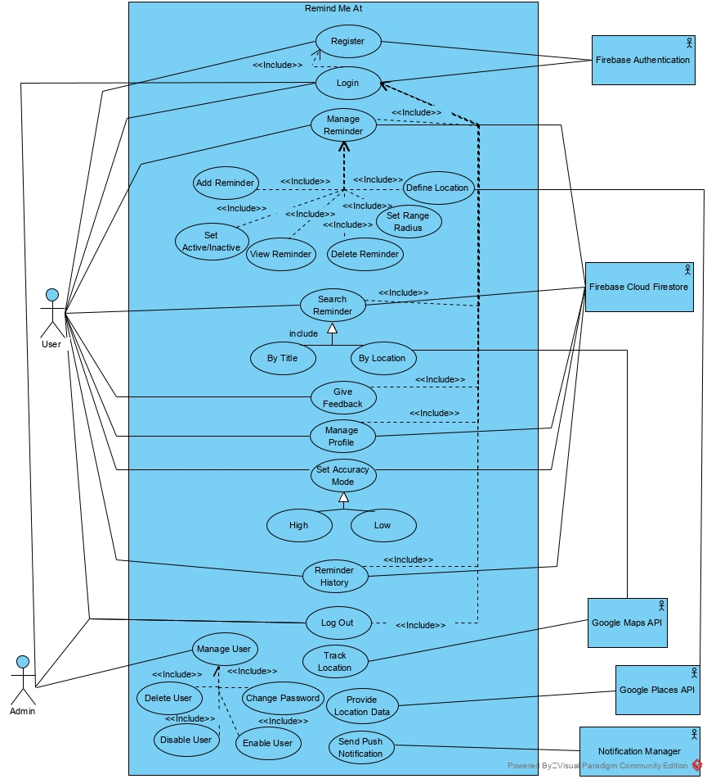

Figure 1.Use case diagram

* 1. Sequence Diagrams
* **1-Register**

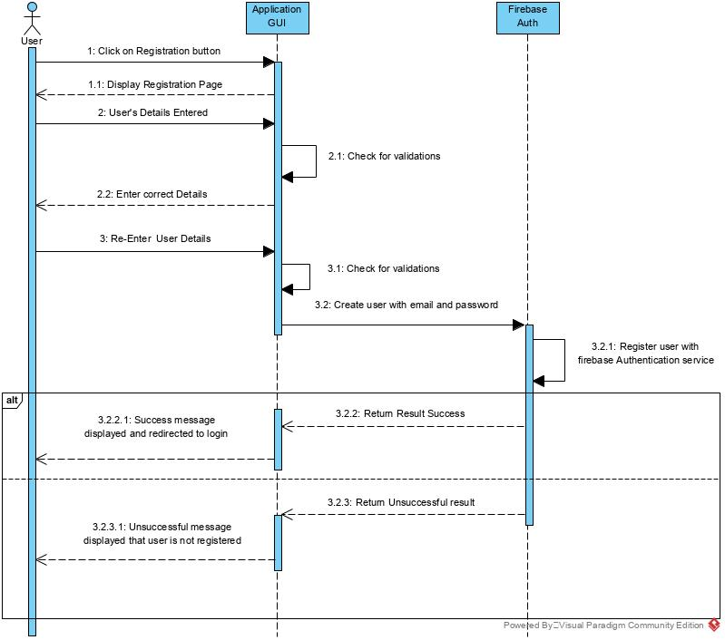

Figure 2.Registration Sequence Diagram

* **2-Set reminder**

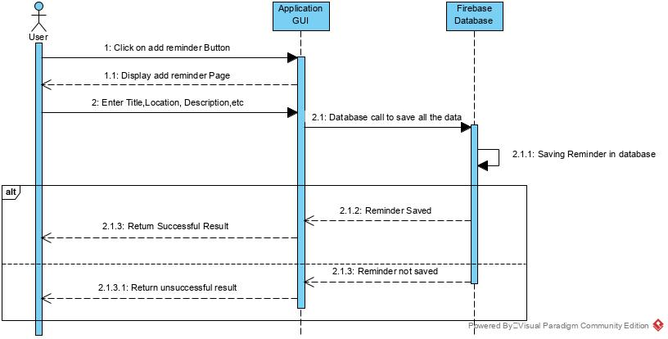

Figure 3.Set Reminder Sequence Diagram

* **3-Login**

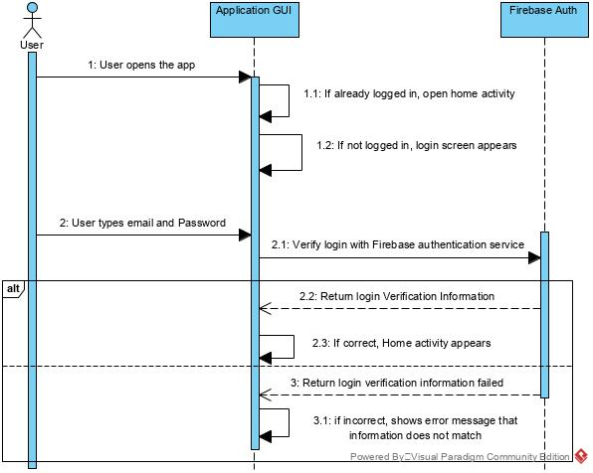

Figure 4.Login Sequence Diagram

* **4-Delete Account(User)**

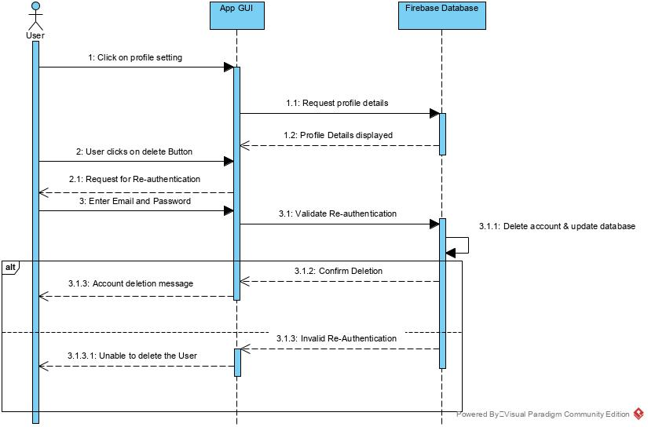

Figure 5.Delete Account Sequence Diagram

* **5-Delete User(Admin)**

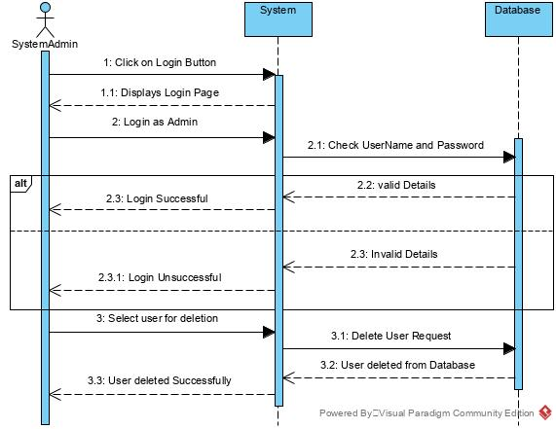

Figure 6.Delete User (Admin) Sequence Diagram

* 1. **Class Diagram**

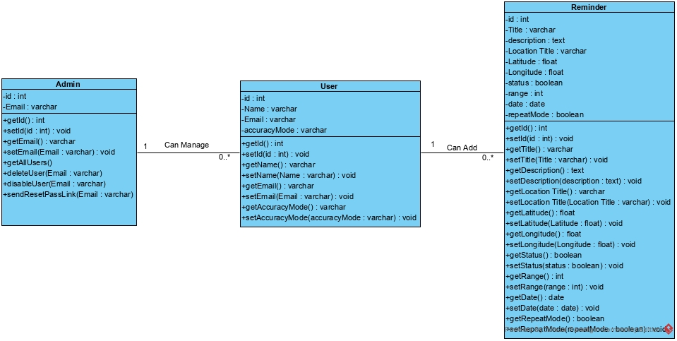

Figure 7.Class diagram

* 1. Screen flows diagram and Screen design

<https://www.justinmind.com/usernote/tests/44751178/48474142/48474144/index.html>

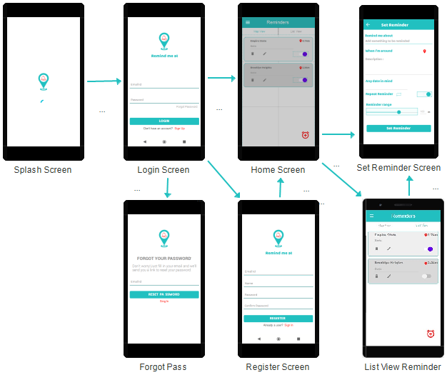

Figure 8.Screen flows diagram-1

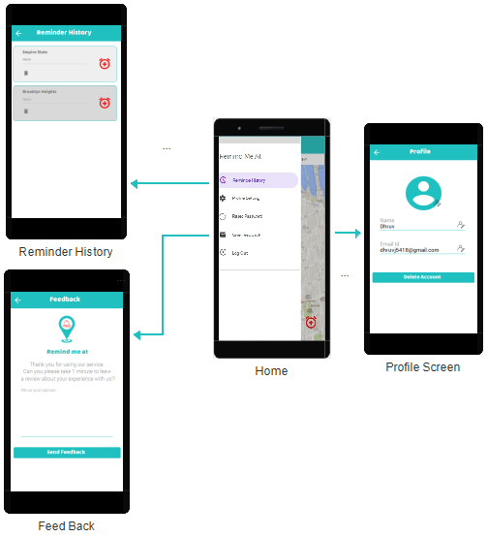

Figure 9.Screen flow diagram-2

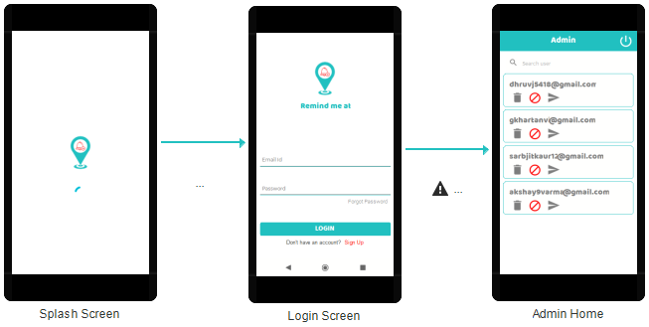

Figure 10.Screen flow diagram-Admin

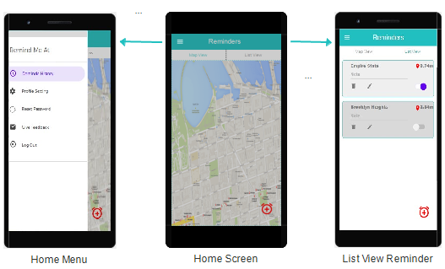

Figure 11.Screen design

1. Database
   1. Conceptual E-R Diagram

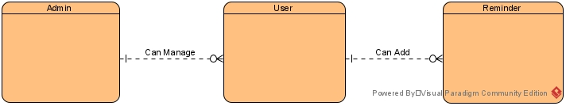

Figure 12.Conceptual E-R Diagram

* 1. Logical E-R Diagram

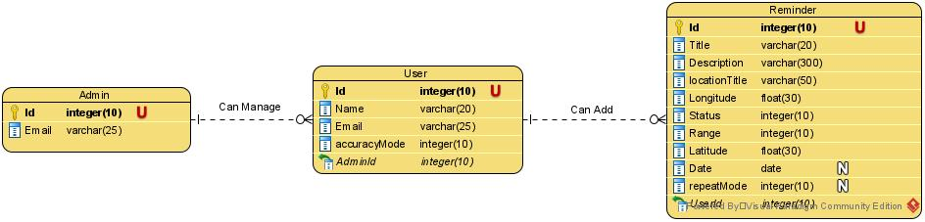

Figure 13.Logical E-R Diagram

* 1. Database Queries
* CREATE TABLE Admin (Id int(10) NOT NULL AUTO_INCREMENT, Email int(10) NOT NULL UNIQUE, PRIMARY KEY (Id));
* CREATE TABLE Reminder (Id int(10) NOT NULL AUTO_INCREMENT, Title varchar(255) NOT NULL, Description varchar(255) NOT NULL, locationTitle varchar(100) NOT NULL, Longitude float NOT NULL, Latitude float NOT NULL, `Date` date, repeatMode int(1), status int(1) NOT NULL, UserId int(10) NOT NULL, PRIMARY KEY (Id));
* CREATE TABLE `User` (Id int(10) NOT NULL AUTO_INCREMENT, Name varchar(50) NOT NULL, AccuracyMode int(10) NOT NULL, Email varchar(100) NOT NULL UNIQUE, AdminId int(10) NOT NULL, PRIMARY KEY (Id));

1. Use Case Scenarios
   1. User Story

|  |  |  |  |  |
| --- | --- | --- | --- | --- |
| Story Id | As a… | I want to… | So that… | Acceptance Criteria |
| S001 | Register User | Fill all my login details only once | I can access my application without doing login process every time. | User does not have to fill login information several time. |
| S002 | Register User | I want to update location. | So I can add updated location to my previously added reminder. | User can update location in previous reminder same description without adding new reminder. |
| S003 | Register User | I want to see all my reminders on map also. | So that I can see on map at which locations I’m having reminders. | User can see reminders on the map by location markers. |
| S004 | Register User | I want to see all my upcoming reminders as list. | So that I can see all my reminders as a list view. | User can search for reminders in a list view. |
| S005 | Register User | I want to see my completed reminder. | So that I can check which reminders are completed? | User can see history of reminders. |
| S006 | Register User | I want to reset a reminder from my history. | So that I don’t need to add same reminder once more. | User can directly reset reminder from history. |
| S007 | Register User | I want to reset my password. | So that I can login to my account. | User will get password reset link on their registered email. |
| S008 | Register User | I want to delete reminder. | So that I don’t get notified by system for that reminder. | If the user has already set a reminder and now he don’t want to do that task. The user can delete that reminder from a list. |
| S009 | Register User | I want to get notification about the reminder. | So that I can complete my task. | Back end system is going to match user’s current location with reminder’s location and if it matches, user will get push notification. |
| S010 | Register User | I want to give suggestions or I want to discuss about the issue which I’m facing while using the application. | So that I can get better user experience. | User can give feedback about the application to admin team. |
| S011 | Register User | I want to inactive previously added reminder. | So that I can active it later without adding it again. | User can active/inactive reminders using toggle button. |
| S012 | Admin | I want to delete user from application. | So that user can’t login directly without new registration. | Admin can delete user from application. |
| S013 | Admin | I want to disable user from application. | So that user can’t login or re-register using same email with application. | Admin can disable user from application. |
| S014 | Admin | I want to send reset password link to user on request. | So that user can reset their password using received link via email. | Admin can send password reset link and user will be able to login. |
| S015 | Register User | I want to set location accuracy mode. | So that I can manage battery and memory consumption of application. | User can set accuracy mode (High/Low). |
| S016 | Admin | I want to enable user in application. | So that user can login or re-register using same email with application. | Admin can enable user from application. |

* 1. Use Case Scenario
* 1-Register

|  |  |
| --- | --- |
| System | A Mobile Application – Remind me at |
| Identifier | UC-1 |
| Author(s) | Team-4 |
| Version | None |
| Name | Register new User |
| Pre-Condition(s) | The user is non-registered and does not have an account on Remind me at Application |
| Post-Condition(s) | The user is directed to the Login Page of the mobile application. |
| Trigger | The user has clicked on the Sign Up button. |
| Normal Flow | 1. User clicks on the Sign Up button to create the user profile. 2. User enters the details in the form and sets up the email and password. 3. User clicks on submit the information. 4. User is redirected to the login Page. |
| Alternate Flow | None |
| Exceptional Flow(s) | Exception: Only unregistered emails can be used for registration.   1. The system will prompt the message “Email has already been registered, enter new email”. 2. The password should be a minimum 6 characters. 3. The system will prompt the message “Password is short, it should be at least 6 characters” on the application display. 4. The system will prompt the message “Email and Password required” |
| Related Actor(s) | Primary-Non-Registered User |
| Related Use Case(s) | Login |

* 2-Login

|  |  |
| --- | --- |
| System | A Mobile Application – Remind me at |
| Identifier | UC-2 |
| Author(s) | Team-4 |
| Version | None |
| Name | Login |
| Pre-Condition(s) | The user is registered and has an account on Remind me at Application |
| Post-Condition(s) | The user is directed to the homepage of Remind me at Application. |
| Trigger | The user has clicked on the Login button |
| Normal Flow | 1. User clicks on the Login button 2. User enters the email and the password in the form. 3. User is directed to the homepage specific to the user. |
| Alternate Flow | 1. User clicks on “forget password.  2. User enters the email used for registration.  3. Email to change password is sent to the given email address.  4. User changes the password and confirms the changes.  5. User is directed to the Login page.  6. User enters the user name and the password in the form.  7. User is directed to the homepage specific to the user |
| Exceptional Flow(s) | The password should be a minimum 6 characters.  The system will prompt the message “Password is short, it should be at least 6 characters” on the application display.  The system will prompt the message “Email is not registered”.  The system will prompt the message “Email and Password required”. |
| Related Actor(s) | Primary-Registered User |
| Related Use Case(s) | Sign Up |

* 3-Reset Password

|  |  |
| --- | --- |
| System | A Mobile Application – Remind me at |
| Identifier | UC-3 |
| Author(s) | Team-4 |
| Version | None |
| Name | Reset Password |
| Pre-Condition(s) | The user is registered and have an account on Remind me at Application |
| Post-Condition(s) | None |
| Trigger | The user has clicked on the Reset Password button. |
| Normal Flow | 1. User clicks on the Reset Password button. 2. User enters the email used for registration. 3. User clicks on reset password. 4. User will change password using link received by email. 5. User is redirected to the Login Page. |
| Alternate Flow | None |
| Exceptional Flow(s) | Exception: Password should be a minimum 6 character.   1. The system will prompt the message “Password is too short, it should be at least 6 characters”. 2. The system will prompt the message “Email is not registered with application”. |
| Related Actor(s) | Primary-Registered User |
| Related Use Case(s) | View Profile, Login. |

* 4-View Profile

|  |  |
| --- | --- |
| System | A Mobile Application – Remind me at |
| Identifier | UC-4 |
| Author(s) | Team-4 |
| Version | None |
| Name | View Profile |
| Pre-Condition(s) | The user is registered and have an account on Remind me at application |
| Post-Condition(s) | None |
| Trigger | The user has clicked on the View Profile button. |
| Normal Flow | 1. User clicks on View Profile. 2. User can view personal details like profile picture and Personal details. |
| Alternate Flow | 1. User can click on the setting button. 2. User can edit profile settings such as username and email id. 3. User clicks the reset password button to reset password. 4. Users can sign out of the application. |
| Exceptional Flow(s) | None |
| Related Actor(s) | Primary-Registered User |
| Related Use Case(s) | Reset Password, Update Profile, Delete Profile. |

* 5-Set Reminder

|  |  |
| --- | --- |
| System | A Mobile Application – Remind me at |
| Identifier | UC-5 |
| Author(s) | Team-4 |
| Version | None |
| Name | Set Reminder |
| Pre-Condition(s) | The user is registered and have an account on Remind me at application |
| Post-Condition(s) | Show a reminder message to user, when user reaches on the saved location. |
| Trigger | The user has clicked on the Set Reminder button. |
| Normal Flow | 1. User selects the reminder option from the dashboard screen of the app. 2. Search the location and save the desired location, and then enter the reminder name and description. After that click on save button to save the reminder. |
| Alternate Flow | None |
| Exceptional Flow(s) | 1. System gives an error message whenever system fails to connect database. 2. System gives an error message “Reminder title cannot be empty”. |
| Related Actor(s) | Primary-Registered User |
| Related Use Case(s) | Set Reminder |

* 6-View Reminder

|  |  |
| --- | --- |
| System | A Mobile Application –Remind me at |
| Identifier | UC-6 |
| Author(s) | Team-4 |
| Version | None |
| Name | View Reminder |
| Pre-Condition(s) | The user is registered and have an account on Remind me at application. |
| Post-Condition(s) | None |
| Trigger | The user has opened Home page. |
| Normal Flow | 1. User opens home page. 2. User views a list of reminders which he has added previously. 3. User clicks on particular reminder to view all details. |
| Alternate Flow | None |
| Exceptional Flow(s) | None |
| Related Actor(s) | Primary-Registered User |
| Related Use Case(s) | Update Reminder, Delete Reminder |

* 7- Update Reminder

|  |  |
| --- | --- |
| System | A Mobile Application – Remind me at |
| Identifier | UC-7 |
| Author(s) | Team-4 |
| Version | None |
| Name | Update Reminder |
| Pre-Condition(s) | The user is have an account on Remind me at application and minimum one previously added reminder. |
| Post-Condition(s) | None |
| Trigger | The user has clicked the update button. |
| Normal Flow | 1. User clicks on the update button. 2. User will edit details like title, description and location. 3. User will click save button. |
| Alternate Flow | None |
| Exceptional Flow(s) | 1. System gives an error message whenever system fails to connect database. 2. System gives an error message “Reminder title cannot be empty”. |
| Related Actor(s) | Primary-Registered User |
| Related Use Case(s) | None |

* 8- Delete Profile

|  |  |
| --- | --- |
| System | A Mobile Application –Remind me at |
| Identifier | UC-8 |
| Author(s) | Team-4 |
| Version | None |
| Name | Delete Profile |
| Pre-Condition(s) | The user is registered and have an account on remind me at Application |
| Post-Condition(s) | User will be deleted completely with all user data from the application. |
| Trigger | The user has clicked the delete profile button. |
| Normal Flow | 1. User clicks on the delete profile button. 2. User enters correct email and password of the account. 3. User click Delete button. 4. User will be redirected to Login page. |
| Alternate Flow | None |
| Exceptional Flow(s) | 1. Email and Password combination doesn’t match. |
| Related Actor(s) | Primary-Registered User. |
| Related Use Case(s) | None |

* 9- Push Notification

|  |  |
| --- | --- |
| System | A Mobile Application –Remind me at |
| Identifier | UC-9 |
| Author(s) | Team-4 |
| Version | None |
| Name | Send push notification |
| Pre-Condition(s) | The user is registered and have an account on Remind me at application |
| Post-Condition(s) | None |
| Trigger | When application is in background and minimum one reminder is added. |
| Normal Flow | 1. App will compare User’s current location with target location continuously when the app will be in back ground. 2. If location got matched system will send push notification to user. |
| Alternate Flow | None |
| Exceptional Flow(s) | 1. System might fail to send notification in case of no internet connection, no GPS connection. |
| Related Actor(s) | Primary-Registered User |
| Related Use Case(s) | None |

* 10- Delete Reminder

|  |  |
| --- | --- |
| System | A Mobile Application –Remind me at |
| Identifier | UC-10 |
| Author(s) | Team-4 |
| Version | None |
| Name | Delete Reminder |
| Pre-Condition(s) | The user is registered and minimum one previously added reminder. |
| Post-Condition(s) | None |
| Trigger | The user has clicked the Delete reminder button. |
| Normal Flow | 1. User has clicked the delete reminder button. 2. Reminder will be deleted. |
| Alternate Flow | None |
| Exceptional Flow(s) | None |
| Related Actor(s) | Primary-Registered User |
| Related Use Case(s) | None |

1. Test Cases

|  |  |
| --- | --- |
| **Project Name:** Remind Me At | |
| **Test Case** | |
| **Test Case ID:** 001 | **Test Designed by: Dhruv Patel** |
| **Test Priority (Low/Medium/High):** High | **Test Designed date**: October 30, 2020 |
| **Module Name:** Registration screen | **Test Executed by: Kamaljit Kaur** |
| **Test Title:** Test the registration functionality in Remind Me At | **Test Execution date**: October 30, 2020 |
| **Description**: Verify registration with valid email and password. |  |

**Pre-conditions:** Entered Email should not be already registered. Password should be minimum six characters.

|  |  |  |  |  |  |  |
| --- | --- | --- | --- | --- | --- | --- |
| **Step** | **Test Steps** | **Test Data** | **Expected Result** | **Actual Result** | **Status (Pass/Fail)** | **Notes** |
| 1 | Navigate to registration page |  | User should be directed to registration Page | Registration screen opens | Pass |  |
| 2 | Provide valid name | First name = test | Credentials can be entered | As expected | Pass |  |
| 3 | Provide valid email | Email= test@gmail.com | Credentials can be entered | As expected | Pass |  |
| 4 | Provide valid password | Password= 123456 | Credentials can be entered | As expected | Pass |  |
| 5 | Confirm Password | Password= 123456 | Credentials can be entered | As expected | Pass |  |
| 6 | Click on <Sign Up> Button |  | Login Page opens | Login Page opens | Pass |  |

**Post Condition:**  User has been registered successfully and the details of the user has been saved in the firebase.

|  |  |
| --- | --- |
| **Project Name:** Remind Me At | |
| **Test Case** | |
| **Test Case ID:** 002 | **Test Designed by: Dhruv Patel** |
| **Test Priority (Low/Medium/High):** High | **Test Designed date**: October 30, 2020 |
| **Module Name:** Registration screen | **Test Executed by: Kamaljit Kaur** |
| **Test Title:** Test the registration functionality in Remind Me At | **Test Execution date**: October 30, 2020 |
| **Description**: Verify registration with valid email and password. |  |

**Pre-conditions:** Entered Email should not be already registered. Password should be minimum six characters.

|  |  |  |  |  |  |  |
| --- | --- | --- | --- | --- | --- | --- |
| **Step** | **Test Steps** | **Test Data** | **Expected Result** | **Actual Result** | **Status (Pass/Fail)** | **Notes** |
| 1 | Navigate to registration page |  | User should be able to navigate to registration Page | Registration screen opens | Pass |  |
| 2 | Provide valid first name | Name =test | Credentials can be entered | As expected | Pass |  |
| 3 | Provide valid email | Email= test@gmail.com | Credentials can be entered | User cannot enter email | Fail | Only new users can register |
| 4 | Provide valid password | Password= 1236 | Credentials can be entered | User cannot enter password | Fail | Password should be minimum 6 characters |
| 5 | Confirm Password | Password= 123456 | Credentials can be entered | User cannot enter Confirm password | Fail | Confirm password should match the password |
| 6 | Click on <Sign Up> Button |  | Login Page opens | Login Page cannot open | Fail | User can not register |

**Post Condition:**  User has failed to register.

|  |  |
| --- | --- |
| **Project Name:** Remind Me At | |
| **Test Case** | |
| **Test Case ID:** 003 | **Test Designed by: Dhruv Patel** |
| **Test Priority (Low/Medium/High):** High | **Test Designed date**: October 30, 2020 |
| **Module Name:** Login screen | **Test Executed by: Kamaljit Kaur** |
| **Test Title:** Test the Login functionality in Remind Me At | **Test Execution date**: October 30, 2020 |
| **Description**: Login user with valid email and password. |  |

**Pre-conditions:** Entered Email should exist in the Firebase. Email and password should be valid.

|  |  |  |  |  |  |  |
| --- | --- | --- | --- | --- | --- | --- |
| **Step** | **Test Steps** | **Test Data** | **Expected Result** | **Actual Result** | **Status (Pass/Fail)** | **Notes** |
| 1 | Navigate to Login page |  | Login screen should appear | Login Screen appears | Pass |  |
| 2 | Provide valid email | Email= kamal@gmail.com | Credentials can be entered | As expected | Pass |  |
| 3 | Provide valid password | Password= 123456 | Credentials can be entered | As expected | Pass |  |
| 4 | Click on <Login> Button |  | Home Screen opens | Home screen opens | Pass |  |

**Post Condition:**  Email and password is valid and user is able to login. The Home screen of application appears on login.

|  |  |
| --- | --- |
| **Project Name:** Remind Me At | |
| **Test Case** | |
| **Test Case ID:** 004 | **Test Designed by: Dhruv Patel** |
| **Test Priority (Low/Medium/High):** High | **Test Designed date**: October 30, 2020 |
| **Module Name:** Profile Setting screen | **Test Executed by: Kamaljit Kaur** |
| **Test Title:** Test the Email Edit functionality in Profile Setting Screen | **Test Execution date**: October 30, 2020 |
| **Description**: Edit the Email by confirming current email and password |  |

**Pre-conditions:** Entered Email and Password should be valid and registered. New email should not be already registered.

|  |  |  |  |  |  |  |
| --- | --- | --- | --- | --- | --- | --- |
| **Step** | **Test Steps** | **Test Data** | **Expected Result** | **Actual Result** | **Status (Pass/Fail)** | **Notes** |
| 1 | Navigate to Profile Setting page |  | User should be able to edit Email | User is able to edit Email | Pass |  |
| 2 | Click on Edit Email |  | Edit email popup view should appear | Edit Email popup view appears | Pass |  |
| 3 | Provide New Email | Email=abc@gmail.com | Credentials can be entered | As expected | Pass |  |
| 4 | Provide Current email | Email= kamal@gmail.com | Credentials can be entered | As expected | Pass |  |
| 5 | Provide Current Password | Password=123456 | Credentials can be entered | As expected | Pass |  |
| 6 | User clicks on<Update email> button |  | Email should be updated | Email is updated | Pass |  |

**Post Condition:** Email has been successfully edited and saved in the firebase.

|  |  |
| --- | --- |
| **Project Name:** Remind Me At | |
| **Test Case** | |
| **Test Case ID:**005 | **Test Designed by: Dhruv Patel** |
| **Test Priority (Low/Medium/High):** High | **Test Designed date**: October 30, 2020 |
| **Module Name:** Profile Setting screen | **Test Executed by: Kamaljit Kaur** |
| **Test Title:** Test the Delete profile functionality in Profile Setting Screen | **Test Execution date**: October 30, 2020 |
| **Description**: Delete profile by confirming current email and password |  |

**Pre-conditions:** Entered Email and Password should be valid and registered.

|  |  |  |  |  |  |  |
| --- | --- | --- | --- | --- | --- | --- |
| **Step** | **Test Steps** | **Test Data** | **Expected Result** | **Actual Result** | **Status (Pass/Fail)** | **Notes** |
| 1 | Navigate to Profile Setting page |  | Profile Setting page should appear | Profile Setting Page opens | Pass |  |
| 2 | Click on <Delete Account> button |  | Delete profile pop up view should appear | Delete profile pop up view appears | Pass |  |
| 3 | Provide email | Email= kamal@gmail.com | Credentials can be entered | As expected | Pass |  |
| 4 | Provide Password | Password=123456 | Credentials can be entered | As expected | Pass |  |
| 5 | User clicks on<Delete Profile> button |  | Profile is deleted | Profile is deleted | Pass |  |

**Post Condition:** User profile is successfully deleted from authentication as well as cloud fire store.

|  |  |
| --- | --- |
| **Project Name:** Remind Me At | |
| **Test Case** | |
| **Test Case ID:** 006 | **Test Designed by: Dhruv Patel** |
| **Test Priority (Low/Medium/High):** High | **Test Designed date**: October 30, 2020 |
| **Module Name:** Notification | **Test Executed by: Kamaljit Kaur** |
| **Test Title:** test whether the user is being notified about reminder | **Test Execution date**: October 30, 2020 |
| **Description**: test by checking the location of the user and the status of reminder. |  |

**Pre-conditions:** User must be within the described range in the Reminder. Phone must have a good internet connection and allowed to use the location service.

|  |  |  |  |  |  |  |
| --- | --- | --- | --- | --- | --- | --- |
| **Step** | **Test Steps** | **Test Data** | **Expected Result** | **Actual Result** | **Status (Pass/Fail)** | **Notes** |
| 1 | Check the internet connection of phone | Phone, internet connection | Phone have a good internet connection | Phone have a good internet connection | Pass |  |
| 2 | Check the Active reminders | Status of reminder (Active /Inactive) | Status of reminder is Active | As expected | Pass |  |
| 3 | User is within the described range | Checking the longitude and latitude | User is within the range to be notified | As expected | Pass |  |
| 4 | Check for the date of reminders. | Date of reminder (Today’s date or no date). | Reminders are having correct date value | As expected | Pass |  |
| 5 | Sending notification to user |  | User receives the notification | As expected | Pass |  |

**Post Condition:**  User has been notified about the reminder.

|  |  |
| --- | --- |
| **Project Name:** Remind Me At | |
| **Test Case** | |
| **Test Case ID:** 007 | **Test Designed by: Dhruv Patel** |
| **Test Priority (Low/Medium/High):** High | **Test Designed date**: October 30, 2020 |
| **Module Name:** Reminder | **Test Executed by: Tanvi Gakhar** |
| **Test Title:** testing the specified date when to notify | **Test Execution date**: October 30, 2020 |
| **Description**: test by matching the current date with the date mentioned in the reminder. |  |

**Pre-conditions:** User must be within the described range in the Reminder on the specific date mentioned.

|  |  |  |  |  |  |  |
| --- | --- | --- | --- | --- | --- | --- |
| **Step** | **Test Steps** | **Test Data** | **Expected Result** | **Actual Result** | **Status (Pass/Fail)** | **Notes** |
| 1 | Check the internet connection of phone | Phone, internet connection | Phone have a good internet connection | Phone have a good internet connection | Pass |  |
| 2 | Check for the Active reminder | Status of reminder (Active /Inactive) | Status of reminder is Active | As expected | Pass |  |
| 3 | Compare the date in the reminder with the current date | Current date =specified date in the reminder | User is at the location on the specified date | As expected | Pass |  |
| 3 | User is within the described range | Checking the longitude and latitude | User is within the range to be notified | As expected | Pass |  |
| 4 | Sending notification to user |  | User receives the notification | As expected | Pass |  |

**Post Condition:**  User has been notified about the reminder on the specific date.

|  |  |
| --- | --- |
| **Project Name:** Remind Me At |  |
| **Test Case** | |
| **Test Case ID:**008 | **Test Designed by: Dhruv Patel** |
| **Test Priority (Low/Medium/High):** Medium | **Test Designed date**: November 8, 2020 |
| **Module Name:** Login screen | **Test Executed by: Kamaljit Kaur** |
| **Test Title:** Test the Login functionality in Remind Me At | **Test Execution date**: November 8, 2020 |
| **Description**: Login user with valid email and password. |  |

**Pre-conditions:** Entered Email should exist in the Firebase. Email and password should be valid.

|  |  |  |  |  |  |  |
| --- | --- | --- | --- | --- | --- | --- |
| **Step** | **Test Steps** | **Test Data** | **Expected Result** | **Actual Result** | **Status (Pass/Fail)** | **Notes** |
| 1 | Navigate to Login page |  | Login screen should appear | Login Screen appears | Pass |  |
| 2 | Provide valid email | Email= ricky@[gmail.com](mailto:kamal@gmail.com) | Credentials can be entered | Email does not exist | Fail | User need to register first |
| 3 | Provide valid password | Password= 1456 | Credentials can be entered | Password incorrect | Fail | Password should be minimum 6 characters and should match with database |
| 4 | Click on <Login> Button |  | Home Screen opens | User cannot login | Fail |  |

**Post Condition:**  Email and password is not valid and user is unable to login. User need to register first or if already registered then he should provide valid information.

|  |  |
| --- | --- |
| **Project Name:** Remind Me At |  |
| **Test Case** | |
| **Test Case ID:**009 | **Test Designed by: Dhruv Patel** |
| **Test Priority (Low/Medium/High):** Medium | **Test Designed date**: November 8, 2020 |
| **Module Name:** Admin | **Test Executed by: Kamaljit Kaur** |
| **Test Title:** Test the delete User functionality by Admin | **Test Execution date**: November 8, 2020 |
| **Description**: Login Admin with valid email and password. |  |

**Pre-conditions:** Admin should have a valid email and password.

|  |  |  |  |  |  |  |
| --- | --- | --- | --- | --- | --- | --- |
| **Step** | **Test Steps** | **Test Data** | **Expected Result** | **Actual Result** | **Status (Pass/Fail)** | **Notes** |
| 1 | Navigate to Login page |  | Login screen should appear | Login Screen appears | Pass |  |
| 2 | Provide valid admin email | Email= [admin@admin.com](mailto:kamal@gmail.com) | Credentials can be entered | As expected | Pass |  |
| 3 | Provide valid password | Password= 123456 | Credentials can be entered | As expected | Pass |  |
| 4 | Click on delete icon of the user that you want to delete |  | User will be deleted successfully | User is deleted successfully | Pass |  |

**Post Condition:**  Email and password is valid and Admin is able to login. The user is deleted successfully.

|  |  |
| --- | --- |
| **Project Name:** Remind Me At |  |
| **Test Case** | |
| **Test Case ID:**010 | **Test Designed by: Dhruv Patel** |
| **Test Priority (Low/Medium/High):** Medium | **Test Designed date**: November 8, 2020 |
| **Module Name:** Reminder History | **Test Executed by: Kamaljit Kaur** |
| **Test Title:** Re-adding reminder from history | **Test Execution date**: November 9, 2020 |
| **Description**: Login Admin with valid email and password. |  |

**Pre-conditions:** User should be login. Reminder should be in history that you want to Re-add.

|  |  |  |  |  |  |  |
| --- | --- | --- | --- | --- | --- | --- |
| **Step** | **Test Steps** | **Test Data** | **Expected Result** | **Actual Result** | **Status (Pass/Fail)** | **Notes** |
| 1 | Navigate to Reminder history page |  | Reminder history page should appear | Reminder history Screen appears | Pass |  |
| 2 | Search for the reminder to be re-added | Search = testing (reminder title) | Reminder can be searched | Reminder appears in the list | Pass |  |
| 3 | Click on the <+> icon |  | Add-Reminder page opened with pre-filled data like title, description, location and range. |  | Pass |  |
| 4 | Fill required details in add reminder page and click Add button. | Repeat mode on. | Reminder can be Re-added to active reminder list | Reminder is added to Active Reminder list | Pass |  |

**Post Condition:**  Reminder is Re-added to the active reminder list.

1. References

* <https://console.developers.google.com/>
* <https://console.firebase.google.com/>
* <https://developers.google.com/maps/documentation/android-sdk/overview>
* <https://developers.google.com/places/android-sdk/overview>
* <https://developers.google.com/android/reference/com/google/android/gms/location/FusedLocationProviderApi>
* <https://developer.android.com/training/volley>
* <https://developer.android.com/training/notify-user/build-notification>
* <https://developer.android.com/guide/components/services>
* <https://developer.android.com/guide/components/foreground-services>
* <https://material.io/develop/android>
* <https://square.github.io/picasso/>
* <https://firebase.google.com/docs/auth/admin>