PCCST501 – Computer Networks
Module 1 Assignment
How the Internet Delivers a Web Page
A Case Study of www.google.com

Name | Armaan Bin Karim
Roll No. | 15
Class | CSE A
Submitted To | Arsha JK Miss
Date | 20 July 2026

Introduction
Every time a user types a URL such as www.google.com into a browser and presses Enter, a chain of well-defined networking processes runs in a fraction of a second to fetch and display the requested page. This report walks through that entire journey using Google's website as a running example, covering the TCP/IP protocol stack, DNS resolution, HTTP communication, TCP's reliability guarantees, the client-server model, a comparison with FTP, the role of cookies, and a visual flow of the whole exchange.

1. The TCP/IP Protocol Stack
The TCP/IP model organizes network communication into four layers, each responsible for a distinct part of getting data from the browser to the web server and back.
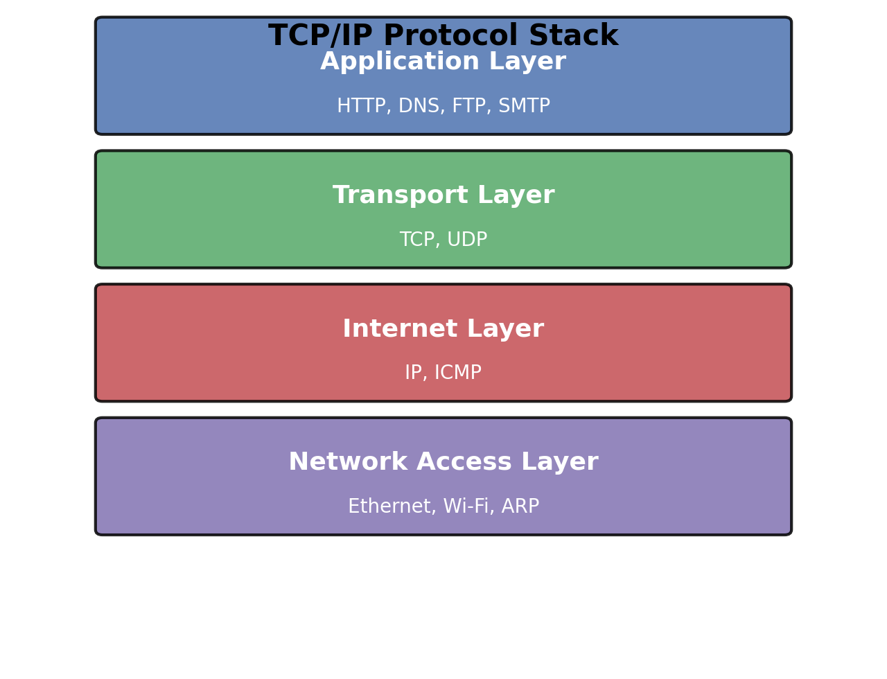

Application Layer
This is the layer the user's browser and Google's server directly interact with. It houses protocols such as HTTP/HTTPS (for retrieving the page), DNS (for resolving the domain name), and others like SMTP or FTP for different tasks. When you request google.com, the browser here formats an HTTP GET request.

Transport Layer
This layer, using TCP (or UDP for some services), is responsible for end-to-end delivery between the browser and the server. TCP breaks the HTTP request into segments, numbers them, and ensures they arrive reliably and in order.

Internet Layer
The IP protocol operates here, addressing each packet with the source and destination IP addresses (e.g., the browser's IP and Google's server IP) and routing it across intermediate networks toward its destination.

Network Access Layer
This lowest layer handles the physical and data-link details, such as Wi-Fi or Ethernet framing and MAC addressing, that move the packet across the local network to the first router and eventually to Google's servers.

2. Role of DNS in Resolving the Domain Name
Computers communicate using IP addresses, not human-friendly names, so the Domain Name System (DNS) acts as the internet's phonebook. When the user types www.google.com, the browser first checks its local cache; if the address is not cached, it sends a DNS query to a resolver (usually provided by the ISP).
The resolver queries a hierarchy of DNS servers — root servers, then the .com Top-Level-Domain (TLD) servers, then Google's authoritative name servers — until it obtains the IP address mapped to www.google.com (for example, an address such as 142.250.x.x). This IP address is returned to the browser, which can now open a connection directly to Google's server.

3. How HTTP Requests and Receives the Webpage
Once the browser knows Google's IP address, it uses the Hypertext Transfer Protocol (HTTP, typically HTTPS in practice) to communicate. The browser sends an HTTP GET request addressed to the server, specifying the resource path (e.g., "/") along with headers describing the browser type, accepted content formats, and cookies.
Google's web server processes the request and returns an HTTP response containing a status code (such as 200 OK), response headers, and the actual content — the HTML document, which the browser then parses. The HTML often references additional resources (CSS stylesheets, JavaScript files, images), and the browser issues further HTTP requests to fetch each of these before fully rendering the page.

4. How TCP Provides Reliable Communication for HTTP
HTTP relies entirely on TCP to make sure the request and the page data arrive intact. Before any HTTP message is exchanged, TCP performs a three-way handshake (SYN, SYN-ACK, ACK) to establish a connection between the browser and the server.
- Sequencing: each byte of data is numbered so segments can be reassembled in the correct order even if they arrive out of sequence.
- Acknowledgments: the receiver confirms received segments, and the sender retransmits any segment that is lost or corrupted.
- Flow control: TCP adjusts the rate of data transfer so a fast server does not overwhelm a slower browser connection.
- Error checking: checksums detect corrupted data so it can be retransmitted.
Because of these guarantees, the HTML, images, and scripts that make up the Google homepage arrive completely and in the correct order, rather than as a jumbled or partial page.

5. Client–Server or Peer-to-Peer Architecture?
Loading www.google.com follows a Client–Server architecture. The user's browser acts purely as a client that initiates requests, while Google's infrastructure of web servers acts as the server that listens for and responds to those requests. The browser never serves content to other users, and it depends entirely on centralized servers for the resources it displays.
This is distinct from Peer-to-Peer (P2P) architecture, where each participating node can act as both client and server, sharing resources directly with other peers (as in BitTorrent). Google's model is client-server because responsibility for storing and serving the webpage rests solely with dedicated, centrally managed servers.

6. HTTP vs. FTP: Key Differences
Aspect | HTTP | FTP
Purpose | Transfers web pages and resources for display in a browser | Transfers files between a client and server
Connections | Uses a single connection for request/response | Uses two connections: one for control, one for data
Statefulness | Stateless by default (state added via cookies) | Stateful — maintains a session throughout the transfer
Port | Port 80 (HTTP) / 443 (HTTPS) | Port 21 (control) / 20 (data)
Typical use | Loading websites and web applications | Uploading or downloading files, backups

7. How Cookies Improve User Experience
Cookies are small pieces of data that a web server asks the browser to store and send back on subsequent requests, giving an otherwise stateless HTTP protocol a form of memory. When the response headers include a Set-Cookie instruction, the browser stores it and automatically attaches it to future requests to the same domain.
Real-world example: when a user signs in to a Google account, a session cookie is created so the user remains logged in while browsing Gmail, YouTube, and other Google services without re-entering credentials on every page. Cookies are also used to remember language preferences, keep items in a shopping cart, and personalize search results, all of which make repeat visits faster and more convenient.

8. Communication Flow Diagram
The diagram below summarizes the complete round trip from the moment the user presses Enter to the page being displayed.
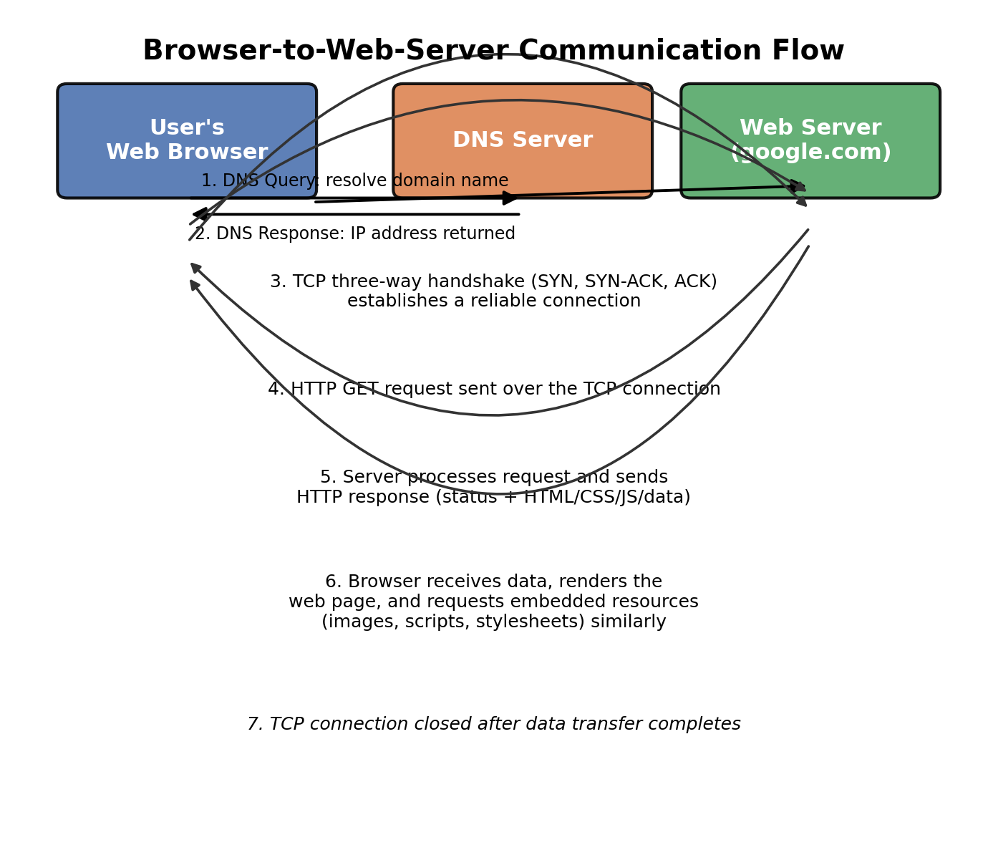

9. Conclusion
Retrieving a single webpage like www.google.com depends on a tightly coordinated stack of application-layer protocols working together. DNS translates a memorable domain name into a routable IP address, TCP establishes a reliable channel across an unreliable network, and HTTP defines the language in which the browser and server exchange the actual request and content. Supporting features such as cookies add statefulness, letting services personalize and streamline repeat interactions. Without these application-layer protocols operating seamlessly beneath the surface, everyday tasks such as searching the web, checking email, or streaming video would be slow, unreliable, or altogether impossible. Understanding this process highlights how much invisible engineering underlies something as simple as typing a URL and pressing Enter.

