Instructor: Monisha Verma

CS-1302 Programming Principles II

**Project 1 - MAZE**

Write a Maze class with the following requirements:

* Takes any two-dimensional array that represents a maze: 0s (zeros) for the walls, and 1s for the available paths. A zip file has been uploaded to the project folder for you to complete.
* There will be only one constructor that takes a two-dimensional array
* A method named “displayMaze” should print the maze (bird-view) that shows the walls and the available paths,
* A method named “displayPath” should print the maze (bird-view) that shows the walls and the available paths, and the route for the solution until the current location (for example the location of the mouse and the path it took from start point to current location)
* A method named “takeStep” that takes one step each time when it is called and displays the maze again
* A method named “findExit” runs and finds the solution all the way to the exit and displays the maze showing the suggested path
* Assume that entry point of the maze is always the last row and the first column and the first move direction will be to the north. Therefore, with the constructor, set the location and direction properly. Ignore checking exit for the first 3 steps.
* Test program is given for your testing
* The program should work with any Maze including different size of maze.

Submit the entire project file zipped up with output screenshots to D2L. Check D2l for submission deadlines.

Sample display of the maze

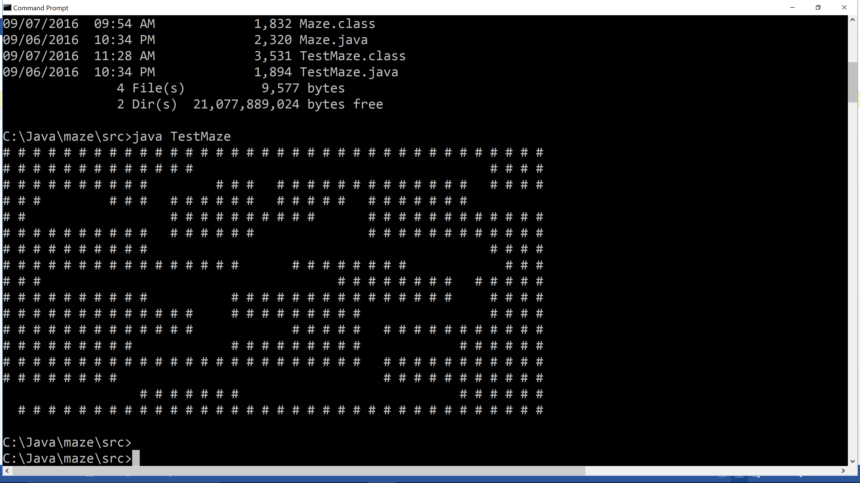

Sample output after taking some steps. “~” represents the path towards solution, “@” represents a mouse.

