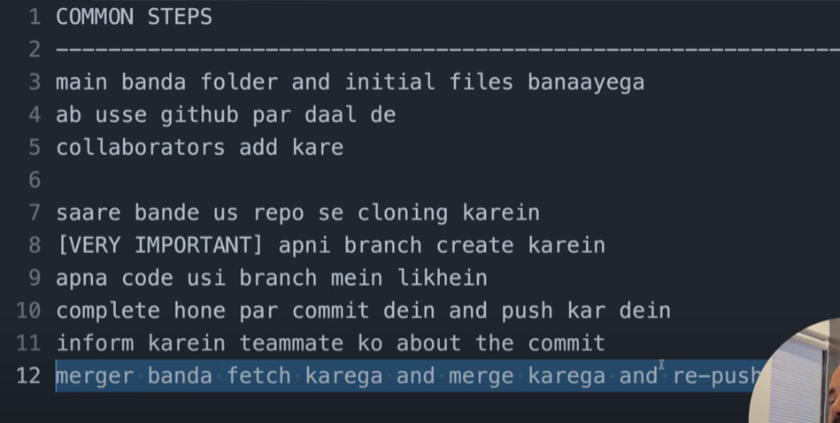

1. Clone:  
   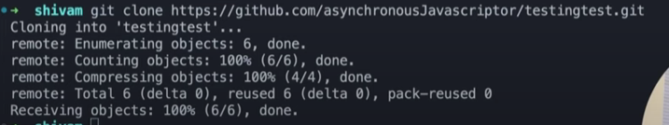
2. Branch:  
     
   
3. Git branch status: git branch  
     
   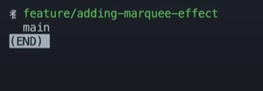
4. Commit:

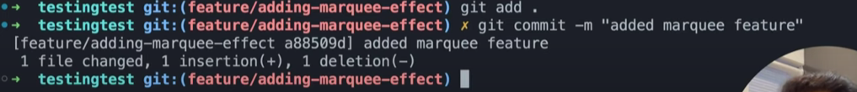

1. Push:  
   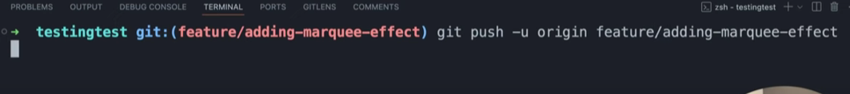

Then the other person can merge.  
  
Then I will:  
get it locally on my machine:

Fetch:

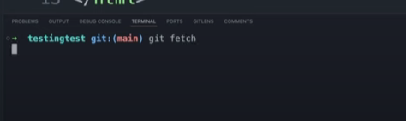

Pull: fetch and merge