Armaan Dhanda Assignment 4

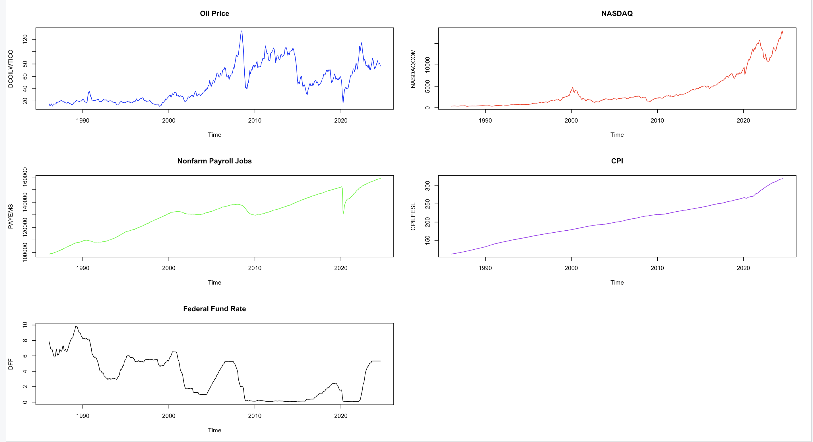  
applied (diff()) for FFr and log(diff()) for rest

**Level Model (data00) Forecast:**

**Growth Model (data11):**

**Level Model (data00):**

* **Forecast Pattern**: The level model seems to provide smoother, more linear forecasts for variables like non-farm payrolls, CPI, and Federal Fund Rate (FFR). This is because the model operates directly on the levels of the series, including both constant and trend components. For example:
  + **Oil prices** (first panel, top-left) show some volatility in the forecast but maintain a consistent trend.
  + **Stock prices** (top-right) exhibit a relatively stable upward trend without much deviation.
  + **CPI** (bottom-left) shows steady growth, while **FFR** (bottom-right) is forecasted to slightly increase or remain stable.
* **Stability**: Since this model operates on levels, it tends to capture the general trend over time, providing forecasts that are more predictable and smooth, especially for variables that exhibit long-term growth (like stock prices or payrolls).
* **Drawback**: If the data has underlying growth dynamics or structural changes, the level model may not capture the nuances in short-term fluctuations, which is often reflected in the smoothness of the forecasts.

**Growth Model (data11):**

* **Forecast Pattern**: The growth model’s forecasts (differenced data) show more **short-term volatility** and **fluctuations** compared to the level model. For example:
  + **Oil prices** show significant oscillations in the growth rates, which makes the forecast appear less smooth.
  + **Stock prices** similarly show fluctuations but with smaller deviations than the oil prices.
  + **CPI and FFR** also exhibit relatively small fluctuations in the forecast but remain much closer to the zero-growth line.
* **Interpretation**: The growth model captures the short-term variations or percentage changes in the series, which leads to greater sensitivity to small changes in the data. This is why the forecasted growth rates are more volatile compared to the level forecasts.
* **Drawback**: The growth model might be **too reactive** to short-term fluctuations and could lead to overfitting, as the forecasted values are more sensitive to recent movements in the data.

**Differences Between the Models:**

1. **Volatility**: The growth model forecast is more volatile, capturing small fluctuations in the data. This makes sense because the model is forecasting changes (differenced data), which can reflect short-term dynamics more prominently.
   * The level model is smoother, indicating that it captures long-term trends but may miss short-term variability.
2. **Long-term Trends vs Short-term Fluctuations**:
   * **Level Model**: This model is better at capturing long-term trends in the data, such as stock prices or payrolls, which tend to follow a more predictable path over time.
   * **Growth Model**: This model focuses more on capturing the immediate changes in the data, making it better at modeling short-term fluctuations but potentially overreactive for stable variables.

**Residual Standard Error and Fit:**

* The **Level model** achieves higher **R-squared values** (e.g., for job_ts, adjusted R-squared ~0.99), indicating a stronger fit due to the cumulative nature of the data.
* The **Growth model**, by contrast, has more moderate fit (e.g., adjusted R-squared around 0.27–0.56), reflecting the noisier nature of growth rates and short-term volatility.

* **Oil ARIMA Forecast**:
  + Shows fluctuations with a slight upward forecast but relatively wide confidence intervals, indicating uncertainty about future trends.
* **NASDAQ ARIMA Forecast**:
  + Strong upward trend with increasing variability reflected in the widening confidence intervals. This suggests the ARIMA model predicts continued stock market growth with some uncertainty.
* **Job ARIMA Forecast**:
  + Continues its upward trend, reflecting economic growth with a smaller confidence interval.
* **CPI ARIMA Forecast**:
  + Displays consistent upward growth, reflecting inflationary pressure with very narrow confidence intervals, showing a more confident prediction.
* **Federal Fund Rate ARIMA Forecast**:
  + Predicts a stable trend after the recent rise, but with a wide confidence interval reflecting uncertainty about future monetary policy decisions.

For short-term predictions, ARIMA may be competitive or even better if individual series behave smoothly over time (like CPI or jobs). However, for complex interrelated systems, **VAR models** provide better context and understanding of interactions, particularly for financial data where one variable influences another.

Plot 1

Plot 2

Plot 3

Plot 4

Plot 5

Plot 6

Plot 7

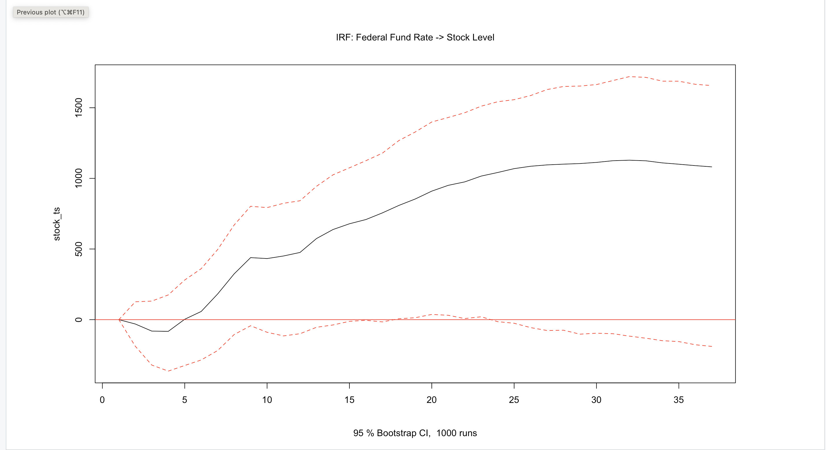

1. **Oil Growth → CPI Growth (IRF Plot 1):**  
   The response of CPI to an oil shock shows a sharp initial positive response, indicating that an increase in oil prices tends to raise inflation in the short term. The confidence intervals (dotted lines) are wider during the initial periods, showing some uncertainty, and stabilize over time. This suggests that oil price changes have a significant but short-lived effect on inflation.
2. **CPI Growth → Federal Funds Rate (IRF Plot 2)**: This IRF likely shows how inflation (CPI growth) impacts the central bank's decision to adjust interest rates. Typically, if inflation rises, the Federal Reserve might increase interest rates to curb inflationary pressures.
3. **Federal Funds Rate → Job Growth (IRF Plot 3)**: We might observe a negative response of job growth to an increase in the federal funds rate, reflecting the contractionary effects of tighter monetary policy.
4. **Federal Funds Rate → Stock Market Growth (IRF Plot 4)**: Higher interest rates generally have a negative impact on stock prices, as future earnings are discounted more heavily.
5. **Oil Level → CPI Level (IRF Plot 5)**: Similar to the first plot, we would expect oil price levels to have a positive effect on the CPI level, as energy costs are a significant component of inflation indices.
6. **CPI Level → Federal Funds Rate (IRF Plot 6)**: Again, this would capture the reaction of the central bank to changes in the price level, possibly showing a tightening of monetary policy in response to inflationary pressures.
7. **Federal Funds Rate → Jobs Level (IRF Plot 7)**: A tightening of monetary policy (higher federal funds rate) would likely have a negative effect on employment levels, as borrowing becomes more expensive for businesses, potentially leading to reduced hiring.

**Summary:**

* **Oil shocks** tend to have a short-term impact on inflation, and oil price increases generally lead to inflationary pressures.
* The **federal funds rate** is used as a tool to respond to inflationary changes, but its impact on job and stock market growth is negative in the short term.
* **Long-term effects** such as the response of jobs and inflation to interest rates are significant but display uncertainty over time.
* > # Output the MSLE results
* > cat("MSLE for VAR Level model: ", msle_var_level, "\n")
* MSLE for VAR Level model: 0.001206959
* > cat("MSLE for VAR Growth model: ", msle_var_growth, "\n")
* MSLE for VAR Growth model: 0.0004811428
* > cat("MSLE for ARIMA model: ", msle_arima, "\n")
* MSLE for ARIMA model: 0.000382364

Arima is just a little better than the var growth model . For short-term predictions, ARIMA may be competitive or even better