**Design Report**

**Laptop Battery Status Monitor**

**– Under Guidance of Prof. G. Thakur**

**Presented By: -**

|  |  |  |
| --- | --- | --- |
| **Roll** | **SRN ID** | **Name** |
| 36 | 202101635 | Armaan Naik |

**Created & Presented: Python GUI Based & Designed with Adobe Photoshop**

**1. Project Overview:**

**1.1 Project Name:**

**Battery Status Monitor**

**1.2 Objective:**

**Develop a graphical interface application for real-time monitoring of a laptop's battery status.**

**Integrate the psutil library to access and retrieve accurate battery information.**

**Enhance user experience through visualizations of battery charge percentage and estimated time.**

**1.3 Rationale:**

**Users often require a convenient tool to monitor their laptop's battery status, aiding in decision-making related to charging and usage.**

**1.4 Scope:**

**Aimed at laptop users seeking a reliable solution for monitoring battery health.**

**Provides valuable insights into the current charging status, remaining charge, and estimated time for charging or discharging.**

**2. Code Structure:**

**2.1 Battery Information Functions:**

**update_battery_info():**

**Retrieves and processes battery information using the psutil library.**

**Determines the laptop's current charging state and adjusts the display accordingly.**

**Calculates and displays the estimated time to full charge or time left for discharge.**

**Utilizes label widgets to convey the current status, charge percentage, and estimated time.**

**Implements a canvas widget for a graphical representation of the battery charge.**

**refresh_battery_info():**

**Manually triggers the update of battery information, allowing users to refresh information on demand.**

**Graphical User Interface (Tkinter):**

**Configures the main window with an appropriate title and dimensions.**

**Integrates the PIL library for handling and resizing the banner image.**

**GUI elements include labeled widgets for status, charge percentage, and estimated time.**

**Utilizes a canvas widget for graphical representation, enhancing user comprehension.**

**Incorporates a manual refresh button (Refresh) for immediate updates.**

**3. Code Implementation:**

import tkinter as tk #standard Python interface-GUI components banane ke liye

from tkinter import ttk #widgets k enhance krne k liye (modern and consistent look) #ttk=Themed Tkinter

import psutil #battery status/info #Accessing system & process-related information.

from PIL import Image, ImageTk

#function to update battery information and visualization

def update_battery_info(): #function responsible- battery status update karne k liye & to display in GUI

    battery = psutil.sensors_battery() #battery status & assigns it to battery variable

    charge_percent = battery.percent #% & assigns it to c_p variable

 #laptop charging pe hai ya nahi check karega

    if battery.power_plugged: #examining the power_plugged attribute of the battery object.

        status_label.config(text="Charging")  #If the laptop is charging, this line updates a label widget called status_label to display "Charging."

        # Calculate the estimated time to full charge

        if battery.secsleft == -1: #check if the est time to full charge is not avlble

            estimated_time_label.config(text="Charging (Calculating...)")

        else:

            # Calculate remaining time to fully charge the battery #based on current charge percentage and charging rate

            charging_rate = battery.power_plugged  # Charging rate=percentage of charge added per minute.

            remaining_capacity = 100 - charge_percent  # Remaining capacity to charge from current percentage to 100%

            remaining_time_minutes = remaining_capacity / charging_rate  # Time in minutes 39/1min

            hours = int(remaining_time_minutes // 60) #Floor/ciel division

            minutes = int(remaining_time_minutes % 60) #mod=remainder

            estimated_time_label.config(text=f"Time to Full: {hours} hours {minutes} minutes")

    else:

        status_label.config(text="Discharging") #If the laptop is not on charging, this line updates a label widget called status_label to display "Discharging." as already done ↑

        time_left = battery.secsleft / 60 # calculates the time left to fully discharge the battery convert it into minutes.

        # Convert time left from minutes to hours and minutes

        hours = int(time_left // 60) #Floor/ciel division

        minutes = int(time_left % 60)  #mod=remainder

        estimated_time_label.config(text=f"Time Left: {hours} hours {minutes} minutes")

    charge_label.config(text=f"Charge: {charge_percent}%") #current charge % display karne ke liye

   #clear karne ke liye jo previous battery visualization the

    battery_canvas.delete("all")

    #draw the battery outline

    battery_canvas.create_rectangle(10, 10, 100, 40, outline="black", width=2) #top-left corner-x,y & bottom-right corner-x,y

    #calculate the width of the battery based on the charge percentage (remining)

    battery_width = (charge_percent / 100) * 80 # It is a proportion of the total width (80 pixels)

    #draw the filled battery based on charge percentage

    battery_canvas.create_rectangle(10, 10, 10 + battery_width, 40, fill="green", width=0)

def refresh_battery_info():

    update_battery_info()

#main window banane ke liye

window = tk.Tk()

window.title("Battery Status Monitor")

window.geometry("800x500")

image = Image.open("batterysm.png")

image = image.resize((800, 160))

photo = ImageTk.PhotoImage(image)

image_label = tk.Label(window, image=photo)

image_label.pack(pady=10)

#labels banaya battery information ke liye=label widget for displaying the battery status.

status_label = ttk.Label(window, text="", font=("JuliaMono", 16)) #status #referred-https://realpython.com/coding-font/

status_label.pack(pady=10)

charge_label = ttk.Label(window, text="", font=("JuliaMono", 16))  #charge percentage #referred-https://realpython.com/coding-font/

charge_label.pack(pady=5)

estimated_time_label = ttk.Label(window, text="", font=("Arial", 16)) #est. time

estimated_time_label.pack(pady=5)

#widget banaya battery visualization k liye as told by ma'am

battery_canvas = tk.Canvas(window, width=120, height=50)

battery_canvas.pack(pady=5)

# update battery info button

refresh_button = ttk.Button(window, text="Refresh", command=refresh_battery_info)

refresh_button.pack(pady=10)

#Update battery info. n' visualization

update_battery_info()

# #Automatic Update battery info./details n' visualization every 15 Sec. (60,000 milliseconds)

# window.after(1500, update_battery_info) #

#Starting GUI main loop

window.mainloop()

**4. Output Screenshot:**

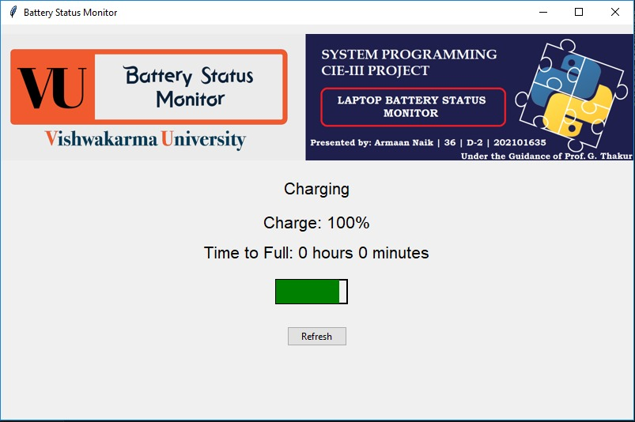

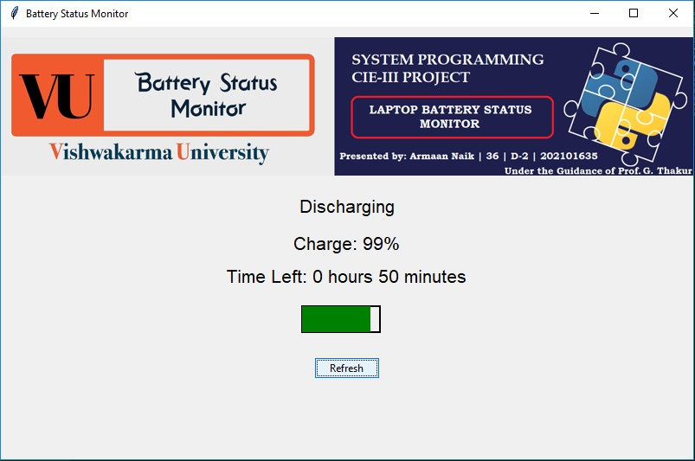

**5. Conclusion:**

**5.1 User Experience:**

**The GUI offers an intuitive and informative display of essential battery metrics.**

**Visualizations contribute to a user-friendly interface, aiding in quick comprehension of the battery status.**

**5.2 Functionality:**

**Effectively utilizes the psutil library to access and process real-time battery information.**

**Visual elements, such as the graphical representation of the battery, enhance the overall user experience.**

**5.3 Automation:**

**The manual refresh button (Refresh) provides users with the flexibility to update battery information at their convenience.**

**Automatic updates every 15 seconds ensure continuous monitoring without user intervention.**

**5.4 Potential for Expansion:**

**The project lays the groundwork for future expansions, such as incorporating notifications for critical battery levels or maintaining a historical log of battery performance.**

**In summary, the Battery Status Monitor project provides a practical solution for users seeking an efficient and user-friendly tool for monitoring their laptop's battery health. The integration of real-time information and visualizations establishes a solid foundation for potential enhancements and extended functionalities in the realm of battery monitoring.**