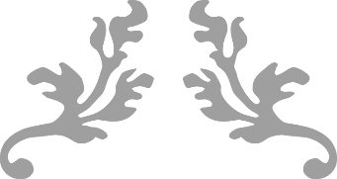

Min-VIS-2016

Assignment 5 – Group4



Group Members:

* Sandio Fongang R
* Armaan Rustami

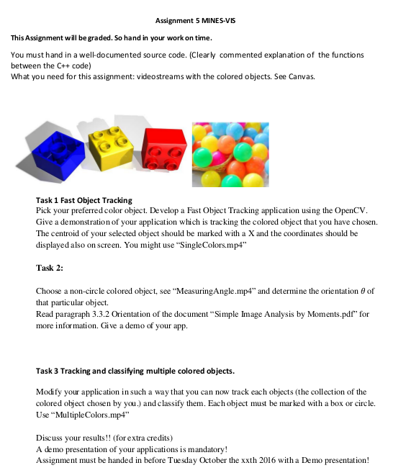

**2. Solution**

1. **Fast Object Tracking:**

In order to track coloured Object and mark the Centre of Selected Object by marking With “X” , here are some Steps we took:

* Convert camera frame colour from BGR to HSV to get the actual colour . *Figure1*
* Detect an object based on the range of pixel value using OpenCV inRange() .*Figure1*
* Dilates white space( making it larger) and Erode int White space (making it smaller or non-existent) using OpenCV functions.*Figure2*

"Figure" 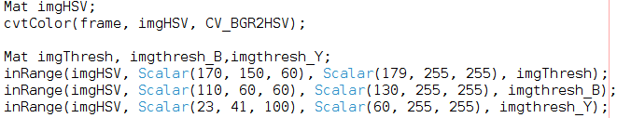1: Define object color range

Figure 2: Dilate And Erode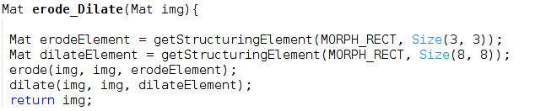

* Afterward, we apply findContour function on the output of erode and dilate ,which has the object of inrange (between specific pixel value range ).*Figure3*
* After doing the mentioned above steps , we find the Find the biggest area of object using Moments *(Figure 4)* to Circle the object and its Centre of Gravity (COG) to centroid the object by marking with “X” label. *(Figure 5)*

Figure 3: find Contours

Figure 4: find the biggest Area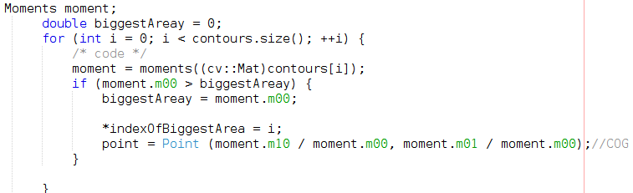

Figure 5: Label centre of Object

* Then we apply circling the object but before that we find the enclosing circle to the contour and then circle based in radius of contour .Figure 6

Figure 6: Circle the Contour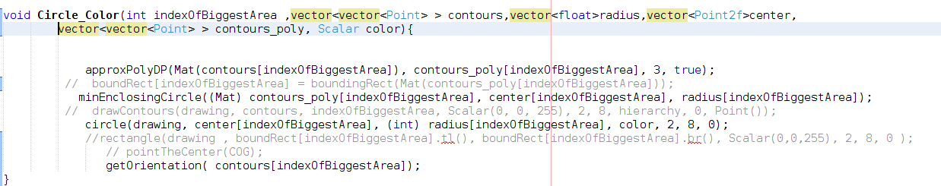

Figure : Show the output

Output:

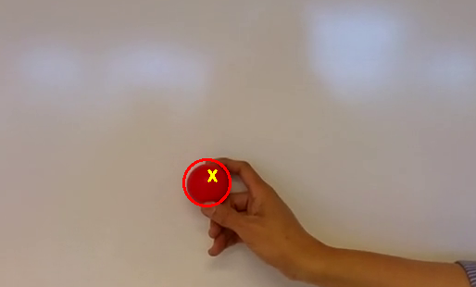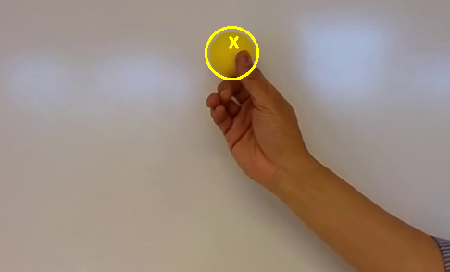

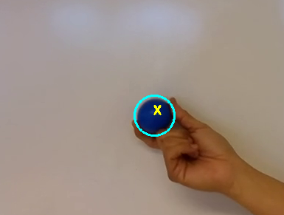

1. Measuring Angle:

The goal of this assignment is to determine the orientation of object ,in this Task we OpenCV builtin “RotatedRect” function , which its rotating with the object Rotation.

We the use mostly the same methods as Task1 ,and since its asked to determine the orientation of the object ,in that case we use the 'RotatedRect' angle property which gives us angle of the object.

"Figure" 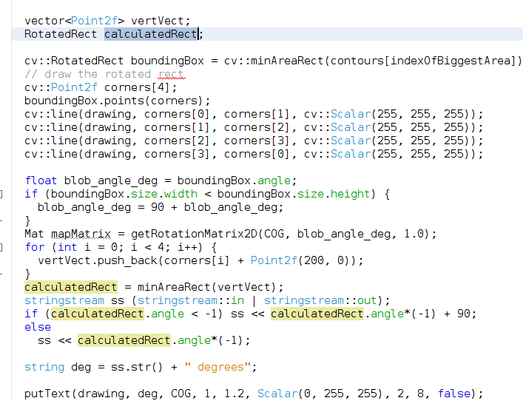8: Drawing Rotated Rectangle and Degree

Output:

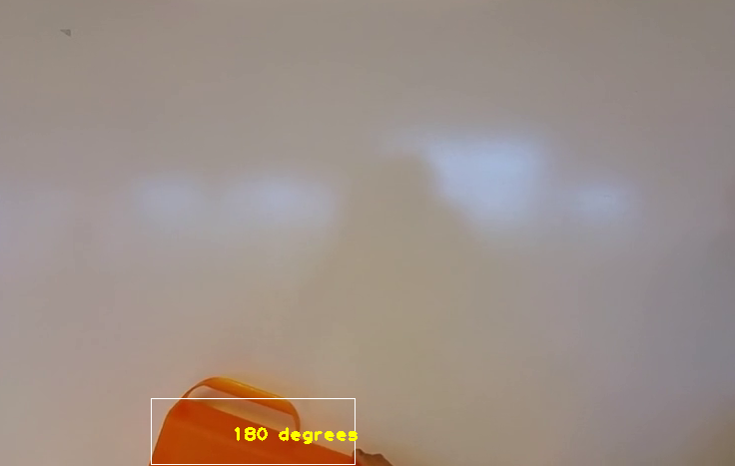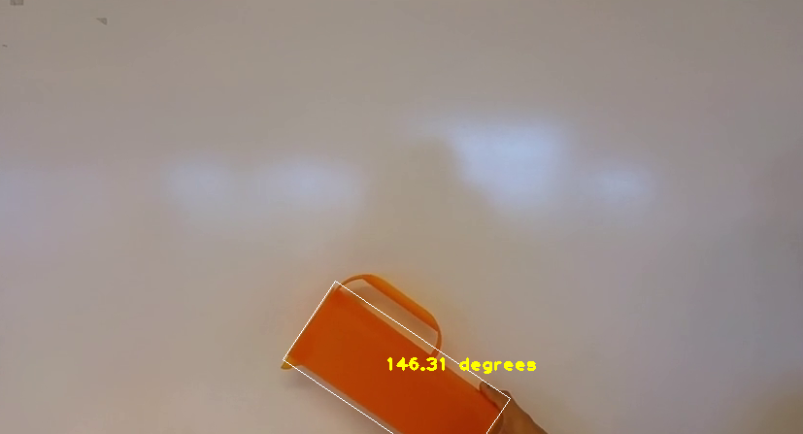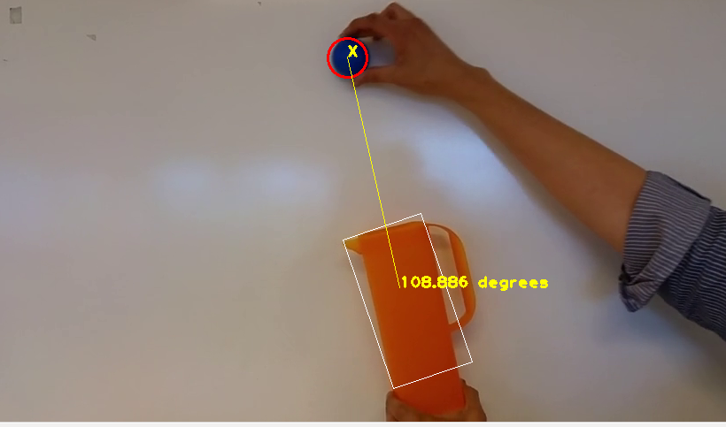

c. Tracking and classifying multiple coloured objects:

this task follows “Task a (**Fast Object Tracking**)” ,in which we define the ranges for multiple colours and find its contour .

The same as “Task a” we the find the biggest contour area and draw the minimum enclosing circle to the contour .

Figure 9: Define Range for Red,yellow and Blue color .FInd thier contours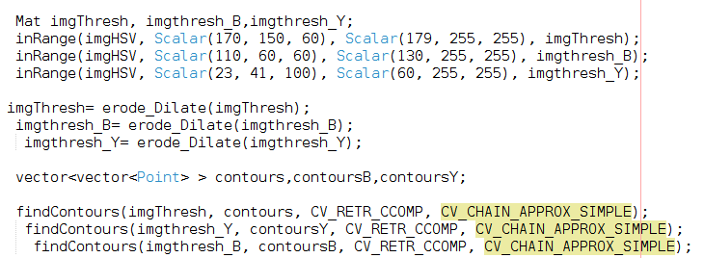

Output :

Figure 10: Find the biggest contour ,draw the min-enclosing Circle