

Min-VIS-2016

Assignment 10 – Group4



Group Members:

* Sandio Fongang R
* Armaan Rustami

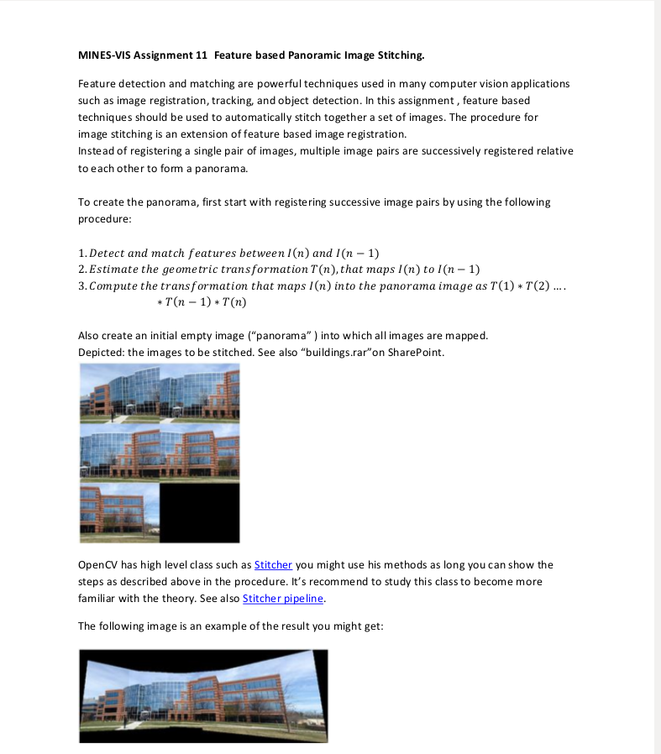

**2. Solution**

1. **Feature based Panoramic Image Stitching:**

In order to stitch images base on the matches and make Panoramic Image from it we tried to make the images into 3 blocks, which means each block is stitched of two images,, here are some Steps we took:.

* Load the images and convert
* Detect keypoints using SurfFeatureDetector on Grayscale images based on specific number of key Point . we use the concept of “Detect and match features between I(n) and I(n − 1)” and Calcuate and Compute Descriptor using keyPoints .*Figure1*

Figure 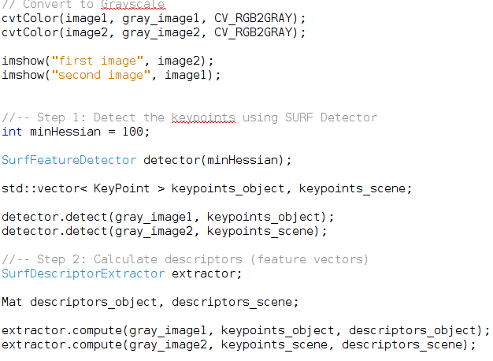1

* After getting the descriptors we try to get matches using FlannBasedMatcher OpenCV function.

Figure 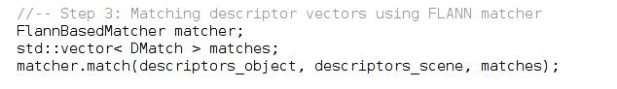2

* Get keypoint from the good Matches.

Figure 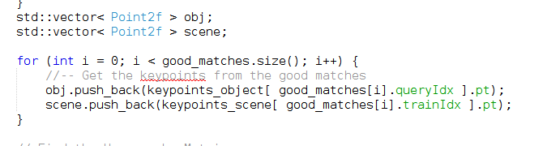3

* Used the function findHomography to find the transform between matched keypoints

Figure 4

* After all we used WrapPerspective OpenCV function to transform the source image using the findHomography matrix result and use sum of first image and second image columns as Width and rows size of right image as Height of WrapPerspective Size.

Figure 5

* Create Mat variable assigning the result of WrapPerspective with rectangle using Height and width size of left image for the rectangle and copy the leftImage to the created Mat, where it makes the WrapPerspective restult stitched with left image and make them as one image where we called it as Block in this assignment

Figure 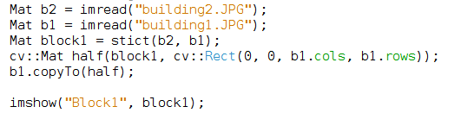6

* So the same we applied the mentioned above methods for other images also to get one block from each two images.

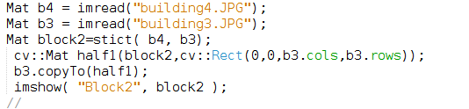

Figure 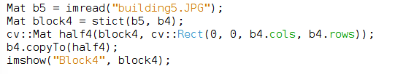7

* Finally to get Panorama Image we used estimateTransform which the one of the Stitcher Functions, is used to match the given images and to estimate rotations And we used composePoanorama function which is used to compose the given images into the final pano under the assumption that the image transformations were estimated before.

Figure 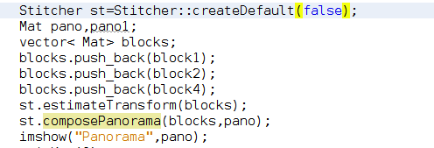8

Output:



