#### A IOMP(CS705PC) Report

On

#### MediSync – Medication Reminder Mobile Application

Submitted

in partial fulfillment of the requirements for the award of the degree of

#### Bachelor of Technology

in

#### Computer Science and Engineering

by

#### Shaik Armaan Shoaib

#### (21261A05C0)

Under the guidance of

**Ms. K. Shirisha, Asst. Prof**



**Department Of Computer Science and Engineering MAHATMA GANDHI INSTITUTE OF TECHNOLOGY**

**(Affiliated to Jawaharlal Nehru Technological University Hyderabad) Gandipet, Hyderabad-500 075, Telangana, India.**

**2024-25**

# MAHATMA GANDHI INSTITUTE OF TECHNOLOGY

(Affiliated to Jawaharlal Nehru Technological University Hyderabad) GANDIPET, HYDERABAD – 500075, Telangana (INDIA)

## CERTIFICATE



This is to certify that the project entitled “MediSync-Medication Reminder Mobile Application**”** is being submitted by Shaik Armaan Shoaib bearing Roll No.21261A05C0 in partial fulfillment of the requirements for the IOMP(CS705PC) report in **COMPUTER SCIENCE AND ENGINEERING** is a record of bonafide work carried out by them.

The results of the investigations enclosed in this report have been verified and found satisfactory.

**Project Guide** **Head of the Department**

**Ms. K Shirisha** (Assistant Professor) **Dr. C.R.K. REDDY**

Professor

**External Examiner**

# DECLARATION

This is to certify that the work reported in the project titled “**MediSync – Medication Reminder Mobile Application**” is a record of work done by us in the Department of Computer Science and Engineering, Mahatma Gandhi Institute of Technology, Hyderabad.

No part of the work is copied from books/journals/internet and wherever the portion is taken, the same has been duly referred in the text. The report is based on the work done entirely by us and not copied from any other source.

**Shaik Armaan Shoaib**

**(21261A05C0)**

# ACKNOWLEDGEMENT

The satisfaction that accompanies the successful completion of any task would be incomplete without introducing the people who made it possible and whose constant guidance and encouragement crowns all efforts with success. They have been a guiding light and source of inspiration towards the completion of the project.

I would like to express my sincere thanks to **Dr. G. ChandraMohan Reddy**, **Principal, MGIT**, providing the working facilities in college.

I wish to express my sincere thanks and gratitude to **Dr. C R K Reddy, Professor and HoD**, Department of CSE, MGIT, for all the timely support and valuable suggestions during the period of project.

I am extremely thankful to **Dr. C R K Reddy, Professor and HoD**, and **Ratna Raju A Sir, Assistant Professor**, and **Poornima Madam, Assistant Professor,** Department of CSE, MGIT, minor project coordinators for their encouragement and support throughout the project.

I am extremely thankful and indebted to my mentor **Ms. K Shirisha, Assistant Professor**, Department of CSE, for her constant guidance, encouragement and moral support throughout the project.

Finally, I would also like to thank all the faculty and staff of CSE Department who helped me directly or indirectly, for completing this project.

**Shaik Armaan Shoaib**

**(21261A05C0)**

**TABLE OF CONTENTS**

CERTIFICATE ii

DECLARATION iii

ACKNOWLEDGEMENT iv

LIST OF FIGURES vi

LIST OF TABLES viii

ABSTRACT ix

1. INTRODUCTION 
   1. PROBLEM STATEMENT
   2. EXISTING SYSTEM
   3. PROPOSED SYSTEM
2. LITERATURE SURVEY
3. DESIGN METHODOLOGY
4. IMPLEMENTATION AND RESULTS
5. CONCLUSION AND FUTURE SCOPE

BIBLIOGRAPHY   
  
APPENDIX

**LIST OF FIGURES**

|  |  |
| --- | --- |
| **FIGURE NO** | **NAME OF THE FIGURE** |
| 3.1 | Flowchart diagram of MediSync app |
| 3.2 | Attribute diagram of Medicine Object |
| 3.3 | Flowchart of manage reminder |
| 3.4 | Flowchart of display medicine info |
|  |  |
| 4.1 | Download Microsoft VS Code |
| 4.2 | Download Flutter SDK |
| 4.3 | Download Dart SDK |
| 4.4 | Launching app in emulator |
|  |  |
| 5.1 | App running in emulator |
| 5.2 | List of users/accounts in firebase |
| 5.3 | Sign In Page |
| 5.4 | Sign-Up Page |
| 5.5 | Sign in through Google Page |
| 5.6 | App Home Page |
| 5.7 | Add Medication Page 1 |
| 5.8 | Add Medication Page 2 |
| 5.9 | Add Medication Page 3 |
| 5.10 | Add Medication Page 4 |
| 5.11 | List of Medicines Page |
| 5.12 | Medicine Info Page |
| 5.13 | Notification pop up screen |
| 5.14 | Notification Banner |
| 5.15 | Statistics Page |
| 5.16 | More Options Page |
| 5.17 | Prescription Image Page |
| 5.18 | Check BMI Page |
| 5.19 | Emergency Calls Page |
| 5.20 | Sign Out Page |

**LIST OF TABLES**

|  |  |  |
| --- | --- | --- |
| **TABLE NO** | **NAME OF THE TABLE** | **PAGE NO** |
| 2.1 | Literature Survey of Medication Reminder Mobile Applications | 8 |
|  |  |  |
|  |  |  |
|  |  |  |

### ABSTRACT

In our ever growing and technologically dependent lives, everyone nowadays owns a smartphone. As a result, we will be able to better exploit technology in order to make it more useful to us. It also plays a vital role in our daily lives, assisting us in a variety of ways. Life today is full with duties and stress. As a result, humans are susceptible to a variety of ailments, and it is our responsibility to keep ourselves fit and healthy. MediSync is a mobile application that helps those who are forgetful or busy remember to take their daily meds.

My app takes up the prescription details from the user such as the duration of the prescription, the names of the medicines, the times they are to be taken and the amount of each medicine which is to be taken. After all this data has been entered, our system will remind the user at the prescribed time of which medicine is to be taken in form of a mobile notification and a reminder. Whenever the time for the medicine is up, they will be notified and they only have to take their prescriptions during that time, and no other time.

### INTRODUCTION

**1.1 Background**

According to the FDA, **50%** of prescribed medicines are **NOT** taken as prescribed. Many people neglect their health and prioritize other activities over taking their medicines. The Medicine Reminder app is designed to help users remember to take their medication on time and in the correct dosage. The app's smart reminder system is particularly beneficial for the elderly, assisting them in managing their medication schedules. Under the Report page, the app gives a predefined condition list for patients' convenience, which helps them keep track of their medical history. Use the finest Medicine Reminder app to keep track of your medications.

### 1.2 Problem Statement

Patients have a noteworthy difficulty in that they forget to take their medications in the exact amounts and at the correct times. Medicine adherence, or the degree to which a patient takes the proper medicine at the right time according to a doctor's prescription, has recently been a hot topic because multiple studies have shown that non-adherence can have a negative impact on the patient, resulting in higher medical costs. Medicine non-adherence is a prevalent, complicated, and costly issue that leads to poor treatment outcomes and drains health-care resources.

* 1. **Existing System**

Many existing medication reminder apps provide generic reminderswithout personalizing based on the user’s habits or medical conditions. For example, **MedsLog**, which is only available for iPhone users, is a very complicated software in comparison to others. Users will need to spend much more time with the software in order to fully comprehend its capabilities. The system's fundamental flaw is that it features a "consumed by" box where a user is meant to enter his username in the provided space. Despite this, the system displays "no persons." The proposed system, on the other hand, is more user-friendly because it is designed for people of all ages. As a result, rather than wasting time learning how to use the software, time can be spent actually using it. Users are able to manage their profiles without difficulty.

### 1.4 Proposed System

The “MediSync” medicine reminder app will remind the user that he/she is due for taking the medicine. The app makes sure that the user never forgets to take the medicine and hence the reminder will be in two ways. One will be the notification which will work even on low power mode and is very reliable. In this project, I will be using “Flutter Local Notifications” with version 18.0.1, the latest version available at the time of making this project. The mobile application can be installed in any android/iOS devices. It will add recurring events to the mobile’s calendar and will alert the user when he has to take the medicine with the list of medicines and its prescribed dosage.

This application will also provide the user with statistics in a pie chart to view the adherence of the medicines in a graphical interface which will help gain useful insights to the user. It also provides BMI to quickly check their BMI and take a decision to correct their BMI if its either underweight/overweight/obese. In addition to that, Emergency calling feature is also available for emergency services such as Police, Ambulance. The medicine data is stored in Google Firebase Firestore database and can be viewed in the Firebase console in browser.

### LITERATURE SURVEY

**[1]** **Ameta, D., Mudaliar, K. and Patel, P., 2015. “**Medication reminder and healthcare-an android application. *International Journal of Managing Public Sector Information and Communication Technologies (IJMPICT)*, *6*(2), pp.39-48”: This paper discusses the implementation of an android-based application in with an automatic alarm ringing system. It also focuses on doctor and patient interaction. Patients need not remember their medicine dosage timings as they can set an alarm on their dosage timings. The alarm can be set for multiple medicines and timings including date, time and medicine description. A notification will be sent to them through email or message inside the system preferably chosen by the patients. They can search doctor disease wise. The patients will get the contact details of doctors as per their availability.

**[2] Patel S, Jacobus-Kantor L, Marshall L, et al. “**Mobilizing Your Medications: An Automated Medication Reminder Application for Mobile Phones and Hypertension Medication Adherence in a High-Risk Urban Population. Journal of Diabetes Science and Technology”: The objectives included in this paper are: (1) assess adherence to antihypertensive medication in the 3-month period before versus during activation of the app provided on a personal mobile phone in Medicaid patients recruited from a university clinic in Washington, DC, (2) assess continued medication adherence in the 3-month period after withdrawal of the Pill Phone, and (3) evaluate patient usage patterns and acceptance of the app.

1. **Mayuresh Waykole, Vatsalya Prakash, Himanshu Singh, Nalini N**, “ArduMed - Smart Medicine Reminder for Old People”: This paper provides a solution for medicine adherence in two categories using IOT, i.e. hardware & software. The software part will do the reminder part of the task, which is to remind patients to take their medicines. The hardware part includes a Raspberry Pi which detects the medicines stored in a physical box and store the details automatically as the user puts the medicine into the box. Overall, this solution is a very interesting one with mix of hardware and software components.
2. **Ms. S. A. Patil , Ms. Monika Bhanuse, Ms. Snehal Mali, Ms. Vishaka Swami**, “REVIEW ON MOBILE APPLICATION FOR MEDICINE REMINDER”: This study discusses different types of Medication Reminder Systems have been developed on different concept & platforms. These all systems require special hardware devices to remind the patients about the medicine details & timings. Since purchasing new hardware devices as medicine remainder devices are very costly and is very money consuming, they have developed a system which is economical, easily accessible and improves medication adherence.
3. **Nawal Chanane, Farhaan Mirza, M. Asif Naeem**, “Co-Designing a Medication Notification Application with Multi-Channel Reminders”: The study explores the development of a user-centric medication reminder application called MAMA (Medication Adherence Management App). The authors conducted three focus group sessions with 12 participants, ranging in age from 15 to 65+, to gather insights on user preferences and requirements. The study employed a co-design methodology, where participants actively contributed to the app's iterative design process. Key findings highlighted the importance of the following features: Multi-Channel Reminders, Medication Intake Acknowledgment and Reporting, Smart Loading of Prescriptions.

**Table 2.1:** The below table shows the Literature Survey of medicine reminder mobile applications.

|  |  |  |  |  |  |
| --- | --- | --- | --- | --- | --- |
| S.NO | NAME OF  THE AUTHORS | TITLE OF  THE PROJECT | YEAR | FEATURES IMPLEMENTED | DEMERITS |
| 1 | Deepti Ameta, Kalpana Mudaliar and Palak Patel​ | Medication Reminder and Healthcare – An Android Application​ | 2021 | * Doctor Patient Relation​ * Disease Analysis​ * Appointment Facility​ * Email notification​ * Video tips​ * Choice of alarm​ * Lightweight app | * Complex UI​ * Hard to use the app​ * Requires technical knowledge​ * Only Android app​ * Lacks multiplatform support​ * No statistics of data |
| 2 | Patel S, Jacobus-Kantor L, Marshall L | Mobilizing Your Medications: An Automated Medication Reminder Application for Mobile Phones and Hypertension Medication Adherence in a High-Risk Urban Population | 2020 | * Appointment reminder​ * GPS​ * Health tracker​ * BMI​ * Blood pressure & glucose | * Limited Features​ * Generic UI​ * No database​ * No statistics​ * Only on Android |
| 3 | Mayuresh Waykole, Vatsalya Prakash, Himanshu Singh, Nalini | ArduMed - Smart Medicine Reminder for Old People​ | 2021 | * Google Authentication​ * Mobile and web app​ * Lightweight​ * Good UI ​ * Prescription facility​ * Database support​ * LED System | * Not much practical​ * Limited Interaction​ * Requires Raspberry Pi​ * Lack of detailed info of medicine​ |
| 4 | J Ms. S. A. Patil , Ms. Monika Bhanuse, Ms. Snehal Mali, Ms. Vishaka Swami | REVIEW ON MOBILE APPLICATION FOR MEDICINE REMINDER | 2021 | * Registration Form * Lightweight​ * Economical app * Database support​ * Email notification | * No cancellation option * Lacks patient info validation​ * Lack of detailed info of medicine​ * Works only on android |
| 5 | Nawal Chanane, Farhaan Mirza, M. Asif Naeem | Co-Designing a Medication Notification Application with Multi-Channel Reminders | |  | | --- | | 2021 |  |  | | --- | |  | | * Multiple notification channel * Progress indicator * Statistics support * Database support​ * Prescription facility | * Generic UI * No emergency calling feature * Requires technical knowledge​ * High memory usage |

### DESIGN METHODOLOGY

##### FLOW CHART OF MEDISYNC MOBILE APPLICATION:

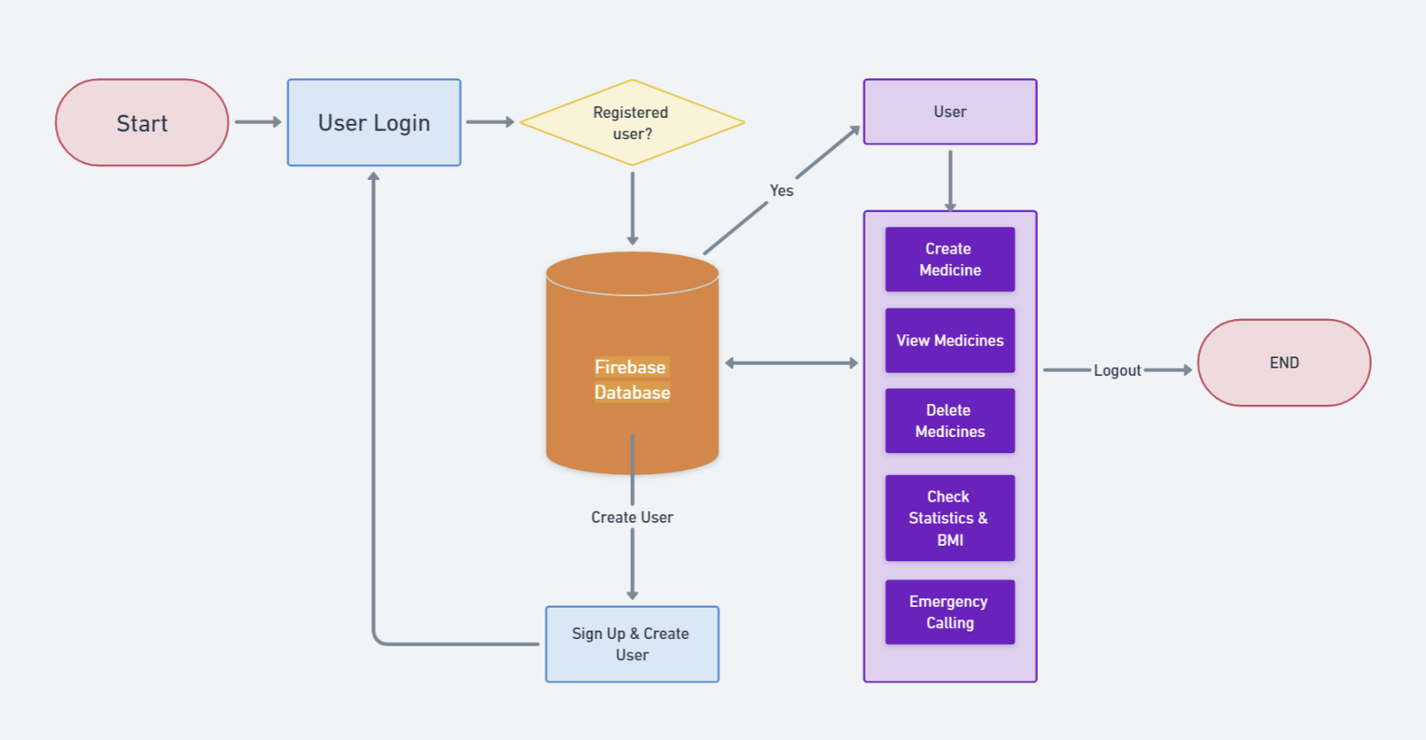



Fig.3.1 Flow chart of the MediSync Application

Fig. 3.1 describes the flowchart of the medicine reminder app, which is designed to remind the user to take the medicines when its time to for the user to take the medicine.

The process begins with the Start node, which displays a user login screen by default. If the user is not registered already, he/she can go to “Sign Up” page to register themselves and create an account using their email. The user details are stored in the Firebase Database.

If the user is already registered, they can simply enter their email ID & password and login to the app dashboard.

The user details are validated using the database before logging them in to the app.

Thereafter, the user can perform the following actions:

* Create Medicines
* View Medicines
* Delete Medicines
* Check Statistics & BMI
* Call emergency contacts

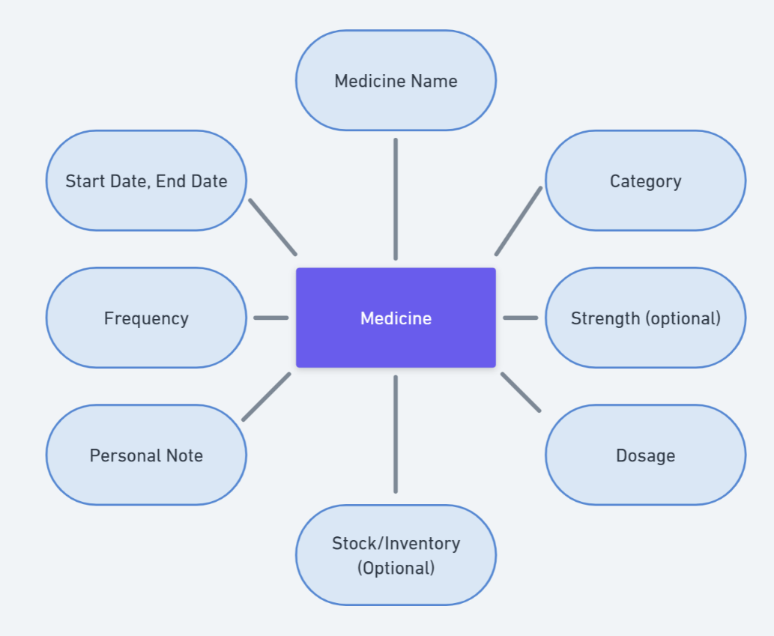

Fig. 3.2 Attribute diagram of Medicine object

Fig. 3.2 Shows the attributes of medicine object. The medicine object consists of 8 attributes:

1. Medicine Name: This attribute requires correct naming of the medicine as the name is used to fetch the detailed information of that particular medicine using “LLAMA 3.5 API” provided by “Groq” platform.
2. Category: This attribute is required and has sub-attributes such as
   1. Capsule
   2. Tablet
   3. Liquid
   4. Topical
   5. Cream
   6. Drops
   7. Foam
   8. Gel
   9. Herbal
   10. Inhaler
   11. Injection
   12. Lotion
   13. Nasal Spray
   14. Ointment
   15. Patch
   16. Powder
   17. Suppository
   18. Spray
3. Strength: This is optional attribute which has sub attributes such as
   1. Mg (Milligram)
   2. Mcg (Microgram)
   3. g (Gram)
   4. ml (Milligram)
4. Dosage: This is required attribute and takes input of quantity of medicine such as no of items (Tablet, Capsule) & ml (Syrup, Injection, Lotion, Gel, Foam) etc. In the notification, the dosage is displayed when its time to take the actual medicine.
5. Stock/Inventory: This is an optional attribute where the user can enter the available medicine quantity.
6. Personal Note: This is also an optional attribute where user can enter medication notes such as “*For Fever*”, “*For Heart*” or “*Don’t take on Saturday*” etc.
7. Frequency: This is required attribute and user have to enter the no of times the medication is supposed to be taken (At least once) in a day. User can enter any no. of times. And it also has subcategories such as:
   1. Every Day
   2. Every 2 Days
   3. Every 3 Days
   4. Every 4 Days
   5. Every 5 Days
   6. Every 6 Days
   7. Every Week (7 days)
   8. Every 2 Weeks (14 days)
   9. Every 3 Weeks (21 days)
   10. Every Month (30 days)
   11. Every 2 Months (60 days)
   12. Every 3 Months (90 days)
8. Start Date/End Date: The start date is required and by default selected as the current day. The end date is optional and if end date is not specified, it is selected as 30 days from start date by default.

FLOW CHART OF MANAGE NOTIFICATION/REMINDER

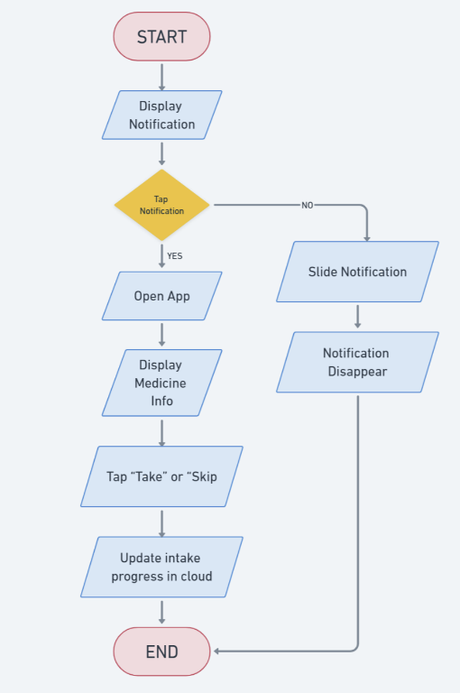

Fig. 3.3 Flowchart of manage reminder

Fig 3.3 shows the workflow when a notification pops up. User can either tap on the notification or slide it to make it disappear. If user taps on the notification, it opens the MediSync app which displays the users’ notifications. When user taps on the notification, it displays another popup with two options: 1) Take 2) Skip. When user selects either option, it updates the information into the cloud database.

FLOW CHART OF DISPLAY MEDICINE INFO

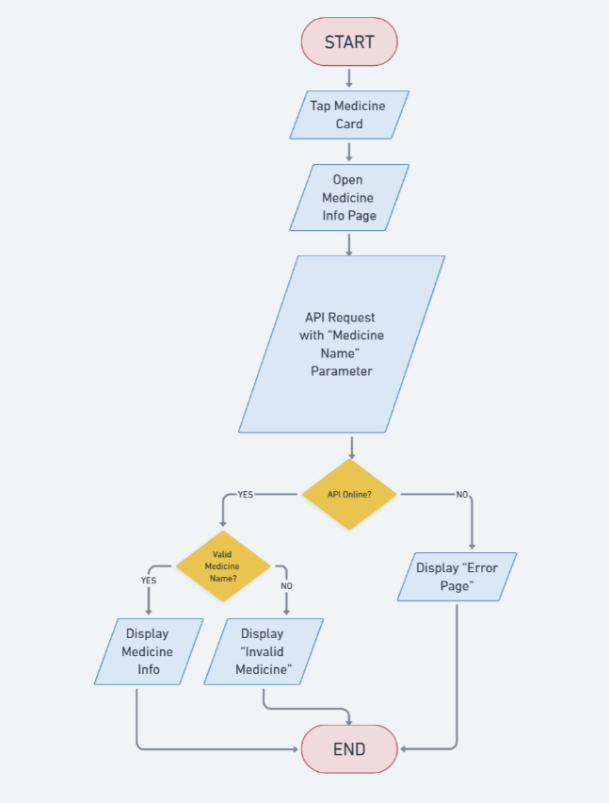

Fig. 3.4 Flowchart of Display Medicine Info

Fig 3.4 shows the workflow of “Medicine Information” when user clicks on the medicine card. It opens “Medicine Info” page in the app, which displays medicine name along with detailed explanation of it such as

* Why it’s used
* How to use it
* Benefits of the medicine
* Side effects of the medicine
* How the medicine works
* Whether it’s safe to consume with
  + Alcohol
  + While Driving
  + During Pregnancy
* Alternatives of the medicine

All the above details are fetched using *llama3-8b-8192* API provided by “Groq” Platform

### 4. IMPLEMENTATION AND RESULTS

**Setting up Visual Studio Code**

Getting up and running with Visual Studio Code is quick and easy. It is a small download so you can install in a matter of minutes.

**Cross Platform Support:**

VS Code is a free code editor, which runs on the macOS, Linux, and Windows operating systems.

Follow the platform-specific guides below:

* macOS
* Linux
* Windows

##### VS Code – INSTALLATION

1. Download the [Visual Studio Code installer](https://go.microsoft.com/fwlink/?LinkID=534107) for Windows.
2. Once it is downloaded, run the installer (VSCodeUserSetup-{version}.exe).
3. By default, VS Code is installed under C:\Users\{Username}\AppData\Local\Programs\Microsoft VS Code.

Alternatively, you can also download a Zip Archive, extract it and run Code from there.

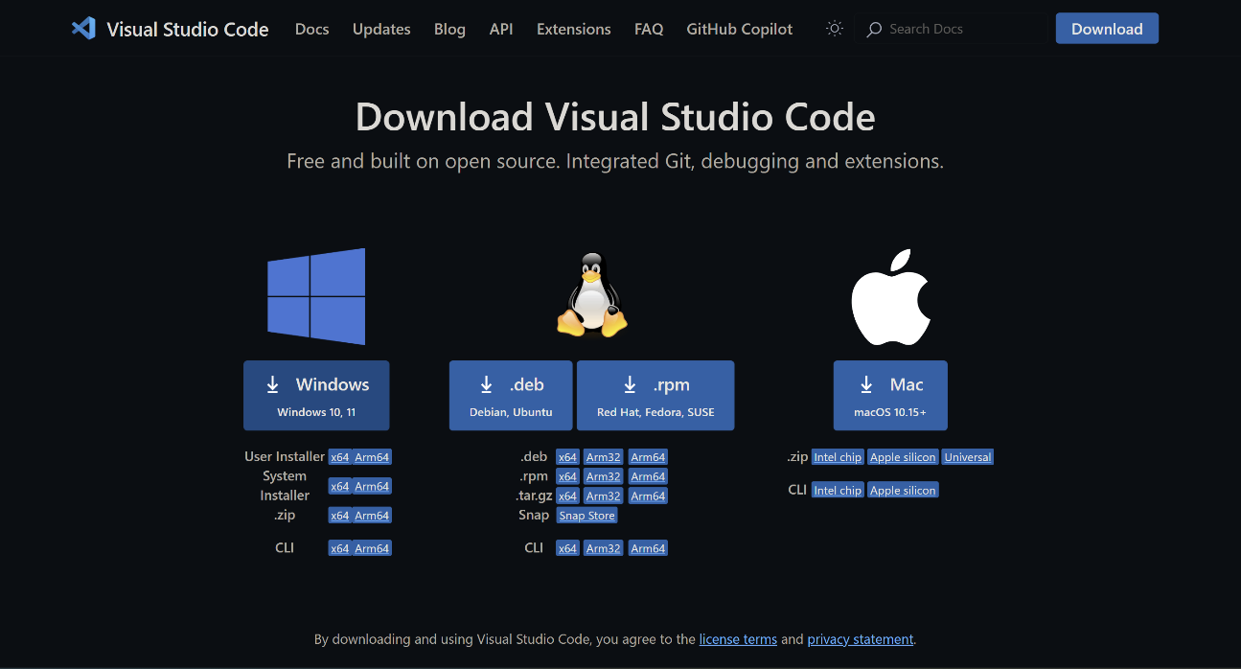

Fig 4.1 Download Microsoft VS Code IDE

**Setting up Flutter SDK**

Download and install the Flutter SDK from the official Flutter website

(<https://flutter.dev/docs/get-started/install>).

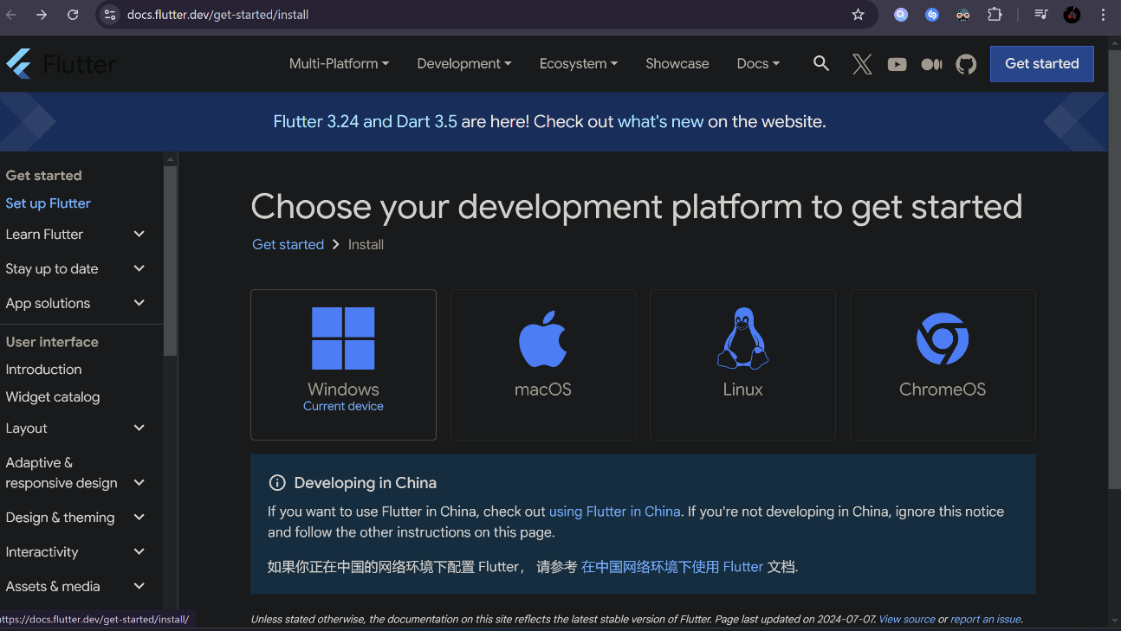

Fig 4.2 Download Flutter SDK

**Setting up Dart SDK :**

Flutter relies on the Dart programming language. Download and install the Dart SDK from the Dart SDK download page (<https://dart.dev/get-dart>).

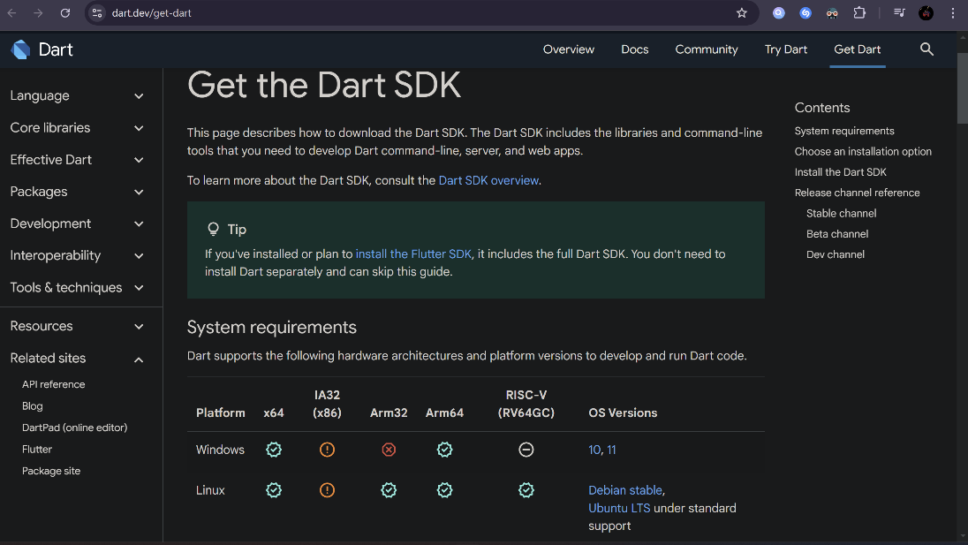

Fig 4.3 Download Dart SDK

**Setting Up Flutter in Visual Studio Code:**

Once you have the prerequisites installed, follow these steps to set up Flutter in Visual Studio Code:

**Step 1: Install the Flutter Extension**

Open Visual Studio Code, and navigate to the Extensions view by clicking on the Extensions icon in the Activity Bar on the side of the window (or using the shortcut `Ctrl+Shift+X`).

Search for “Flutter” in the “Extensions” view search bar. Look for the official Flutter extension, published by the Dart Code team. Click the install button to install the extension.

**Step 2: Install Dart SDK**

Similarly, search for “Dart” in the Extensions view search bar and install the Dart extension. This extension provides support for the Dart programming language, which Flutter is built upon.

**Step 3: Configure Flutter SDK Path**

After installing the Flutter extension, open the command palette by pressing `Ctrl+Shift+P` (Windows/Linux) or `Cmd+Shift+P` (Mac) and run the command `Flutter: Select Flutter SDK`. Choose the path where you installed the Flutter SDK.

**Step 4: Create a New Flutter Project**

Now that your Flutter environment is set up, create a new Flutter project. Open the command palette again (`Ctrl+Shift+P` or `Cmd+Shift+P`) and run the command `Flutter: New Project`. Follow the prompts to specify your project’s name and location.

**Step 5: Open the Project in VSCode**

Open the newly created Flutter project folder in Visual Studio Code. You can do this by selecting “File” > “Open Folder” and choosing the folder where you created your Flutter project.

**Step 6: Run Your Flutter App**

Open the terminal in VSCode (View > Terminal or `Ctrl+` ` `). Navigate to your project folder using the `cd` command and run the command:

flutter run

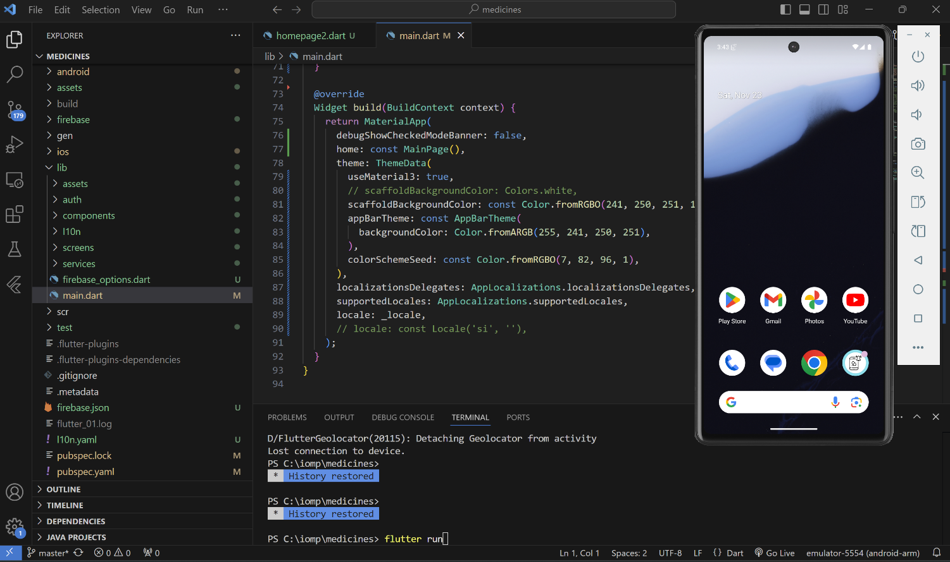

Pixel 6 Emulator

Fig 4.4 Launching app in mobile emulator using VS Code

The “flutter run” command will launch “*lib\main.dart*” on sdk gphone64 x86 64 emulator in debug mode.

It will also display the following:

*Running Gradle task 'assembleDebug'... 58.1s*

*√ Built build\app\outputs\flutter-apk\app-debug.apk*

*Installing build\app\outputs\flutter-apk\app-debug.apk... 6.0s*

Once the compiling is done, the emulator automatically opens up the application.

Alternatively, if you don’t want virtual android emulator, you can use your own personal real mobile device.

For **Android**, this is easy:

1. Enable Developer Options and USB debugging on your device. This varies slightly by Android version, but the short version is you tap on the Device Build Number 7 times. Then a "Developer Options" option comes up and you can click "enable USB Debugging."
2. Then plug your phone into your computer with a USB cable. You'll probably see some popup on your phone asking if you want to allow USB debugging with that computer. Click "yes".
3. Run Flutter just like you would if you had a simulator running.

# 5. RESULTS

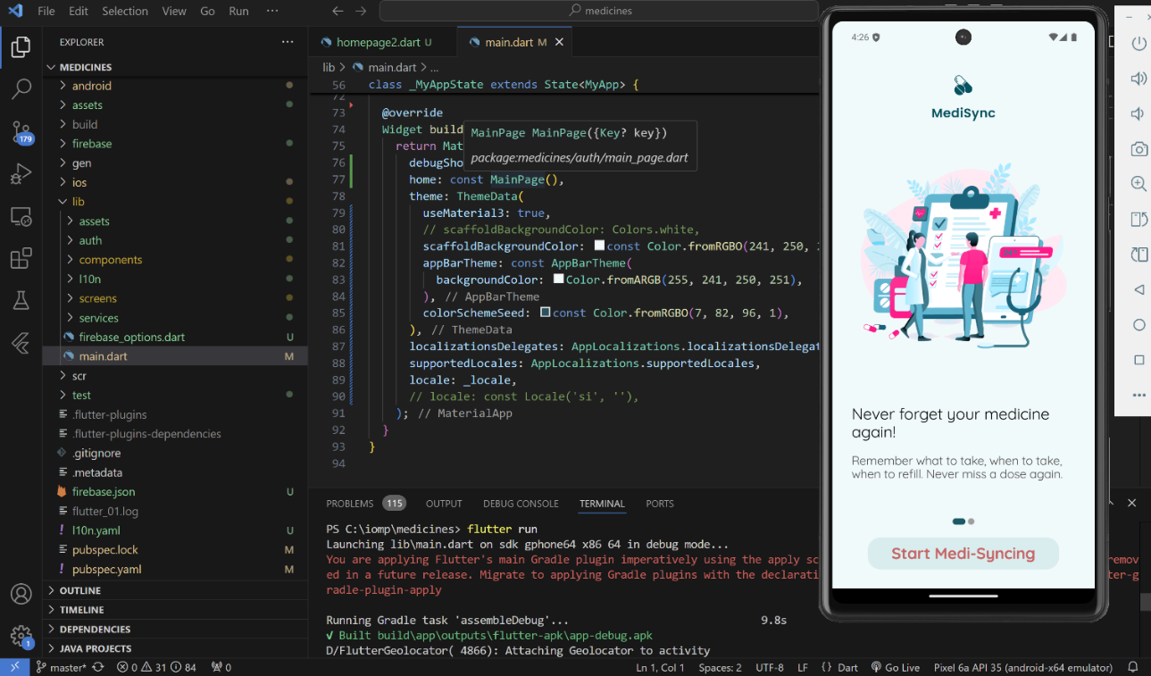

Fig 5.1 App running in the emulator

Fig. 5.1 shows the successful execution of the mobile application in the Google Pixel 6 Emulator. All the activity performed on the emulator will be displayed in the terminal as a log.

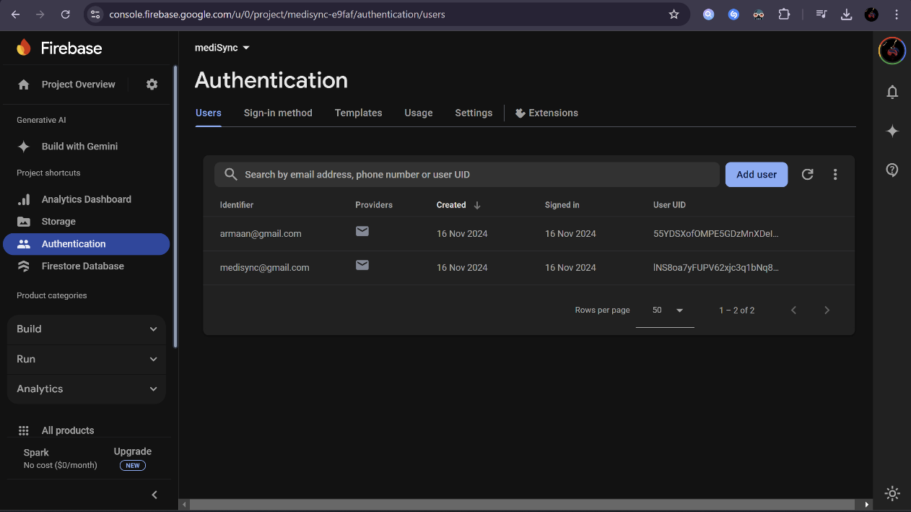

Fig 5.2 List of users/accounts stored in Firebase

Fig 5.2 shows the list of users/accounts that are stored in the firebase. Whenever user enters their email and password, the app crosschecks with the Firebase before logging them into the app.

When a user registers themselves in the app, their details are created in the Firebase so that they can sign in again.

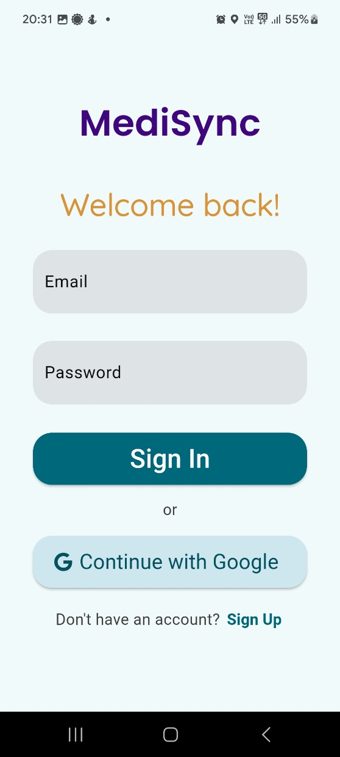 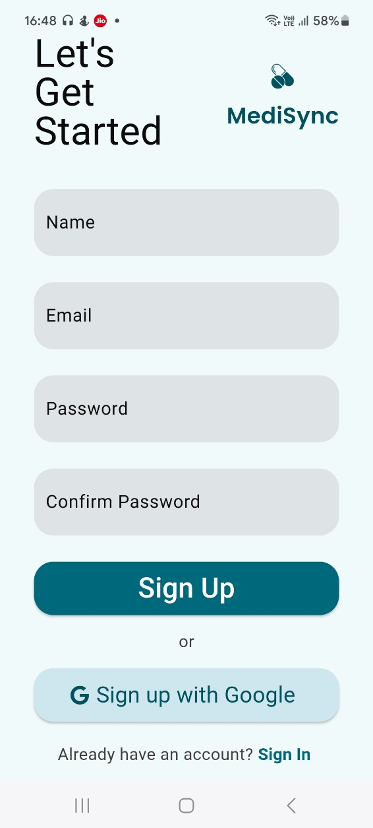

Fig 5.3 Sign In Page Fig 5.4 Sign-Up Page

Fig 5.3 & 5.4 Show the Sign In & Sign-Up page respectively. Sign in page requires email & password or alternatively, they can sign in using their Gmail account. If user is not registered, they can create an account through the sign-up page which requires name, email & password. They can also choose their Gmail account.

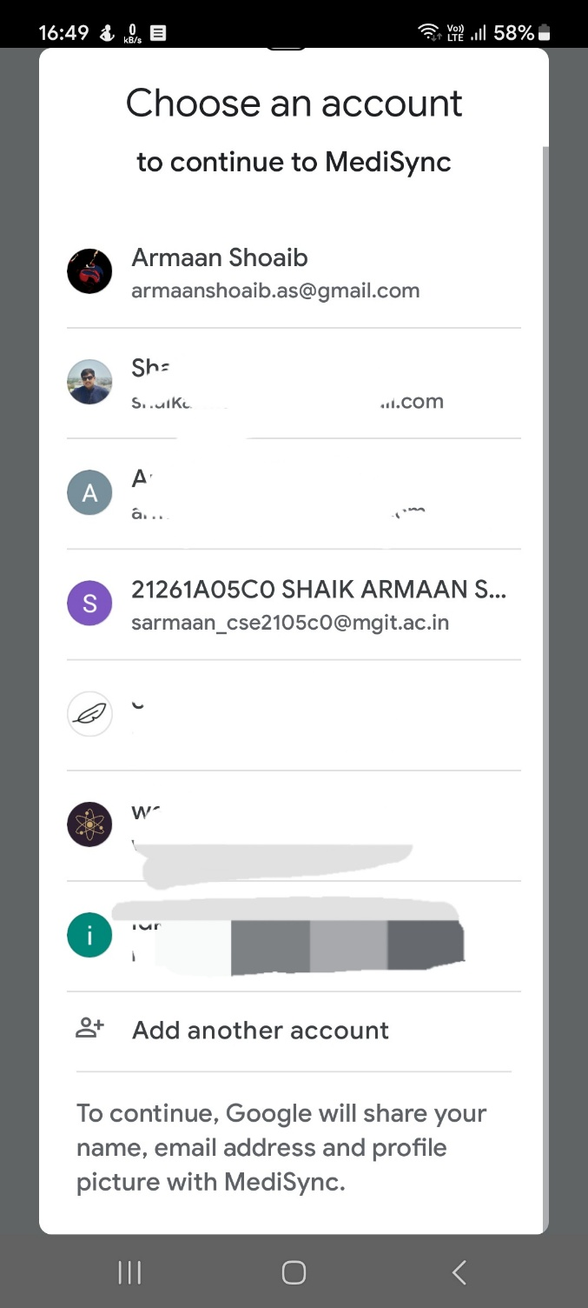 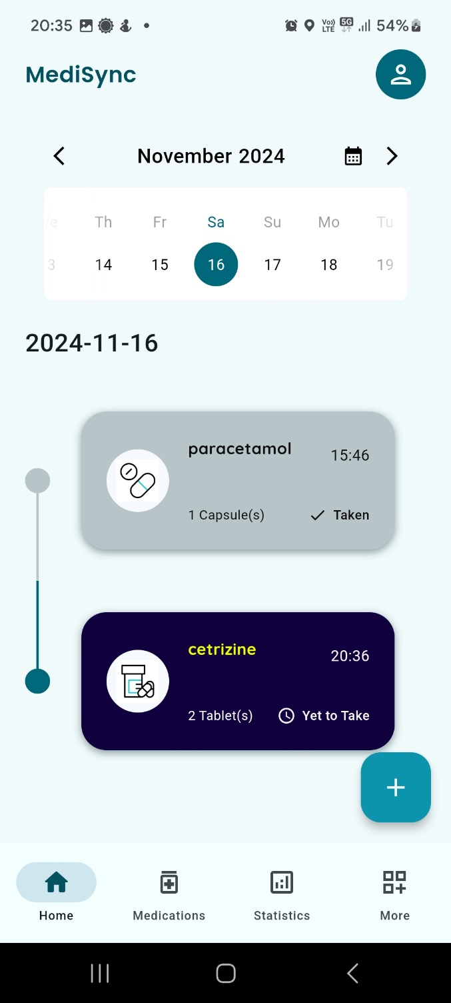

Fig 5.5 Sign in through Google Page Fig 5.6 App Home Page

Fig 5.5 shows the provision of signing in & sign up through Google account. Here, the user doesn’t need to create a password and can seamlessly access the app using his/her google account.

Fig 5.6: This is the home page/dashboard of the app. Here the user will have a view of list of medicines to be taken

on that particular day. If user wants to look what meds to be taken on a particular day, they can do so by clicking on the date in the calendar view. Additionally, they can history of their medicines by clicking on past date.

Medicines which are marked as “Taken” are displayed in gray color and in dark blue otherwise.

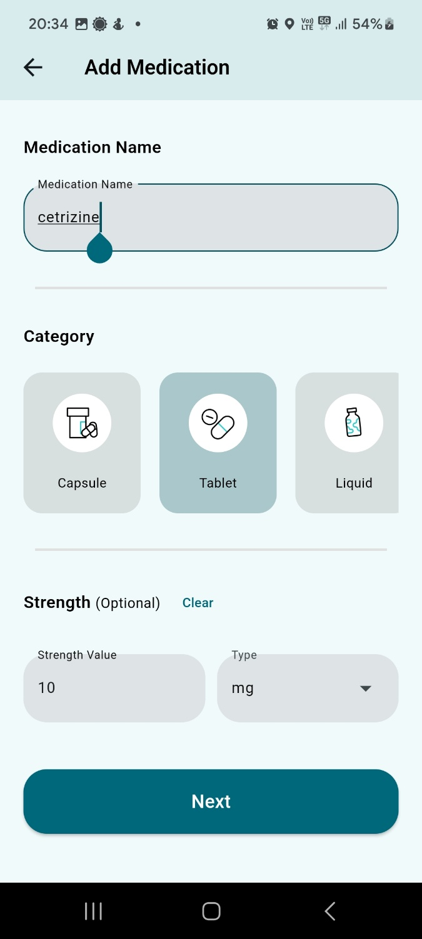 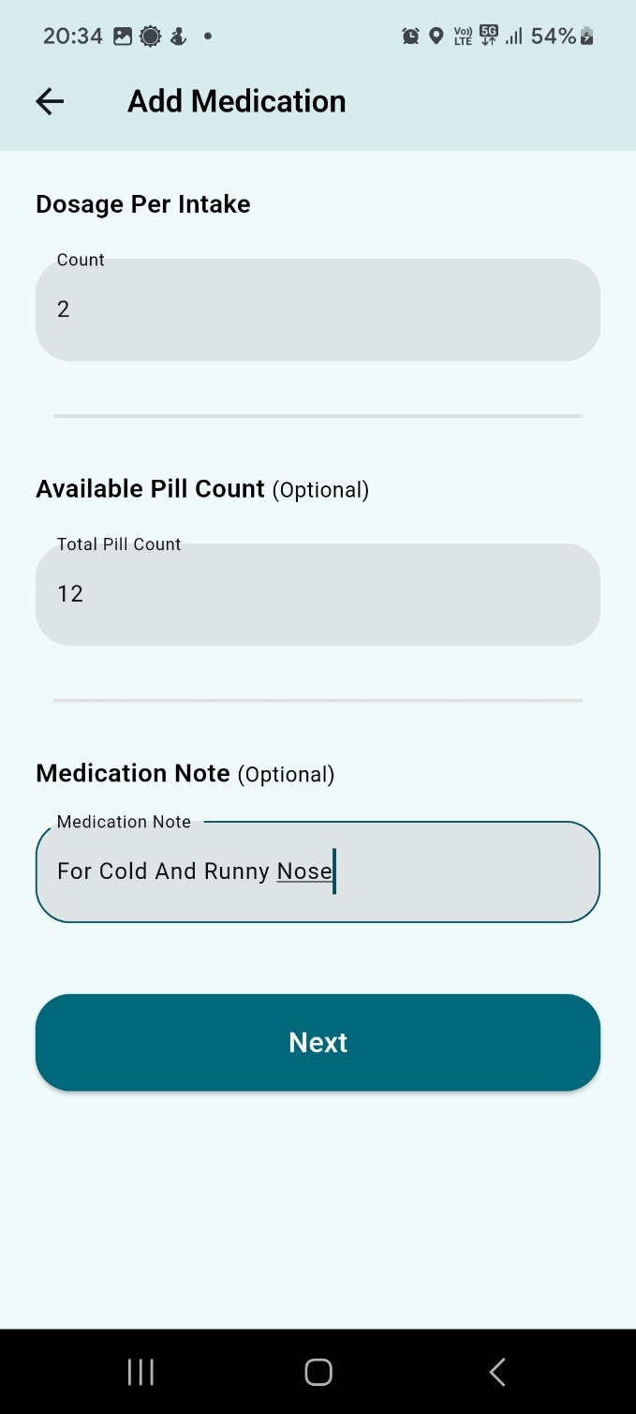

Fig 5.7 Add Medication Page 1 Fig 5.8 Add Medication Page 2

When “+” button is pressed, it shows “**Add Medication**” page which consists of 4 pages in total.

Fig 5.7 shows first sub-page of add med page. This page takes the following input from user: Medicine Name, Category and Strength (Optional) [Strength Value, Type].

Fig 5.8 is the second sub-page of add med page which takes following input from user: Dosage, Available Pill Count (Stock), Medication Note (Optional).

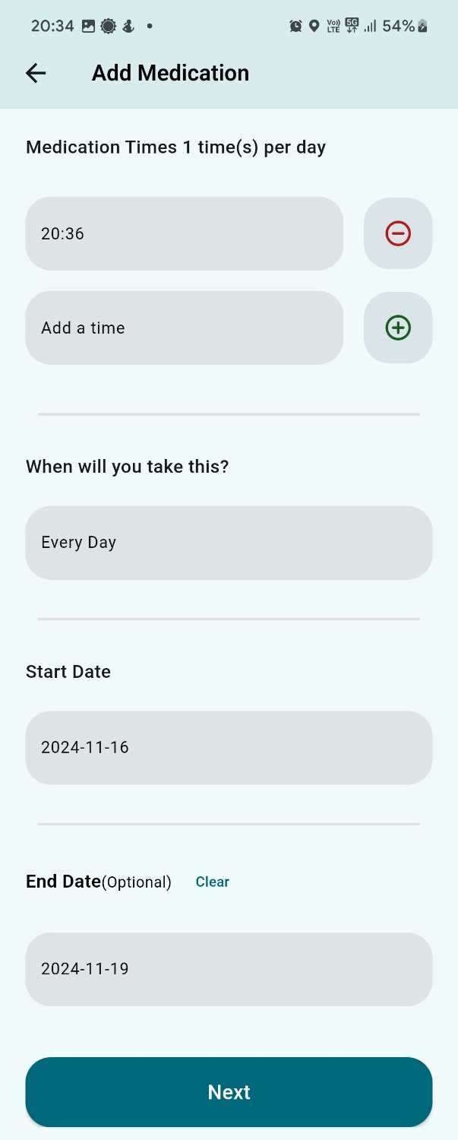 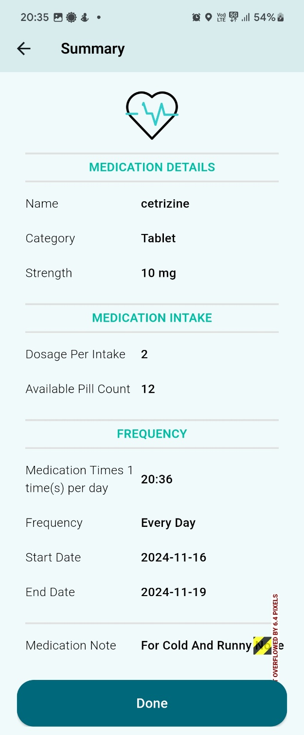

Fig 5.9 Add Medication Page 3 Fig 5.10 Add Medication Page 4

Fig 5.9 shows third sub-page of add med page. This page takes the following input from user: Medication Times (At least 1 time per day), Frequency, Start Date, End Date (Optional, if not specified, assumes 30 days from start date).

Fig 5.10 is the last sub-page of add med page which shows the summary of the medicine that is to be added. User can review the details and can correct the changes if the details were given incorrectly earlier.

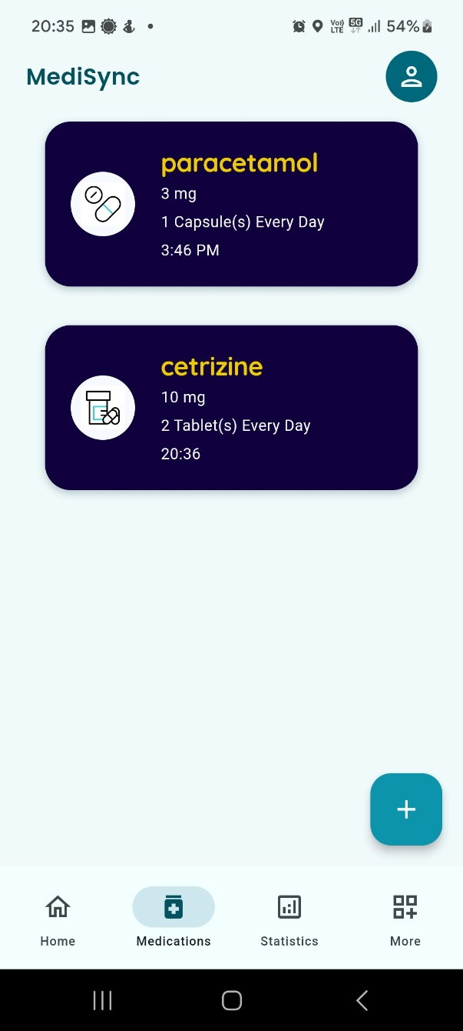 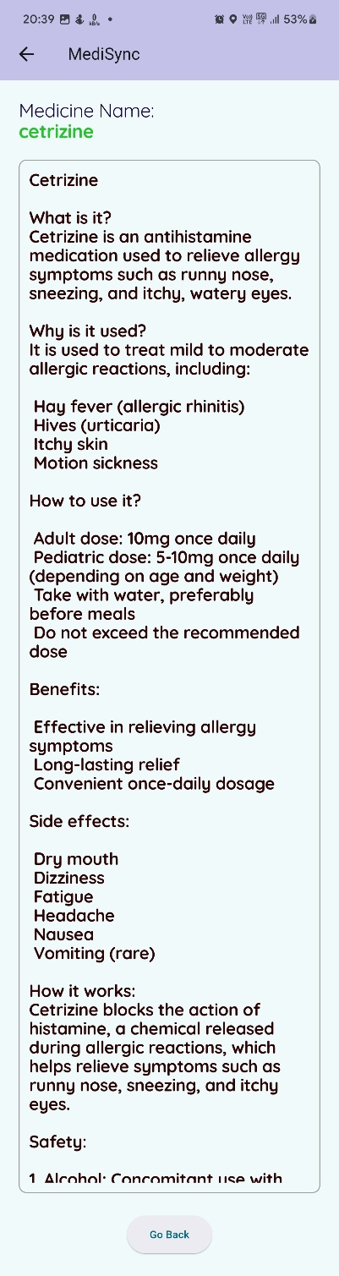

Fig 5.11 List of Medicines Page Fig 5.12 Medicine Info Page

Fig 5.11 displays the list of all the medicines that a user has added. They are displayed in cards with Medicine name, frequency and time to take the medicine. When user taps on a particular medicine, they are displayed Fig 5.12

User is redirected to what is shown in Fig 5.12 when they tap on medicine card. Here they are shown the detailed info about the medicine fetched from “LLAMA 3.5 API”.

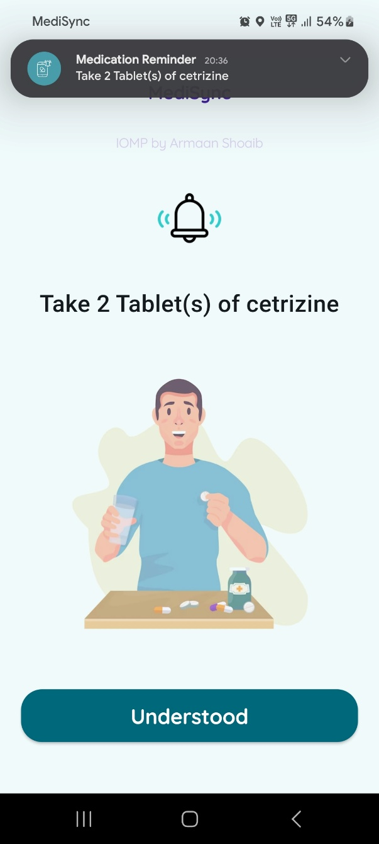 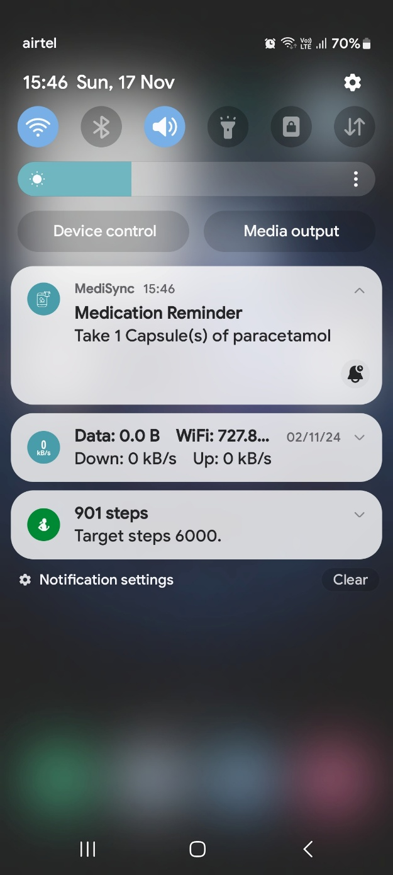

Fig 5.13 Notification pop up screen Fig 5.14 Notification Banner

Fig 5.9 shows the notification popup along with notification banner when the user is within the app. When the user is not in the app, they will be getting only a notification banner as seen in Fig 5.14.

The notification banner will consist of Medicine name and quantity so that the user can easily what to be taken and how much quantity. When user taps on the notification, the app will be opened. Thereby the user can either choose to “Take” or “Skip” the medicine. The data will be updated to cloud firebase and synced with the application.

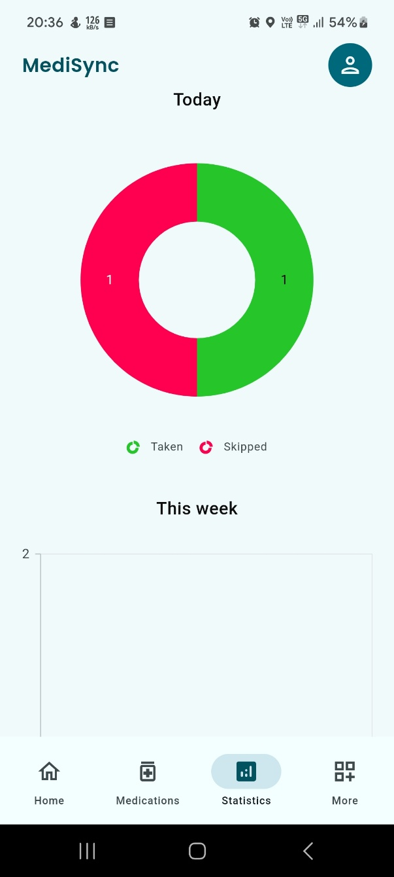 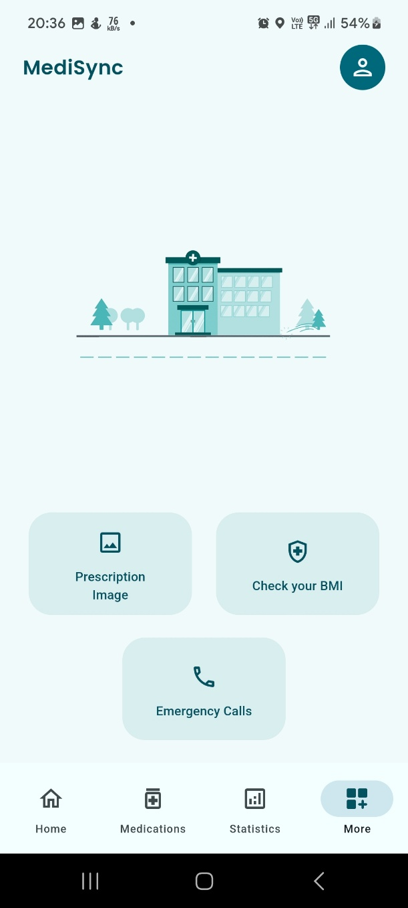

Fig 5.15 Statistics Page Fig 5.16 More Options Page

When user selects “Statistics” section from the dashboard, they will be shown the screen in Fig 5.15. When there is no data, it displays “No data available”. After some data is created, a pie chart is created with two values:

* Taken (Green)
* Skipped (Red)

In the “More” options page shown in Fig 5.16, there are 3 options.

1. Prescription Image – User can upload an image of their prescription
2. Check BMI – User can directly check their BMI.
3. Emergency Calls – If the user is having any emergency, they can directly get help from this section.

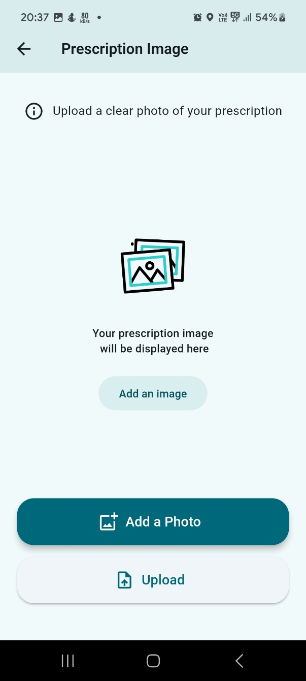 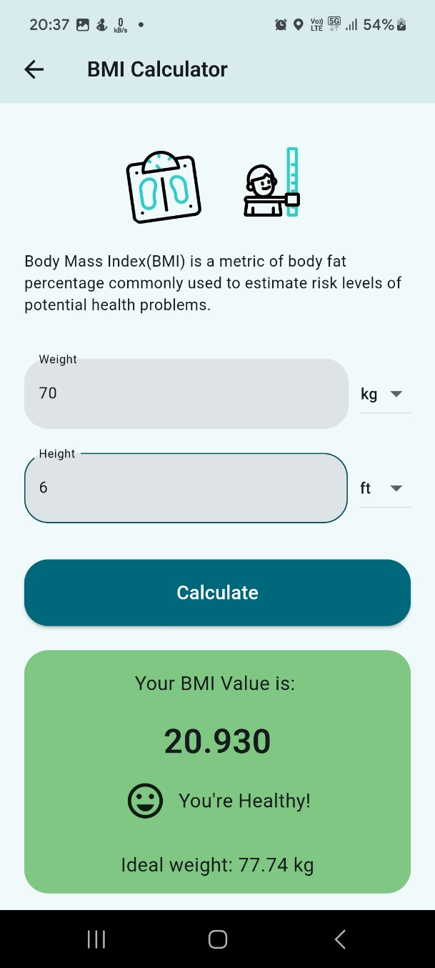

Fig 5.17 Prescription Image Page Fig 5.18 Check BMI Page

In Fig 5.16, user can select “Add Prescription Image” option, they are displayed page shown in 5.17 where user can upload image from their phone gallery.

Fig 5.18 shows the BMI Calculator page where user can check whether their BMI is either:

* **Underweight**: BMI is less than 18.5
* **Healthy weight**: BMI is between 18.5 and 24.9
* **Overweight**: BMI is between 25 and 29.9
* **Obese**: BMI is 30 or higher

Along with ideal weight.  
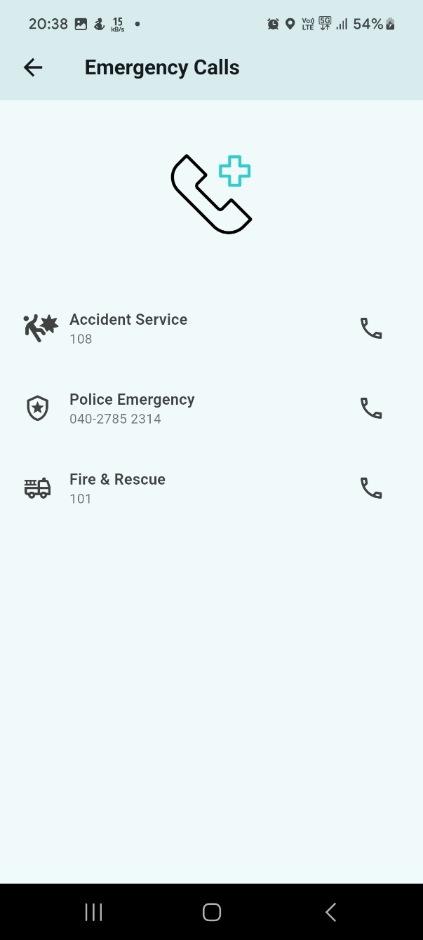 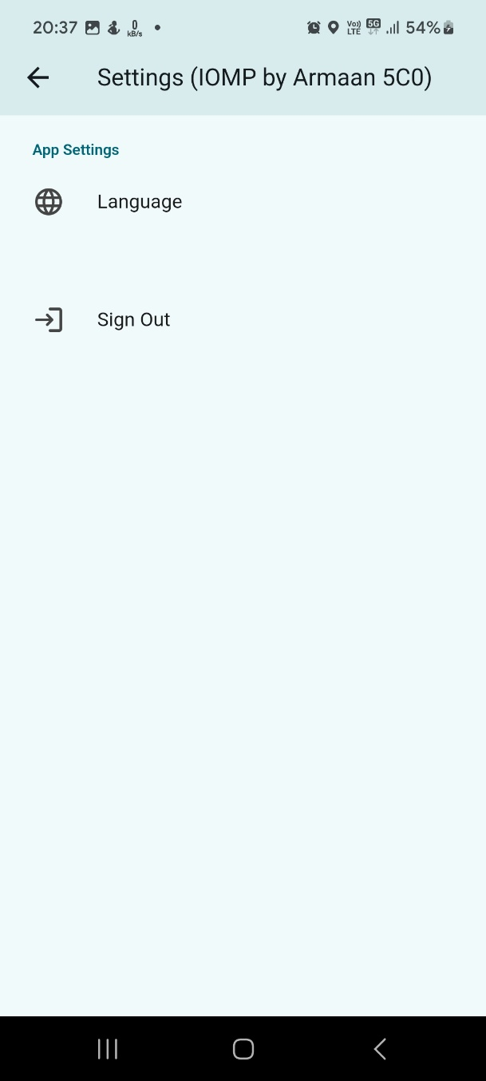

Fig 5.19 Emergency Calls Page Fig 5.20 Sign Out Page

As shown in Fig 5.19, when a user is having an emergency, they can directly call for help from the above services instantly. By clicking on the “call” symbol, phone dialer opens up and user can directly call the emergency service and get help easily.

On clicking the “person” symbol from the dashboard, user is directed to page shown in Fig 5.20 from where user can change language and sign out.

**6. CONCLUSION AND FUTURE SCOPE**

The MediSync medication reminder app, is a smart solution that provides improvement and make medication management easier. MediSync use the features of user login, managing data in firebase, and sending notifications to make sure that customers never skip the medicine. It is also beneficial for managing medicine schedules owing to the ability to save, delete, and show extensive details about the medicines.

As medication non-adherence reduces the effectiveness of a treatment and imposes financial losses on health care systems, the MediSync app shows its versatility through setting multiple notification times and frequency for various medication schedules. The app enables users to see their medication history by providing insight of data through pie chart showing medication compliance The BMI checker, as well as emergency calling features, increases safety.

##### Future scope

This MediSync application still has its own limitation and constraint even when we have made comparison with existing application strengths and weaknesses. The limitation that could be identified from this application are:

* Internet constraint: Internet is required to run this app however there could still be a possibility to reduce the dependency on internet.
* Language: The system run in English language, and there is possibility that users did not fully understand it especially elders in the rural areas.
* Voice Command: Since this app is designed with assumption that there will be physical interaction, it lacks voice command integration with Google, Amazon Alexa, Samsung Bixby etc.

#### BIBLIOGRAPHY

* 1. Ameta, D., Mudaliar, K. and Patel, P., 2015. Medication reminder and healthcare-an android application. *International Journal of Managing Public Sector Information and Communication Technologies (IJMPICT)*, *6*(2), pp.39-48.
  2. Patel S, Jacobus-Kantor L, Marshall L, et al. Mobilizing Your Medications: An Automated Medication Reminder Application for Mobile Phones and Hypertension Medication Adherence in a High-Risk Urban Population. Journal of Diabetes Science and Technology. 2013;7(3):630-639. doi:10.1177/193229681300700307
  3. Mayuresh Waykole, Vatsalya Prakash, Himanshu Singh, Nalini N: ArduMed - Smart Medicine Reminder for Old People
  4. Ms. S. A. Patil, Ms. Monika Bhanuse, Ms. Snehal Mali, Ms. Vishaka Swami: REVIEW ON MOBILE APPLICATION FOR MEDICINE REMINDER
  5. Nawal Chanane, Farhaan Mirza, M. Asif Naeem: Co-Designing a Medication Notification Application with Multi-Channel Reminders

### APPENDIX

//Include the library files