Regarding my project, I have begun by creating an Software Requirement Specification document, a class diagram, partially completing the UI, and a nonfunctional prototype of a few pages. I next need to identify which models are necessary for algorithms as I need to implement one for filling the list of sins in from a file dynamically and creating the elements of the GUI based off those.

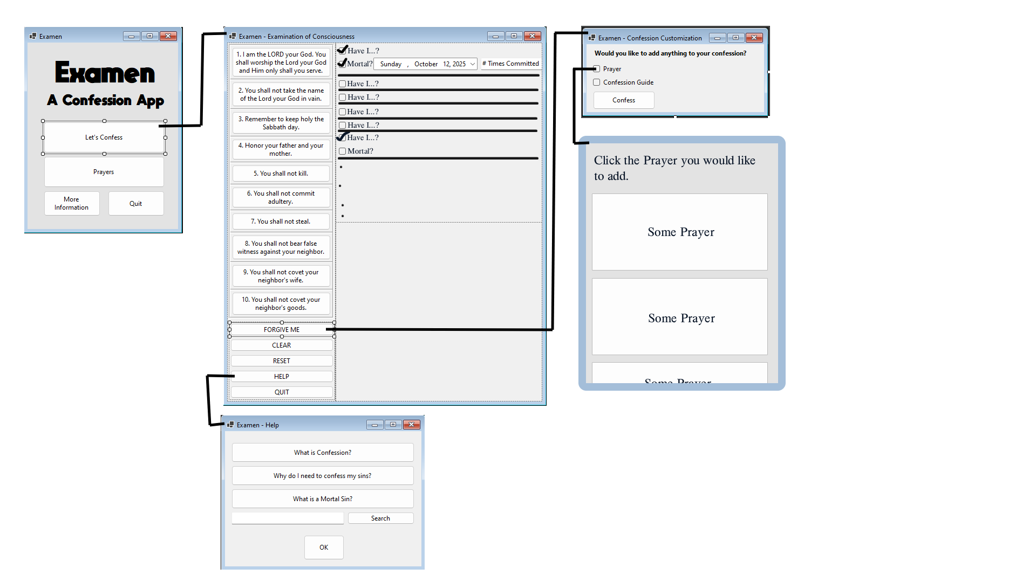
Here is the UI. The class diagram cannot go here because of how its saved.

