

Computer Architecture & Logic Design Project

5 Bit BCD Up-Down Counter

Submitted to:
Sir Zain Ul Hassan
Ma’am Rimsha Ghias

Submitted by: Group 10
Ahmed Rehan Tauseef (531185)
Armaghan Mahmood Shams (510059)
Arslan Ali (502198)
M. Hammad Zahid (502933)

1 | Statement
2 | Objective
3 | Description
4 | Software required
5 | Equipment required
6 | Theory
7 | Design procedure
8 | Verilog Code
9 | Proteus Simulation screenshots
10 | Conclusion

TABLE OF CONTENTS

STATEMENT
Design and implement a 5-bit Binary Coded Decimal (BCD) up/down counter that can count from 0 to 9 in BCD format, with the ability to increment or decrement based on a control input. The counter should wrap around on overflow/underflow. It can count automatically or manually

OBJECTIVE
- To develop an asynchronous digital counter that operates in BCD representation.
- To implement up/down counting functionality controlled by an external signal.
- To simulate and verify the counter behavior using Proteus
- To write code for counter in Verilog

DESCRIPTION
The 5-bit BCD up/down counter consists of five binary ripple counters each arranged to represent the BCD digits from 0000 to 1001 (0 to 9). An additional fifth bit may be used for status or control. The counter has:
- Clock input: advances the count on each rising edge.
- Up/Down control: determines counting direction (logic HIGH for up, LOW for down).
- Reset input: clears the count to 0.
On reaching 9 in up mode, the next pulse wraps count to 0; similarly, counting down from 0 wraps to 9.

SOFTWARE REQUIRED
- ModelSim for Verilog coding and waveform analysis.
- Proteus for circuit simulation.
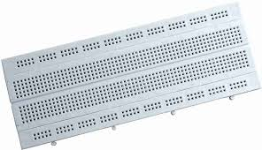
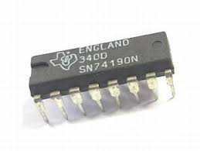
EQUIPMENT REQUIRED
- 4 breadboards to setup the circuit.
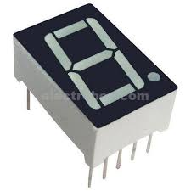
- IC 74190(4-bit binary ripple up down counter 0-9), 5 needed for 5 digits
- 7-segment display (common Anode), to display the counted digits
- IC 7447 (BCD to seven segment decoder), to convert BCD output to 7-segment code.
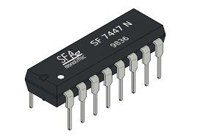
- 2X1 MUX, to select between automatic and manual counting
- 555 Timer (Astable state), clock source
- Battery for power source
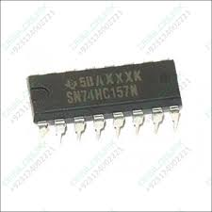
- 9V to 5V converter
- Pushbuttons for toggle and manual counting
- Resistors and Capacitors
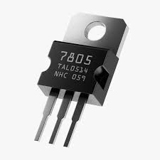
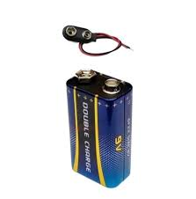
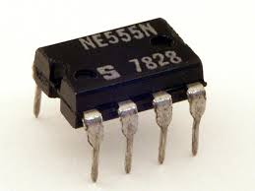

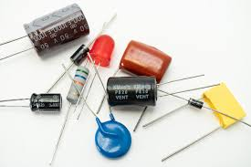

THEORY
A BCD counter uses four flip-flops to represent decimal digits 0–9. To implement up/down behavior, the next-state logic is defined by:
- When Up = 1:
Next count = (Current count + 1) mod 10
- When Up = 0:
Next count = (Current count − 1 + 10) mod 10
The fifth bit may indicate overflow or be unused. Synchronous design ensures all flip-flops trigger on the same clock edge.
If we connect 5 of these counters in an asynchronous counter, we can count 5 digits.

DESIGN PROCEDURE:
- Brainstorming phase and research
- Understanding of the design
- Creation of the design on Proteus
- Checked for improvements and rectified mistakes
- Wrote Verilog code and simulated waveforms
- Noted down material needed for hardware
- Implemented hardware
- Secured the project

VERILOG CODE

// Multiplexer module
module Multiplexer (
output wire out,
input wire select,
input wire btn,
input wire clk
);
assign out = select ? btn : clk; // Use button if select is 1, else use clk
endmodule

module decimal_counter (
output reg [3:0] count,
output reg carry, // 1-cycle pulse when overflow/underflow occurs
input wire clk,
input wire rst,
input wire enable,
input wire direction // 0 = up, 1 = down
);

always @(posedge clk or posedge rst) begin
if (rst) begin
count <= 4'd0;
carry <= 1'b0;
end else if (enable) begin
if (direction == 1'b0) begin
// Count UP
if (count == 4'd9) begin
count <= 4'd0;
carry <= 1'b1;
end else begin
count <= count + 4'd1;
carry <= 1'b0;
end
end else begin
// Count DOWN
if (count == 4'd0) begin
count <= 4'd9;
carry <= 1'b1;
end else begin
count <= count - 4'd1;
carry <= 1'b0;
end
end
end else begin
carry <= 1'b0;
end
end

endmodule

module top_counter_5digit (
input wire clk,
input wire btn,
input wire sel, // Select between clk and btn
input wire rst,
input wire direction, // 0 = up, 1 = down
output wire [3:0] digit0,
output wire [3:0] digit1,
output wire [3:0] digit2,
output wire [3:0] digit3,
output wire [3:0] digit4
);

wire clk_mux;
wire c0, c1, c2, c3;

// MUX to choose between clk and btn
Multiplexer mux_inst (
.out(clk_mux),
.select(sel),
.btn(btn),
.clk(clk)
);

// Least significant digit (always enabled)
decimal_counter d0 (
.count(digit0),
.carry(c0),
.clk(clk_mux),
.rst(rst),
.enable(1'b1),
.direction(direction)
);

// Higher digits only count on carry
decimal_counter d1 (
.count(digit1),
.carry(c1),
.clk(clk_mux),
.rst(rst),
.enable(c0),
.direction(direction)
);

decimal_counter d2 (
.count(digit2),
.carry(c2),
.clk(clk_mux),
.rst(rst),
.enable(c1),
.direction(direction)
);

decimal_counter d3 (
.count(digit3),
.carry(c3),
.clk(clk_mux),
.rst(rst),
.enable(c2),
.direction(direction)
);

decimal_counter d4 (
.count(digit4),
.carry(), // Not used
.clk(clk_mux),
.rst(rst),
.enable(c3),
.direction(direction)
);

endmodule

`timescale 1ns / 1ps

module tb_top_counter_5digit;

// Testbench signals
reg clk;
reg btn;
reg sel;
reg rst;
reg direction; // 0 = up, 1 = down
wire [3:0] digit0;
wire [3:0] digit1;
wire [3:0] digit2;
wire [3:0] digit3;
wire [3:0] digit4;

// Instantiate the top-level 5-digit counter module
top_counter_5digit uut (
.clk(clk),
.btn(btn),
.sel(sel),
.rst(rst),
.direction(direction),
.digit0(digit0),
.digit1(digit1),
.digit2(digit2),
.digit3(digit3),
.digit4(digit4)
);

// Generate clock signal
always begin
#5 clk = ~clk; // Toggle every 5ns
end

// Stimulus block
initial begin
// Initialize signals
clk = 0;
btn = 0;
sel = 0; // Use the clock as the clock source
rst = 1;
direction = 0; // Start with counting up

// Apply reset for a few clock cycles
#10 rst = 0;

// Test counting up (direction = 0)
#10 direction = 0; // Up counting
#1000; // Simulate counting up for a while

// Test counting down (direction = 1)
#10 direction = 1; // Down counting
#1000; // Simulate counting down for a while

// Change clock source to btn (sel = 1)
#10 sel = 1;
btn = 1; // Simulate button press
#10 btn = 0; // Release button
#10 btn = 1; // Another button press
#10 btn = 0;

// Test counting up with btn as clock
#10 direction = 0; // Up counting
#1000;

// Test counting down with btn as clock
#10 direction = 1; // Down counting
#1000;

// Finish simulation
$stop;
end

endmodule

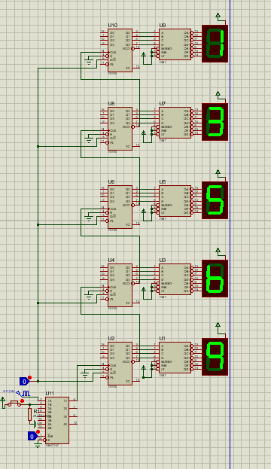
SIMULATION SCREENSHOTS

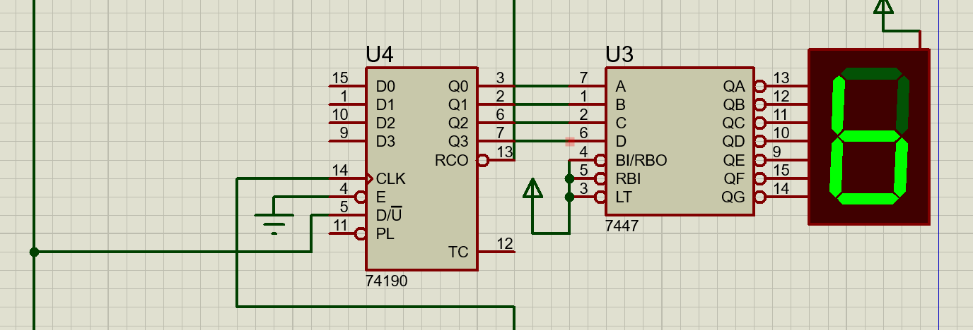

CONCLUSION
The 5-bit BCD up/down counter meets the design requirements, correctly counting between 0 and 9 in both directions and wrapping around on overflow/underflow. Simulation validates the logic and code as well explains it

